Appendix 1: Critical Systems Heuristics
Table 1: Critical System Heuristics table for stakeholders connected to drug related deaths in Scotland
1. Beneficiary | 2. Purpose | 3. Success measure
People with lived or living experience | Reduce drug-related mortality, reduce high-risk drug use, reduce undiagnosed/suboptimal management of health and social risk factors that place people who use drugs at increased risk of drug-related death. | Number of drug-related deaths, number of near-fatal overdoses, number of health and social care conditions facing people who use drugs that are diagnosed and optimally manged to their satisfaction.
4. Decision Maker | 5. Resources | 6. Decision environment
Police Scotland, City Council, NHS, Scottish Government, Alcohol and Drugs Partnerships. | Budgets, strategic priorities, health and care service targets, managers and front line staff, policy and practice frameworks. | International treaties, competing national priorities, Governments (Scottish and UK), people who use drugs, Police Scotland
7. Expert | 8. Expertise | 9. Guarantors of success
Community Justice Scotland, NHS, Addiction Psychiatrists, Scottish Prison Service, Public Health Scotland, Department of Work and Pensions, Public Health Scotland, third sector organisations, Community Pharmacy | How to identify and meet the needs of people who use drugs, How to influence public opinion / media (re: stigmatisation of people who use drugs and services), Sourcing and sharing evidence to inform policy and practice, Access to and interpretation of data on key indicators and measures, Intervention development and delivery, Implementation science based approaches, Monitoring and evaluation skills, Health and Care needs assessments, Influencing local / regional / national narratives, priority setting, Enabling PWLE and affected family members to influence policy and practice | Cross-stakeholder dialogue and participatory process, Evidence-informed policy, Evidence-informed practice, Intervention development, Pilot / test of change work, Roll-out of identified best practice, Resourcing for intervention / practice developments (money and time), Trust-building and other engagement work with people who use drugs, Commitment, consensus, decision makers drives action outcomes.
10. Witness | 11. Legitimacy | 12. Worldview
Advisory Councils, MSPs, MPs, Councillors | Deliberative processes, Research (esp. participatory methods, Policy developments, Practice guidelines and operational delivery developments, Health and Care staff engagement / buy-in / development. | Public Health informed priorities & measures (national/regional/local), Transparency regarding pressures, resources, competing priorities across stakeholders, Cross-stakeholder dialogue at national (DDTF, RRR evaluation, policy development ), regional and local (ADP/IJB) levels, Consensus-seeking across people who use drugs, Health and Care providers, Advocacy orgs, and wider (P/p)olitical stakeholders.

Appendix 2 - Preliminary subsystems analysis of the NDRDD before linking to other data
At the workshops, we presented preliminary analysis of the NDRDD before its linkage to the other administrative datasets. This analysis used the ebicLasso algorithm in the R package qgraph. Below is a description of the subsystems, Table 2 shows the subsystems and most connected nodes, and Figure 1 shows the visual that was brought to the workshops for discussion. High resolution versions of all images can be downloaded from github.

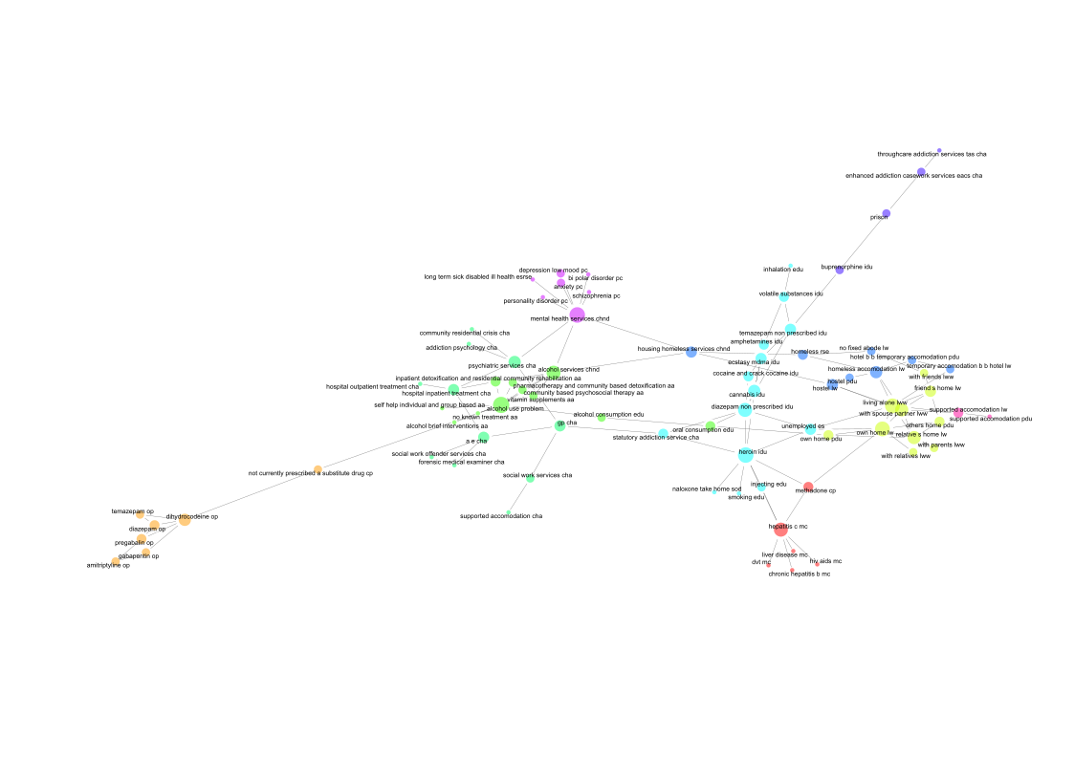
Figure 1: Co-occurrence network for the NDRDD dataset without linkage to other dataset

Table 2: Subsystem and the most connected variable for the NDRDD before linkage to other datasets
 | community | Variable | degree | betweenness
 | Medically Diagnosed Health Conditions | hepatitis c mc | 7 | 0.12
 | Pain and Benzodiazepines | dihydrocodeine op | 5 | 0.12
 | Living Arrangements | own home lw | 8 | 0.18
 | Living Arrangements | living alone lww | 8 | 0.25
 | Alcohol and Detoxification | alcohol use problem | 10 | 0.26
 | Community Health and Social Care Services | psychiatric services cha | 5 | 0.13
 | Evidence of Substances at Scene of Death | heroin idu | 9 | 0.11
 | Homelessness | homeless accomodation lw | 5 | 0.06
 | Prison | enhanced addiction casework services cha | 2 | 0.03
 | Prison | buprenorphine idu | 2 | 0.07
 | Prison | prison | 2 | 0.05
 | Mental Health | mental health services chnd | 9 | 0.20
 | Supported Accommodation | supported accommodation lw | 3 | 0.03

The variable suffix codes refer to variable groupings in the NDRDD: mc – medical conditions; op – other prescriptions; lw – Living where; lww – Living with whom; cha – contact history with drug treatment services; idu – illicit drug use.

Medically Diagnosed Health Conditions
Medically diagnosed health conditions were a distinct sub-system in the NDRDD. The health conditions in this sub-system are those which individuals would have had a formal diagnosis of (hepatitis c, hiv/aids, chronic hepatitis b, liver disease, and dvt). Hepatitis C is the most central condition (degree = 7). The factor for having a current prescription for methadone at time of death connects the health conditions sub-system to the sub-system for evidence of substances at the scene of death, via the factor for heroin being evidenced at the scene of death. Hepatitis C also connects to the evidence of substances at scene of death, via the factor for evidence of injecting drug use at the scene of death.
Pain and Benzodiazepines
here was a distinct sub-system of drugs detected in the NDRDD data, these were pain drugs individuals had a prescription for prior to death. The most central factor in this sub-system was “dihydrocodeine” (degree = 5). The factor “not currently prescribed a substitute drug” is a bridging factor. This can be interpreted as evidence that these pain prescriptions were more likely to be present among those individuals who were not currently prescribed a substitute drug, and perhaps indicate a distinct sub-system of drug-related deaths. The factor “not currently prescribed a substitute drug” joined to alcohol use problem, which is part of the sub-system for alcohol and detoxification.
Living Arrangements
The living arrangements sub-system captures the diversity of living arrangements. However, living alone was the most central factor (degree = 8). Among drug-related deaths where the death occurred in an individual’s own home, the NDRDD indicates that this is likely to co-occur with evidence of oral consumption of drug use at scene of death.
Alcohol and Detoxification
The most central factor in the alcohol and detoxification sub-system was “alcohol use problem” (degree = 10). The alcohol and detoxification sub-system captured various forms of treatment for alcohol use problems, including residential, community, and self-help treatment, detoxification, psychosocial, and group-based interventions. Inpatient detoxification and residential community rehabilitation connected to hospital inpatient treatment for drug treatment. However, hospital inpatient treatment was part of a distinct sub-system for community health and social care services for drug treatment.
Community Health and Social Care Services
The Community health and social care services for drug treatment sub-system is a particularly complex sub-system to interpret. It contained a range of factors which indicate different service contact events prior to death. What was surprising was that some services are very clearly only connected to a few other services. For example, addiction psychology and community and residential crisis services for drug treatment are only connected to psychiatric services for drug treatment. This indicates that addiction psychology and crisis services are not widely connect in the system. This contrasts with GP services, which are the most common point of referral service, and are more widely connect to other factors in the system. GP services for drug-treatment were connected to psychiatric services, accident and emergency services for drug treatment, and social work services for drug treatment. GP services for drug treatment also bridges to other sub-systems via statutory addiction services. It is perhaps surprising that GP services did not bridge to more sub-systems.
Evidence of Substances at Scene of Death
The most central factor in the evidence of substance use at scene of death was for evidence of injecting heroin (degree = 9). There are perhaps two unexpected factors in this sub-system: being unemployed and having statutory addiction service. Both of these factors connect to evidence of injecting heroin at scene of death and are also connected to evidence of injecting non-prescribed diazepam at scene of death.
Homelessness
Homelessness was an unexpected sub-system. Homelessness is a high prevalence factor in many epidemiological study but in the NDRDD system map was not connected to as many other factors as might have been anticipated. Homelessness factors were mostly connected to other indicators of homelessness such as service use or living arrangements, which could partly reflect the nature of the NDRDD relying on administrative data sources. An important feature of this sub-system was that homelessness services not for drug treatment bridged to two other sub-systems via factors for services not for drug treatment: Mental health services and alcohol services.
Prison
Prison was an unexpected sub-system. Prison is a high prevalence factor in many epidemiological study designs but had a low degree of 2 meaning in the NDRDD system map prison was connected to very few other factors. The prison sub-system included evidence of injecting buprenorphine at scene of death, most other evidence of substance use at scene of death were in a separate sub-system.
Mental Health
The mental health sub-system was linked to three other sub-systems, alcohol and detoxification, community health and social care for drug treatment, and homelessness. The connections were all to factors that represented service use (psychiatry services for drug treatment, alcohol services not for drug treatment, and homelessness services not for drug treatment). The mental health sub-system captures psychiatric conditions such as depression, bipolar disorder, anxiety, schizophrenia, and personality disorder. It also includes a factor for long term sick or disabled.
Supported Accommodation
Supported accommodation was a distinct sub-system with only two factors: for individuals who experienced a drug-related death and who were living in supported accommodation, the place of death was more likely than by chance to occur in the supported accommodation.

Appendix 3: Network analysis of the linked data network
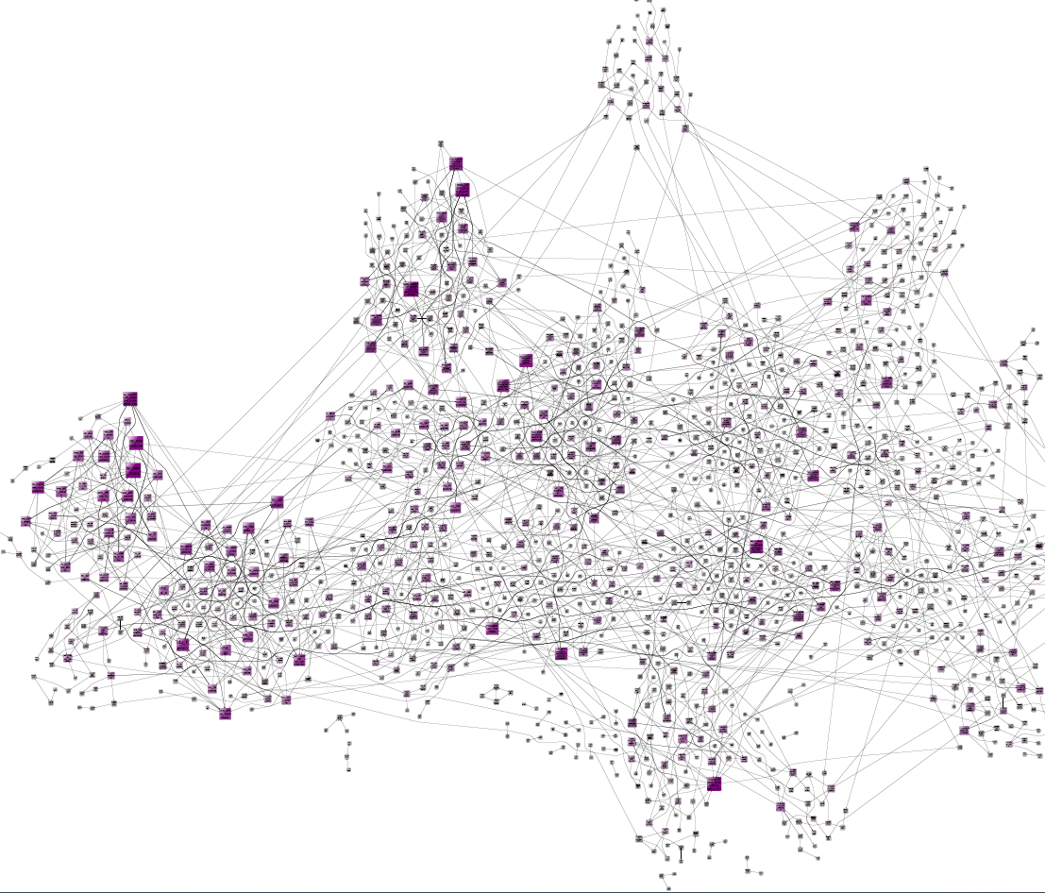
Figure 2: Condition co-occurrence network for variables in hospital episode, prescription data, and the National Drug Related Deaths databases. 1,229 variables relating to 6,608 individuals. Node size and colour represents number of connections, node position based on Louvain community detection algorithm using yEd organic layout.

Figure 2 shows a visualisation of the co-occurrence network, with node position based on the community detection algorithm used to classify variables in Table 2 of the main manuscript. Several of the larger subsystems can be seen by eye, but many connections between the subsystems are also visible, indicating that the patterns of co-occurrence are not distinct and it is common for many conditions to co-occur.

Table 3: List of subsystems in the linked data containing only two variables
Subsystem description
Meloxican anti inflammatory
Otex ear drops
Twinrix hepatitis A vaccine
Peak flow meter
Hydrocortisone cream
Tobacco related mental disorder
Epaderm ointment
Respiratory failure
Iron tablets
Fall
Tubigrip dressing
Stomach problems
Terbinafine
Symbicort turbohaler
Diclofenac Anti inflammatory
AQ_CRM Aqueous cream
Bactroban antibiotic cream
Respiratory failure
Open wound of cheek
Unspecified abnormal blood chemistry
Unspecified viral infection
Recurrent depression
Arthritis
In education or training

Appendix 4: Information on National Drug Related Deaths Database variables

The NDRDD data contains information compiled from multiple sources. The variables have the following suffixes to describe the broad theme of the variables.

Table 4: Description of NDRDD variable prefixes
Prefix | Description
aa | Alcohol treatment
cha | Community health
chnd | Contact with services for reason other than drug use
cp | Evidence of a community prescription
edu | Evidence of drug taking method
es | Employment status
lw | Living where
lww | Living with whom
mc | Medical conditions
op | Other prescriptions
pc | Psychiatric conditions
pdu | Place of drug use
td | Toxicology drug
idu | Illicit drug use
ppch_ | Drug treatment psychiatric service
ppchnd_ | Psychiatric service for reason other than drug use
recent_ | Recent diagnosis before death
rse_ | Recent significant events
mh_ | Mental health

Appendix 5: Detailed interpretation of the system map subsystems and network metrics

Table 5 shows the subsystems identified in the map along with the factors with the highest degree centrality in each sub-system. Data on all factors and the subsystems are available at github.com/MRC-CSO-SPHSU/NDRDD-linkage.
Table 5: Subsystems returned from community detection algorithms applied to the system map, and five factors within each subsystem with highest degree
Subsystem description | Factors in subsystem | Five central factors | Degree | Between-  ness
Drug death and proximal causes | 22 | Control and regularity of substance use | 10 | 0.11
 |  | Initiation of drug use | 8 | 0.07
 |  | Physical health | 8 | 0.02
 |  | Continued use of drugs | 7 | 0.06
 |  | Drug-related death | 7 | 0
Life experiences and mental wellbeing | 16 | Mental health and wellbeing | 17 | 0.09
 |  | Poverty | 14 | 0.03
 |  | Criminalisation of drugs | 12 | 0.03
 |  | Positive future aspirations | 11 | 0.03
 |  | Contact with criminal justice system | 9 | 0.04
Public and workforce stigmatising attitudes | 16 | Prevalence of stigmatising norms around drugs | 18 | 0.14
 |  | Quality of treatment planning | 6 | 0.01
 |  | Service Quality | 6 | 0.02
 |  | Workforce development | 4 | 0
 |  | Poor treatment of PWUD | 4 | 0.04
Social influences on drug harms | 13 | Peer relationships | 6 | 0
 |  | Drug type | 6 | 0.02
 |  | Exposure to drugs | 5 | 0.04
 |  | Public versus private drug taking | 5 | 0
 |  | Knowledge of drugs and risk among general public | 4 | 0
Experience of services | 11 | Attending services | 9 | 0.01
 |  | Retention in services | 6 | 0.06
 |  | Collaboration between services | 5 | 0
 |  | Missed appointments | 5 | 0.01
 |  | Internalised stigma | 4 | 0.01
Community influences on wellbeing | 8 | Trusting community relationships | 12 | 0.03
 |  | Trusting family relationships | 7 | 0.05
 |  | Recovery capital | 5 | 0.02
 |  | Practical support | 3 | 0
 |  | Community hubs | 1 | 0
Public perspectives on substance use | 7 | Policy making environment: health focussed vs criminal justice | 11 | 0.09
 |  | Availability of services | 5 | 0.01
 |  | Harm reduction interventions | 4 | 0
 |  | Relative value of professional versus peer evidence | 3 | 0.07
 |  | Lived experience representation in policy | 3 | 0
Safe physical environments | 5 | Feeling safe | 6 | 0.01
 |  | Homelessness | 6 | 0.01
 |  | Housing Policy | 3 | 0
 |  | Quality of housing | 3 | 0
 |  | Risk of crime victimisation | 3 | 0

Death and proximal causes
The subsystem with the most factors (22 in total) included those relating to substance use and the risk of death. DRD, the focal issue – and ultimate outcome – for the system mapping exercise, was found in this subsystem. Other factors included those that place someone at a risk of fatal overdose at the biological (e.g. heart & lung health, drug tolerance, toxicity), and psychosocial (e.g. dependence, self-medication, regularity of use) levels. Many factors that are proximal to the physical process of drug fatality are points which may inform how to target and adapt individual level interventions, such as considering how to increase an individual’s knowledge of risk according to their physical health status and the type of drugs they use.
Life experiences and mental wellbeing
This subsystem contained 16 factors including mental health and wellbeing, poverty, and positive future aspirations. These factors were among the most central in the system, with 17, 14 and 12 connections to other factors. This subsystem comprised factors relating to internalised perspectives (mental health, life aspirations, quality of life), and the social factors which affect these perspectives, such as poverty, trauma, and social inclusion. The connections within this set of factors points towards the potential for community change to enhance interventions focused on the individual. For example, the causal pathways in the system maps suggest that efforts to enhance social inclusion may influence the types of substances individuals use. This in turn may influence the risk of harm occurring when using drugs, and augment individual level strategies to increase knowledge of risks.
Public and workforce stigmatising attitudes
This subsystem contained 16 factors. Prevalence of stigmatising norms around drug use was the factor with the most connections in this subsystem and the whole system map, with a degree of 18. Its high betweenness centrality score (0.14) indicates its role as a potential mediating factor for many other pathways throughout the system. That is, the prevalence of stigmatising norms was caused by various other factors (indegree = 9), such as public and professional attitudes, media reporting, as well as criminalisation, education, and treatment of peer workers (people in the workforce with lived experience of substance dependence) and people who use drugs. This factor was also causally related to numerous other factors (outdegree = 9) relating to service organisation and workforce behaviour, public discourse, and positive expectations among people who use drugs. Effectively addressing stigmatising attitudes may act to mitigate against some of the influence of broader social factors (e.g. media reporting), while also facilitating change across many elements of the system e.g. public perceptions, experiences in services, and individuals’ positive expectations.
Other factors in the subsystem related to organisation of the workforce, the representation and value placed on peer workers, media representations, wider public perceptions, and poor treatment of people who use drugs. This subsystem was also characterised by many feedback loops, which may act to reinforce and entrench stigmatising norms. For example, negative public perceptions of PWUD leads to more occurrences of poor treatment of PWUD, which reinforces stigmatising norms. Stigma means lower value is placed on peer workers, this in turns means peer workers receive lower pay than other staff, causing peer workers to be overrepresented in lower pay grades within an organisation, which in turn contributes to stigmatising norms.
Social influences on drug harms
This subsystem contained 13 factors which broadly related to interpersonal factors (peer relationships, lone/group drug taking, life-saving activity), and also drug market factors (exposure and access to drugs, type and toxicity of drugs) which may improve or worsen the risk of a DRD. Many of these factors point to the opportunities for peer to peer support for harm reduction approaches, and the diffusion of information and safe practices within communities.
Experience of services
This subsystem contained 11 factors related to the experience of services, the most connected factor being attendance at services itself, and the others related to the barriers and facilitators of attending, as well as structural influences such as the pressure on services, and collaboration. This subsystem had fewer connections to other communities and was relatively self-contained. Many of the factors here implied that support in one area may have positive consequences for other aspects of this subsystem, for example, interventions to reduce bureaucracy to get help, or to ease transitions from one service to another would improve attendance and retention in services, in turn reducing missed appointments.
Community influences on wellbeing
This subsystem contained eight factors related to aspects of community connections, family and peer relationships, and factors that facilitate and promote connections. These factors had similar influences on the drug death subsystem as those found in the social influences subsystem, but was distinct in the range of community resources which could have an influence, such as provision of warm spaces and inclusive community activities.
Public perspectives on substance use
This subsystem contained seven factors and conceptually spanned several domains, broadly related to societal, organisational and individual views about substance use. The most connected node in this system related to the primary focus of the policy environment as being either health or criminal justice focused, this subsequently influenced factors in other subsystems relating to stigma, experience of services, and mental wellbeing. Other nodes within this subsystem related to funding, use of evidence, and the value of lived experience representation.
Physical environment
The smallest subsystem contained five factors, primarily related to poor housing, homelessness, and the effects these have on personal safety. Housing policy was a key point of leverage which could affect these factors.

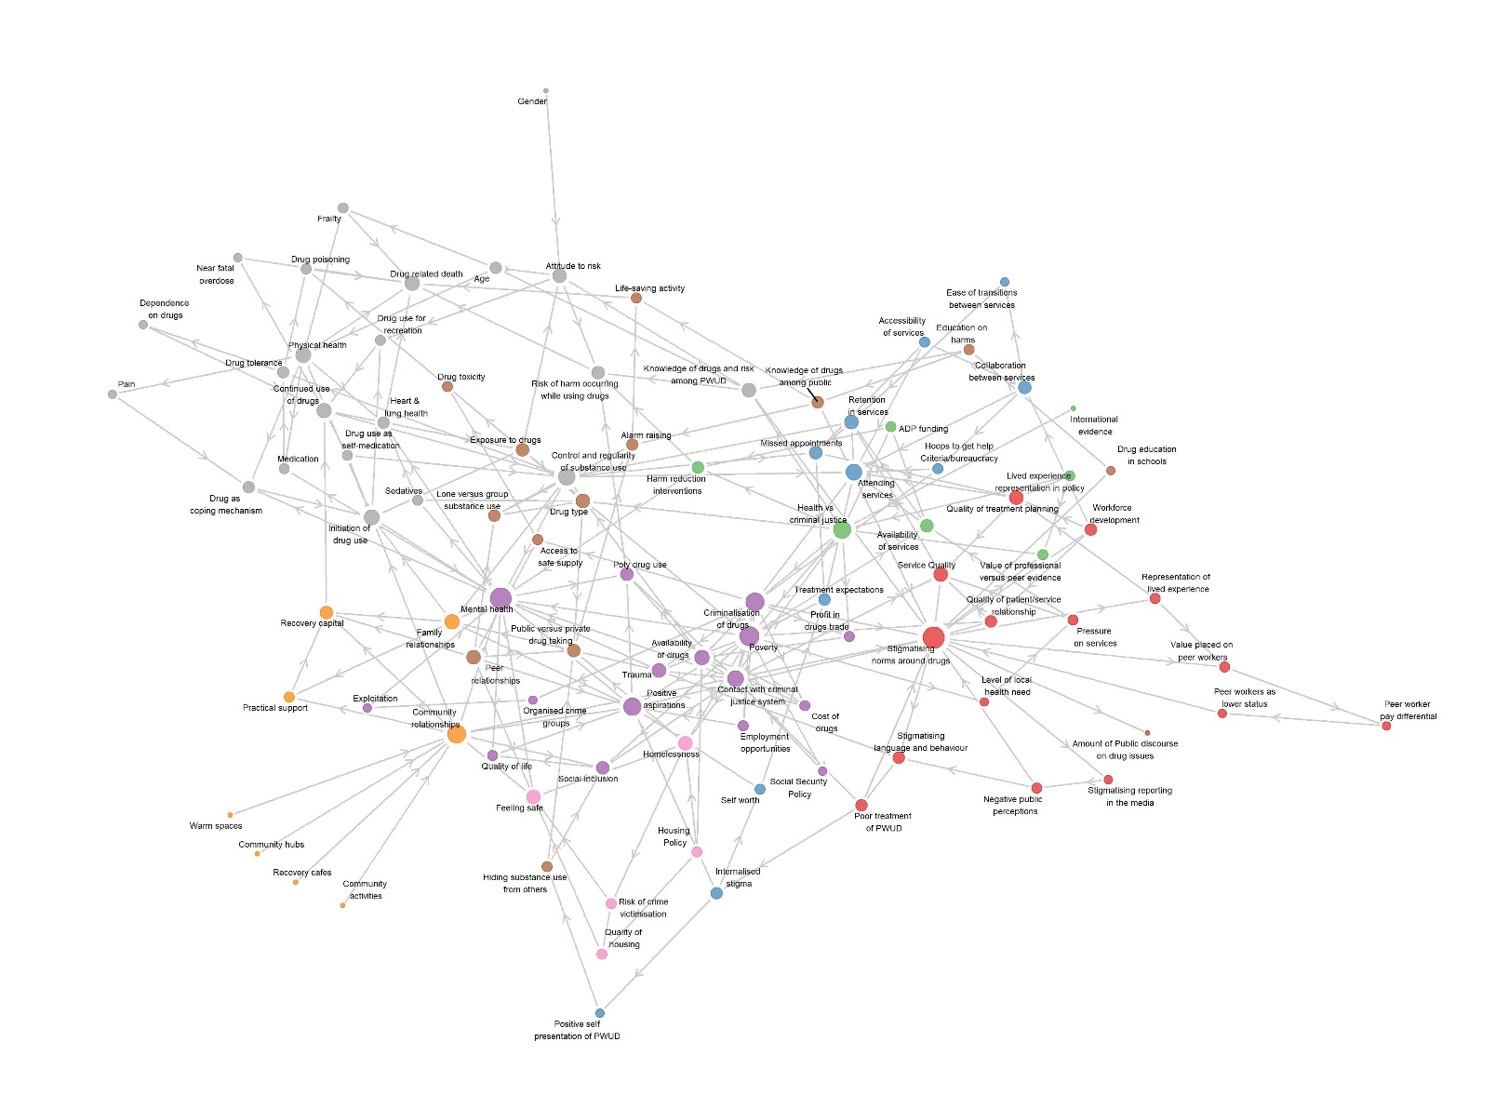
Figure 3: System map of connections between 98 factors relating to drug-related deaths in Scotland. Node position uses the Fruchterman-Rheingold algorithm instead of level of influence in vertical layers.

Appendix 5: Classification of the system map by levels of influence

Each of the nodes in the system map was classified according to the author’s understanding of the social ecological model of health. After independent coding, KS developed the levels: Biological; Contextual; Individual; Interpersonal/community; Interpersonal/organisational; Organisational; Policy and Unsure. MMcC developed the levels: death; behavioural; environmental; internal – psychosocial; interpersonal; organisational; physical; policy making and social-organisational.
After discussion of the independent coding, we found there was high correspondence in terms of the classification of factors, but with variation in the description of the level. The final description of the levels appears in Table 6, with the number of nodes at each level. The full classification of nodes can be found at the Github repository.

Table 6: Distribution of system map factors by level of influence according to the social ecological model of health
Level of influence | Number of factors | Example factor
Death | 1 | Death
Physical | 14 | Age
Behavioural | 7 | Regularity of drug use
Thoughts & emotions | 13 | Mental health
Interpersonal | 13 | Exploitation
Community | 5 | Warm spaces
Service interaction | 9 | Hoops to get help
Organisational | 10 | Quality of treatment planning
Policy | 6 | Criminalisation
Wider context | 20 | Organised crime

Figure 4: Number of system map factors by level of influence and subsystem

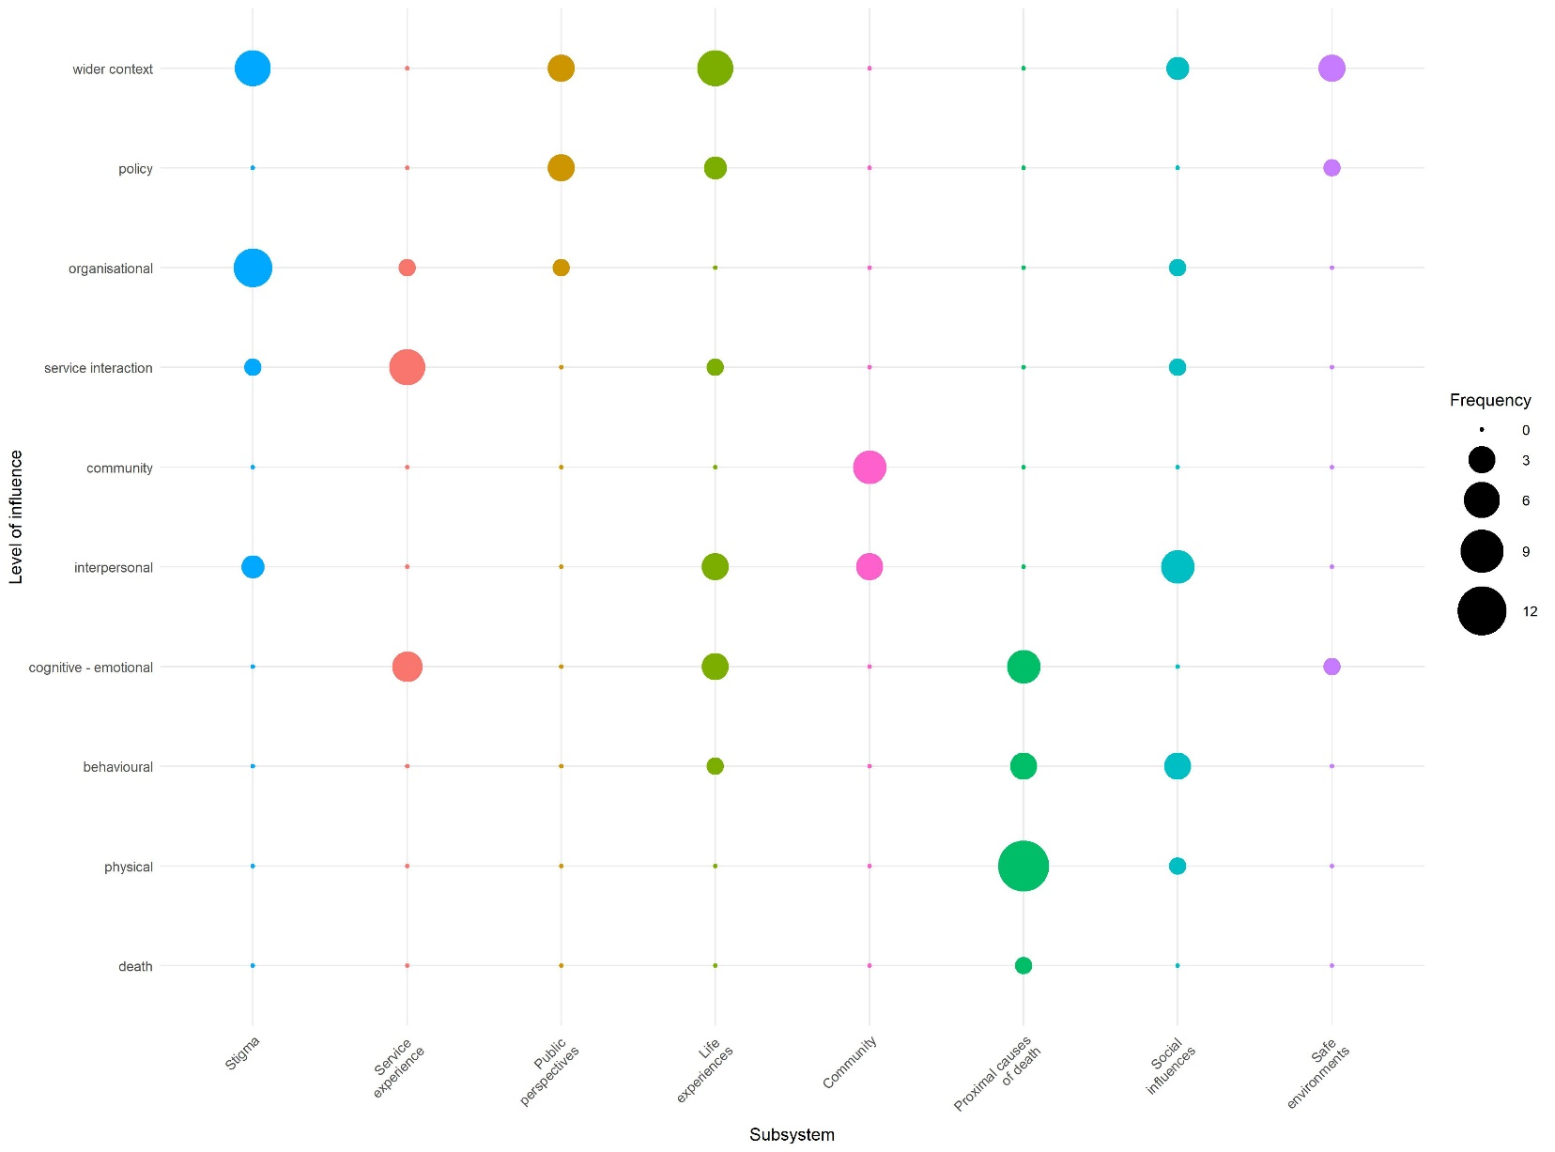
Figure 5: System map showing shaded subsystems across level of influence

