Supplementary Information (SI)

Librarian: an open-access web application for high-resolution mass spectral library assembly

Jacob Ahlberg Weidenfors¹, Bénilde Bonnefille^{2,3}, Stefano Papazian^{2,3} ✉

¹ Unit of Integrative Metabolomics, Institute of Environmental Medicine, Karolinska Institutet, Stockholm 171 77, Sweden
² Department of Environmental Science, Science for Life Laboratory (SciLifeLab), Stockholm University, Stockholm 106 91, Sweden
³ National Facility for Exposomics, Metabolomics Platform, Science for Life Laboratory (SciLifeLab), Stockholm University, Solna 171 65, Sweden
✉ Corresponding author: Stefano Papazian stefano.papazian@scilifelab.se

§SI-1. Prestwick FDA library project.
Compound list
For the spectral library project, we used the Prestwick Chemical Libraries (PW-FDA) (1) consisting of 1,200 compounds representing a broad range of small molecules with medical applications, such as pharmaceuticals and diagnostic reagents, the majority of which received current or previous approval by the FDA and/or the EMA for at least one use or indication. The compounds were obtained from the Compound Center of Chemical Biology Consortium Sweden (CBCS), SciLifeLab Campus Solna (Stockholm, Sweden). Using the mix module of Librarian, the PW-FDA compounds were distributed into 40 different mixtures. For each compound in each mixture, expected accurate masses, ion species, and charged adducts for each ionization mode were generated automatically by the mix module. These outputs were subsequently compiled by the Librarian ddaLists utility into a targeted inclusion list compatible with Xcalibur.

Instrumental acquisition
Each standard mixture was analyzed by LC-HRMS using a Vanquish Horizon system coupled to an Orbitrap Exploris 480 (ThermoFisher). Data were acquired in both ESI+ and ESI–, with each mixture injected once per ESI mode. The HRMS instrument was operated in parallel MS¹ full-scan (80-950 m/z; 120,000 nominal resolution at m/z 200) and MS² data-dependent acquisition (DDA) (30,000 nominal resolution at m/z 200). From each MS¹, the top 7-10 (top-N) most intense precursors were selected for fragmentation, with a fallback rule triggering fragmentation of the most intense ion when none of the inclusion-list masses were detected. For each ionization mode, 20 µL of each mixture was injected onto a reversed phase column (Acquity UPLC BEH C18, 1.7 μm, 2.1 × 100 mm, 130 Å, Waters) maintained at 50°C. Separation was performed using a binary gradient at 0.4 mL/min with the mobile phases (A) water (Optima LC-MS grade, Fisher Chemical) containing 1 mM ammonium fluoride (Honeywell Fluka, ≥98.0%) and (B) methanol (Optima LC-MS grade, Fisher Chemical).

Data pre-processing
Following acquisition, raw LC-HRMS files (.raw) were converted to .abf format (Reifycs ABF Converter) and pre-processed with the open-source software MS-DIAL (v4.9.221218). After peak picking, features were filtered by matching accurate masses to PW-FDA ion masses, retaining only features with acquired MS² spectra, and applying blank filtering. The processed data was exported in .mat format, with one file exported per compound feature. Complete pre-processing parameters for MS-DIAL are provided in §SI-2.

Retention time indexing
To facilitate inter-laboratory comparison of PW-FDA compound retention times, retention time indexing (RTI) was implemented following the approach by Aalizadeh et al (2). During LC-HRMS acquisition, mixtures of RTI calibrants for ESI+ and ESI- modes were injected within the same injection sequence of the PW-FDA compounds. Raw data from RTI injections were processed as described above, and the measured retention times of both RTI calibrants and PW-FDA compounds were submitted to the RTI web application. Calibration curves were generated using the “Auto-calibrate” option, and RTI values were obtained by providing input sheets containing raw PW-FDA retention times and compound SMILES.
§SI-2: Supplementary Table 1. MS-DIAL processing parameters.
Prestwick FDA library project
Data collection |  | Peak detection
MS1 tolerance | 0.002 | Minimum peak height | 90 000
MS2 tolerance | 0.005 | Mass slice width | 0.05
Maximum charge n | 3 | Advanced settings
Consider Cl and Br elements | TRUE | Smoothing method | Linear weighted  moving average
 |  | Smoothing level | 3
 |  | Minimum peak width | 5
Identification |  | Adducts
All identifications made through supplied lists of ion types/adducts with accurate mass information (one list per mix and mode). Initially, as retention times were unknown, all retention times were set to 8 min (≈ midpoint of chromatographic method). |  | ESI+: M+H+, M+NH4+, M+Na+, M+H-H2O+, M+H-2H2O+, 2M+H+, M+2H2+
 |  | ESI–: M-H-, M-H2O-H-, M+Cl-, 2M-H-, M-2H2-
Alignment
Reference file | Either of duplicated .abf files per mixture | Remove features based on blank information | TRUE
RT tolerance (min) | 0.2 | Sample max / blank average | 5 fold-change
MS1 tolerance | 0.005 | Keep 'reference matched' metabolite features | FALSE
Advanced settings |  | Keep 'suggested (w/o MS2)' metabolite features | FALSE
RT factor | 0.5 | Keep removable features and assign the tag | TRUE
MS1 factor | 0.5 | Gap filling by compulsion | TRUE

§SI-3: Supplementary Table 2. MS-DIAL processing parameters.
Environmental monitoring application by retrospective NTA of public datasets
Data collection |  | Peak detection
MS1 tolerance | 0.001 | Minimum peak height | 50 000
MS2 tolerance | 0.005 | Mass slice width | 0.05
Maximum charge n | 2 | Advanced settings
Consider Cl and Br elements | TRUE | Smoothing method | Linear weighted  moving average
 |  | Smoothing level | 3
 |  | Minimum peak width | 5
Identification |  | Adducts
MSP file | PWFDA .msp | ESI+: M+H+, M+NH4+, M+Na+, M+H-H2O+, M+H-2H2O+, 2M+H+, M+2H2+
Retention time tolerance |  | ESI–: M-H-, M-H2O-H-, M+Cl-, 2M-H-, M-2H2-
Accurate mass tolerance (MS1) | 0.01
Accurate mass tolerance (MS2) | 0.05
Identification score cutoff | 70%
Use RT for scoring, filtering | FALSE
Alignment
Reference file | Largest file by byte size (B2-3) | Remove features based on blank information | TRUE
RT tolerance (min) | 0.3 | Sample max / blank average | 5 fold-change
MS1 tolerance | 0.005 | Keep 'reference matched' metabolite features | FALSE
Advanced settings |  | Keep 'suggested (w/o MS2)' metabolite features | FALSE
RT factor | 0.5 | Keep removable features and assign the tag | TRUE
MS1 factor | 0.5 | Gap filling by compulsion | TRUE

§SI-4. Supplementary Figures 1-3.
Environmental monitoring application by retrospective NTA of public datasets
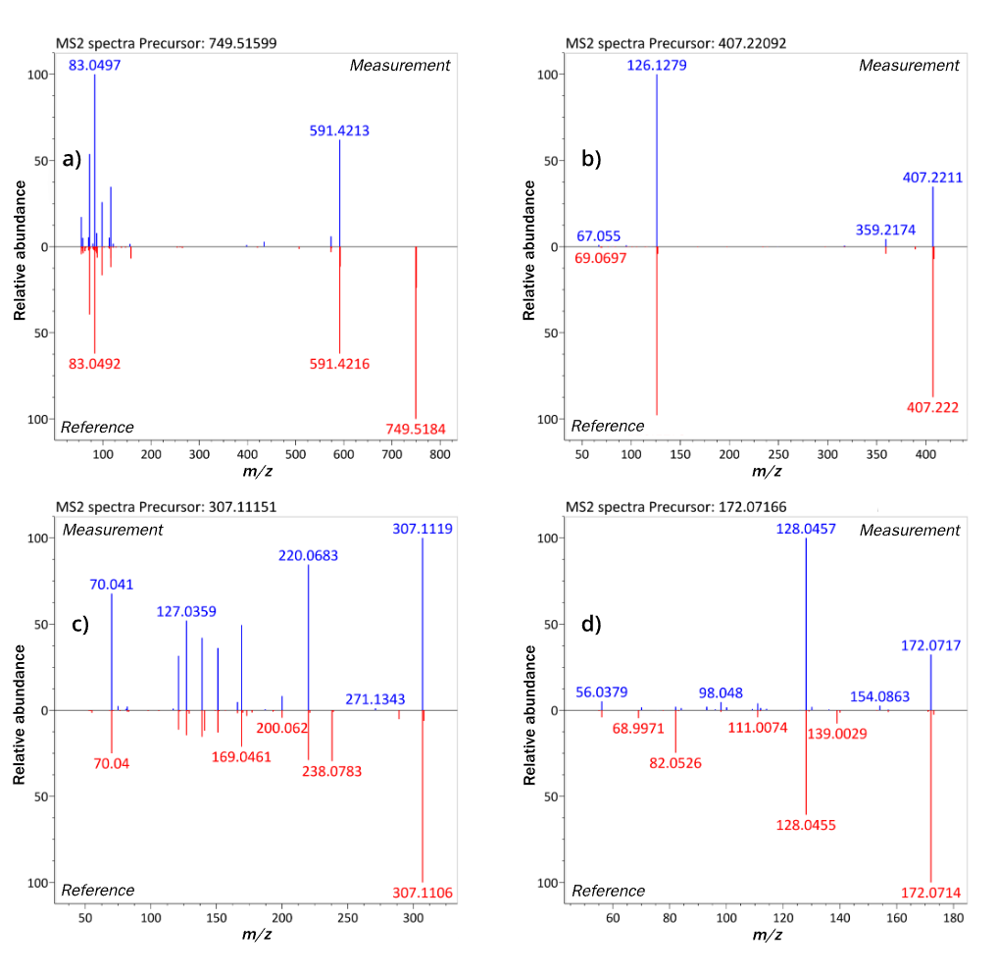
Figure S1. Spectral matching examples of antibiotics reproduced by retrospective NTA. Retrospective analysis of wastewater treatment plant effluents from two Chinese cities (Qinghai and Beijing) (3) using the PW-FDA MS2 libraries assembled via Librarian. The analysis reproduced confident annotations (Level 2) for all the antibiotics reported in the original study and present in the current library, including a) azithromycin, b) lincomycin, c) fluconazole and d) metronidazole.

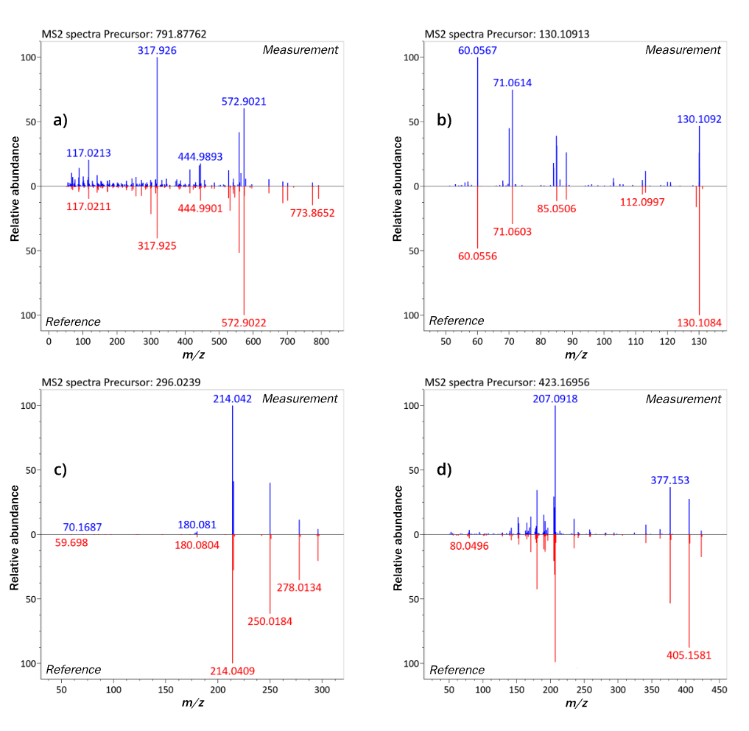
Figure S2. Spectral matching examples of common pharmaceutical environmental contaminants identified by retrospective NTA. Retrospective analysis of wastewater treatment plant effluents from two Chinese cities (Qinghai and Beijing) (3) using the PW-FDA MS2 libraries assembled via Librarian. Several confident annotations (Level 2) were attained of non-antibiotic pharmaceuticals including a) the radiological contrast agent iopromide, b) the antidiabetic drug metformin, c) the non-steroidal anti-inflammatory drug diclofenac, and d) the antihypertensive drug losartan. Iopromide was identified exclusively in effluent samples collected from the hospital wastewater treatment plant in Beijing.
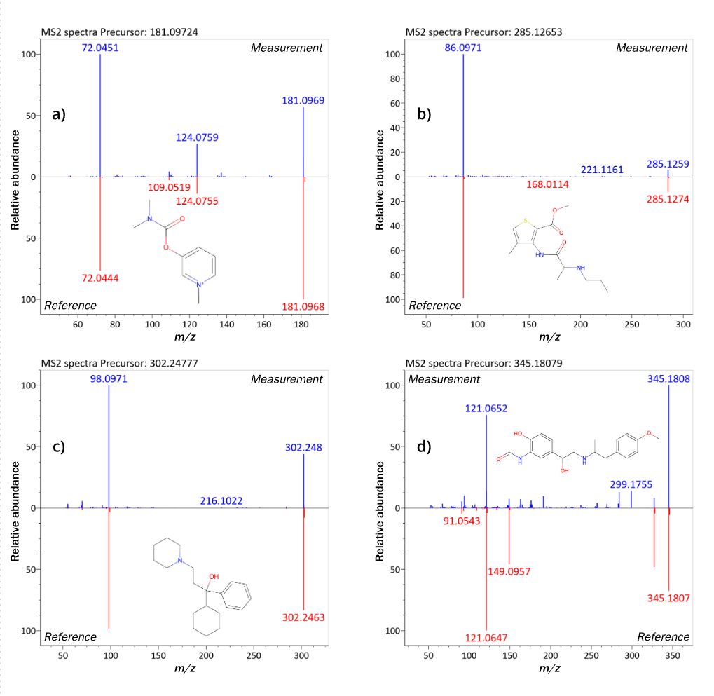
Figure S3. Spectral matching examples of new compounds identified by retrospective NTA. Retrospective analysis of wastewater treatment plant effluents from two Chinese cities (Qinghai and Beijing) (3) using the PW-FDA MS² libraries assembled via Librarian. Additional annotations for compounds at confidence Level 2 for novel pharmaceuticals which were not previously deposited in public spectral databases (MassBank and GNPS) and with limited prior documentation of environmental occurrence. Spectral matches and chemical structures shown for a) the cholinergic agent pyridostigmine, b) the local anaesthetic articaine, c) the antimuscarinic trihexyphenidyl and d) the β2 receptor agonist formoterol.
§SI-5. Librarian command-line user guide
A brief user guide for the command-line distribution of Librarian is given below. We recommend working with Librarian through a dedicated virtual environment (e.g., conda) to simplify installation and management of necessary dependencies.

First, the Librarian command-line GitHub repository should be cloned to your local system and necessary dependencies installed. Once cloned, navigate to the main Librarian folder through your command-line interface (CLI) to access module functions via the “main” Librarian script file.
Module functions are accessed by standard Python CLI syntax, by supplying commands which are read by the main script file librarian.py. I.e., all commands or calls to use module functions are initiated with the terms python librarian.py followed by the abbreviation for a specific module and related arguments. Brief descriptions, commands and arguments for use of each module and utility are given below.

The pcq module initiates the Librarian workflow. Use via the command-line requires only a .csv file preferably placed in the input folder. Arguments and a use example are given below.

Module | Argument | Description
pcq
 | [sheet_path] | Path to input compound list. E.g., "input/compoundList.csv".
 | -s [save_path] | Specify the save path for the pcq output. Defaults to the output folder.
 | -n [save_name] | Specify the save name for the pcq output. Defaults to "pcq_out".
 | Use example | python librarian.py pcq input/compoundList.csv -n compound_metadata

The sdb module may be used to interrogate public repository records for compound entries. Use via the command-line requires that at least one repository record file is downloaded and placed within the files/survey folder. Several repositories may be interrogated at a time (i.e., with one command prompt) or separately. Arguments and a use example are given below.

Module | Argument | Description
sdb
 | [sheet_path] | Path to an output sheet from the pcq module. E.g., "output/pcq_out.csv".
 | -mb [file_name] | Specifies file names for the repository records to be surveyed. All downloaded records should be placed in the files/survey folder. Only the name of the file needs to be supplied. The -mb should be followed by the file name of the MassBank records, -cp and -cn by file names of GNPS records in .csv formats in positive and negative mode respectively, -mp and -mp by file names of GNPS records in .mgf formats in positive and negative modes respectively. At least one flag and file name should be provided.
 | -cp [file_name]
 | -cn [file_name]
 | -mp [file_name]
 | -mn [file_name]
 | -s [save_path] | Specify the save path for the sdb output. Defaults to the output folder.
 | -n [save_name] | Specify the save name for the sdb output. Defaults to "sdb_out".
 | Use example | python librarian.py sdb -mb MassBank.json -cp GNPS_pos.csv -cn GNPS_neg.csv

The mix module may be used to distribute compounds to mixtures following metadata retrieval. Use via the command-line requires an output sheet from the pcq or sdb modules (the pcq-related metadata is the only required information – sdb output will have that, too). Use also requires an argument for the desired number of mixtures. Options are available to auto-assign compounds if the algorithm fails to find a solution conforming to the minimum mass difference within mixtures for the compounds and desired number of mixtures. Arguments and a use example are given below.

Module | Argument | Description
mix
 | [sheet_path] | Path to an output sheet from pcq or sdb. E.g., "output/pcq_out.csv".
 | [n_mixes] | Desired number of mixtures, integer.
 | -d [min_diff] | Desired minimum mass difference within mixtures in Da. Defaults to 0.01.
 | -a [True/False] | Auto-assign unassigned (by mass) compounds by xlogp. Defaults to True.
 | -s [save_path] | Specify the save path for the mix output. Defaults to the output folder.
 | -n [save_name] | Specify the save name for the mix output. Defaults to "mix_out".
 | Use example | python librarian.py mix output/mix pcq_out.csv 10 -d 0.05 -a False

The pre-assembly module (“precomp” in the command-line version) is used to compile required data and optional data sources in preparation for the final library assembly. Use via the command-line requires an output sheet with pcq-derived chemical metadata, a .tsv file with experimental parameters placed in the files/compiler folder as well as the presence of .mat files inside “pos” or “neg” folders (preceded by any optional folder structure) in the input/mat folder. The ionization mode should be provided as an argument.

Optional data types (RTI, ClassyFire) can be included by placing files in their respective folder, inside the input folder. Sheets from the RTI web application should be placed in the input/RTI folder, inside either “pos” or “neg” folders. A sheet with ClassyFire data from the ClassyFire Batch website (4) should be placed inside the input/classyfire folder and be named “cf_manual”. Arguments and a use example are given below. To be noted, ClassyFire chemical ontologies are automatically provided by MassBank for new records since release 2025.05.1.

Module | Argument | Description
precomp
 | [mode] | Ionization mode of data being (pre-)pre-compiled. "pos" or "neg".
 | [sheet_path] | Sheet to pull chemical metadata from; e.g., pcq, sdb or mix output sheet.
 | -fa [True/False] | Perform fragment annotation. Defaults to True.
 | -rti [True/False] | Include RTI data. Requires .csv sheets from the RTI web app to be placed in the input/RTI/(pos/neg) folder. Defaults to False.
 | -cf m | Include ClassyFire data. Calling -cf m takes data fron a .csv sheet, which must be placed in the input/classyfire folder and be named cf_manual.
 | Use example | python librarian.py precomp pos output/pcq_out.csv -rti True -cf m

The assembly module (“compile” in the command-line version) is used to generate MassBank-format .txt files and .msp library files from the pre-assembly module output sheet. The pre-assembly sheet may be manually edited prior to final assembly to e.g. exclude particular compounds or append additional data. Use via the command-line requires the presence of a pre-assembly output sheet (named either preComp_pos or _neg) to be present in the output/compiler folder. A start for record accession numbering and the ionization mode should be provided as arguments.
Arguments and a use example are given below.

Module | Argument | Description
compile
 | [acc_start] | Start of accession numbering.
 | [mode] | Ionization mode of data being compiled. "pos" or "neg".
 | Use example | python librarian.py compile 123 pos

References
- Prestwick Chemical Libraries.
https://www.prestwickchemical.com/. Accessed 1 Dec 2025.
- Aalizadeh R, Alygizakis NA, Schymanski EL, Krauss M, Schulze T, Ibáñez M, et al. Development and Application of Liquid Chromatographic Retention Time Indices in HRMS-Based Suspect and Nontarget Screening. Anal Chem. 2021 Aug 24;93(33):11601–11.
- Hu J, Lyu Y, Chen H, Li S, Sun W. Suspect and Nontarget Screening Reveal the Underestimated Risks of Antibiotic Transformation Products in Wastewater Treatment Plant Effluents. Environ Sci Technol. 2023 Nov 14;57(45):17439–51.
MassIVE Dataset ID MSV000092880.
- ClassyFire Batch by Fiehn Lab.
https://cfb.fiehnlab.ucdavis.edu/. Accessed 1 Dec 2025.

