Electronic Supplementary Materials: Fine-scale aggregations and ecology of high-density Heliometra glacialis (Crinoidea) beds in a Marine Protected Area, Atlantic Canada
by
Laura L. Teed¹* and Peter Lawton¹
¹St. Andrews Biological Station, Fisheries and Oceans Canada, 125 Marine Science Drive, St. Andrews, NB, Canada, E5B 0E4
*Corresponding author: Laura L. Teed (email: laura.teed94@gmail.com)
Author ORCIDs
Laura L. Teed: 0009-0009-9375-6619
Peter Lawton: 0000-0002-5522-6993

Journal: Marine Biology

Supplementary Tables
Table 1 Number of observations (from still images and seconds of continuous seafloor video) in each crinoid density class (0 = 0 ind. m⁻², 1 = 1-5 ind. m⁻², 2 = 6-10 ind. m⁻², 3 = 11-15 ind. m⁻², 4 = 16-20 ind. m⁻², and 5 = >20 ind. m⁻²) according to transect
Transect | Density class | Number of observations (still images) | Proportion of still images (%) | Number of observations (seconds of video) | Proportion of continuous video (%)
CON027 | 0 | 2 | 1.8 | 391 | 21.4
CON027 | 1 | 35 | 31.5 | 595 | 32.6
CON027 | 2 | 35 | 31.5 | 468 | 25.7
CON027 | 3 | 15 | 13.5 | 202 | 11.1
CON027 | 4 | 15 | 13.5 | 77 | 4.2
CON027 | 5 | 9 | 8.1 | 91 | 5.0
CON053 | 0 | 7 | 12.7 | 594 | 40.8
CON053 | 1 | 25 | 45.5 | 531 | 36.5
CON053 | 2 | 8 | 14.5 | 123 | 8.4
CON053 | 3 | 5 | 9.1 | 43 | 3.0
CON053 | 4 | 3 | 5.5 | 20 | 1.4
CON053 | 5 | 7 | 12.7 | 144 | 9.9
CON054 | 0 | 5 | 7.8 | 677 | 50.3
CON054 | 1 | 19 | 29.7 | 227 | 16.9
CON054 | 2 | 9 | 14.1 | 128 | 9.5
CON054 | 3 | 2 | 3.1 | 96 | 7.1
CON054 | 4 | 10 | 15.6 | 74 | 5.5
CON054 | 5 | 19 | 29.7 | 145 | 10.8
CON055 | 0 | 43 | 44.8 | 1639 | 73.2
CON055 | 1 | 32 | 33.3 | 400 | 17.9
CON055 | 2 | 8 | 8.3 | 102 | 4.6
CON055 | 3 | 7 | 7.3 | 40 | 1.8
CON055 | 4 | 2 | 2.1 | 20 | 0.9
CON055 | 5 | 4 | 4.2 | 38 | 1.7
CON072 | 0 | 56 | 54.9 | 1273 | 71.2
CON072 | 1 | 29 | 28.4 | 421 | 23.5
CON072 | 2 | 10 | 9.2 | 65 | 3.6
CON072 | 3 | 4 | 3.9 | 12 | 0.7
CON072 | 4 | 2 | 2.0 | 9 | 0.5
CON072 | 5 | 1 | 0.9 | 8 | 0.4

Supplementary Figures
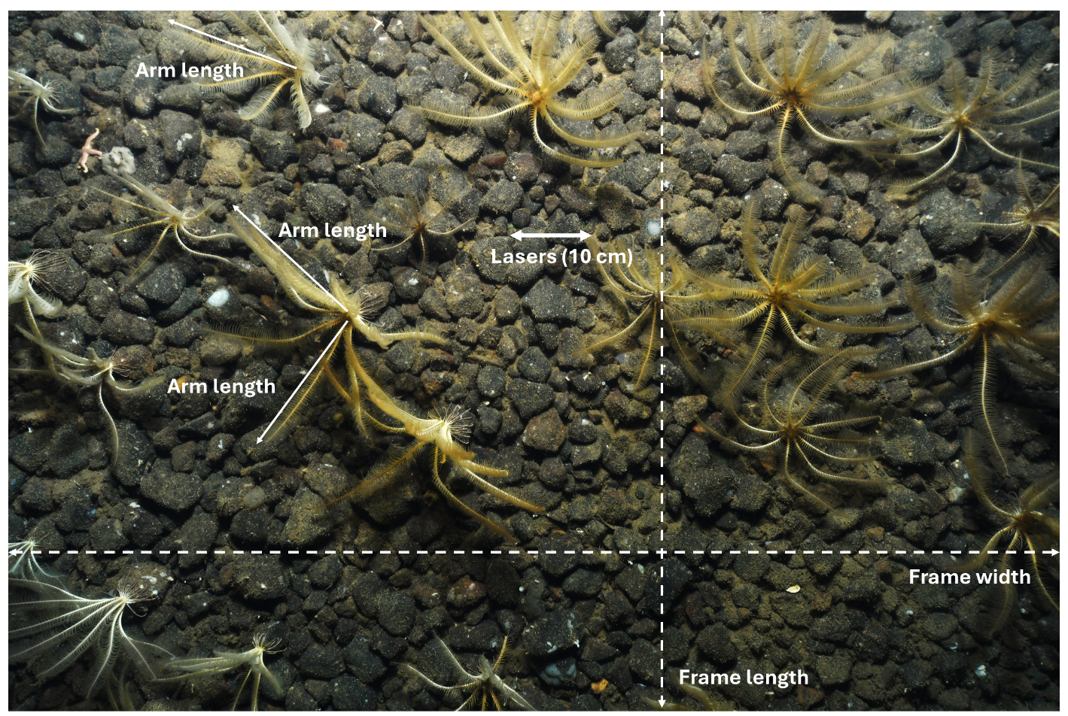
Fig. 1 Example still image from the underwater transect CON054 (file name: CON054-20240808T180521.jpg; depth: 119 m; altitude: 1.4 m), outlining example crinoid arm length measurements (i.e., only easily distinguishable, elongated arms parallel to the seafloor were measured), as well as the laser location (used for 10-cm scale), and the length and width measurements used to estimated image field of view
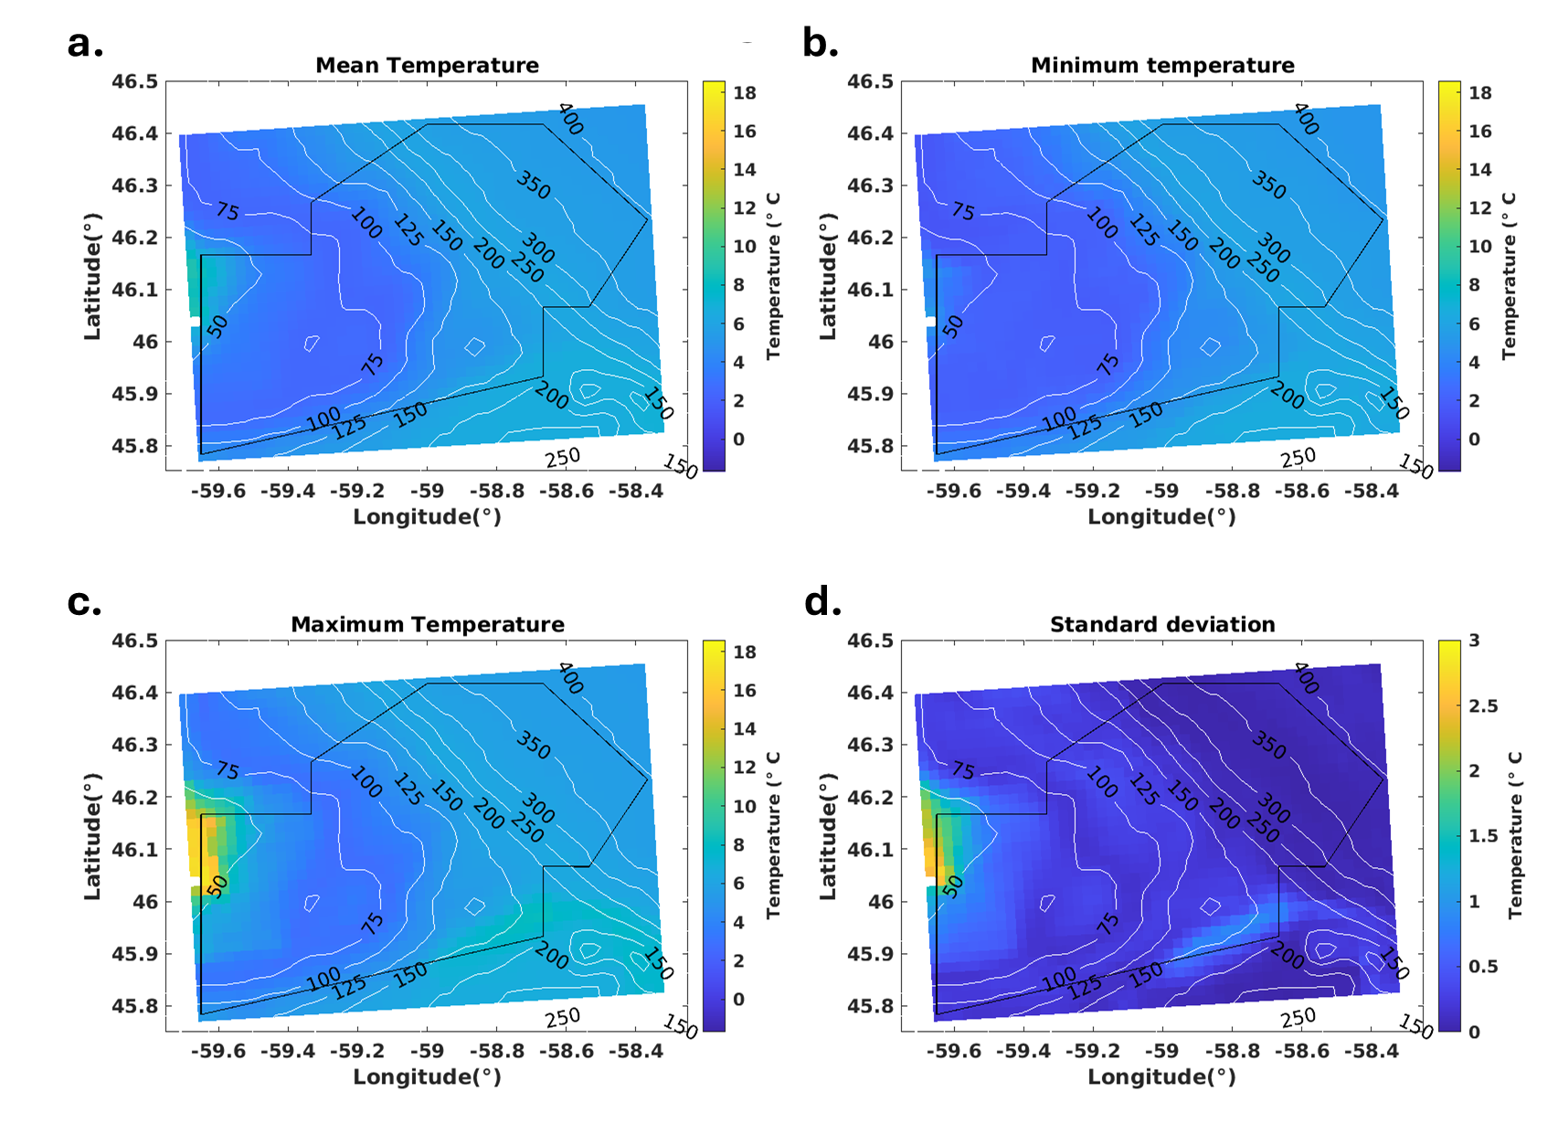
Fig. 2 CIOPS-E (Coastal Ice-Ocean Prediction System for the East Coast of Canada) monthly statistics from hourly data of the bottom temperature (°C) in the St. Anns Bank Marine Protected Area at the model’s conception, August 2016. Monthly statistics include (a) mean temperature, (b) minimum temperature, (c) maximum temperature and (d) the standard deviation with underlying depth contours. Maps and model outputs are courtesy of Michael Casey (Department of Fisheries and Oceans, Bedford Institute of Oceanography, Dartmouth, Nova Scotia, Canada)
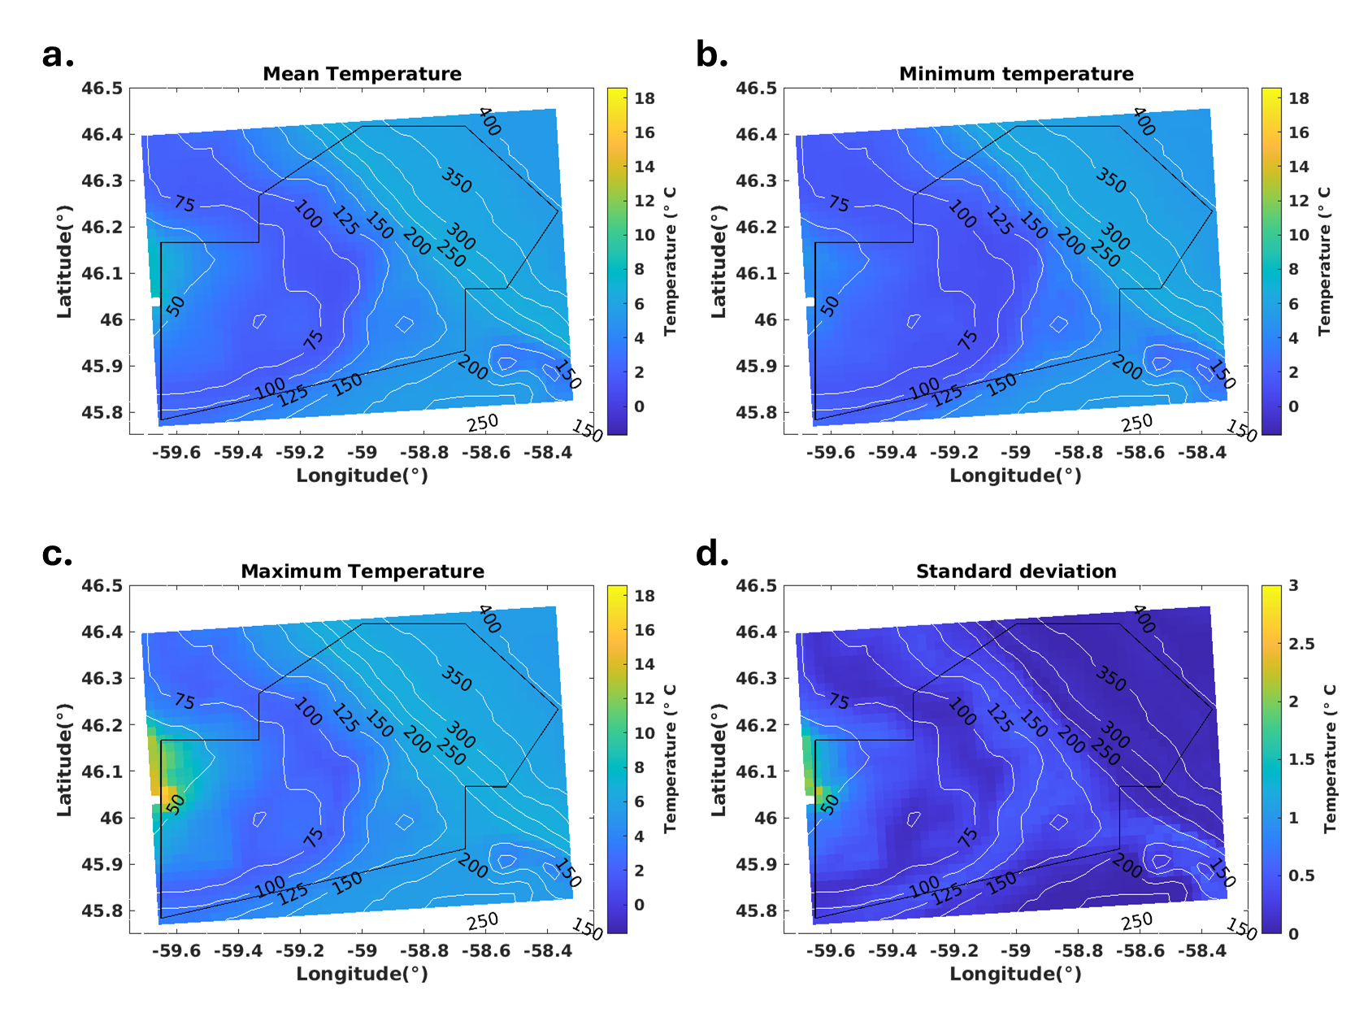
Fig. 3 CIOPS-E (Coastal Ice-Ocean Prediction System for the East Coast of Canada) monthly statistics from hourly data of the bottom temperature (°C) in the St. Anns Bank Marine Protected Area at the time of the first year of the optical imagery survey, August 2023. Monthly statistics include (a) mean temperature, (b) minimum temperature, (c) maximum temperature and (d) the standard deviation with underlying depth contours. Maps and model outputs are courtesy of Michael Casey
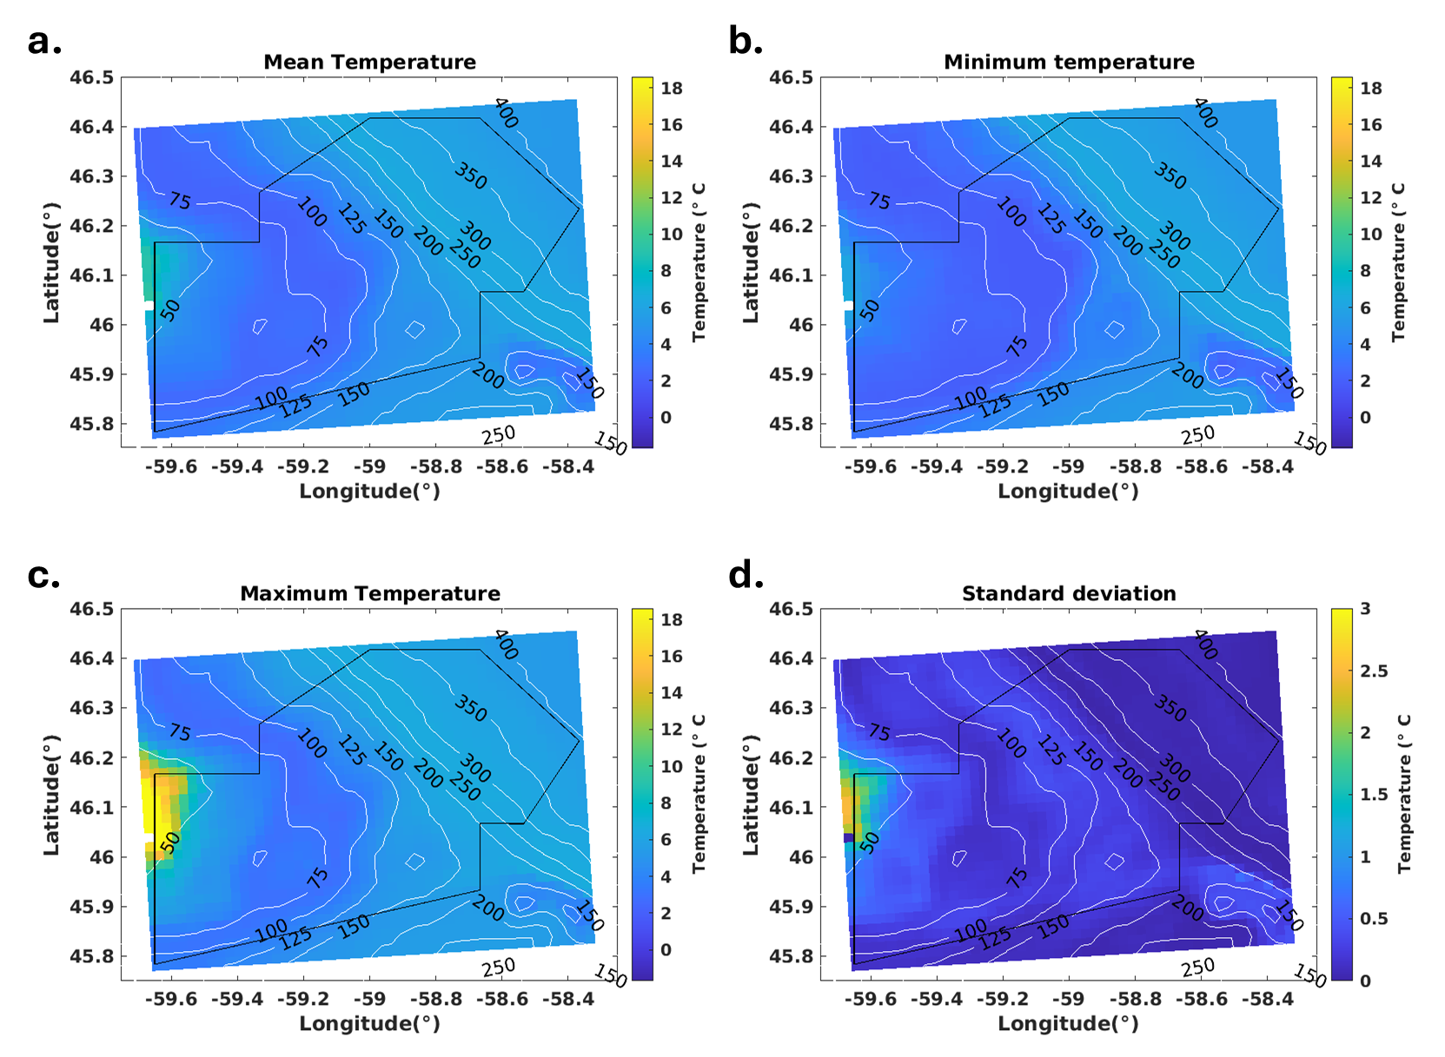
Fig. 4 CIOPS-E (Coastal Ice-Ocean Prediction System for the East Coast of Canada) monthly statistics from hourly data of the bottom temperature (°C) in the St. Anns Bank Marine Protected Area at the time of the second year of the optical imagery survey, August 2024. Monthly statistics include (a) mean temperature, (b) minimum temperature, (c) maximum temperature and (d) the standard deviation with underlying depth contours. Maps and model outputs are courtesy of Michael Casey
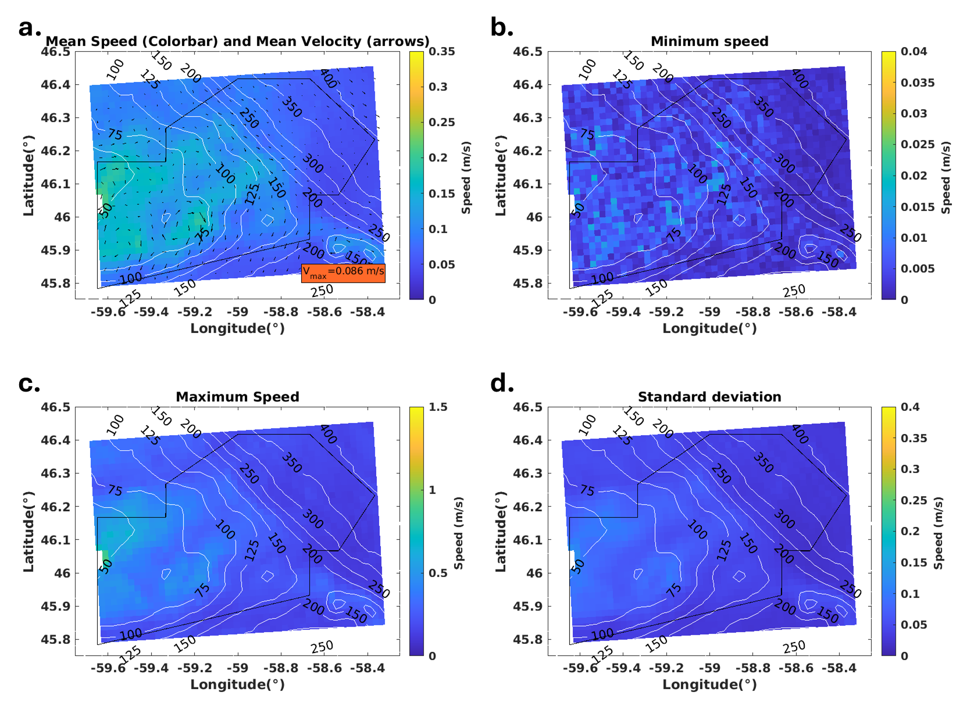
Fig. 5 CIOPS-E (Coastal Ice-Ocean Prediction System for the East Coast of Canada) monthly statistics from hourly data of the bottom current speed (m s⁻¹) and velocity (arrows) in the St. Anns Bank Marine Protected Area at the model’s conception, August 2016. Monthly statistics include (a) mean bottom current speed, (b) minimum bottom current speed, (c) maximum bottom current speed and (d) the standard deviation with underlying depth contours. Maps and model outputs are courtesy of Michael Casey
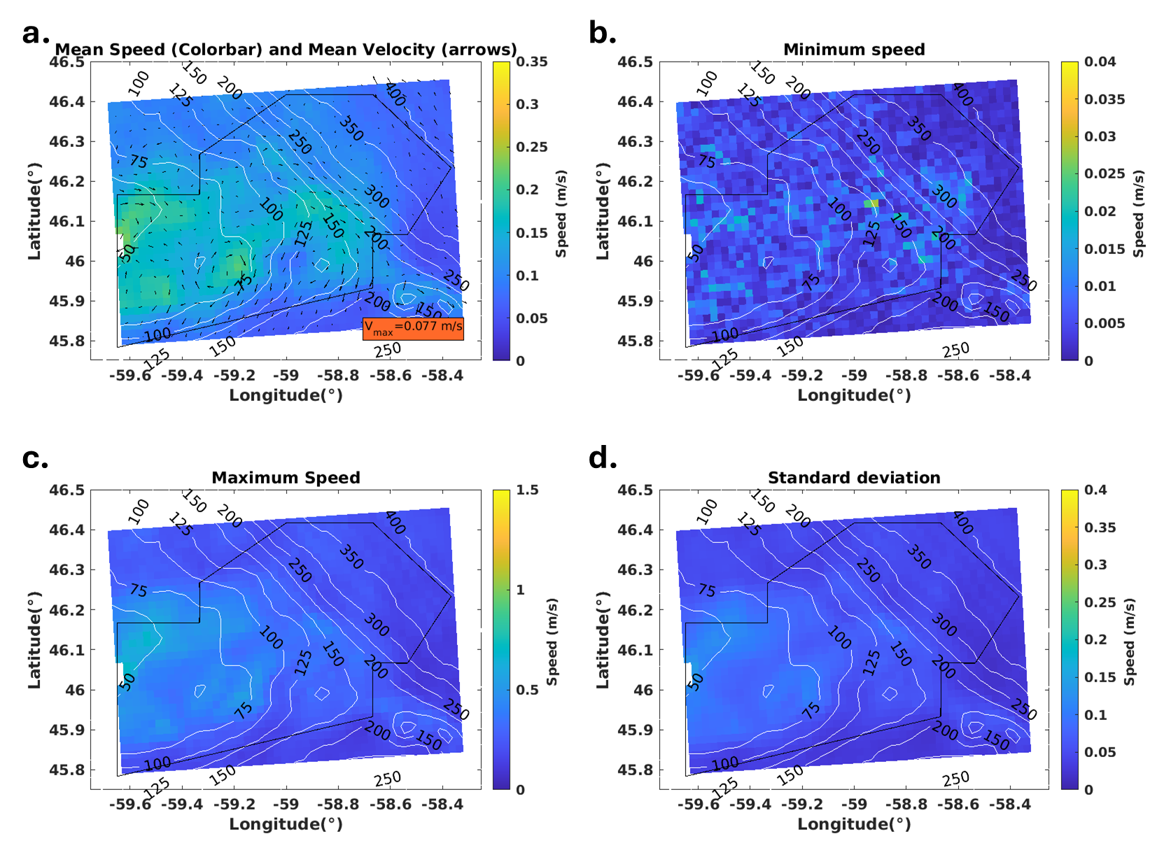
Fig. 6 CIOPS-E (Coastal Ice-Ocean Prediction System for the East Coast of Canada) monthly statistics from hourly data of the bottom current speed (m s⁻¹) and velocity (arrows) in the St. Anns Bank Marine Protected Area at the time of the first year of the optical imagery survey, August 2023. Monthly statistics include (a) mean bottom current speed, (b) minimum bottom current speed, (c) maximum bottom current speed and (d) the standard deviation with underlying depth contours. Maps and model outputs are courtesy of Michael Casey
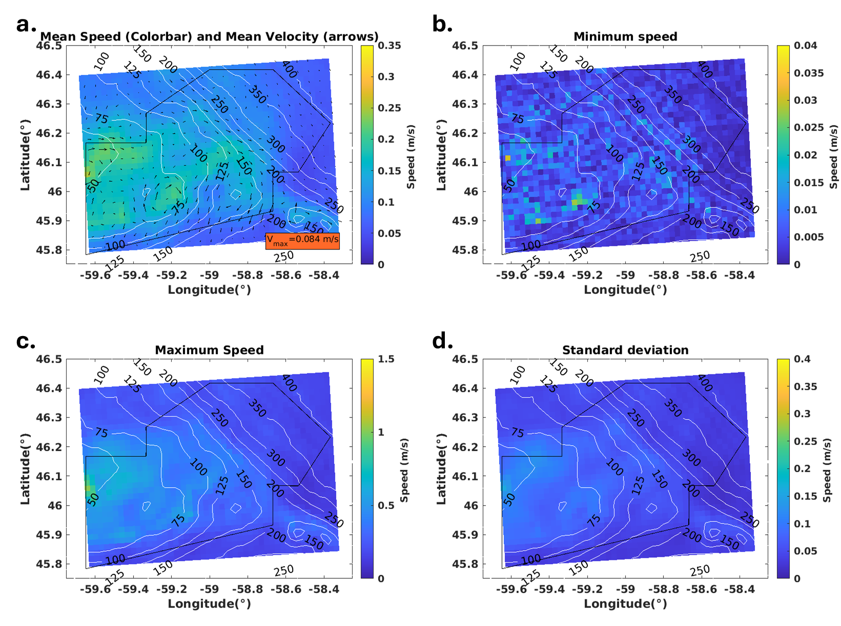
Fig. 7 CIOPS-E (Coastal Ice-Ocean Prediction System for the East Coast of Canada) monthly statistics from hourly data of the bottom current speed (m s⁻¹) and velocity (arrows) in the St. Anns Bank Marine Protected Area at the time of the second year of the optical imagery survey, August 2024. Monthly statistics include (a) mean bottom current speed, (b) minimum bottom current speed, (c) maximum bottom current speed and (d) the standard deviation with underlying depth contours. Maps and model outputs are courtesy of Michael Casey
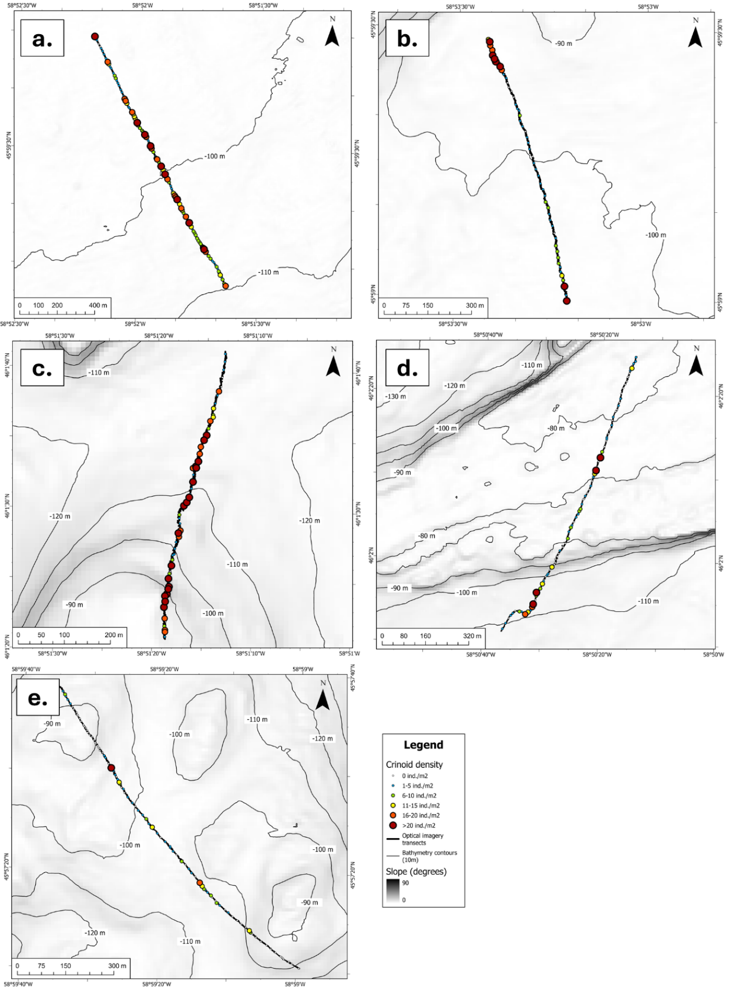
Fig. 8 Crinoid densities across digital still images in five transects in the St. Anns Bank Marine Protected Area; in consecutive order of (a) CON027, (b) CON053, (c) CON054, (d) CON055, and (e) CON072. Image locations are coloured based on crinoid density class 0 = 0 ind. m⁻², 1 = 1-5 ind. m⁻², 2 = 6-10 ind. m⁻², 3 = 11-15 ind. m⁻², 4 = 16-20 ind. m⁻², and 5 = >20 ind. m⁻². Transects are underlain by slope (based on 5-35 m resolution multibeam bathymetry data) and 10-m bathymetry contours. Bathymetry data was obtained from the Canadian Hydrographic Service
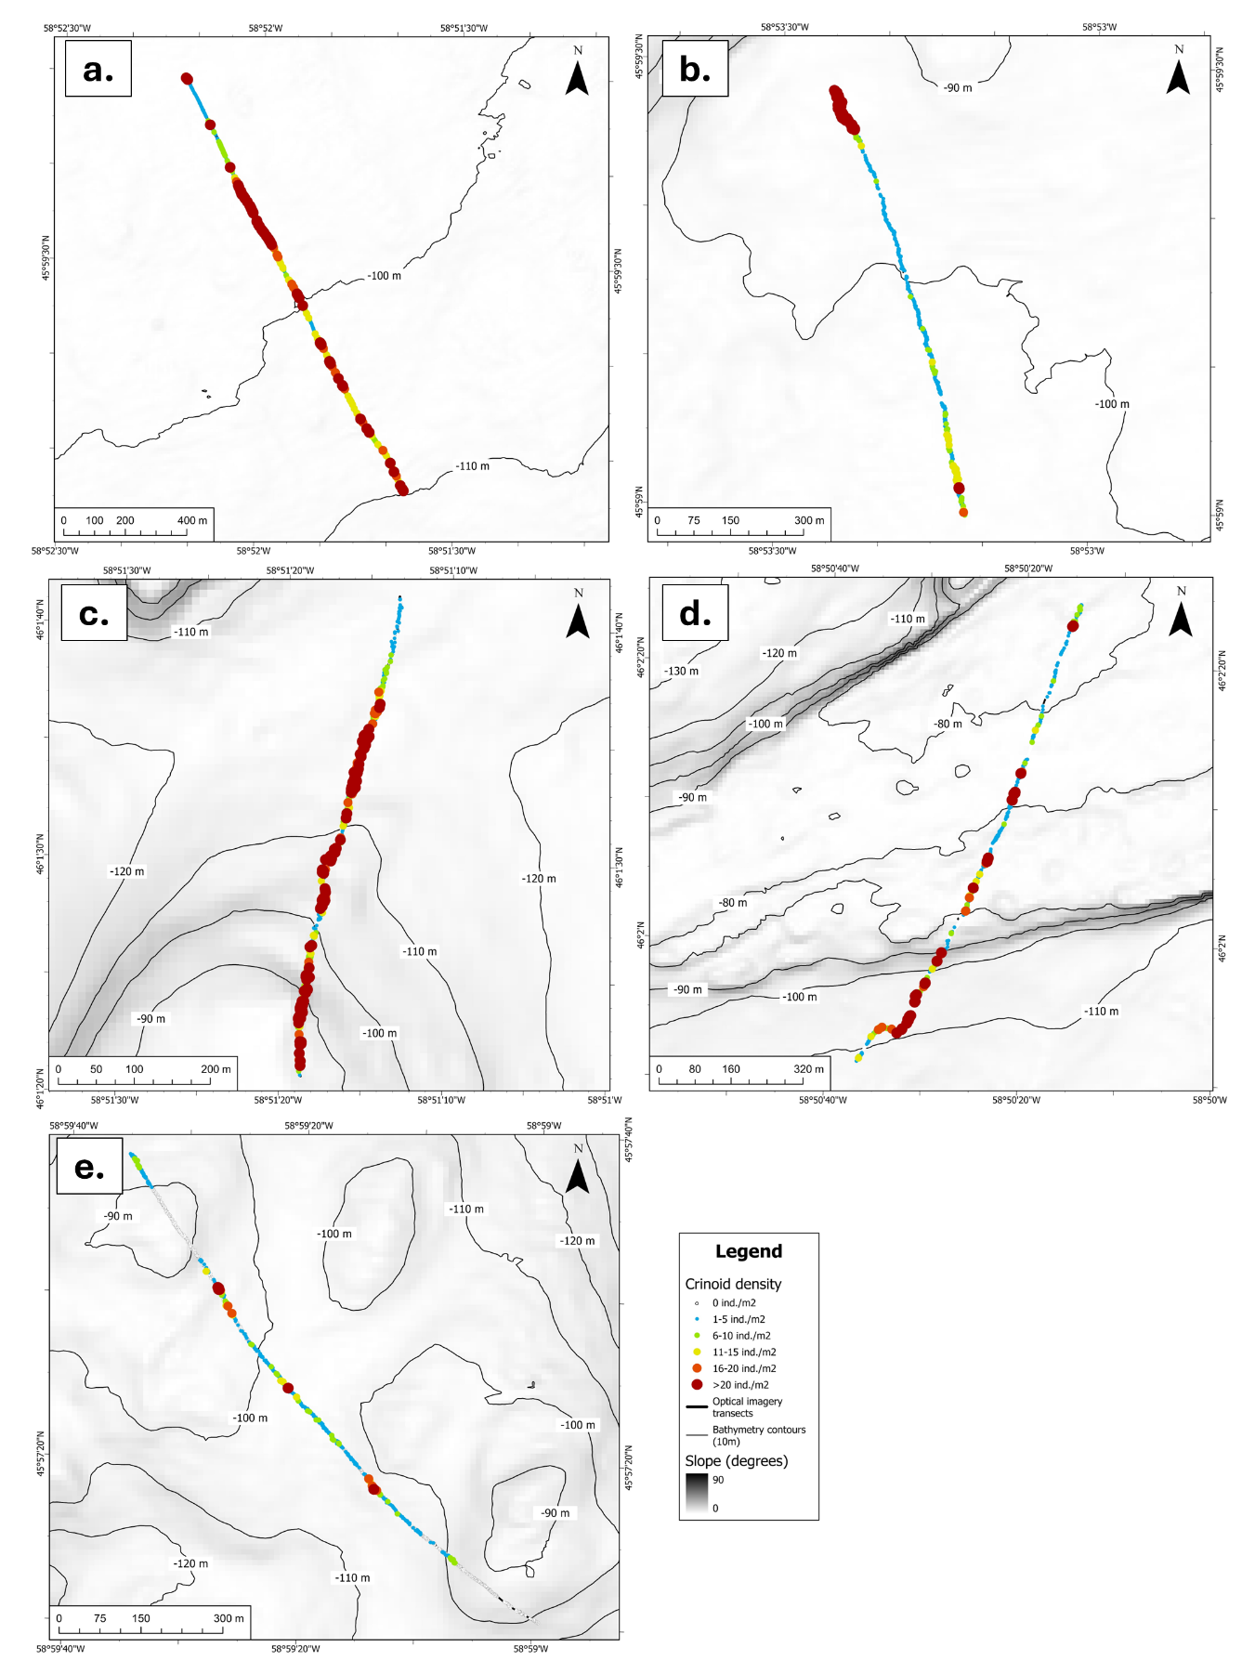
Fig. 9 Crinoid densities across video observations in five transects in the St. Anns Bank Marine Protected Area; in consecutive order of (a) CON027, (b) CON053, (c) CON054, (d) CON055, and (e) CON072. Video observation locations are coloured based on crinoid density class 0 = 0 ind. m⁻², 1 = 1-5 ind. m⁻², 2 = 6-10 ind. m⁻², 3 = 11-15 ind. m⁻², 4 = 16-20 ind. m⁻², and 5 = >20 ind. m⁻². Transects are underlain by slope (based on 5-35 m resolution multibeam bathymetry data) and 10-m bathymetry contours. Bathymetry data was obtained from the Canadian Hydrographic Service
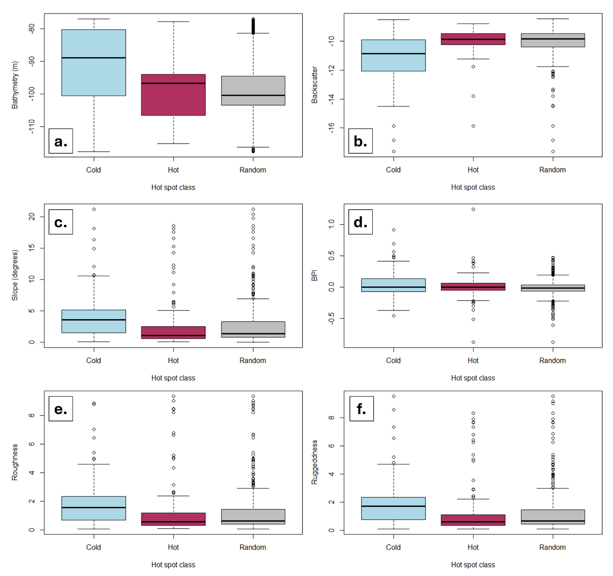
Fig. 10 Boxplots of crinoid video observations according to environmental parameters including (a) bathymetry, (b) backscatter, (c) slope, (d) Bathymetric Position Index – BPI, (e) seafloor roughness, and (f) ruggeddness. Slope, BPI, roughness and ruggedness were all derived from the bathymetry layer at a 5-35 m spatial resolution. Crinoid observations were binned according to Gi* statistic results including hotspots (maroon), coldspots (blue) and areas of random crinoid distribution (grey). Bathymetry data was obtained from the Canadian Hydrographic Service

