A molybdenum coordination complex that enables honey bees to mitigate the sublethal toxic effects of fipronil
Loïc COLIN-DUCHEVET,ª Précillia COCHARD,^{b} Benjamin POIROT,^{b} Jean-Luc BRUNET,^{c} Jean-Christophe SANDOZ,^{a,}* and Sébastien FLOQUET^{d,}*

- Evolution Genomes Behaviour & Ecology, University Paris-Saclay, CNRS, IRD, 91198 Gif Sur Yvette, France
- Apinov S.A.S, 17140 Lagord (La Rochelle), France
- INRAE, UR 406 Abeilles & Environnement, Toxicologie Environnementale, Avignon, France
- Institut Lavoisier de Versailles, CNRS UMR 8180, Univ. Versailles Saint Quentin en Yvelines, Université Paris-Saclay, 45 av. des Etats-Unis, 78035 Versailles cedex (France)

Corresponding author’s E-mails: jean-christophe.sandoz@cnrs.fr ; sebastien.floquet@uvsq.fr

Supporting Information

Table of contents:

Part 1: Synthesis of Na-Mo₂O₄-EDTA
Part 2: Fipronil lethal and Sublethal Tests
Part 3: Mortality studies with a cocktail of pesticides
Part 4: Xanthine Oxydase levels in abdomens

Part 1 : Synthesis of Na-Mo₂O₄-EDTA
The complex Na₂[Mo₂O₄(EDTA)](H₂O)₂(NaCl)_{0.2}, abbreviated Na-Mo₂O₄-EDTA, was prepared using a one-pot procedure in water as reported by Fuior et al. (2022) [1]. The purity quality of the complex was checked by routine methods (¹H NMR, FT-IR, ESI-MS, UV-visible spectroscopy and elemental analysis) before use to establish the exact formula and determine its molecular weight (MM = 637.79 g/mol). The elemental analysis reveals of small amount of NaCl as impurity and hydration rate which can vary from 1 to 5 depending of the storage conditions (in air or in a desiccator). Percentage Calculated (Found) for Na₂[Mo₂O₄(EDTA)](H₂O)₂(NaCl)_{0.2}: %C 18.83 (18.63) ; %H 2.53 (2.81) ; %N 4.39 (4.34) ; %Mo 30.09 (29.70) ; %Na 7.93 (8.10) ; %Cl 1.11 (0.84). The ESI-MS (methanol/water medium) and UV-Visible spectra in water are given Figure S1 and fully agree with the expected m/z and extinction coefficient values, respectively.
Figure S1. ESI-MS (top) and UV-Visible spectra (bottom) recorded for Na-Mo₂O₄-EDTA .
Part 2. Fipronil lethal and Sublethal Tests

I. Determination of LD₅₀ of fipronil on honey bees.
1.1 Preparation of bees for the experiment
Bees were kept in Pain-type plexiglass cages in groups of 30 individuals (Figure S2) after their emergence.

Figure S2 : “Pain”-type Cage used in this experiment (PAIN J., 1966. - Nouveau modèle de cagettes expérimentales pour le maintien d’abeilles en captivité. Ann. Abeille, 9 (1), 71-76.
.
The cages contained a wax strip, a paper filter used to collect the faeces and 2 pierced tubes providing food and water resources to the bees inside the cage. The cages were kept at 35°C and 50% relative humidity. During the first 8 days after emergence, bees had at their disposal sugar solution (sucrose 50% w/w), water and pollen ad libitum. After 8 days, only water and sugar solution were provided ad libitum to the bees.
The bees were used in the experiment 14 days after emergence. This age was chosen because worker bees become foragers about 14 days after emergence and express strong learning abilities [2].

1.2 Determination of the lethal dose of fipronil
1.2.1 Molybdenum treatment
After bees’ emergence, 20 mg/L of the complex Na-Mo₂O₄-EDTA were added to the sugar solution in the treatment group. The control group was fed with a conventional sugar solution. Sugar solution was provided ad libitum to both groups.

1.2.2 fipronil preparation
The fipronil solutions (Sigma Aldrich) were obtained from a stock solution at 24 g/L in pure acetone (Sigma Aldrich). This solution was diluted with distilled water to obtain a 24 mg/L solution in 0.1% acetone. The other doses used were aliquots of this second solution.

1.2.3 Exposure to fipronil
Topical application of fipronil was chosen on the basis of previous work showing sublethal effect of fipronil when applied topically but not after oral consumption [3,4]. The bees were first narcotized inside a CO₂ chamber at 10°C (Figure S3A). They were then placed on an ice bed (Figure S3B) and 1 µL of solution was applied onto the dorsal part of the thorax using a Hamilton syringe. The solutions used were contained 0, 3, 6, 12 or 24 ng/µL of fipronil. After exposure, the bees were returned to their cage and maintained at 35°C and 50% relative humidity. Two replicates of 30 bees were prepared for each treatment (which means 300 bees for each group of bees) and mortality was recorded at 4, 24 and 48 hours after exposure.

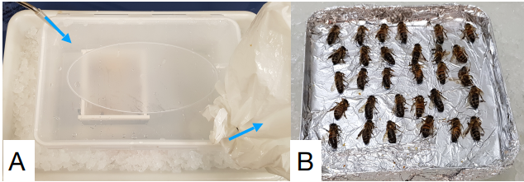
Figure S3: Material used for fipronil exposure. A: CO₂ chamber on an ice bed. Gas flux is represented by the blue arrows. B: narcotized bees on the ice bed ready for fipronil exposure.

1.2.4 Statistical analysis
The LD₅₀ for fipronil was estimated on the R software using the drm function of the drc package [5]. A t-test was used to observe the statistical differences on curve parameters between the two treatments with the compParm function of the drm package.

1.2.5 Results
This experiment was carried out to assess whether molybdenum treatment could reduce the sensitivity of honey bee to fipronil exposure. To do this, we set up two groups of bees, the first with molybdenum-treated individuals and the second with untreated bees. Both groups were exposed to fipronil at doses close to the LD₅₀ found in the literature. These results allowed us to create a dose-response curve showing the mortality rate of bees as a function of the dose of fipronil received (Figure S4).
The dose-response models suggest that molybdenum treatment had no impact on honeybee mortality with increasing doses of fipronil. Indeed, the LD₅₀ were 5.97 ng/bee and 5.49 ng/bee for molybdenum-treated and control bees respectively. The difference between the 2 treatments was not significant (t-test, p = 0.49). Likewise, no difference appeared in the slope of the curve (t-test, p = 0.68).

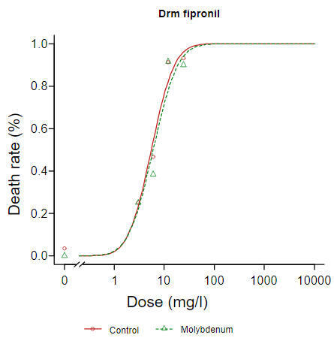
Figure S4 : Dose response model showing honeybee mortality after 48h due to increasing doses of fipronil, in bees which received Na-Mo₂O₄-EDTA treatment (Molybdenum) or not (Control).

1.2.6 Raw data

The raw data have been deposited on Mendeley data and are accessible through the link https://data.mendeley.com/preview/vg8bcz44j4?a=92fd174c-0730-48dc-9703-0ece02a96b17

II. Effect of fipronil at sublethal level on learning abilities of honey bees.
We aimed to understand whether the Na-Mo₂O₄-EDTA complex protects bees from sublethal effects of fipronil on their learning abilities. To do so, bees were subjected to an associative learning task using the conditioning of the proboscis extension reflex (PER) [6, 7], which is known to be a relevant tool to estimate the side effects of stressors on honey bees, in particular pesticides [8, 9]. In this experiment, bees that received or not a chronic treatment with Na-Mo₂O₄-EDTA at 20 mg/L where subjected to a sublethal dose of fipronil or to a solvent control, 4 h before performing an olfactory conditioning experiment. Rearing and Na-Mo₂O₄-EDTA treatment were applied as described above in part 1.1. Fipronil exposure was performed as in part 1.2.3, with the important difference that the dose used here was 0.5 ng/bee, which is more than 10 times lower than de LD₅₀ measured in part 1.2.5.
II.1 Experimental procedure
2.1.1 Animal preparation
The harnessing tubes were prepared from disposable plastic straws (Figure S5). This alternative to conventional harnessing tubes was used to avoid fipronil pollution between two days of experiment. The bees were immobilized the evening before the experiment to regulate their satiety level. At the end of the day they were fed 20 µL of sugar solution before being placed in a dark and humid room for the night. This time allowed them to acclimate to the harnessing tube before conditioning. On the day of the experiment, the bees were exposed to fipronil (see paragraph 1.2.3) and placed back in the dark for 3 hours. Prior to conditioning, control and treated bees were randomized by a third party in order to ensure that the experiment was conducted in a blind fashion.
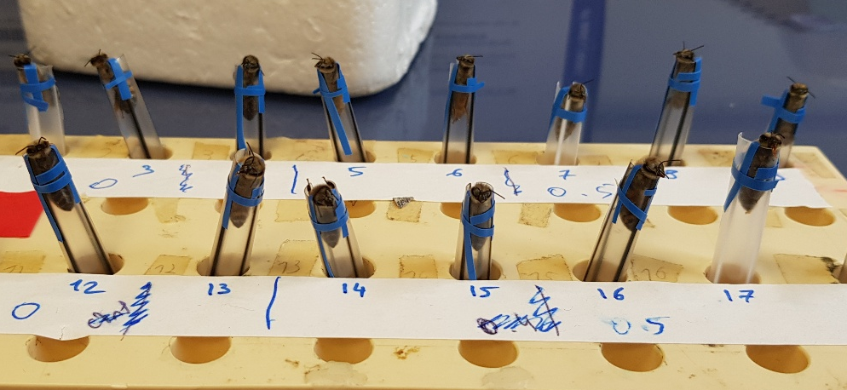
Figure S5: View of the harnessing tubes used in this experiment

2.1.2 Conditioning protocol
Classical PER conditioning is widely used to study the learning and memory abilities of honey bees [6, 7, 10]. Indeed, bees naturally exhibit the reflex of extending their proboscis (mouth parts) when the gustatory receptors located on their mouth parts, tarsi or antennae are stimulated with sugar. Using the principle of Pavlovian conditioning, it is possible to study the ability of a bee to learn to extend its proboscis following the presentation of an odor (conditioned stimulus, CS), after its association with a sugar reward (unconditioned stimulus, US) applied to antennae and then to the proboscis.
The olfactory stimuli used in this experiment were aliphatic alcohols often used in previous experiments: 1-hexanol and 1-nonanol (Sigma-Aldrich). A volume of 5 µL of pure odorant was deposited on a 1 cm² filter paper placed inside a 1 mL glass Pasteur pipette. An odour stimulation device producing a constant air flow of 3.5 L/min was used for olfactory conditioning. The airflow consisted of a primary airflow of 3 L/min and a secondary airflow of 500 mL/min. The secondary airflow could be directed to two different paths, one that led to the odor Pipette, and another that led to an empty Pipette, before being reinjected into the main airflow. Olfactory stimulation was applied manually inducing a switch of the secondary flow from the empty Pipette path to the odor Pipette path for a predefined time. This odor delivery system ensured that the bees associated the odor and not the change in airflow with the sucrose reward. An air extractor was placed behind the bee holder in order to avoid stagnation of odors inside the device.
The conditioning procedure consisted in five conditioning trials with 10 min intertrial intervals following standard procedures [10]. A conditioning trial lasted 38 seconds. The bee was placed in front of the odour stimulation device for 18 seconds to acclimate to the device before being exposed to the CS. The CS was presented for 4 seconds, and 3 seconds after the start of olfactory stimulation, sucrose stimulation was applied to the antennae and then to the mouthparts for 3 seconds. The bee was left in place for another 14 seconds before being removed from the apparatus and replaced with another individual.
One hour after the five conditioning trials, two memory tests were performed with a 10 min inter-trial interval. During these tests, either the CS or a novel, unlearned, odorant (henceforth “NoD”, 1-hexanol for 1-nonanol conditioned bees and vice versa) was presented to the bee for 4 sec, without any US. At the end of the whole experiment, the US alone was presented to each bee in order to check their feeding motivation and intact PER.
The individuals that did not respond to the US at any time during the experiment were considered as not appetitively motivated and were discarded from the data set. Their proportion, between 15.7-31.3%, did not differ between the groups (Fisher’s exact test, 3df, p = 0.46).
Between 32 and 34 bees were tested in all conditions. The individuals that expressed spontaneous responses (i.e that responded to the CS during the first conditioning trial) were discarded from the data set. Their proportion, between 3.1 and 6.3%, did not differ between groups (Fisher’s Exact test, p = 1). In addition, bees that did not respond to the US at any time during the experiment were considered as not appetitively motivated and were discarded from the data set. Their proportion, between 15.6-29.0%, did not differ between the groups (Fisher’s exact test, p = 0.59).

2.1.3 Statistical analysis
Bees that expressed a spontaneous response to the CS (extension of the proboscis in response to the odor on the first trial) were discarded from the analysis of learning performances as their responses could not be unambiguously attributed to conditioning. The proportion of spontaneous responses amounted to 6% or less for all treatments and no difference was found among treatment groups (Fisher exact test, p = 0.9).
Learning performances were compared between groups though a generalized linear mixed model (GLMM) using a binomial distribution and logit link, using R (version 4.3.2). Successive trials and treatments (molybdenum and/or fipronil) were considered as fixed factors. The individuals tested were considered as random factors in the model to allow for repeated measures. The glmer function of the lme4 package was used for this analysis. Pairwise comparisons were performed by Tukey’s multiple contrast with the emmeans function of the eponyme package and p-values were adjusted with Holm correction.
Responses to retention tests were compared between treatments with Fisher’s exact test (fisher.test function). Responses to the CS and to the novel odorant within a treatment group were compared with a Mc Nemar test using the mcnemar.test function.
2.1.4 Raw data

The raw data have been deposited on Mendeley data and are accessible through the link https://data.mendeley.com/preview/vg8bcz44j4?a=92fd174c-0730-48dc-9703-0ece02a96b17

Part 3. Mortality studies with a cocktail of pesticides
We aimed to determine the protection potential effect of Na-Mo₂O₄-EDTA on honeybees (Apis mellifera) on an oral exposure to a pesticide cocktail.

- Preparation of bees for the experiment
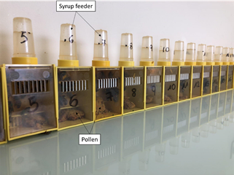
Young honeybees (1-3 days) are placed in boxes (see Figure S6) by groups of 16-20 bees per box and kept at 25+/-2°C; +/-50% relative humidity and fed ad libitum with sugar syrup and organic pollen paste.

Figure S6: Experimental boxes, each containing 16 to 20 honeybees.

- Preparation of the solutions

  - Sugar syrup / “control” diet
A sugar syrup diet will be used as control for the evaluation and comparison. The control diet is composed of sugar syrup alone (Apistar© sugar syrup = Sucrose: 34%, Fructose: 33%, Glucose: 33%; ICKO Apiculture, France).
  - Pesticide cocktail / “Pesticides” diet
Two fungicides, one insecticide and one chemical used to enhance the insecticidal properties were chosen to compose pesticides contaminated diet, dimoxystrobine, spiroxamine, phosmet and piperonylbutoxide (≥ 98% purity, Pestanal, Sigma-Aldrich, Darmstadt, Germany). They are frequently detected in beebread samples (many years of collected samples, data not shown). All pesticides were dissolved in a small volume of acetone before preparation of 1 mM stock solutions by adding water. Pesticides were then dissolved in Apistar© sugar syrup, trying to follow field realistic concentration detected in nectar :10 µg/L for each. This concentration is of the same order that values found by Hayat et al. (2018) and Azpiazu et al. (2019) [11, 12] in nectar of different flower.
  - Sugar syrup supplemented with Na-Mo₂O₄-EDTA/ “Pesticides+Mo” diet

The complex Na-Mo₂O₄-EDTA is highly soluble in water (above 1000 g/L). Few milligrams of complex dissolved in a minimum amount of water was dissolved in syrup Apistar© already containing the cocktail of pesticides to get a syrup containing 2 mg/L of Na-Mo₂O₄-EDTA in addition to the cocktail of pesticides. This concentration (about 3 µM) was checked by ICP-MS analysis before use and corresponds to that used recently in field tests [13] and could be representative of the concentration proposed for beekeepers. Furthermore, a mixture of pesticides and Mo-complex could be representative of feeding of bees in real conditions in hives alternating nectar and syrup consumptions, especially in spring.

- Experimental protocol of mortality studies
The mortality studies were conducted according to “Standard methods for toxicology research in Apis mellifera” (https://doi.org/10.3896/IBRA.1.52.4.14)
11 boxes assigned in one of the 3 following feedings: “Control”, “Pesticides” and Pesticides + Na-Mo₂O₄-EDTA (group “Pesticides+Mo”) were used. 16 to 20 young honeybees (< 3 days) are place in each box. Every 2 or 3 days, mortality is registered. The syrup was consumed ad libitum. When the syrup level in the feeders reaches a low point, an appropriate amount is automatically added to maintain a constant supply.

Endpoints measured | Number of cages evaluated | Date of evaluation | Assessment
Bee morality | Control: 3  Pesticides : 4  Pesticides + Mo : 4 | D0 to D28 | Number of dead bees

Statistical analysis
Survival curves using the Kaplan-Meier method have been constructed for each treatment, and pairwise by Log-Rank test has been realized to compare the survival probability curves between each pair of treatments. All statistical analyzes are performed using RStudio software (Version 1.2.5033© 2009-2019 RStudio, Inc.).
We will consider a significant effect of the additive on endpoints assessed when p_{value} < 0.05.
Our H_{o} hypothesis is that the Na-Mo₂O₄-EDTA syrup has no influence on daily mortality from previous toxicity studies [14], whereas our alternative hypothesis H_{a} predicts that the Na-Mo₂O₄-EDTA syrup reduce the daily mortality.

- Raw data
The raw data have been deposited on Mendeley data and are accessible through the link https://data.mendeley.com/preview/vg8bcz44j4?a=92fd174c-0730-48dc-9703-0ece02a96b17

Part 4. Xanthine Oxydase levels in abdomens
The objective of this study was to determine the variation in xanthine oxidase (XO) levels in honeybees exposed to a cocktail of pesticides and fed or not fed with Na Mo₂O₄ EDTA at 2 mg/L. The preparation of the bees was identical to that in part 3.
- Preparation of the solutions
For this experiment, 4 modalities were used:
- “Control”: bees fed with Apistar syrup
- “Pesticides”
- “Pesticides+Mo”
- “Mo complex”
The 3 formers are identical to those of the experiment described in Part 3. Apistar©, Apistar©+ pesticides, Apistar©+pesticides+ Na-Mo₂O₄-EDTA at 2 mg/L were used to fed groups of 16 honey bees in boxes at 25°C 50% HR. An additional group of honey bees was considered to evaluate the impact of Na-Mo₂O₄-EDTA on the XO expression. For this group Apistar© syrup supplemented with Na-Mo₂O₄-EDTA at 2 mg/L was used.

- Experimental protocol for the determination of XO level
11 boxes assigned in one of the 4 following feedings: “Control”, “Pesticides”, “Mo-complex”, and Pesticides + Na-Mo₂O₄-EDTA (group “Pesticides+Mo”) were used and 16 young honeybees (< 3 days) were placed in each box. Every 2 or 3 days, mortality is registered. The syrup was consumed ad libitum. When the syrup level in the feeders reaches a low point, an appropriate amount is automatically added to maintain a constant supply. On the days 15 and 20 of exposure, bees were sampled and kept at -80°C until analyses.

2.1 Determination of XO acitivity
To study the effects of Molybdenum supplementation on workers physiology, and specially on a molybdenum dependent oxidase, the Xanthine Oxydase activity was measured in abdomen.
2.2 Reagents
Triton X-100, monosodium phosphate (NaH₂PO₄), sodium chloride (NaCl), pepstatin A, leupeptin, aprotinin, trypsin, antipain, disodium phosphate (Na₂HPO₄) were obtained from MERCK (Saint Quentin Fallavier, France) and Invitrogen Amplex® Red Xanthine/Xanthine Oxidase Assay KIT from Fischer Scientific (Illkirch, France).
2.3 Sample preparation.
Three frozen bees per cage of each modality are dissected to collect the abdomens (n=8 or n=9 per modality respectively for Day15 and D20), and the intestinal tract was removed. Pools of abdomen were placed in 2 mL microfuges at 4°C. The tissues were homogenized in the extraction buffer [10 mM sodium chloride, 1% (w/v) Triton X-100, 40 mM sodium phosphate pH 7.4 and protease inhibitors (2 μg/mL of pepstatin A, leupeptin and aprotinin, 0.1 mg/mL soybean trypsin inhibitor and 25 units/mL antipain)] to make 10% (m/v) extracts. Homogenization was achieved by grinding tissues with a Qiagen® TissueLyser II at 30 Hz for 5 periods of 30 s at 30 s intervals. After 10 min at 4°C, the homogenization procedure was repeated a second time. The extracts were centrifuged at 4°C for 20 min at 15 000g and the supernatants were kept on ice for further enzyme assays.
2.4 XO assay
Assays were performed following the Invitrogen Amplex® Red Xanthine/Xanthine Oxidase Assay KIT instructions. Sample solutions were was previously diluted at 1/5. Xanthine oxidase assay is monitored by indirect detection, based on the production of hydrogen peroxide (H₂O₂), a byproduct of the reaction catalyzed by this enzyme. Detection of this hydrogen peroxide is performed by a coupling reaction using Amplex Red reagent in the presence of peroxidase (HRP) to produce resorufin. The fluorescence of resofurin was measured with an excitation wavelength of 530 nm and an emission wavelength of 590 nm using a BioTek® Synergy HT microplate reader. For each sample, the XO activity was determined in triplicate.
2.5 Statistical analyses
The statistical analyses were performed using XLStat software (XLSTAT 2019.3.2.62913). The effects of the Molybdenum supplementation on the XO were determined by a Kruskal-Wallis test, followed by a post hoc Dunn test (with Bonfferroni correction) because data followed a non-normal distribution.

- Results

To determine whether the Mo complex could regulate the amount of molybdenum-containing detoxifying enzymes, we measured XO activity in the abdomen of bees supplemented with Mo in combination or not with pesticides on days 15 and 20 of treatment. (Fig. S7).
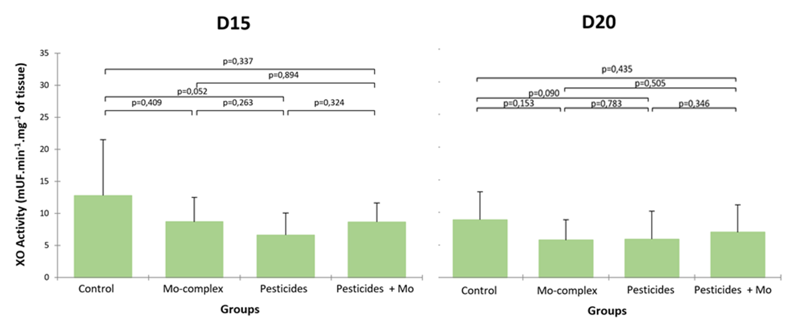
Figure S7. XO levels at D15 and D20 in abdomen of bees (n=8 and n=9 at D15 and D20 respectively for each group).
- Raw data
The raw data have been deposited on Mendeley data and are accessible through the link https://data.mendeley.com/preview/vg8bcz44j4?a=92fd174c-0730-48dc-9703-0ece02a96b17
References
[1] Fuior A, Hijazi A, Garbuz O, Bulimaga V, Zosim L, Cebotari D, Haouas M, Toderaş I, Gulea A, Floquet S (2022). Screening of biological properties of Mo^{V}₂O₂S₂- and Mo^{V}₂O₄-based coordination complexes: Investigation of antibacterial, antifungal, antioxidative and antitumoral activities versus growing of Spirulina platensis biomass. J. Inorg. Biochem. 226, 111627. https://doi.org/10.1016/j.jinorgbio.2021.111627

[3] Winston, M. L. (1987). The biology of the honey bee. Cambridge, Massachussetts: Harvard University Press.
[3] El Hassani, A. K., Dacher, M., Gauthier, M., & Armengaud, C. (2005). Effects of sublethal doses of fipronil on the behavior of the honeybee (Apis mellifera). Pharmacology Biochemistry and Behavior, 82(1), 30-39.
[4] Aliouane, Y., El Hassani, A. K., Gary, V., Armengaud, C., Lambin, M., & Gauthier, M. (2009). Subchronic exposure of honeybees to sublethal doses of pesticides: effects on behavior. Environmental Toxicology and Chemistry, 28(1), 113-122.
[5] Ritz, C., Baty, F., Streibig, J. C., & Gerhard, D. (2015). Dose-response analysis using R. Plos One, 10(12), e0146021.
[6] Bitterman, M. E., Menzel, R., Fietz, A., & Schäfer, S. (1983). Classical conditioning of proboscis extension in honeybees. Journal of Comparative Psychology, 97(2), 107-119.
[7] Giurfa, M., & Sandoz, J. C. (2012). Invertebrate learning and memory: Fifty years of olfactory conditioning of the proboscis extension response in honeybees. Learning and Memory, 19(2), 54-66.
[8] Pham-Delègue, M.-H., Decourtye, A., Kaiser, L., & Devillers, J. (2002). Behavioural methods to assess the effects of pesticides on honey bees. Apidologie, 33(5), 425-432.
[9] Siviter, H., Koricheva, J., Brown, M. J. F., & Leadbeater, E. (2018). Quantifying the impact of pesticides on learning and memory in bees. Journal of Applied Ecology, 55(6), 2812-2821.
[10] Matsumoto, Y., Menzel, R., Sandoz, J. C., & Giurfa, M. (2012). Revisiting olfactory classical conditioning of the proboscis extension response in honey bees: a step toward standardized procedures. J Neurosci Methods, 211(1), 159-167.
[11] Hayat K, Afzal M, Aqueel MA, Khan QM (2018) Determination of Insecticide Residues in Fruits, Vegetables, Pollen, Nectar and Ground Water of Punjab (Pakistan). J. Agric. Res. 56:95–105.
[12] Azpiazu, C, Bosch J, Viñuela E, Medrzycki P, Teper D, Sgolastra F (2019) Chronic oral exposure to field-realistic pesticide combinations via pollen and nectar: effects on feeding and thermal performance in a solitary bee. Sci Rep. 9: 13770
[13] Benito-Murcia M, Riva C, García-Vicente EJ, Pérez A, Domínguez MM, Hermosilla N, Cochard P, Hatjina F, Holmiere M, Martínez-Morcillo S, Risco D, Floquet S. (2025) Reducing honey bee winter mortality with molybdenum supplementation: field evidence across Europe. Research in Veterinary Science, 197: 105932. https://doi.org/10.1101/2025.07.23.666091

[14] Fuior A, Colin-Duchevet L, Cebotari V, Noël A, Ribaud I, Gérard I, Garbuz O, Fregnaux M, López X, Larcher V, Shestopalov MA, Solovieva AO, Pozmogova TN, Gliga O, Railean N, Cochard P, Poirot B, Charistos L, Hatjina F, Somogyi A, Medjoubi K, Gaumer S, Gulea A, Toderas I, Sandoz JC, Floquet S (2025) Feed supplementation with molybdenum complexes improves honey bee health. Inorg. Chem. Front. 12: 7107–7122.

