Supplementary Information
Step-by-step mechanism insights into TiO₂/Ce₂S₃ S-scheme photocatalyst for enhanced aniline production with water as proton source
Xu et al.

Supplementary Figures

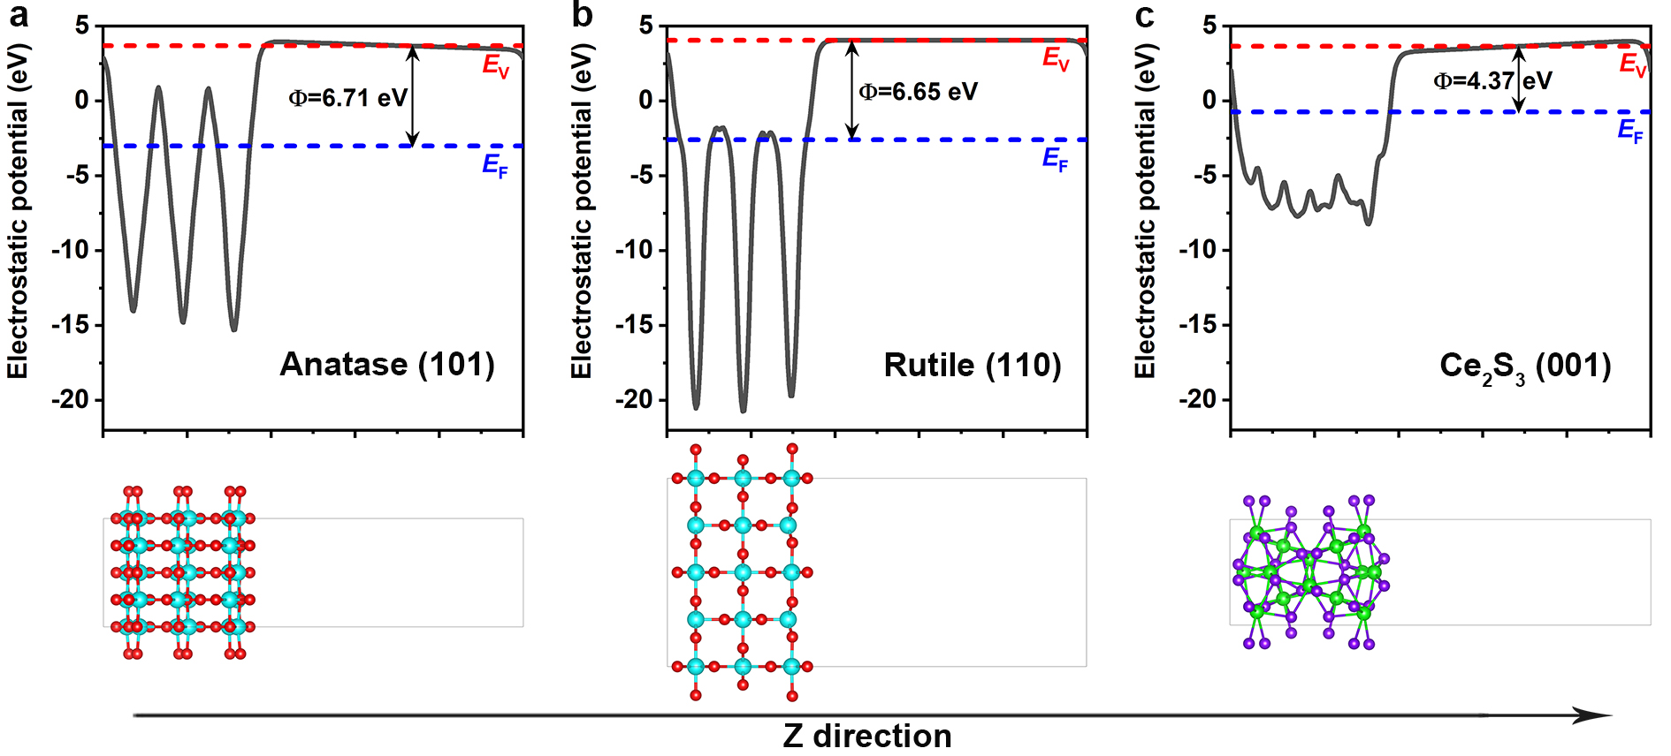
Supplementary Figure 1. The calculation of work function. The electrostatic potentials of a anatase TiO₂ (101), b rutile TiO₂ (110) and c Ce₂S₃ (001) facets. The cyan, red, green and violet spheres stand for Ti, O, Ce and S atoms, respectively. Blue and red dashed lines indicate the Fermi and vacuum energy levels, respectively.

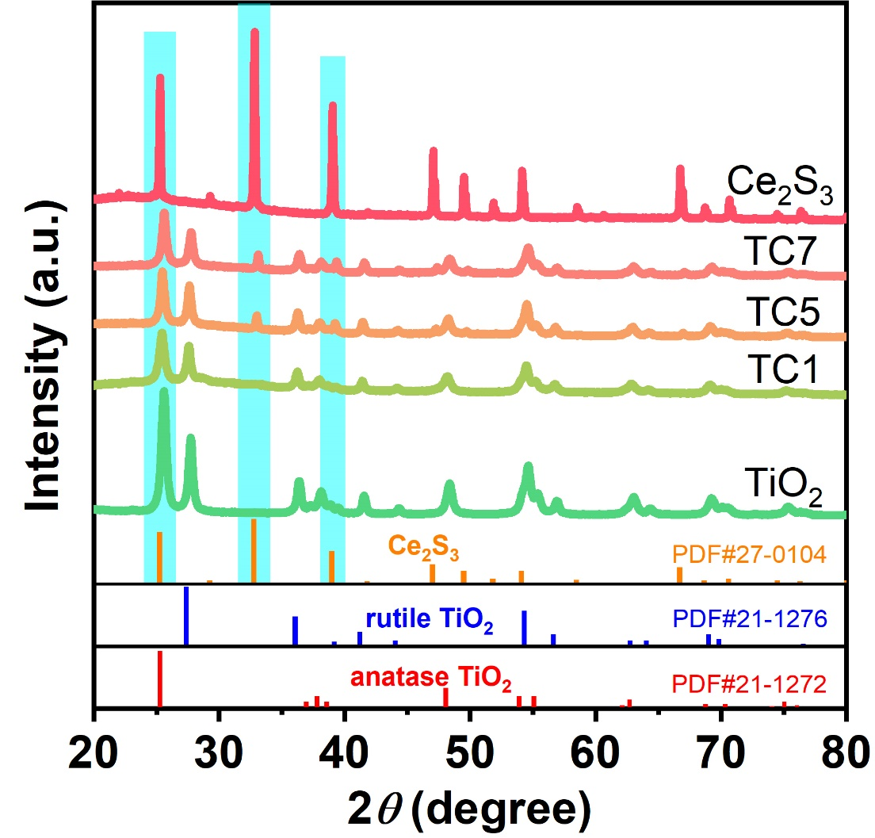
Supplementary Figure 2. X-ray diffraction (XRD) patterns of TiO₂, TC1, TC5, TC7 and Ce₂S₃. TCx represents the TiO₂/Ce₂S₃ hybrids, where T and C represent TiO₂ nanofiber and Ce₂S₃ nanoparticle, respectively; x is the mole percentages of Ce₂S₃ with respect to TiO₂.

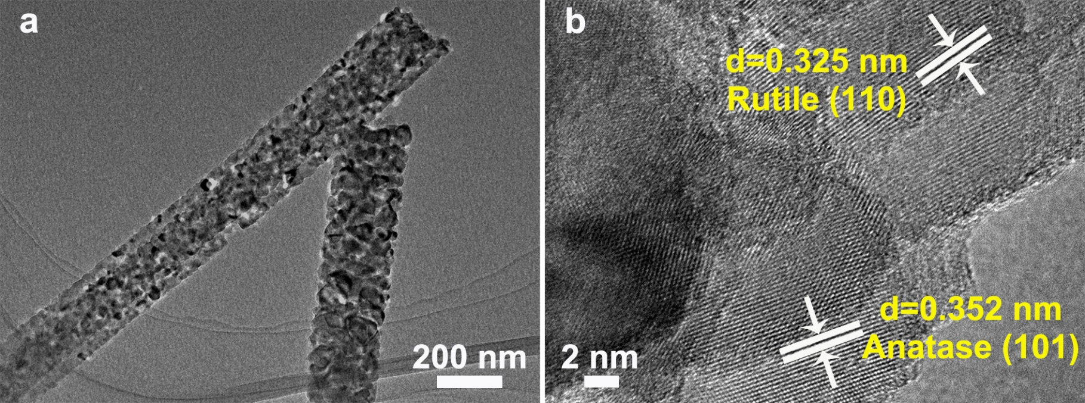
Supplementary Figure 3. Morphology of TiO₂ nanofibers. a TEM image, b HRTEM image.

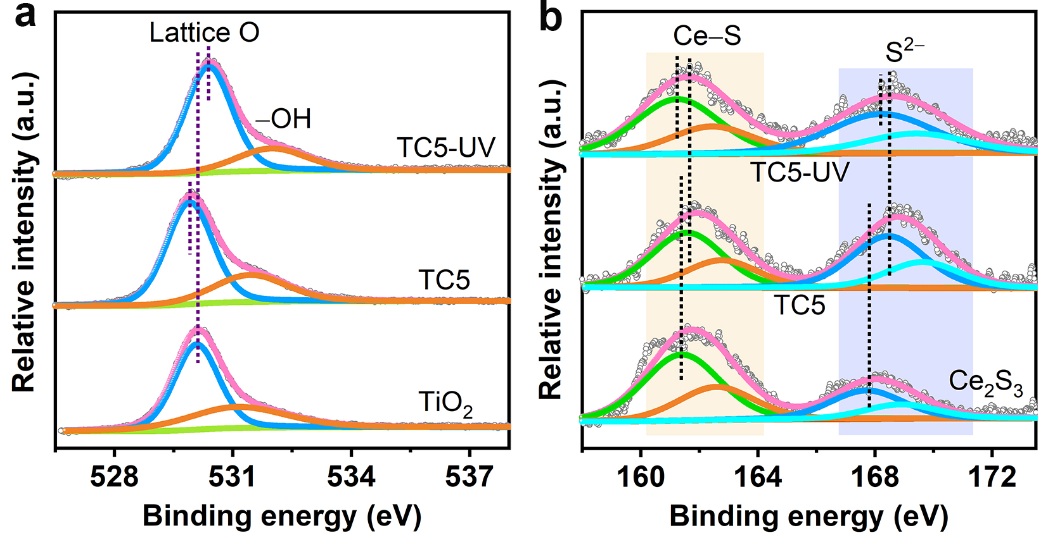
Supplementary Figure 4. X-ray photoelectron spectroscopy (XPS) spectra of resultant samples. High resolution XPS spectra a O 1s of TiO₂ and TC5, b S 2p of Ce₂S₃ and TC5. In-situ XPS spectra were recorded under UV-vis light irradiation. TC5 represents the TiO₂/Ce₂S₃ hybrid, where T and C represent TiO₂ nanofiber and Ce₂S₃ nanoparticle, respectively; 5 is the mole percentages of Ce₂S₃ with respect to TiO₂.
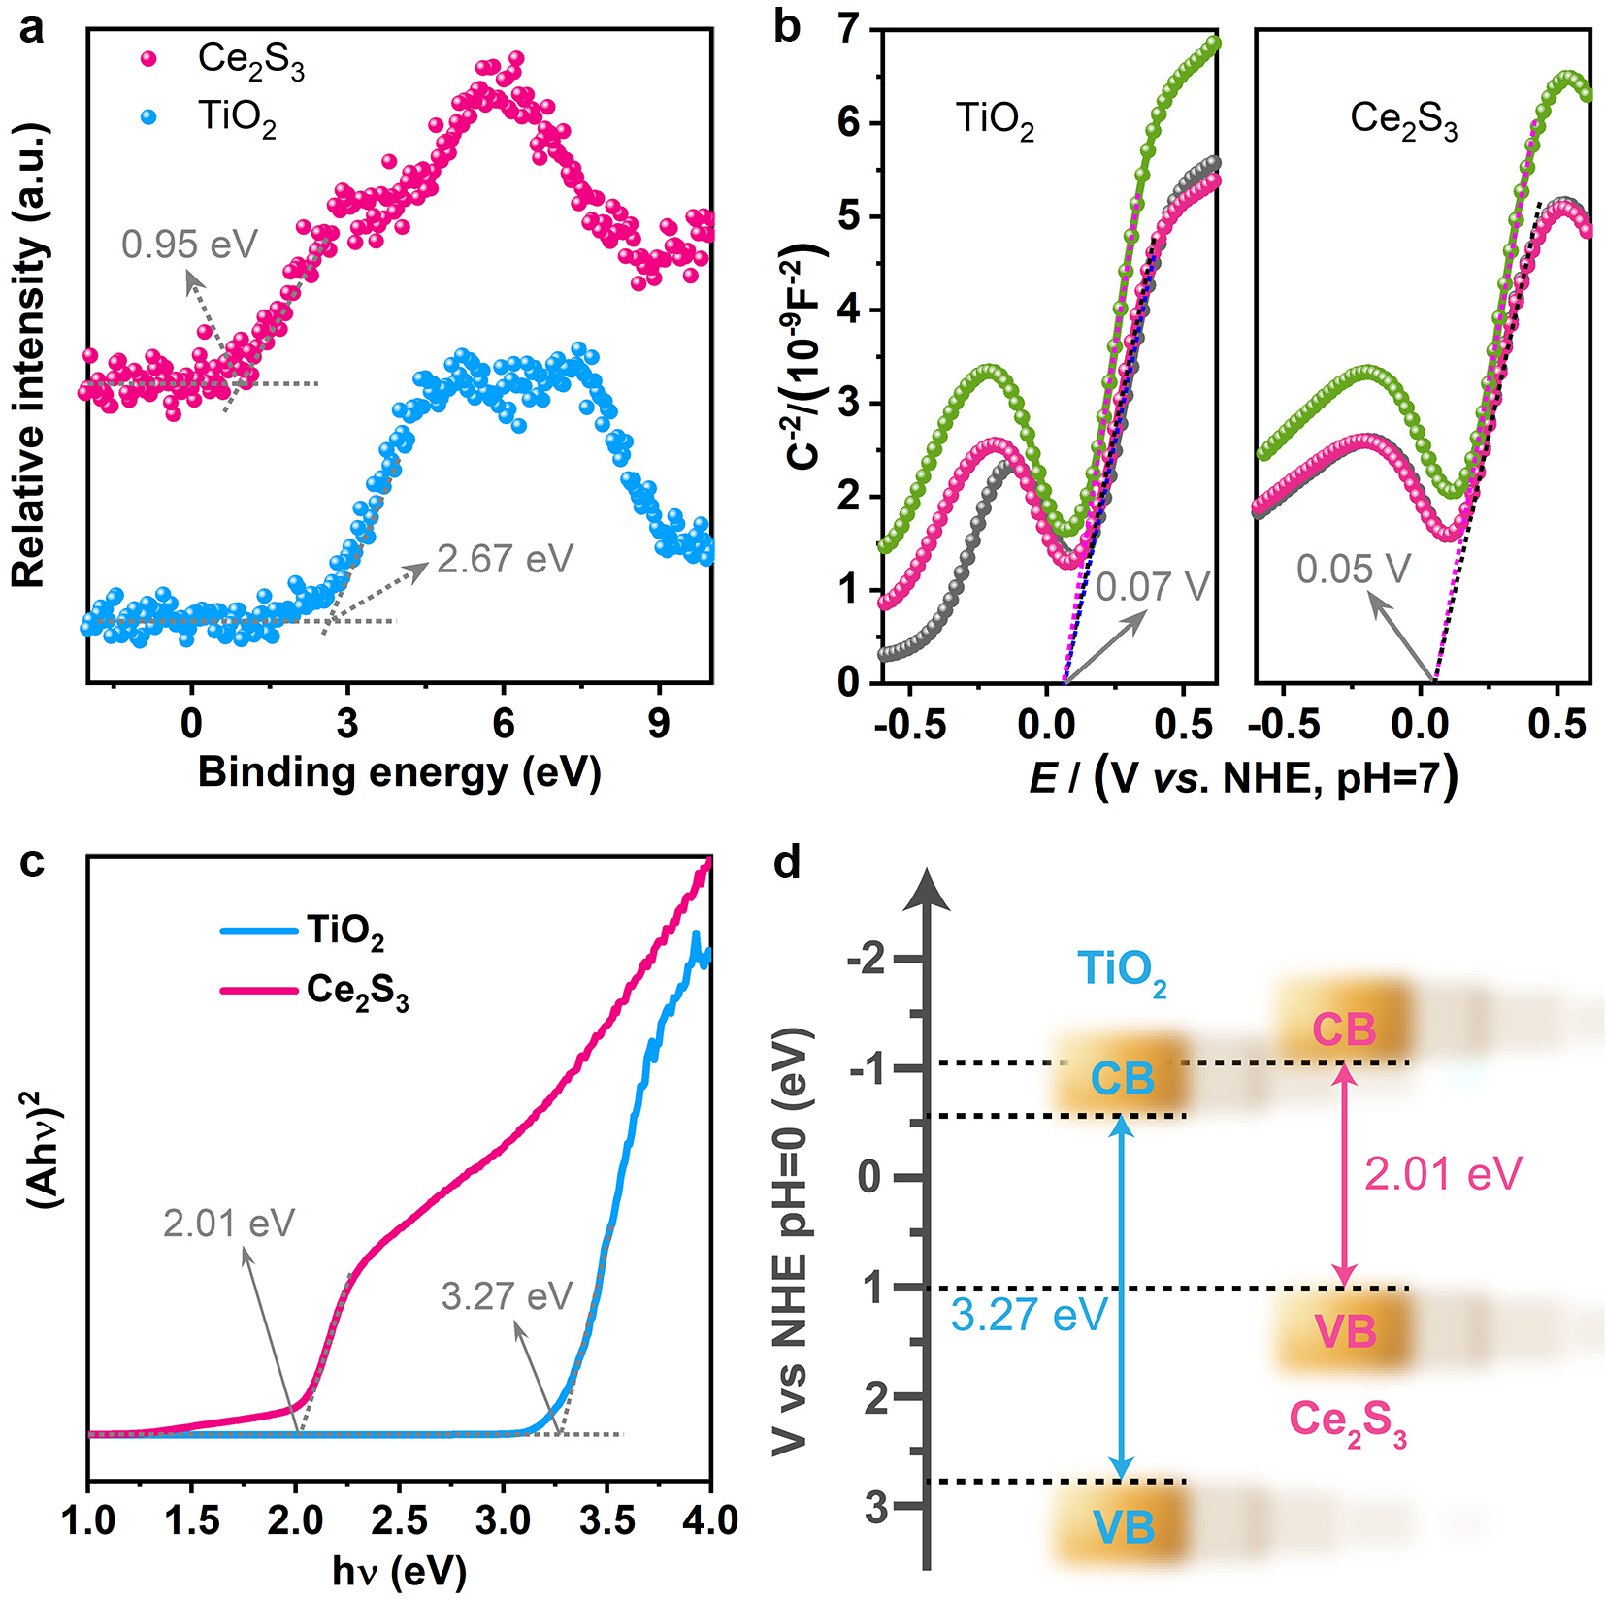
Supplementary Figure 5. Band structures of TiO₂ and Ce₂S₃. a Valence band (VB) XPS spectra, b Mott-Schottky plots and c Kubelka–Munk energy curve plots of TiO₂ and Ce₂S₃. d Band structures of the composite photocatalyst.

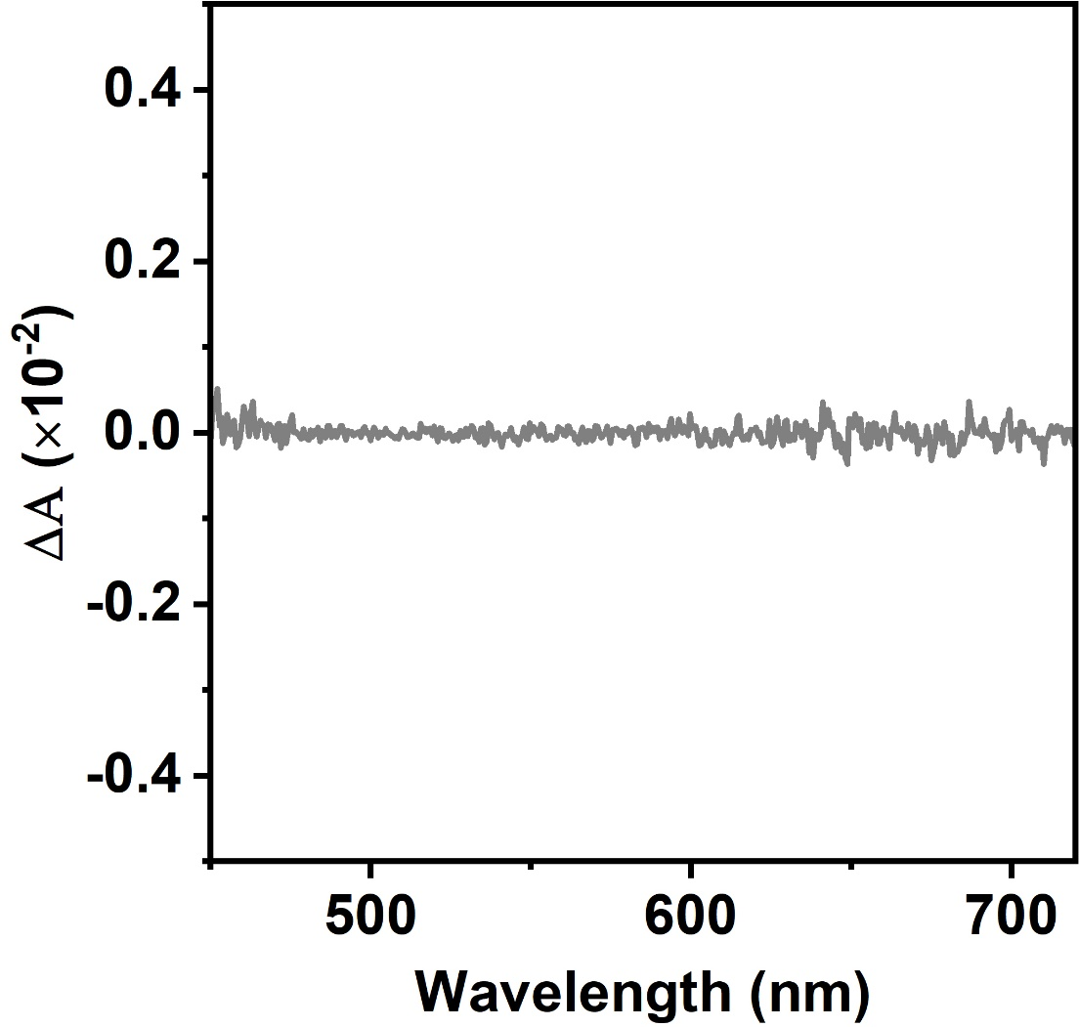
Supplementary Figure 6. The transient absorption spectrum of TiO₂ nanofibers recorded following the addition of an electron scavenger (AgNO₃) and measured with 350 nm excitation.

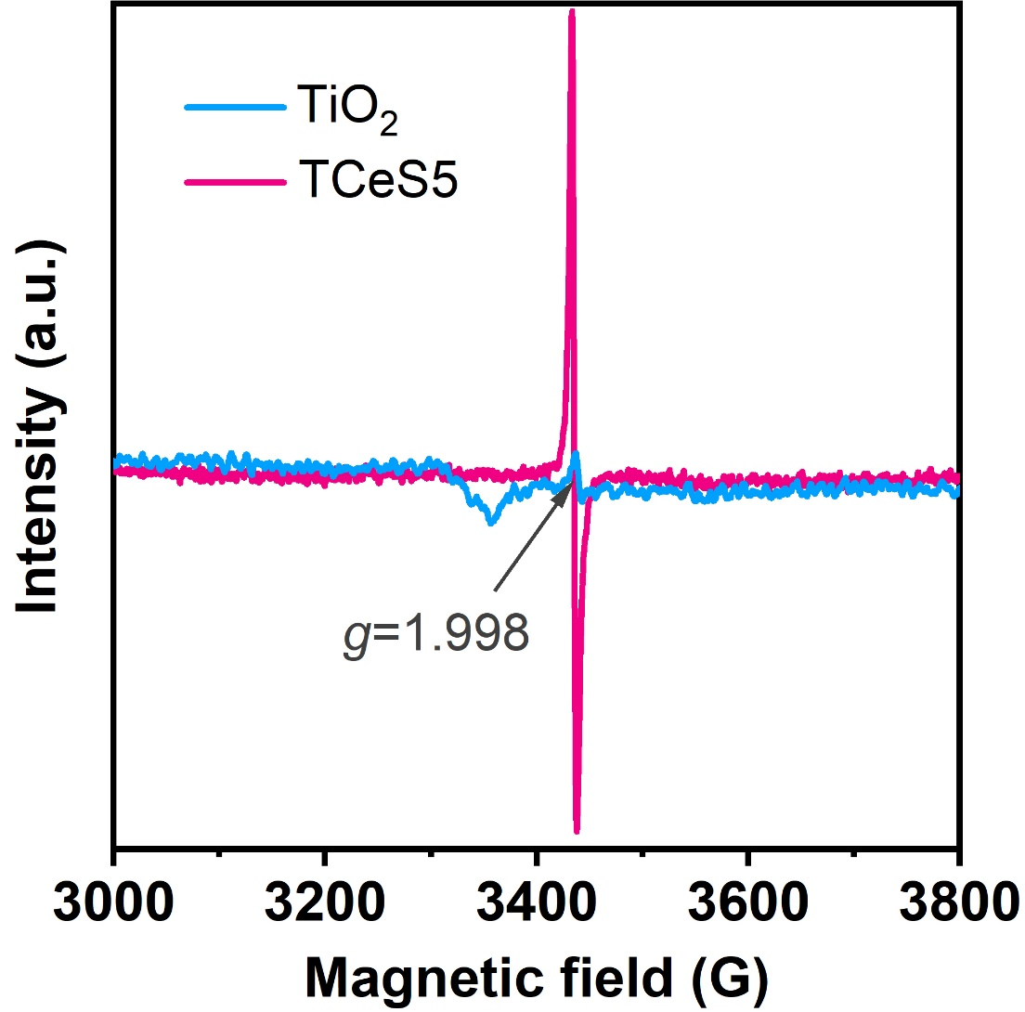
Supplementary Figure 7. Electron spin resonance (ESR) spectra of TiO₂ and TC5. TC5 represents the TiO₂/Ce₂S₃ hybrids, where T and C represent TiO₂ nanofiber and Ce₂S₃ nanoparticle, respectively; 5 is the mole percentages of Ce₂S₃ with respect to TiO₂.

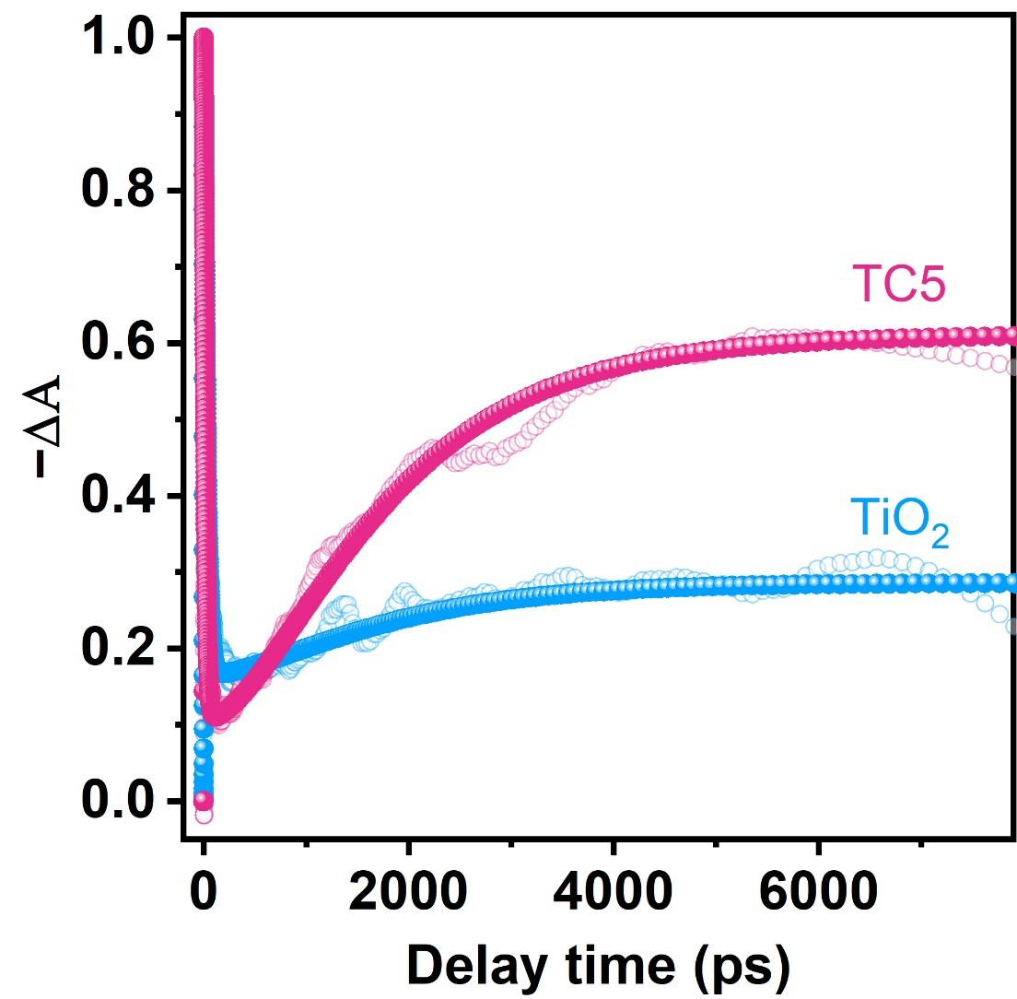
Supplementary Figure 8. The transient absorption kinetic traces of TiO₂ and TC5 at 645 nm with prolonging the delay time.

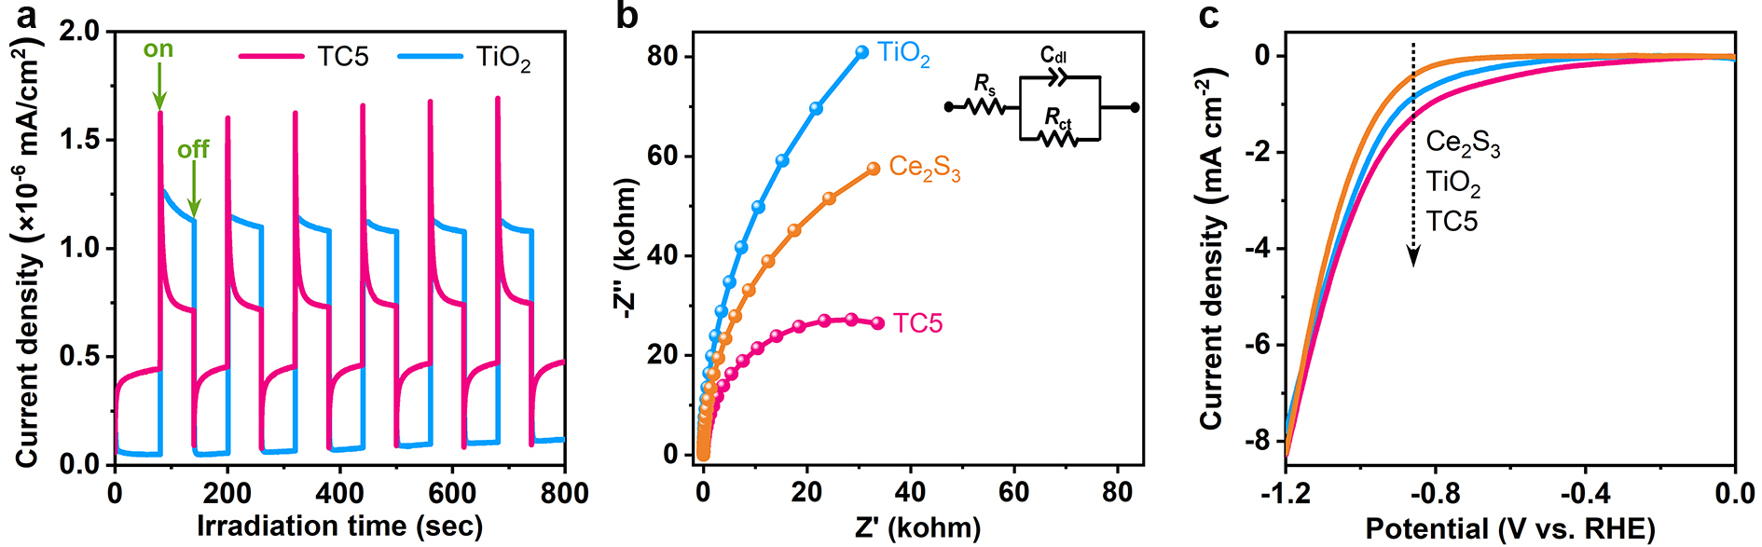
Supplementary Figure 9. Electrochemical characterizations. a Transient photocurrent response for TiO₂ and TC5 under UV-visible light irradiation in 0.5 M Na₂SO₄ aqueous solution. b Nyquist plots of TiO₂, TC5 and Ce₂S₃ in 0.5 M Na₂SO₄ aqueous solution. c Polarization curves of TiO₂, TC5 and Ce₂S₃ at a scan rate of 5 mV s⁻¹ in 0.5 M Na₂SO₄ under UV-visible light irradiation. TC5 represents the TiO₂/Ce₂S₃ hybrids, where T and C represent TiO₂ nanofiber and Ce₂S₃ nanoparticle, respectively; 5 is the mole percentages of Ce₂S₃ with respect to TiO₂.

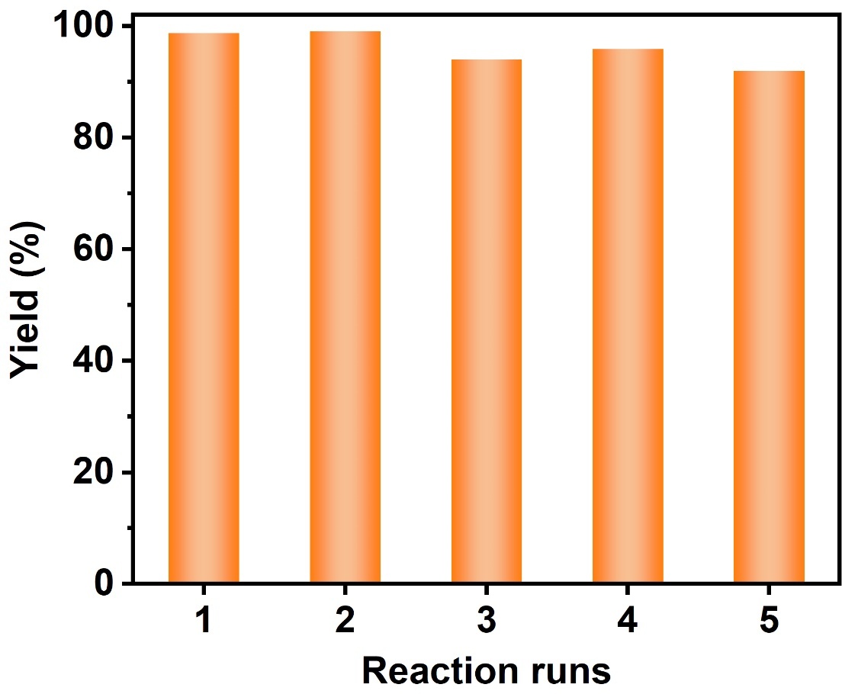
Supplementary Figure 10. The recyclability of TC5 for the photocatalytic transfer hydrogenation. TC5 represents the TiO₂/Ce₂S₃ hybrid, where T and C represent TiO₂ nanofiber and Ce₂S₃ nanoparticle, respectively; 5 is the mole percentages of Ce₂S₃ with respect to TiO₂.

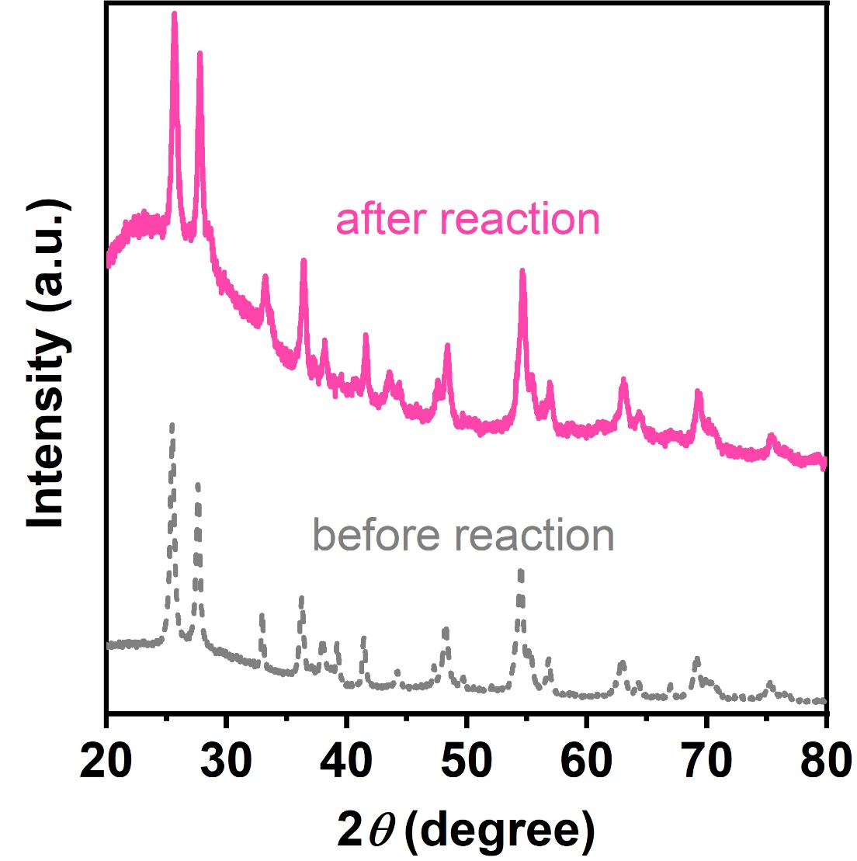
Supplementary Figure 11. XRD patterns of TC5 before and after photocatalytic reaction. TC5 represents the TiO₂/Ce₂S₃ hybrid, where T and C represent TiO₂ nanofiber and Ce₂S₃ nanoparticle, respectively; 5 is the mole percentages of Ce₂S₃ with respect to TiO₂.

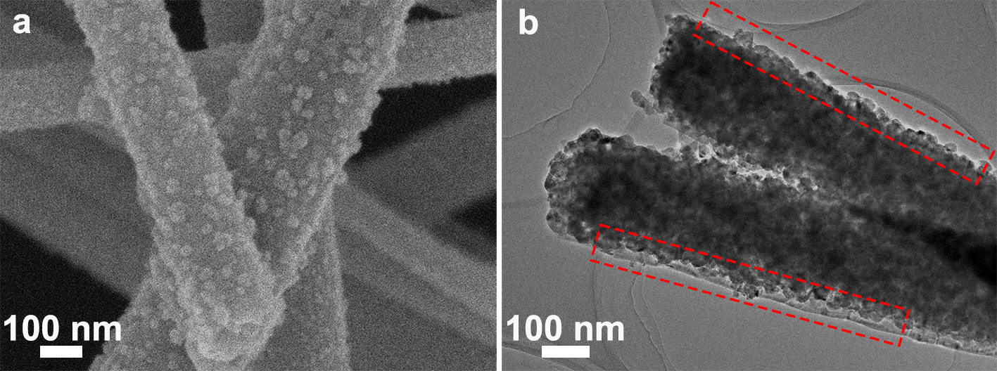
Supplementary Figure 12. FESEM and TEM images of TC5 after photocatalytic reaction. TC5 represents the TiO₂/Ce₂S₃ hybrid, where T and C represent TiO₂ nanofiber and Ce₂S₃ nanoparticle, respectively; 5 is the mole percentages of Ce₂S₃ with respect to TiO₂.

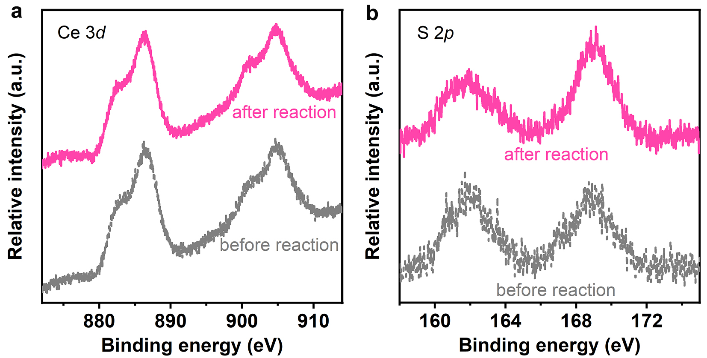
Supplementary Figure 13. High resolution XPS spectra of a Ce 3d and b S 2p of TC5 after photocatalytic reaction. TC5 represents the TiO₂/Ce₂S₃ hybrid, where T and C represent TiO₂ nanofiber and Ce₂S₃ nanoparticle, respectively; 5 is the mole percentages of Ce₂S₃ with respect to TiO₂.

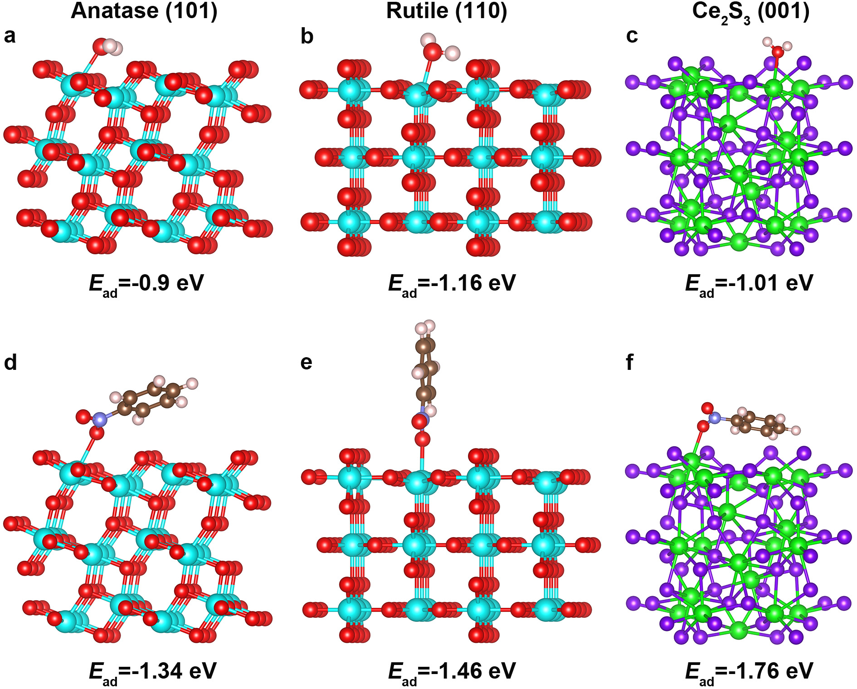
Supplementary Figure 14. The adsorption of reactants. Optimized structures of H₂O and nitrobenzene molecules adsorbed on anatase TiO₂ (101), rutile TiO₂ (110), and Ce₂S₃ (001) facets. The cyan, red, green, violet, light pink, brown and blue spheres stand for Ti, O, Ce, S, H, C and N atoms, respectively.

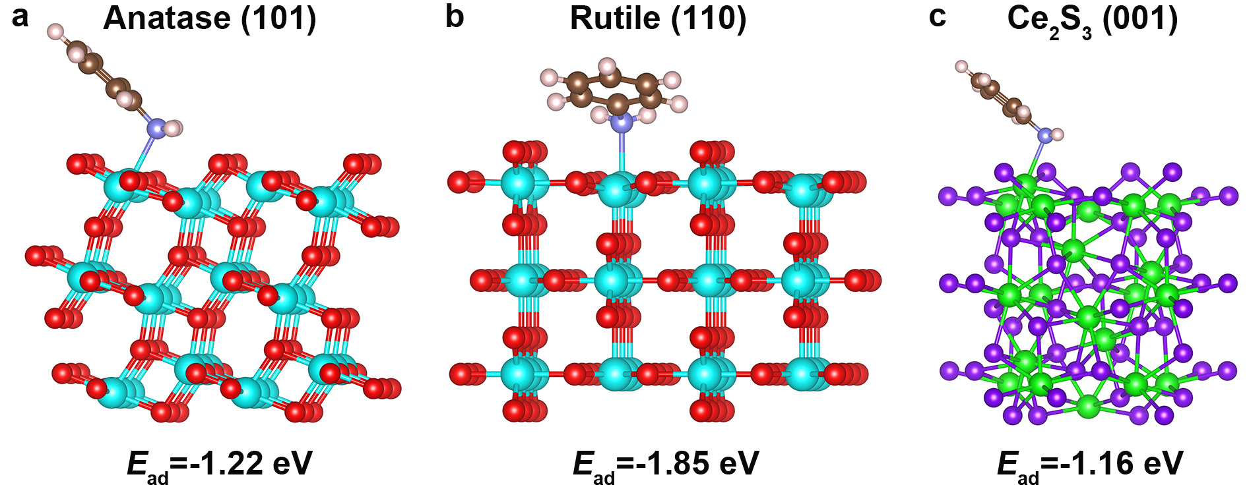
Supplementary Figure 15. The desorption of products. Optimized structures of aniline molecule adsorbed on anatase TiO₂ (101), rutile TiO₂ (110), and Ce₂S₃ (001) facets. The cyan, red, green, violet, light pink, brown and blue spheres stand for Ti, O, Ce, S, H, C and N atoms, respectively.

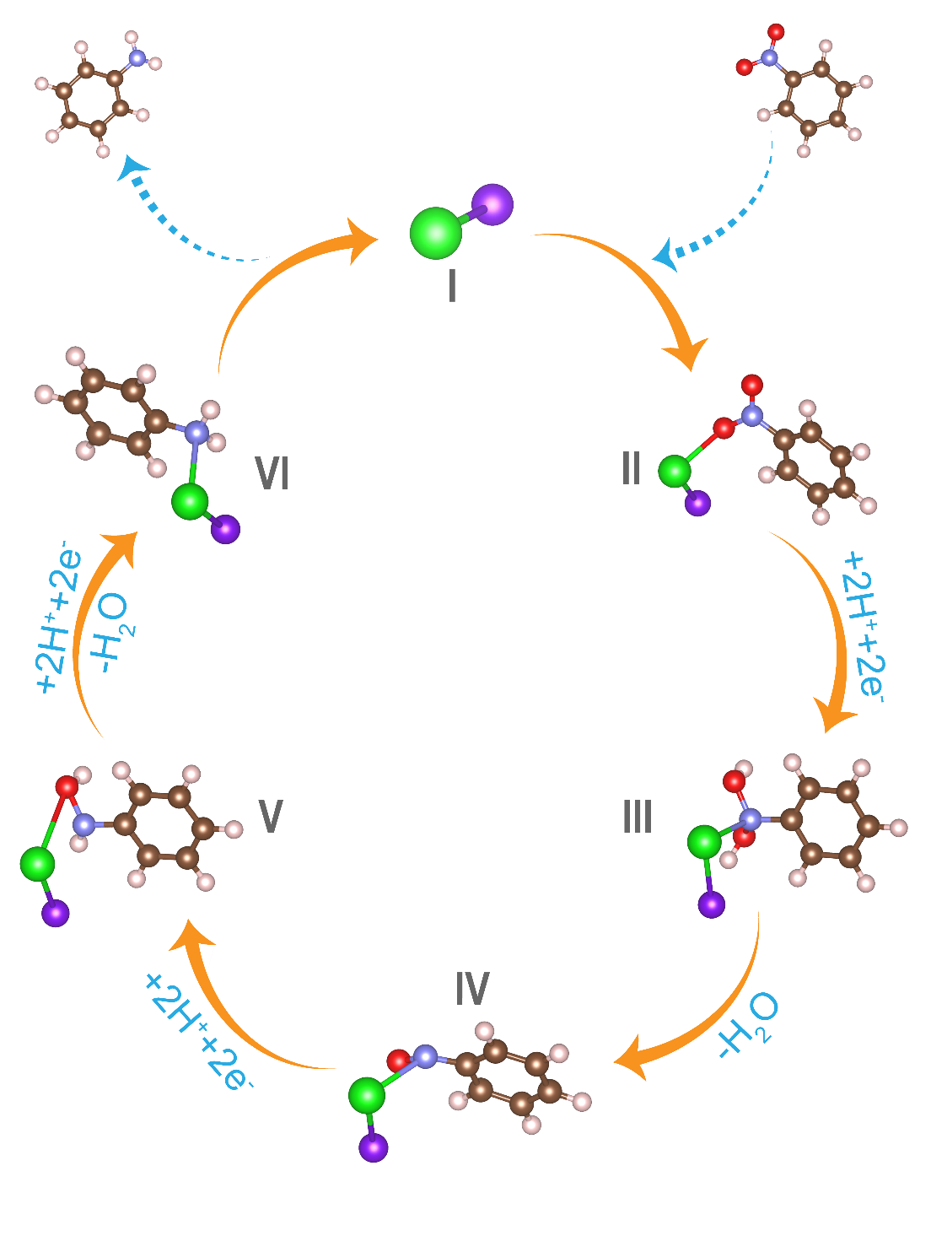
Supplementary Figure 16. The photocatalytic hydrogenation process over TiO₂/Ce₂S₃ hybrid. The green, red, violet, light pink, brown and blue spheres stand for Ce, S, O, H, C and N atoms, respectively.

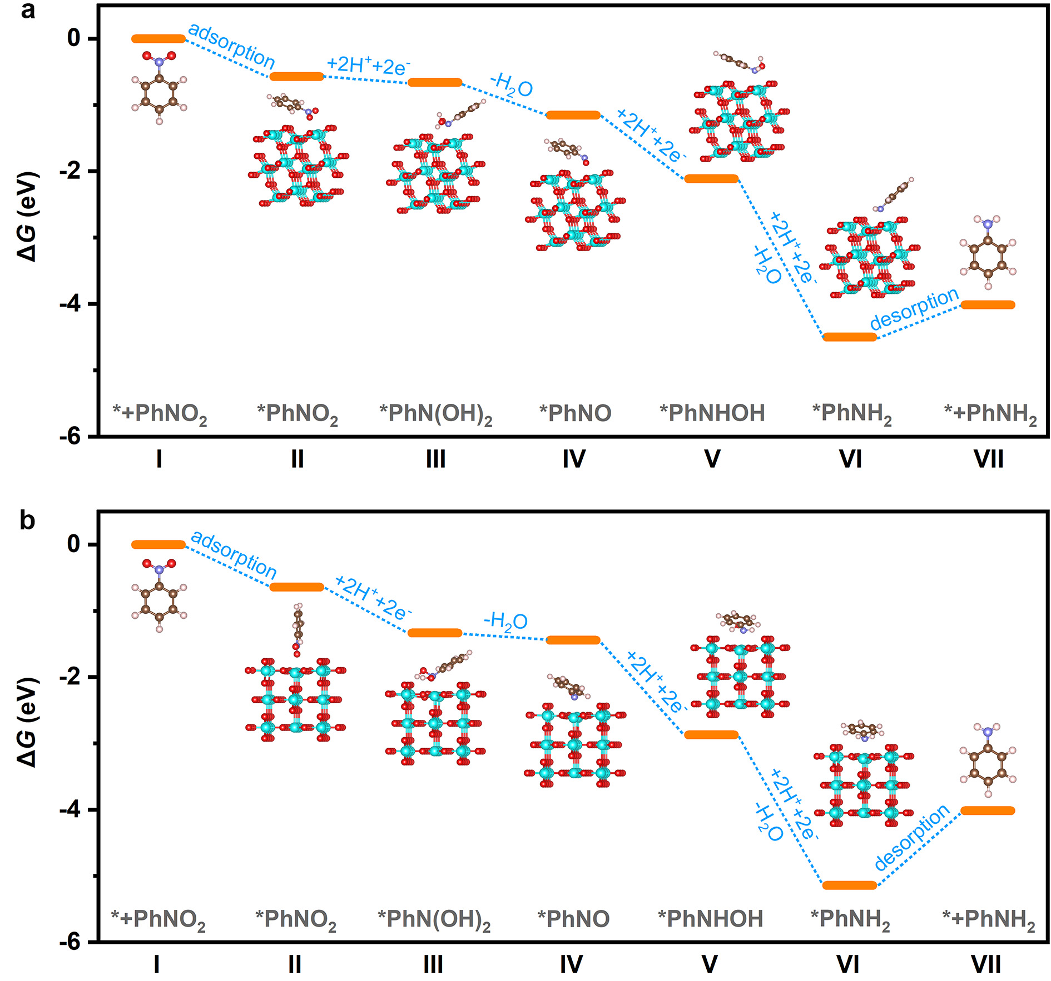
Supplementary Figure 17. Free energy diagrams of photocatalytic nitrobenzene hydrogenation to aniline for: a anatase TiO₂ and b rutile TiO₂ single-unit-cell layers. The cyan, red, light pink, brown and blue spheres stand for Ti, O, H, C and N atoms, respectively.

Supplementary Table
Supplementary Table 1. The calculated surface energy of the typical low-index surfaces of Ce₂S₃.
Facets | Surface energy (J m⁻²)
(001) | 0.34
(011) | 0.59
(111) | 0.80
(113) | 0.73
(121) | 0.91

