Supplementary Information

Large-Language-Model-Assisted Microbial Source Tracking Reveals Mechanisms of Tropical Cyclone Impacts on Microbial Water Quality in Coastal Environments

Van-Khuong Trinh¹⁾, Palash Sashittal²⁾, Shin-Ah Lee¹⁾, Amanda Chappel¹⁾, Megan Sanford¹⁾, David Tomasko³⁾, Edward Sherwood⁴⁾, Jennifer Hecker⁵⁾, Abbey Tyrna⁶⁾, Sungyoon Jung¹⁾, Elise S. Morrison¹⁾, Chamteut Oh¹⁾

- Department of Environmental Engineering Sciences, University of Florida
- Department of Computer Science, Virginia Tech
- Sarasota Bay Estuary Program
- Tampa Bay Estuary Program
- Coastal & Heartland National Estuary Partnership
- Suncoast Waterkeeper

Corresponding author: chamteutoh@ufl.edu

Five figures and five tables are included.

Table S1. Sampling sites with geographic coordinates and estuarine groupings
Site ID | Latitude (°) | Longitude (°) | Estuary group
TB1 | 27.5337 | -82.6693 | Lower estuary
TB2 | 27.5308 | -82.6506 | Lower estuary
MR1 | 27.5208 | -82.6332 | Middle estuary
MR2 | 27.5174 | -82.6189 | Middle estuary
MR5 | 27.5071 | -82.544 | Middle estuary
MR3 | 27.504 | -82.5946 | Middle estuary
MR4 | 27.5021 | -82.5678 | Middle estuary
LB | 27.4229 | -82.6151 | Lower estuary
BC | 27.4121 | -82.5911 | Lower estuary
NC | 27.3813 | -82.5691 | Lower estuary
LSBC | 27.2139 | -82.5036 | Lower estuary
LSBS | 27.2035 | -82.5011 | Lower estuary
DRB1 | 27.1171 | -82.4637 | Lower estuary
DRB2 | 27.117 | -82.4539 | Middle estuary
DRB3 | 27.1139 | -82.4651 | Lower estuary
DRB4 | 27.1113 | -82.4504 | Middle estuary
ULB4 | 27.0423 | -82.4296 | Lower estuary
ULB1 | 26.9926 | -82.3965 | Lower estuary
WSPLK | 26.9735 | -82.1198 | Middle estuary
ULB2 | 26.9686 | -82.3776 | Lower estuary
ULB3 | 26.9501 | -82.3632 | Lower estuary
LOPNT | 26.9487 | -82.0593 | Middle estuary
GODFC | 26.9385 | -82.3453 | Middle estuary
LBV004 | 26.9349 | -82.3526 | Lower estuary
LBANG | 26.931 | -82.3366 | Middle estuary
LBOYS | 26.9227 | -82.3314 | Middle estuary
BUCKCK | 26.8904 | -82.3091 | Middle estuary
RVMRNA | 26.8884 | -82.0529 | Middle estuary
735137 | 26.8293 | -82.2847 | Lower estuary
BGCSWY | 26.8265 | -82.2701 | Lower estuary

Table S2. A completed dMIQE table.
Time to check | Y/N | Comment
1. SPECIMEN
Detailed description of specimen type and numbers | Y | 2.1. Site description and sample collection
Sampling procedure (including time to storage) | Y | 2.1. Site description and sample collection
Sample aliquotation, storage conditions and duration | Y | 2.1. Site description and sample collection
2. NUCLEIC ACID EXTRACTION
Description of extraction method including amount of sample processed | Y | 2.2. Sample processing
Volume of solvent used to elute/resuspend extract | Y | 2.2. Sample processing
Number of extraction replicates | Y | 2.2. Sample processing
Extraction blanks included? | Y | 2.2. Sample processing
3. NUCLEIC ACID ASSESSMENT AND STORAGE
Method to evaluate quality of nucleic acids | Y | 2.4. 16S rRNA amplicon sequencing
Method to evaluate quantity of nucleic acids (including molecular weight and calculations when using mass) | N | Not relevant
Storage conditions: temperature, concentration, duration, buffer, aliquots | Y | 2.2. Sample processing
Clear description of dilution steps used to prepare working DNA solution | Y | 2.3. DNA Quantification
4. NUCLEIC ACID MODIFICATION
Template modification (digestion, sonication, pre-amplification, bisulphite etc.) | Y | 2.3. DNA Quantification
Details of repurification following modification if performed | N | Not relevant
5. REVERSE TRANSCRIPTION
cDNA priming method and concentration | N | Not relevant
One or two step protocol (include reaction details for two step) | Y | 2.3. DNA Quantification
Amount of RNA added per reaction | N | Not relevant
Detailed reaction components and conditions | Y | 2.3. DNA Quantification
Estimated copies measured with and without addition of RT* | N | Not relevant
Manufacturer of reagents used with catalogue and lot numbers | Y | 2.3. DNA Quantification
Storage of cDNA: temperature, concentration, duration, buffer and aliquots | N | Not relevant
6. dPCR OLIGONUCLEOTIDES DESIGN AND TARGET INFORMATION
Sequence accession number or official gene symbol | Y | Table S3. Information about primers
Method (software) used for design and in silico verification | Y | PrimerQuest™: PCR & qPCR primer design tool
Location of amplicon | Y | Table S3. Information about primers
Amplicon length | Y | Table S3. Information about primers
Primer and probe sequences (or amplicon context sequence)** | Y | Table S3. Information about primers
Location and identity of any modifications | N | Not relevant
Manufacturer of oligonucleotides | Y | Integrated DNA Technologies, Inc
7. dPCR PROTOCOL
Manufacturer of dPCR instrument and instrument model | Y | QIAGEN
Buffer/kit manufacturer with catalogue and lot number | Y | 2.3. DNA Quantification
Primer and probe concentration | Y | 2.3. DNA Quantification
Pre-reaction volume and composition (incl. amount of template and if restriction enzyme added) | N | Not relevant
Template treatment (initial heating or chemical denaturation) | Y | 2.3. DNA Quantification
Polymerase identity and concentration, Mg++ and dNTP concentrations*** | Y | 2.3. DNA Quantification
Complete thermocycling parameters | Y | 2.3. DNA Quantification
8. ASSAY VALIDATION
Details of optimisation performed | Y | 2.3. DNA Quantification
Analytical specificity (vs. related sequences) and limit of blank (LOB) | Y | 2.3. DNA Quantification
Analytical sensitivity/LoD and how this was evaluated | Y | 2.3. DNA Quantification
Testing for inhibitors (from biological matrix/extraction) | Y | Fig. S3. Inhibition test
9. DATA ANALYSIS
Description of dPCR experimental design | Y | 2.3. DNA Quantification
Comprehensive details negative and positive of controls (whether applied for QC or for estimation of error) | Y | 2.3. DNA Quantification
Partition classification method (thresholding) | Y | 2.3. DNA Quantification
Examples of positive and negative experimental results (including fluorescence plots in supplemental material) | Y | Fig. S2. Examples of dPCR results
Description of technical replication | Y | 2.3. DNA Quantification
Repeatability (intra-experiment variation) | Y | 2.3. DNA Quantification
Reproducibility (inter-experiment/user/lab etc. variation ) | N | Not relevant
Number of partitions measured (average and standard deviation ) | N | All data is presented in a unit of concentration or DNA count.
Partition volume | Y | 2.3. DNA Quantification
Copies per partition (λ or equivalent ) (average and standard deviation) | N | All data is presented in a unit of concentration or DNA count.
dPCR analysis program (source, version) | Y | 2.3. DNA Quantification
Description of normalisation method | Y | 2.3. DNA Quantification
Statistical methods used for analysis | Y | 2.7. Statistical analysis
Data transparency | Y | Upon request

Table S3. Information about primers
No. | Primer name | Sequence (5’ to 3’) | Length (bp) | GC content (%) | Annealing temperature (ºC)^{a)} |  | Target gene | Amplicon size^{b)} | Reference sequence
 |  |  |  |  | Conventional PCR | dPCR | Target gene | Amplicon size^{b)} | Reference sequence
1 | Sul1_F | 5′-CGCACCGGAAACATCGCTGCAC-3′ | 22 | 63.6 | 63.8 | 69.9 | Sul1 | 163 | 1
1 | Sul1_R | 5′-TGAAGTTCCGCCGCAAGGCTC-3′ | 21 | 61.9 | 62.7 | 69.0 | Sul1 | 163 | 1
2 | Sul2_F | 5′-TCCGGTGGAGGCCGGTATCTGG-3′ | 22 | 68.2 | 65.1 | 70.9 | Sul2 | 191 | 1
2 | Sul2_R | 5′-CGGGAATGCCATCTGCCTTGAG-3′ | 22 | 59.1 | 60.6 | 67.1 | Sul2 | 191 | 1
3 | qnrS_F | 5′-GCAAGTTCATTGAACAGGGT-3′ | 20 | 45 | 53.5 | 61 | qnrS | 428 | 2
3 | qnrS_R | 5′-TCTAAACCGTCGAGTTCGGCG-3′ | 21 | 57.1 | 59.3 | 65.9 | qnrS | 428 | 2
4 | tetA_F | 5′-GCTACATCCTGCTTGCCTTC-3′ | 20 | 55 | 56.2 | 62.9 | tetA | 210 | 3
4 | tetA_R | 5′-CATAGATCGCCGTGAAGAGG-3′ | 20 | 55 | 55.1 | 61.7 | tetA | 210 | 3
5 | floR_F | 5-CGGTCGGTATTGTCTTCACG-3 | 20 | 55 | 55.6 | 62.3 | floR | 171 | 4
5 | floR_R | 5′-TCACGGGCCACGCTGTAT-3′ | 18 | 61.1 | 59.5 | 65.8 | floR | 171 | 4
6 | aadA_F | 5′-AAATTCTTCCAACTGATCTGCG-3′ | 22 | 40.9 | 53.5 | 61.4 | aadA | 276 | 5
6 | aadA_R | 5′-CCTGAACAGGATCTATTTGAGGC-3′ | 23 | 47.8 | 55.3 | 62.6 | aadA | 276 | 5
7 | E.coli-ybbW_F | 5′-TGATTGGCAAAATCTGGCCG-3′ | 20 | 50 | 56.4 | 63.6 | ybbW | 210 | 6
7 | E.coli-ybbW_R | 5′-GAAATCGCCCAAATCGCCAT-3′ | 20 | 50 | 56.5 | 63.7 | ybbW | 210 | 6
8. | Pseudomonas-oprl_F | 5′-ATGAACAACGTTCTGAAATTCTCTGCT-3′ | 27 | 37 | 57.1 | 65.5 | oprl | 249 | 6
8. | Pseudomonas-oprl_R | -5′-CTTGCGGCTGGCTTTTTCCAG-3′ | 21 | 57.1 | 59.7 | 66.3 | oprl | 249 | 6
9. | Universal 16s_341_F | 5′-CCTACGGGAGGCAGCAG-3′ | 17 | 70.6 | 58.2 | 63.5 | 16s | 195 | CP142448.1
9. | Universal 16s_518_R | 5′-ATTACCGCGGCTGCTGG-3′ | 17 | 64.7 | 58.7 | 64.6 | 16s | 195 | CP142448.1
10 | vvhA_F | 5′-TGTTTATGGTGAGAACGGTGACA-3′ | 23 | 43.5 | 56.4 | 64.1 | vvhA | 100 | 7
10 | vvhA_R | 5′-TTCTTTATCTAGGCCCCAAACTTG-3′ | 24 | 41.7 | 54.9 | 62.8 | vvhA | 100 | 7
10 | vvhA_P | 5′-/56-FAM/CCGTTAACC/ZEN/GAACCACCCGCAA-3′ | 22 | 59.1 | 62.4 | 68.9 | vvhA | 100 | 7
11 | tlh_F | 5′-ACTCAACACAAGAAGAGATCGACAA-3′ | 25 | 40 | 56.1 | 64.2 | tlh | 200 | 8
11 | tlh_R | 5′-GATGAGCGGTTGATGTCCAA-3′ | 20 | 50 | 55.3 | 62.4 | tlh | 200 | 8
11 | tlh_P | 5′-/56-FAM/CGCTCGCGT/ZEN/TCACGAAACCGT-3′ | 21 | 61.9 | 62.9 | 69.2 | tlh | 200 | 8
12 | 16s_Seq_27F | 5′-AGAGTTTGATCMTGGCTCAG-3′ | 20 | 47.5 | 53.2 | - | 16s rRNA | 1486 | 9
12 | 16s_Seq_1491R | 5′-CGGTTACCTTGTTACGACTT-3′ | 20 | 45 | 52.3 | - | 16s rRNA | 1486 | 9

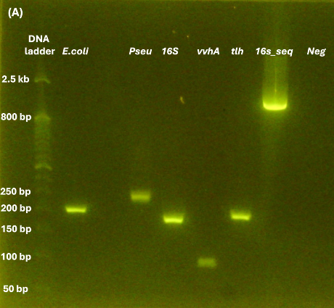 | 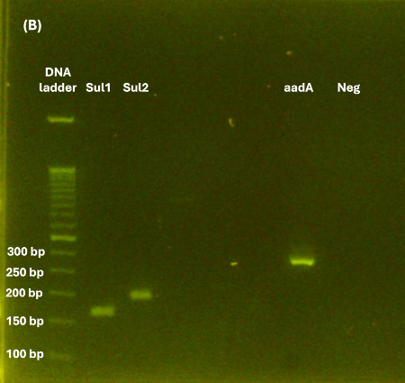 | 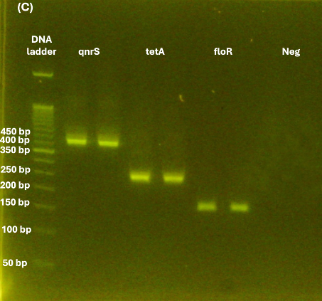
Fig. S1. Gel electrophoresis image showing PCR amplicons synthesized using the E.coli-ybbW, Pseudomonas-oprl, Universal 16s, vvhA, tlh, and 16s_seq (A), Sul1, Sul2, aadA (B), qnrS, tetA, floR gene (C) described in Table S3. The gel electrophoresis was performed on E-gel power snap electrophoresis device (G8100, Invitrogen) for 15 minutes using E-gel EX 2% agarose (G401002, Invitrogen). These results indicate that all primer sets specifically amplify their target sequences.

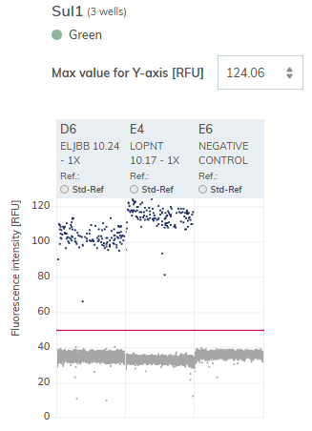 | 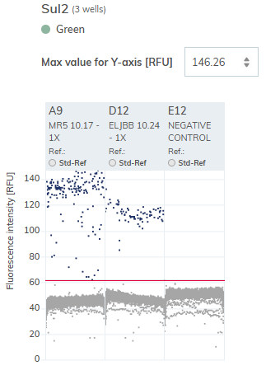 | 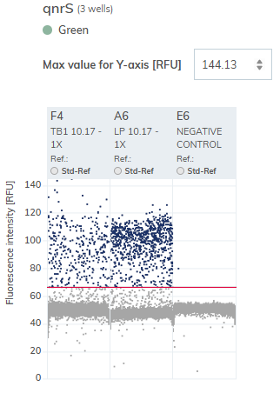 | 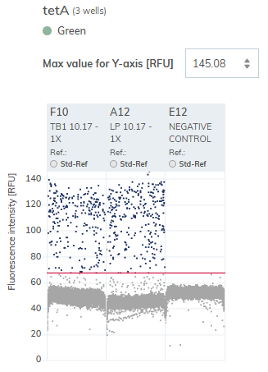 | 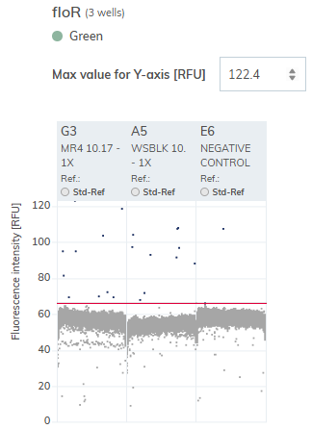 | 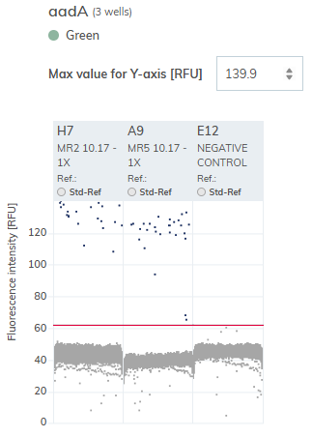
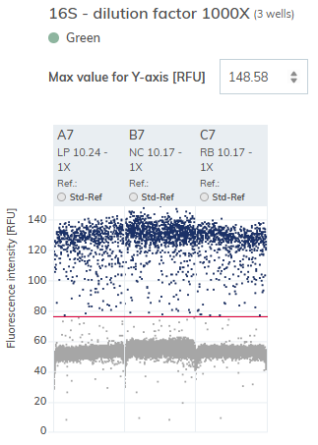 | 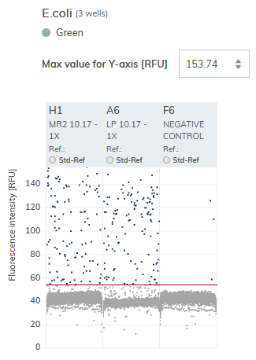 | 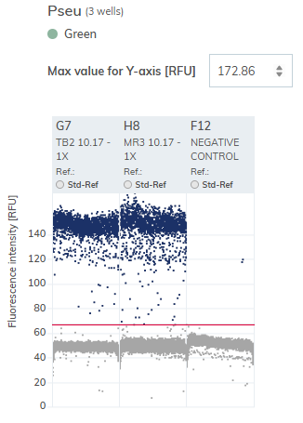 | 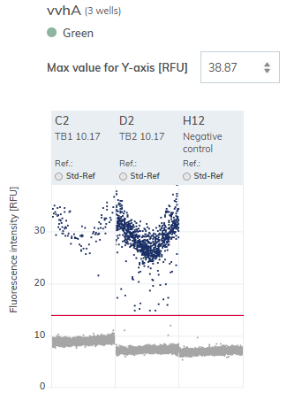 | 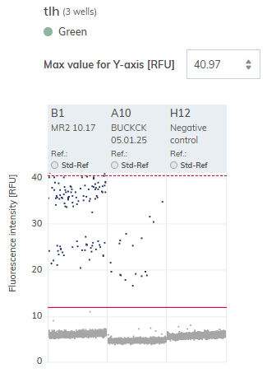
Fig. S2. Examples of dPCR results. Positive (blue) and negative (gray) partitions were distinctly separated by a threshold of approximately 15 RFU with the Probe PCR kit and 70 RFU with the EG PCR kit.

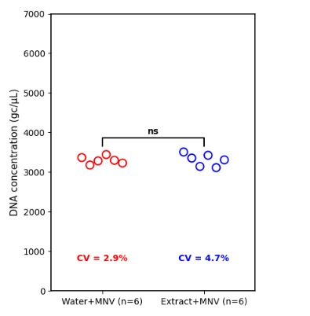

Fig. S3. Inhibition test. Approximately 3300 gc/μL of murine norovirus RNA was added to molecular biology-grade water (Water on the x-axis; n=6) and to the nucleic acids extracted from seawater samples (Extract on the x-axis; n=6). The six extracts were collected from the BC, NC, LSBC, LSBS, ULB1, and ULB2 sites one week after Hurricane Milton.
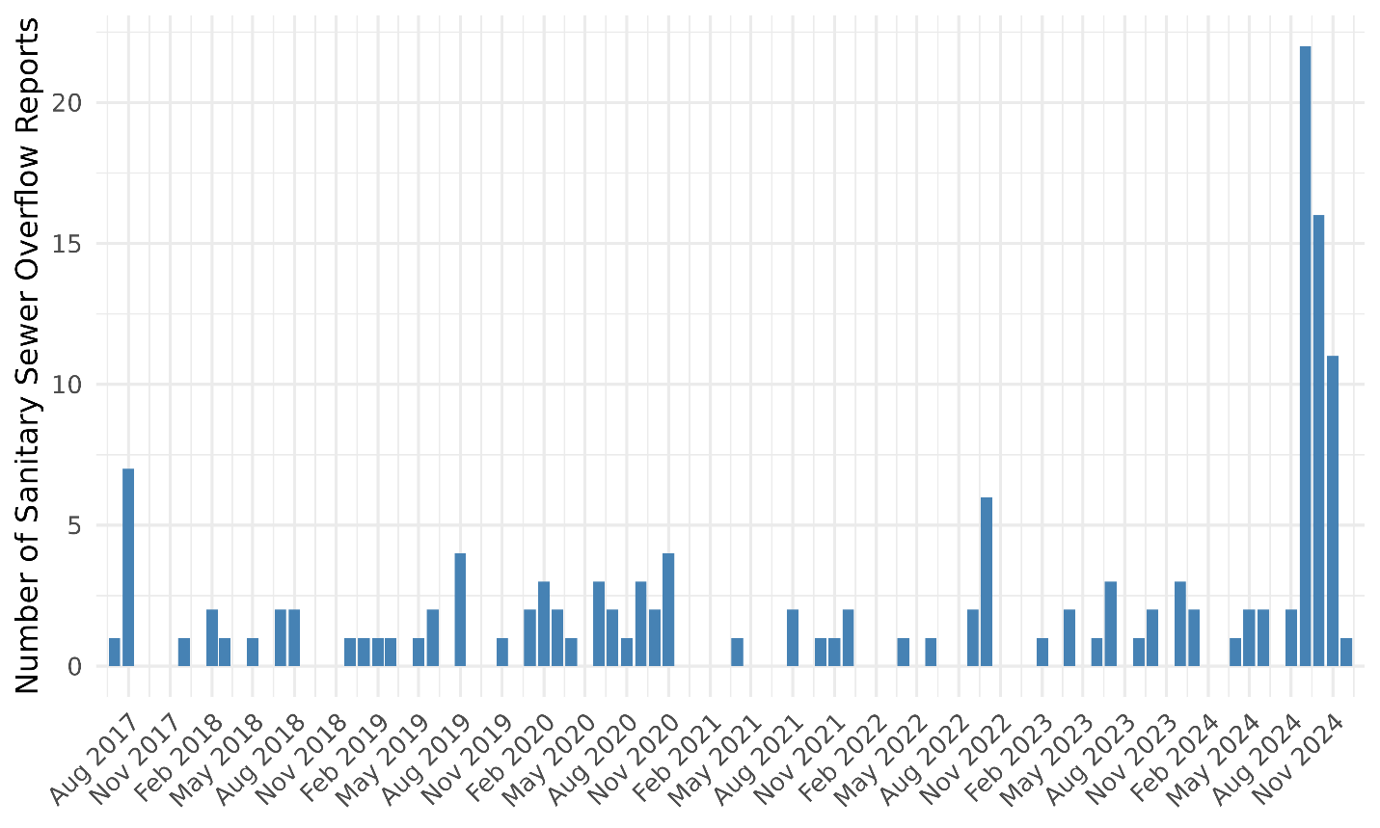
Fig. S4. Number of sanitary sewer overflow reports in the Manatee River watershed. Raw data are available at https://tbep-tech.github.io/sso-reporting/sso-reporting.html (last accessed on October 31, 2025).

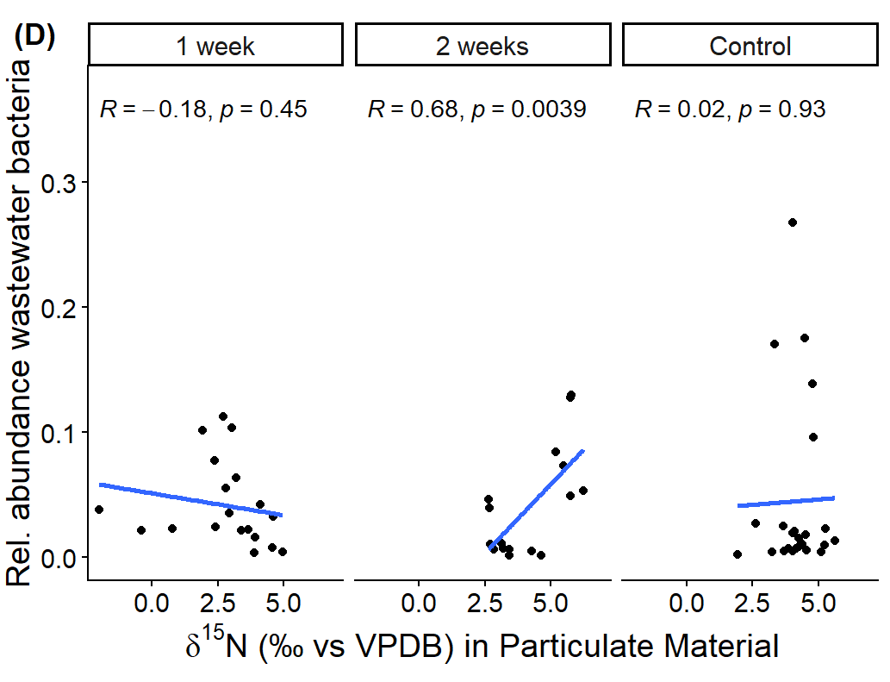
Fig. S5. Relationships between the relative abundance of wastewater bacteria compared with nitrogen stable isotopes in particulate material. R and p values are shown for Pearson correlations.

Table S4. Summary of statistical analysis for data in Fig. 1
Analyte | GroupA | GroupB | N_pairs | ShapiroP | Normality | Test | P_value | Data
Terrestrial  bacteria | 1 week | 2 weeks | 17 | 0.341 | normal | paired_t | 0.337 | Fig. 1C
Terrestrial  bacteria | 1 week | control | 30 | 0.065 | normal | paired_t | 0.000 | Fig. 1C
Wastewater  bacteria | 1 week | 2 weeks | 17 | 0.000 | non-normal | wilcoxon_signed_rank | 0.185 | Fig. 1D
Wastewater  bacteria | 1 week | control | 30 | 0.000 | non-normal | wilcoxon_signed_rank | 0.011 | Fig. 1D
16S rRNA | 1 week | 2 weeks | 17 | 0.549 | normal | paired_t | 0.944 | Fig. 1E
16S rRNA | 1 week | control | 30 | 0.000 | non-normal | wilcoxon_signed_rank | 0.000 | Fig. 1E
Enterococci | 1 week | 2 weeks | 17 | 0.000 | non-normal | wilcoxon_signed_rank | 0.003 | Fig. 1F
Enterococci | 1 week | control | 30 | 0.000 | non-normal | wilcoxon_signed_rank | 0.000 | Fig. 1F
Ecoli | 1 week | 2 weeks | 17 | 0.004 | non-normal | wilcoxon_signed_rank | 0.058 | Fig. 1G
Ecoli | 1 week | control | 30 | 0.000 | non-normal | wilcoxon_signed_rank | 0.000 | Fig. 1G
Pseudomonas | 1 week | 2 weeks | 17 | 0.011 | non-normal | wilcoxon_signed_rank | 0.118 | Fig. 1H
Pseudomonas | 1 week | control | 30 | 0.000 | non-normal | wilcoxon_signed_rank | 0.000 | Fig. 1H
Sul1 | 1 week | 2 weeks | 17 | 0.195 | normal | paired_t | 0.046 | Fig. 1I
Sul1 | 1 week | control | 30 | 0.001 | non-normal | wilcoxon_signed_rank | 0.004 | Fig. 1I
Sul2 | 1 week | 2 weeks | 17 | 0.130 | normal | paired_t | 0.005 | Fig. 1J
Sul2 | 1 week | control | 30 | 0.000 | non-normal | wilcoxon_signed_rank | 0.000 | Fig. 1J
qnrS | 1 week | 2 weeks | 17 | 0.001 | non-normal | wilcoxon_signed_rank | 0.019 | Fig. 1K
qnrS | 1 week | control | 30 | 0.100 | normal | paired_t | 0.012 | Fig. 1K
tetA | 1 week | 2 weeks | 17 | 0.099 | normal | paired_t | 0.576 | Fig. 1L
tetA | 1 week | control | 30 | 0.000 | non-normal | wilcoxon_signed_rank | 0.000 | Fig. 1L
floR | 1 week | 2 weeks | 17 | 0.045 | non-normal | wilcoxon_signed_rank | 0.456 | Fig. 1M
floR | 1 week | control | 30 | 0.000 | non-normal | wilcoxon_signed_rank | 0.002 | Fig. 1M
aadA | 1 week | 2 weeks | 17 | 0.000 | non-normal | wilcoxon_signed_rank | 0.012 | Fig. 1N
aadA | 1 week | control | 30 | 0.000 | non-normal | wilcoxon_signed_rank | 0.000 | Fig. 1N
Parahaemolyticus | 1 week | 2 weeks | 17 | 0.000 | non-normal | wilcoxon_signed_rank | 0.349 | Fig. 1O
Parahaemolyticus | 1 week | control | 30 | 0.000 | non-normal | wilcoxon_signed_rank | 0.036 | Fig. 1O
Vulnificus | 1 week | 2 weeks | 17 | 0.000 | non-normal | wilcoxon_signed_rank | 0.255 | Fig. 1C
Vulnificus | 1 week | control | 30 | 0.000 | non-normal | wilcoxon_signed_rank | 0.006 | Fig. 1C

Table S5. Summary of statistical analysis for data in Fig. 2
Metric | group1 | n1 | mean1 | sd1 | shapiro_p1 | group2 | n2 | mean2 | sd2 | shapiro_p2 | selected_test | p_value
Marine bacteria | Middle estuary | 14 | 0.33 | 0.14 | 0.82 | Lower estuary | 16 | 0.73 | 0.11 | 0.06 | Welch t-test | 0.00
Terrestrial bacteria | Middle estuary | 14 | 0.61 | 0.14 | 0.95 | Lower estuary | 16 | 0.23 | 0.07 | 0.41 | Welch t-test | 0.00
Wastewater bacteria | Middle estuary | 14 | 0.06 | 0.03 | 0.19 | Lower estuary | 16 | 0.04 | 0.09 | 0.00 | Mann-Whitney U | 0.00
Marine bacteria | Middle estuary (Control) | 14 | 0.80 | 0.07 | 0.71 | Lower estuary (Control) | 16 | 0.81 | 0.07 | 0.04 | Mann-Whitney U | 0.69
Terrestrial bacteria | Middle estuary (Control) | 14 | 0.16 | 0.06 | 0.29 | Lower estuary (Control) | 16 | 0.14 | 0.04 | 0.01 | Mann-Whitney U | 0.57
Wastewater bacteria | Middle estuary (Control) | 14 | 0.04 | 0.07 | 0.00 | Lower estuary (Control) | 16 | 0.05 | 0.07 | 0.00 | Mann-Whitney U | 0.52
Marine bacteria | Middle estuary | 14 | 0.33 | 0.14 | 0.82 | Middle estuary (Control) | 14 | 0.80 | 0.07 | 0.71 | Welch t-test | 0.00
Terrestrial bacteria | Middle estuary | 14 | 0.61 | 0.14 | 0.95 | Middle estuary (Control) | 14 | 0.16 | 0.06 | 0.29 | Welch t-test | 0.00
Wastewater bacteria | Middle estuary | 14 | 0.06 | 0.03 | 0.19 | Middle estuary (Control) | 14 | 0.04 | 0.07 | 0.00 | Mann-Whitney U | 0.00
Marine bacteria | Lower estuary | 16 | 0.73 | 0.11 | 0.06 | Lower estuary (Control) | 16 | 0.81 | 0.07 | 0.04 | Mann-Whitney U | 0.02
Terrestrial bacteria | Lower estuary | 16 | 0.23 | 0.07 | 0.41 | Lower estuary (Control) | 16 | 0.14 | 0.04 | 0.01 | Mann-Whitney U | 0.00
Wastewater bacteria | Lower estuary | 16 | 0.04 | 0.09 | 0.00 | Lower estuary (Control) | 16 | 0.05 | 0.07 | 0.00 | Mann-Whitney U | 0.66
Marine bacteria | Marine samples | 19 | 0.49 | 0.22 | 0.51 | Terrestrial samples | 16 | 0.10 | 0.05 | 0.00 | Mann-Whitney U | 0.00
Marine bacteria | Marine samples | 19 | 0.49 | 0.22 | 0.51 | Wastewater samples | 23 | 0.10 | 0.06 | 0.27 | Welch t-test | 0.00
Terrestrial bacteria | Terrestrial samples | 16 | 0.80 | 0.07 | 0.00 | Marine samples | 19 | 0.44 | 0.18 | 0.16 | Mann-Whitney U | 0.00
Terrestrial bacteria | Terrestrial samples | 16 | 0.80 | 0.07 | 0.00 | Wastewater samples | 23 | 0.68 | 0.16 | 0.03 | Mann-Whitney U | 0.03
Wastewater bacteria | Wastewater samples | 23 | 0.21 | 0.12 | 0.27 | Marine samples | 19 | 0.07 | 0.08 | 0.00 | Mann-Whitney U | 0.00
Wastewater bacteria | Wastewater samples | 23 | 0.21 | 0.12 | 0.27 | Terrestrial samples | 16 | 0.10 | 0.03 | 0.27 | Welch t-test | 0.00

References
- Campbell, M. S., & Wright, A. C. (2003). Real-Time PCR Analysis of Vibrio vulnificus from Oysters. Applied and Environmental Microbiology, 69(12), 7137–7144. https://doi.org/10.1128/AEM.69.12.7137-7144.2003
- Dos Santos, H. R. M., Argolo, C. S., Argôlo-Filho, R. C., & Loguercio, L. L. (2019). A 16S rDNA PCR-based theoretical to actual delta approach on culturable mock communities revealed severe losses of diversity information. BMC Microbiology, 19(1), 1–14. https://doi.org/10.1186/S12866-019-1446-2/FIGURES/4
- Li, J., Shao, B., Shen, J., Wang, S., & Wu, Y. (2013). Occurrence of Chloramphenicol-Resistance Genes as Environmental Pollutants from Swine Feedlots. Environmental Science and Technology, 47(6), 2892–2897. https://doi.org/10.1021/ES304616C
- Macovei, L., & Zurek, L. (2006). Ecology of Antibiotic Resistance Genes: Characterization of Enterococci from Houseflies Collected in Food Settings. Applied and Environmental Microbiology, 72(6), 4028. https://doi.org/10.1128/AEM.00034-06
- Nordstrom, J. L., Vickery, M. C. L., Blackstone, G. M., Murray, S. L., & DePaola, A. (2007). Development of a Multiplex Real-Time PCR Assay with an Internal Amplification Control for the Detection of Total and Pathogenic Vibrio parahaemolyticus Bacteria in Oysters. Applied and Environmental Microbiology, 73(18), 5840–5847. https://doi.org/10.1128/AEM.00460-07
- Pei, R., Kim, S. C., Carlson, K. H., & Pruden, A. (2006). Effect of River Landscape on the sediment concentrations of antibiotics and corresponding antibiotic resistance genes (ARG). Water Research, 40(12), 2427–2435. https://doi.org/10.1016/J.WATRES.2006.04.017
- Tang, M., Dou, X., Wang, C., Tian, Z., Yang, M., & Zhang, Y. (2017). Abundance and distribution of antibiotic resistance genes in a full-scale anaerobic–aerobic system alternately treating ribostamycin, spiramycin and paromomycin production wastewater. Environmental Geochemistry and Health, 39(6), 1595–1605. https://doi.org/10.1007/S10653-017-9987-5/TABLES/1
- Xiong, W., Sun, Y., Zhang, T., Ding, X., Li, Y., Wang, M., & Zeng, Z. (2015). Antibiotics, Antibiotic Resistance Genes, and Bacterial Community Composition in Fresh Water Aquaculture Environment in China. Microbial Ecology, 70(2), 425–432. https://doi.org/10.1007/S00248-015-0583-X/FIGURES/2
- Yu, P., Zaleski, A., Li, Q., He, Y., Mapili, K., Pruden, A., Alvarez, P. J. J., & Stadler, L. B. (2018). Elevated Levels of Pathogenic Indicator Bacteria and Antibiotic Resistance Genes after Hurricane Harvey’s Flooding in Houston. Environmental Science & Technology Letters, 5(8), 481–486. https://doi.org/10.1021/ACS.ESTLETT.8B00329

