Supplementary Information for: (controllare di mettere il titolo finale)
Vicarious experience modulates implicit and explicit evaluation of virtual agents delivering pain and touch over an embodied avatar
Lisi M.P. ^{1,2*}, Fusaro M.^{1,2}, March F.^{1,3}, Aglioti S.M. ^{1,2}
¹Department of Psychology, Sapienza University of Rome and CLN²S@Sapienza, Istituto Italiano di Tecnologia, 00161, Rome, Italy.
² IRCCS Santa Lucia Foundation, 00142, Rome, Italy
³ School of Advanced Studies, Centre for Neuroscience, University of Camerino, Camerino, Italy

* Corresponding author:
E-mail: matteo.lisi@uniroma1.it

Motion Capture Recording
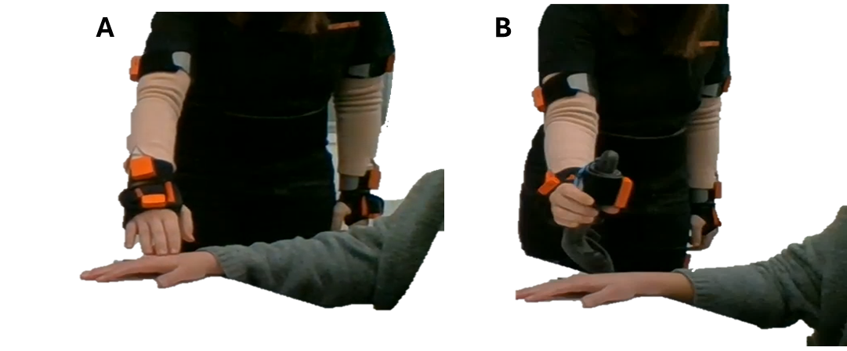
Fig.S1 Motion capture recording. We used the Xsense motion capture suit (https://www.xsens.com/) to record the kinematics of an actor, either gently caressing or stabbing the right hand of another actor with the right hand.

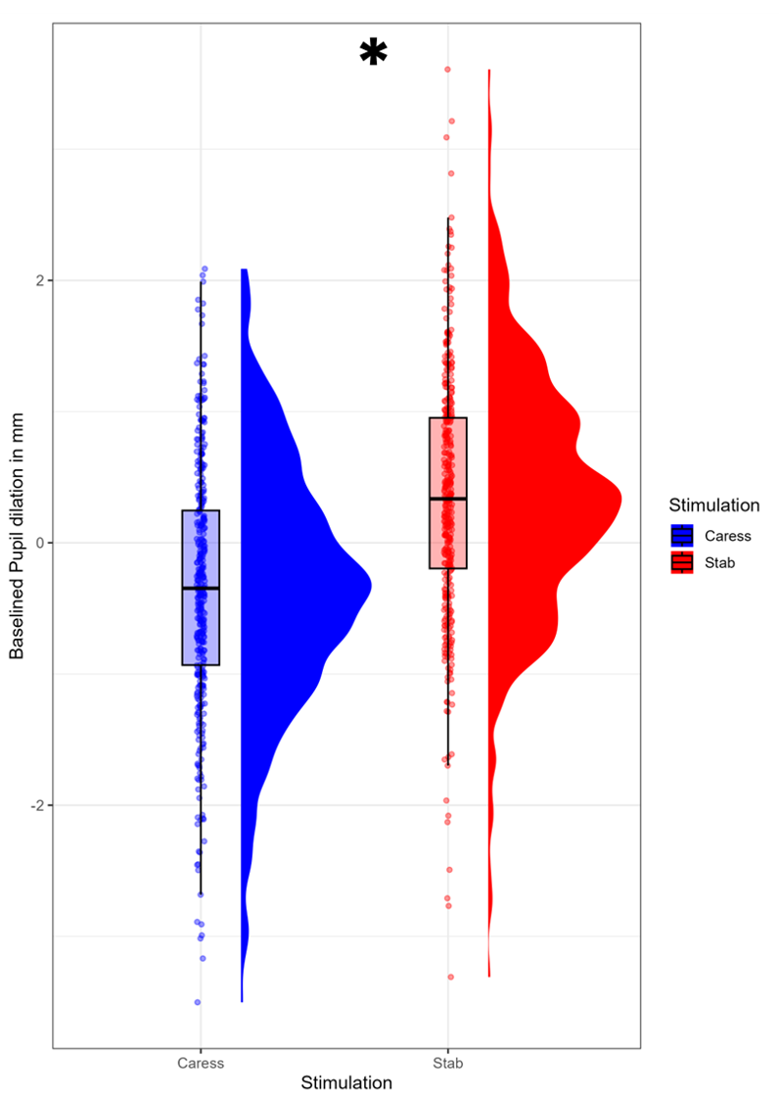
Fig.S2 Pupil dilation during the touch task was higher for the stabs compared to the caresses.

Tab.S1 Demographic characteristics of the sample
Variable | Mean | SD
Age | 24.38 | 2.05
STAI-T | 46.23 | 7.56
STAI-S | 35.48 | 5.78
Virtual Reality Prior Experience (0-100) | 22.30 | 29.78
Resting RMSSD (pre-touch task) | 33.20 | 17.81
High-Frequency n.u. (pre-touch task) | 35.97 | 19.00

Tab.S2 Questions during the Touch Task.
Trial-by-trial
Attractiveness | How attractive do you find the avatar you just observed?
Trustworthiness | How trustworthy do you find the avatar you just observed?
UnPleasantness | How unpleasant/pleasant was the stimulus (0= extremely unpleasant; 50=neutral; 100= extremely pleasant)?
Vicariousness | It felt as if the stimulus was applied to my body.
End Block
Body Ownership | It was like I was watching my body
Body Ownership | It was like the virtual body was my body
Body Ownership (Control) | It was like I had more than one body
Body Ownership (Control) | It was like I had not my body anymore

Tab.S3 Avatar validation
59 participants (30 females, mean age = 27.67±2.73) rated multiple dimensions regarding the avatars’ appearance on 0-100 visual analogue scales. In order to assign one male and one female avatar to each type of touch, we selected the most similar in terms of perceived age: Female_Adult_07, Female_Adult_09, Male_Adult_02, Male_Adult_20.

AvatarID | Age | Gender (0=M, 100=F) | Eurocentrism | Attractiveness | Trustworthiness | Valence (0=Negative, 100= Positive)
F01 | 32.12 ± 5.72 | 95.78 ± 9.51 | 84.98 ± 21.87 | 65.93 ± 18.56 | 59.27 ± 18.14 | 62.58 ± 16.48
F04 | 29.14 ± 4.28 | 96.92 ± 7.82 | 81.34 ± 23.03 | 66.54 ± 21.17 | 54.15 ± 18.93 | 58.78 ± 18.32
F07 | 36.49 ± 8.69 | 94.12 ± 11.27 | 81.51 ± 24.23 | 55.46 ± 19.43 | 60.64 ± 18.07 | 58.56 ± 15.93
F09 | 39.10 ± 6.45 | 96.36 ± 8.41 | 81.80 ± 24.22 | 54.07 ± 20.79 | 55.34 ± 19.58 | 54.03 ± 16.51
F14 | 47.24 ± 8.58 | 96.71 ± 8.37 | 84.95 ± 20.43 | 49.36 ± 19.68 | 67.03 ± 17.46 | 61.02 ± 15.68
M01 | 31.27 ± 5.73 | 3.73 ± 13.11 | 79.63 ± 25.47 | 46.05 ± 25.93 | 54.12 ± 20.32 | 55.93 ± 14.05
M02 | 41.03 ± 6.74 | 3.22 ± 6.87 | 81.58 ± 21.93 | 33.14 ± 20.98 | 52.42 ± 17.54 | 52.41 ± 14.79
M11 | 37.29 ± 6.96 | 3.47 ± 6.94 | 79.41 ± 27.83 | 30.88 ± 21.48 | 47.49 ± 22.86 | 50.69 ± 15.59
M16 | 36.15 ± 7.59 | 2.51 ± 5.28 | 81.80 ± 27.86 | 40.80 ± 24.90 | 55.51 ± 19.44 | 55.53 ± 16.15
M20 | 41.41 ± 6.40 | 2.41 ± 6.45 | 81.19 ± 23.42 | 39.37 ± 23.14 | 54.58 ± 20.10 | 53.36 ± 15.48

Trial-by-trial changes in Attractiveness and Trustworthiness.
To investigate trial-by-trial changes in Attractiveness and Trustworthiness during the touch task, we fit two linear mixed-effect models with the interaction between Stimulation and Trial, and the effect of (Un)Pleasantness as predictors, and by-Stimulation slopes and by-participant intercepts as random effects. For Attractiveness, we found weak evidence for a decrease over trials for the stabbing agents (-0.04± 0.02 [-0.08, -0.002], pd= 94.65%) nor for the caressing agents (-0.01± 0.02 [-0.05, 0.03], pd= 67.11%). Attractiveness change was not sustained in the subsequent interpersonal distance task (see main text). For Trustworthiness, we found no evidence of trial-by-trial change during the touch task for either the stabbing (-0.007± 0.01 [-0.03, 0.02], pd= 69.07%) nor caressing agents (0.004± 0.01 [-0.02, 0.03], pd= 60.51%). Conversely, trustworthiness change emerged in the subsequent interpersonal distance task (see main text).
Tab.S4 Syntax for all models.
Task | Model Formula | Family (link) | Priors
IPD | Attractiveness_sc ~ 1 + Session*Stimulation+ (1 + Stimulation||ID) | Gaussian | Fixed effects β ~ Normal(0, 1);  Intercept ~ Student_t (3, 0.1., 2.5);  Random-effects SDs ~ half-Student (3, 0, 2.5);  Residual SD ~ half- Student (3, 0, 2.5)
IPD | Δ Attractiveness_sc ~ 1 + Stimulation*UnPleasantness_sc + (1 + Stimulation||ID) | Student | Fixed effects β ~ Normal(0, 1);  Intercept ~ Student_t (3, 0.1., 2.5);  Likelihood df (nu) ~ Gamma (2, 0.1.), lower-bounded at 1;  Random-effects SDs ~ half-Student (3, 0, 2.5);  Residual SD ~ half- Student (3, 0, 2.5)
IPD | Trustworthiness_sc ~ 1 + Session*Stimulation+ (1 + Stimulation||ID) | Gaussian | Fixed effects β ~ Normal(0, 1);  Intercept ~ Student_t (3, 0.1., 2.5);  Likelihood df (nu) ~ Gamma (2, 0.1.), lower-bounded at 1;  Random-effects SDs ~ half-Student (3, 0, 2.5);  Residual SD ~ half- Student (3, 0, 2.5)
IPD | Δ Trustworthiness _sc ~ 1 + Stimulation*UnPleasantness_sc + (1 + Stimulation||ID) | Student | Fixed effects β ~ Normal(0, 1);  Intercept ~ Student_t (3, 0.1., 2.5);  Likelihood df (nu) ~ Gamma (2, 0.1.), lower-bounded at 1;  Random-effects SDs ~ half-Student (3, 0, 2.5);  Residual SD ~ half- Student (3, 0, 2.5)
IPD | IPD_sc ~ 1 + Session*Stimulation + STAI_Trait_sc + STAI_State_sc+ (1+Stimulation|ID) | Student | Fixed effects β ~ Normal(0, 1);  Intercept ~ Student_t (3, -0.1, 2.5);  Likelihood df (nu) ~ Gamma (2, 0.1.), lower-bounded at 1;  Random-effects SDs ~ half-Student (3, 0, 2.5);  Random-effects Cor ~ LKJ(1) on Cholesky factor  Residual SD ~ half- Student (3, 0, 2.5)
IPD | Δ IPD _sc ~ 1 + Stimulation*UnPleasantness_sc + STAI_Trait_sc + STAI_State_sc + (1 + Stimulation||ID) | Student | Fixed effects β ~ Normal(0, 1);  Intercept ~ Student_t (3, -0.2., 2.5);  Likelihood df (nu) ~ Gamma (2, 0.1.), lower-bounded at 1;  Random-effects SDs ~ half-Student (3, 0, 2.5);  Residual SD ~ half- Student (3, 0, 2.5)
IPD | HR_sc ~ 1 + Session*Stimulation + STAI_Trait_sc + STAI_State_sc+ (1+Stimulation|ID) | Student | Fixed effects β ~ Normal(0, 1);  Intercept ~ Student_t (3, 0, 2.5);  Likelihood df (nu) ~ Gamma (2, 0.1.), lower-bounded at 1;  Random-effects SDs ~ half-Student (3, 0, 2.5);  Random-effects Cor ~ LKJ(1) on Cholesky factor  Residual SD ~ half- Student (3, 0, 2.5)
IPD | Δ HR _sc ~ 1 + Stimulation*UnPleasantness_sc + STAI_Trait_sc + STAI_State_sc + (1 + Stimulation||ID) | Student | Fixed effects β ~ Normal(0, 1);  Intercept ~ Student_t (3, -0.2., 2.5);  Likelihood df (nu) ~ Gamma (2, 0.1.), lower-bounded at 1;  Random-effects SDs ~ half-Student (3, 0, 2.5);  Residual SD ~ half- Student (3, 0, 2.5)
IPD | SCR_sc ~ 1 + Session*Stimulation + STAI_Trait_sc + STAI_State_sc+ (1+Stimulation|ID) | Student | Fixed effects β ~ Normal(0, 1);  Intercept ~ Student_t (3, -0.3, 2.5);  Likelihood df (nu) ~ Gamma (2, 0.1.), lower-bounded at 1;  Random-effects SDs ~ half-Student (3, 0, 2.5);  Random-effects Cor ~ LKJ(1) on Cholesky factor  Residual SD ~ half- Student (3, 0, 2.5)
IPD | Δ SCR_sc ~ 1 + Stimulation*UnPleasantness_sc + STAI_Trait_sc + STAI_State_sc + (1 + Stimulation||ID) | student | Fixed effects β ~ Normal(0, 1);  Intercept ~ Student_t (3, 0.2., 2.5);  Likelihood df (nu) ~ Gamma (2, 0.1.), lower-bounded at 1;  Random-effects SDs ~ half-Student (3, 0, 2.5);  Residual SD ~ half- Student (3, 0, 2.5)
IPD | Elog_sc ~ 1 + Session * Stimulation * TimeWindow + STAI_Trait_sc + STAI_State_sc + (1 + Stimulation | ID) | Student | Fixed effects β ~ Normal(0, 1);  Intercept ~ Student_t (3, 0.2, 2.5);  Likelihood df (nu) ~ Gamma (2, 0.1.), lower-bounded at 1;  Random-effects SDs ~ half-Student (3, 0, 2.5);  Random-effects Cor ~ LKJ(1) on Cholesky factor  Residual SD ~ half- Student (3, 0, 2.5)
IPD | Elog_sc ~ 1 + Stimulation * TimeWindow * UnPleasantness_sc + (1 + Stimulation || ID) | Gaussian | Fixed effects β ~ Normal(0, 1);  Intercept ~ Student_t (3, -0.1., 2.5);  Random-effects SDs ~ half-Student (3, 0, 2.5);  Residual SD ~ half- Student (3, 0, 2.5)
Mouse Tracking | MAD_sc ~ 1 + Session*Condition + (1|ID) + (1|stim) | Student | Fixed effects β ~ Normal(0, 1);  Intercept ~ Student_t (3, -0.3., 2.5);  Likelihood df (nu) ~ Gamma (2, 0.1.), lower-bounded at 1;  Random-effects SDs ~ half-Student (3, 0, 2.5);  Residual SD ~ half- Student (3, 0, 2.5)
Mouse Tracking | AUC_sc ~ 1 + Session*Condition + (1|ID) + (1|stim) | Student | Fixed effects β ~ Normal(0, 1);  Intercept ~ Student_t (3, -0.3., 2.5);  Likelihood df (nu) ~ Gamma (2, 0.1.), lower-bounded at 1;  Random-effects SDs ~ half-Student (3, 0, 2.5);  Residual SD ~ half- Student (3, 0, 2.5)
Mouse Tracking | RT_sc ~ 1 + Session*Condition + (1|ID) + (1|stim) | Student | Fixed effects β ~ Normal(0, 1);  Intercept ~ Student_t (3, -0.3., 2.5);  Likelihood df (nu) ~ Gamma (2, 0.1.), lower-bounded at 1;  Random-effects SDs ~ half-Student (3, 0, 2.5);  Residual SD ~ half- Student (3, 0, 2.5)
Touch | UnPleasantness_sc ~ 1 + Stimulation + STAI_Trait_sc+ STAI_State_sc+ Stimulation * VR_Experience_sc+ (1+ Stimulation|ID) | Gaussian | Fixed effects β ~ Normal(0, 1);  Intercept ~ Student_t (3, 0.1, 2.5);  Random-effects SDs ~ half-Student (3, 0, 2.5);  Random-effects Cor ~ LKJ(1) on Cholesky factor  Residual SD ~ half- Student (3, 0, 2.5)
Touch | Vicariousness_sc ~ 1 + Stimulation + STAI_Trait_sc+ STAI_State_sc+ Stimulation * VR_Experience_sc+ (1+ Stimulation|ID) | Gaussian | Fixed effects β ~ Normal(0, 1);  Intercept ~ Student_t (3, -0.1, 2.5);  Random-effects SDs ~ half-Student (3, 0, 2.5);  Random-effects Cor ~ LKJ(1) on Cholesky factor  Residual SD ~ half- Student (3, 0, 2.5)
Touch | SCR_sc ~ 1 + Stimulation + STAI_Trait_sc+ STAI_State_sc+ (1+ Stimulation|ID) | Student | Fixed effects β ~ Normal(0, 1);  Intercept ~ Student_t (3, -0.2, 2.5);  Random-effects SDs ~ half-Student (3, 0, 2.5);  Random-effects Cor ~ LKJ(1) on Cholesky factor  Residual SD ~ half- Student (3, 0, 2.5)
Touch | HR1 + Stimulation + STAI_Trait_sc+ STAI_State_sc+ (1+ Stimulation|ID) | Student | Fixed effects β ~ Normal(0, 1);  Intercept ~ Student_t (3, 0, 2.5);  Random-effects SDs ~ half-Student (3, 0, 2.5);  Random-effects Cor ~ LKJ(1) on Cholesky factor  Residual SD ~ half- Student (3, 0, 2.5)
Touch | PupilDiameter_sc + Stimulation + STAI_Trait_sc+ STAI_State_sc+ UnPleasantness_sc + Vicariousness_sc + (1+ Stimulation|ID) | Gaussian | Fixed effects β ~ Normal(0, 1);  Intercept ~ Student_t (3, 0, 2.5);  Random-effects SDs ~ half-Student (3, 0, 2.5);  Random-effects Cor ~ LKJ(1) on Cholesky factor  Residual SD ~ half- Student (3, 0, 2.5)
Touch | VAS_sc ~ OwnershipQuestion + (1+Item|ID) | Gaussian | Fixed effects β ~ Normal(0, 1);  Intercept ~ Student_t (3, -0.1, 2.5);  Random-effects SDs ~ half-Student (3, 0, 2.5);  Random-effects Cor ~ LKJ(1) on Cholesky factor  Residual SD ~ half- Student (3, 0, 2.5)
Touch | Attractiveness_sc ~ Stimulation*Trial + UnPleasantness_sc+ (1+Stimulation+ Trial|ID) | Gaussian | Fixed effects β ~ Normal(0, 1);  Intercept ~ Student_t (3, -0.1, 2.5);  Random-effects SDs ~ half-Student (3, 0, 2.5);  Random-effects Cor ~ LKJ(1) on Cholesky factor  Residual SD ~ half- Student (3, 0, 2.5)
Touch | Trustworthiness_sc ~ Stimulation*Trial + UnPleasantness_sc+ (1+Stimulation+ Trial|ID) | Gaussian | Fixed effects β ~ Normal(0, 1);  Intercept ~ Student_t (3, -0.1, 2.5);  Random-effects SDs ~ half-Student (3, 0, 2.5);  Random-effects Cor ~ LKJ(1) on Cholesky factor  Residual SD ~ half- Student (3, 0, 2.5)

