SUPPLEMENTARY MATERIAL
Fig. S1 Experimental treatments and replication
T0  (21 cuttings) |  |  |  |  | B1  (21 cuttings) |  |  |  |  | B2  (21 cuttings)
3  7 cuttings | 2  7 cuttings |  | 1  7 cuttings |  | 1  7 cuttings | 2  7 cuttings |  | 3  7 cuttings |  | 3  7 cuttings | 2  7 cuttings |  | 1  7 cuttings
T30  (21 cuttings) |  |  |  |  | B24  (21 cuttings) |  |  |  |  | T4  (21 cuttings)
2  7 cuttings | 3  7 cuttings |  | 1  7 cuttings |  | 3  7 cuttings | 1  7 cuttings |  | 2  7 cuttings |  | 3  7 cuttings | 2  7 cuttings |  | 1  7 cuttings
B4  (21 cuttings) |  |  |  |  | T1  (21 cuttings) |  |  |  |  | B30  (21 cuttings)
1  7 cuttings | 2  7 cuttings |  | 3  7 cuttings |  | 3  7 cuttings | 1  7 cuttings |  | 2  7 cuttings |  | 1  7 cuttings | 3  7 cuttings |  | 2  7 cuttings
T2  (21 cuttings) |  |  |  |  | B0  (21 cuttings) |  |  |  |  | T24  (21 cuttings)
3  7 cuttings | 2  7 cuttings |  | 1  7 cuttings |  | 1  7 cuttings | 2  7 cuttings |  | 3  7 cuttings |  | 3  7 cuttings | 1  7 cuttings |  | 2  7 cuttings
T Rooting  24 cuttings |  |  |  |  |  |  | B rooting  24 cuttings
1  8 cuttings |  | 2  8 cuttings |  | 3  8 cuttings |  |  | 3  8 cuttings |  | 2  8 cuttings |  |  | 1  8 cuttings
Table S1 Percentage of recovery during the extraction of phytohormones in Prunus subhirtella ‘Autumnalis’
Coumpound | % of Recovery (Mean)
IAA | 80,85
4-Cl-IAA | 81,00
IBA | 74,64
IAA-Asp | 52,92
IAA-Glu | 59,00
Ox-IAA | 91,70
Ox-IAA-Asp | 44,20
JA | 75,00
JA-Ile | 77,70
Indole-3-acetic acid (IAA), Indole-3-butyric acid (IBA), 4-chloro-indole-3-acetic acid (4-Cl-IAA), Indole-3-acetyl-aspartic acid (IAA-Asp), Indole-3-acetyl-glutamic acid (IAA-Glu), Oxindole-3-acetic acid (ox-IAA), 2-Oxindole-3- acetyl-aspartic acid (ox-IAA-Asp), Jasmonic acid (JA), Jasmonoyl-isoleucine (JA-Ile)
Table S2 Changes in phytohormone content depending on cutting type and time after severance
Type of cutting | Time after severance | IAA (ng g⁻¹ DW ± SE) | 4-Cl-IAA (ng g⁻¹ DW ± SE) | IBA (ng g⁻¹ DW ± SE) | IAA-Asp (ng g⁻¹ DW ± SE)
Basal | 0 min | 11.39±3.46 c | 438.74±86.79 c | 15.77±6.22 d | 19.85±1.66 a
Basal | 30 min | 9.74±1.28 c | 1097.12±244.24 bc | 73.06±2.59 ab | 15.48±5.75 b
Basal | 1 hour | 13.20±4.06 c | 2283.73±122.46 ab | 80.68±7.03 a | 33.40±5.92 b
Basal | 2 hours | 55.49±12.91 ab | 2553.58±707.82 a | 60.83±3.27 bc | 162.54±15.43 b
Basal | 4 hours | 79.93±20.39 a | 2016.07±494.59 ab | 68.97±5.89 abc | 674.29±242.76 b
Basal | 24 hours | 26.41±8.08 bc | 0.00±0.00 c | 53.48±1.78 c | 141.38±44.89 b
Terminal | 0 min | 16.43±4.75 c | 3562.76±529.14 a | 16.01±5.25 b | 91.86±9.70 a
Terminal | 30 min | 26.31±8.97 bc | 1720.19±29.24 b | 82.75±8.61 a | 71.43±15.13 a
Terminal | 1 hour | 18.01±4.06 c | 1185.22±115.63 bc | 82.86±11.27 a | 87.19±5.13 b
Terminal | 2 hours | 57.49±12.15 ab | 576.48±158.88 cd | 60.50±5.59 a | 338.59±110.41 b
Terminal | 4 hours | 61.00±18.28 a | 801.13±88.12 cd | 23.40±12.19 b | 506.16±145.18 b
Terminal | 24 hours | 46.03±6.71 abc | 123.25±24.49 d | 7.10±3.55 b | 7.30±7.30 b
 |  | IAA-Glu (ng g⁻¹ DW ± SE) | Ox-IAA (ng g⁻¹ DW ± SE) | Ox-IAA-Asp (ng g⁻¹ DW ± SE)
Basal | 0 min | 78.35±3.69 a | 12.54±0.94 ab | 1.60±0.14 b
Basal | 30 min | 75.80±3.53 a | 14.44±0.10 a | 2.48±0.24 ab
Basal | 1 hour | 48.09±15.25 ab | 9.60±0.44 cd | 2.58±1.35 ab
Basal | 2 hours | 48.69±19.57 ab | 11.34±0.52 bc | 0.93±0.20 b
Basal | 4 hours | 25.39±4.31 b | 10.70±1.15bc | 1.64±1.13 b
Basal | 24 hours | 50.66±13.66 ab | 7.87±1.35 d | 4.50±0.45 a
Terminal | 0 min | 151.99±12.06 a | 23.94±1.24 b | 3.87±0.84 abc
Terminal | 30 min | 66.15±0.96 b | 86.37±34.72 a | 4.41±0.33 a
Terminal | 1 hour | 68.19±3.76 b | 74.30±14.39 a | 4.22±0.92 ab
Terminal | 2 hours | 54.24±0.87 bc | 15.56±0.82 b | 1.51±0.19 c
Terminal | 4 hours | 43.39±3.24 c | 15.42±2.08 b | 1.81±0.20 bc
Terminal | 24 hours | 22.52±4.84 d | 15.56±0.59 b | 4.92±1.34 a
 |  | JA (ng g⁻¹ DW ± SE) | JA-Ile (ng g⁻¹ DW ± SE)
Basal | 0 min | 289.22±37.97 a | 850.50±149.88 a
Basal | 30 min | 381.12±157.07 a | 530.27±225.26 ab
Basal | 1 hour | 179.59±16.08 a | 130.07±56.82 c
Basal | 2 hours | 200.23±21.52 a | 48.54±12.15 c
Basal | 4 hours | 433.78±119.10 a | 30.75±9.55 c
Basal | 24 hours | 303.24±40.44 a | 366.21±40.76 bc
Terminal | 0 min | 747.98±73.35 a | 465.20±38.51 a
Terminal | 30 min | 148.76±25.21 b | 82.79±11.66 b
Terminal | 1 hour | 195.18±30.06 b | 85.27±23.56 b
Terminal | 2 hours | 197.19±7.93 b | 68.08±51.61 b
Terminal | 4 hours | 167.85±40.43 b | 59.52±14.90 b
Terminal | 24 hours | 240.91±55.22 b | 151.48±100.21 b
Indole-3-acetic acid (IAA), Indole-3-butyric acid (IBA), 4-chloro-indole-3-acetic acid (4-Cl-IAA), Indole-3-acetyl-aspartic acid (IAA-Asp), Indole-3-acetyl-glutamic acid (IAA-Glu), Oxindole-3-acetic acid (ox-IAA), 2-Oxindole-3-acetyl-aspartic acid (ox-IAA-Asp), Jasmonic acid (JA), Jasmonoyl-isoleucine (JA-Ile), (n=3)
The different lowercase letters in the same columns indicate significant difference (p < 0.05), (ANOVA, n=3).
June
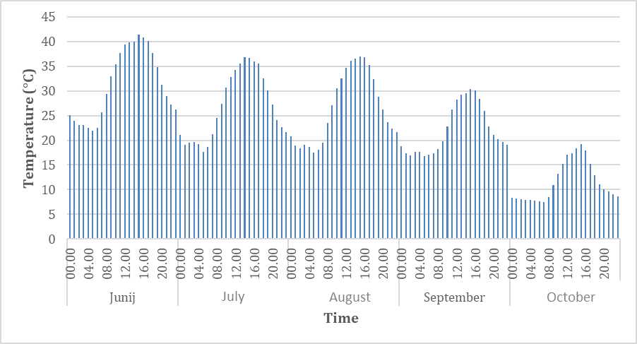
Fig. S2 Average hourly air temperature (° C) measured 3 cm above the leaf lamina during the experimental period
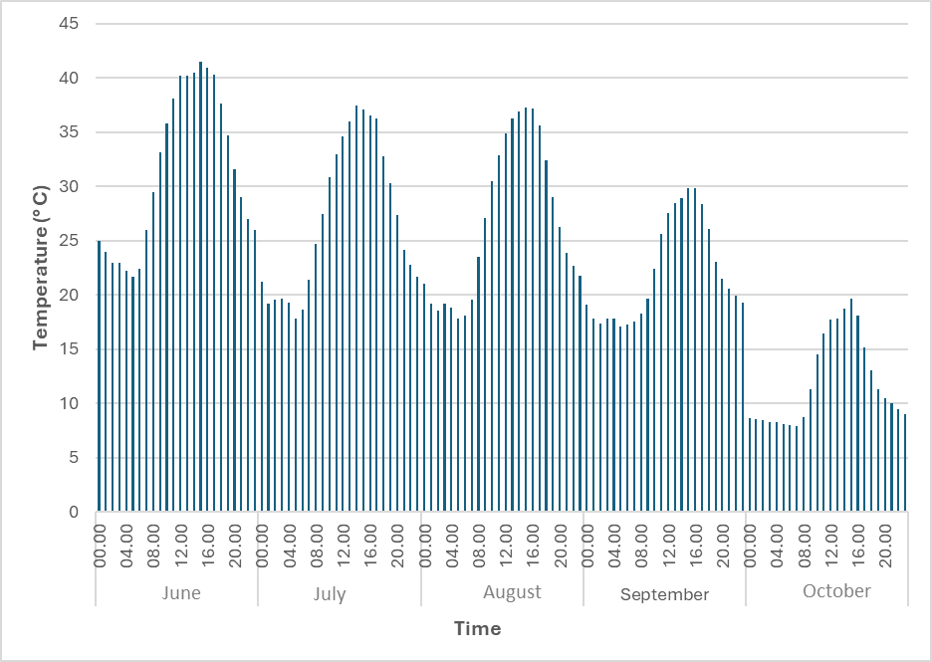
Fig. S3 Average hourly leaf lamina temperature (° C) measured during the experimental period

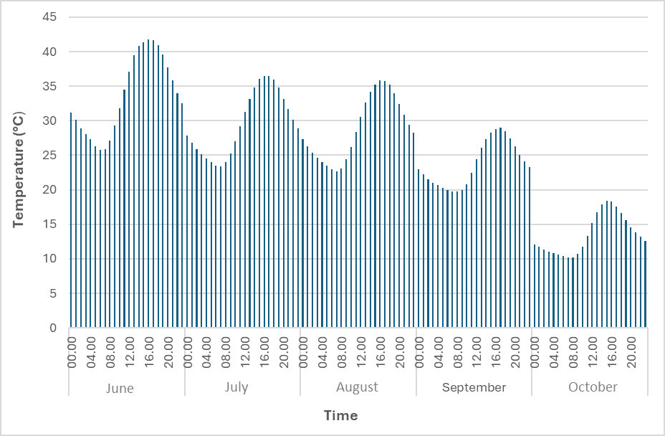
Fig. S4 Average hourly soil temperature (° C) measured during the experimental period

Table S3 Rooting success and callus formation in terminal and basal cuttings
Type of cutting | Successfully rooted cutting | Successfully rooted cutting (%) | Callus formation in successfully rooted cuttings | Callus formation (%) in successfully rooted cuttings
Terminal | 16/24 | 66,67 | 0/24 | 0
Basal | 16/24 | 66,67 | 0/24 | 0

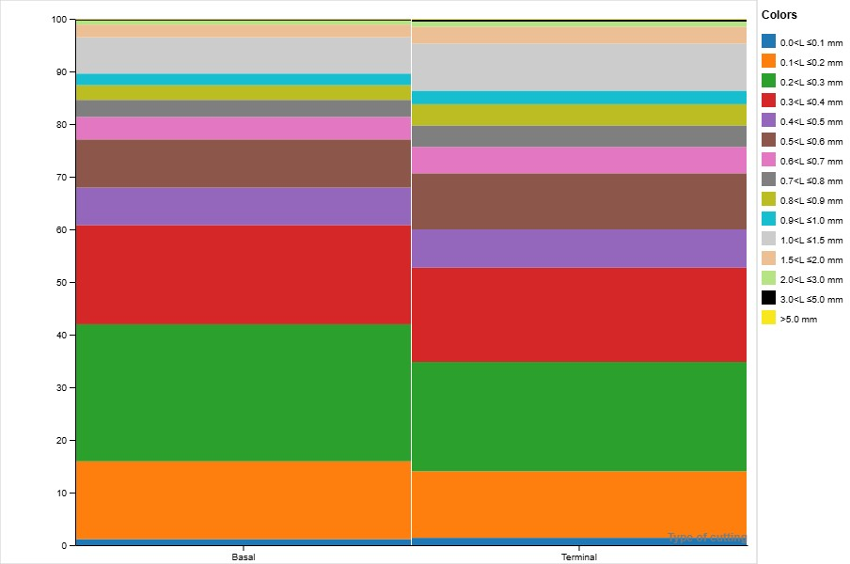
Root length in each root diameter class (%)
Fig. S5 Relative distribution of root length across diameter classes according to cutting type

