Supplementary Figures and Tables

Supplementary Figures

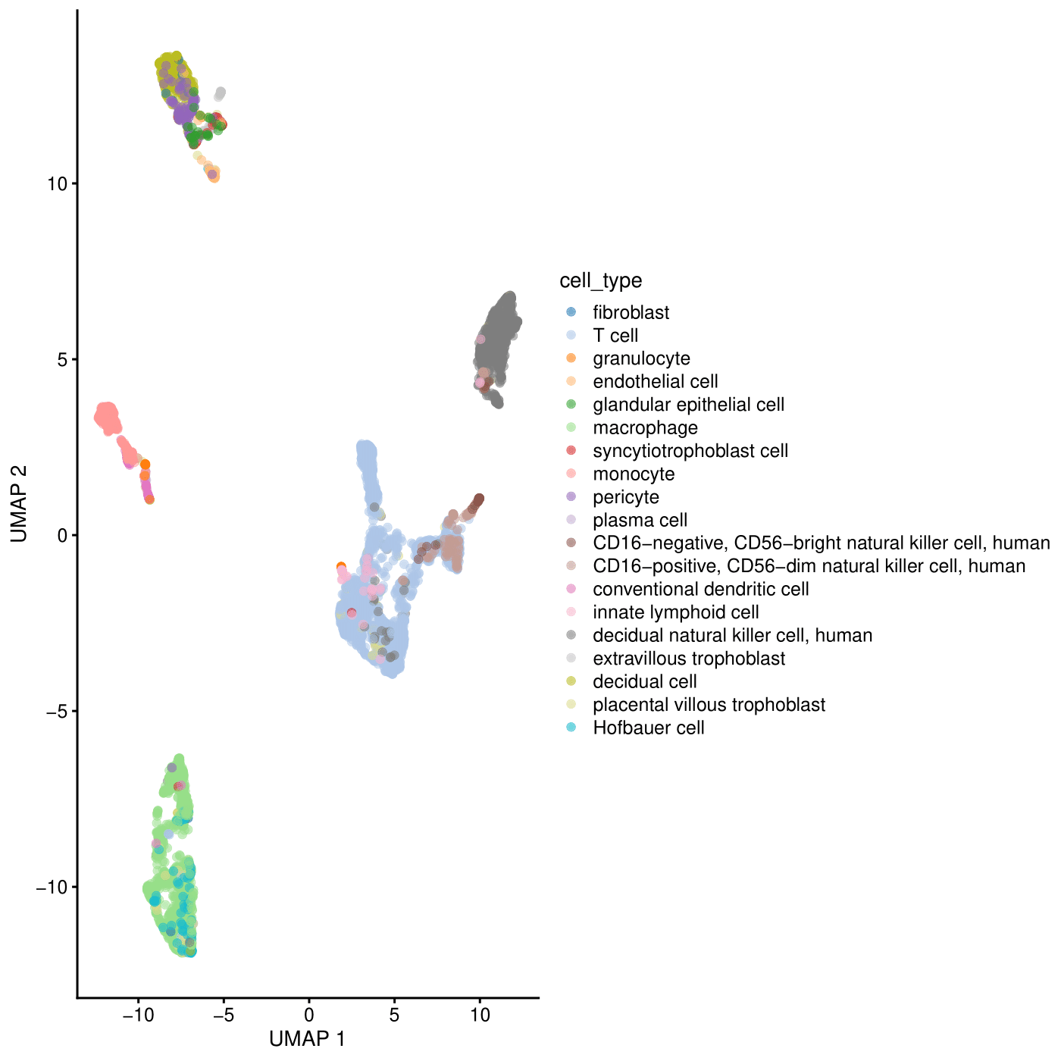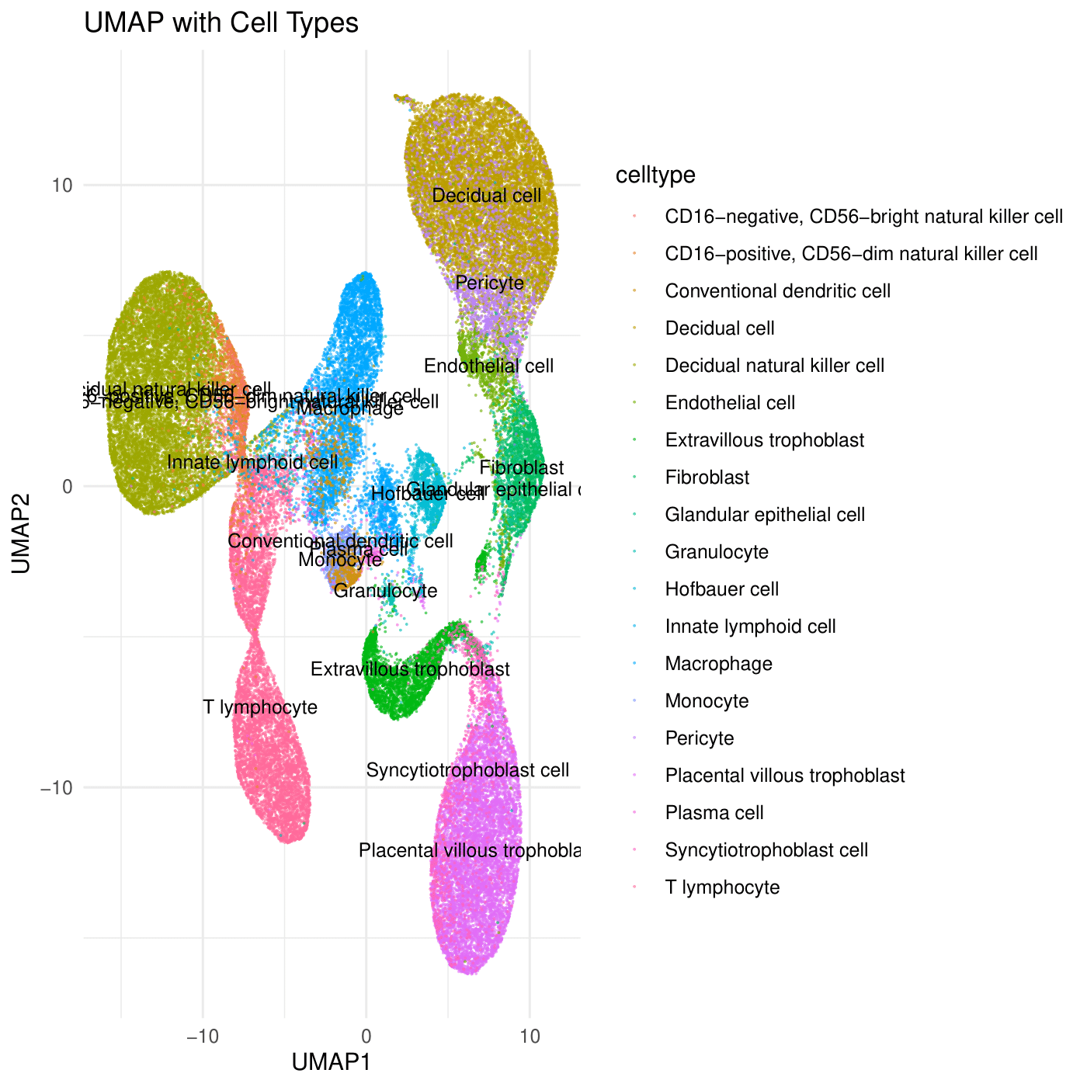

Supplementary Figure 1. UMAPs from Smart-Seq2 (left) and 10x Genomics (right) of endometrial biopsies from interrupted pregnancies. Cell types were defined from reported sub cell-types in studies defined in Table 1 (main manuscript).

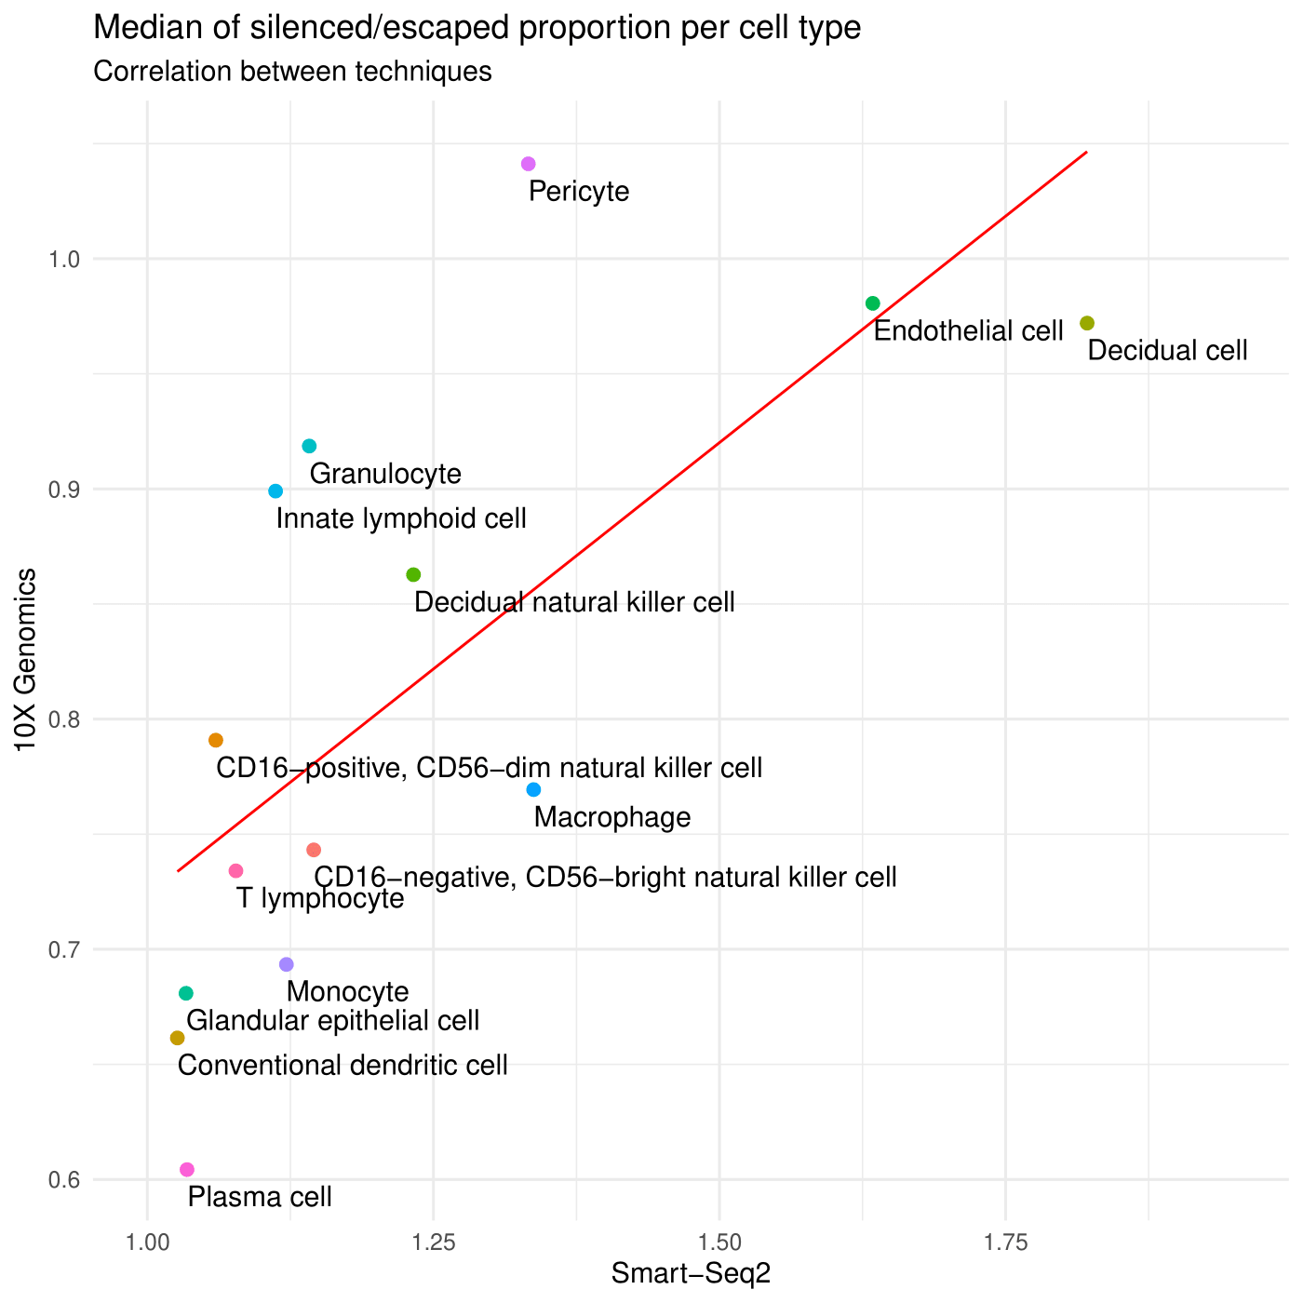

Supplementary Figure 2. Correlation of mean STER across cells of the same cell type obtained from the two independent platforms Smart-Seq2 and 10x Genomics.

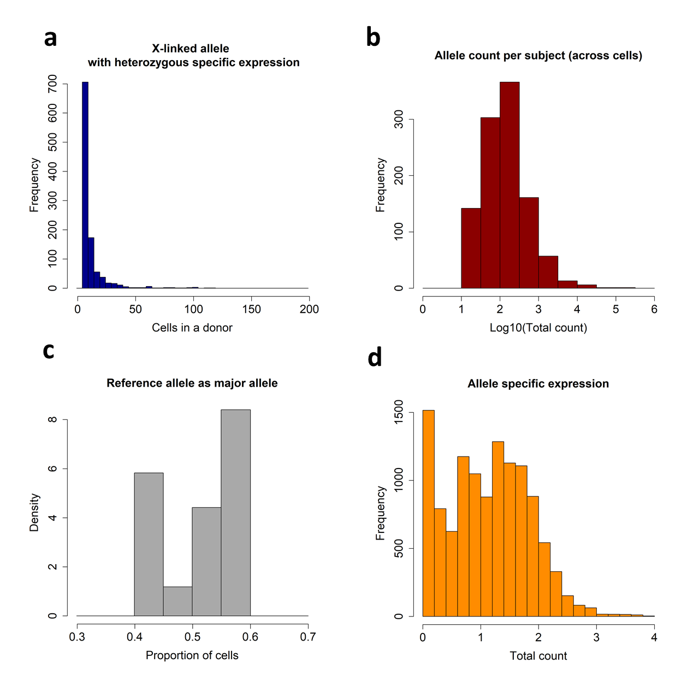

Supplementary Figure 3. Characteristics of filtered allelic specific expression data from endometrial samples over 18 donors. (a) histogram of number of cells observed for a heterozygous allele from contributing donor. Alleles expressed in at least 5 cells were selected for downstream analysis. (b) Counts per allele across the cells of a subject. Alleles with more than 10 counts were selected for downstream analysis. (c) Proportion of cells for which the reference allele is the major expressed allele. Alleles with proven heterozygous expression across the donors’ cells with proportions between 0.4 and 0.6 were selected for downstream analysis. (d) Total counts per allele in a cell. The median of log10(counts)=1.14 (median counts=14) show low allele counts in X-linked genes per cell.

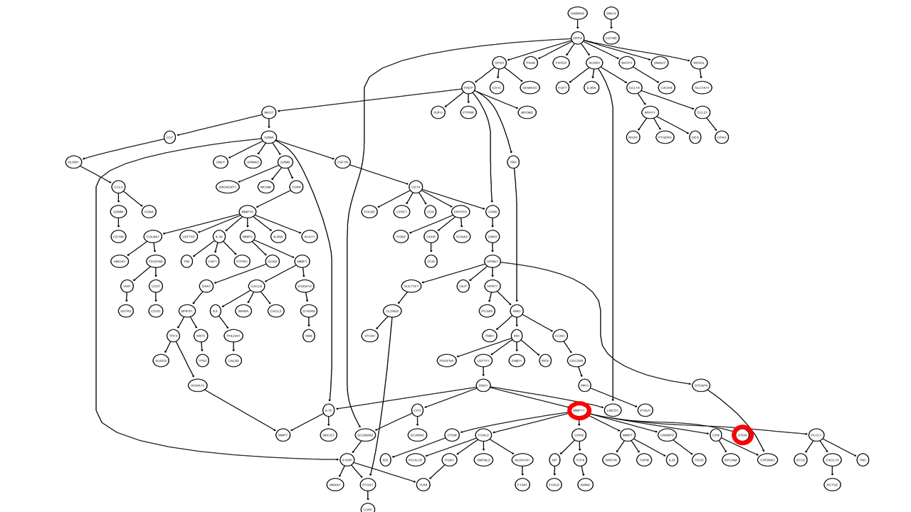

Supplementary Figure 4. Bayesian network analysis for the cell type transcriptomic markers of bulk endometrium samples, including STER. STER variation immediately depends on MMP11 a stromal cell marker involved in tissue remodeling and aggressive cancer.

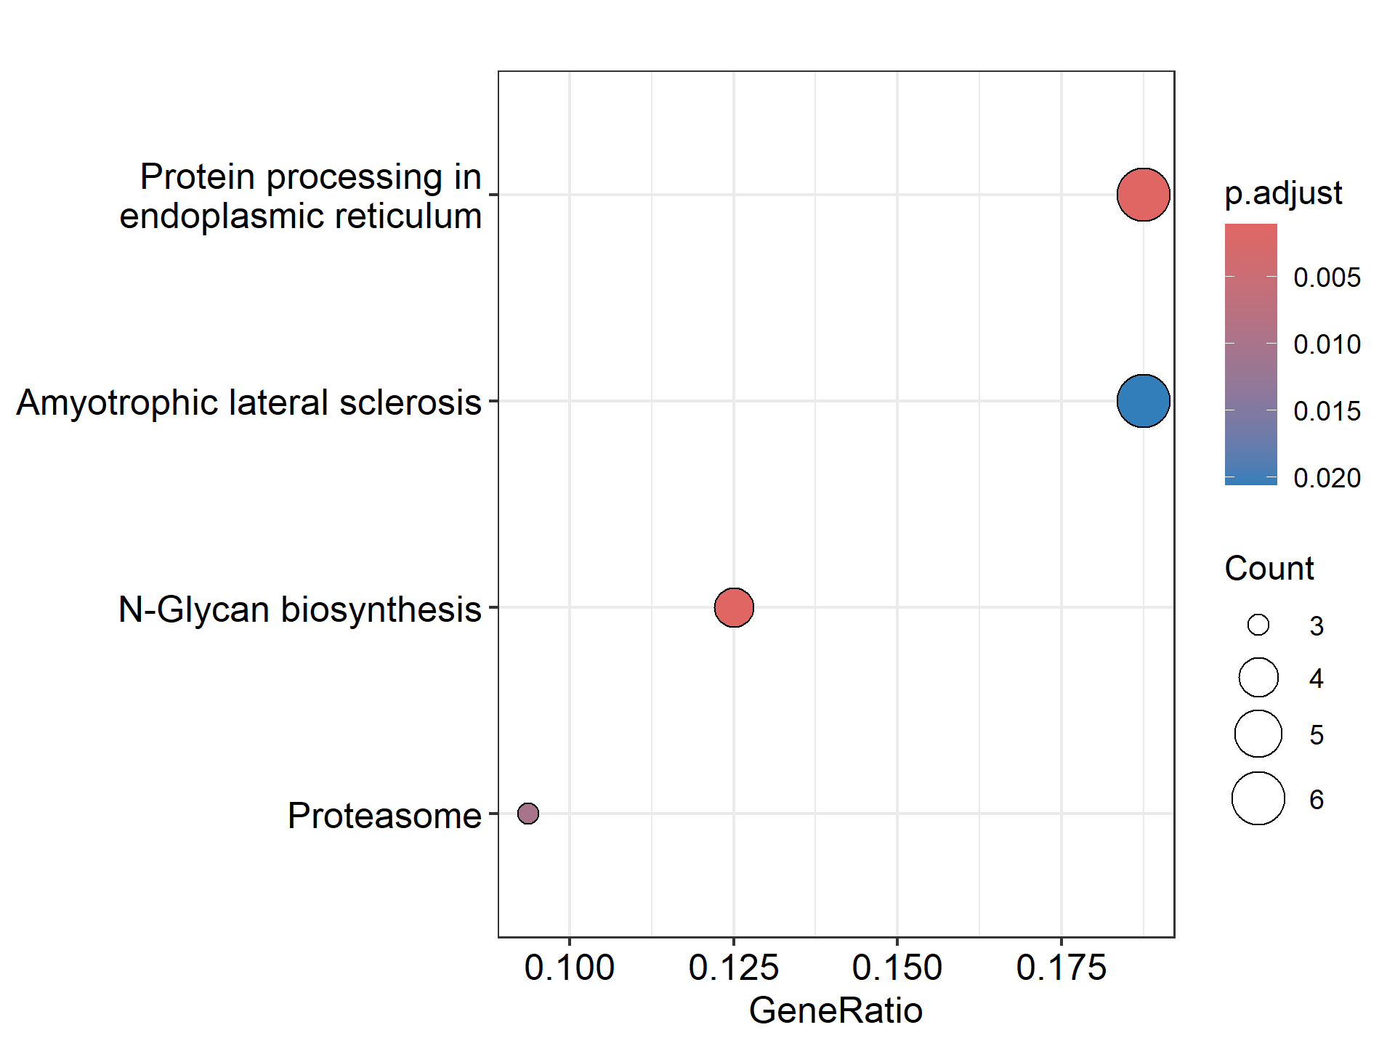

Supplementary Figure 5. Enrichment analysis for genes significantly associated with STER in endometrial bulk samples across the menstrual cycle.

