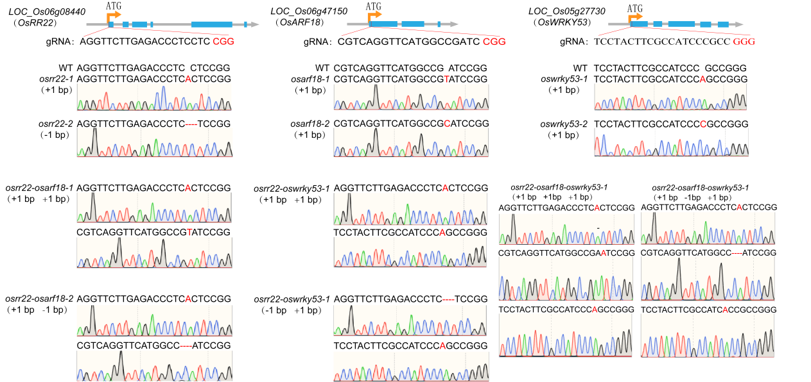
Fig.S1-The gRNAs and their target sites in the transgenic materials were identified via sequencing. The genomic schematics illustrate the design of gRNAs and the two mutation types generated by CRISPR/Cas9 in the wild-type Shuanghui 459 background for OsRR22, OsARF18, and OsWRKY53. The generated mutants included single-gene mutants for each target, double-gene mutants (OsRR22-OsARF18 and OsWRKY53-OsRR22), and the triple-gene mutant (OsRR22-OsARF18-OsWRKY53).
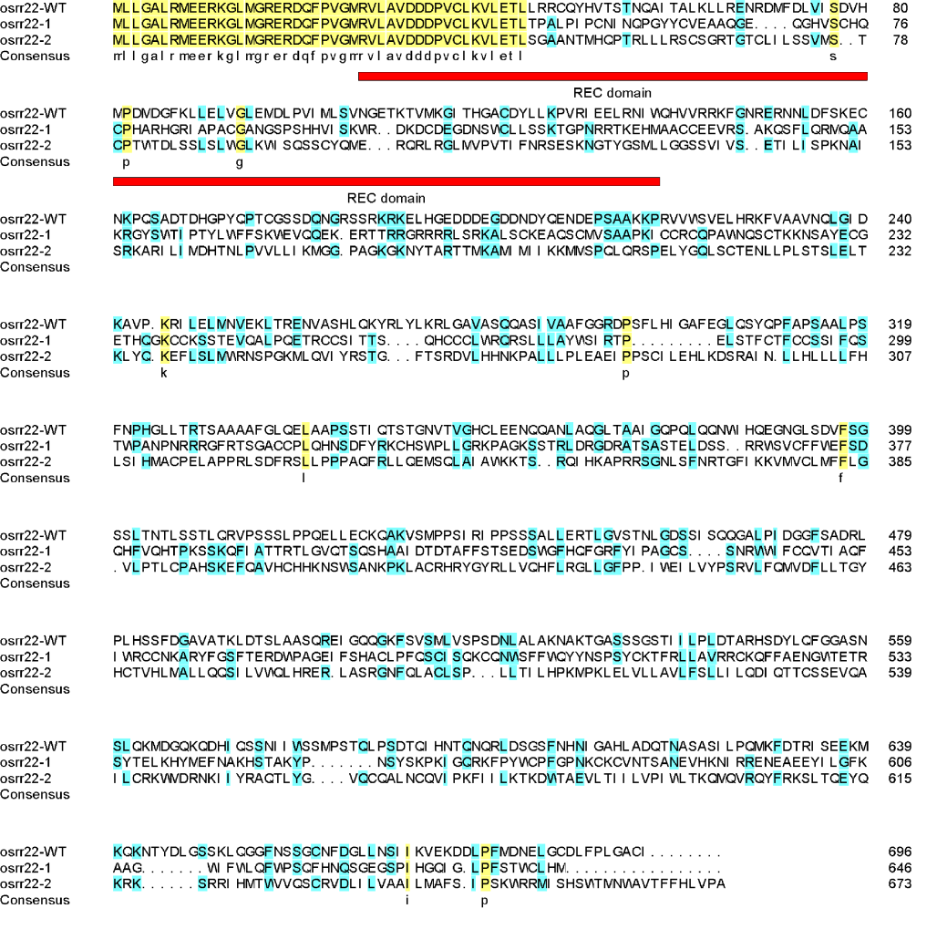
Fig.S2-The amino acid sequence alignment between wild-type OsRR22 and its mutant variants is shown, with the REC domain of OsRR22 indicated by a red line. While the wild-type sequence (osrr22-WT) contains an intact REC domain, mutants osrr22-1 and osrr22-2 (carrying an A insertion and a C deletion, respectively) harbor disruptions within this domain.
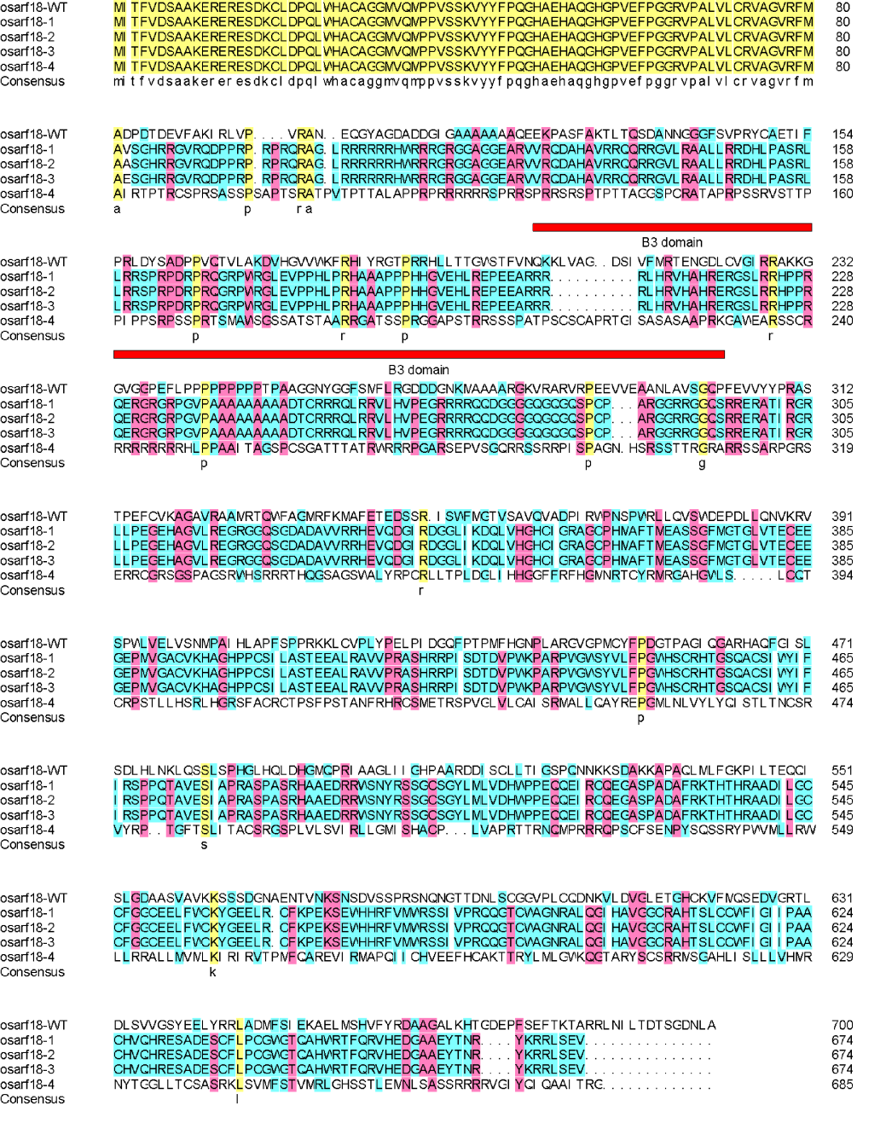
Fig.S3-Amino acid sequence alignment of wild-type OsARF18 and its mutant variants, with the red line denoting the B3 domain. The wild-type sequence (osarf18-WT) contains an intact B3 domain, whereas the mutants osarf18-1 through osarf18-4 harbor insertions (T, C, A) or a deletion (G) that consequently disrupt this domain.
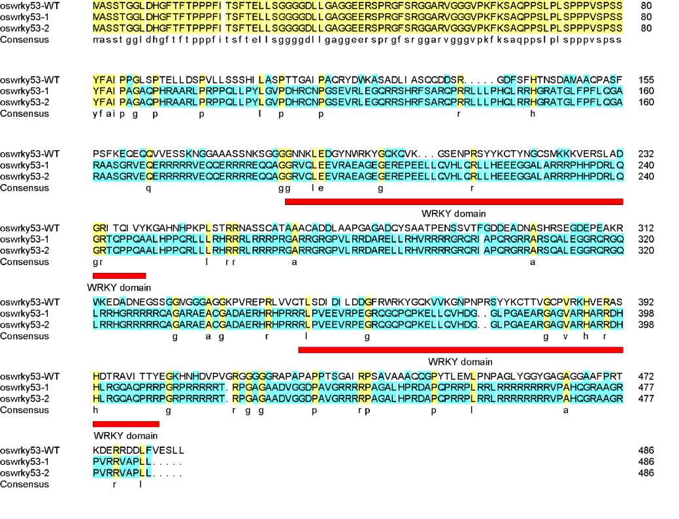
Fig.S4-The amino acid sequence alignment between wild-type OsWRKY53 and its mutant variants is shown, with the WRKY domain indicated by a red line. While the wild-type sequence (oswrky53-WT) possesses an intact WRKY domain, the mutants oswrky53-1 and oswrky53-2 (carrying an A and a C insertion, respectively) harbor disruptions within this domain.
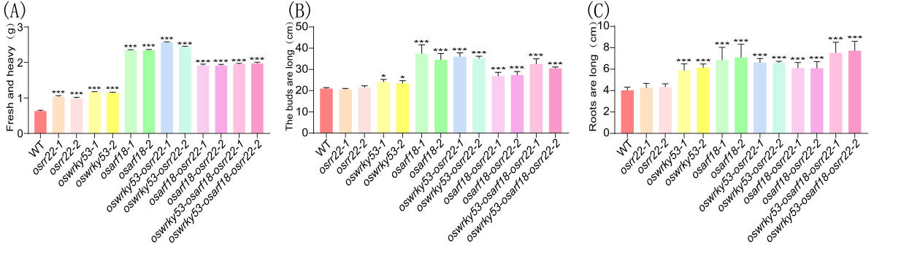
Fig.S5-Phenotypic Characterization of Different Genotypes Under Salt Stress. (A-C) Fresh weight, shoot length, and root length of WT and mutant plants were assessed following a 7-day treatment with 1.0% NaCl and a subsequent 7-day recovery period. The experiment was conducted with three biological replicates, each containing five randomly selected seedlings. Data are presented as mean ± SD (n = 5). Significant differences versus the WT, determined by one-way ANOVA, are indicated (*p < 0.05, ***p < 0.001).
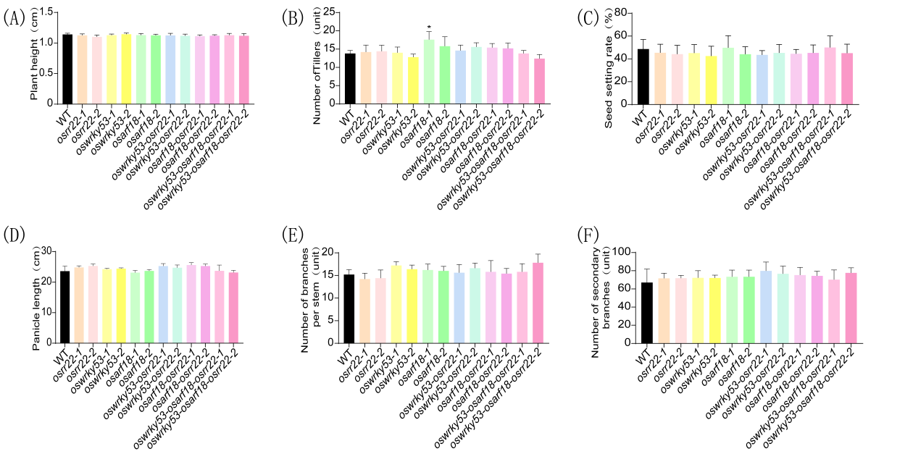
Fig.S6-Phenotypic identification of different genotypes under normal field growth conditions. (A-F) Field phenotypes of WT and mutant plants under normal growth conditions until maturity. Traits evaluated include plant height, tiller number, grain setting rate, spike length, and the number of primary and secondary branches. The experiment was conducted with three biological replicates, each comprising five randomly selected plants. Data are shown as mean ± SD (n = 5). Significant differences versus the WT, determined by one-way ANOVA, are indicated (*p < 0.05).
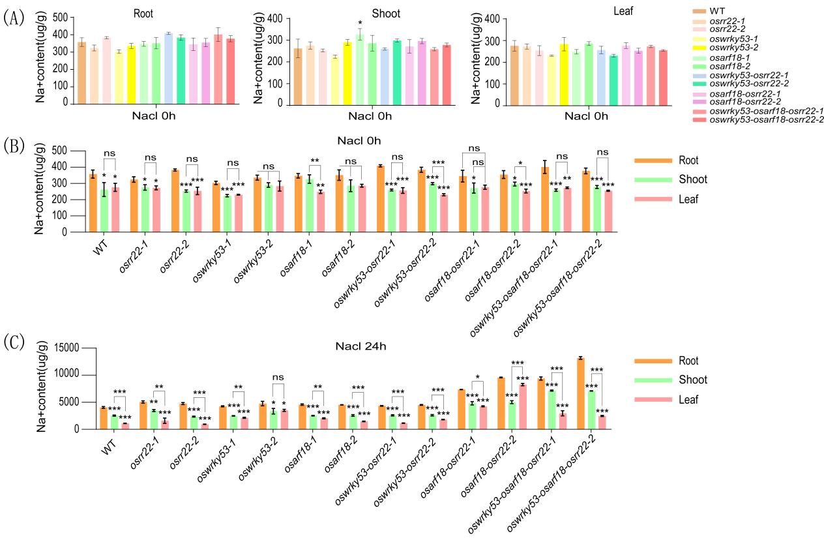
Fig.S7-Quantitative analysis of sodium ion content in different genotypes treated with 1.0% NaCl solution for 0 hours and 30 hours. (A) Na⁺ content in roots, stems, and leaves of individual mutants versus the WT under control (pre‑salt) conditions. (B) Comparative Na⁺ content across all lines (mutants and WT) under control conditions. (C) Comparative Na⁺ content across all lines after 24‑h treatment with 1.0% NaCl. Data are presented as mean ± SD of three biological replicates (n = 3). ns, not significant. Significant differences versus the WT or among all genotypes, determined by one-way ANOVA, are indicated (*p < 0.05, **p < 0.01, ***p < 0.001).
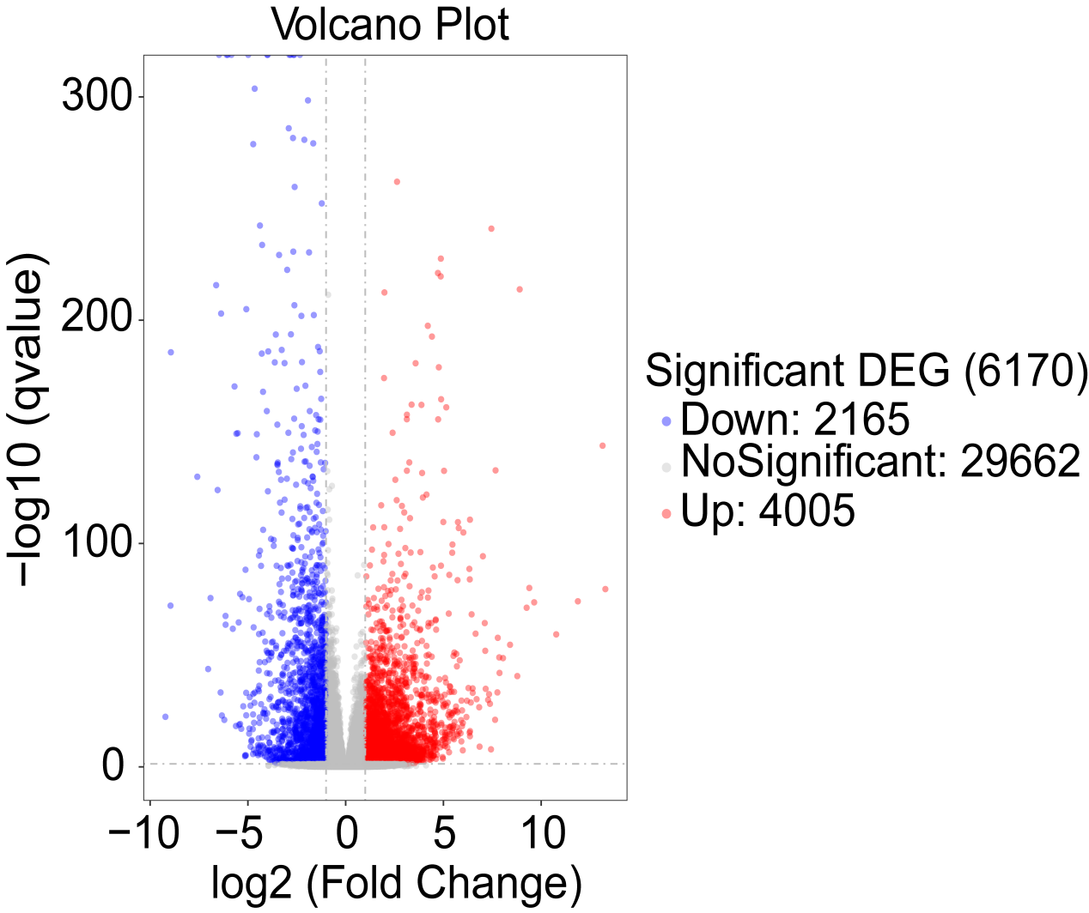
Fig.S8-RNA‑seq analysis revealed the total number of differentially expressed genes (DEGs) in all plants between salt‑stress and normal conditions.

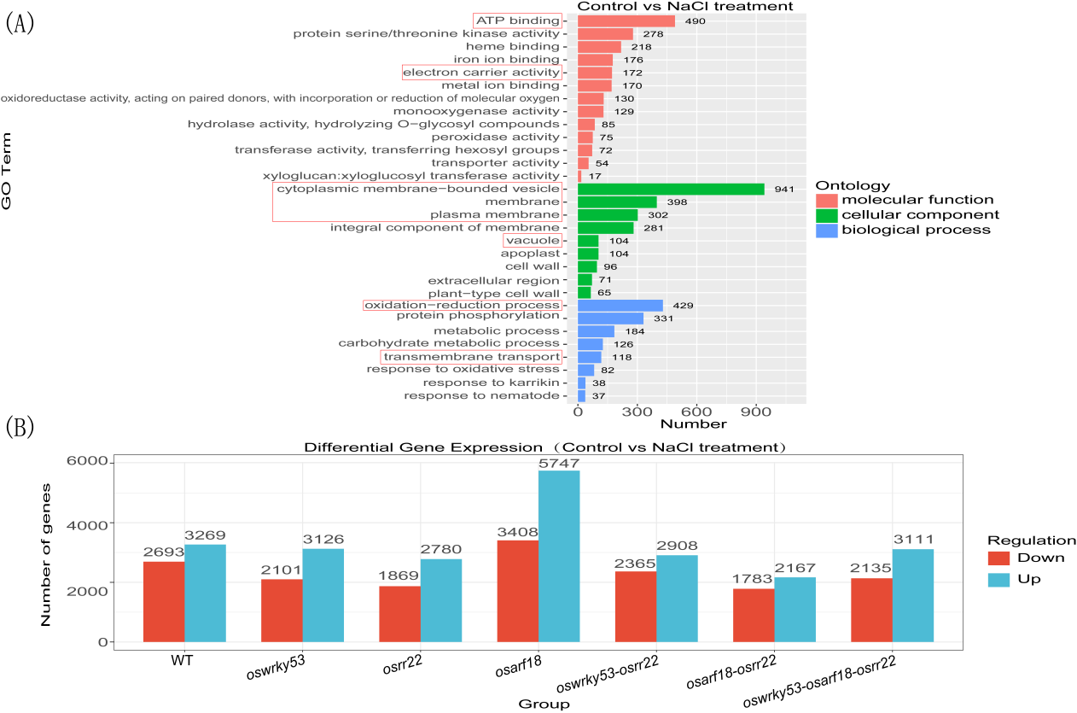
Fig.S9-GO enrichment analysis and differential gene expression analysis of different genotypes under salt stress and normal conditions. (A) GO pathway enrichment analysis based on RNA-seq of differentially expressed genes (DEGs) across all mutants and the WT between salt-stress and normal conditions. (B) Total numbers of DEGs identified in each mutant line and the WT under salt stress compared to normal conditions.
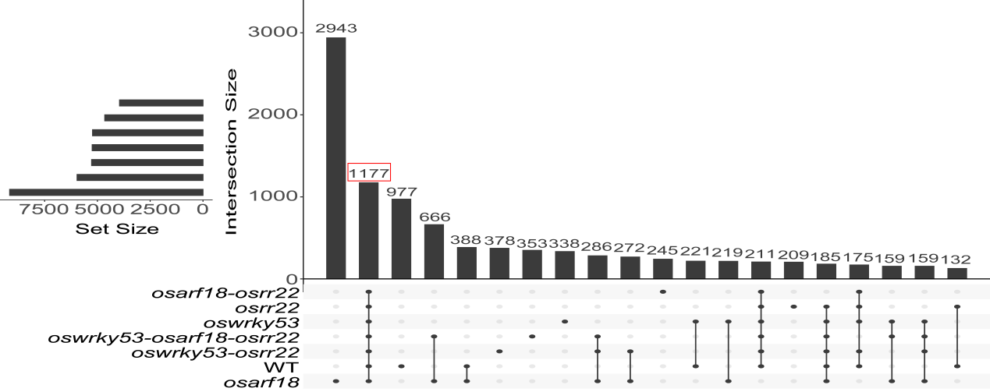
Fig.S10-The intersecting region of the Venn diagram (represented by the connected black dots) identifies the common responsive genes that are differentially expressed across all plant groups under salt stress versus normal conditions.
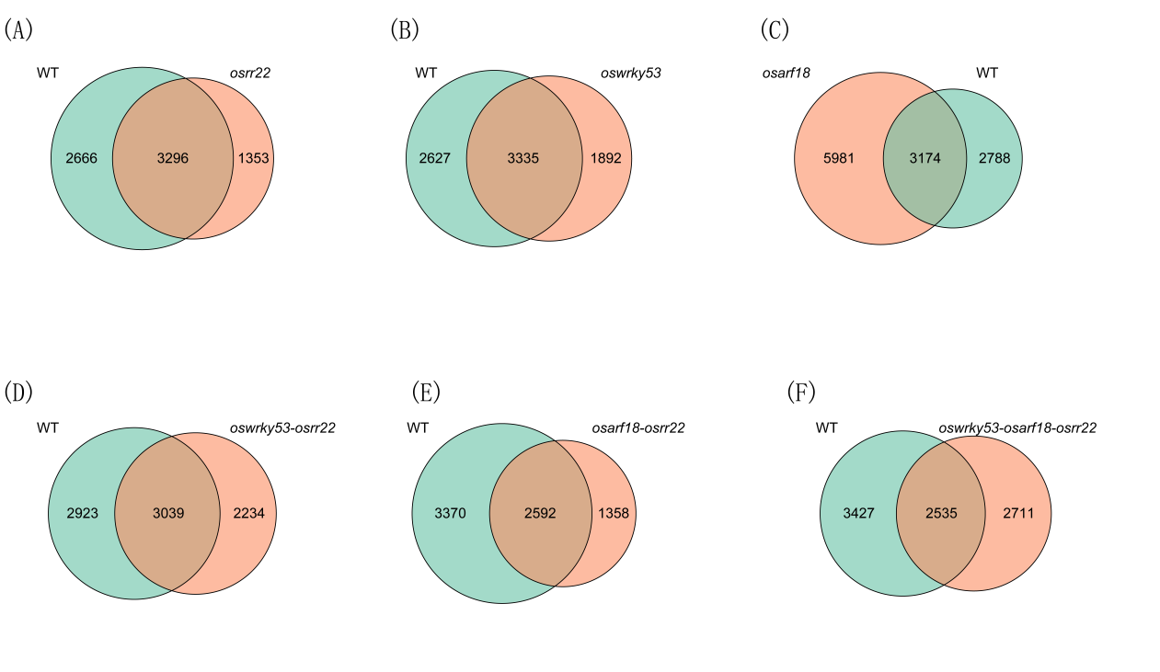
Fig.S11-Analysis of Intersecting Differentially Expressed Genes Among Genotypes Under Salt Stress. (A–F) Number of gene differences between each mutant and the WT under salt stress compared to normal conditions.
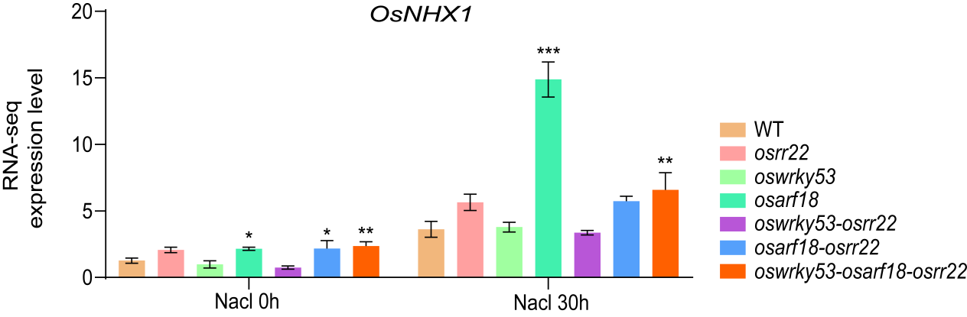
Fig.S12-Transcriptome analysis of OsNHX1 expression levels is presented. Values are shown as the mean ± standard deviation of three biological replicates (n = 3). Significant differences among the plant groups, as determined by one-way ANOVA, are indicated (*p < 0.05, **p < 0.01, ***p < 0.001).

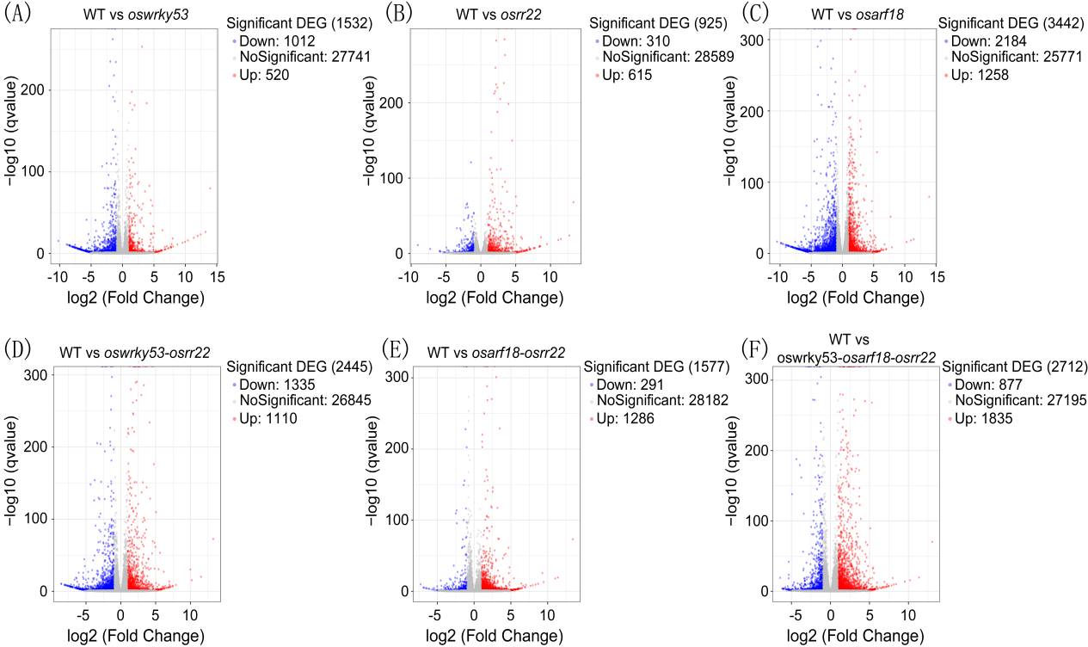
Fig.S13-Analysis of differentially expressed genes among genotypes under normal conditions. (A-F) Comparative analysis of differentially expressed genes (DEGs) between each mutant and the WT under normal growth conditions.
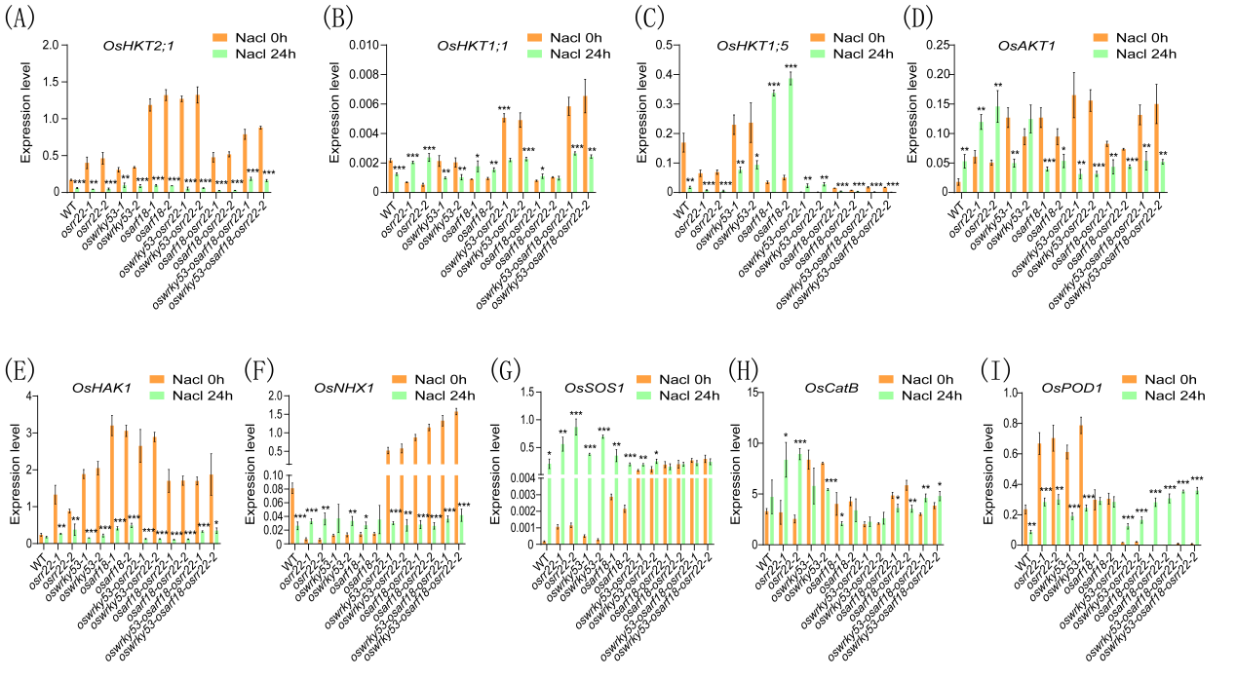
Fig.S14-RT-qPCR Analysis of Salt Stress Response Genes. (A-I) Expression profiles of key sodium ion transporters and antioxidant enzymes across all plant lines at 0 h and after 24 h of treatment with 1.0% NaCl. Data are presented as the mean ± standard deviation of three biological replicates (n = 3). Significant differences among the lines, as determined by one-way ANOVA, are indicated (*p < 0.05, **p < 0.01, ***p < 0.001).

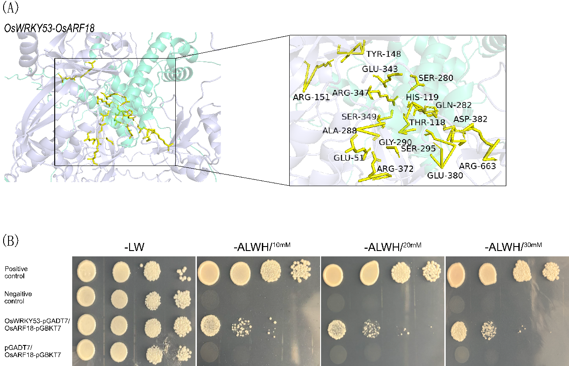Fig.S15-OsWRKY53 and OsARF18 physically interact. (A) Predicted binding interface between OsWRKY53 and OsRR22 amino acids. The three-dimensional structures of OsWRKY53 and OsARF18 are shown in cyan and dark blue, respectively. (B) Yeast two-hybrid (Y2H) assay for the interaction between OsWRKY53 and OsARF18. Yeast cells co‑transformed with pGBKT7‑OsARF18 (bait) and pGADT7‑OsWRKY53 (prey) were plated on selective media: SD/‑Trp/‑Leu (+3‑AT) and SD/‑Trp/‑Leu/‑His/‑Ade. Controls included: positive (pGBKT7‑53 + pGADT7‑T), negative (pGBKT7‑Lam + pGADT7‑T), and bait self‑activation (OsARF18‑pGBKT7 + pGADT7). Plates were incubated for 3–5 days.

