Symptom-based clusters in people with post-COVID-19 condition (PCC)

Supplement

Summary

Supplement Table 1. FIT indices of the two-step cluster analysis, including the 14 symptom-impairment variables (included: only patients who are currently still affected).

Supplement Figure 1. Results of the two-step cluster analysis including the symptom-impairment variables: graphical representation of predictor importance across the 14 PCC symptoms.

Supplement Figure 2. Results of the two-step cluster analysis, including the symptom-impairment variables: graphical representation of cluster quality

Supplement Table 2. Shown are the four clusters resulting from the two-step cluster analysis based on the symptom-presence variables, with the frequency n (%) of the 14 symptoms in the total sample and within each cluster. The symptoms are sorted in descending order of importance for cluster formation.

Supplement Figure 3. Results of the two-step cluster analysis, including the symptom-presence variables: prevalence of the 14 symptoms across clusters. Cluster 1 – Systemic: N = 426; Cluster 2 – Neurocognitive: N = 447; Cluster 3 – Pain: N = 369; Cluster 4 – Few Symptoms: N = 431. PEM = post-exertional malaise

Supplement Table 3. FIT indices of the two-step cluster analysis, including the 14 symptom-presence variables (included only patients currently still affected).

Supplement Figure 4. Results of the two-step cluster analysis, including the symptom-presence variables: graphical representation of predictor importance across the 14 symptom variables.

Supplement Figure 5. Results of the two-step cluster analysis, including the symptom-presence variables: graphical representation of cluster quality.

Supplement Table 4. Comparison of the symptom-presence clusters regarding sociodemographic, clinical, and psychological continuous variables.

Supplement Table 5. Comparison of the symptom-presence clusters regarding sociodemographic, clinical, and psychological categorical variables.

Supplement Table 6. Comparison of the symptom-impairment clusters regarding comorbid chronic conditions.

Supplement Table 1. FIT indices of the two-step cluster analysis, including the 14 symptom-impairment variables (included: only patients who are currently still affected).
Number of Clusters | Schwarz’s Bayesian Criterion (BIC) | BIC Change ª | Ratio of BIC Changes ^{b} | Ratio of Distance Measures ^{c}
1 | 29203.18
2 | 25320.01 | -3883.17 | 1.00 | 1.96
3 | 23384.35 | -1935.66 | 0.50 | 1.63
4 | 22233.06 | -1151.29 | 0.30 | 2.01
5 | 21713.12 | -519.94 | 0.13 | 1.12
6 | 21257.61 | -455.51 | 0.12 | 1.32
7 | 20936.18 | -321.43 | 0.08 | 1.11
8 | 20655.88 | -280.30 | 0.07 | 1.02
9 | 20383.02 | -272.85 | 0.07 | 1.04
10 | 20123.31 | -259.71 | 0.07 | 1.05
11 | 19881.90 | -241.41 | 0.06 | 1.19
12 | 19695.40 | -186.50 | 0.05 | 1.02
13 | 19514.09 | -181.31 | 0.05 | 1.02
14 | 19338.08 | -176.01 | 0.05 | 1.08
15 | 19182.69 | -155.40 | 0.04 | 1.14
Notes: ª The changes are from the previous number of clusters in the table. ^{b} The ratios of changes are relative to the change for the two-cluster solution. ^{c} The ratios of distance measures are based on the current number of clusters against the previous number of clusters. The cluster solution that best fits the data according to the fit indices is highlighted in bold.

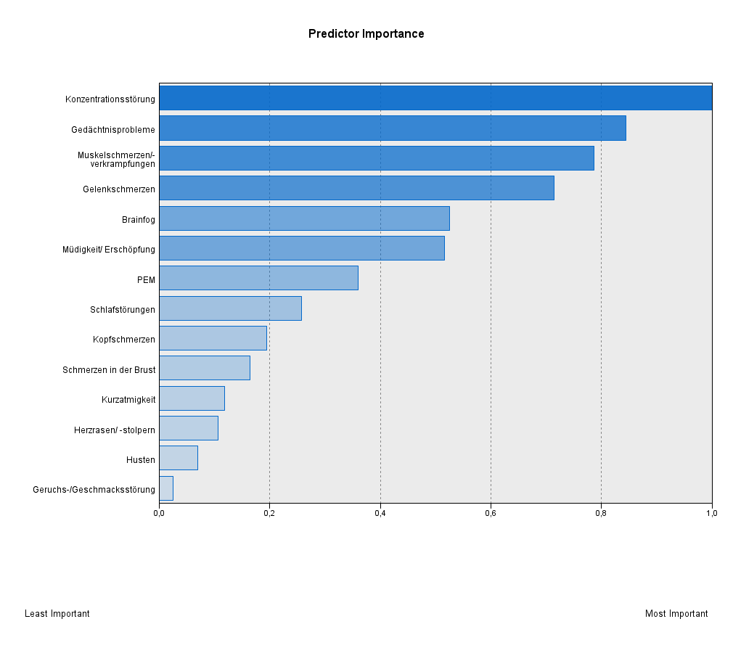
Concentration difficulties
Memory difficulties
Muscle pain/cramps
Joint pain
Brain fog
Fatigue/exhaustion
PEM
Sleep disorders
Headaches
Chest pain
Shortness of breath
Heart palpitations
Cough
Loss of smell/taste

Supplement Figure 1. Results of the two-step cluster analysis including the symptom-impairment variables: graphical representation of predictor importance across the 14 PCC symptoms.

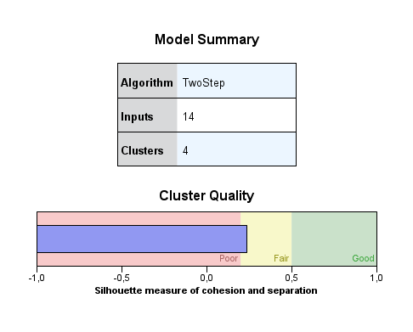

Supplement Figure 2. Results of the two-step cluster analysis, including the symptom-impairment variables: graphical representation of cluster quality

Supplement Table 2. Shown are the four clusters resulting from the two-step cluster analysis based on the symptom-presence variables, with the frequency n (%) of the 14 symptoms in the total sample and within each cluster. The symptoms are sorted in descending order of importance for cluster formation.
 |  | Cluster
Symptom  Variables n (%)  (1-14) | Total  N = 1673 | Systemic  N = 426 | Neurocognitive  N =447 | Pain  N = 369 | Few  Symptoms  N = 431
Muscle pain/cramps | 736 (44.0) | 371 (87.1) | 30 (6.7) | 323 (87.5) | 12 (2.8)
Difficulty concentrating | 998 (59.7) | 414 (97.2) | 423 (94.6) | 148 (40.1) | 13 (3.0)
Joint Pain | 801 (47.9) | 376 (88.3) | 47 (10.5) | 341 (92.4) | 37 (8.6)
Brain fog | 676 (40.4) | 366 (85.9) | 276 (61.7) | 27 (7.3) | 7 (1.6)
Memory difficulties | 901 (53.9) | 408 (95.8) | 350 (78.3) | 114 (30.9) | 29 (6.7)
Fatigue | 1295 (77.4) | 417 (97.9) | 373 (83.4) | 312 (84.6) | 193 (44.8)
PEM | 962 (57.5) | 370 (86.9) | 229 (51.2) | 238 (64.5) | 125 (29.0)
Headache | 601 (35.9) | 279 (65.5) | 134 (30.0) | 128 (34.7) | 60 (13.9)
Sleep disorder | 909 (79.1) | 337 (79.1) | 219 (49.0) | 233 (63.1) | 120 (27.8)
Chest pain | 346 (20.7) | 179 (42.0) | 40 (8.9) | 86 (23.3) | 41 (9.5)
Heart palpitations | 535 (32.0) | 224 (52.6) | 103 (23.0) | 125 (33.9) | 83 (19.3)
Shortness of breath | 983 (58.8) | 326 (76.5) | 209 (46.8) | 229 (62.1) | 219 (50.8)
Loss of smell/taste | 254 (15.2) | 110 (25.8) | 49 (11.0) | 42 (11.4) | 53 (12.3)
Cough | 505 (30.2) | 167 (39.2) | 107 (23.9) | 122 (33.1) | 109 (25.3)
PEM = post-exertional malaise

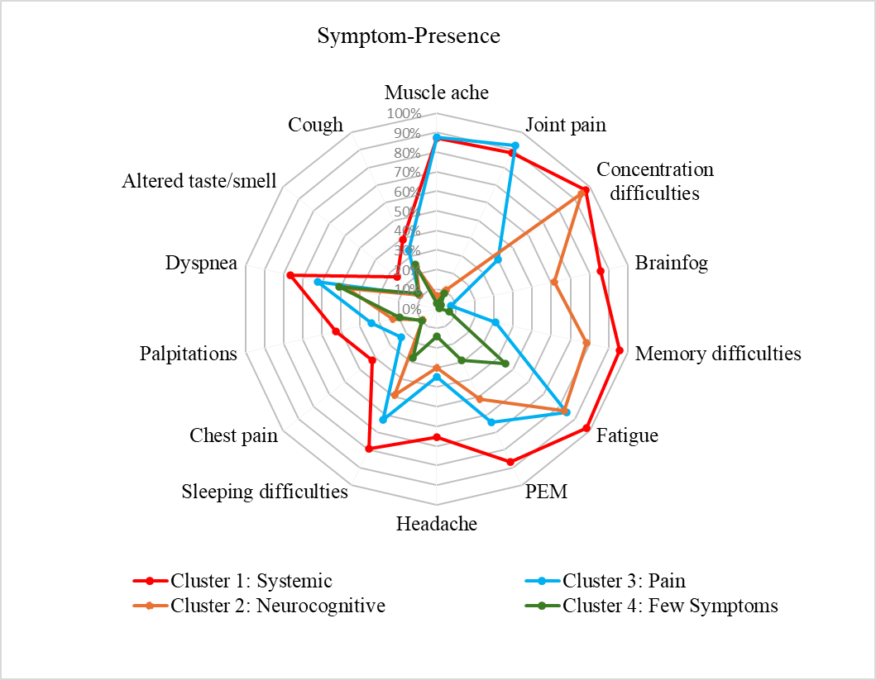
Supplement Figure 3. Results of the two-step cluster analysis, including the symptom-presence variables: prevalence of the 14 symptoms across clusters. Cluster 1 – Systemic: N = 426; Cluster 2 – Neurocognitive: N = 447; Cluster 3 – Pain: N = 369; Cluster 4 – Few Symptoms: N = 431. PEM = post-exertional malaise

Supplement Table 3. FIT indices of the two-step cluster analysis, including the 14 symptom-presence variables (included only patients currently still affected).
Number of Clusters | Schwarz’s Bayesian Criterion (BIC) | BIC Change ª | Ratio of BIC Changes ^{b} | Ratio of Distance Measures ^{c}
1 | 29643.46
2 | 26280.84 | -3362.61 | 1.00 | 2.03
3 | 24679.59 | -1601.22 | 0.48 | 1.13
4 | 23277.44 | -1402.14 | 0.42 | 2.09
5 | 22660.81 | -616.63 | 0.18 | 1.16
6 | 22144.01 | -516.80 | 0.15 | 1.27
7 | 21757.81 | -386.20 | 0.12 | 1.13
8 | 21427.32 | -330.50 | 0.10 | 1.27
9 | 21189.72 | -237.60 | 0.07 | 1.05
10 | 20968.86 | -220.86 | 0.07 | 1.04
11 | 20759.07 | -209.79 | 0.06 | 1.07
12 | 20569.21 | -189.86 | 0.06 | 1.03
13 | 20387.92 | -181.29 | 0.05 | 1.13
14 | 20238.21 | -149.71 | 0.05 | 1.04
15 | 20097.29 | -140.92 | 0.04 | 1.02
Notes: ª The changes are from the previous number of clusters in the table. ^{b} The ratios of changes are relative to the change for the two-cluster solution. ^{c} The ratios of distance measures are based on the current number of clusters against the previous number of clusters. The cluster solution that best fits the data according to the fit indices is highlighted in bold.

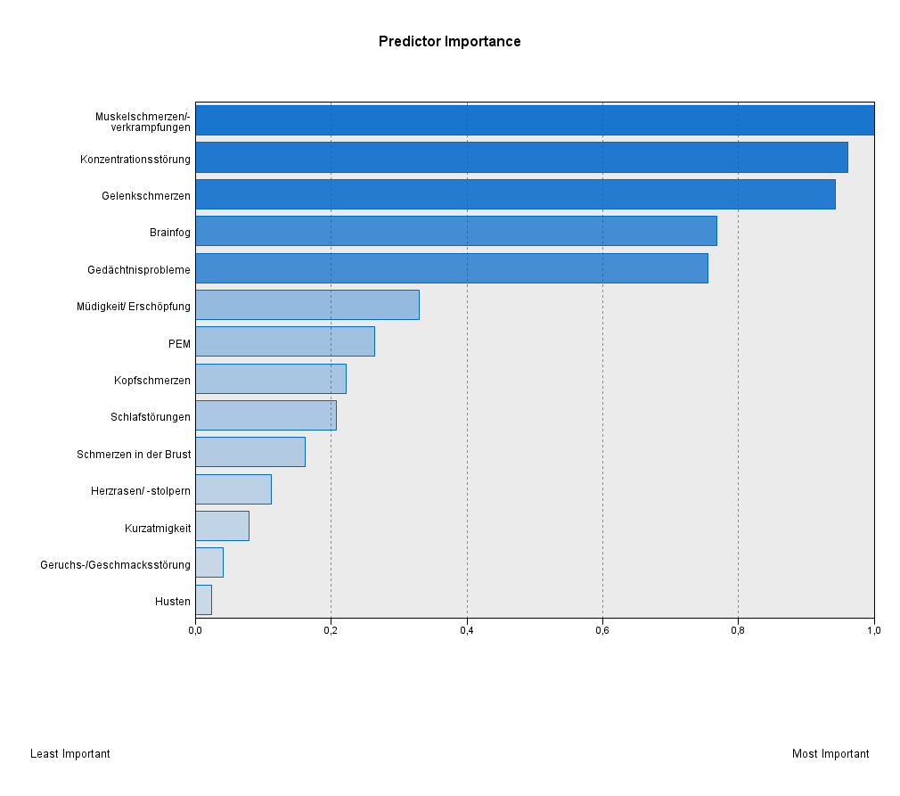
Muscle pain/cramps
Concentration difficulties
Joint pain
Brain fog
Memory difficulties
Fatigue/exhaustion
PEM
Headaches
Sleep disorders
Chest pain
Heart palpitations
Shortness of breath
Loss of smell/taste
Cough

Supplement Figure 4. Results of the two-step cluster analysis, including the symptom-presence variables: graphical representation of predictor importance across the 14 symptom variables.

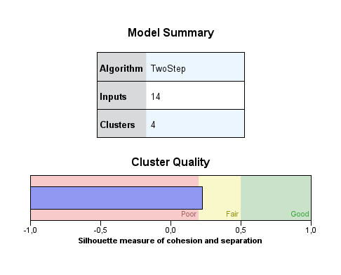

Supplement Figure 5. Results of the two-step cluster analysis, including the symptom-presence variables: graphical representation of cluster quality.

Supplement Table 4. Comparison of the symptom-presence clusters regarding sociodemographic, clinical, and psychological continuous variables.

Variable | Cluster |  |  |  | Kruskal-Wallis-Test df=3
M (SD) | Systemic  N=426 | Neurocognitive  N=447 | Pain  N=369 | Few symptoms  N=431
Age, years | 51.67 (11.24) ª | 48.97 (12.52) ^{b} | 54.21 (11.40) ^{c} | 50.71 (13.80) ^{ab} | H =30.87  p < .001
PHQ-4 | 6.83 (3.29) ª | 5.57 (3.07) ^{b} | 4.66 (2.83) ^{c} | 2.88 (2.52) ^{d} | H =320.21  p < .001
PHQ-2 | 3.57 (1.75) ª | 2.88 (1.62) ^{b} | 2.55 (1.55) ^{b} | 1.50 (1.38) ^{c} | H =310.94  p < .001
GAD-2 | 3.25 (1.78) ª | 2.69 (1.74) ^{b} | 2.10 (1.55) ^{c} | 1. 37 (1.44) ^{d} | H=256.30  p < .001
BS-6 | 17.07 (5.03) ª | 17.29 (5.21) ^{ab} | 17.44 (5.15) ^{abc} | 18.16 (5.59) ^{c} | H=14.33,  p =00.002
KsT-5 | 11.56 (3.32) ª | 12.81 (3.33) ^{b} | 12.92 (3.15) ^{b} | 14.41 (3.01) ^{c} | H=129.43  p < .001
C (total) | 10.33 (1.30) ª | 8.97 (2.26) ^{b} | 7.88 (2.80) ^{c} | 4.84 (3.21) ^{d} | H=667.79  p < .001
C (physical) | 17.42 (2.84) ª | 14.60 (3.40) ^{b} | 14.61 (3.53) ^{b} | 10.71 (3.79) ^{c} | H=557.49  p < .001
C (psychological) | 9.27 (2.0) ª | 8.27 (2.19) ^{b} | 6.18 (2.31) ^{c} | 4.82 (2.12) ^{d} | H=681.68  p < .001
DSQ-PEM | 4.26 (1.29) ª | 3.01 (1.90) ^{b} | 3.10 (1.86) ^{b} | 1.29 (1.63) ^{c} | H=481.39  p < .001
Number of therapies | 3.32 (3.12) ª | 2.16 (2.52) ^{b} | 2.25 (2.74) ^{b} | 1.36 (2.13) ^{c} | H=106.94  p < .001
Number of specialists consulted | 3.52 (1.68) ª | 2.68 (1.51) ^{b} | 2.71 (1.61) ^{b} | 2.11 (1.26) ^{c} | H=151.37  p < .001
Time since infection, months | 23.10 (8.80) ª | 22.48 (8.78) ª | 22.11 (8.37) ^{ab} | 20.64 (7.73) ^{b} | H= 18.73  p < .001
Sick days due to infection | 223.27 (267.32) ª | 118.62 (209.06) ^{b} | 112.82(199.54)^{b} | 48.08 (97.75) ^{c} | H= 138.49  p < .001
Notes. Values with different superscripts are significantly different. PHQ-4: Patient Health Questionnaire-4; PHQ-2: Patient Health Questionnaire-2; GAD-2: Generalized Anxiety Disorder-2; BS-6: Brief Social Support Scale. KsT-5: Short Scale Measuring Perceived Social Participation; CFS: Chalder Fatigue-Scale; DSQ-PEM: DePaul Symptom Questionnaire – Post-Exertional Malaise.

Supplement Table 5. Comparison of the symptom-presence clusters regarding sociodemographic, clinical, and psychological categorical variables.

Variable | Cluster |  |  |  | Chi-square test, df=3
n (%) | Systemic  n=426 | Neurocognitive  n=447 | Pain  n=369 | Few symptoms  n=431
Gender, f | 313 (73.5) | 331 (74.0) | 263 (71.1) | 291 (67.5) | χ²= 5.61  p = .132
Unemployed | 132 (33.4) | 81 (19.5) | 96 (27.8) | 88 (22.6) | χ² = 23.46  p < .001
School, ≥ 12 years | 95 (24.7) | 126 (31.5) | 79 (24.1) | 115 (31.3) | χ² = 9.05  p = .029
Partnership, yes | 306 (79.1) | 315 (78.8) | 275 (83.8) | 305 (82.9) | χ² = 4.82  p = .186
Other chronic diseases, yes | 217 (56.1) | 180 (45.0) | 178 (54.1) | 150 (40.5) | χ² = 24.31  p = < .001
PHQ-4 ≥ 6 | 134 (49.4) | 87 (32.1) | 38 (14.0) | 12 (4.4) | χ² = 216.25  p = < .001
DSQ-PEM: Dead, heavy feeling after starting to exercise | 387 (90.8) | 301 (68.3) | 279 (77.3) | 156 (37.6) | χ² = 310.0  p = < .001
DSQ-PEM: Next day soreness or fatigue after non-strenuous, everyday activities | 345 (81.0) | 234 (53.2) | 230 (63.7) | 78 (18.8) | χ² = 358.20  p = < .001
DSQ-PEM: Mentally tired after the slightest effort | 360 (86.1) | 290 (65.8) | 165 (45.7) | 71 (17.1) | χ² = 435.83  p = < .001
DSQ-PEM: Minimum exercise makes you physically tired | 344 (82.3) | 252 (57.1) | 220 (60.9) | 119 (28.7) | χ² = 247.52  p = < .001
DSQ-PEM: Physically drained or sick after mild activity | 346 (82.8) | 251 (56.9) | 225 (62.3) | 112 (27.0) | χ² = 270.18  p = < .001
DSQ-PEM: Recovery time ≥ 14 hours | 159 (47.2) | 74 (22.0) | 67 (19.9) | 37 (11.0) | χ² = 117.32  p = < .001
C ≥ 4 | 418 (28.9) | 429 (29.6) | 334 (23.1) | 267 (18.4) | χ² = 335.59  p = < .001
Use of psychological therapy | 176 (43.7) | 139 (32.8) | 96 (27.2) | 68 (16.8) | χ² = 72.08  p = < .001
Use of active therapy | 150 (37.2) | 104 (24.5) | 83 (23.5) | 70 (17.3) | χ² = 44.25  p = < .001
Inpatient admission due to post-COVID | 49 (12.0) | 36 (8.3) | 37 (10.4) | 25 (6.1) | χ² = 9.65  p = .022
ICU due to infection | 24 (5.6) | 9 (2.0) | 11 (3.0) | 7 (1.6) | χ² = 10.40  p = .015
Notes: CFS: Chalder-Fatigue-Scale; DSQ-PEM: DePaul Symptom Questionnaire – Post-Exertional Malaise. Psychological therapy includes relaxation therapy, psychological counseling, and psychotherapy. Active therapy includes rehabilitative sports and functional training/sports therapy.

Supplement Table 6. Comparison of the symptom-impairment clusters regarding comorbid chronic conditions.
Chronic disease | Cluster |  |  |  |  | Chi-square test, df=3
n (%) | Total  (n = 1673) | Systemic  (n=461) | Neurocognitive  (n=489) | Pain  (n=419) | Few Symptoms  (n=304)
Asthma | 237 (15.9) | 85 (20.5) | 61 (16.3) | 54 (12.2) | 37 (14.5) | χ² = 11.38  p = .010
Chronic lung disease | 100 (6.7) | 35 (8.4) | 27 (7.2) | 25 (5.7) | 13 (5.1) | χ² = 3.96  p = .270
Heart disease | 63 (4.2) | 25 (6.0) | 19 (5.1) | 10 (2.3) | 9 (3.5) | χ² = 8.48  p = .040
Hypertension | 281 (18.9) | 91 (21.9) | 85 (22.7) | 71 (16.1) | 34 (13.3) | χ² = 13.53  p = .004
Stroke | 16 (1.1) | 5 (1.2) | 4 (1.1) | 5 (1.1) | 2 (0.8) | χ² = 0.28  p = .964
Chronic complaints in the lower back/lumbar spine | 238 (16.0) | 91 (21.9) | 72 (19.3) | 46 (10.4) | 29 (11.4) | χ² = 28.12  p < .001
Chronic complaints in the neck/cervical spine | 218 (14.7) | 90 (21.7) | 59 (15.8) | 55 (12.4) | 14 (5.5) | χ² =35.60  p < .001
Osteoarthritis | 189 (12.7) | 75 (18.1) | 56 (15.0) | 38 (8.6) | 20 (7.8) | χ² =24.65  p < .001
Diabetes | 88 (5.9) | 32 (7.7) | 19 (5.1) | 28 (6.3) | 9 (3.5) | χ² =5.62  p = .132
Chronic kidney disease | 24 (1.6) | 8 (1.9) | 7 (1.9) | 7 (1.6) | 2 (0.8) | χ² =1.52  p = .678
Elevated blood lipids or cholesterol levels | 92 (6.2) | 30 (7.2) | 21 (5.6) | 26 (5.9) | 15 (5.9) | χ² =1.10  p = .778
Depression | 167 (11.2) | 76 (18.3) | 28 (7.5) | 51 (11.5) | 12 (4.7) | χ² =37.05  p < .001
Anxiety disorder | 93 (6.3) | 42 (10.1) | 13 (3.5) | 28 (6.3) | 10 (3.9) | χ² =17.87  p < .001
Cancer | 41 (2.8) | 12 (2.9) | 10 (2.7) | 10 (2.3) | 9 (3.5) | χ² =1.02  p = .799
Epilepsy | 19 (0.7) | 1 (0.2) | 3 (0.8) | 4 (0.9) | 2 (0.8) | χ² =1.66  p = .647
Multiple sclerosis | 8 (0.5) |  | 2 (0.5) | 6 (1.4) | - | χ² =9.17  p = .027
Rheumatoid arthritis | 57 (3.8) | 25 (6.0) | 21 (5.6) | 7 (1.6) | 4 (1.6) | χ² =18.23  p < .001
Other | 285 (19.2) | 100 (24.1) | 63 (16.8) | 89 (20.1) | 33 (12.9) | χ² =14.45  p = .002

