Supplementary Data
- HSD - Tukey results of all the analysed parameters
Table 5: HSD - Tukey results of all the analysed parameters
 | HSD - Tukey
 | B140_80 | B140_10 | B258_80 | B258_10 | CTRL_80 | CTRL_10
Chl a | ab | ab | a* | b* | ab | ab
Chl b | a | a | a | a | a | a
Carotenoids | a | a | a | a | a | a
Athocianins | a | a | a | a | a | a
Performance Index | a | a | a | a | a | a
Stomatal Conductance | b* | b* | ab | b* | a* | b*
CO2 Fixation | ab | ab | ab | ab | a* | b*
Total Soluble Sugars | a | a | a | a | a | a
Total Insoluble Sugars | a | a | a | a | a | a
Total Phenols Content | a | a | a | a | a | a
A/gs | a | a | a | a | a | a
Transpiration | ab | b* | a* | ab | a* | b*
H2O2 | a | a | a | a | a | a
O2- | a | a | a | a | a | a
Total Soluble Proteins | a | a | a | a | a | a
APx | a | a | a | a | a | a
SOD | b* | ab | c | ab | ab | a*
GPx | a | a | a | a | a | a

- LSD - Fisher results of all the analysed parameters
Table 6: LSD - Fisher results of all the analysed parameters
 | LSD - Fisher
 | B140_80 | B140_10 | B258_80 | B258_10 | CTRL_80 | CTRL_10
Chl a | a | b | a | b | a | b
Chl b | a | a | a | b | a | a
Carotenoids | a | a | a | b | b | b
Athocianins | a | a | a | a | a | a
Performance Index | a | a | b | a | b | a
Stomatal Conductance | b | cd | b | b | a | d
CO2 Fixation | a | b | a | b | a | c
Total Soluble Sugars | a | b | a | a | a | a
Total Insoluble Sugars | a | a | a | a | a | b
Total Phenols Content | a | a | a | a | a | a
A/gs | a | a | a | a | a | a
Transpiration | bc | bc | a | b | a | c
H2O2 | a | b | a | a | b | a
O2- | a | b | a | a | a | a
Total Soluble Proteins | a | a | a | a | a | a
APx | ab | b | ab | a | ab | ab
SOD | b | ab | c | ab | b | a
GPx | a | a | a | a | a | a

- One-Way ANOVAs for the analysis of pigment synthesis
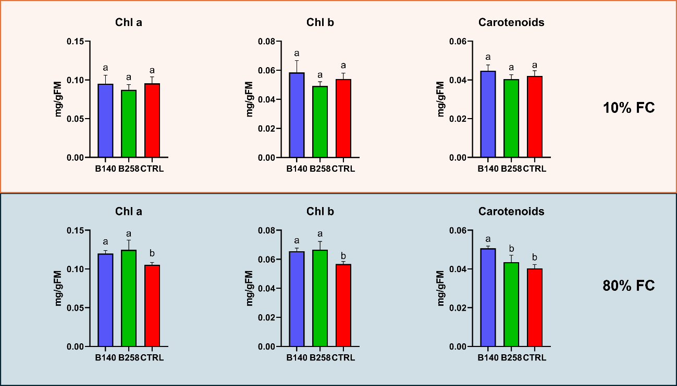

Figure 6: One-way ANOVAs for the analysis of pigment synthesis in potted grapevines; B140 – Myroides odoratimimus; B258 Arthrobacter nicotinovorans; CTRL – Control plants; Chl a – Chlorophyll a; Chl b – Chlorophyll b;

- One-way ANOVAs for the analysis of stomata status and gas exchange efficiency in potted grapevines
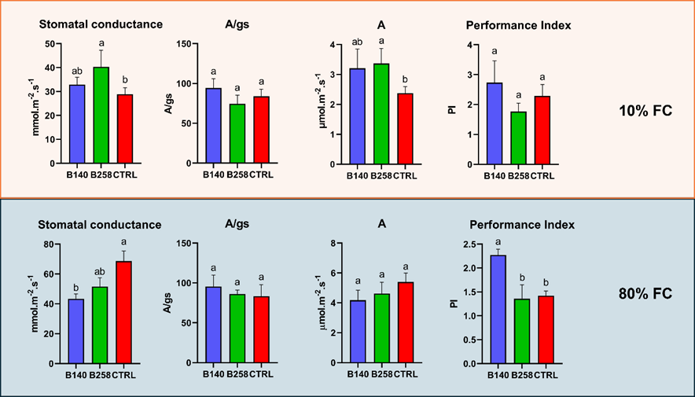
Figure 7: One-way ANOVAs for the analysis of stomata status and gas exchange efficiency in potted grapevines; B140 – Myroides odoratimimus; B258 Arthrobacter nicotinovorans; CTRL – Control plants; Performance index, Photosynthetic rate (A), CO₂ fixation efficiency (A/gs), and stomatal conductance were measured/calculated for 10% and 80% field capacity; Different letters mean statistically different results.
- Transpiration rate (E), total soluble (TSS) and insoluble sugars (TIS) quantification in potted grapevines
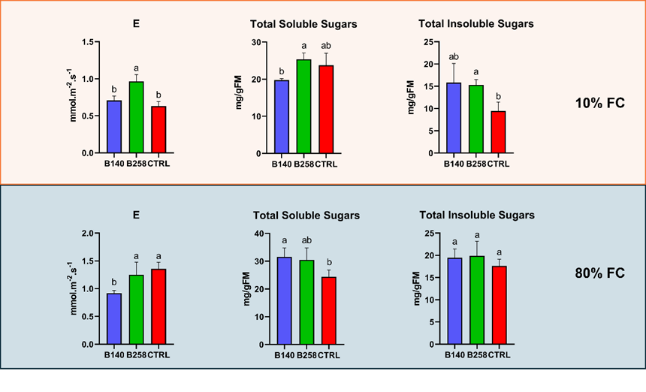
Figure 8: Transpiration rate (E), total soluble (TSS) and insoluble sugars (TIS) quantification of plants treated with B140, B258, and control ones, in both irrigation treatments.

- Quantification of Total Phenols Content, H₂O₂ and O₂⁻ in potted grapevines
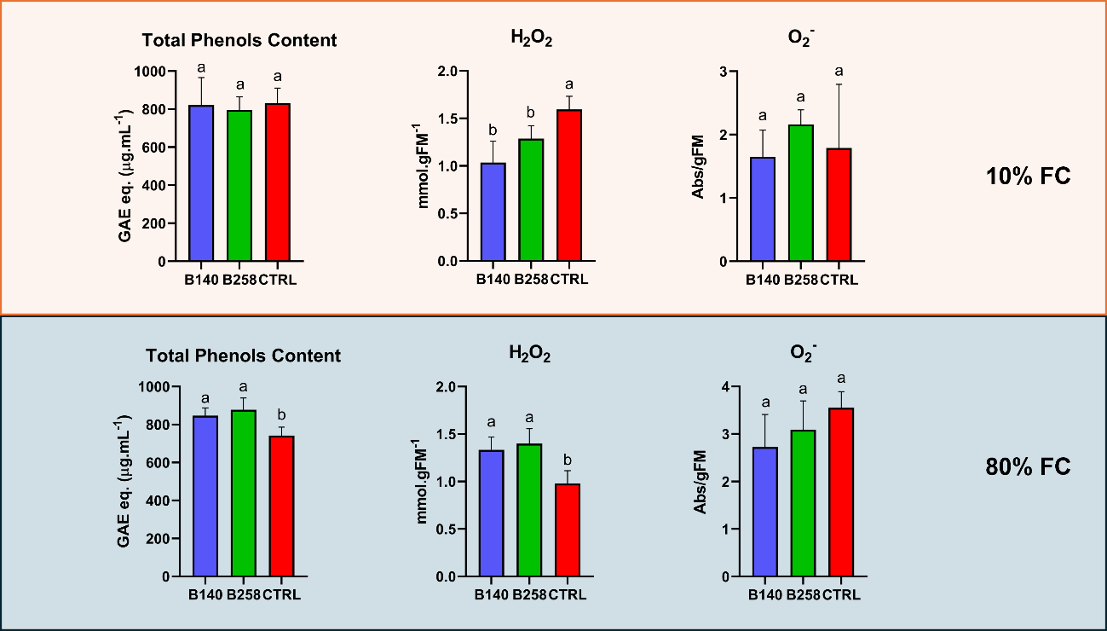
Figure 9: Quantification of Total Phenols Content, H₂O₂ and O₂⁻ in grapevines treated with B140, B258, and control ones, in both irrigation treatments.
- Quantification of Total Soluble Proteins (TSP), Guaiacol Peroxidase (GPx), Ascorbate Peroxidase (APx), and Superoxide Dismutase (SOD) in potted grapevines
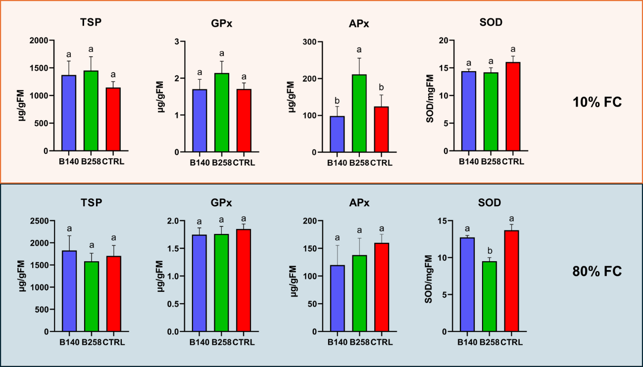
Figure 10: Quantification of Total Soluble Proteins (TSP), Guaiacol Peroxidase (GPx), Ascorbate Peroxidase (APx), and Superoxide Dismutase (SOD) in grapevines treated with B140, B258, and control ones, in both irrigation treatments.

- Two-way ANOVA of the Ascorbate peroxidase concentration of the leaves of potted grapevines
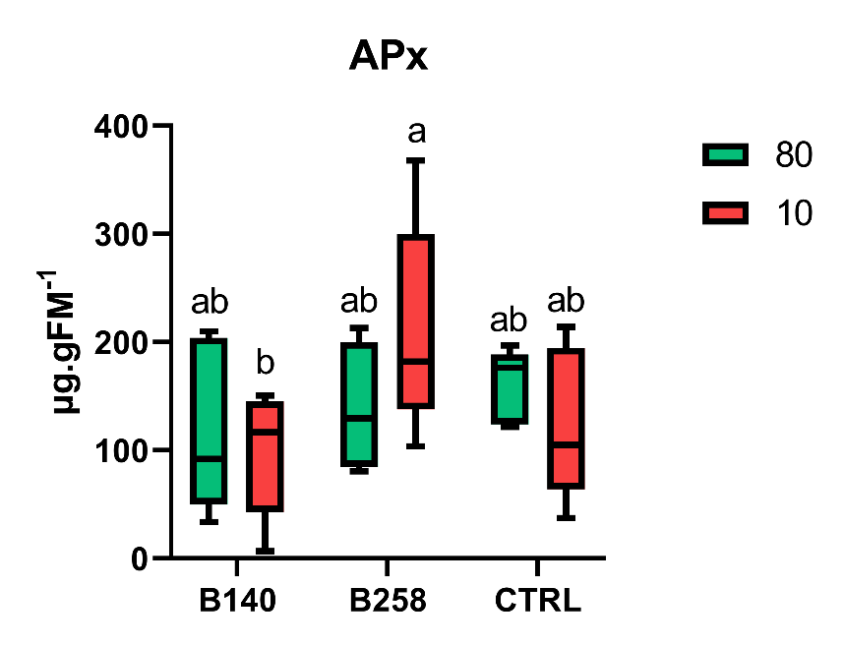
Figure 11: Two-way ANOVA of the Ascorbate peroxidase concentration of the leaves of potted grapevines

