Supplementary Material
Suppl. Table 1: Descriptive statistics of grain yield by field trial [g*m–², except for CV]. SD: standard deviation, CV: coefficient of variation. Table adapted from table 1 from Heinemann et al., 2025.⁠

Trial | Mean | Min | Max | SD | CV | n
HZ_20 | 715 | 290 | 1031 | 108 | 15 % | 4349
HZ_21 | 818 | 500 | 1027 | 72 | 9 % | 2711
HZ_22 | 695 | 306 | 950 | 93 | 13 % | 1869
HZ_23 | 628 | 139 | 1018 | 131 | 21 % | 3442
MR_20 | 792 | 223 | 1131 | 126 | 16 % | 4423
MR_21 | 849 | 300 | 1116 | 91 | 11 % | 2787
MR_22 | 714 | 350 | 927 | 70 | 10 % | 1785

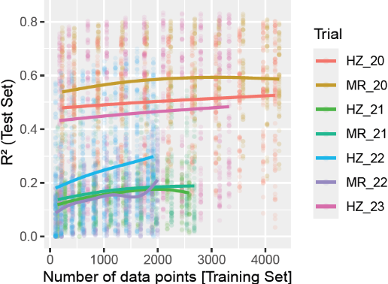
Suppl. Figure 1: Interaction plot: R²-values by absolute number of data points and trial (coloured lines). Dots of same colour and at same number of data points (x-axis), models run with different dates or date combinations but with the same TSR-values. Lines indicate R²-values per trial based on a general additive model (GAM).

Suppl. Figure 2: Distribution of R²-values by TSR, individual measurement date and algorithm: Example from location HZ in 2020. The variation within boxplots corresponds to the results from 60 random data splits.

