Appendix 1. Experimental setup of the corn straw-based wastewater treatment system.
Appendix 2. Two-way analysis of the effects of influent concentration and straw treatment on NH₄⁺-N, TN, and TP removal by corn straw. Here, “*” indicates significant differences among the different concentrations (p < 0.05).
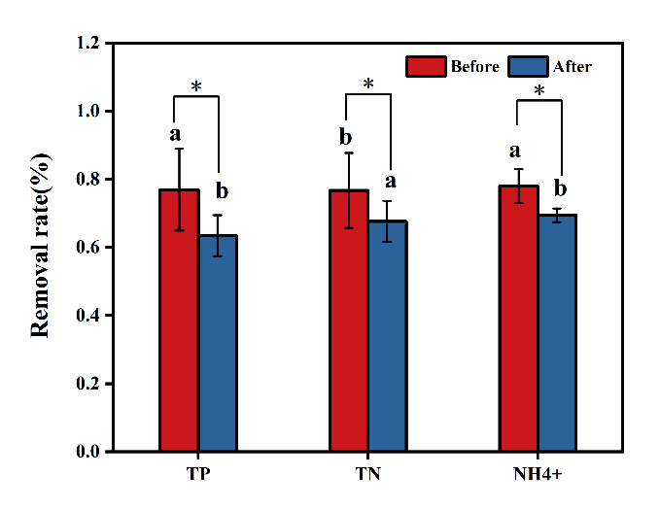
Appendix 3. Analysis of the differences in pollutant removal from the water before and after eight days.
To characterize the dissolved organic matter (DOM) released from corn straw after wastewater immersion and to analyze its composition, three-dimensional fluorescence spectroscopy was employed. Excitation-emission matrix (EEM) spectra were analyzed in combination with parallel factor analysis (PARAFAC). Prior to measurement, the samples were filtered through 0.45 μm membranes. Fluorescence spectra were recorded with excitation wavelengths ranging from 220 to 550 nm and emission wavelengths from 220 to 500 nm, with a scanning increment of 5 nm. Fluorescence intensity was Raman-normalized, and background noise and scattering artifacts were corrected using ultrapure water subtraction and Delaunay interpolation, respectively (Bahram et al., 2006). The PARAFAC model was constructed in MATLAB R2021a (MathWorks, USA) using the DOM Fluor and dr EEM toolboxes (Jia et al., 2019). Model stability was evaluated by split-half validation. The identified fluorescent components were compared against the Open Fluor database, and similarity was assessed using Tucker’s congruence coefficient (values > 0.90 were considered indicative of high similarity (Antonio et al., 2025). The maximum fluorescence intensity (Fmax) was used to indicate changes in component concentrations, while the fluorescence regional integration (FRI) method was applied to partition the EEM spectra into different regions for assessing DOM compositional characteristics (Duan et al., 2023).
In this study, parallel factor analysis (PARAFAC) was applied to the three-dimensional excitation-emission matrix (EEM) fluorescence spectra of dissolved organic matter (DOM), and three main fluorescent components were identified in Table S1. The contour plots and characteristic excitation (Ex) and emission (Em) wavelengths of these components are shown in Appendix 2. Comparison with typical PARAFAC components reported in the OpenFluor database demonstrated high consistency, confirming the reliability of the component classification. The three components included two humic-like substances (C1 and C3) and one protein-like substance (C2). Specifically, component C1 exhibited a characteristic peak at λEx/λEm = 330/430 nm, corresponding to microbially derived humic-like material (Niloy et al., 2021). Component C2 showed a distinct protein-like peak at λEx/λEm = 275/313 nm, associated with aromatic amino acids such as tryptophan and tyrosine, representing freshly produced, bioavailable organic matter (Niloy et al., 2021; Zhang et al., 2021a). Component C3 presented a maximum peak at λEx/λEm = 410/490 nm, representing high-molecular-weight, highly humified humic substances, consistent with previously identified humic-like DOM components (Murphy et al., 2011)
Appendix 4. PARAFAC modeling was used to identify different fluorescence components.

Appendix 5. Comprehensive analysis of water purification and fertilization potential of maize straw under different pretreatments and influent concentrations. ABC represent Low-(L-S-C), DEF represent Medium-(L-S-C), and GHI represent High-(L-S-C) treatments. (a) denotes the integrated analysis of water quality, nutrients, and decomposition performance of maize straw; (b) denotes the integrated analysis of water purification and fertilization potential of maize straw.
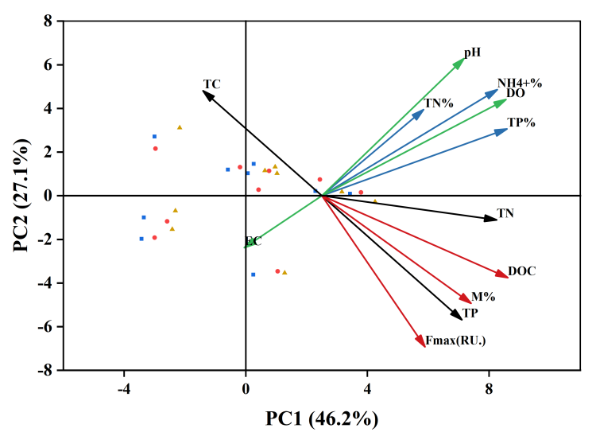
Appendix 6. Principal Component Analysis of Maize Straw for Water Purification and Fertilization Potential.

Table S1. The maximum positions and characteristics of the three components identified by fluorescence-PARAFAC analysis in this study, as well as their comparison with previously identified components.
This study |  | Previous studies |  | Refs
Component | Ex/Em(nm) | Compound | Description and assignment | Refs
C1 | 330/430 | Humic acid-like | UVC + UVA humic acid-like | (Fellman et al., 2010; Ishii and Boyer, 2012; McIntyre and Guéguen, 2013)
C2 | 275/313 | Protein like | Aromatic protein containing tryptophan and tyrosine | (Chen et al., 2003; Stedmon and Bro, 2008)
C3 | 410/490 | Humic acid-like | UVA humic acid-like, low molecular weight humic acid | (Chen et al., 2003; Fellman et al., 2010)

Table S2. Weighted analysis of water purification performance, nutrient content, and decomposition characteristics of maize straw under different pretreatments and influent concentrations.
Influent concentration | Treatment type | Water purification | Nutrient retention | Decomposition | Composite score
Low | 3 cm | 0.53 | 0.33 | 0 | 2.15
Low | 6 cm | 0.69 | 0.40 | 0.30 | 1.39
Low | Crushed | 0.92 | 0.42 | 0.81 | 2.15
Medium | 3 cm | 0.66 | 0.30 | 0.37 | 1.32
Medium | 6 cm | 0.75 | 0.46 | 0.36 | 1.56
Medium | Crushed | 0.93 | 0.64 | 0.93 | 2.50
High | 3 cm | 0.26 | 0.18 | 0.34 | 0.79
High | 6 cm | 0.09 | 0.33 | 0.49 | 0.91
High | Crushed | 0.27 | 0.60 | 1 | 1.90

Table S3. ANOVA results of NH₄⁺-N removal efficiency for influent concentration and treatment method
Fixed factor | F值 | P值
A | 5.633 | 0.013
B | 5.608 | 0.013
A×B | 0.363 | 0.832
Note: A represents influent concentration; B represents treatment method; A × B represents the interaction between the two factors. P-value indicates the significance level, and F-value indicates the F statistic of the effect.

Table S4. Effects of influent concentration and straw treatment on NH₄⁺-N removal efficiency.
Influent concentration | Treatment type | NH₄⁺-N removal efficiency (%)  (Mean ± SD)
Low | Cut-6 cm | 0.67 ± 0.067^{c}
Low | Cut-3 cm | 0.68 ± 0.12^{bc}
Low | Crushed | 0.76 ± 0.034^{abc}
Medium | Cut-6 cm | 0.73 ± 0.015^{bc}
Medium | Cut-3 cm | 0.80 ± 0.015^{ab}
Medium | Crushed | 0.85 ± 0.025ª
High | Cut-6 cm | 0.69 ± 0.048^{bc}
High | Cut-3 cm | 0.71 ± 0.03^{bc}
High | Crushed | 0.75 ± 0.07^{abc}

Table S5. ANOVA results of TN removal efficiency for influent concentration and treatment method
Fixed factor | F值 | P值
A | 34.941 | 0.000
B | 17.954 | 0.000
A×B | 6.991 | 0.001
Note: A represents influent concentration; B represents treatment method; A × B represents the interaction between the two factors. P-value indicates the significance level, and F-value indicates the F statistic of the effect.

Table S6. Effects of influent concentration and straw treatment on TN removal efficiency.
Influent concentration | Treatment type | TN removal efficiency (%)  (Mean ± SD)
Low | Cut-6 cm | 0.47± 0.048e
Low | Cut-3 cm | 0.57 ± 0.043^{cd}
Low | Crushed | 0.68 ± 0.02^{b}
Medium | Cut-6 cm | 0.69 ± 0.021^{b}
Medium | Cut-3 cm | 0.77 ± 0.037ª
Medium | Crushed | 0.69 ± 0.050^{b}
High | Cut-6 cm | 0.56 ± 0.056^{d}
High | Cut-3 cm | 0.66 ± 0.015^{b}
High | Crushed | 0.64 ± 0.025^{bc}

Table S7. ANOVA results of TP removal efficiency for influent concentration and treatment method
Fixed factor | F值 | P值
A | 25.482 | 0.000
B | 4.272 | 0.030
A×B | 3.077 | 0.043
Note: A represents influent concentration; B represents treatment method; A × B represents the interaction between the two factors. P-value indicates the significance level, and F-value indicates the F statistic of the effect.

Table S8. Effects of influent concentration and straw treatment on TP removal efficiency.
Influent concentration | Treatment type | TP removal efficiency (%)  (Mean ± SD)
Low | Cut-6 cm | 0.75± 0.036^{bc}
Low | Cut-3 cm | 0.64 ± 0.048^{d}
Low | Crushed | 0.66 ± 0.048^{d}
Medium | Cut-6 cm | 0.79 ± 0.056^{ab}
Medium | Cut-3 cm | 0.75 ± 0.055^{bc}
Medium | Crushed | 0.84 ± 0.028ª
High | Cut-6 cm | 0.65 ± 0.021^{d}
High | Cut-3 cm | 0.65 ± 0.031d
High | Crushed | 0.68 ± 0.034^{cd}

