Supplementary Material
Construction of triazine-based COF/Zr-based MOF S-scheme heterojunctions for efficient photocatalytic H₂O₂ production under simulated sunlight irradiation
Lisong Chen ^{a,b}, Yunchao Zhang ^{c}, Yan Yan ^{c}, Jinhui Jiang ^{a,c}, Rongfeng Guan ^{a,b,}*, Pengyu Dong ^{a,c,}*
ª Key Laboratory for Advanced Technology in Environmental Protection of Jiangsu Province, Yancheng Institute of Technology, Jiangsu, China.
^{b} School of Chemistry and Chemical Engineering, Yancheng Institute of Technology, Jiangsu, China.
^{c} School of Materials Science and Engineering, Yancheng Institute of Technology, Jiangsu, China.

* Corresponding authors.
E-mail addresses: rongfengg@163.com (R. Guan), dongpy11@ycit.edu.cn (P. Dong).

1. Additional experimental section
1.1. Detection of H₂O₂
After sampling every 15 min, solid-liquid separation procedure was carried out with a filter of 0.22 μm. To this solution, 1 mL of 0.1 mol·L⁻¹ aqueous potassium hydrogen phthalate (C₈H₅KO₄) solution and 1 mL of 0.4 mol·L⁻¹ aqueous potassium iodide (KI) solution was added, and the mixture was allowed to sit for 30 minutes. Under acidic conditions (H₂O₂ + 3I⁻ + 2H⁺ → I³⁻ + 2H₂O), H₂O₂ molecules reacted with iodide anions (I⁻) to produce triiodide anions (I³⁻) with strong absorption around 350 nm. The quantity of I³⁻ was determined via UV-vis spectroscopy based on the absorbance at 350 nm, which allowed the estimation of the amount of H₂O₂ produced during each reaction.
1.2. Measurement and calculation of apparent quantum efficiency
The measurement of AQE (Apparent Quantum efficiency) for H₂O₂ evolution was conducted under monochromatic light irradiation (300 W xenon lamp, λ = 420, 450, 500, and 550 nm). The concentration of catalyst is 0.3 mg/mL, and the radiation area is 6.9 cm².The calculation formula for AQE was estimated as following equation:
$$AQE=\frac{\left(number of H_{2}O_{2} production\right)×2}{number of incidaent photons}×100\%$$
The number of incident photons is:
$$N_{incident}=\frac{Pt}{hv}=\frac{ptλ}{hc}=\frac{IStλ}{hc}$$
Where I is the light power intensity (W m⁻²), S is the irradiation area (m²), t is the reaction time (s), λ is the wavelength length (m) of the monochromatic light, h is Planck’s constant (6.63×10⁻³⁴ m² kg s⁻¹), and c is the speed of light in free space (3.0 ×10⁸ m s⁻¹).

2. Supplementary Figures

Fig. S1 The H₂O₂ concentration-absorbance standard curve.
The absorbance and standard fitting curves of H₂O₂ aqueous solutions with different known concentrations reacted with potassium iodide are shown in Fig. S1.

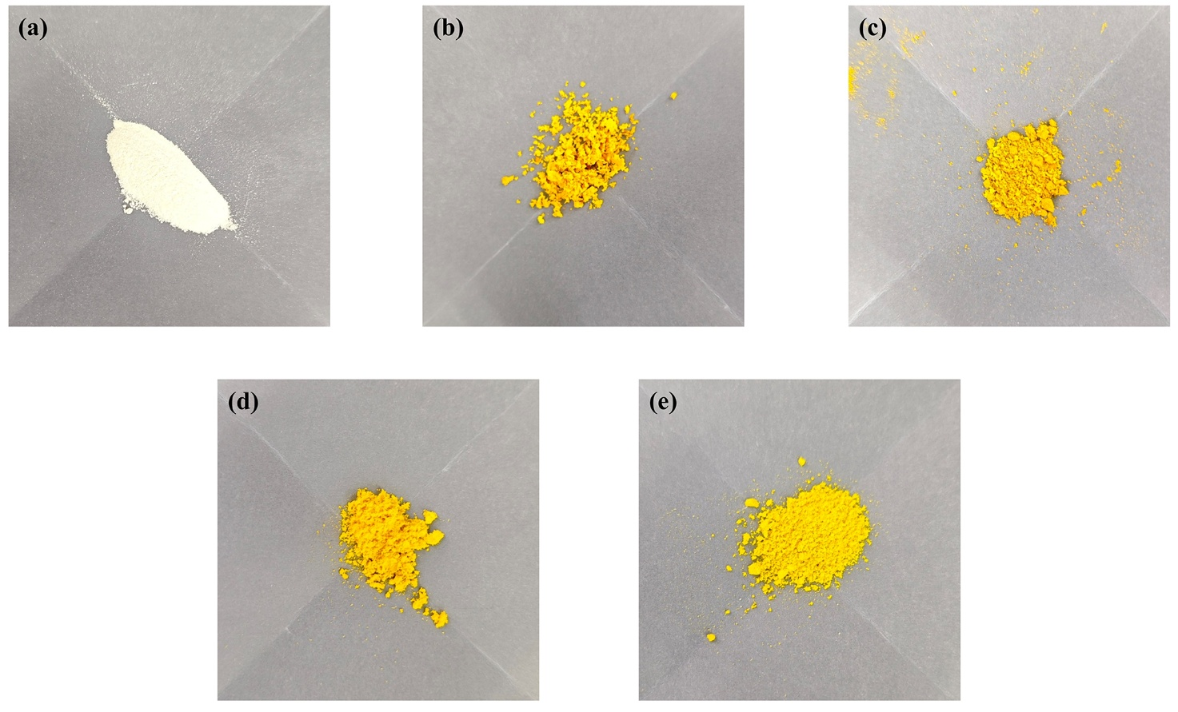
Fig. S2. Optical photograph of (a) NH₂-UiO-66, (b) TFPT-Pa(CH₃)₂, (c) TNU-1, (d) TNU-2 and (e) TNU-3.

Fig. S3. XRD patterns of as-prepared products after photocatalytic cycles.

Fig. S4. (a) XPS survey, (b) C1s, (c) N 1s, (d) O 1s of TNU-2 before and after photocatalytic cycles.

3. Supplementary Table
Table S1. BET-specific surface area and pore volume of TFPT-Pa(CH₃)₂，NH₂-UiO-66 and TNU-2 samples.
Samples | BET-specific surface area  (m² g⁻¹) | Pore volume  (cm³ g⁻¹)
TFPT-Pa(CH₃)₂ | 467 | 0.529
NH₂-UiO-66 | 795 | 0.622
TNU-2 | 689 | 0.577

