Supplementary Material

Magnetically Actuated Helical Microrobots Enabling Ultrasound-Free Precision Fragmentation of Lens Nuclei in Cataract Surgery

Li Zhelin^{1,2}, Wei yingying¹, Tang qiongyan¹, Song weitao²，Fan xinjian^{3*}, Lin ding¹*

Correspondence: Fan xinjian (xinjianfan@suda.edu.cn) or Lin Ding (linding@csu.edu.cn)
¹Changsha Aier Eye Hospital, Aier School of Ophthalmology, Central South University, Changsha, Hunan, China.
² The Xiangya Hospital, Central South University, Changsha, Hunan, China.
³Jiangsu Provincial Key Laboratory of Advanced Robotics, School of Mechanical and Electric Engineering, Soochow University, Suzhou, 215123 China

Figure S1 The photo of the electromagnetic coil platform.

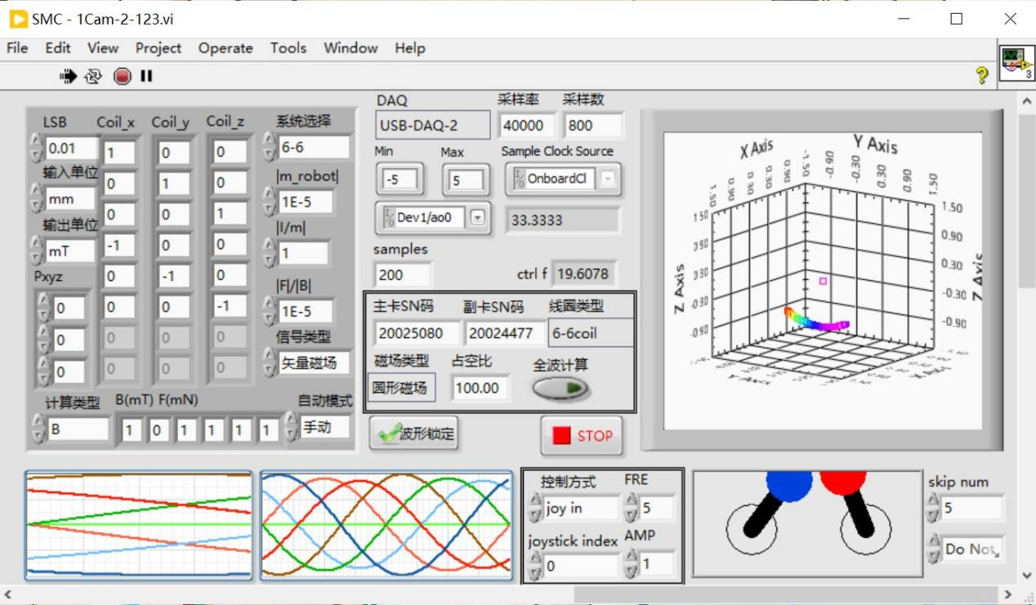
Figure S2 The photo of the three-dimensional motion control program interface.

Figure S3 The cutting movement speed of the Helixbot in porcine lenses.
Figure S4 Lens segmentation by helixbot across cataract severity grades under microwave exposure a Helixbot performing cutting operations in the lens with mild cataract (3-second microwave exposure); b Helixbot performing cutting operations in the lens with moderate cataract (5-second microwave exposure); c Helixbot performing cutting operations in the lens with severe cataract (7-second microwave exposure)

Figure S5 Investigation of helixbot rotational characteristic across different Grades of cataract severity a Helixbot executing rotational maneuvers within untreated lens; b Helixbot executing rotational maneuvers within mild-grade cataract lens (3-second microwave exposure); c Helixbot executing rotational maneuvers within moderate-grade cataract lens (5-second microwave exposure); d Helixbot executing rotational maneuvers within severe-grade cataract lens (7-second microwave exposure)

Figure S6 Helixbot-mediated deep intranuclear segmentation a Helixbot executing deep segmentation within mild-grade cataract in porcine lens (3-second microwave exposure); b Helixbot executing deep segmentation within moderate-grade cataract in porcine lens (5-second microwave exposure); c Helixbot executing deep segmentation within severe-grade cataract in porcine lens (7-second microwave exposure);

