Phytochemical Profiling, Network Pharmacology, and Molecular Dynamics Simulations of Sinularia levi Metabolites as Potent α-Glucosidase Inhibitors in Metabolic Syndrome
Basma Khalaf Mahmoud^{1≠}, Mamdouh Nabil Samy^{1≠}, Francisco Les^{2,3}, Hesham A. Abou-Zied⁴, Nada M. Mostafa⁵*, Hashem A Madkour⁶, Elsayed A.E. Hamed⁷, Mostafa E. Rateb⁸, Usama Ramadan Abdelmohsen^{1,9}*, and Hanaa Bahaa Elkhouly¹

¹ Department of Pharmacognosy, Faculty of Pharmacy, Minia University, 61519 Minia, Egypt
² Department of Pharmacy, Faculty of Health Sciences, Universidad San Jorge, 50830 Zaragoza, Spain
³ Instituto Agroalimentario de Aragón-IA2, CITA-Universidad de Zaragoza, 50059 Zaragoza, Spain
⁴Department of Medicinal Chemistry, Faculty of Pharmacy, Deraya University, Minia 61111, Egypt. hisham.alaa@deraya.edu.eg
⁵Department of Pharmacognosy, Faculty of Pharmacy, Ain Shams University, Cairo 11566, Egypt.
⁶Department of Marine and environmental Geology, National institute of oceanography and Fisheries Red Sea Branch 84511 Hurghada, Egypt
⁷National institute of oceanography and Fisheries, Hurghada-Red Sea (NIOF) 84511, Egypt
⁸Natural and Medical Sciences Research Center, University of Nizwa, P. O. Box 33, Birkat Al Mauz, Nizwa, Oman
⁹Department of Pharmacognosy, Faculty of Pharmacy, Deraya University, 61111 New Minia, Egypt.

≠Those authors have equally contributed.
*Correspondence:
(U.R.A.) E-mail: Usama.ramadan@mu.edu.eg; Fax: +20-086-2369075; Tel: +20-086-2347759
(N.M.M.) E-mail: nadamostafa@pharma.asu.edu.eg; Tel: +20-1011779590

Abstract:
This study has investigated the phytochemical composition and therapeutic potential of the Red Sea soft coral Sinularia levi. Five compounds (1-5) comprising three glyceryl derivatives, a ceramide, and a diterpene were isolated and characterized. To elucidate their role in metabolic syndrome, an integrated network pharmacology and structure-based modelling workflow was employed. This approach identified 45 shared targets between S. levi metabolites and disease proteins, clustered into inflammatory and metabolic nodes, with α-glucosidase (GAA) emerging as a primary target. Molecular docking against GAA (PDB: 5NN8) identified glyceryl nonacosanol (2) as the most potent ligand (–8.5 kcal/mol), stabilized by a unique glycerol-head polar clamp involving Glu139 and Lys137. The stability of this complex was confirmed through a 100-ns MD simulation, which demonstrated sustained equilibrium and persistent hydrogen bonding. In vitro assays revealed that the total extract possesses significant antioxidant activity (DPPH IC₅₀​ = 18.66 μg/mL), the isolated compounds exhibited selective enzyme inhibition. In which, Glyceryl nonacosanol (2) proved to be the most effective α-glucosidase inhibitor (IC₅₀​=326.77 μg/mL), whereas glyceryl pentacosanoate (5) showed the highest activity against pancreatic lipase (IC₅₀​= 170.75 μg/mL). These findings suggest that S. levi metabolites, particularly glyceryl nonacosanol, represent promising leads for managing postprandial glucose levels.
Keywords: Sinularia levi; network pharmacology; antioxidant; lipase inhibitor; α-glucosidase.
Compound 1 Glyceryl tridecyloxy nonanoate 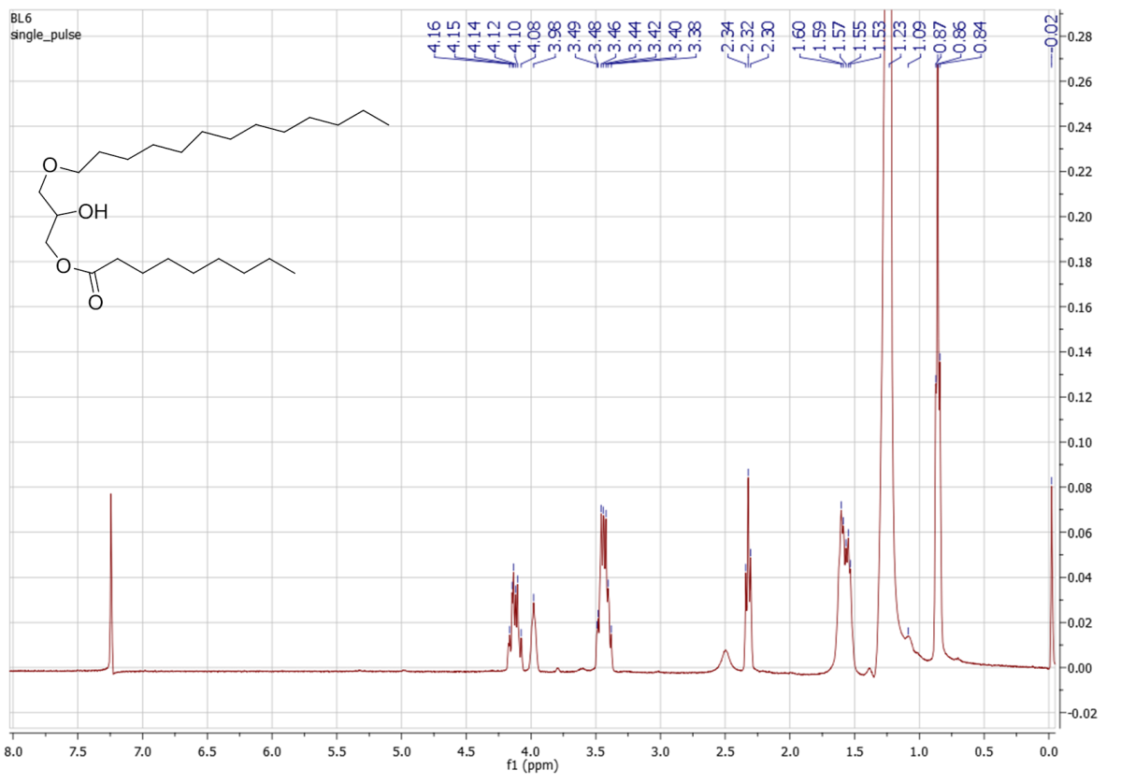
Figure S1^{: 1}H-NMR spectrum of Compound 1 (400 MHz, CDCl₃)

Figure S2^{: 13}C-NMR spectrum of Compound 1 (CDCl₃, 100 MHz)
Figure S3: HMQC spectrum of Compound 1.
Figure S4: HMBC spectrum of Compound 1.
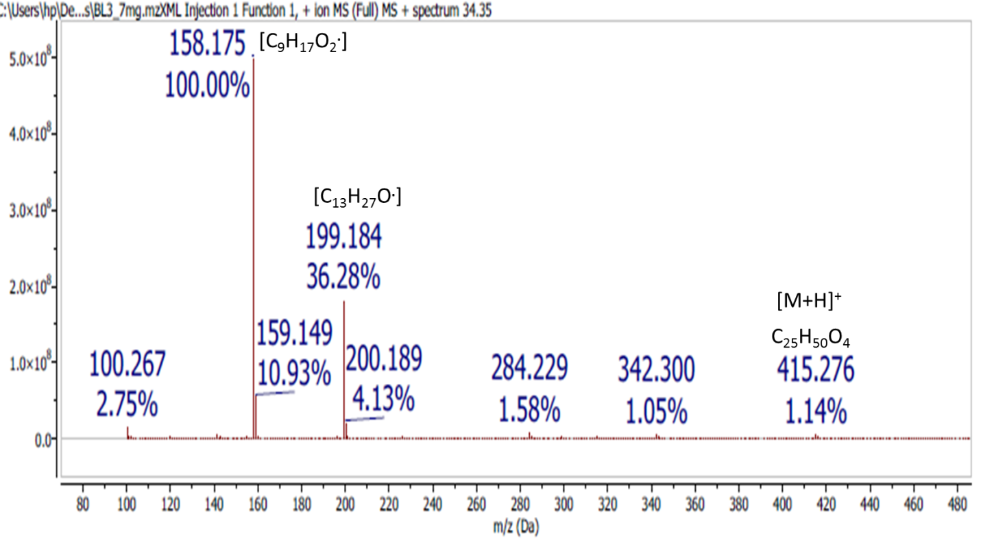
Figure S5: HR-ESI-MS positive ion mode mass spectrum of Compound 1.

Compound 2 (Glyceryl nonacosanol)
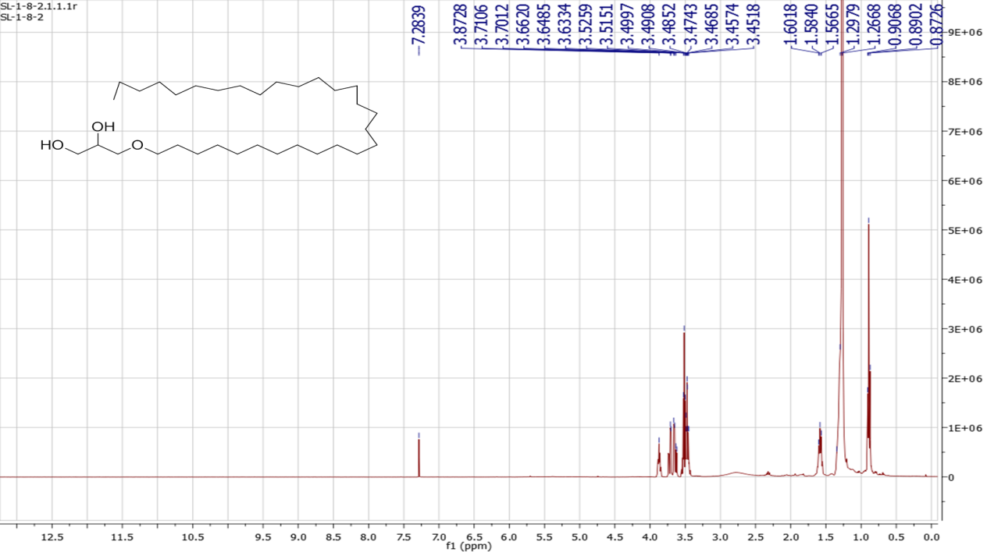
Figure S6^{: 1}H-NMR spectrum of Compound 2 (400 MHz, CDCl₃)

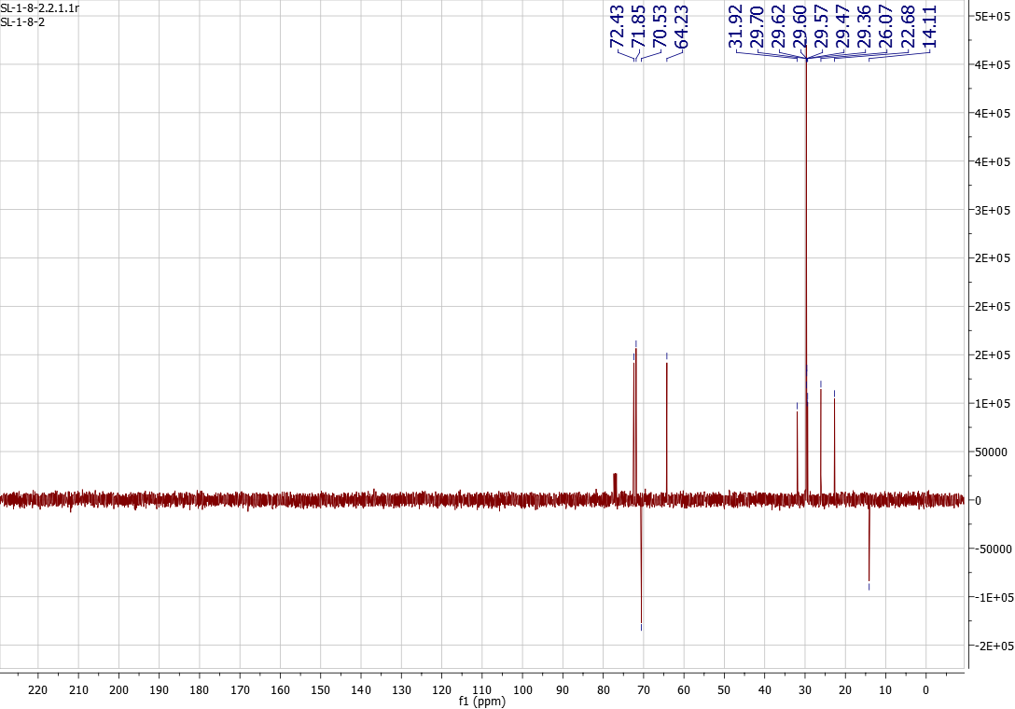
Figure S7: APT spectrum of Compound 2 (100 MHz, CDCl₃)
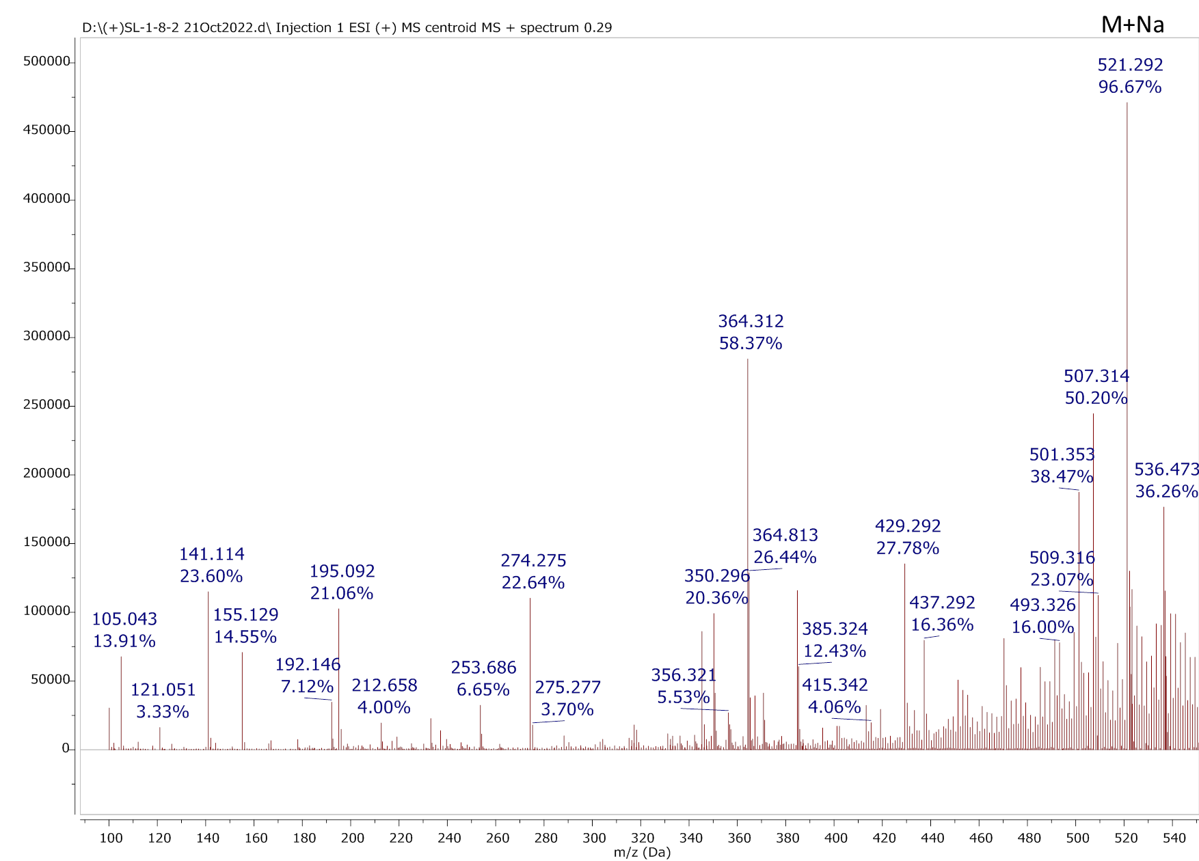
Figure S8: HR-ESI-MS positive ion mode mass spectrum of Compound 2.

Compound 3 (Sinumaximol G)
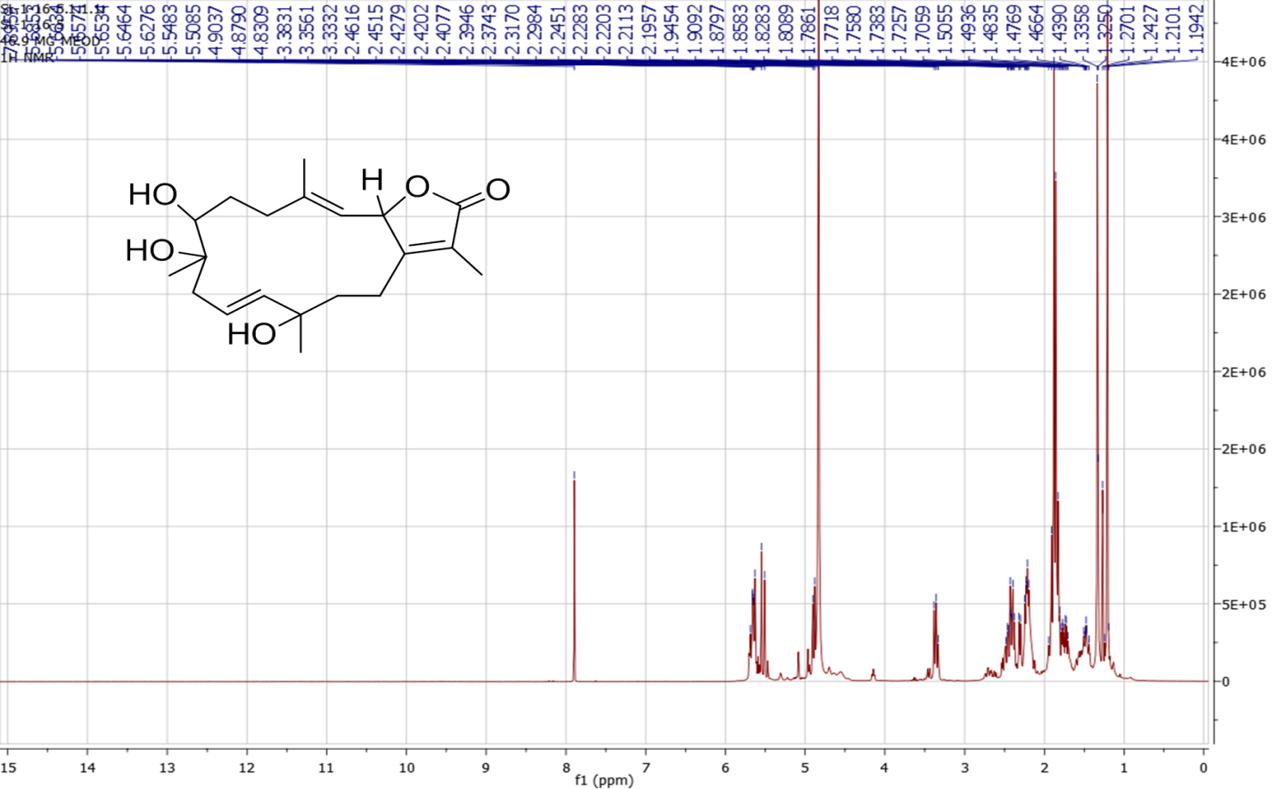
Figure S9^{: 1}H-NMR spectrum of Compound 3 (400 MHz, CDCl₃)

Figure S10^{: 13}C-NMR spectrum of Compound 3 (100 MHz, CDCl₃).

Figure S11: DEPT spectrum of Compound 3 (100 MHz, CDCl₃).

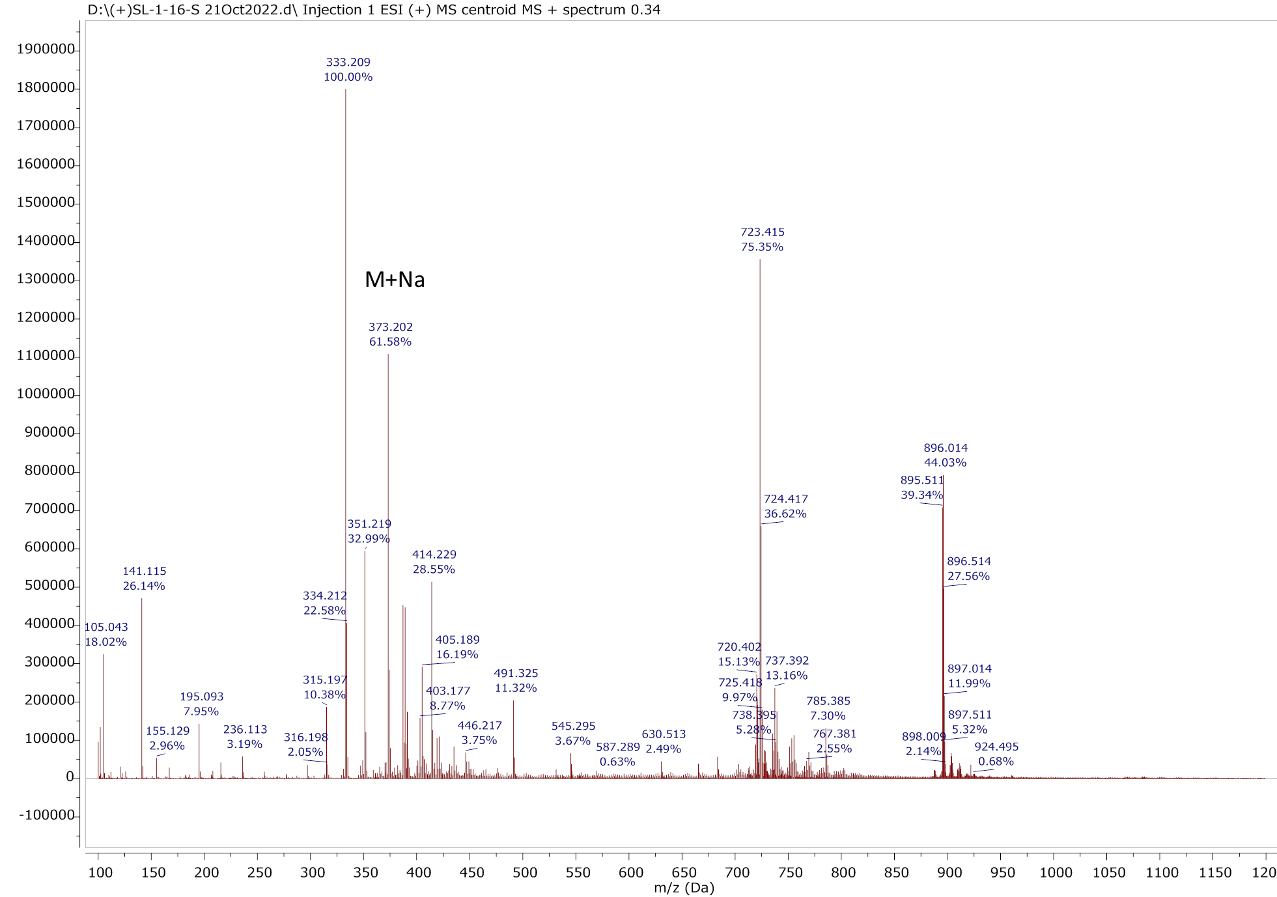
Figure S12: HR-ESI-MS positive ion mode mass spectrum of Compound 3.

Compound 4 (N-palmitoyloctadecasphinga-4(E),8(E)-dienine)
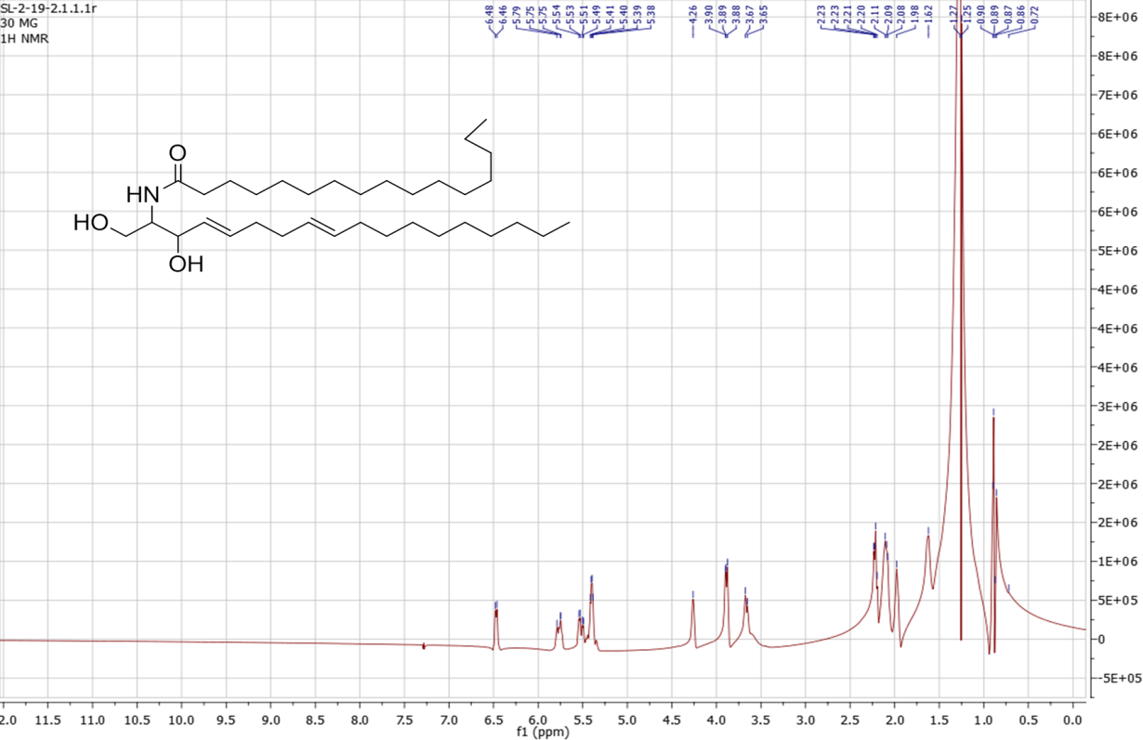
Figure S13^{: 1}H-NMR spectrum of Compound 4 (400 MHz, CDCl₃).

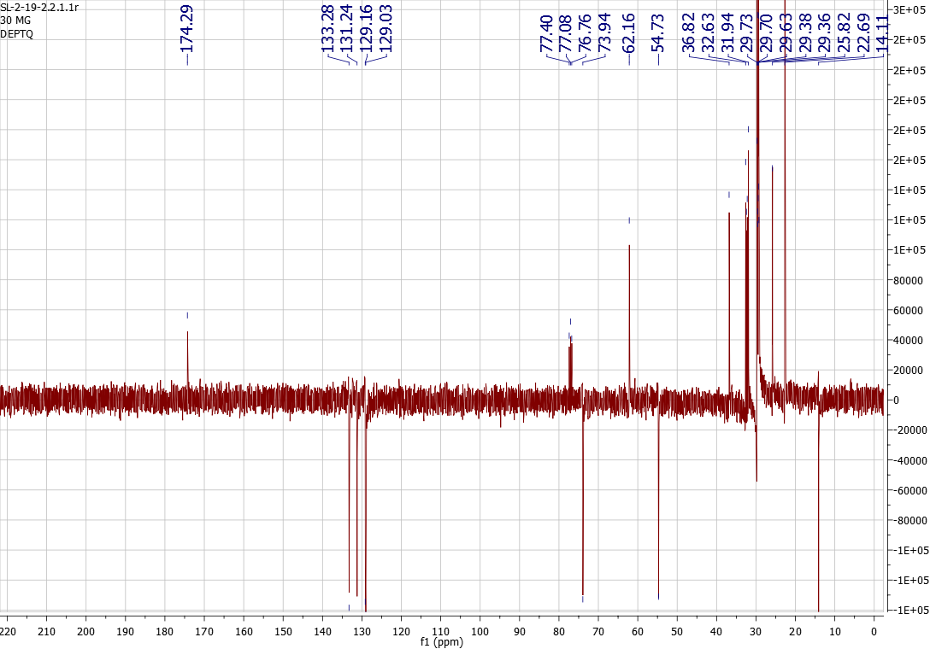
Figure S14: DEPT-Q spectrum of Compound 4 (100 MHz, CDCl₃).

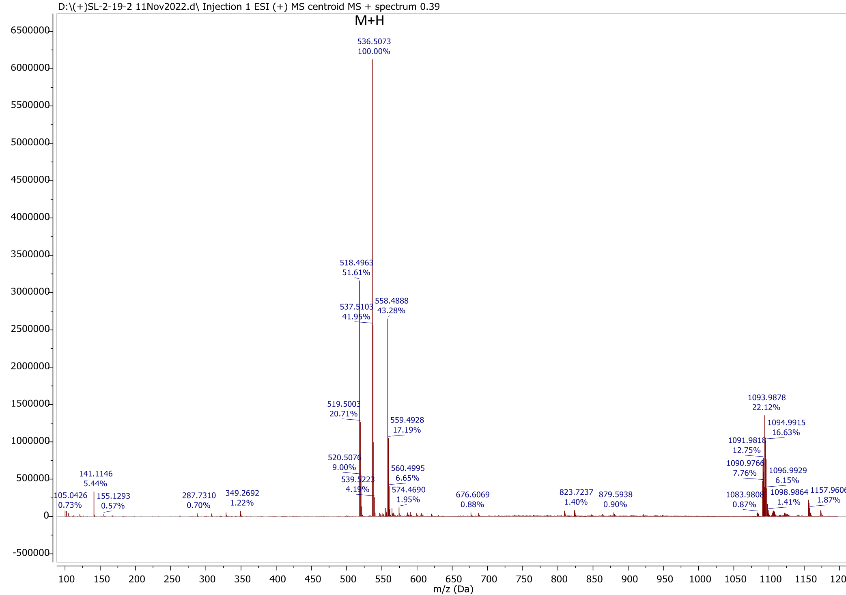
Figure S15: HR-ESI-MS positive ion mode mass spectrum of Compound 4.

Compound 5 (Glyceryl pentacosanoate)
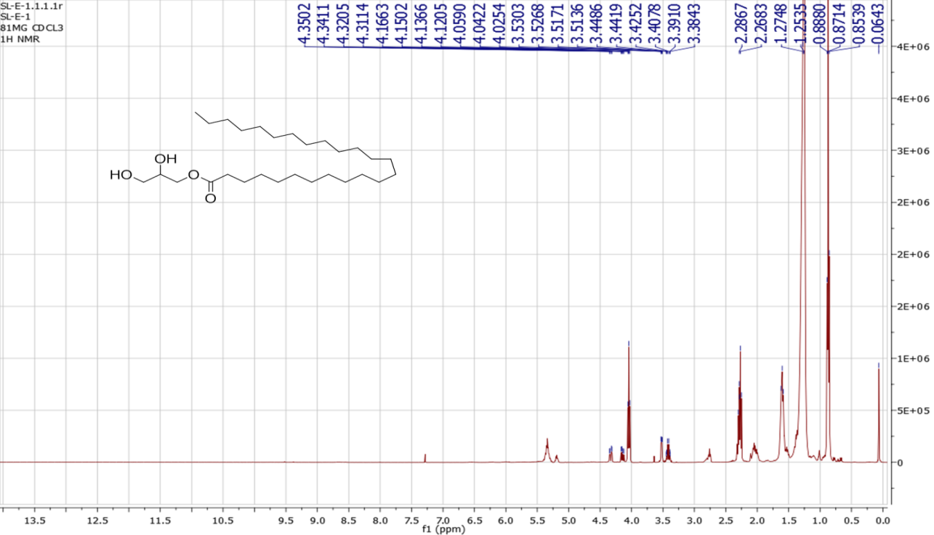
Figure S16^{: 1}H-NMR spectrum of Compound 5 (400 MHz, CDCl₃)

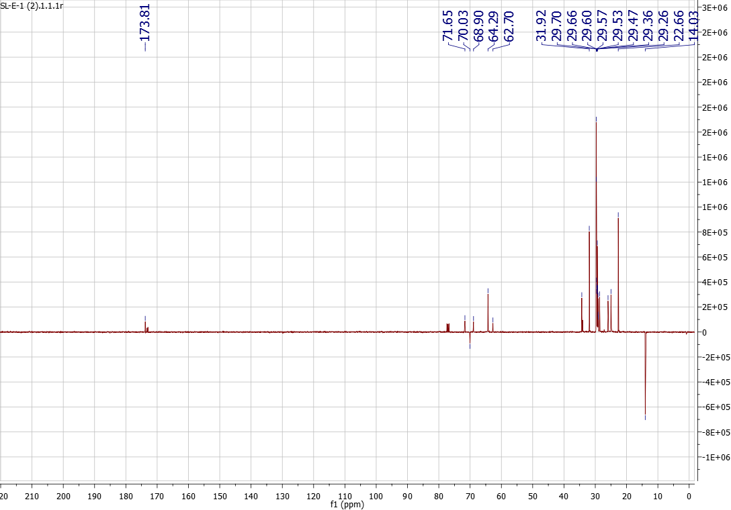
Figure S17: APT spectrum of Compound 5 (100 MHz, CDCl₃)
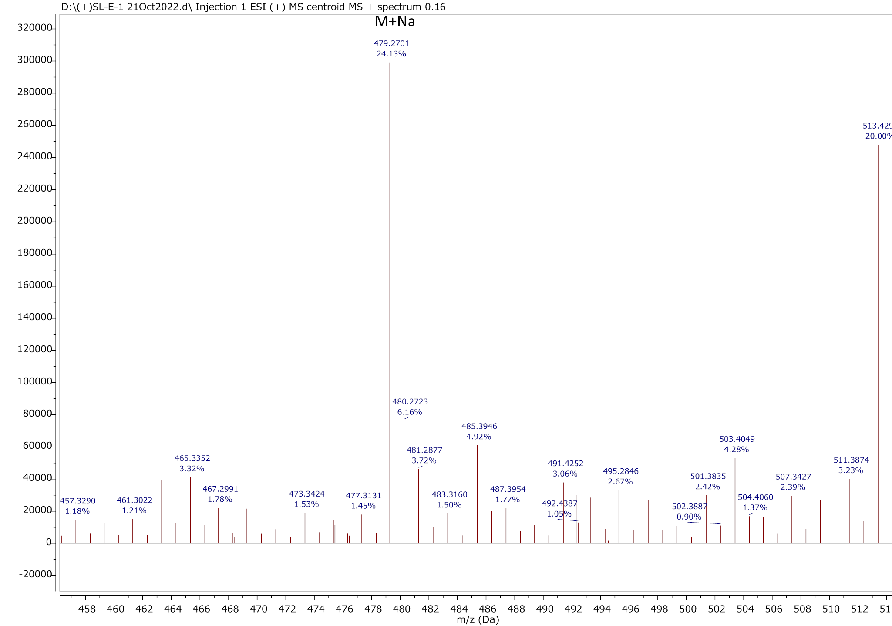
Figure S18: HR-ESI-MS positive ion mode mass spectrum of Compound 5.

Table S1: List of proteins related to metabolic syndrome.
Protein
PNLIP (Pancreatic Lipase)
MGAM (Maltase-Glucoamylase)
AMY2A (Alpha-Amylase 2A)
GAA (Acid Alpha-Glucosidase)
INSR (Insulin Receptor)
IRS1 (Insulin Receptor Substrate 1)
IRS2 (Insulin Receptor Substrate 2)
PIK3CA (Phosphatidylinositol-4,5-Bisphosphate 3-Kinase Catalytic Subunit Alpha)
AKT2 (RAC-Beta Serine/Threonine-Protein Kinase)
FOXO1 (Forkhead Box Protein O1)
PPARG (Peroxisome Proliferator-Activated Receptor Gamma)
PPARA (Peroxisome Proliferator-Activated Receptor Alpha)
PRKAA1 (5'-AMP-Activated Protein Kinase Catalytic Subunit Alpha-1)
SREBF1 (Sterol Regulatory Element-Binding Transcription Factor 1)
SREBF2 (Sterol Regulatory Element-Binding Transcription Factor 2)
LPL (Lipoprotein Lipase)
APOE (Apolipoprotein E)
MTOR (Mechanistic Target of Rapamycin Kinase)
MST1R (Macrophage Stimulating 1 Receptor)
TNF (Tumor Necrosis Factor)
IL6 (Interleukin 6)
SOCS3 (Suppressor of Cytokine Signaling 3)
MAPK8 (Mitogen-Activated Protein Kinase 8)
PTEN (Phosphatase and Tensin Homolog)
ROCK1 (Rho Associated Coiled-Coil Containing Protein Kinase 1)
GSK3B (Glycogen Synthase Kinase 3 Beta)
SLC2A4 (Solute Carrier Family 2 Member 4)
FABP4 (Fatty Acid Binding Protein 4)
LEP (Leptin)
ADIPOQ (Adiponectin)
CEBPA (CCAAT Enhancer Binding Protein Alpha)
CEBPB (CCAAT Enhancer Binding Protein Beta)
LIPE (Hormone-Sensitive Lipase)
DGAT2 (Diacylglycerol O-Acyltransferase 2)
ACLY (ATP Citrate Lyase)
SCD1 (Stearoyl-CoA Desaturase 1)
ACADM (Acyl-CoA Dehydrogenase Medium Chain)
UCP1 (Uncoupling Protein 1)
SIRT1 (NAD-Dependent Protein Deacetylase Sirtuin 1)
GLP1R (Glucagon-Like Peptide 1 Receptor)
TOP1 (DNA Topoisomerase I)
TOP2A (DNA Topoisomerase II Alpha)
TOP2B (DNA Topoisomerase II Beta)
KDR (Vascular Endothelial Growth Factor Receptor 2)
CYP19A1 (Aromatase)
ADIPOQ (Adiponectin)
LEPR (Leptin Receptor)
FTO (Fat Mass and Obesity-Associated Protein)
MC4R (Melanocortin 4 Receptor)
SLC2A2 (Solute Carrier Family 2 Member 2)
SLC2A1 (Solute Carrier Family 2 Member 1)
PPARD (Peroxisome Proliferator-Activated Receptor Delta)
NR1H3 (Nuclear Receptor Subfamily 1 Group H Member 3 / Liver X Receptor Alpha)
NR1H2 (Nuclear Receptor Subfamily 1 Group H Member 2 / Liver X Receptor Beta)
CPT1A (Carnitine Palmitoyltransferase 1A)
ACACA (Acetyl-CoA Carboxylase Alpha)
ACACB (Acetyl-CoA Carboxylase Beta)
FASN (Fatty Acid Synthase)
HMGCR (3-Hydroxy-3-Methylglutaryl-CoA Reductase)
FABP2 (Fatty Acid Binding Protein 2)
ANGPTL4 (Angiopoietin Like 4)
PLIN1 (Perilipin 1)
SREBF1C (Sterol Regulatory Element-Binding Protein 1C Isoform)
GCK (Glucokinase)
PDK4 (Pyruvate Dehydrogenase Kinase 4)

Table S2. Results of the Swiss-based target prediction for compound 1.
NO. | Name
1 | 11-beta-hydroxysteroid dehydrogenase 1
2 | 6-phosphofructo-2-kinase/fructose-2,6-bisphosphatase 3
3 | Acetylcholinesterase
4 | Acetyl-CoA carboxylase 2
5 | Acid alpha-glucosidase
6 | ADAMTS5
7 | Adenosine A1 receptor (by homology)
8 | Adenosine A3 receptor
9 | Adrenergic receptor beta
10 | Alpha-amylase 2A
11 | Beta-1 adrenergic receptor
12 | Beta-3 adrenergic receptor
13 | Bradykinin B2 receptor
14 | Brain adenylate cyclase 1
15 | Carbonic anhydrase I
16 | Carbonic anhydrase II
17 | Carnitine O-palmitoyltransferase 1, liver isoform (by homology)
18 | Caspase-3
19 | Caspase-6
20 | Caspase-7
21 | Cyclooxygenase-2
22 | Cyclophilin A
23 | Cytochrome P450 19A1
24 | Delta opioid receptor
25 | Dual specificity phosphatase Cdc25A
26 | Dual specificity protein phosphatase 3
27 | Epidermal growth factor receptor erbB1
28 | Estrogen receptor alpha
29 | Forkhead box protein O1
30 | Gamma-secretase
31 | Glucose transporter
32 | Glutaminase kidney isoform, mitochondrial
33 | Hexokinase type IV
34 | Histone deacetylase 3
35 | HMG-CoA reductase (by homology)
36 | Induced myeloid leukemia cell differentiation protein Mcl-1
37 | Insulin receptor
38 | Insulin receptor substrate 1
39 | Insulin receptor substrate 2
40 | Kappa Opioid receptor
41 | Leukocyte elastase
42 | Low molecular weight phosphotyrosine protein phosphatase
43 | Lysophosphatidic acid receptor 4
44 | Lysophosphatidic acid receptor 5
45 | Lysophosphatidic acid receptor 6
46 | Lysophosphatidic acid receptor Edg-2
47 | Lysophosphatidic acid receptor Edg-4
48 | Lysophosphatidic acid receptor Edg-7
49 | Macrophage colony stimulating factor receptor
50 | Maltase-glucoamylase
51 | MAP kinase ERK2
52 | Mu opioid receptor
53 | NAD-dependent deacetylase sirtuin 2
54 | Pancreatic lipase
55 | Pepsinogen C
56 | Peptidyl-glycine alpha-amidating monooxygenase
57 | P-glycoprotein 1
58 | Phosphatidylinositol 4,5-bisphosphate 3-kinase catalytic subunit alpha
59 | Phosphodiesterase 4B
60 | Phospholipase A2 group IIA
61 | Phospholipase A2 group V
62 | PI3-kinase p110-alpha subunit
63 | PI3-kinase p110-gamma subunit
64 | Platelet activating factor receptor (by homology)
65 | Prolyl endopeptidase
66 | Protein kinase C alpha
67 | Protein kinase C delta
68 | Protein kinase C epsilon
69 | Protein kinase C eta (by homology)
70 | Protein kinase C gamma
71 | Protein kinase C theta
72 | Protein phosphatase 2C beta
73 | Proteinase-activated receptor 1
74 | Protein-tyrosine phosphatase 1B
75 | Purinergic receptor P2Y12
76 | RAC-beta serine/threonine-protein kinase
77 | Receptor protein-tyrosine kinase erbB-2
78 | Renin
79 | Serine/threonine protein phosphatase PP1-alpha catalytic subunit
80 | Serine/threonine protein phosphatase PP1-gamma catalytic subunit
81 | Serine/threonine-protein kinase Aurora-A
82 | Serine/threonine-protein kinase mTOR
83 | Serine/threonine-protein phosphatase
84 | Stem cell growth factor receptor
85 | Transient receptor potential cation channel subfamily V member 4 (by homology)
86 | Tyrosine-protein kinase BTK
87 | Tyrosine-protein kinase ITK/TSK
88 | Tyrosine-protein kinase receptor FLT3
89 | Tyrosine-protein kinase SRC
90 | UDP-glucuronosyltransferase 2B7
91 | Vascular endothelial growth factor receptor 1
92 | Vascular endothelial growth factor receptor 2
93 | Vascular endothelial growth factor receptor 3
94 | Vitamin D receptor

Table S3. Results of the Swiss-based target prediction for compound 2.
NO. | Name
1 | Beta-glucocerebrosidase (by homology)
2 | Cytochrome P450 19A1
3 | Protein kinase C alpha
4 | Protein kinase C epsilon
5 | Protein kinase C theta
6 | Protein kinase C eta (by homology)
7 | Protein kinase C gamma (by homology)
8 | DNA polymerase alpha subunit
9 | Dual specificity phosphatase Cdc25A
10 | Acyl coenzyme A:cholesterol acyltransferase
11 | Protein kinase C delta (by homology)
12 | Gamma-secretase
13 | Heat shock protein HSP 90-alpha
14 | NAD-dependent deacetylase sirtuin 2
15 | P-glycoprotein 1
16 | Cannabinoid receptor 1 (by homology)
17 | Vascular endothelial growth factor A
18 | Acidic fibroblast growth factor
19 | Basic fibroblast growth factor
20 | Heparanase
21 | UDP-glucuronosyltransferase 2B7
22 | Peptidyl-glycine alpha-amidating monooxygenase
23 | Dynamin-1
24 | HMG-CoA reductase (by homology)
25 | 11-beta-hydroxysteroid dehydrogenase 1 (by homology)
26 | Acetylcholinesterase
27 | Sonic hedgehog protein (by homology)
28 | Cytochrome P450 51 (by homology)
29 | Niemann-Pick C1-like protein 1
30 | Galectin-4
31 | Galectin-3
32 | Galectin-8
33 | Transient receptor potential cation channel subfamily V member 4 (by homology)
34 | Carnitine O-palmitoyltransferase 1, liver isoform (by homology)
35 | Cannabinoid receptor 2
36 | Protein phosphatase 2C beta
37 | Protein-tyrosine phosphatase 1B
38 | Serine/threonine protein phosphatase PP1-gamma catalytic subunit
39 | Cyclin-dependent kinase 1
40 | Lysophosphatidic acid receptor 6
41 | Lysophosphatidic acid receptor Edg-7
42 | Lysophosphatidic acid receptor Edg-4
43 | Lysophosphatidic acid receptor Edg-2
44 | Lysophosphatidic acid receptor 5
45 | Lysophosphatidic acid receptor 4
46 | Cathepsin K
47 | Cathepsin L
48 | Cathepsin (B and K)
49 | Phosphodiesterase 4D
50 | Vitamin D receptor
51 | Carboxylesterase 2
52 | Nuclear receptor ROR-gamma
53 | Carbonic anhydrase II
54 | Carbonic anhydrase I
55 | Estradiol 17-beta-dehydrogenase 3
56 | Kappa Opioid receptor
57 | Serine/threonine-protein phosphatase
58 | Serine/threonine protein phosphatase PP1-alpha catalytic subunit
59 | Serotonin 2b (5-HT2b) receptor
60 | Alpha-2a adrenergic receptor
61 | Adrenergic receptor alpha-2
62 | Alpha-2b adrenergic receptor
63 | Dopamine D1 receptor
64 | Dopamine D2 receptor
65 | Alpha-1d adrenergic receptor
66 | Serotonin 2a (5-HT2a) receptor
67 | Serotonin 2c (5-HT2c) receptor
68 | Dopamine D3 receptor
69 | Cytochrome P450 2D6
70 | Serotonin 6 (5-HT6) receptor
71 | Alpha-1a adrenergic receptor (by homology)
72 | Serotonin 1b (5-HT1b) receptor (by homology)
73 | Anandamide amidohydrolase
74 | Signal transducer and activator of transcription 3
75 | Peroxisome proliferator-activated receptor gamma
76 | Peroxisome proliferator-activated receptor alpha
77 | 5'-AMP-activated protein kinase catalytic subunit alpha-1
78 | Sterol regulatory element-binding protein 1
79 | Sterol regulatory element-binding protein 2
80 | Lipoprotein lipase
81 | Apolipoprotein E
82 | Serine/threonine-protein kinase mTOR
83 | Macrophage-stimulating protein receptor
84 | Tumor necrosis factor

Table S4. Results of the Swiss-based target prediction for compound 3.
NO. | Name
1 | Acid ceramidase (by homology)
2 | ADAM17
3 | Adenosine A1 receptor (by homology)
4 | Adiponectin
5 | Adrenergic receptor beta
6 | ALK tyrosine kinase receptor
7 | Androgen Receptor
8 | Beta amyloid A4 protein
9 | Beta-1 adrenergic receptor
10 | Beta-3 adrenergic receptor
11 | Bromodomain-containing protein 2
12 | Bromodomain-containing protein 4
13 | C-C chemokine receptor type 1
14 | CDC7/DBF4 (Cell division cycle 7-related protein kinase/Activator of S phase kinase)
15 | CREB-binding protein/p53
16 | Cyclin-dependent kinase 2
17 | Cyclin-dependent kinase 5/CDK5 activator 1
18 | Cyclin-dependent kinase 9
19 | Cyclooxygenase-2
20 | Cytochrome P450 19A1
21 | DNA-dependent protein kinase
22 | Dual serine/threonine and tyrosine protein kinase
23 | Dual specificity mitogen-activated protein kinase kinase 1
24 | Ephrin receptor
25 | Eukaryotic translation initiation factor 2-alpha kinase 3
26 | Fatty acid-binding protein, adipocyte
27 | FK506-binding protein 1A
28 | G protein-coupled receptor kinase 7
29 | Gamma-secretase
30 | Glycogen synthase kinase 3 beta
31 | Homeodomain-interacting protein kinase 4
32 | Hormonally up-regulated neu tumor-associated kinase
33 | Interleukin-6
34 | Interleukin-8 receptor A
35 | Interleukin-8 receptor B
36 | Kappa Opioid receptor
37 | Kinesin-1 heavy chain/ Tyrosine-protein kinase receptor RET
38 | Leptin
39 | Leucine-rich repeat serine/threonine-protein kinase 2
40 | Liver glycogen phosphorylase
41 | Macrophage colony stimulating factor receptor
42 | MAP kinase ERK2
43 | MAP kinase p38 alpha
44 | MAP kinase signal-integrating kinase 2
45 | Matrix metalloproteinase 1
46 | Matrix metalloproteinase 2
47 | Matrix metalloproteinase 3
48 | Microtubule-associated serine/threonine-protein kinase 1
49 | Mitogen-activated protein kinase 8
50 | Mitogen-activated protein kinase kinase kinase 12
51 | Mitogen-activated protein kinase kinase kinase 13
52 | Mitogen-activated protein kinase kinase kinase 15
53 | Myeloperoxidase
54 | Nerve growth factor receptor Trk-A
55 | p53-binding protein Mdm-2
56 | Peroxisome proliferator-activated receptor gamma
57 | P-glycoprotein 1
58 | Phosphatase and tensin homolog
59 | Platelet-derived growth factor receptor beta
60 | Poly [ADP-ribose] polymerase-1
61 | Potassium-transporting ATPase alpha chain 2
62 | Presenilin 1
63 | Presenilin 2
64 | Progesterone receptor
65 | Protein kinase C alpha
66 | Protein kinase C epsilon
67 | Protein-tyrosine phosphatase 1B
68 | Rho-associated protein kinase 1
69 | Ribosomal protein S6 kinase alpha 5
70 | Serine/threonine-protein kinase 38
71 | Serine/threonine-protein kinase ICK
72 | Serine/threonine-protein kinase OSR1
73 | Serine/threonine-protein kinase PIM1
74 | Serine/threonine-protein kinase PIM2
75 | Serine/threonine-protein kinase PRP4 homolog
76 | Serine/threonine-protein kinase SBK1
77 | Serine/threonine-protein kinase/endoribonuclease IRE1
78 | Serotonin 2b (5-HT2b) receptor
79 | SNF-related serine/threonine-protein kinase
80 | Sodium channel protein type IX alpha subunit
81 | Solute carrier family 2, facilitated glucose transporter member 4
82 | STE20/SPS1-related proline-alanine-rich protein kinase
83 | Stem cell growth factor receptor
84 | Suppressor of cytokine signaling 3
85 | Transketolase
86 | Tubulin--tyrosine ligase
87 | Tyrosine-protein kinase ABL
88 | Tyrosine-protein kinase FYN
89 | Tyrosine-protein kinase JAK1
90 | Tyrosine-protein kinase JAK2
91 | Tyrosine-protein kinase JAK3
92 | Tyrosine-protein kinase LCK
93 | Tyrosine-protein kinase SYK
94 | Tyrosine-protein kinase TYK2
95 | Vascular endothelial growth factor receptor 1
96 | Vascular endothelial growth factor receptor 2
97 | Vascular endothelial growth factor receptor 3
98 | Voltage-gated potassium channel subunit Kv1.5

Table S5. Results of the Swiss-based target prediction for compound 4.
NO. | Name
1 | 11-beta-hydroxysteroid dehydrogenase 1
2 | 11-beta-hydroxysteroid dehydrogenase 2 (by homology)
3 | 2-acylglycerol O-acyltransferase 2
4 | 6-phosphofructo-2-kinase/fructose-2,6-bisphosphatase 3
5 | Adrenergic receptor alpha-2
6 | Aldehyde dehydrogenase
7 | ALK tyrosine kinase receptor
8 | Alpha-1a adrenergic receptor
9 | Alpha-1b adrenergic receptor
10 | Anandamide amidohydrolase
11 | Angiotensin-converting enzyme (by homology)
12 | Apoptosis regulator Bcl-2
13 | ATP-citrate synthase
14 | Autotaxin
15 | Butyrylcholinesterase
16 | Cannabinoid receptor 1
17 | Cannabinoid receptor 2
18 | CCAAT/enhancer-binding protein alpha
19 | CCAAT/enhancer-binding protein beta
20 | c-Jun N-terminal kinase 1
21 | Cyclin-dependent kinase 2
22 | Cyclin-dependent kinase 2/cyclin E
23 | Delta opioid receptor (by homology)
24 | Diacylglycerol O-acyltransferase 2
25 | Dopamine D2 receptor
26 | Dopamine D3 receptor
27 | Dopamine D4 receptor
28 | Dopamine transporter
29 | Dual specificity phosphatase Cdc25A
30 | Dual specificity phosphatase Cdc25B
31 | Dual specificity protein phosphatase 3
32 | Epoxide hydratase
33 | Estrogen receptor alpha
34 | Glucose-dependent insulinotropic receptor
35 | Glycogen synthase kinase-3 alpha
36 | Gonadotropin-releasing hormone receptor
37 | Hepatocyte growth factor receptor
38 | Histamine H3 receptor
39 | Histone deacetylase 1
40 | Histone deacetylase 3
41 | Hormone-sensitive lipase
42 | Insulin-like growth factor I receptor
43 | Intercellular adhesion molecule (ICAM-1), Integrin alpha-L/beta-2
44 | LXR-alpha
45 | Lysophosphatidic acid receptor Edg-4
46 | MAP kinase p38 alpha
47 | MAP kinase p38 gamma
48 | Medium-chain specific acyl-CoA dehydrogenase
49 | Mitochondrial uncoupling protein 1
50 | Mu opioid receptor (by homology)
51 | Niemann-Pick C1-like protein 1
52 | NPM/ALK (Nucleophosmin/ALK tyrosine kinase receptor)
53 | Peptidyl-prolyl cis-trans isomerase FKBP5
54 | Peroxisome proliferator-activated receptor alpha
55 | Peroxisome proliferator-activated receptor gamma
56 | Phosphodiesterase 4B
57 | PI3-kinase p110-alpha subunit
58 | PI3-kinase p110-gamma subunit
59 | Prostaglandin E synthase
60 | Prostanoid EP2 receptor
61 | Prostanoid EP3 receptor
62 | Prostanoid EP4 receptor
63 | Protein farnesyltransferase
64 | Protein kinase C delta
65 | Protein kinase C epsilon
66 | Protein kinase C eta
67 | Protein kinase C theta
68 | Receptor protein-tyrosine kinase erbB-2
69 | Rho-associated protein kinase 1
70 | Rho-associated protein kinase 2
71 | Ribosomal protein S6 kinase alpha 1
72 | Ribosomal protein S6 kinase alpha 5
73 | Serine/threonine-protein kinase AKT
74 | Serine/threonine-protein kinase AKT
75 | Serine/threonine-protein kinase AKT2
76 | Serine/threonine-protein kinase Chk1
77 | Serine/threonine-protein kinase mTOR
78 | Serotonin 1d (5-HT1d) receptor
79 | Serotonin transporter
80 | Sphingosine 1-phosphate receptor Edg-1
81 | Sphingosine 1-phosphate receptor Edg-3
82 | Sphingosine 1-phosphate receptor Edg-5
83 | Sphingosine kinase 1
84 | Squalene synthetase (by homology)
85 | Stearoyl-CoA desaturase-1
86 | Steroid 5-alpha-reductase 2
87 | TRAF2- and NCK-interacting kinase
88 | Tyrosine-protein kinase HCK
89 | Vanilloid receptor
90 | Vasopressin V1a receptor
91 | Vasopressin V1b receptor
92 | Vitamin D3 receptor-interacting protein

Table S6. Results of the Swiss-based target prediction for compound 5.
NO. | Name
1 | 11-beta-hydroxysteroid dehydrogenase 1
2 | Adrenergic receptor alpha-2
3 | Alpha-1a adrenergic receptor (by homology)
4 | Alpha-1d adrenergic receptor
5 | Alpha-2a adrenergic receptor
6 | Alpha-2b adrenergic receptor
7 | Anandamide amidohydrolase
8 | Androgen Receptor
9 | Arachidonate 5-lipoxygenase
10 | Aromatase (cytochrome P450 19A1)
11 | Autotaxin
12 | Beta-glucocerebrosidase (by homology)
13 | Bile acid receptor FXR
14 | Brain adenylate cyclase 1
15 | Cannabinoid receptor 1 (by homology)
16 | Cannabinoid receptor 2 (by homology)
17 | Carbonic anhydrase I
18 | Carbonic anhydrase II
19 | Carbonic anhydrase IX
20 | Carboxylesterase 2
21 | Carnitine O-palmitoyltransferase 1, liver isoform (by homology)
22 | Chymotrypsin C
23 | Cyclooxygenase-2
24 | Cytochrome P450 19A1
25 | Cytochrome P450 2D6
26 | DNA polymerase alpha subunit
27 | DNA polymerase beta
28 | DNA topoisomerase I
29 | DNA topoisomerase II alpha
30 | DNA topoisomerase II beta
31 | Dopamine D1 receptor
32 | Dopamine D2 receptor
33 | Dopamine D3 receptor
34 | Dual specificity phosphatase Cdc25A
35 | Estradiol 17-beta-dehydrogenase 3
36 | Gamma-secretase
37 | Glucagon-like peptide 1 receptor
38 | Glucose transporter
39 | Glycine receptor subunit alpha-1
40 | Glycine receptor subunit alpha-2
41 | G-protein coupled receptor 55
42 | HMG-CoA reductase (by homology)
43 | Kappa Opioid receptor
44 | Lysophosphatidic acid receptor 4
45 | Lysophosphatidic acid receptor 5
46 | Lysophosphatidic acid receptor 6
47 | Lysophosphatidic acid receptor Edg-2
48 | Lysophosphatidic acid receptor Edg-4
49 | Lysophosphatidic acid receptor Edg-7
50 | Mitochondrial carnitine/acylcarnitine carrier protein
51 | Monoglyceride lipase
52 | Mu opioid receptor
53 | Muscarinic acetylcholine receptor M2
54 | NAD-dependent deacetylase sirtuin 2
55 | NAD-dependent protein deacetylase sirtuin-1
56 | Nitric oxide synthase, inducible (by homology)
57 | Nuclear receptor ROR-gamma
58 | Peptidyl-glycine alpha-amidating monooxygenase
59 | P-glycoprotein 1
60 | Platelet activating factor receptor (by homology)
61 | Probable G-protein coupled receptor 174
62 | Probable G-protein coupled receptor 34
63 | Prolyl endopeptidase
64 | Prostaglandin E synthase
65 | Protein kinase C alpha
66 | Protein kinase C delta (by homology)
67 | Protein kinase C epsilon
68 | Protein kinase C eta (by homology)
69 | Protein kinase C gamma (by homology)
70 | Protein kinase C theta
71 | Protein phosphatase 2C alpha
72 | Protein phosphatase 2C beta
73 | Protein-tyrosine phosphatase 1B
74 | Putative P2Y purinoceptor 10
75 | Serine/threonine protein phosphatase PP1-alpha catalytic subunit
76 | Serine/threonine protein phosphatase PP1-gamma catalytic subunit
77 | Serine/threonine-protein phosphatase
78 | Serotonin 1b (5-HT1b) receptor (by homology)
79 | Serotonin 2a (5-HT2a) receptor
80 | Serotonin 2b (5-HT2b) receptor
81 | Serotonin 2c (5-HT2c) receptor
82 | Serotonin 6 (5-HT6) receptor
83 | Sn1-specific diacylglycerol lipase alpha
84 | T-cell protein-tyrosine phosphatase
85 | Thrombin
86 | Toll-like receptor (TLR7/TLR9)
87 | Transient receptor potential cation channel subfamily V member 4 (by homology)
88 | Trypsin I
89 | UDP-glucuronosyltransferase 2B7
90 | Vanilloid receptor
91 | Vascular endothelial growth factor receptor 2
92 | Vitamin D receptor

Table S7: Docking scores and refinement RMSD values of 5 isolated compounds from Sinularia levi against α-glucosidase.
# | Compound (Manuscript ID) | Docking S-score (kcal/mol) | RMSD (Å)
1 | Glyceryl tridecyloxy nonanoate (1) | –6.5 | 2.7
2 | Glyceryl nonacosanol (2) | –8.5 | 1.2
3 | Sinumaximol G (3) | –6.8 | 2.4
4 | Ceramide (4) | –7.2 | 2.1
5 | Glyceryl pentacosanoate (5) | –7.9 | 1.6
6 | Acarbose (control) | –9.3 | 0.9

