Supplementary Materials
Supplementary Figure 1. Output from ALDEx2 plot
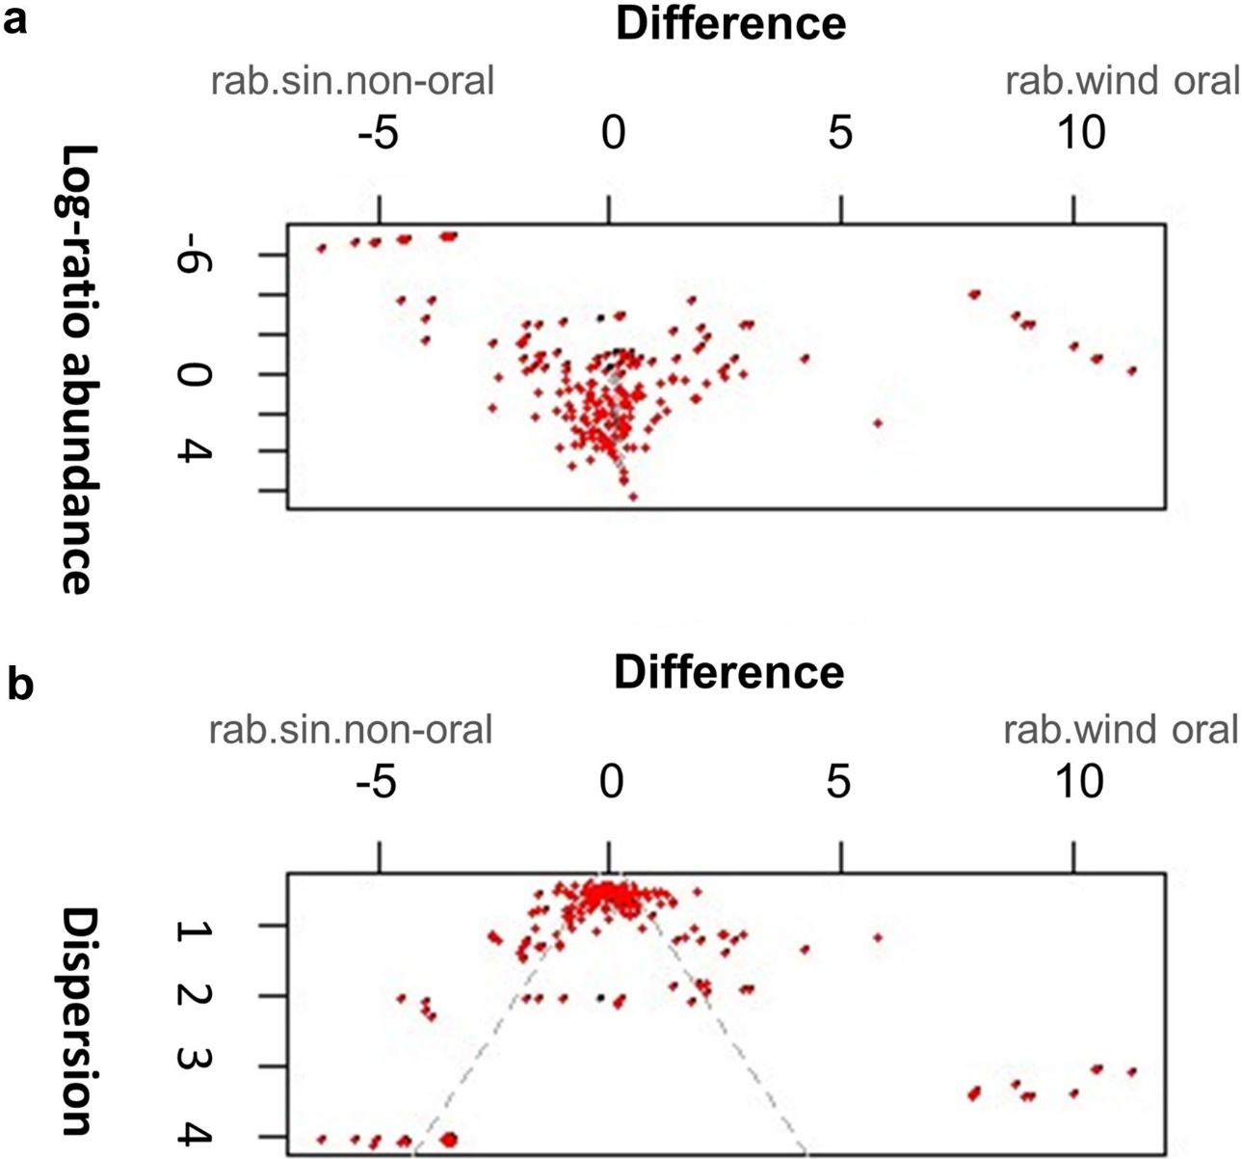

Supplementary Table 1. Gene Ontology (GO)-pathway analysis
Positively correlated genes in oral cancer
Category | ID | Term | Count | P-value | FDR | Genes
BP | GO:0031424 | keratinisation | 8 | 6.82E-07 | 4.08E-04 | SPRR2E, TGM1, LCE3D, SPRR2G, KRT17, SFN, SPRR1B, SPRR2D
BP | GO:0018149 | peptide cross-linking | 8 | 9.09E-07 | 4.08E-04 | SPRR2E, TGM1, LCE3D, SPRR2G, CSTA, C1ORF68, SPRR1B, SPRR2D
BP | GO:0008544 | epidermis development | 9 | 3.27E-06 | 9.79E-04 | SPRR2E, LCE3D, SPRR2G, KRT17, GJB5, C1ORF68, SPRR1B, KRT9, SPRR2D
BP | GO:0030216 | keratinocyte differentiation | 8 | 1.58E-05 | 0.003542843 | SPRR2E, TGM1, LCE3D, SPRR2G, CSTA, C1ORF68, SPRR1B, SPRR2D
CC | GO:0070062 | extracellular exosome | 69 | 1.13E-12 | 2.16E-10 | GLTP, CLIC3, TPMT, ARPC1A, ARPC5L, CBLC, DMKN, METRNL, TGM1, TUBB6, PNP, NAPRT, SH3BGRL3, LGALS7, SERPINB1, ACOT7, GLRX3, PGAM1, IL18, RRAS2, NUTF2, UCHL3, DYNLL1, SDCBP2, TUBA4A, KRT9, CARHSP1, SLPI, DNAJC7, IL1B, UBE2V2, GARS, UBE2V1, S100A9, PPIA, S100A8, OTUB1, CSTB, CSTA, SDC4, GSTP1, GLO1, AK2, GDPD3, SLC3A2, SLC5A10, S100A16, SFN, PI3, S100A14, CD58, MARK3, ATP6V1D, EIF4E, S100A11, S100A10, H3F3B, C1ORF68, TUBB4B, BAIAP2, ERP44, KRT17, EIF6, SH3D21, RNF149, EIF3I, DNAJA2, RAN, SPRR1B
CC | GO:0001533 | cornified envelope | 8 | 3.94E-07 | 3.78E-05 | SPRR2E, TGM1, LCE3D, SPRR2G, CSTA, C1ORF68, SPRR1B, SPRR2D
CC | GO:0005829 | cytosol | 59 | 1.17E-05 | 7.48E-04 | GLTP, TPMT, WDR4, ARPC1A, ADK, PNP, NAPRT, UPP1, CHAC1, NUDT15, DFFA, ACOT7, PGAM1, CTNNBIP1, IL18, NUTF2, CTPS1, DYNLL1, TUBG1, RHOD, TUBA4A, DUS2, IL1A, CARHSP1, PLCB3, DNAJC7, IL1B, GARS, UBE2V1, S100A9, PPIA, S100A8, GSTP1, GLO1, RPL36A, S100A16, LMNA, S100A12, SFN, MARK3, ATP6V1D, EIF4E, PLA2G2F, YARS, TRAPPC3, EIF2B2, CNBP, SIAH2, STARD10, MEMO1, TUBB4B, EIF2S2, BAIAP2, FOSL1, EIF6, EIF3I, PPP2R2D, DNAJA2, RAN
CC | GO:0005737 | cytoplasm | 79 | 6.77E-05 | 0.003249 | GLTP, TEX40, CLIC3, CITED4, WDR4, ADK, ARPC5L, NOC2L, PITPNC1, TUBA1C, TUBB6, PNP, NAPRT, PIP5KL1, SH3BGRL3, UPP1, LGALS7, MFSD2A, BOK, DFFA, SERPINB1, ACOT7, DNAAF3, ACTR5, PGAM1, CTNNBIP1, UCHL3, DYNLL1, TUBG1, SDCBP2, DUS2, ARL4D, DNAJC7, BDH1, MRTO4, UBE2V2, GARS, AKNAD1, UBE2V1, DNAJC8, MDFI, OTUB1, SPRR2E, CSTB, SPRR2G, CSTA, GSTP1, GLO1, SLC3A2, PLCXD1, LCE3D, KLC3, S100A16, LMNA, S100A12, RGS20, SFN, S100A14, EIF4E, S100A11, SPRR2D, UBE2F, YARS, TRAPPC3, PPP1R14C, EIF2B2, BNIP3, SIAH2, C1ORF68, EIF2S2, BAIAP2, TPD52L2, ABTB1, KRT17, EIF6, RPS6KB2, RAN, SPRR1B, MPHOSPH6
MF | GO:0005198 | structural molecule activity | 11 | 2.37E-04 | 0.03579 | SPRR2E, TUBA1C, LCE3D, SPRR2G, CSTA, KRT17, LMNA, C1ORF68, SPRR1B, KRT9, SPRR2D
MF | GO:0005149 | interleukin-1 receptor binding | 4 | 2.81E-04 | 0.03579 | IL1A, IL1B, IL36G, IL36RN
MF | GO:0003743 | translation initiation factor activity | 6 | 3.99E-04 | 0.03579 | EIF1AD, EIF2B2, EIF6, EIF3I, EIF2S2, EIF4E
MF | GO:0003924 | GTPase activity | 10 | 7.02E-04 | 0.0472 | TUBA1C, ARL4D, TUBB6, RRAS2, GNL2, TUBG1, TUBB4B, RHOD, TUBA4A, RAN

Negatively correlated genes in oral cancer
Category | ID | Term | Count | P-Value | FDR | Genes
BP | GO:0007165 | signal transduction | 68 | 7.25E-07 | 0.001679 | NRP1, FAM13B, PDE3B, FAM13A, PTPRM, LIMD1, ITGAL, NR3C2, EPS8, SPN, MRC2, SYDE2, SHE, FGF7, SALL2, TAGAP, PDE4A, SCARF1, PRKACB, IGFBP5, PRKCB, STARD8, NFAM1, UNC5C, ZDHHC17, TLR1, RASA4, LTA, SPARCL1, PDE5A, PGR, ROR2, TLR6, ZNF831, PPP1R12B, DTHD1, PRKAA2, NRXN3, ITPR1, FPR3, PIK3R1, IQGAP2, FYB, INPP5D, SPOCK2, SH3BP5, LPXN, IL12RB1, GABRP, TRAT1, TNFSF12, TNFSF13, NR2F1, LILRB1, NR2F2, LILRB4, GULP1, SMOC2, EVI2A, PDE10A, TNFSF4, IL2RB, FGF18, PI4KA, SARM1, TNFSF8, PDCD1, SIGLEC8
CC | GO:0005887 | integral component of plasma membrane | 700 | 1.02E-04 | 0.02346 | PLXND1, PTPRO, HTR2B, SLC40A1, PTPRM, PTPRJ, LRMP, TSPAN12, PKD2, SLC2A5, ZDHHC2, SLC8A1, SPN, MRC2, GJA5, SLCO2B1, SCN9A, ENPP2, PLXNC1, NEO1, GPR34, TACR2, SLC6A12, TNFRSF1B, TLR1, GJD3, TLR10, ROR2, TLR6, EPHA3, NLGN3, PTGER4, SLC24A1, SLC26A2, SELPLG, SLC26A1, LRP1, HVCN1, NOTCH4, SLC1A1, NRXN3, LPAR1, OPRL1, SLCO5A1, FPR3, SLC7A2, RASGRP3, P2RY8, SYNDIG1, S1PR3, NCKAP1L, GPC4, TIGIT, MSR1, NTRK2, TRAT1, GOLM1, TNFRSF9, TNFSF12, INSR, MERTK, SELP, PTPRC, TNFSF4, IL2RB, SSPN, TNFSF8, PCDHB4, EVI2B, GPR18
CC | GO:0016021 | integral component of membrane | 200 | 1.40E-04 | 0.02346 | SPI1, TMEM200A, LDLRAD4, ZDHHC2, GPR174, GJA5, PAQR8, ENTPD4, ISLR2, SLC6A12, UNC5C, TMEM170B, WBSCR17, SFRP2, KCNQ1, GPR161, ORAI2, EPHA3, LPAR1, TMTC2, FPR3, SLCO5A1, LY9, UGT8, FAM171A1, ZNF708, SLAMF8, SLAMF6, KCNN3, RHBDL3, FZD1, MSR1, FZD7, TNFSF13, SIGLEC10, PARP16, TNFSF4, FXYD6, FAT3, PCDHB4, TNFSF8, ITM2A, TECPR1, GPR18, GAPT, ROBO2, NRP1, PTPRO, PTPRM, PTPRJ, SLC35F1, MRC2, PCLO, KCNT2, RNF150, HAVCR2, GPR34, ELOVL2, FCRL3, NFAM1, TACR2, GAB3, ZDHHC17, ZDHHC15, TLR1, F8, GPRC5B, TLR9, TLR10, MICU3, TLR6, GLCCI1, SLC29A3, PTGER4, LRRC15, SELPLG, LILRA1, KCNA7, ZFP14, FRZB, MGAT3, SUSD3, SUSD5, TP53I11, LAIR1, LRRC25, GABRP, IL10RA, TMEM176B, LILRB1, LILRB4, GPR141, SMOC2, FAM171B, SIGLEC8, MEGF8, SEMA5B, NRROS, GALNT16, TMEM140, SLC8A1, TMEM143, HHAT, GNPTAB, SLCO2B1, FAM198B, ENPP2, ENPP4, SCARA3, LZTFL1, FRMD3, TMX4, MYCN, SLC9A7, MADD, SIDT1, SLC25A53, ROR2, SLC27A2, WDFY4, SLC26A2, SLC26A1, PARM1, KCNE3, SLC41A2, NOTCH4, HVCN1, RNF180, SLC1A1, ITPR1, PLD4, ITPRIPL2, TMEM26, FUT8, ZNF546, VCAM1, WSCD2, TNFRSF9, PTCH1, TMEM132B, RARRES1, SMAD6, SELP, SDK1, PTPRC, TMEM119, PDE3B, HTR2B, SLC40A1, SIRPB2, LRMP, TSPAN12, ITGAL, PKD2, SLC2A5, TMEM220, SPN, LRRTM2, TMEM108, SCARF1, GAL3ST4, PTGIS, PVRIG, PCDHGA3, GRID1, PCDHGA2, KCNAB2, TNFRSF1B, ETV6, PXYLP1, PPP1R12B, NLGN3, SLC24A1, PRKAA2, LRP1, SEMA3D, NRXN3, OPRL1, P2RY8, LRIG1, IL21R, NCAM2, TIGIT, KLRG1, KCNJ5, NTRK2, GALNT5, ZNF804A, TM6SF1, MERTK, SCIMP, HS3ST2, FMNL1, EVI2A, PIK3IP1, MGAT4A, PDCD1, PI16, EVI2B, UNC79
CC | GO:0005886 | plasma membrane | 164 | 2.27E-04 | 0.025464 | NRROS, PLXND1, JADE1, SLA2, ZDHHC2, SLC8A1, GPR174, SLCO2B1, ENPP2, PLCE1, ENPP4, PLXNC1, PRKACB, EPM2A, PAQR8, PRKCB, ISLR2, SLC6A12, UNC5C, IPCEF1, HSPG2, SLC9A7, KCNQ1, MADD, ELMO1, ROR2, SKAP1, EPHA3, SLC26A2, SLC26A1, PARM1, KCNE3, HVCN1, SLC41A2, NOTCH4, SLC1A1, LPAR1, ITPR1, LPL, FPR3, XPC, PIK3R1, LY9, PIK3R6, RASGRP3, PIK3R5, UGT8, RIC8B, NLRP6, PRKAR2B, INPP5D, EPB41L2, LPXN, SLAMF6, KCNN3, PACSIN1, FZD1, MSR1, VCAM1, TGFB3, TNFSF12, INSR, PTCH1, FZD7, SIGLEC10, RAB39B, SELP, SDK1, PTPRC, NBEA, TNFSF4, ITGA11, TMEM119, PI4KA, FAT3, FXYD6, PCDHB4, PLCH1, ITM2A, GPR18, GAPT, MAP3K12, NRP1, KCNC3, ITGB2, PTPRO, HTR2B, SLC40A1, PTPRJ, ITGAL, SLC2A5, PKD2, PIK3CG, SPN, MCF2L, FAM21C, SCARF1, NEO1, ZHX2, PCDHGA3, PVRIG, PCDHGA2, NFAM1, FCRL3, TACR2, IL16, KCNAB2, TNFRSF1B, VAV1, F5, RGMA, TLR1, FGR, F8, GPRC5B, RASA4, TLR9, LTA, TLR10, TLR6, PPP1R12B, PTGER4, SLC24A1, SELPLG, LRP1, MGRN1, RGS16, OPRL1, NTN4, LILRA1, KCNA7, SLC7A2, FYB, P2RY8, MVB12B, SUSD3, S1PR3, NCAM2, SLIT2, GPC4, IL12RB1, LAIR1, KLRG1, RFTN2, TUB, GABRP, KCNJ5, TRAT1, IL10RA, PLCL1, LILRB1, SULF1, MERTK, SNX20, LILRB4, SYT17, GPR141, FMNL1, PIK3IP1, IL2RB, PDCD1, GPD1L, PIK3AP1, UNC79
Negatively correlated genes in oral cancer (Continued)
Category | ID | Term | Count | P-Value | FDR | Genes
MF | GO:0003700 | transcription factor activity, sequence-specific DNA binding | 60 | 2.75E-07 | 1.79E-04 | RERE, ZNF496, SPI1, ZNF490, ZNF43, SIX1, ZNF45, IKZF1, RORB, ELK1, PARK2, IKZF4, NR3C2, SPIB, ZXDA, SALL2, MECOM, ZNF41, ZNF445, LZTS1, SOX4, ZNF641, KLF12, ZHX2, ZFP2, RFX3, MITF, ETV1, RUNX3, HIC1, RUNX2, VAV1, ETV6, PAX1, MYCN, RFX5, IRF8, PGR, ZNF831, NFIX, LEF1, ZFP14, ZBED1, ZNF227, ZNF546, ZNF225, ZNF420, ZBTB18, EGR2, SMAD4, ZNF182, NR2F1, NR2F2, SMAD6, MEIS2, FLI1, POU6F1, ZNF33A, TCF4, ZNF135
MF | GO:0005509 | calcium ion binding | 43 | 4.68E-05 | 0.015185 | SNED1, SLC24A1, MEGF6, LRP1, NOTCH4, LTBP4, ITPR1, PKD2, FBLN2, SLC8A1, FBLN5, THBS4, RASGRP3, SCUBE2, SCUBE3, SCUBE1, SCIN, PCLO, GNPTAB, SPOCK2, MAN1C1, ENPP2, EFHD1, SLIT3, SLIT2, HMCN1, RHBDL3, PLA2G2D, PCDHGA3, PCDHGA2, SULF1, HSPG2, SYT17, SMOC2, MEX3B, EHD3, SPARCL1, PADI2, PCDHB4, MICU3, PLCH1, FAT3, MEGF8
MF | GO:0046872 | metal ion binding | 93 | 1.41E-04 | 0.030535 | ZNF496, NRP1, GALNT16, ZNF490, GFI1, PDE3B, ITGB2, ZNF43, ZNF45, IKZF1, ZC3H6, ITGAL, PARK2, IKZF4, ZNF280D, ZC3H12D, ZXDA, SALL2, MECOM, TRIM2, ZNF280B, ZNF41, ENPP2, PDE4A, ZNF844, PLCE1, ZNF689, ENPP4, ZNF445, ZNF641, HAVCR2, ZNF441, ZC3H10, KLF12, PHYH, ZNF362, ZHX2, HGD, ZFP2, VEZF1, GMIP, HIC1, VAV1, WBSCR17, ZNF718, RASA4, PDE5A, ROR2, ZNF831, ZFPM2, NAIP, PRKAA2, ZBTB46, NRXN3, PPM1K, ZNF25, ZNF708, ZFP14, FGD5, ZNF703, ZNF747, ZBED1, ZNF227, ZNF546, ZNF347, PATZ1, ZNF423, ZNF225, ZNF420, ZBED3, ZNF100, ZBTB18, MAP3K3, EGR2, GALNT5, ZNF582, SMAD4, EYA2, ZNF182, EYA4, ZBTB10, ZNF804A, SUOX, SMAD6, ZNF33A, ZNF70, PDE10A, TCN2, MGAT4A, ZNF737, ITGA11, ZNF578, ZNF135

Positively correlated genes in non-oral cancer
Category | ID | Term | Count | P-Value | FDR | Genes
CC | GO:0005654 | nucleoplasm | 57 | 1.77E-04 | 0.021482 | TRMU, PDCD7, CBY1, CWC25, HIF3A, SOX2, POLB, SNAPC5, CHEK2, CASP3, ENSA, SNRPD3, DDX17, FNBP4, PRMT2, ANAPC7, STRADA, REV1, RAD51C, PSMA4, DDX39A, PRPF3, KCTD13, SNRPG, LUC7L3, BIRC5, MAPKAPK5, RPP25, ZNF830, ATF4, BLM, CEBPG, ZBTB48, AKAP8, XPA, ANAPC10, NXF1, CDC45, HNRNPDL, CEP70, HSF4, POLR2H, ARGLU1, MAP2K6, CHTOP, LSM4, USF1, FAM200B, LSM8, RAD51, RPS27, PHF5A, ATG16L2, HNRNPD, MDM4, POLR3K, SUGP2
CC | GO:0005681 | spliceosomal complex | 8 | 1.83E-04 | 0.021482 | LSM8, RBM17, DDX39A, HNRNPDL, PRPF3, SNRPG, SNRPD3, LSM4

Negatively correlated genes in non-oral cancer
Category | ID | Term | Count | P-Value | FDR | Genes
CC | GO:0005925 | focal adhesion | 16 | 1.05E-09 | 1.92E-07 | CAP1, ACTN3, ITGB3, ACTN1, FHL2, MSN, L1CAM, ENAH, PNMA1, ITGAV, FLNB, CSPG4, ITGB6, TLN1, PDLIM7, TGM2
CC | GO:0001725 | stress fibre | 5 | 1.59E-04 | 0.01451 | MYO1C, ACTN1, FLNB, SYNPO, PDLIM7

FDR, false discovery rate

Supplementary Table 2. The top 10 hub genes identified by the degree method of the Plugin CytoHubba in Cytoscape software
 | Rank | Gene Symbol | Description
Positively correlated genes in oral cancer | 1 | PI3 | WAP four-disulfide core domain protein 14
Positively correlated genes in oral cancer | 2 | CXCL8 | Monocyte-derived neutrophil chemotactic factor
Positively correlated genes in oral cancer | 3 | IL1B | Interleukin 1, beta
Positively correlated genes in oral cancer | 3 | EIF2S2 | Eukaryotic translation initiation factor 2, subunit 2 beta, 38kDa
Positively correlated genes in oral cancer | 5 | MRTO4 | mRNA turnover 4 homolog (S. cerevisiae)
Positively correlated genes in oral cancer | 5 | YARS | Tyrosine--tRNA ligase, cytoplasmic
Positively correlated genes in oral cancer | 7 | SPRR1B | Small proline-rich protein 1B
Positively correlated genes in oral cancer | 7 | EIF3I | Eukaryotic translation initiation factor 3, subunit I
Positively correlated genes in oral cancer | 9 | EIF6 | Eukaryotic translation initiation factor 6
Positively correlated genes in oral cancer | 9 | CSTA | Cystatin A (stefin A)
Negatively  correlated genes in oral cancer | 1 | PTPRC | Protein tyrosine phosphatase, receptor type, C
Negatively  correlated genes in oral cancer | 2 | ITGB2 | Cell surface adhesion glycoproteins LFA-1/CR3/p150,95 subunit beta
Negatively  correlated genes in oral cancer | 3 | SPI1 | 31 kDa-transforming protein
Negatively  correlated genes in oral cancer | 4 | BTK | Bruton agammaglobulinemia tyrosine kinase
Negatively  correlated genes in oral cancer | 5 | IKZF1 | IKAROS family zinc finger 1 (Ikaros)
Negatively  correlated genes in oral cancer | 5 | CSF1R | Macrophage colony-stimulating factor 1 receptor
Negatively  correlated genes in oral cancer | 7 | FGR | Gardner-Rasheed feline sarcoma viral (v-fgr) oncogene homolog
Negatively  correlated genes in oral cancer | 8 | CXCR4 | Leukocyte-derived seven transmembrane domain receptor
Negatively  correlated genes in oral cancer | 9 | ITGAL | Leukocyte function-associated molecule 1 alpha chain
Negatively  correlated genes in oral cancer | 9 | CD53 | Cell surface glycoprotein CD53
Positively  correlated genes in  non-oral cancer | 1 | SNRPG | Small nuclear ribonucleoprotein polypeptide G
Positively  correlated genes in  non-oral cancer | 2 | SNRPD3 | Small nuclear ribonucleoprotein D3 polypeptide 18kDa
Positively  correlated genes in  non-oral cancer | 3 | POLR2H | DNA-directed RNA polymerases I, II, and III 17.1 kDa polypeptide
Positively  correlated genes in  non-oral cancer | 4 | LSM4 | LSM4 homolog, U6 small nuclear RNA associated (S. cerevisiae)
Positively  correlated genes in  non-oral cancer | 5 | CHEK2 | Serine/threonine-protein kinase Chk2
Positively  correlated genes in  non-oral cancer | 5 | HNRNPD | Heterogeneous nuclear ribonucleoprotein D (AU-rich element RNA binding protein 1, 37kDa)
Positively  correlated genes in  non-oral cancer | 5 | PHF5A | PHD finger-like domain-containing protein 5A
Positively  correlated genes in  non-oral cancer | 5 | HNRNPDL | Heterogeneous nuclear ribonucleoprotein D-like
Positively  correlated genes in  non-oral cancer | 5 | LSM8 | LSM8 homolog, U6 small nuclear RNA associated (S. cerevisiae)
Positively  correlated genes in  non-oral cancer | 5 | CASP3 | Caspase 3, apoptosis-related cysteine peptidase
Negatively  correlated genes in non-oral cancer | 1 | ITGB3 | Integrin, beta 3 (platelet glycoprotein IIIa, antigen CD61)
Negatively  correlated genes in non-oral cancer | 1 | ACTN1 | Alpha-actinin cytoskeletal isoform
Negatively  correlated genes in non-oral cancer | 3 | ITGAV | Vitronectin receptor subunit alpha
Negatively  correlated genes in non-oral cancer | 3 | TLN1 | Talin 1
Negatively  correlated genes in non-oral cancer | 5 | FLNB | Truncated actin-binding protein
Negatively  correlated genes in non-oral cancer | 6 | ITGB6 | Integrin, beta 6
Negatively  correlated genes in non-oral cancer | 7 | POLR2A | Polymerase (RNA) II (DNA directed) polypeptide A, 220kDa
Negatively  correlated genes in non-oral cancer | 8 | CAMK2A | Calcium/calmodulin-dependent protein kinase type II subunit alpha
Negatively  correlated genes in non-oral cancer | 8 | L1CAM | Neural cell adhesion molecule L1
Negatively  correlated genes in non-oral cancer | 10 | ACTN3 | Alpha-actinin skeletal muscle isoform 3

