SUPPLEMENTARY APPENDIX
Table of Contents：
Table S1. The time of the first reported COVID-19 case in the countries or regions. 2
Table S2. Summary of the duration “time period” (TP_{dura}) of SARS-CoV-2 epidemics in different countries or regions. 5
Table S3. Summary of the peak “time period” (TP_{peak}) of SARS-CoV-2 serotype epidemics in different countries or regions. 8
Table S4. Summary of the alternation “time period” (TP_{alter}) of SARS-CoV-2 serotype epidemics in different countries or regions. 11
Table S5. Summary of the interval between epidemic onsets (TP_{inter}) in different countries or regions. 14
Table S6. Different levels of ACE2 affinity for serotypes of the SARS-CoV-2. 17
Figure S1. Mutation sites in the RBDs of 19 selected SARS-CoV-2 variants. 18
Figure S2. The overall global epidemic trends of COVID-19 from 2020 to 2024. 19
Figure S3. Comparison of seroepidemiological features based on different income levels of different countries or regions. 20
Figure S4. Comparative of seroepidemiological features based on Global Health Security (GHS) Index of different countries or regions. 22
Figure S5. Distribution of the time period of epidemic among different groups of countries or regions. 24
Figure S6. Other models of the interval time of epidemic for different SARS-CoV-2 serotypes. 26
Figure S7. Curve regression of different onset time points for SARS-CoV-2 serotypes. 28
Figure S8. Evolution of SARS-CoV-2 serotypes. 30
References 31

Table S1. The time of the first reported COVID-19 case in the countries or regions.
Country or region | Time of reporting the first case | News source (website）
Argentina | 3/3/20 | https://www.clarin.com/sociedad/coronavirus-confirmaron-primer-caso-argentina-espera-conferencia-gobierno_0_awnywhZX.htmlhttps://www.clarin.com/sociedad/coronavirus-confirmaron-primer-caso-argentina-espera-conferencia-gobierno_0_awnywhZX.html
Australia | 1/25/20 | https://www.health.gov.au/ministers/the-hon-greg-hunt-mp/media/first-confirmed-case-of-novel-coronavirus-in-australia
Austria | 2/25/20 | https://www.theguardian.com/world/live/2020/feb/25/coronavirus-live-updates-outbreak-latest-news-italy-italia-deaths-symptoms-china-stocks-wall-street-dow-jones-economy-falls?page=with:block-5e550d8a8f086a28115b222d#block-5e550d8a8f086a28115b222d
Bahrain | 2/24/20 | https://world.huanqiu.com/article/3xDFXHBaIcL
Bangladesh | 3/8/20 | https://www.chinanews.com.cn/gj/2020/03-08/9118058.shtml
Belgium | 2/4/20 | https://www.bjnews.com.cn/detail/158080748115269.html
Brazil | 2/26/20 | https://www.bjnews.com.cn/detail/158273224815853.html
Bulgaria | 3/8/20 | https://www.rferl.org/a/bulgaria-confirms-coronavirus-cases-amid-flu-outbreak/30475539.html
Canada | 1/25/20 | https://www.guancha.cn/internation/2020_01_26_533192.shtml
Chile | 3/3/20 | https://www.reuters.com/article/us-health-coronavirus-chile/chile-records-first-confirmed-case-of-coronavirus-health-ministry-idUSKBN20Q2UU/
China | 1/3/20 | https://www.who.int/news/item/29-06-2020-covidtimeline
Colombia | 3/6/20 | https://www.reuters.com/article/us-health-coronavirus-colombia/colombia-confirms-its-first-case-of-coronavirus-idUSKBN20T2QQ/
Costa Rica | 3/6/20 | https://www.chinanews.com.cn/gj/2020/03-09/9118548.shtml
Croatia | 2/25/20 | https://www.theguardian.com/world/live/2020/feb/25/coronavirus-live-updates-outbreak-latest-news-italy-italia-deaths-symptoms-china-stocks-wall-street-dow-jones-economy-falls?page=with:block-5e550d8a8f086a28115b222d#block-5e550d8a8f086a28115b222d
Cyprus | 3/9/20 | https://www.inewsweek.cn/world/2020-03-11/8775.shtml
Czechia | 3/1/20 | https://world.huanqiu.com/article/9CaKrnKpFZT
Denmark | 2/27/20 | https://www.sst.dk/da/Nyheder/2020/En-person-der-er-blevet-undersoegt-paa-Rigshospitalet-er-det-andet-bekraeftede-tilfaelde-af-COVID-19
Estonia | 2/27/20 | https://news.err.ee/1057196/first-coronavirus-case-found-in-estonia
Finland | 1/29/20 | https://www.gov.cn/xinwen/2020-01/30/content_5473217.htm
France | 1/24/20 | https://www.lefigaro.fr/sciences/coronavirus-trois-premiers-cas-confirmes-en-france-20200124
Georgia | 2/26/20 | https://www.chinanews.com/hr/2020/02-28/9107881.shtml
Germany | 1/27/20 | https://www.spiegel.de/wissenschaft/medizin/corona-virus-erster-fall-in-deutschland-bestaetigt-a-19843b8d-8694-451f-baf7-0189d3356f99
Greece | 2/26/20 | https://eody.gov.gr/en/current-state-of-covid-19-outbreak-in-greece-and-timeline-of-key-containment-events/
HongKong,  China | 1/22/20 | https://www.scmp.com/news/hong-kong/health-environment/article/3047193/china-coronavirus-first-case-confirmed-hong-kong
India | 1/30/20 | https://www.hindustantimes.com/india-news/india-s-first-coronavirus-patient-discharged-after-being-cured/story-mjVW4VnSwT9mgYU5V1F4jK.html
Indonesia | 3/2/20 | https://www.theguardian.com/world/2020/mar/02/first-coronavirus-cases-confirmed-in-indonesia-amid-fears-nation-is-ill-prepared-for-outbreak
Ireland | 2/29/20 | https://www.irishtimes.com/news/health/coronavirus-timeline-the-cases-confirmed-in-ireland-so-far-1.4195178
Israel | 2/21/20 | https://www.timesofisrael.com/israel-confirms-first-coronavirus-case-as-cruise-ship-returnee-diagnosed/
Italy | 1/30/20 | https://www.corriere.it/cronache/20_gennaio_30/coronavirus-italia-corona-9d6dc436-4343-11ea-bdc8-faf1f56f19b7.shtml
Japan | 1/16/20 | https://www.mhlw.go.jp/stf/newpage_08906.html
Latvia | 3/2/20 | https://eng.lsm.lv/article/society/health/first-case-of-covid-19-coronavirus-confirmed-in-latvia.a350338/
Lithuania | 2/28/20 | http://www.xinhuanet.com/english/2020-02/28/c_138828127.htm
Luxembourg | 2/29/20 | https://m.news.cctv.com/2020/03/01/ARTIwVENYbyPqbt4rPN3SpOu200301.shtml
Malaysia | 1/25/20 | https://www.who.int/docs/default-source/wpro---documents/emergency/wpsar/wpsar.2020.11.4.001-krishna-final.pdf?sfvrsn=a8617211_3
Mexico | 2/28/20 | https://www.chinanews.com.cn/gj/2020/02-29/9108527.shtml
Netherlands | 2/27/20 | https://m.news.cctv.com/2020/02/28/ARTIFoUWai2H6AOo9HkSnc8u200228.shtml
New Zealand | 2/28/20 | https://www.nzdoctor.co.nz/timeline-coronavirus
Norway | 2/26/20 | https://www.chinanews.com.cn/gj/2020/02-27/9106037.shtml
Panama | 3/9/20 | https://m.news.cctv.com/2020/03/10/ARTIhL0l41W23qC2OWHeHhkA200310.shtml
Peru | 3/6/20 | https://www.reuters.com/article/health-coronavirus-peru-idUSE6N29R02T/
Poland | 3/4/20 | https://www.usnews.com/news/world/articles/2020-03-04/poland-reports-first-coronavirus-case-health-minister
Portugal | 3/2/20 | https://expresso.pt/sociedade/2020-03-02-Ministra-confirma-primeiro-caso-positivo-de-coronavirus-em-Portugal
Romania | 2/26/20 | https://www.digi24.ro/stiri/actualitate/primul-caz-de-coronavirus-in-romania-1266806
Russia | 1/31/20 | https://www.themoscowtimes.com/2020/12/21/russias-response-to-the-coronavirus-the-2020-timeline-a72420
Singapore | 1/23/20 | https://www.moh.gov.sg/news-highlights/details/confirmed-imported-case-of-novel-coronavirus-infection-in-singapore-multi-ministry-taskforce-ramps-up-precautionary-measures
Slovakia | 3/6/20 | https://www.chinanews.com.cn/gj/2020/03-06/9116412.shtml
Slovenia | 3/4/20 | https://news.cri.cn/toutiaopic/40e86779-6b73-85d3-fbae-c8d842113a67.html
South Africa | 3/5/20 | https://www.nicd.ac.za/first-case-of-covid-19-coronavirus-reported-in-sa/
South Korea | 1/20/20 | http://world.people.com.cn/n1/2020/0120/c1002-31557363.html
Spain | 1/31/20 | https://news.cctv.com/2020/02/01/ARTIc0HNwgbApXM0AaF23M1N200201.shtml
Sweden | 1/31/20 | https://www.krisinformation.se/en/news/2020/january/who-classes-the-outbreak-of-the-corona-virus-as-an-international-threat-to-human-life2
Switzerland | 2/25/20 | https://www.theguardian.com/world/live/2020/feb/25/coronavirus-live-updates-outbreak-latest-news-italy-italia-deaths-symptoms-china-stocks-wall-street-dow-jones-economy-falls?page=with:block-5e550d8a8f086a28115b222d#block-5e550d8a8f086a28115b222d
Thailand | 1/8/20 | https://www.who.int/news/item/13-01-2020-who-statement-on-novel-coronavirus-in-thailand
Trinidad and Tobago | 3/12/20 | https://m.news.cctv.com/2020/03/13/ARTI5nzM32gbpdSDS6842X8B200313.shtml?spm=C96370.PsikHJQ1ICOX.Em32AuyOHUeL.5
Türkiye | 3/11/20 | http://www.xinhuanet.com/world/2020-03/11/c_1125696946.htm
United Kingdom | 1/31/20 | https://www.gov.uk/government/news/cmo-confirms-cases-of-coronavirus-in-england
United States | 1/20/20 | https://www.cdc.gov/museum/timeline/covid19.html
Vietnam | 1/23/20 | http://www.xinhuanet.com/world/2020-02/14/c_1125575713.htm
Due to the fact that Serotype Ⅰ is the pre-Omicron variants, we defined the onset time point of the epidemic of Serotype I as the time when first reported COVID-19 case in the countries or regions. In order to better reflect the actual situation, we uniformly use the officially-announced onset time point for Serotype I. The data sources are mainstream media reports from countries and regions. The time indicated on the table are presented in the format: xx (month) / xx (date) / xx (year).

Table S2. Summary of the duration “time period” (TP_{dura}) of SARS-CoV-2 epidemics in different countries or regions.
 | Serotype Ⅰª |  |  | Serotype Ⅱ |  |  |  | Serotype Ⅲ |  |  | Serotype Ⅳ |  |  | Serotype Ⅴ |  |  | Serotype Ⅵ
Country or region | T_{onset} ^{Ⅰ} | T_{end} ^{Ⅰ} | TP_{dura} Ⅰ | T_{onset} ^{Ⅱ} | T_{end} ^{Ⅱ} | TP_{dura} ^{Ⅱ} |  | T_{onset} ^{Ⅲ} | T_{end} ^{Ⅲ} | TP_{dura} ^{Ⅲ} | T_{onset} ^{Ⅳ} | T_{end} ^{Ⅳ} | TP_{dura} ^{Ⅳ} | T_{onset} ^{Ⅴ} | T_{end} ^{Ⅴ} | TP_{dura} ^{Ⅴ} | T_{onset} ^{Ⅵ} | T_{end} ^{Ⅵ} |  | TP_{dura} ^{Ⅵ}
Argentina | 3/3/20 | *^{b} | NA | 11/8/21 | * |  | NA | 1/31/22 | NA | NA | * | NA | NA | * | NA | NA | NA | NA | NA
Australia | 1/25/20 | 4/11/22 | 115 | 12/6/21 | 7/4/22 |  | 30 | 12/6/21 | 8/14/23 | 88 | 4/11/22 | 7/31/23 | 68 | 9/26/22 | NA | NA | 8/28/23 | NA | NA
Austria | 2/25/20 | 6/6/22 | 119 | 11/8/21 | 2/27/23 |  | 68 | 1/3/22 | 5/8/23 | 70 | 2/14/22 | * | NA | 8/15/22 | NA | NA | 10/9/23 | NA | NA
Bahrain | 2/24/20 | 4/25/22 | 113 | 12/6/21 | * |  | NA | 1/17/22 | * | NA | 5/9/22 | * | NA | * | NA | NA | NA | NA | NA
Bangladesh | 3/8/20 | * | NA | 12/20/21 | * |  | NA | 1/3/22 | NA | NA | * | NA | NA | NA | NA | NA | NA | NA | NA
Belgium | 2/4/20 | 6/20/22 | 124 | 11/22/21 | 12/19/22 |  | 56 | 12/20/21 | 3/13/23 | 64 | 2/14/22 | * | NA | 9/26/22 | NA | NA | 9/11/23 | NA | NA
Brazil | 2/26/20 | 3/28/22 | 109 | 11/8/21 | 12/19/22 |  | 58 | 12/6/21 | 2/27/23 | 64 | 2/14/22 | 6/19/23 | 70 | 10/10/22 | NA | NA | 10/9/23 | NA | NA
Bulgaria | 3/8/20 | 3/14/22 | 105 | 12/20/21 | * |  | NA | 1/17/22 | NA | NA | * | NA | NA | NA | NA | NA | NA | NA | NA
Canada | 1/25/20 | 5/23/22 | 121 | 11/22/21 | 10/24/22 |  | 48 | 12/6/21 | 7/17/23 | 84 | 4/25/22 | 1/1/24 | 88 | 9/12/22 | NA | NA | 8/28/23 | NA | NA
Chile | 3/3/20 | 3/28/22 | 108 | 12/6/21 | 8/1/22 |  | 34 | 1/31/22 | 2/13/23 | 54 | 3/28/22 | * | NA | 10/24/22 | NA | NA | * | NA | NA
China | 1/3/20 | 3/14/22 | 114 | * | 5/9/22 |  | NA | * | 3/13/23 | NA | 5/9/22 | 12/4/23 | 82 | 10/10/22 | NA | NA | 9/11/23 | NA | NA
Colombia | 3/6/20 | 2/28/22 | 103 | 12/20/21 | 8/1/22 |  | 32 | 1/3/22 | * | NA | 2/28/22 | * | NA | * | NA | NA | NA | NA | NA
Costa Rica | 3/6/20 | 1/31/22 | 99 | 12/20/21 | 5/23/22 |  | 22 | 1/31/22 | 1/16/23 | 50 | 5/9/22 | 4/24/23 | 50 | 10/24/22 | NA | NA | * | NA | NA
Croatia | 2/25/20 | 2/28/22 | 105 | 12/6/21 | 8/29/22 |  | 38 | 1/3/22 | 1/30/23 | 56 | 5/9/22 | * | NA | 11/7/22 | NA | NA | * | NA | NA
Cyprus | 3/9/20 | 2/28/22 | 103 | 12/6/21 | * |  | NA | 12/20/21 | NA | NA | 5/9/22 | NA | NA | NA | NA | NA | NA | NA | NA
Czechia | 3/1/20 | 4/25/22 | 112 | 11/22/21 | 8/15/22 |  | 38 | 1/3/22 | * | NA | 5/9/22 | * | NA | 10/24/22 | NA | NA | * | NA | NA
Denmark | 2/27/20 | 3/14/22 | 107 | 12/6/21 | 7/4/22 |  | 30 | 12/20/21 | 2/13/23 | 60 | 4/11/22 | * | NA | 9/26/22 | NA | NA | * | NA | NA
Estonia | 2/27/20 | 2/14/22 | 103 | 12/20/21 | 7/4/22 |  | 28 | 1/3/22 | NA | NA | 5/9/22 | NA | NA | NA | NA | NA | NA | NA | NA
Finland | 1/29/20 | 3/14/22 | 111 | 12/6/21 | 7/4/22 |  | 30 | 1/17/22 | 3/13/23 | 60 | 5/9/22 | * | NA | 10/24/22 | NA | NA | 9/25/23 | NA | NA
France | 1/24/20 | 8/15/22 | 133 | 11/22/21 | 1/16/23 |  | 60 | 11/22/21 | 8/28/23 | 92 | 2/14/22 | 1/15/24 | 100 | 9/26/22 | NA | NA | 8/28/23 | NA | NA
Georgia | 2/26/20 | * | NA | 12/20/21 | * |  | NA | 1/3/22 | * | NA | * | NA | NA | NA | NA | NA | NA | NA | NA
Germany | 1/27/20 | 7/4/22 | 127 | 12/6/21 | 10/10/22 |  | 44 | 12/20/21 | 4/24/23 | 70 | 3/28/22 | 8/14/23 | 72 | 9/26/22 | NA | NA | 8/28/23 | NA | NA
Greece | 2/26/20 | * | NA | 12/6/21 | * |  | NA | 1/17/22 | 3/27/23 | 62 | 5/9/22 | * | NA | 10/10/22 | NA | NA | 9/11/23 | NA | NA
Hong Kong, China | 1/22/20 | 2/28/22 | 110 | * | 2/28/22 |  | NA | 1/3/22 | NA | NA | 4/11/22 | NA | NA | 10/10/22 | NA | NA | NA | NA | NA
India | 1/30/20 | 8/15/22 | 133 | 11/8/21 | 8/15/22 |  | 40 | 12/6/21 | * | NA | 4/11/22 | 4/24/23 | 54 | 8/29/22 | NA | NA | * | NA | NA
Indonesia | 3/2/20 | * | NA | 12/6/21 | 12/19/22 |  | 54 | 1/3/22 | * | NA | 2/14/22 | * | NA | 9/26/22 | NA | NA | * | NA | NA
Ireland | 2/29/20 | 3/28/22 | 108 | 12/6/21 | 7/18/22 |  | 32 | 1/17/22 | 4/10/23 | 64 | 4/25/22 | * | NA | 9/26/22 | NA | NA | 9/25/23 | NA | NA
Israel | 2/21/20 | 4/11/22 | 111 | 11/22/21 | 10/10/22 |  | 46 | 1/3/22 | * | NA | 4/25/22 | 10/9/23 | 76 | 10/24/22 | NA | NA | 9/11/23 | NA | NA
Italy | 1/30/20 | 5/23/22 | 121 | 12/6/21 | 8/29/22 |  | 38 | 1/3/22 | 4/10/23 | 66 | 2/14/22 | 8/14/23 | 78 | 9/26/22 | NA | NA | 9/25/23 | NA | NA
Japan | 1/16/20 | 4/11/22 | 117 | 12/6/21 | 8/1/22 |  | 34 | 1/3/22 | 9/25/23 | 90 | 2/14/22 | 12/4/23 | 94 | 9/26/22 | NA | NA | 8/28/23 | NA | NA
Latvia | 3/2/20 | 2/28/22 | 104 | 12/20/21 | 4/11/22 |  | 16 | 1/17/22 | NA | NA | 5/9/22 | NA | NA | 10/10/22 | NA | NA | NA | NA | NA
Lithuania | 2/28/20 | 2/28/22 | 104 | 12/20/21 | * |  | NA | 1/3/22 | * | NA | * | * | NA | * | NA | NA | * | NA | NA
Luxembourg | 2/29/20 | 3/14/22 | 106 | 12/20/21 | 6/20/22 |  | 26 | 1/3/22 | 3/27/23 | 64 | 5/9/22 | * | NA | 9/26/22 | NA | NA | 8/28/23 | NA | NA
Malaysia | 1/25/20 | 6/6/22 | 123 | 11/22/21 | 9/12/22 |  | 42 | 1/3/22 | 6/5/23 | 74 | 3/28/22 | 5/22/23 | 60 | 8/15/22 | NA | NA | * | NA | NA
Mexico | 2/28/20 | 3/28/22 | 108 | 11/22/21 | 10/10/22 |  | 46 | 1/3/22 | 3/13/23 | 62 | 2/14/22 | 6/19/23 | 70 | 11/21/22 | NA | NA | * | NA | NA
Netherlands | 2/27/20 | 3/14/22 | 107 | 11/22/21 | 9/26/22 |  | 44 | 1/3/22 | 3/27/23 | 64 | 4/11/22 | 8/28/23 | 72 | 9/26/22 | NA | NA | 9/11/23 | NA | NA
New Zealand | 2/28/20 | 3/28/22 | 108 | 12/20/21 | 8/1/22 |  | 32 | 1/3/22 | 4/24/23 | 68 | 5/9/22 | * | NA | 9/12/22 | NA | NA | 10/9/23 | NA | NA
Norway | 2/26/20 | 3/14/22 | 107 | 12/6/21 | 7/18/22 |  | 32 | 12/20/21 | 1/30/23 | 58 | 4/25/22 | NA | NA | 10/10/22 | NA | NA | NA | NA | NA
Panama | 3/9/20 | * | NA | 12/20/21 | * |  | NA | 1/31/22 | * | NA | 5/23/22 | NA | NA | * | NA | NA | NA | NA | NA
Peru | 3/6/20 | 4/25/22 | 111 | 12/6/21 | 8/1/22 |  | 34 | 2/14/22 | 12/19/22 | 44 | 5/23/22 | 5/22/23 | 52 | 10/24/22 | NA | NA | 10/9/23 | NA | NA
Poland | 3/4/20 | 3/28/22 | 108 | 12/20/21 | 7/4/22 |  | 28 | 1/3/22 | 10/24/22 | 42 | 4/25/22 | * | NA | * | NA | NA | 10/23/23 | NA | NA
Portugal | 3/2/20 | 4/25/22 | 112 | 11/22/21 | 6/20/22 |  | 30 | 1/3/22 | 2/13/23 | 58 | 4/11/22 | * | NA | 10/10/22 | NA | NA | * | NA | NA
Romania | 2/26/20 | 4/11/22 | 111 | 12/6/21 | 8/15/22 |  | 36 | 1/17/22 | 9/12/22 | 34 | 2/28/22 | * | NA | 10/24/22 | NA | NA | NA | NA | NA
Russia | 1/31/20 | 5/9/22 | 118 | 12/6/21 | 11/7/22 |  | 48 | 1/17/22 | 1/2/23 | 50 | 6/6/22 | * | NA | 10/24/22 | NA | NA | 10/9/23 | NA | NA
Singapore | 1/23/20 | 2/28/22 | 110 | 12/6/21 | 5/23/22 |  | 24 | 12/20/21 | 7/17/23 | 82 | 4/25/22 | 5/22/23 | 56 | 9/12/22 | NA | NA | 10/9/23 | NA | NA
Slovakia | 3/6/20 | 3/28/22 | 107 | 12/6/21 | 7/4/22 |  | 30 | 1/17/22 | * | NA | 2/28/22 | NA | NA | 11/7/22 | NA | NA | * | NA | NA
Slovenia | 3/4/20 | 3/28/22 | 108 | 12/6/21 | 8/1/22 |  | 34 | 1/17/22 | 2/27/23 | 58 | 3/14/22 | * | NA | 10/24/22 | NA | NA | 10/9/23 | NA | NA
South Africa | 3/5/20 | 6/6/22 | 118 | 10/25/21 | 10/10/22 |  | 50 | 11/22/21 | * | NA | 2/28/22 | * | NA | 10/10/22 | NA | NA | * | NA | NA
South Korea | 1/20/20 | 3/28/22 | 114 | 12/6/21 | 8/1/22 |  | 34 | 1/3/22 | 10/9/23 | 92 | 5/9/22 | 8/14/23 | 66 | 9/26/22 | NA | NA | 8/28/23 | NA | NA
Spain | 1/31/20 | 8/15/22 | 132 | 12/6/21 | 8/1/22 |  | 34 | 12/20/21 | 3/13/23 | 64 | 2/14/22 | 8/14/23 | 78 | 10/24/22 | NA | NA | 8/14/23 | NA | NA
Sweden | 1/31/20 | 5/9/22 | 118 | 11/22/21 | 8/1/22 |  | 36 | 12/20/21 | 2/27/23 | 62 | 5/9/22 | 7/17/23 | 62 | 9/26/22 | NA | NA | 8/14/23 | NA | NA
Switzerland | 2/25/20 | 6/20/22 | 121 | 11/22/21 | 7/4/22 |  | 32 | 12/20/21 | 1/30/23 | 58 | 4/11/22 | 8/28/23 | 72 | 9/26/22 | NA | NA | 9/11/23 | NA | NA
Thailand | 1/8/20 | 4/11/22 | 118 | 12/6/21 | 7/4/22 |  | 30 | 1/3/22 | * | NA | 4/25/22 | 6/5/23 | 58 | 9/26/22 | NA | NA | * | NA | NA
Trinidad and Tobago | 3/12/20 | * | NA | * | * |  | NA | 1/31/22 | * | NA | * | NA | NA | NA | NA | NA | NA | NA | NA
Türkiye | 3/11/20 | * | NA | 12/6/21 | 5/9/22 |  | 22 | 1/31/22 | * | NA | * | * | NA | * | NA | NA | 10/9/23 | NA | NA
United Kingdom | 1/31/20 | 3/14/22 | 110 | 12/6/21 | 1/2/23 |  | 56 | 1/3/22 | 10/9/23 | 92 | 4/11/22 | 11/20/23 | 84 | 9/12/22 | NA | NA | 8/14/23 | NA | NA
United States | 1/20/20 | 5/9/22 | 120 | 11/22/21 | 11/21/22 |  | 52 | 1/3/22 | 8/28/23 | 86 | 3/28/22 | 11/20/23 | 86 | 9/12/22 | NA | NA | 8/14/23 | NA | NA
Vietnam | 1/23/20 | 7/18/22 | 130 | 1/3/22 | * |  | NA | 1/3/22 | * | NA | * | * | NA | * | NA | NA | NA | NA | NA
ª T_{onset} represents the onset time point of the epidemic, which is defined as the date when each country or region initially reports a proportion of variant strains with corresponding serotypes exceeding 0·01% (For Serotype Ⅱ to Ⅵ) as described in detail in the Methods part. Since the pre-Omicron variants belongs to Serotype Ⅰ, the onset points of Serotype Ⅰ epidemic will be based on the date when each country or region officially announced the discovery of their first SARS-CoV-2 case (Table S1). T_{end} represents the end time point of the epidemic, which is defined as the date when the proportion of the original prevalent serotype reported by each country or region for the first time falls below 0·01%. TP_{dura} represents the duration “time period” of epidemic, TP_{dura}= T_{end} - T_{onset}, the unit is in weeks. The data were obtained from Our World in Data (OWID) website, updated from March 2021 to May 2024 [1].
^{b} “*” represents epidemic time points that cannot be inferred due to missing data, “NA” represents epidemic time points that have not yet occurred or epidemic time periods cannot be calculated. Superscript I-Ⅵ represent Serotype Ⅰ, Serotype Ⅱ, Serotype Ⅲ, Serotype Ⅳ, Serotype Ⅴ, and Serotype Ⅵ respectively.

Table S3. Summary of the peak “time period” (TP_{peak}) of SARS-CoV-2 serotype epidemics in different countries or regions.
 | Serotype Ⅰª |  |  | Serotype Ⅱ |  |  | Serotype Ⅲ |  |  | Serotype Ⅳ |  |  | Serotype Ⅴ |  |  | Serotype Ⅵ
Country or region | T_{onset} ^{Ⅰ} | T_{peak} ^{Ⅰ} | TP_{peak} Ⅰ | T_{onset} ^{Ⅱ} | T_{peak} ^{Ⅱ} | TP_{peak} ^{Ⅱ} | T_{onset} ^{Ⅲ} | T_{peak} ^{Ⅲ} | TP_{peak} ^{Ⅲ} | T_{onset} ^{Ⅳ} | T_{peak} ^{Ⅳ} | TP_{peak} ^{Ⅳ} | T_{onset} ^{Ⅴ} | T_{peak} ^{Ⅴ} | TP_{peak} ^{Ⅴ} | T_{onset} ^{Ⅵ} | T_{peak} ^{Ⅵ} | TP_{peak} ^{Ⅵ}
Argentina | 3/3/20 | NA | NA | 11/8/21 | * ^{b} | NA | 1/31/22 | * | NA | * | * | NA | * | NA | NA | NA | NA | NA
Australia | 1/25/20 | NA | NA | 12/6/21 | 1/17/22 | 6 | 12/6/21 | 5/9/22 | 22 | 4/11/22 | 8/15/22 | 18 | 9/26/22 | 10/9/23 | 54 | 8/28/23 | NA | NA
Austria | 2/25/20 | NA | NA | 11/8/21 | 1/17/22 | 10 | 1/3/22 | 4/11/22 | 14 | 2/14/22 | 8/29/22 | 28 | 8/15/22 | * | NA | 10/9/23 | NA | NA
Bahrain | 2/24/20 | NA | NA | 12/6/21 | 1/3/22 | 4 | 1/17/22 | 4/25/22 | 14 | 5/9/22 | * | NA | * | * | NA | NA | NA | NA
Bangladesh | 3/8/20 | NA | NA | 12/20/21 | 1/17/22 | 4 | 1/3/22 | * | NA | * | NA | NA | NA | NA | NA | NA | NA | NA
Belgium | 2/4/20 | NA | NA | 11/22/21 | 1/17/22 | 8 | 12/20/21 | 4/25/22 | 18 | 2/14/22 | 8/29/22 | 28 | 9/26/22 | * | NA | 9/11/23 | NA | NA
Brazil | 2/26/20 | NA | NA | 11/8/21 | 1/31/22 | 12 | 12/6/21 | 5/9/22 | 22 | 2/14/22 | 11/7/22 | 38 | 10/10/22 | 7/17/23 | 40 | 10/9/23 | NA | NA
Bulgaria | 3/8/20 | NA | NA | 12/20/21 | 1/31/22 | 6 | 1/17/22 | * | NA | * | NA | NA | NA | NA | NA | NA | NA | NA
Canada | 1/25/20 | NA | NA | 11/22/21 | 1/17/22 | 8 | 12/6/21 | 5/23/22 | 24 | 4/25/22 | 9/12/22 | 20 | 9/12/22 | 8/14/23 | 48 | 8/28/23 | NA | NA
Chile | 3/3/20 | NA | NA | 12/6/21 | 2/14/22 | 10 | 1/31/22 | 5/23/22 | 16 | 3/28/22 | 8/29/22 | 22 | 10/24/22 | 11/6/23 | 54 | * | NA | NA
China | 1/3/20 | NA | NA | * | * | NA | * | 5/9/22 | NA | 5/9/22 | 1/30/23 | 38 | 10/10/22 | 8/28/23 | 46 | 9/11/23 | NA | NA
Colombia | 3/6/20 | NA | NA | 12/20/21 | 2/14/22 | 8 | 1/3/22 | 5/9/22 | 18 | 2/28/22 | * | NA | * | * | NA | NA | NA | NA
Costa Rica | 3/6/20 | NA | NA | 12/20/21 | 1/31/22 | 6 | 1/31/22 | 5/23/22 | 16 | 5/9/22 | 8/29/22 | 16 | 10/24/22 | 4/24/23 | 26 | * | NA | NA
Croatia | 2/25/20 | NA | NA | 12/6/21 | 1/31/22 | 8 | 1/3/22 | 5/9/22 | 18 | 5/9/22 | 9/12/22 | 18 | 11/7/22 | 9/25/23 | 46 | * | NA | NA
Cyprus | 3/9/20 | NA | NA | 12/6/21 | 1/31/22 | 8 | 12/20/21 | * | NA | 5/9/22 | NA | NA | NA | NA | NA | NA | NA | NA
Czechia | 3/1/20 | NA | NA | 11/22/21 | 1/31/22 | 10 | 1/3/22 | 5/9/22 | 18 | 5/9/22 | 8/29/22 | 16 | 10/24/22 | * | NA | * | NA | NA
Denmark | 2/27/20 | NA | NA | 12/6/21 | 1/3/22 | 4 | 12/20/21 | 4/11/22 | 16 | 4/11/22 | 8/29/22 | 20 | 9/26/22 | * | NA | * | NA | NA
Estonia | 2/27/20 | NA | NA | 12/20/21 | 1/17/22 | 4 | 1/3/22 | 4/25/22 | 16 | 5/9/22 | * | NA | NA | NA | NA | NA | NA | NA
Finland | 1/29/20 | NA | NA | 12/6/21 | 1/31/22 | 8 | 1/17/22 | 5/9/22 | 16 | 5/9/22 | 10/24/22 | 24 | 10/24/22 | * | NA | 9/25/23 | NA | NA
France | 1/24/20 | NA | NA | 11/22/21 | 1/31/22 | 10 | 11/22/21 | 4/25/22 | 22 | 2/14/22 | 9/26/22 | 32 | 9/26/22 | 8/14/23 | 46 | 8/28/23 | NA | NA
Georgia | 2/26/20 | NA | NA | 12/20/21 | 1/3/22 | 2 | 1/3/22 | * | NA | * | * | NA | NA | NA | NA | NA | NA | NA
Germany | 1/27/20 | NA | NA | 12/6/21 | 1/31/22 | 8 | 12/20/21 | 5/9/22 | 20 | 3/28/22 | 8/29/22 | 22 | 9/26/22 | 7/31/23 | 44 | 8/28/23 | NA | NA
Greece | 2/26/20 | NA | NA | 12/6/21 | 1/31/22 | 8 | 1/17/22 | * | NA | 5/9/22 | 8/29/22 | 16 | 10/10/22 | * | NA | 9/11/23 | NA | NA
Hong Kong, China | 1/22/20 | NA | NA | * | 1/3/22 | NA | 1/3/22 | 2/28/22 | 8 | 4/11/22 | 9/26/22 | 24 | 10/10/22 | * | NA | NA | NA | NA
India | 1/30/20 | NA | NA | 11/8/21 | 1/3/22 | 8 | 12/6/21 | 4/25/22 | 20 | 4/11/22 | 12/19/22 | 36 | 8/29/22 | 5/22/23 | 38 | * | * | NA
Indonesia | 3/2/20 | NA | NA | 12/6/21 | 1/31/22 | 8 | 1/3/22 | 4/11/22 | 14 | 2/14/22 | 8/29/22 | 28 | 9/26/22 | * | NA | * | NA | NA
Ireland | 2/29/20 | NA | NA | 12/6/21 | 1/17/22 | 6 | 1/17/22 | 4/25/22 | 14 | 4/25/22 | 8/29/22 | 18 | 9/26/22 | * | NA | 9/25/23 | NA | NA
Israel | 2/21/20 | NA | NA | 11/22/21 | 1/17/22 | 8 | 1/3/22 | 4/25/22 | 16 | 4/25/22 | 8/15/22 | 16 | 10/24/22 | * | NA | 9/11/23 | NA | NA
Italy | 1/30/20 | NA | NA | 12/6/21 | 1/31/22 | 8 | 1/3/22 | 5/9/22 | 18 | 2/14/22 | 8/15/22 | 26 | 9/26/22 | 7/3/23 | 40 | 9/25/23 | NA | NA
Japan | 1/16/20 | NA | NA | 12/6/21 | 1/31/22 | 8 | 1/3/22 | 5/23/22 | 20 | 2/14/22 | 9/12/22 | 30 | 9/26/22 | 8/28/23 | 48 | 8/28/23 | NA | NA
Latvia | 3/2/20 | NA | NA | 12/20/21 | 1/31/22 | 6 | 1/17/22 | 4/11/22 | 12 | 5/9/22 | 9/12/22 | 18 | 10/10/22 | NA | NA | NA | NA | NA
Lithuania | 2/28/20 | NA | NA | 12/20/21 | 1/31/22 | 6 | 1/3/22 | * | NA | * | * | NA | * | * | NA | * | NA | NA
Luxembourg | 2/29/20 | NA | NA | 12/20/21 | 1/31/22 | 6 | 1/3/22 | 4/25/22 | 16 | 5/9/22 | 9/12/22 | 18 | 9/26/22 | * | NA | 8/28/23 | NA | NA
Malaysia | 1/25/20 | NA | NA | 11/22/21 | 1/31/22 | 10 | 1/3/22 | 5/23/22 | 20 | 3/28/22 | 9/12/22 | 24 | 8/15/22 | * | NA | * | NA | NA
Mexico | 2/28/20 | NA | NA | 11/22/21 | 2/14/22 | 12 | 1/3/22 | 5/23/22 | 20 | 2/14/22 | 9/12/22 | 30 | 11/21/22 | 6/19/23 | 30 | * | * | NA
Netherlands | 2/27/20 | NA | NA | 11/22/21 | 1/31/22 | 10 | 1/3/22 | 4/25/22 | 16 | 4/11/22 | 9/12/22 | 22 | 9/26/22 | * | NA | 9/11/23 | * | NA
New Zealand | 2/28/20 | NA | NA | 12/20/21 | 2/14/22 | 8 | 1/3/22 | 5/9/22 | 18 | 5/9/22 | 9/12/22 | 18 | 9/12/22 | * | NA | 10/9/23 | * | NA
Norway | 2/26/20 | NA | NA | 12/6/21 | 1/17/22 | 6 | 12/20/21 | 5/9/22 | 20 | 4/25/22 | 8/29/22 | 18 | 10/10/22 | * | NA | NA | NA | NA
Panama | 3/9/20 | NA | NA | 12/20/21 | 1/31/22 | 6 | 1/31/22 | * | NA | 5/23/22 | 8/29/22 | 14 | * | NA | NA | NA | NA | NA
Peru | 3/6/20 | NA | NA | 12/6/21 | 2/14/22 | 10 | 2/14/22 | 5/23/22 | 14 | 5/23/22 | 8/29/22 | 14 | 10/24/22 | 5/22/23 | 30 | 10/9/23 | NA | NA
Poland | 3/4/20 | NA | NA | 12/20/21 | 1/31/22 | 6 | 1/3/22 | 5/23/22 | 20 | 4/25/22 | 11/7/22 | 28 | * | * | NA | 10/23/23 | NA | NA
Portugal | 3/2/20 | NA | NA | 11/22/21 | 1/31/22 | 10 | 1/3/22 | 4/11/22 | 14 | 4/11/22 | 8/1/22 | 16 | 10/10/22 | * | NA | * | * | NA
Romania | 2/26/20 | NA | NA | 12/6/21 | 1/31/22 | 8 | 1/17/22 | 5/23/22 | 18 | 2/28/22 | 9/12/22 | 28 | 10/24/22 | * | NA | NA | NA | NA
Russia | 1/31/20 | NA | NA | 12/6/21 | 1/31/22 | 8 | 1/17/22 | 4/25/22 | 14 | 6/6/22 | 9/26/22 | 16 | 10/24/22 | 6/5/23 | 32 | 10/9/23 | * | NA
Singapore | 1/23/20 | NA | NA | 12/6/21 | 1/17/22 | 6 | 12/20/21 | 4/25/22 | 18 | 4/25/22 | 8/29/22 | 18 | 9/12/22 | 8/28/23 | 50 | 10/9/23 | NA | NA
Slovakia | 3/6/20 | NA | NA | 12/6/21 | 1/31/22 | 8 | 1/17/22 | 5/9/22 | 16 | 2/28/22 | 10/10/22 | 32 | 11/7/22 | * | NA | * | NA | NA
Slovenia | 3/4/20 | NA | NA | 12/6/21 | 1/31/22 | 8 | 1/17/22 | 5/9/22 | 16 | 3/14/22 | 9/26/22 | 28 | 10/24/22 | * | NA | 10/9/23 | NA | NA
South Africa | 3/5/20 | NA | NA | 10/25/21 | 12/6/21 | 6 | 11/22/21 | 2/28/22 | 14 | 2/28/22 | 8/1/22 | 22 | 10/10/22 | * | NA | * | NA | NA
South Korea | 1/20/20 | NA | NA | 12/6/21 | 2/14/22 | 10 | 1/3/22 | 5/9/22 | 18 | 5/9/22 | 8/29/22 | 16 | 9/26/22 | 9/11/23 | 50 | 8/28/23 | * | NA
Spain | 1/31/20 | NA | NA | 12/6/21 | 1/31/22 | 8 | 12/20/21 | 4/25/22 | 18 | 2/14/22 | 9/26/22 | 32 | 10/24/22 | 5/22/23 | 30 | 8/14/23 | 2/12/24 | 26
Sweden | 1/31/20 | NA | NA | 11/22/21 | 1/17/22 | 8 | 12/20/21 | 4/11/22 | 16 | 5/9/22 | 9/12/22 | 18 | 9/26/22 | 7/31/23 | 44 | 8/14/23 | NA | NA
Switzerland | 2/25/20 | NA | NA | 11/22/21 | 1/31/22 | 10 | 12/20/21 | 4/25/22 | 18 | 4/11/22 | 9/26/22 | 24 | 9/26/22 | * | NA | 9/11/23 | NA | NA
Thailand | 1/8/20 | NA | NA | 12/6/21 | 1/31/22 | 8 | 1/3/22 | 4/25/22 | 16 | 4/25/22 | 9/12/22 | 20 | 9/26/22 | 7/31/23 | 44 | * | NA | NA
Trinidad and Tobago | 3/12/20 | NA | NA | * | * | NA | 1/31/22 | * | NA | * | 8/29/22 | NA | NA | NA | NA | NA | NA | NA
Türkiye | 3/11/20 | NA | NA | 12/6/21 | 1/31/22 | 8 | 1/31/22 | 5/23/22 | 16 | * | 9/12/22 | NA | * | * | NA | 10/9/23 | NA | NA
United Kingdom | 1/31/20 | NA | NA | 12/6/21 | 1/17/22 | 6 | 1/3/22 | 4/25/22 | 16 | 4/11/22 | 8/15/22 | 18 | 9/12/22 | 7/31/23 | 46 | 8/14/23 | NA | NA
United States | 1/20/20 | NA | NA | 11/22/21 | 1/31/22 | 10 | 1/3/22 | 5/9/22 | 18 | 3/28/22 | 9/12/22 | 24 | 9/12/22 | 8/28/23 | 50 | 8/14/23 | NA | NA
Vietnam | 1/23/20 | NA | NA | 1/3/22 | 1/31/22 | 4 | 1/3/22 | * | NA | * | 8/29/22 | NA | * | * | NA | NA | NA | NA
ª T_{onset} represents the onset time point of the epidemic, which is defined as the date when each country or region initially reports a proportion of variant strains with corresponding serotypes exceeding 0·01% (For Serotype Ⅱ to Ⅵ) as described in detail in the Methods part. Since the pre-Omicron variants belongs to Serotype Ⅰ, the onset points of Serotype Ⅰ epidemic will be based on the date when each country or region officially announced the discovery of their first SARS-CoV-2 case (Table S1). T_{peak} represents the peak time point of the epidemic, which is defined as the date when the proportion of initial serotype variants reaches its highest point in each country or region. TP_{peak} represents the peak “time period” of epidemic, TP_{peak} = T_{peak} - T_{onset}, the unit is in weeks. The data were obtained from Our World in Data (OWID) website, updated from March 2021 to May 2024 [1].
b “*” represents epidemic time points that cannot be inferred due to missing data, “NA” represents epidemic time points that have not yet occurred or epidemic time periods cannot be calculated. Superscript Ⅰ-Ⅵ represent Serotype Ⅰ, Serotype Ⅱ, Serotype Ⅲ, Serotype Ⅳ, Serotype Ⅴ, and Serotype Ⅵ respectively.

Table S4. Summary of the alternation “time period” (TP_{alter}) of SARS-CoV-2 serotype epidemics in different countries or regions.
 | Serotype Ⅰª |  |  | Serotype Ⅱ |  |  | Serotype Ⅲ |  |  | Serotype Ⅳ |  |  | Serotype Ⅴ |  |  | Serotype Ⅵ
Country or region | T_{onset} ^{Ⅰ} | T_{alter} ^{Ⅰ} | TP_{alter} ^{Ⅰ} | T_{onset} ^{Ⅱ} | T_{alter} ^{Ⅱ} | TP_{alter} ^{Ⅱ} | T_{onset} ^{Ⅲ} | T_{alter} ^{Ⅲ} | TP_{alter} ^{Ⅲ} | T_{onset} ^{Ⅳ} | T_{alter} ^{Ⅳ} | TP_{alter} ^{Ⅳ} | T_{onset} ^{Ⅴ} | T_{alter} ^{Ⅴ} | TP_{alter} ^{Ⅴ} |  | T_{onset} ^{Ⅵ} | T_{alter} ^{Ⅵ} | TP_{alter} ^{Ⅵ}
Argentina | 3/3/20 | 1/3/22 | 96 | 11/8/21 | * ^{b} | NA | 1/31/22 | 7/4/22 | 22 | * | NA | NA | * | NA | NA | NA |  | NA | NA
Australia | 1/25/20 | 1/3/22 | 101 | 12/6/21 | 3/14/22 | 14 | 12/6/21 | 7/4/22 | 30 | 4/11/22 | 2/13/23 | 44 | 9/26/22 | 1/1/24 | 66 | 8/28/23 |  | NA | NA
Austria | 2/25/20 | 1/3/22 | 97 | 11/8/21 | 2/14/22 | 14 | 1/3/22 | 6/20/22 | 24 | 2/14/22 | 2/13/23 | 52 | 8/15/22 | 12/18/23 | 70 | 10/9/23 |  | NA | NA
Bahrain | 2/24/20 | 1/3/22 | 97 | 12/6/21 | * | NA | 1/17/22 | 6/6/22 | 20 | 5/9/22 | * | NA | * | NA | NA | NA |  | NA | NA
Bangladesh | 3/8/20 | 1/17/22 | 97 | 12/20/21 | 1/31/22 | 6 | 1/3/22 | * | NA | * | NA | NA | NA | NA | NA | NA |  | NA | NA
Belgium | 2/4/20 | 1/3/22 | 100 | 11/22/21 | 3/14/22 | 16 | 12/20/21 | 6/20/22 | 26 | 2/14/22 | 2/27/23 | 54 | 9/26/22 | 12/4/23 | 62 | 9/11/23 |  | NA | NA
Brazil | 2/26/20 | 1/3/22 | 97 | 11/8/21 | 4/11/22 | 22 | 12/6/21 | 6/20/22 | 28 | 2/14/22 | 2/13/23 | 52 | 10/10/22 | 12/18/23 | 62 | 10/9/23 |  | NA | NA
Bulgaria | 3/8/20 | 1/17/22 | 97 | 12/20/21 | 3/14/22 | 12 | 1/17/22 | * | NA | * | NA | NA | NA | NA | NA | NA |  | NA | NA
Canada | 1/25/20 | 1/3/22 | 101 | 11/22/21 | 3/28/22 | 18 | 12/6/21 | 7/4/22 | 30 | 4/25/22 | 3/13/23 | 46 | 9/12/22 | 1/1/24 | 68 | 8/28/23 |  | NA | NA
Chile | 3/3/20 | 1/3/22 | 96 | 12/6/21 | 4/25/22 | 20 | 1/31/22 | 6/20/22 | 20 | 3/28/22 | 2/27/23 | 48 | 10/24/22 | 1/29/24 | 66 | * |  | NA | NA
China | 1/3/20 | * | NA | * | 2/28/22 | NA | * | * | NA | 5/9/22 | 4/24/23 | 50 | 10/10/22 | 1/29/24 | 68 | 9/11/23 |  | NA | NA
Colombia | 3/6/20 | 1/3/22 | 95 | 12/20/21 | 4/11/22 | 16 | 1/3/22 | 7/4/22 | 26 | 2/28/22 | * | NA | * | NA | NA | NA |  | NA | NA
Costa Rica | 3/6/20 | 1/3/22 | 95 | 12/20/21 | 4/11/22 | 16 | 1/31/22 | 7/4/22 | 22 | 5/9/22 | 1/30/23 | 38 | 10/24/22 | * | NA | * |  | NA | NA
Croatia | 2/25/20 | 1/17/22 | 99 | 12/6/21 | 3/28/22 | 16 | 1/3/22 | 6/20/22 | 24 | 5/9/22 | 2/27/23 | 42 | 11/7/22 | NA | NA | * |  | NA | NA
Cyprus | 3/9/20 | 1/3/22 | 95 | 12/6/21 | 3/14/22 | 14 | 12/20/21 | * | NA | 5/9/22 | NA | NA | NA | NA | NA | NA |  | NA | NA
Czechia | 3/1/20 | 1/17/22 | 98 | 11/22/21 | 3/14/22 | 16 | 1/3/22 | 6/20/22 | 24 | 5/9/22 | * | NA | 10/24/22 | 12/18/23 | 60 | * |  | NA | NA
Denmark | 2/27/20 | 1/3/22 | 97 | 12/6/21 | 1/31/22 | 8 | 12/20/21 | 6/20/22 | 26 | 4/11/22 | 2/27/23 | 46 | 9/26/22 | 12/4/23 | 62 | * |  | NA | NA
Estonia | 2/27/20 | 1/17/22 | 99 | 12/20/21 | 2/28/22 | 10 | 1/3/22 | 6/20/22 | 24 | 5/9/22 | NA | NA | NA | NA | NA | NA |  | NA | NA
Finland | 1/29/20 | 1/3/22 | 101 | 12/6/21 | 3/14/22 | 14 | 1/17/22 | 7/4/22 | 24 | 5/9/22 | 2/27/23 | 42 | 10/24/22 | 1/1/24 | 62 | 9/25/23 |  | NA | NA
France | 1/24/20 | 1/3/22 | 101 | 11/22/21 | 3/14/22 | 16 | 11/22/21 | 6/20/22 | 30 | 2/14/22 | 2/27/23 | 54 | 9/26/22 | 12/4/23 | 62 | 8/28/23 |  | NA | NA
Georgia | 2/26/20 | 1/3/22 | 97 | 12/20/21 | 2/14/22 | 8 | 1/3/22 | * | NA | * | NA | NA | NA | NA | NA | NA |  | NA | NA
Germany | 1/27/20 | 1/17/22 | 103 | 12/6/21 | 3/14/22 | 14 | 12/20/21 | 6/20/22 | 26 | 3/28/22 | 2/27/23 | 48 | 9/26/22 | 12/18/23 | 64 | 8/28/23 |  | NA | NA
Greece | 2/26/20 | 1/3/22 | 97 | 12/6/21 | * | NA | 1/17/22 | * | NA | 5/9/22 | 3/13/23 | 44 | 10/10/22 | 12/18/23 | 62 | 9/11/23 |  | NA | NA
Hong Kong, China | 1/22/20 | 1/3/22 | 102 | * | 1/31/22 | NA | 1/3/22 | 8/29/22 | 34 | 4/11/22 | * | NA | 10/10/22 | NA | NA | NA |  | NA | NA
India | 1/30/20 | 1/17/22 | 103 | 11/8/21 | 1/3/22 | 8 | 12/6/21 | 8/1/22 | 34 | 4/11/22 | 9/26/22 | 24 | 8/29/22 | * | NA | * |  | NA | NA
Indonesia | 3/2/20 | 1/3/22 | 96 | 12/6/21 | 3/14/22 | 14 | 1/3/22 | 6/20/22 | 24 | 2/14/22 | 12/5/22 | 42 | 9/26/22 | * | NA | * |  | NA | NA
Ireland | 2/29/20 | 1/3/22 | 96 | 12/6/21 | 2/28/22 | 12 | 1/17/22 | 6/20/22 | 22 | 4/25/22 | 2/13/23 | 42 | 9/26/22 | 12/18/23 | 64 | 9/25/23 |  | NA | NA
Israel | 2/21/20 | 1/3/22 | 97 | 11/22/21 | 3/14/22 | 16 | 1/3/22 | 6/20/22 | 24 | 4/25/22 | 2/13/23 | 42 | 10/24/22 | 12/4/23 | 58 | 9/11/23 |  | NA | NA
Italy | 1/30/20 | 1/3/22 | 101 | 12/6/21 | 3/14/22 | 14 | 1/3/22 | 7/4/22 | 26 | 2/14/22 | 3/13/23 | 56 | 9/26/22 | 1/1/24 | 66 | 9/25/23 |  | NA | NA
Japan | 1/16/20 | 1/3/22 | 103 | 12/6/21 | 4/11/22 | 18 | 1/3/22 | 7/18/22 | 28 | 2/14/22 | 4/10/23 | 60 | 9/26/22 | 1/29/24 | 70 | 8/28/23 |  | NA | NA
Latvia | 3/2/20 | 1/17/22 | 98 | 12/20/21 | 2/28/22 | 10 | 1/17/22 | * | NA | 5/9/22 | NA | NA | 10/10/22 | NA | NA | NA |  | NA | NA
Lithuania | 2/28/20 | 1/17/22 | 98 | 12/20/21 | 2/28/22 | 10 | 1/3/22 | * | NA | * | * | NA | * | 12/18/23 | NA | * |  | NA | NA
Luxembourg | 2/29/20 | 1/3/22 | 96 | 12/20/21 | 3/14/22 | 12 | 1/3/22 | 6/20/22 | 24 | 5/9/22 | 2/13/23 | 40 | 9/26/22 | * | NA | 8/28/23 |  | NA | NA
Malaysia | 1/25/20 | 1/3/22 | 101 | 11/22/21 | 2/28/22 | 14 | 1/3/22 | 7/18/22 | 28 | 3/28/22 | 11/7/22 | 32 | 8/15/22 | 12/18/23 | 70 | * |  | NA | NA
Mexico | 2/28/20 | 1/3/22 | 96 | 11/22/21 | 4/25/22 | 22 | 1/3/22 | 7/4/22 | 26 | 2/14/22 | 2/13/23 | 52 | 11/21/22 | * | NA | * |  | NA | NA
Netherlands | 2/27/20 | 1/17/22 | 99 | 11/22/21 | 3/14/22 | 16 | 1/3/22 | 6/20/22 | 24 | 4/11/22 | 2/13/23 | 44 | 9/26/22 | 12/4/23 | 62 | 9/11/23 |  | NA | NA
New Zealand | 2/28/20 | 1/17/22 | 98 | 12/20/21 | 3/14/22 | 12 | 1/3/22 | 7/18/22 | 28 | 5/9/22 | 2/13/23 | 40 | 9/12/22 | 1/1/24 | 68 | 10/9/23 |  | NA | NA
Norway | 2/26/20 | 1/3/22 | 97 | 12/6/21 | 2/28/22 | 12 | 12/20/21 | 6/20/22 | 26 | 4/25/22 | 2/27/23 | 44 | 10/10/22 | * | NA | NA |  | NA | NA
Panama | 3/9/20 | 1/3/22 | 95 | 12/20/21 | * | NA | 1/31/22 | 7/4/22 | 22 | 5/23/22 | NA | NA | * | NA | NA | NA |  | NA | NA
Peru | 3/6/20 | 1/3/22 | 95 | 12/6/21 | 4/25/22 | 20 | 2/14/22 | 7/4/22 | 20 | 5/23/22 | 12/5/22 | 28 | 10/24/22 | 12/18/23 | 60 | 10/9/23 |  | NA | NA
Poland | 3/4/20 | 1/17/22 | 98 | 12/20/21 | 3/14/22 | 12 | 1/3/22 | 7/4/22 | 26 | 4/25/22 | 2/27/23 | 44 | * | 1/1/24 | NA | 10/23/23 |  | NA | NA
Portugal | 3/2/20 | 1/3/22 | 96 | 11/22/21 | 3/14/22 | 16 | 1/3/22 | 5/23/22 | 20 | 4/11/22 | 3/13/23 | 48 | 10/10/22 | * | NA | * |  | NA | NA
Romania | 2/26/20 | 1/3/22 | 97 | 12/6/21 | 3/14/22 | 14 | 1/17/22 | 7/4/22 | 24 | 2/28/22 | 3/13/23 | 54 | 10/24/22 | * | NA | NA |  | NA | NA
Russia | 1/31/20 | 1/17/22 | 102 | 12/6/21 | 3/14/22 | 14 | 1/17/22 | 7/4/22 | 24 | 6/6/22 | 1/16/23 | 32 | 10/24/22 | * | NA | 10/9/23 |  | NA | NA
Singapore | 1/23/20 | 1/3/22 | 102 | 12/6/21 | 1/31/22 | 8 | 12/20/21 | 6/20/22 | 26 | 4/25/22 | 10/10/22 | 24 | 9/12/22 | 12/4/23 | 64 | 10/9/23 |  | NA | NA
Slovakia | 3/6/20 | 1/17/22 | 97 | 12/6/21 | 3/14/22 | 14 | 1/17/22 | 7/4/22 | 24 | 2/28/22 | 3/13/23 | 54 | 11/7/22 | 12/18/23 | 58 | * |  | NA | NA
Slovenia | 3/4/20 | 1/3/22 | 96 | 12/6/21 | 3/28/22 | 16 | 1/17/22 | 7/4/22 | 24 | 3/14/22 | 3/13/23 | 52 | 10/24/22 | * | NA | 10/9/23 |  | NA | NA
South Africa | 3/5/20 | 11/22/21 | 90 | 10/25/21 | 1/31/22 | 14 | 11/22/21 | 4/11/22 | 20 | 2/28/22 | 2/13/23 | 50 | 10/10/22 | 11/6/23 | 56 | * |  | NA | NA
South Korea | 1/20/20 | 1/17/22 | 104 | 12/6/21 | 3/14/22 | 14 | 1/3/22 | 7/4/22 | 26 | 5/9/22 | 3/13/23 | 44 | 9/26/22 | 1/15/24 | 68 | 8/28/23 |  | NA | NA
Spain | 1/31/20 | 1/3/22 | 100 | 12/6/21 | 3/14/22 | 14 | 12/20/21 | 6/20/22 | 26 | 2/14/22 | 2/27/23 | 54 | 10/24/22 | 12/4/23 | 58 | 8/14/23 |  | NA | NA
Sweden | 1/31/20 | 1/3/22 | 100 | 11/22/21 | 2/14/22 | 12 | 12/20/21 | 6/20/22 | 26 | 5/9/22 | 2/27/23 | 42 | 9/26/22 | 12/18/23 | 64 | 8/14/23 |  | NA | NA
Switzerland | 2/25/20 | 1/3/22 | 97 | 11/22/21 | 3/14/22 | 16 | 12/20/21 | 6/20/22 | 26 | 4/11/22 | 2/27/23 | 46 | 9/26/22 | 12/18/23 | 64 | 9/11/23 |  | NA | NA
Thailand | 1/8/20 | 1/3/22 | 104 | 12/6/21 | 2/28/22 | 12 | 1/3/22 | 7/4/22 | 26 | 4/25/22 | 1/16/23 | 38 | 9/26/22 | 1/1/24 | 66 | * |  | NA | NA
Trinidad and Tobago | 3/12/20 | 1/31/22 | 99 | * | * | NA | 1/31/22 | 8/1/22 | 26 | * | NA | NA | NA | NA | NA | NA |  | NA | NA
Türkiye | 3/11/20 | 1/17/22 | 97 | 12/6/21 | 3/14/22 | 14 | 1/31/22 | 7/4/22 | 22 | * | * | NA | * | NA | NA | 10/9/23 |  | NA | NA
United Kingdom | 1/31/20 | 1/3/22 | 100 | 12/6/21 | 3/14/22 | 14 | 1/3/22 | 6/20/22 | 24 | 4/11/22 | 2/13/23 | 44 | 9/12/22 | 12/18/23 | 66 | 8/14/23 |  | NA | NA
United States | 1/20/20 | 1/3/22 | 102 | 11/22/21 | 3/28/22 | 18 | 1/3/22 | 7/4/22 | 26 | 3/28/22 | 1/30/23 | 44 | 9/12/22 | 1/1/24 | 68 | 8/14/23 |  | NA | NA
Vietnam | 1/23/20 | 1/31/22 | 106 | 1/3/22 | 2/28/22 | 8 | 1/3/22 | 8/1/22 | 30 | * | * | NA | * | NA | NA | NA |  | NA | NA
ª T_{onset} represents the onset time point of the epidemic, which is defined as the date when each country or region initially reports a proportion of variant strains with corresponding serotypes exceeding 0·01% (For Serotype Ⅱ to Ⅵ) as described in detail in the Methods part. Since the pre-Omicron variants belongs to Serotype Ⅰ, the onset points of Serotype Ⅰ epidemic will be based on the date when each country or region officially announced the discovery of their first SARS-CoV-2 case (Table S1). T_{alter} represents the alternation time point of epidemic, which is defined as the date at which the proportion of newly emerging serotype variants surpasses that of existing prevalent serotype variants. TP_{alter} represents the alternation “time period” of epidemic, TP_{alter}= T_{alter} - T_{onset}, the unit is in weeks. The data were obtained from Our World in Data (OWID) website, updated from March 2021 to May 2024 [1].
^{b} “*” represents epidemic time points that cannot be inferred due to missing data, “NA” represents epidemic time points that have not yet occurred or epidemic time periods cannot be calculated. Superscript Ⅰ-Ⅵ represent Serotype Ⅰ, Serotype Ⅱ, Serotype Ⅲ, Serotype Ⅳ, Serotype Ⅴ, and Serotype Ⅵ respectively.

Table S5. Summary of the interval between epidemic onsets (TP_{inter}) in different countries or regions.
 | Serotype Ⅰª |  |  | Serotype Ⅱ |  |  | Serotype Ⅲ |  |  | Serotype Ⅳ |  |  | Serotype Ⅴ |  |  | Serotype Ⅵ
Country or region | T_{onset} ^{Ⅰ} | T_{onset} ^{Ⅱ} | TP_{inter} ^{Ⅰ} | T_{onset} ^{Ⅱ} | T_{onset} ^{Ⅲ} | TP_{inter} ^{Ⅱ} | T_{onset} ^{Ⅲ} | T_{onset} ^{Ⅳ} | TP_{inter} ^{Ⅲ} | T_{onset} ^{Ⅳ} | T_{onset} ^{Ⅴ} | TP_{inter} ^{Ⅳ} | T_{onset} ^{Ⅴ} | T_{onset} ^{Ⅵ} | TP_{inter} ^{Ⅴ} | T_{onset} ^{Ⅵ} | T_{onset} ^{Ⅶ} | TP_{inter} ^{Ⅵ}
Argentina | 3/3/20 | 11/8/21 | 88 | 11/8/21 | 1/31/22 | 12 | 1/31/22 | * ^{b} | NA | * | * | NA | * | NA | NA | NA | NA | NA
Australia | 1/25/20 | 12/6/21 | 97 | 12/6/21 | 12/6/21 | 0 | 12/6/21 | 4/11/22 | 18 | 4/11/22 | 9/26/22 | 24 | 9/26/22 | 8/28/23 | 48 | 8/28/23 | NA | NA
Austria | 2/25/20 | 11/8/21 | 89 | 11/8/21 | 1/3/22 | 8 | 1/3/22 | 2/14/22 | 6 | 2/14/22 | 8/15/22 | 26 | 8/15/22 | 10/9/23 | 60 | 10/9/23 | NA | NA
Bahrain | 2/24/20 | 12/6/21 | 93 | 12/6/21 | 1/17/22 | 6 | 1/17/22 | 5/9/22 | 16 | 5/9/22 | * | NA | * | NA | NA | NA | NA | NA
Bangladesh | 3/8/20 | 12/20/21 | 93 | 12/20/21 | 1/3/22 | 2 | 1/3/22 | * | NA | * | NA | NA | NA | NA | NA | NA | NA | NA
Belgium | 2/4/20 | 11/22/21 | 94 | 11/22/21 | 12/20/21 | 4 | 12/20/21 | 2/14/22 | 8 | 2/14/22 | 9/26/22 | 32 | 9/26/22 | 9/11/23 | 50 | 9/11/23 | NA | NA
Brazil | 2/26/20 | 11/8/21 | 89 | 11/8/21 | 12/6/21 | 4 | 12/6/21 | 2/14/22 | 10 | 2/14/22 | 10/10/22 | 34 | 10/10/22 | 10/9/23 | 52 | 10/9/23 | NA | NA
Bulgaria | 3/8/20 | 12/20/21 | 93 | 12/20/21 | 1/17/22 | 4 | 1/17/22 | * | NA | * | NA | NA | NA | NA | NA | NA | NA | NA
Canada | 1/25/20 | 11/22/21 | 95 | 11/22/21 | 12/6/21 | 2 | 12/6/21 | 4/25/22 | 20 | 4/25/22 | 9/12/22 | 20 | 9/12/22 | 8/28/23 | 50 | 8/28/23 | NA | NA
Chile | 3/3/20 | 12/6/21 | 92 | 12/6/21 | 1/31/22 | 8 | 1/31/22 | 3/28/22 | 8 | 3/28/22 | 10/24/22 | 30 | 10/24/22 | * | NA | * | NA | NA
China | 1/3/20 | * | NA | * | * | NA | * | 5/9/22 | NA | 5/9/22 | 10/10/22 | 22 | 10/10/22 | 9/11/23 | 48 | 9/11/23 | NA | NA
Colombia | 3/6/20 | 12/20/21 | 93 | 12/20/21 | 1/3/22 | 2 | 1/3/22 | 2/28/22 | 8 | 2/28/22 | * | NA | * | NA | NA | NA | NA | NA
Costa Rica | 3/6/20 | 12/20/21 | 93 | 12/20/21 | 1/31/22 | 6 | 1/31/22 | 5/9/22 | 14 | 5/9/22 | 10/24/22 | 24 | 10/24/22 | * | NA | * | NA | NA
Croatia | 2/25/20 | 12/6/21 | 93 | 12/6/21 | 1/3/22 | 4 | 1/3/22 | 5/9/22 | 18 | 5/9/22 | 11/7/22 | 26 | 11/7/22 | * | NA | * | NA | NA
Cyprus | 3/9/20 | 12/6/21 | 91 | 12/6/21 | 12/20/21 | 2 | 12/20/21 | 5/9/22 | 20 | 5/9/22 | NA | NA | NA | NA | NA | NA | NA | NA
Czechia | 3/1/20 | 11/22/21 | 90 | 11/22/21 | 1/3/22 | 6 | 1/3/22 | 5/9/22 | 18 | 5/9/22 | 10/24/22 | 24 | 10/24/22 | * | NA | * | NA | NA
Denmark | 2/27/20 | 12/6/21 | 93 | 12/6/21 | 12/20/21 | 2 | 12/20/21 | 4/11/22 | 16 | 4/11/22 | 9/26/22 | 24 | 9/26/22 | * | NA | * | NA | NA
Estonia | 2/27/20 | 12/20/21 | 95 | 12/20/21 | 1/3/22 | 2 | 1/3/22 | 5/9/22 | 18 | 5/9/22 | NA | NA | NA | NA | NA | NA | NA | NA
Finland | 1/29/20 | 12/6/21 | 97 | 12/6/21 | 1/17/22 | 6 | 1/17/22 | 5/9/22 | 16 | 5/9/22 | 10/24/22 | 24 | 10/24/22 | 9/25/23 | 48 | 9/25/23 | NA | NA
France | 1/24/20 | 11/22/21 | 95 | 11/22/21 | 11/22/21 | 0 | 11/22/21 | 2/14/22 | 12 | 2/14/22 | 9/26/22 | 32 | 9/26/22 | 8/28/23 | 48 | 8/28/23 | NA | NA
Georgia | 2/26/20 | 12/20/21 | 95 | 12/20/21 | 1/3/22 | 2 | 1/3/22 | * | NA | * | NA | NA | NA | NA | NA | NA | NA | NA
Germany | 1/27/20 | 12/6/21 | 97 | 12/6/21 | 12/20/21 | 2 | 12/20/21 | 3/28/22 | 14 | 3/28/22 | 9/26/22 | 26 | 9/26/22 | 8/28/23 | 48 | 8/28/23 | NA | NA
Greece | 2/26/20 | 12/6/21 | 93 | 12/6/21 | 1/17/22 | 6 | 1/17/22 | 5/9/22 | 16 | 5/9/22 | 10/10/22 | 22 | 10/10/22 | 9/11/23 | 48 | 9/11/23 | NA | NA
Hong Kong, China | 1/22/20 | * | NA | * | 1/3/22 | NA | 1/3/22 | 4/11/22 | 14 | 4/11/22 | 10/10/22 | 26 | 10/10/22 | NA | NA | NA | NA | NA
India | 1/30/20 | 11/8/21 | 93 | 11/8/21 | 12/6/21 | 4 | 12/6/21 | 4/11/22 | 18 | 4/11/22 | 8/29/22 | 20 | 8/29/22 | * | NA | * | NA | NA
Indonesia | 3/2/20 | 12/6/21 | 92 | 12/6/21 | 1/3/22 | 4 | 1/3/22 | 2/14/22 | 6 | 2/14/22 | 9/26/22 | 32 | 9/26/22 | * | NA | * | NA | NA
Ireland | 2/29/20 | 12/6/21 | 92 | 12/6/21 | 1/17/22 | 6 | 1/17/22 | 4/25/22 | 14 | 4/25/22 | 9/26/22 | 22 | 9/26/22 | 9/25/23 | 52 | 9/25/23 | NA | NA
Israel | 2/21/20 | 11/22/21 | 91 | 11/22/21 | 1/3/22 | 6 | 1/3/22 | 4/25/22 | 16 | 4/25/22 | 10/24/22 | 26 | 10/24/22 | 9/11/23 | 46 | 9/11/23 | NA | NA
Italy | 1/30/20 | 12/6/21 | 97 | 12/6/21 | 1/3/22 | 4 | 1/3/22 | 2/14/22 | 6 | 2/14/22 | 9/26/22 | 32 | 9/26/22 | 9/25/23 | 52 | 9/25/23 | NA | NA
Japan | 1/16/20 | 12/6/21 | 99 | 12/6/21 | 1/3/22 | 4 | 1/3/22 | 2/14/22 | 6 | 2/14/22 | 9/26/22 | 32 | 9/26/22 | 8/28/23 | 48 | 8/28/23 | NA | NA
Latvia | 3/2/20 | 12/20/21 | 94 | 12/20/21 | 1/17/22 | 4 | 1/17/22 | 5/9/22 | 16 | 5/9/22 | 10/10/22 | 22 | 10/10/22 | NA | NA | NA | NA | NA
Lithuania | 2/28/20 | 12/20/21 | 94 | 12/20/21 | 1/3/22 | 2 | 1/3/22 | * | NA | * | * | NA | * | * | NA | * | NA | NA
Luxembourg | 2/29/20 | 12/20/21 | 94 | 12/20/21 | 1/3/22 | 2 | 1/3/22 | 5/9/22 | 18 | 5/9/22 | 9/26/22 | 20 | 9/26/22 | 8/28/23 | 48 | 8/28/23 | NA | NA
Malaysia | 1/25/20 | 11/22/21 | 95 | 11/22/21 | 1/3/22 | 6 | 1/3/22 | 3/28/22 | 12 | 3/28/22 | 8/15/22 | 20 | 8/15/22 | * | NA | * | NA | NA
Mexico | 2/28/20 | 11/22/21 | 90 | 11/22/21 | 1/3/22 | 6 | 1/3/22 | 2/14/22 | 6 | 2/14/22 | 11/21/22 | 40 | 11/21/22 | * | NA | * | NA | NA
Netherlands | 2/27/20 | 11/22/21 | 91 | 11/22/21 | 1/3/22 | 6 | 1/3/22 | 4/11/22 | 14 | 4/11/22 | 9/26/22 | 24 | 9/26/22 | 9/11/23 | 50 | 9/11/23 | NA | NA
New Zealand | 2/28/20 | 12/20/21 | 94 | 12/20/21 | 1/3/22 | 2 | 1/3/22 | 5/9/22 | 18 | 5/9/22 | 9/12/22 | 18 | 9/12/22 | 10/9/23 | 56 | 10/9/23 | NA | NA
Norway | 2/26/20 | 12/6/21 | 93 | 12/6/21 | 12/20/21 | 2 | 12/20/21 | 4/25/22 | 18 | 4/25/22 | 10/10/22 | 24 | 10/10/22 | NA | NA | NA | NA | NA
Panama | 3/9/20 | 12/20/21 | 93 | 12/20/21 | 1/31/22 | 6 | 1/31/22 | 5/23/22 | 16 | 5/23/22 | * | NA | * | NA | NA | NA | NA | NA
Peru | 3/6/20 | 12/6/21 | 91 | 12/6/21 | 2/14/22 | 10 | 2/14/22 | 5/23/22 | 14 | 5/23/22 | 10/24/22 | 22 | 10/24/22 | 10/9/23 | 50 | 10/9/23 | NA | NA
Poland | 3/4/20 | 12/20/21 | 94 | 12/20/21 | 1/3/22 | 2 | 1/3/22 | 4/25/22 | 16 | 4/25/22 | * | NA | * | 10/23/23 | NA | 10/23/23 | NA | NA
Portugal | 3/2/20 | 11/22/21 | 90 | 11/22/21 | 1/3/22 | 6 | 1/3/22 | 4/11/22 | 14 | 4/11/22 | 10/10/22 | 26 | 10/10/22 | * | NA | * | NA | NA
Romania | 2/26/20 | 12/6/21 | 93 | 12/6/21 | 1/17/22 | 6 | 1/17/22 | 2/28/22 | 6 | 2/28/22 | 10/24/22 | 34 | 10/24/22 | NA | NA | NA | NA | NA
Russia | 1/31/20 | 12/6/21 | 96 | 12/6/21 | 1/17/22 | 6 | 1/17/22 | 6/6/22 | 20 | 6/6/22 | 10/24/22 | 20 | 10/24/22 | 10/9/23 | 50 | 10/9/23 | NA | NA
Singapore | 1/23/20 | 12/6/21 | 98 | 12/6/21 | 12/20/21 | 2 | 12/20/21 | 4/25/22 | 18 | 4/25/22 | 9/12/22 | 20 | 9/12/22 | 10/9/23 | 56 | 10/9/23 | NA | NA
Slovakia | 3/6/20 | 12/6/21 | 91 | 12/6/21 | 1/17/22 | 6 | 1/17/22 | 2/28/22 | 6 | 2/28/22 | 11/7/22 | 36 | 11/7/22 | * | NA | * | NA | NA
Slovenia | 3/4/20 | 12/6/21 | 92 | 12/6/21 | 1/17/22 | 6 | 1/17/22 | 3/14/22 | 8 | 3/14/22 | 10/24/22 | 32 | 10/24/22 | 10/9/23 | 50 | 10/9/23 | NA | NA
South Africa | 3/5/20 | 10/25/21 | 86 | 10/25/21 | 11/22/21 | 4 | 11/22/21 | 2/28/22 | 14 | 2/28/22 | 10/10/22 | 32 | 10/10/22 | * | NA | * | NA | NA
South Korea | 1/20/20 | 12/6/21 | 98 | 12/6/21 | 1/3/22 | 4 | 1/3/22 | 5/9/22 | 18 | 5/9/22 | 9/26/22 | 20 | 9/26/22 | 8/28/23 | 48 | 8/28/23 | NA | NA
Spain | 1/31/20 | 12/6/21 | 96 | 12/6/21 | 12/20/21 | 2 | 12/20/21 | 2/14/22 | 8 | 2/14/22 | 10/24/22 | 36 | 10/24/22 | 8/14/23 | 42 | 8/14/23 | NA | NA
Sweden | 1/31/20 | 11/22/21 | 94 | 11/22/21 | 12/20/21 | 4 | 12/20/21 | 5/9/22 | 20 | 5/9/22 | 9/26/22 | 20 | 9/26/22 | 8/14/23 | 46 | 8/14/23 | NA | NA
Switzerland | 2/25/20 | 11/22/21 | 91 | 11/22/21 | 12/20/21 | 4 | 12/20/21 | 4/11/22 | 16 | 4/11/22 | 9/26/22 | 24 | 9/26/22 | 9/11/23 | 50 | 9/11/23 | NA | NA
Thailand | 1/8/20 | 12/6/21 | 100 | 12/6/21 | 1/3/22 | 4 | 1/3/22 | 4/25/22 | 16 | 4/25/22 | 9/26/22 | 22 | 9/26/22 | * | NA | * | NA | NA
Trinidad and Tobago | 3/12/20 | * | NA | * | 1/31/22 | NA | 1/31/22 | * | NA | * | NA | NA | NA | NA | NA | NA | NA | NA
Türkiye | 3/11/20 | 12/6/21 | 91 | 12/6/21 | 1/31/22 | 8 | 1/31/22 | * | NA | * | * | NA | * | 10/9/23 | NA | 10/9/23 | NA | NA
United Kingdom | 1/31/20 | 12/6/21 | 96 | 12/6/21 | 1/3/22 | 4 | 1/3/22 | 4/11/22 | 14 | 4/11/22 | 9/12/22 | 22 | 9/12/22 | 8/14/23 | 48 | 8/14/23 | NA | NA
United States | 1/20/20 | 11/22/21 | 96 | 11/22/21 | 1/3/22 | 6 | 1/3/22 | 3/28/22 | 12 | 3/28/22 | 9/12/22 | 24 | 9/12/22 | 8/14/23 | 48 | 8/14/23 | NA | NA
Vietnam | 1/23/20 | 1/3/22 | 102 | 1/3/22 | 1/3/22 | 0 | 1/3/22 | * | NA | * | * | NA | * | NA | NA | NA | NA | NA
ª T_{onset} represents the onset time point of the epidemic, which is defined as the date when each country or region initially reports a proportion of variant strains with corresponding serotypes exceeding 0·01% (For Serotype Ⅱ to Ⅵ) as described in detail in the Methods part. Since the pre-Omicron variants belongs to Serotype Ⅰ, the onset points of Serotype Ⅰ epidemic will be based on the date when each country or region officially announced the discovery of their first SARS-CoV-2 case (Table S1). TP_{inter} represents the interval between the epidemic onsets, the difference between adjacent T_{onset} can be used to calculate it, such as TP_{inter} ^{Ⅰ} = T_{onset} ^{Ⅱ} - T_{onset} ^{Ⅰ}, the unit is in weeks. The data were obtained from Our World in Data (OWID) website, updated from March 2021 to May 2024 [1].
b “*” represents epidemic time points that cannot be inferred due to missing data, “NA” represents epidemic time points that have not yet occurred or epidemic time periods cannot be calculated. Superscript Ⅰ-Ⅵ represent Serotype Ⅰ, Serotype Ⅱ, Serotype Ⅲ, Serotype Ⅳ, Serotype Ⅴ, and Serotype Ⅵ respectively.

Table S6. Different levels of ACE2 affinity for serotypes of the SARS-CoV-2.
Serotype Ⅰ | Pt
Serotype Ⅰ | 20·17±3·95
Serotype Ⅱ | BA.1
Serotype Ⅱ | 16·17±2·72
Serotype Ⅲ | BA.2 | BA.2.75
Serotype Ⅲ | 13·37±2·02 | 5·23±0·34
Serotype Ⅳ | BA.4/5
Serotype Ⅳ | 12·73±3·72
Serotype Ⅴ | XBB | EG.5/EG.5.1
Serotype Ⅴ | 14·50±1·36 | 11·83±1·05
Serotype Ⅵ | BA.2.86
Serotype Ⅵ | 6·38±0·34
Binding affinities between RBDs and hACE2 determined by SPR single cycle kinetics. The units are nM. The data was derived from the article "Spike structures, receptor binding and immune escape of recently-circulating SARS-CoV-2 Omicron BA.2.86, JN.1, EG.5, EG.5.1 and HV.1 sub-variants". For more detailed information, please refer to: https://doi.org/10.1016/j.str.2024.06.012 [2].
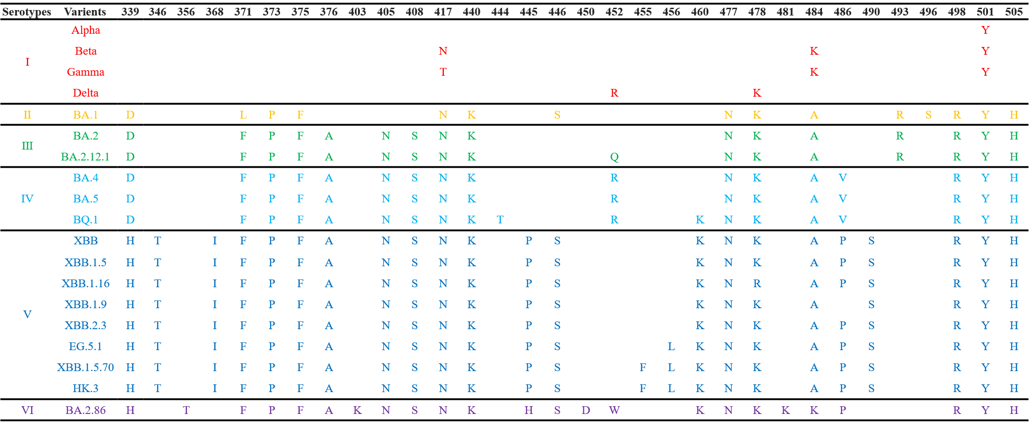

Figure S1. Mutation sites in the RBDs of 19 selected SARS-CoV-2 variants.
The RBD region of the S protein from 19 COVID-19 strains included in this study was compared based on sequence alignment. Figure S1 shows the specific amino acid substitution information present in the RBD region of the variants published by GISAID, the comparison of sequences between different variants was derived from the Lineage Comparison module on the GISAID website(https://gisaid.org/lineage-comparison/), and suggests that the included strains can be classified into different serotypes, indicated by different color.

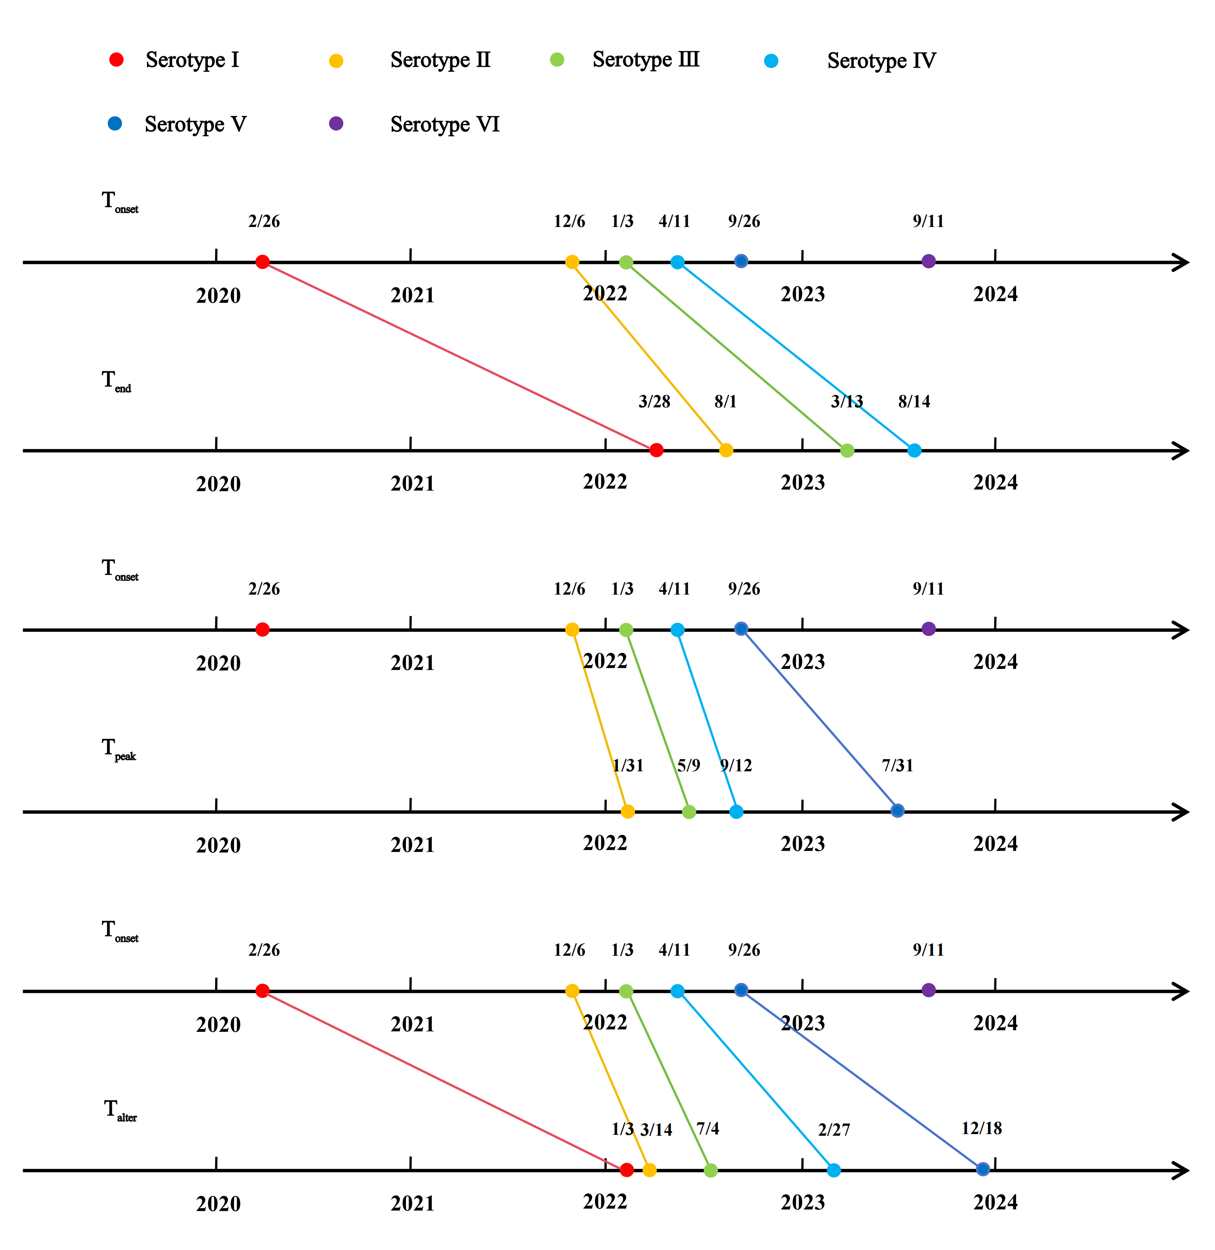

Figure S2. The overall global epidemic trends of COVID-19 from 2020 to 2024.
The median time points for the onset (T_{onset}), end (T_{end}), peak (T_{peak}), and alternation (T_{alter}) of epidemic in 58 countries or regions. The dots represent the median time points for each serotype, with different colors indicating distinct serotypes. The lines connecting the same serotypes represent the duration “time period” of epidemic (TP_{dura}), the peak “time period” of epidemic (TP_{peak}) and the alternation “time period” of epidemic (TP_{alter}) respectively. The time indicated on the dots is presented in the format: xx (month) / xx (date). The definitions of these indicators were described in the Methods. The specific data were described in the Supplementary Material (Table S2- S4).
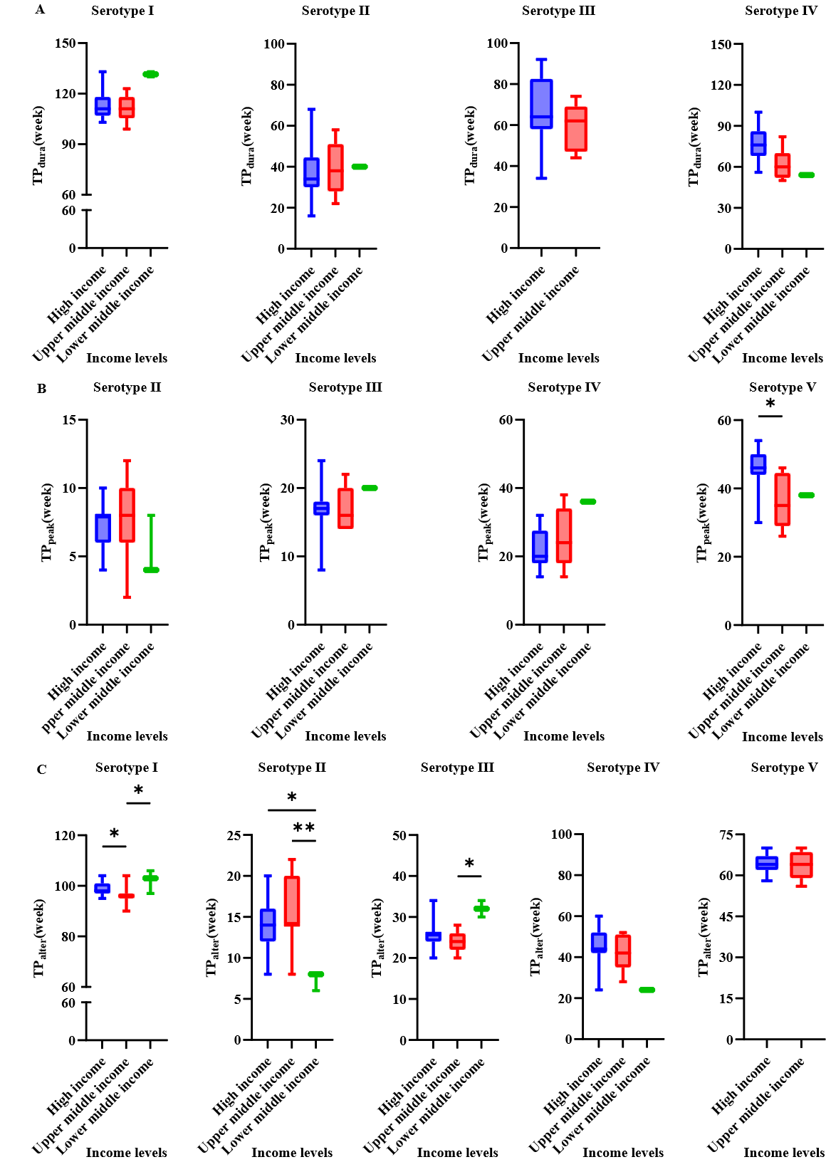

Figure S3. Comparison of seroepidemiological features based on different income levels of different countries or regions.
A. The duration time period of epidemic (TP_{dura}) compared with different income levels. B. The peak time period of epidemic (TP_{peak}) compared with different income levels. C. The alternation time period of epidemic (TP_{alter}) compared with different income levels.[3] Boxplot centers indicate group median, bodies show interquartile range (IQR), and whiskers extend to the largest and smallest value. The * and ** indicate P values less than 0.05, 0.01, respectively.
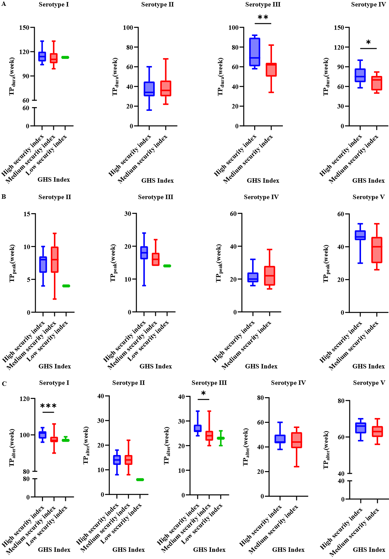

Figure S4. Comparative of seroepidemiological features based on Global Health Security (GHS) Index of different countries or regions.
A. The duration time period of epidemic compared with different GHS index. B. The peak time period of epidemic compared with different GHS index. C. The alternation time period of epidemic compared with different GHS index.[4] Boxplot centers indicate group median, bodies show interquartile range (IQR), whiskers extend to the largest and smallest value. The *, ** and *** indicate P values less than 0.05, 0.01 and 0.001, respectively.
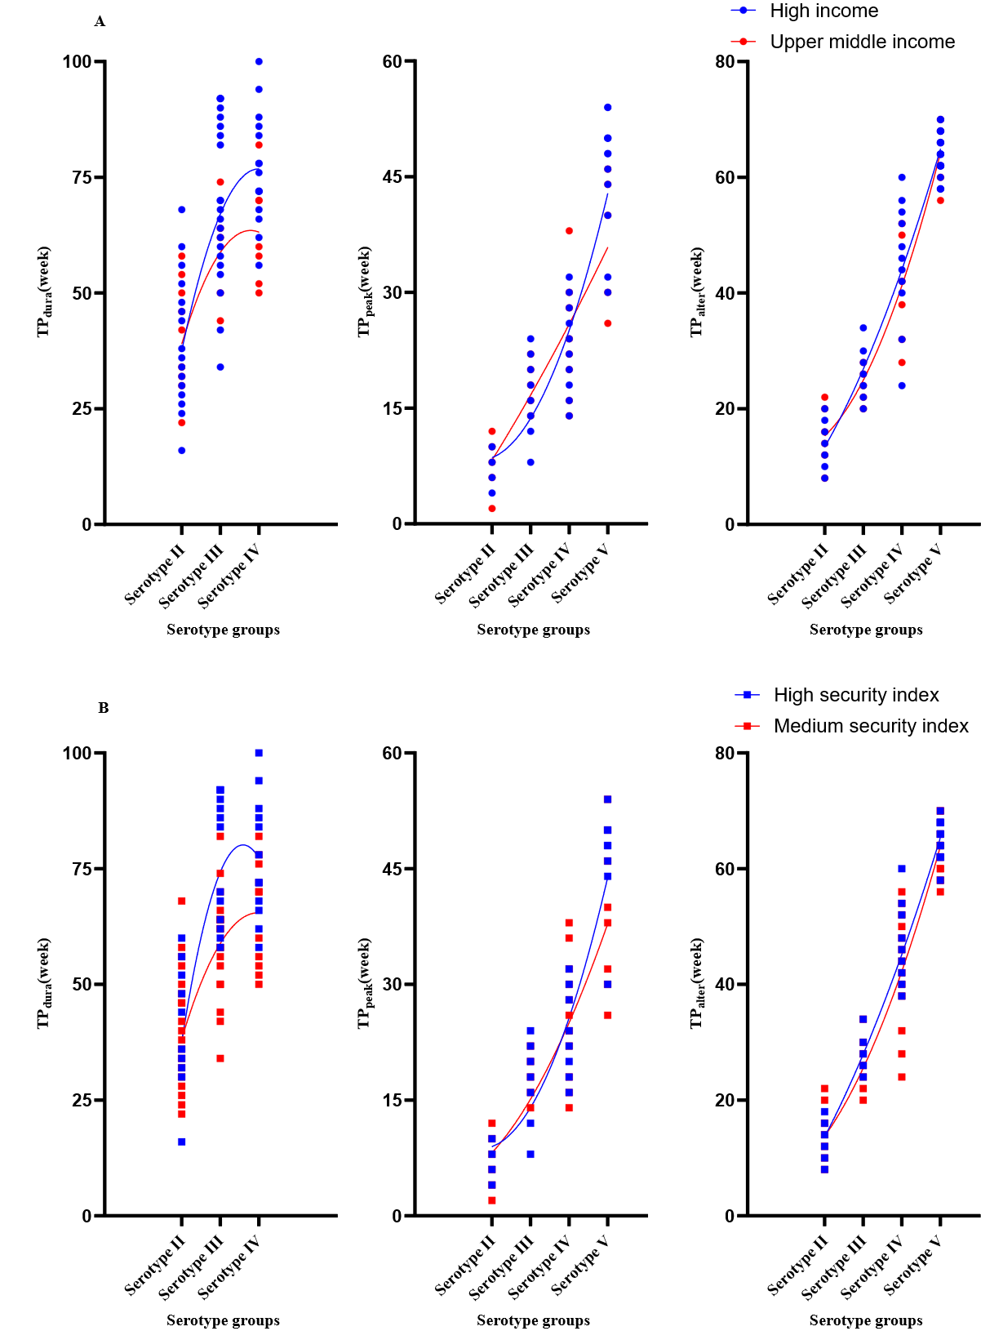

Figure S5. Distribution of the time period of epidemic among different groups of countries or regions.
A. The distribution of the epidemic's time period varies among different income levels, with blue representing the high-income group and red representing the upper-middle-income group. The different colored lines represent epidemic trend of distinct groups, which have been plotted using curve regression (second order polynomial). B. The time period of the epidemic is distributed among different GHS index, with blue indicating a high security index and red indicating a medium security index. The different colored lines represent epidemic trend of distinct groups, which have been plotted using curve regression (second order polynomial) [3, 4].
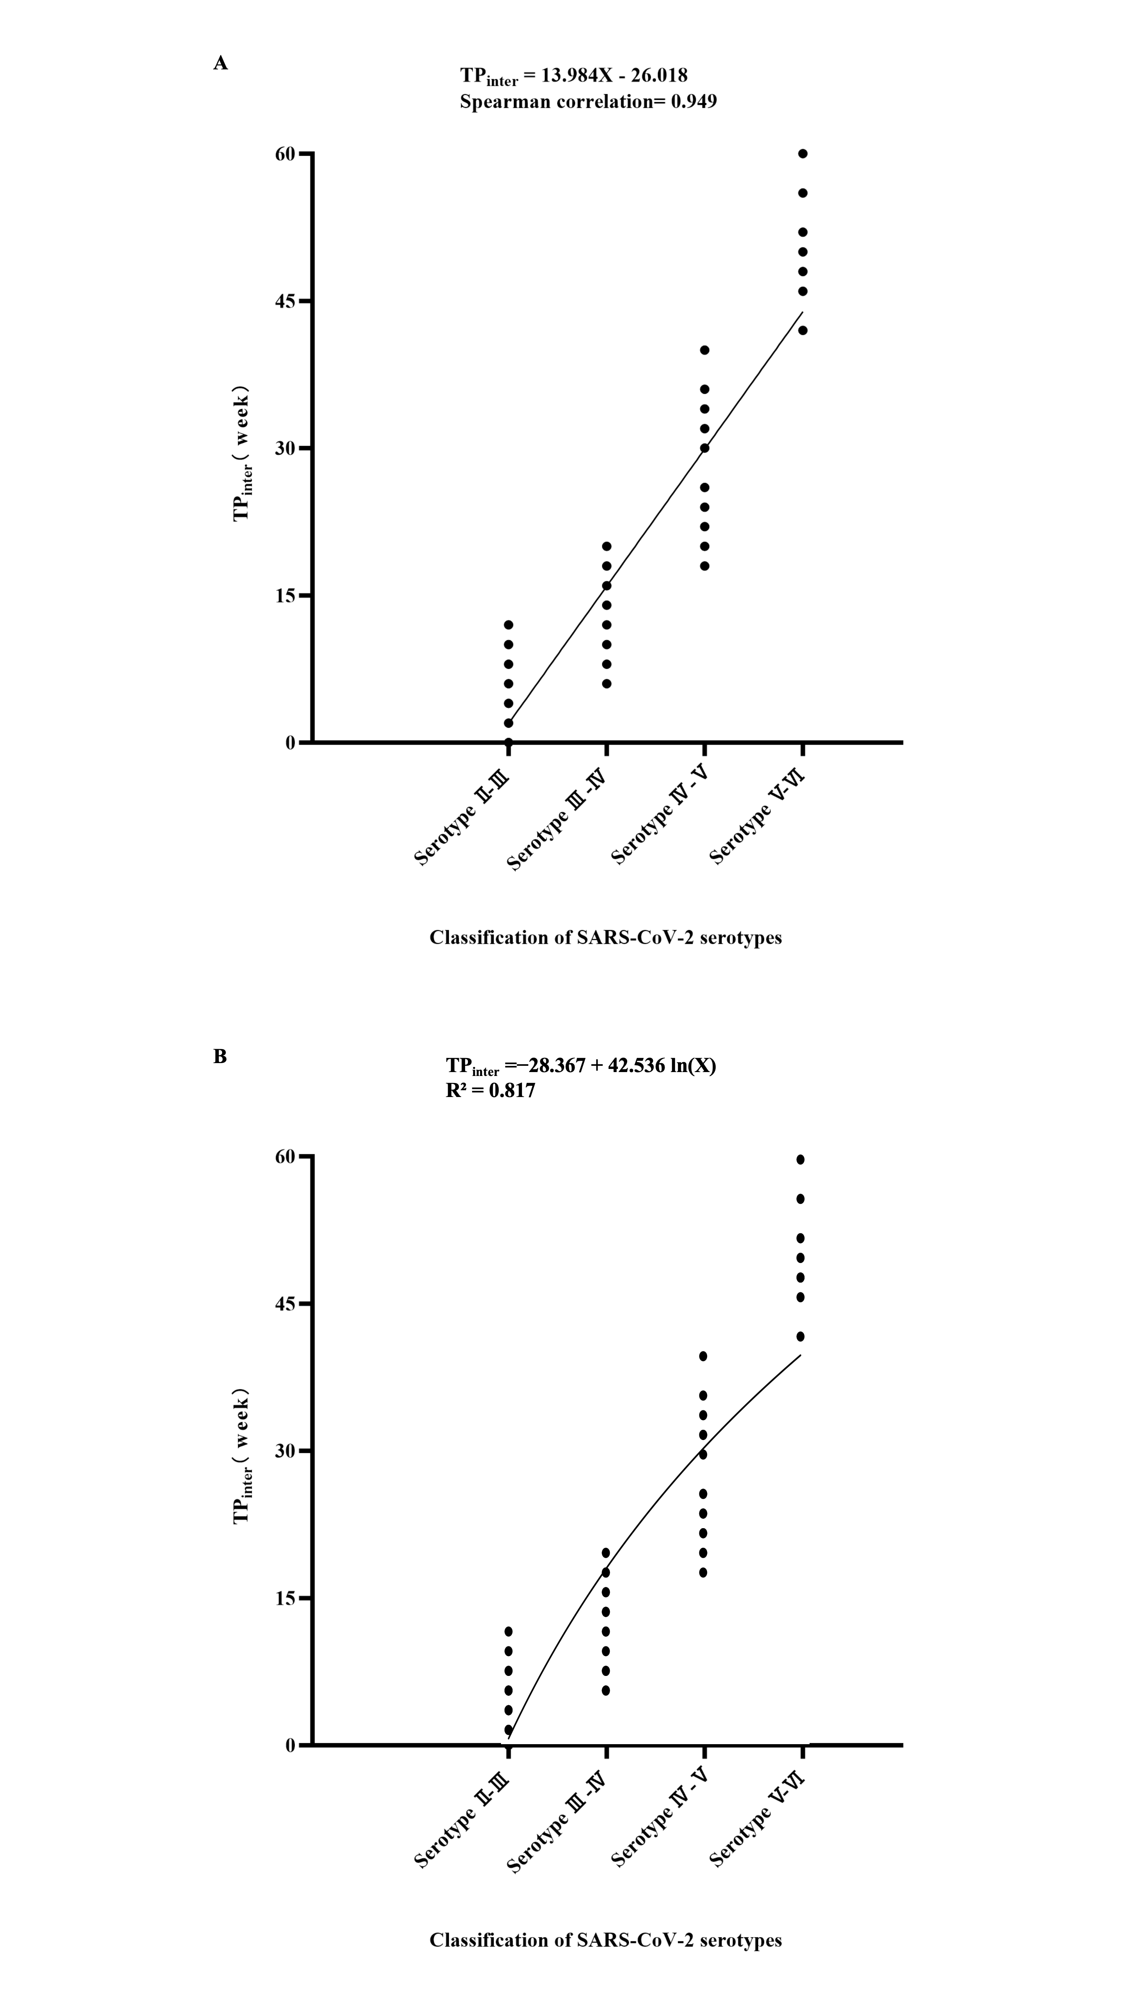

Figure S6. Other models of the interval time of epidemic for different SARS-CoV-2 serotypes.
A. Distribution of the interval between the epidemic onsets (TP_{inter}) for different SARS-CoV-2 serotypes. Notably, the x-axis TP_{inter} (Serotype Ⅱ-Ⅲ) means the time difference between Serotype Ⅱ and Ⅲ. TP_{inter} was used to constructed a simple linear regression equation to estimate the emergence time of new serotypes. TP_{inter} = 13.984X – 26.018, the X represents the serotypes of the time difference between X and X+1. (Ex. When X=6, it means the time difference between serotypes Ⅵ and Ⅶ). By computing the time difference between predicted Serotype Ⅶ and current Serotype Ⅵ as 57.89 weeks with a 95% confidence interval of (55.64,60.14), in conjunction with September 11th, 2023 being identified as the median epidemic start date for Serotype Ⅵ, we converted the aforementioned confidence interval into specific dates and estimated that emergence of the new serotype may transpire within October 4th to November 4th, 2024. Use the linear function of the regression module in SPSS to calculate the predicted values and 95% CI, where the 95% CI serves as the prediction interval with a confidence level of 95%. B. Through a Logarithmic curve fitting calculation, the estimated time difference for the emergence of Serotype Ⅶ relative to current Serotype Ⅵ is 47.85 weeks. With September 11th, 2023, serving as the median epidemic start date for Serotype Ⅵ, the new serotype is predicted to emerge around August 11th, 2024. The 95% confidence interval for this time difference is narrower, from 38.89 to 56.81 weeks, suggesting an emergence period between June 9th, 2024, and October 13th, 2024, indicating a more concentrated prediction by this model.

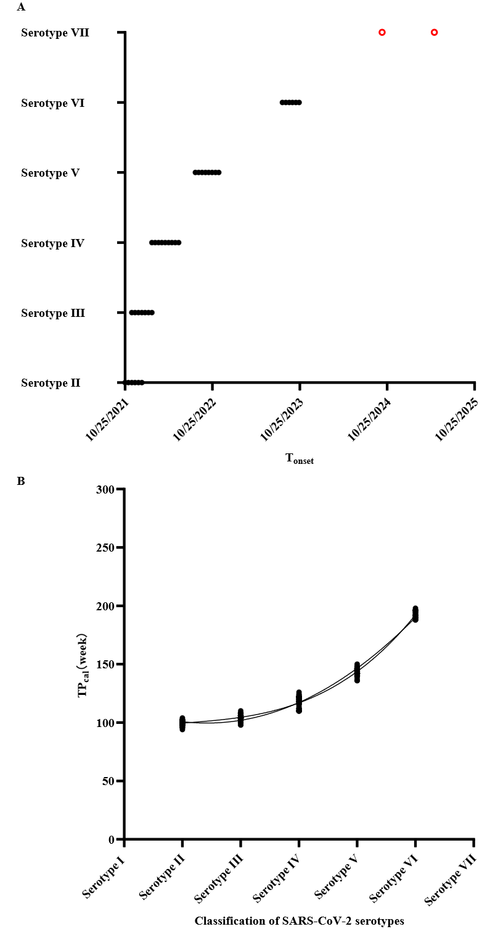

Figure S7. Curve regression of different onset time points for SARS-CoV-2 serotypes.
A. Distribution of the onset points of the epidemic for Serotype Ⅱ-Ⅶ. The red dots represent the appearance time of Serotype Ⅶ predicted by TP_{inter}. We are attempting to verify the results of this prediction using a new method. B. Since it is not continuous time data, we considered using the x-axis as the serotype category and the y-axis (TP_{cal}) as the difference in weeks between each serotype's onset point and January 3, 2020 (the earliest occurrence of COVID-19 mentioned in this article), and performed second-order and third-order polynomial curve fitting calculations. The calculated “time period” of epidemic(TP_{cal}) ：TP_{cal}= T_{onset} - January 3, 2020. The R² values of the second-order and third-order polynomial curves are 0.984 and 0.989, respectively. The obtained second-order polynomial equation is: y = 140.944 – 34.171X + 7.058X^2. By calculation, the difference in weeks between the possible appearance time of serotype Ⅶ and January 3, 2020 is estimated to be 247.55 weeks, possibly occurring on October 1st, 2024. The third-order polynomial equation is: y =83.119 +17.536X -7.043X^2 +1.192X^3. By calculation, the difference in weeks between the possible appearance time of serotype Ⅶ and January 3, 2020 is estimated to be 269.65 weeks, possibly occurring on March 5th, 2025. Using the curve estimation function of the regression module in SPSS to calculate predicted values and 95% CI, where 95% CI serves as the prediction interval with a confidence level of 95%.
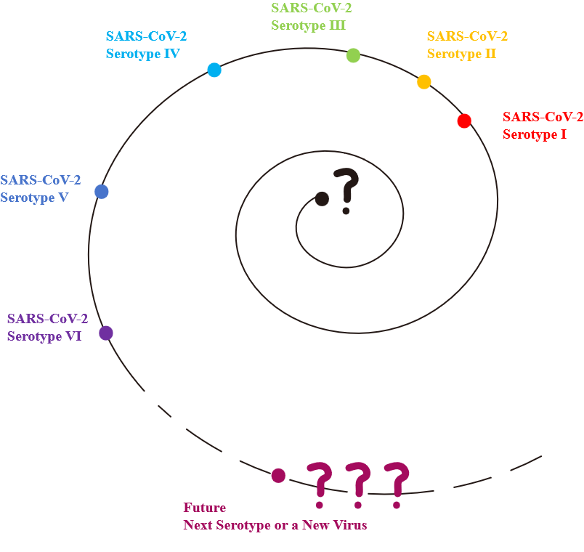

Figure S8. Evolution of SARS-CoV-2 serotypes.
With the mutation of the virus, there is also a replacement of serotypes. SARS-CoV-2 emerged at the end of 2019 and has been monitored and continuously spreading up to now. The future change may be either a replacement of serotypes or even the emergence of new viruses; this remains a question that we need to further explore in the future.

References
1. Our World in Data. GISAID, via CoVariants.org (2024) – with major processing by Our World in Data. 2024. https://ourworldindata.org/covid-cases#coronavirus-sequences-by-variant. Accessed 1 Aug 2024.
2. Li L, Shi K, Gu Y, Xu Z, Shu C, Li D, et al. Spike structures, receptor binding, and immune escape of recently circulating SARS-CoV-2 Omicron BA.2.86, JN.1, EG.5, EG.5.1, and HV.1 sub-variants. Structure. 2024;32(8):1055-67.
3. World Bank. World Bank country classifications by income level for 2024-2025. 2024. https://blogs.worldbank.org/en/opendata/world-bank-country-classifications-by-income-level-for-2024-2025. Accessed 6 Aug 2024.
4. Global Health Security Index. Global Health Security Index: advancing collective action and accountability amid global crisis, 2021. 2021. https://ghsindex.org/. Accessed 1 Aug 2024.

