Supplementary Information
Vagal Sensing of Altered Gut Microbiota Links to Externalizing Behaviors
Min Joung Lee^{1,3†}, So-Hyun Ahn^{6†,} Yea Eun Kang^{3,7,8}, Sang Min Jeon^{2,4}, In Soo Kim^{2, 5, 23}, Jong Hun An^{1,2,3}, Chang Hee Pyo^{1,2,3}, Jaehyun Jeong^{1,2,3}, Young Eun Kim^{1,2,3}, Jiyeon Yoon^{2,7,8}, Kwang-Yeon Choi⁶, Seong Eun Lee^{7,8}, Hyun Seok Kim⁹, Sunjae Lee¹², Samantha O’Keeffe¹³, Junyoung O. Park¹³, June-Young Lee¹⁴, Jin-Woo Bae¹⁴, Da Eun Kim^{15, 16}, Hyunbeom Lee^{15, 16}, Seok-Hwan Kim¹⁷, Woon-Hong Yeo^{18, 19, ,20, 21}, Min-Kyung Yeo²², Eungseok Oh^{2, 24} , Woosuk Chung^{2,10,11}*, Eun-Kyeong Jo^{2,4}*, and Jun Young Heo^{1,2,3}*
¹ Department of Biochemistry, Chungnam National University School of Medicine; Daejeon, 35015, Republic of Korea
² Department of Medical Science, Chungnam National University School of Medicine; Daejeon, 35015, Republic of Korea
³ System Network Inflammation Control Research Center, Chungnam National University School of Medicine; Daejeon, 35015, Republic of Korea
⁴ Department of Microbiology, Chungnam National University School of Medicine; Daejeon, 35015, Republic of Korea
⁵ Department of Pharmacology, Chungnam National University School of Medicine; Daejeon, 35015, Republic of Korea
⁶ Department of Psychiatry, Chungnam National University School of Medicine; Daejeon, 35015, Republic of Korea
⁷ Research Center for Endocrine and Metabolic Disease, Chungnam National University School of Medicine; Daejeon, Republic of Korea
⁸ Division of Endocrinology and Metabolism, Department of Internal Medicine, Chungnam National University School of Medicine; Deajeon, 35015, Republic of Korea
⁹ Department of Bioinspired Science, Ewha Womans University; Seoul, 03760, Republic of Korea
¹⁰ Department of Anesthesiology and Pain Medicine, Chungnam National University School of Medicine; Daejeon, 35015, Republic of Korea
¹¹ Department of Anesthesiology and Pain Medicine, Chungnam National University Hospital; Daejeon, 35015, Republic of Korea
¹² School of Life Sciences, Gwangju Institute of Science and Technology (GIST) ; Gwangju, 61005, Republic of Korea
¹³ Department of Chemical and Biomolecular Engineering, University of California, Los Angeles; Los Angeles, CA 90095, USA
¹⁴ Department of Biology and Department of Biomedical and Pharmaceutical Sciences, Kyung Hee University; Seoul, 02447, Republic of Korea
¹⁵ Center for Advanced Biomolecular Recognition, Korea Institute of Science and Technology; Seoul 02792, Republic of Korea
¹⁶ Department of HY-KIST Bio-convergence, Hanyang University; Seoul 04763, Republic of Korea
¹⁷ Departments of Surgery, Chungnam National University School of Medicine; Daejeon, 35015, Republic of Korea
¹⁸ George W. Woodruff School of Mechanical Engineering, Georgia Institute of Technology; Atlanta, GA, 30332, USA.
¹⁹ Wearable Intelligent Systems and Healthcare Center (WISH Center), Institute for Matter and Systems, Georgia Institute of Technology; Atlanta, GA, 30332, USA
²⁰ Wallace H. Coulter Department of Biomedical Engineering, Georgia Institute of Technology and Emory University School of Medicine; Atlanta, GA, 30332, USA
²¹ Parker H. Petit Institute for Bioengineering and Biosciences, Institute for Robotics and Intelligent Machines, Georgia Institute of Technology; Atlanta, GA, 30332, USA
²² Department of Pathology, Chungnam National University School of Medicine; Daejeon, 35015, Republic of Korea
²³ Biomedical Convergence Research Center, Chungnam National University Hospital; Daejeon, 35015, Republic of Korea
²⁴ Department of Neurology, Chungnam National University Hospital; Daejeon 35015, Republic of Korea

† These authors contributed equally to this work
* Corresponding authors:
Woosuk Chung, M.D, Ph.D
Department of Anesthesiology and Pain Medicine, Chungnam National University School of Medicine, Daejeon, 35015, Republic of Korea. Tel: 82-42-280-7840, Fax: 82-42-280-7968, E-mail: woosuk119@cnu.ac.kr
Eun-Kyeong Jo, M.D, Ph.D
Department of Microbiology, Chungnam National University School of Medicine, Daejeon, 35015, Republic of Korea. Tel: 82-42-580-8368, Fax: 82-42-580-8121, E-mail: hayoungj@cnu.ac.kr
Jun Young Heo, M.D, Ph.D
Department of Biochemistry, Chungnam National University School of Medicine, Daejeon, 35015, Republic of Korea. Tel: 82-42-580-8222, Fax: 82-42-580-8121, E-mail: jyheo@cnu.ac.kr

Materials and Methods
Animals
For all experiments, only male 16-week-old sirt3^{+/+} and sirt3^{-/-} mice were used. Mice were genotyped by PCR using the Sirt3-specific primers; forward 1: 5’-GAGATCCATCAGCTTCTGTG-3’, forward 2: 5’-GGGAGCACTCTCATACTCTA-3’, reverse: 5’-CCCTCAATCACAAATGTCGG-3’. Primers F1 and R1 amplify the wild-type allele (450 bp). Primers F2 and R1 amplify the deleted allele (486 bp). For the cohousing analysis, sirt3^{+/+} and sirt3^{-/-} male mice were cohoused in single cages until 16-week-old from 3-week-old. For the littermate from heterozygote parents, all littermate from the breeding pair of sirt3^{+/+} and sirt3^{-/-} were grown together until 16-week-old.

Microbiota analysis
16S rRNA Gene Amplicon Sequencing
Fecal samples were collected and stored at −80°C until DNA extraction. Genomic DNA was extracted using the DNeasy PowerSoil Pro Kit (Qiagen, Hilden, Germany), following the manufacturer’s protocol. DNA concentration was assessed using the Quant-iT PicoGreen dsDNA Assay Kit (Invitrogen, Carlsbad, CA, USA). To amplify and prepare the 16S rRNA gene amplicons, the PacBio 16S Full-Length Library Preparation Kit (version 3.0) was used. Universal primers targeting the V1–V9 regions of the 16S rRNA gene were employed for amplification: Forward primer (27F): 5′-AGRGTTYGATYMTGGCTCAG-3′, Reverse primer (1492R): 5′-RGYTACCTTGTTACGACTT-3′. PCR amplification was performed with 2 ng of genomic DNA, 10× LA PCR Buffer II (Mg²⁺-free), 2.5 mM dNTP mix, 2.5 mM MgCl₂, 500 nM of each primer, and 5 U of TaKaRa LA Taq polymerase (Takara, Kusatsu, Japan). The PCR cycling conditions were as follows: initial denaturation at 94°C for 5 minutes, followed by 25 cycles of 94°C for 30 seconds, 53°C for 30 seconds, and 72°C for 90 seconds, with a final extension at 72°C for 5 minutes. The PCR products were purified using the SMRTbell cleanup beads (Pacific Biosciences, Menlo Park, CA, USA). Amplicon concentration was quantified using the Quant-iT PicoGreen dsDNA Assay Kit (Invitrogen), and quality was assessed with the TapeStation D5000 ScreenTape system (Agilent Technologies, Waldbronn, Germany). For full-length 16S rRNA gene sequencing, 500 ng of pooled amplicon DNA was used to construct a 10 μL library using the PacBio SMRTbell Prep Kit (version 3.0). SMRTbell templates were annealed using the Sequel II Binding Kit 3.1 with Internal Control 3.1. The sequencing reaction was performed with the Sequel II Sequencing Kit 2.0 using an SMRT Cell 8M Tray (Pacific Biosciences). Sequencing was conducted on the PacBio Sequel IIe system (Pacific Biosciences) at Macrogen (Seoul, South Korea). Each SMRT cell was processed with a 10-hour movie capture time to maximize read quality. The sequencing workflow followed the PacBio Sample Net-Shared Protocol, available at https://www.pacb.com/.
Sequencing data processing and analysis
Following sequencing, raw PacBio (Sequel IIe) reads were demultiplexed using index sequences to assign reads to individual samples. High-fidelity (HiFi) reads were generated in FASTQ format and preprocessed using Cutadapt (v3.2) to remove forward and reverse primer sequences. After preprocessing, error correction was performed using the DADA2 (v1.18.0) package in R (v4.0.3). A batch-specific error model was established to correct sequencing errors and remove sample-specific noise. Chimera sequences were filtered out using the DADA2 consensus method, and ASVs (Amplicon Sequence Variants) were generated. ASVs with lengths shorter than 1,000 bp or longer than 2,000 bp were excluded from further analysis. For the taxonomic assignment, each ASV sequence was compared against the NCBI 16S Microbial Database using BLAST+ (v2.9.0). Taxonomy was assigned based on the best-hit subject organism, provided that the query coverage was ≥85% and sequence identity was ≥85%. If these thresholds were not met, no taxonomy was assigned to the ASV. Multiple-sequence alignment of ASVs was performed using MAFFT (v7.475), and a phylogenetic tree was constructed using FastTreeMP (v2.1.10).
Microbial community analysis was conducted using QIIME (v1.9) based on ASV abundance and taxonomic classifications. Alpha diversity was assessed by calculating the Shannon index, Inverse Simpson index, and Chao1 estimator, along with rarefaction curve analysis. Beta diversity was evaluated using weighted and unweighted UniFrac distances to compare microbiome composition across samples. Principal component analysis (PCA) was performed using Canberra distance, which was calculated with the vegan (v2.6-10) package in R (v4.4.2). The significance of group differences was tested using PERMANOVA (Permutational Multivariate Analysis of Variance), which was implemented in vegans. MaAsLin2 (Multivariable Association with Linear Models, v1.10.0) was applied at both the genus and family levels to identify differentially abundant taxa between groups. Linear regression models were used to determine significant associations between microbial taxa and sample groups, adjusting for potential confounders. The strength and direction of associations were determined using the coefficient values, and statistical significance was assessed using FDR (False Discovery Rate)-adjusted p-values.
Behavior experiments
Mice were habituated to the experimenter for 3 days before the start of the behavior tests. All experiments were performed during the light cycle. The tests were analyzed using EthoVision XT 11.5 software (Noldus, Wageningen, Netherlands).
Open-field test
Each mouse was placed at the center of the box (40 x 40 x 40 cm), and the movement was recorded for 1 h.
Elevated plus maze test
The apparatus comprises two open arms (10 x 5 cm) across from each other and perpendicular to two closed arms (10 x 5 cm) arranged at 90° angles. The center area (5 x 5 cm) was connected to all four arms. The height of apparatus is 50 cm. Mice were placed in center area facing the closed arm. The movement was recorded for 10 min (1).
Light-dark box test
The apparatus is a box divided into two sections (light 15x 20 cm, dark 15x10 cm) by a perdition with door. Mouse was placed into the dark part with cover and open the door to allow the mice to move freely dark and light part. The movement was recorded for 10 min after open the door and the tests were analyzed for 6 min (2).
Fear conditioning memory test
Fear conditioning memory test was performed following the previous method (3). Day 1, fear conditioning was performed with 300 sec of free exploration and then three trials of a stimulus (0.1 mA footshock, 1 sec; 320, 400, 480 sec after the start) with after auditory cue (white noise, 20 sec; 300, 380, 460 sec after the start). Analyze freezing duration for auditory cue. Day 2, for context test, mouse was placed in same conditioning chamber without auditory cue and stimulus for 300 sec. Analyze freezing duration for 300 sec. Day 3, for cue test, mouse was placed in another chamber for 360 sec and then the auditory cue for 120 sec. Analyze freezing duration for auditory cue. Freezing duration was analyzed using Freeze Frame 4 (Actimetrics).
Tail suspension test
The apparatus is a box of 55 height x 60 width x 11. 5 cm depth. There are four identical compartments (55 height x 15 width x 11. 5 cm depth). The tail of the mice was suspended of the top with 15 cm tape. The movement was recorded for 10 min (4).
Forced swim test
The apparatus is a transparent cylinder (25 height x 10 cm diameters). The water (20-25 ℃) level is 18 cm from the bottom. Mouse was placed gently into the water. The movement was recorded for 10 min (5).
RNA sequencing
RNA was extracted from amygdala and BNST of SIRT WT and KO mice TRIzol (Thermo Tisher Scientific) following the manufacturer’s protocol. The analysis of RNA sequencing was performed by Ebiogen (Seoul, Republic of Korea). RNA samples with RNA purity (260/280 > 1.8) and RNA integrity number (RIN) value (≥ 7) are used. The NEBNext Ultra II Directional RNA-Seq Kit (NEW ENGLAND BioLabs, Inc., UK) was used to prepare libraries from total RNA. Quantification was performed using the library quantification kit using a StepOne Real-Time PCR System (Life Technologies, Inc., USA). High-throughput sequencing was performed as paired-end 100 sequencing using HiSeq X10 (Illumina, Inc., USA).
Bioinformatics transcriptome analysis
Quality control of raw reads resulting from sequencing was performed using FastQC. Adapter and low-quality reads (<Q20) were removed using FASTX_Trimmer and BBMap. The trimmed reads were mapped to the reference genome using TopHat. The levels of gene expression were estimated using FPKM (Fragments per kilobase of exon per million reads) values and RPKM (Reads per kilobase of transcript per million mapped reads). For differentially expressed gene (DEG) analysis, we performed the “DESeq2” R package and obtained DEG with p-value<0.05 and log2|fold change|≥0.5 (KO vs. WT) and non-significant expressed genes with p-value>0.05 (coKO vs. coWT). Gene set enrichment analysis (GSEA) was performed using the “fgsea” R package. In amygdala and BNST, gene sets included GOBP pathway gene sets from MSigDB (v7.5.1, http://software.broadinstitute.org/gsea) using obtained DEG. For GSEA with 718 genes (upregulated DEGs in KO vs. WT and non-significance in cohousing group), GOCC pathway gene sets from MSigDB (v7.5.1, http://software.broadinstitute.org/gsea) was used. For GSEA analysis, the results represented in the graph were significantly up-or down-regulated in the KO group based on normalized enrichment score (NES). Heat maps were generated with the R program. The RNA sequencing raw data are available at the National Center for Biotechnology Information (NCBI) Gene Expression Omnibus (GEO) database with accession number: GSE305243
Western blot
For western blot, proteins from brain tissue were extracted with 5x protein sample buffer (JUBIOTECH, South Korea) diluted with RIPA buffer supplemented with protease inhibitor and phosphatase inhibitor cocktail (Roche Applied Science, Vienna, Austria). The samples were separated by SDS-PAGE and transferred to the PVDF membrane (Millipore, Burlington, MA, USA). The membranes blocked with 3% BSA for 1hour and then incubated at 4 ℃, overnight with specific primary antibodies against SIRT3 (#5490), CaMKII (#4436), p-CaMKII (#12716) (1:1000, Cell signaling Technology, Inc., Danvers, MA, USA), Arc (1:500, #sc-17839, Santa Cruz Biotechnology, CA, USA), NR2A (1:1000, #07-632, Millipore, Burlington, MA, USA), PSD95 (1:1000, #MA1-046, Invitrogen, Carlsbad, CA, USA), β-actin (1:1000, Santa Cruz Biotechnology, CA, USA), GluR1 (1:2000, #1193) and GluR2 (1:2000, #1195) were described previously(6). After washing with TBS/T, membranes were incubated with horseradish peroxidase-conjugated secondary antibodies for 2 hours at room temperature. Chemiluminescence reagent (#BWB 0200, BioMAX, South Korea) was used for to observe signals. Images were quantified with ImageJ software.
Characteristics of mood disorder patients for plasma sampling
Twelve healthy controls and ten mood disorder patients (MDP) were recruited from the outpatient psychiatry clinic of a university hospital. All patients met the criteria for MDP as defined by the Diagnostic and Statistical Manual of Mental Disorders, Fifth Edition (DSM-5), as determined by board-certified psychiatrists. All participants were aged 18 years or older. Participants with other psychiatric or neurological disorders or serious medical conditions, such as cancer, were excluded. Healthy controls had no history of psychiatric illness. Psychiatric symptoms were assessed using self-report questionnaires, including the Beck Anxiety Inventory (K-BAI) and the State-Trait Anxiety Inventory (STAI), both of which are widely used and validated tools for evaluating anxiety. Blood samples were collected after at least 8 hours of fasting, in accordance with standard clinical procedures. The detailed characteristics of recruited subjects are shown in Supple table 1 and 2.
Choline assay
To analyze choline in plasma, blood samples were collected from SIRT3 WT and KO mice. The blood samples were centrifugated at 3,000 rpm for 5 min at 4 ℃. The choline in collected plasma was measured using a Choline assay kit (#ab65345, Abcam, Cambridge, UK) following the manufacturer’s instructions.
Tissue and plasma metabolites extraction for metabolomics
5-15 mg of tissue was cut on ice and placed in a 2 ml round-bottom cryovial, which was immediately stored in liquid nitrogen (LN2, -180°C). Prior to extraction, the samples were cryomilled. A grinding bead (Inframat Advanced Materials, Lot #YTZ5172S065, Product #4039GM-S065) was added to the E-tube, and the following protocol was applied: precooling the cryomill at a frequency of 5 for 5 minutes, followed by cryomilling each sample at a frequency of 25 for 45 seconds. If any sample was not fully ground, a grinder was used on the E-tube. The ground samples were then stored in a -80°C deep freezer. Subsequently, an extraction solution was added to each tube, and the mixture was vortexed for 10 seconds. The volume of extraction solution (40:40:20 acetonitrile:methanol:water) was calculated as 30 µl per milligram of tissue weight. The samples were then left on ice for 10 minutes before being centrifuged at 4°C and 14,000g for 25 minutes. The supernatant was carefully transferred to a new E-tube, avoiding any particulates, and centrifuged again at 4°C and 14,000g for 25 minutes. Finally, the supernatant was transferred to an HPLC tube for subsequent analysis.
For plasma metabolite extraction, either 10 μL of plasma was mixed with 130 μL of extraction solution (80% methanol), or 5 μL of plasma was mixed with 65 μL of 80% methanol. The mixtures were vortexed briefly and then centrifuged at 14,000 × g for 10 minutes at 4 °C. The resulting supernatant was carefully transferred to HPLC vials for subsequent analysis.
Metabolomics
Metabolite extracts were analyzed on a Vanquish Duo ultra-HPLC system coupled to a Q Exactive Plus orbitrap mass spectrometer (Thermo Fisher Scientific) by electrospray ionization. The order of sample injections was randomized. LC separation was performed on an XBridge BEH Amide XP column (150 mm × 2.1 mm, 2.5-μm particle size; Waters) using a gradient of solvent A (95:5 water/acetonitrile with 20 mM ammonium acetate, 20 mM ammonium hydroxide, pH 9.4) and solvent B (acetonitrile). Two independent LC flow paths were operated in tandem, staggered by 20 min. The gradient for each flow path was 0 min, 90% B; 2 min, 90% B; 3 min, 75% B; 7 min, 75% B; 8 min, 70% B; 9 min, 70% B; 10 min, 50% B; 12 min, 50% B; 13 min, 25% B; 14 min, 25% B; 16 min, 0% B; 20 min, 0% B; 23 min, 0% B; 27 min, 25% B; 30 min, 45% B; 33 min, 90% B; 40 min, 90% B. The flow rate was 150 μl min−1. The injection volume was 5 μl, and the autosampler and column temperatures were 4 °C and 25 °C, respectively. The mass spectrometer was operated in negative and positive ion modes with a resolution of 140,000 at a mass-to-charge ratio (m/z) of 200 with a scan range of m/z 60–2,000. Data was collected using the software Xcalibur (v4.3) (Thermo Fisher Scientific). With retention times determined by authenticated standards, resulting mass spectra and chromatograms were identified and integrated using MAVEN (Metabolomic Analysis and Visualization Engine). No samples were excluded from the analyses. For statistics and processing the data, MetaboAnalyst (https://www.metaboanalyst.ca) was used.
Vagotomy and verification
Subdiaphragmatic vagotomy was performed as previously described(7). Mice were anesthetized with sevoflurane. The skin was incised. The stomach and esophagus were retracted to allow clearly visualize the vagal trunks. These were dissected and all neural and connective tissue surrounding the esophagus below the diaphragm were removed. The sham group underwent a same surgery except dissection of vagus nerve. Mice were tested using cholecystokinin COOH-terminal octapeptide (CCK-8) induced satiety whether the vagotomy was successful at one week after surgery (8, 9). After 20 hours of food deprivation, sham and vagotomized mice were injected intraperitoneally with saline or 4ug/kg CCK-8 (Sigma-Aldrich). Individual food intake was measured for 30 min after the CCK-8 injection. After four weeks from the surgery, the behavior experiments were performed.
Immunofluorescence staining
Mice were perfused and fixed by PBS and 4% paraformaldehyde. Brain tissues were dehydrated in 30% sucrose solution at 4℃. After that, the tissues were frozen and sliced into coronal sections to a thickness of 30 µm using a cryotome. Sections were stored in PBS. The sections were blocked in 2% donkey serum (Gene Tex, CA, USA), 0.3% Triton X-100 with PBS for 1.5 h and then incubated with primary antibodies; C-fos (#2250S, Cell signaling Technology, Inc., Danvers, MA, USA), GABA (#AB175, Millipore, Burlington, MA, USA), ABAT (#ab213508, Abcam, Cambridge, UK), GAD67 (#mab5406, Millipore, Burlington, MA, USA) overnight at 4 ℃. The samples were washed in PBS and incubated with the anti-rabbit Alexa 488-conjugated, anti-goat Alexa 647-conjugated anti-IgG secondary antibody (Jackson, PA, USA). After washing, the samples were incubated with DAPI (#H3570, Invitrogen, Carlsbad, CA, USA) for 5 min.
Statistical analysis
All data were presented as mean ± SD. Statistical analyses were performed using the Prism software (GraphPad, version 8, San Diego, CA, USA). Normality tests were performed to assess whether the data met the assumptions of the statistical analyses. Data were analyzed using unpaired t test with Welch’s correction or the one-way ANOVA Games-Howell’s multiple comparisons test. The statistical significance of all data is indicated by * p<0.05, ** p <0.01 and *** p <0.001.
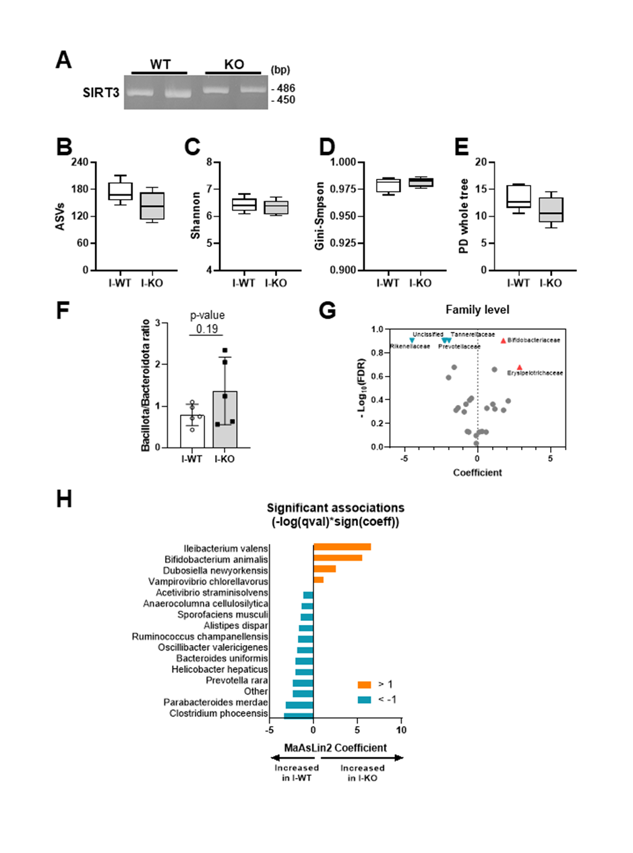
Supplementary Figure 1. Sirt3 deficiency altered gut microbiota composition
(A) Genotype PCR analysis of WT (Sirt3^{+/+}, 450bp) and Sirt3-KO (Sirt3^{-/-}, 486bp). (B-E) The alpha-diversity of 16S rRNA expression. (F) Bacillota/Bacteroidota ratio. (G) Scatter-plots of bacterial family levels between I-WT and I-KO. (H) Bar-plots of bacterial species levels between I-WT and I-KO.
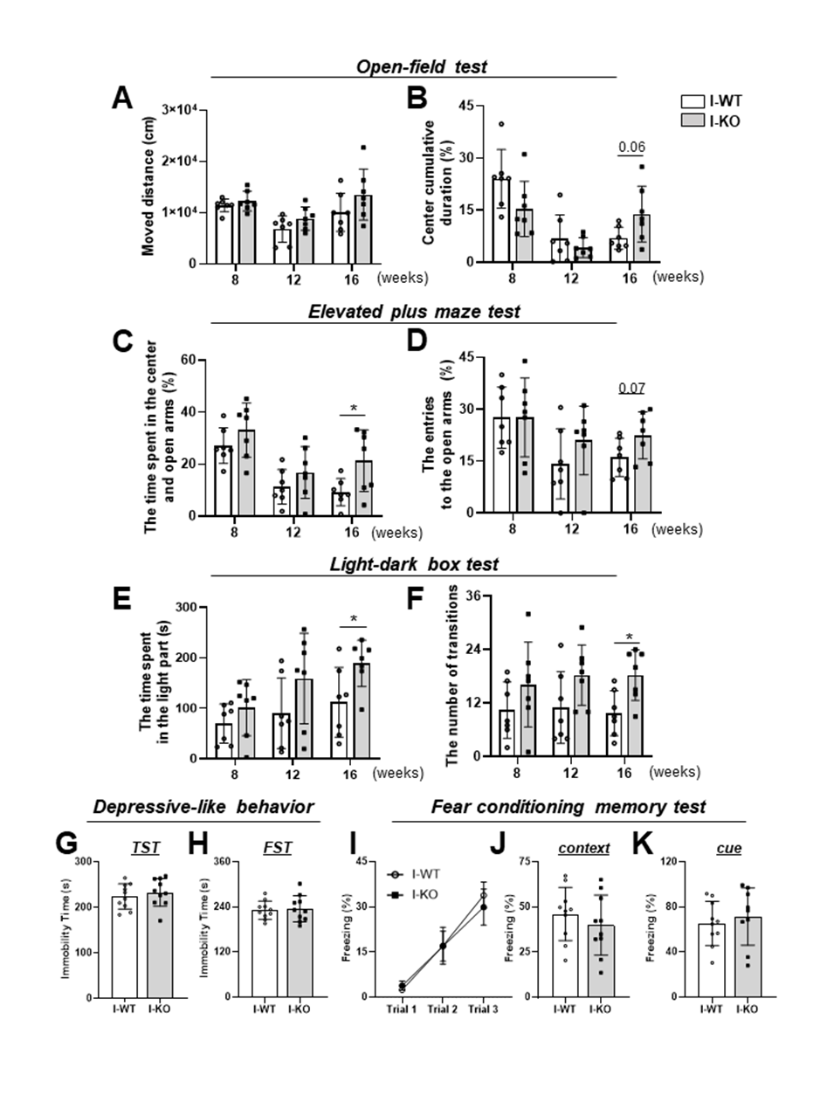
Supplementary Figure 2. Progressive increase of externalizing behavior in 16-week-old Sirt3-KO mice
(A, B) Moved distance and center duration in I-WT and I-KO mice as assessed general movement and assessed anxiety-like behavior in open-field test. (C, D) Elevated plus maze test. (E, F) Light-dark box test. (G, H) Tail-suspension test and forced swim test in I-WT and I-KO mice as assessed depressive-like behavior. (I-K) Fear conditioning memory test, Day1-conditioning (electric footshock after noise) (I), Day 2-context test (same place without noise and electric foot shock) (J), Day 3-cued test (Different place with noise).
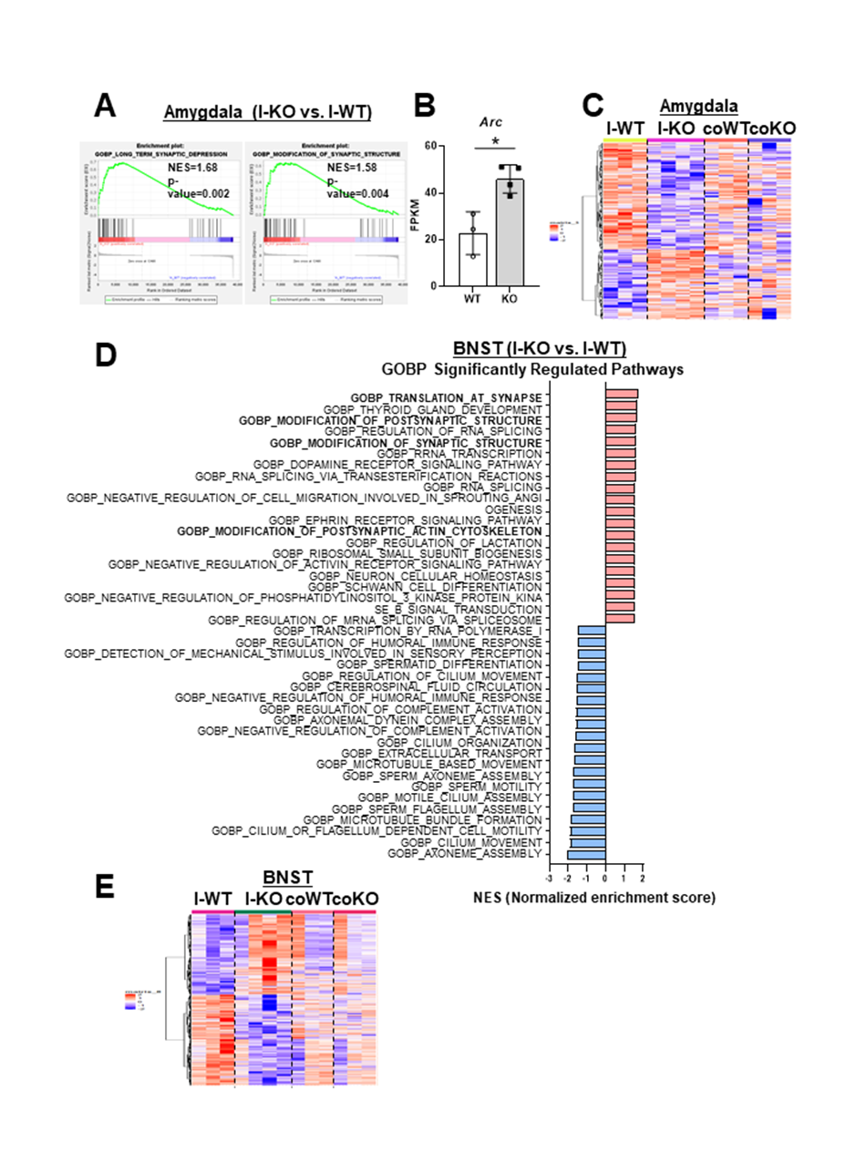
Supplementary Figure 3. Gut microbiota-dependent gene set changes
(A) Enrichment plot of long-term synaptic depression and modification of synaptic structure signaling pathways (p-value < 0.05) among DEGs (I-KO vs. I-WT) in amygdala. (B) FPKM values for the Arc gene in amygdala. (C) The heatmap showing differential gene expression in the amygdala of I-KO, coWT, coKO compared to I-WT. (D) Top 20 Up, Down-regulated enriched biological processes signaling pathways (p-value < 0.05) among DEGs (I-KO vs. I-WT) in BNST. (E) The heatmap showing differential gene expression in the BNST of I-KO, coWT, coKO compared to I-WT.
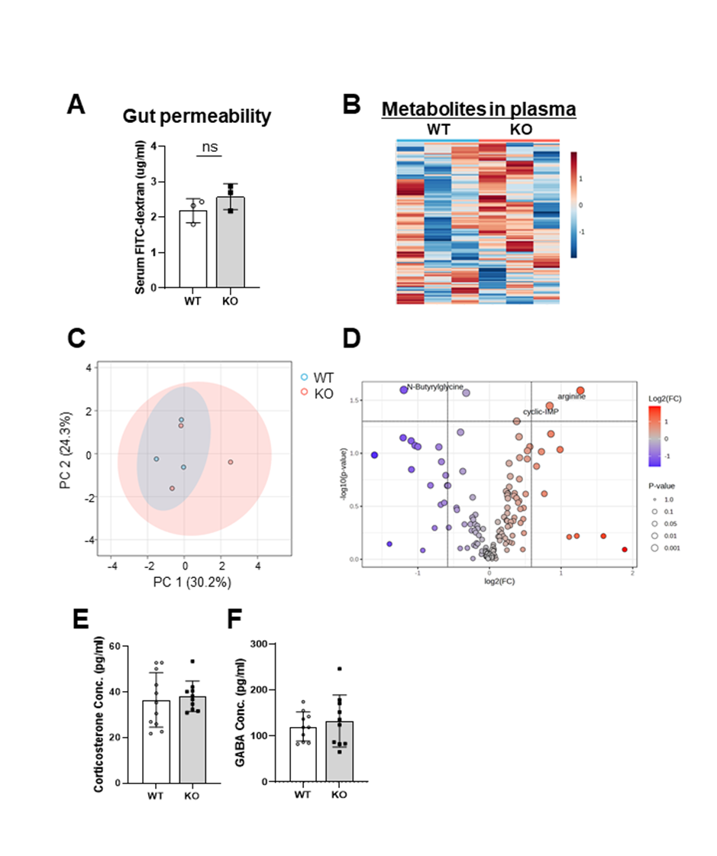

Supplementary Figure 4. Gut microbiota-induced behavioral changes in Sirt3-KO mice are not attributable to plasma circulation factors
(A) Gut permeability assay by FITC intensity showing no difference between WT and KO mice. (B) The heatmap of metabolites in plasma showing no difference between WT and KO mice. (C) PCA of metabolites in plasma indicating no distinct metabolic clustering between two groups. (D) Volcano plot showing the distribution of metabolite changes between WT and KO mice (|FC| ≥ 0.5, p-value ≤ 0.05). (E) Corticosterone (F) GABA concentration in plasma showing no difference between WT and KO mice.

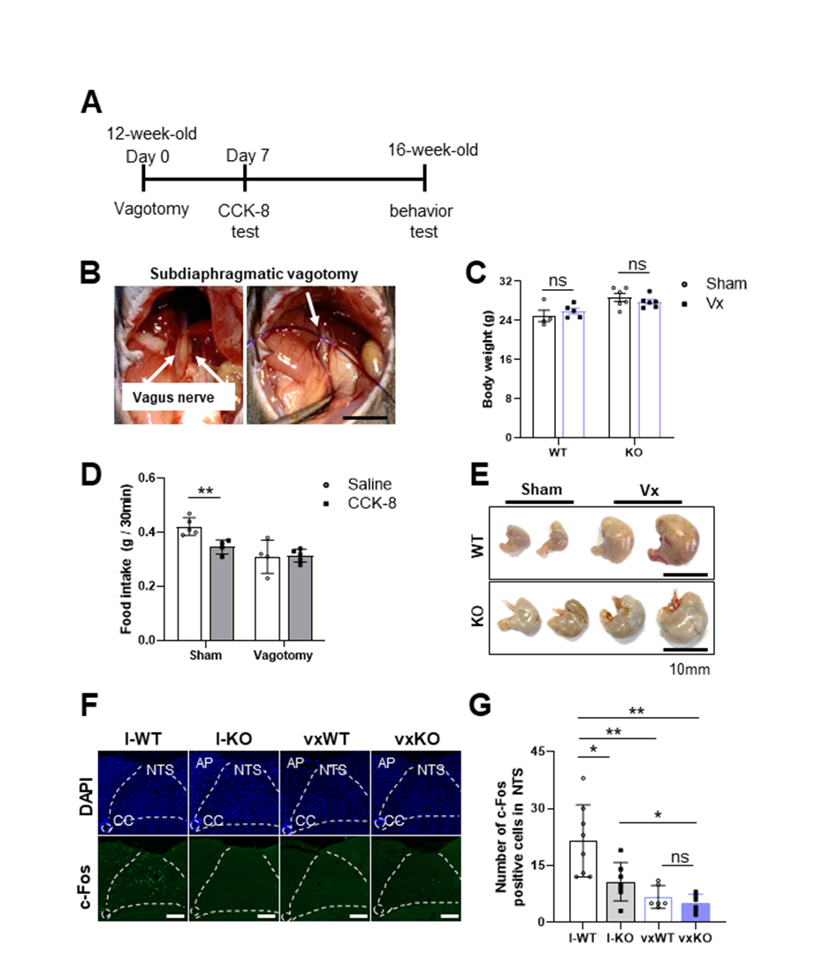

Supplementary Figure 5. Validation of vagotomy
(A) Scheme of vagotomy experimental timeline. (B) Localization of vagus nerve and subdiaphragmatic vagotomy in mice. (C) Comparison of body weight after vagotomy.
(D) CCK-8 assay to validate vagotomy. No difference in food intake after CCK-8 injection in vagotomy group. (E) Increased stomach size after vagotomy. Scale bar: 10mm. (F, G) Representative figure of c-fos (green) and DAPI (blue) immunostaining and the quantification of c-fos-positive cells in the NTS of I-WT, I-KO mice and vagotomized WT, KO mice (vxWT, vxKO). Scale bar: 100um

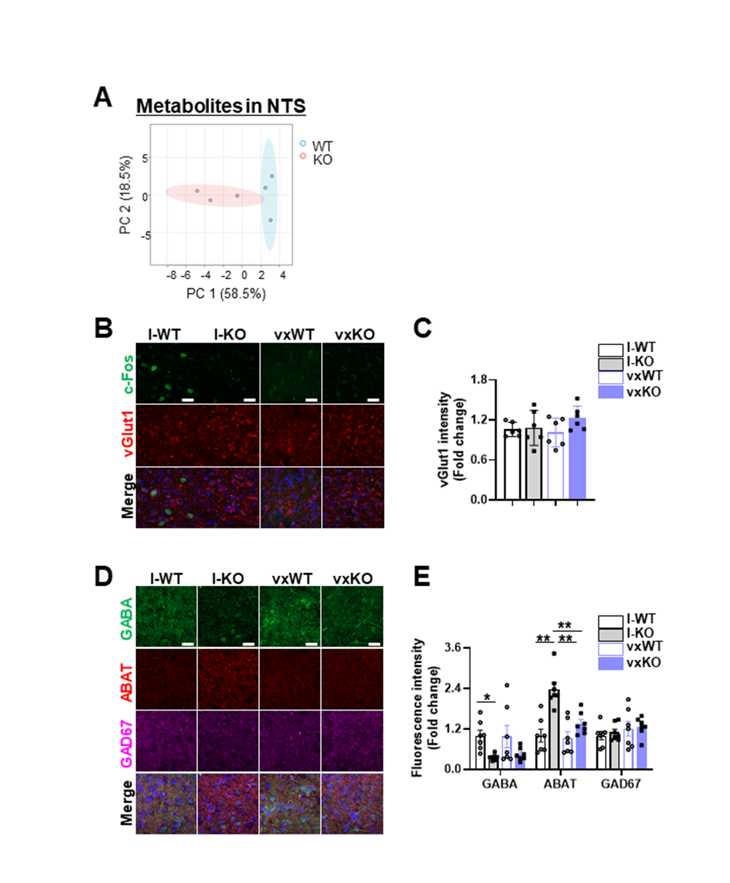

Supplementary Figure 6. Metabolic change related to GABA in NTS of Sirt3-KO
(A) PCA of metabolites in NTS indicating different clusters in WT and KO group (PC1:58.8% and PC2:18.5%). (B, C) Representative figure of c-Fos (green), vGlut1 (red) immunostaining and the quantification of vGlut1 intensity in the NTS of I-WT, I-KO mice and vagotomized WT, KO mice. (D, E) Representative figure of GABA (green), ABAT (red) and GAD67 (magenta) immunostaining and the quantification of these protein intensity in the NTS of I-WT, I-KO mice and vagotomized WT, KO mice. Scale bar: 20um

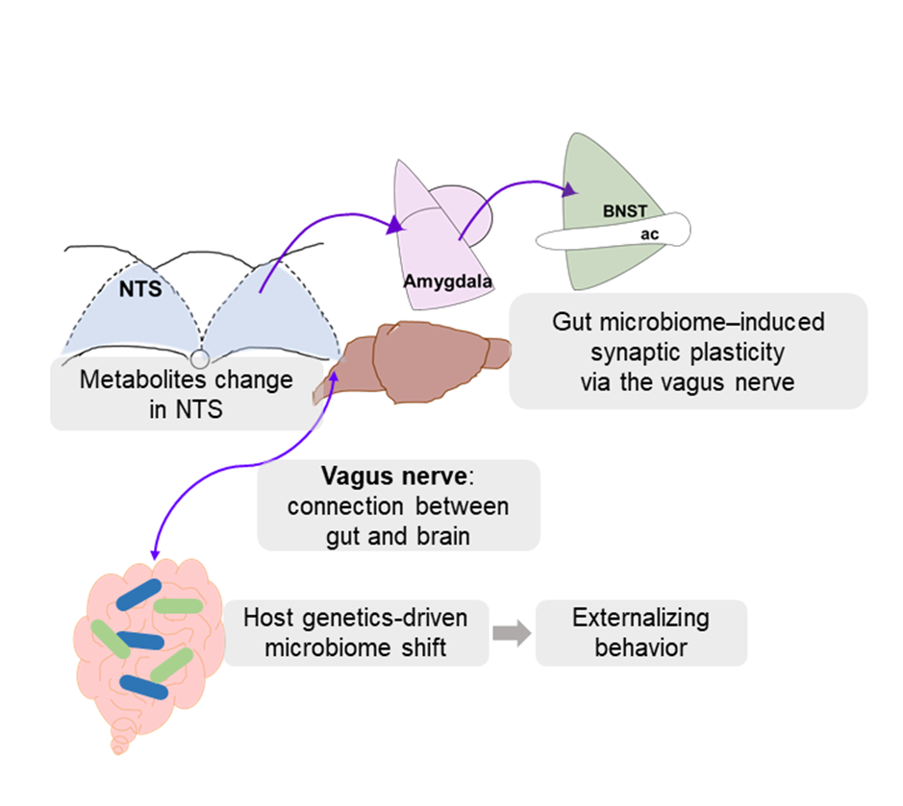

Supplementary Figure 7. Schematic summary
Sirt3 deficiency led to altered gut microbiota composition. The dysbiotic microbiota induced externalizing behaviors and changes in synaptic plasticity-related genes in amygdala and BNST dependent on gut microbiome alteration. These effects were mediated by metabolic changes in the NTS through the gut-brain axis, specifically via the vagus nerve.

Supplementary Table 1. Detailed Characteristics of Recruited Subjects
Group | Gender | Age (years) | STAI-1 | STAI-2 | Anticholinergic drug treatment | Normalized choline Conc.
MDP | F | 29 | 60 | 63 | Quetiapine | 7.34
MDP | F | 22 | 70 | 70 | Doxepin | 12.8
MDP | M | 29 | 80 | 80 | paroxetine, Quetiapine, Olanzapine | 16
MDP | F | 64 | 57 | 53 | No | 17.9
MDP | F | 65 | 51 | 51 | No | 22
MDP | F | 56 | 59 | 60 | Quetiapine | 22.2
MDP | F | 51 | 56 | 62 | Benzatropine, Quetiapine | 18.3
MDP | F | 21 | 65 | 68 | No | 16.1
MDP | M | 40 | 76 | 64 | Paroxetine | 12.7
MDP | M | 54 | 60 | 59 | Quetiapine | 20.9
HC | F | 51 | 32 | 37 | - | 13.6
HC | F | 25 | 33 | 42 | - | 12
HC | M | 39 | 30 | 28 | - | 9.41
HC | F | 50 | 29 | 30 | - | 15.9
HC | F | 32 | 31 | 39 | - | 16.6
HC | F | 43 | 37 | 36 | - | 12
HC | F | 28 | 22 | 25 | - | 9.91
HC | M | 32 | 37 | 38 | - | 14.1
HC | M | 28 | 21 | 24 | - | 11.1
HC | F | 54 | 38 | 43 | - | 14
HC | M | 29 | 29 | 25 | - | 17.9
HC | F | 47 | 33 | 31 | - | 12

Abbreviations: HC, Healthy controls; MDP, mood disorder patients; M/F, male/female; STAI, state-trait anxiety inventory;

Supplementary Table 2. Demographic and Clinical Details of Recruited Subjectsª
 | HC | MDP | P ^{b}
Sample Size | 12 | 10 | –
Anticholinergic drug treatment (Y/N) | N | 9/12 | –
Sex (M/F) | 4/8 | 3/7 | 0.87
Age (year) ^{c} | 38.17±10.4 | 43.1±17.0 | 0.41
K-BAI ^{c} | 2.3±2.7 | 37±11.5 | 0.00
STAI-1 Scores ^{c} | 31±5.4 | 63.4±9.3 | 0.00
STAI-2 Scores ^{c} | 33.2±6.8 | 63±8.4 | 0.00
ª Abbreviations: HC, Healthy controls; MDP, Mood disorder patients; M/F, male/female; STAI, State-Trait Anxiety Inventory; K-BAI, Korean version of the Beck Anxiety Inventory;
^{b} Two-tailed Student’s t-test for continuous variables (age, K-BAI, STAI-1 and STAI-2 scores). Chi-square analyses for categorical variables (sex).
^{c} Values expressed as the means ± standard deviations.

References
1. Komada M, Takao K, Miyakawa T. Elevated plus maze for mice. J Vis Exp. 2008(22).
2. Takao K, Miyakawa T. Light/dark transition test for mice. J Vis Exp. 2006(1):104.
3. Shoji H, Takao K, Hattori S, Miyakawa T. Contextual and cued fear conditioning test using a video analyzing system in mice. J Vis Exp. 2014(85).
4. Can A, Dao Dt Fau - Terrillion CE, Terrillion Ce Fau - Piantadosi SC, Piantadosi Sc Fau - Bhat S, Bhat S Fau - Gould TD, Gould TD. The tail suspension test. (1940-087X (Electronic)).
5. Siopi E, Galerne M, Rivagorda M, Saha S, Moigneu C, Moriceau S, et al. Gut microbiota changes require vagus nerve integrity to promote depressive-like behaviors in mice. Mol Psychiatry. 2023;28(7):3002–12.
6. Kim MH, Choi J Fau - Yang J, Yang J Fau - Chung W, Chung W Fau - Kim J-H, Kim Jh Fau - Paik SK, Paik Sk Fau - Kim K, et al. Enhanced NMDA receptor-mediated synaptic transmission, enhanced long-term potentiation, and impaired learning and memory in mice lacking IRSp53. (1529-2401 (Electronic)).
7. Bravo JA, Forsythe P, Chew MV, Escaravage E, Savignac HM, Dinan TG, et al. Ingestion of Lactobacillus strain regulates emotional behavior and central GABA receptor expression in a mouse via the vagus nerve. Proc Natl Acad Sci U S A. 2011;108(38):16050–5.
8. O'Leary OF, Ogbonnaya ES, Felice D, Levone BR, L CC, Fitzgerald P, et al. The vagus nerve modulates BDNF expression and neurogenesis in the hippocampus. (1873-7862 (Electronic)).
9. Arciniega-Martínez IM, Drago-Serrano ME, Salas-Pimentel M, Ventura-Juárez J, Reséndiz-Albor AA, Campos-Rodríguez R. Anterior subdiaphragmatic vagotomy decreases the IgA antibody response in the small intestines of BALB/c mice. Journal of Neuroimmunology. 2019;337:577072.

