Supporting Information
The efficiency of rare earth doped V₂O₅ nanoparticles on photocatalytic and antibacterial activity
M.V. Arularasu ª and K. Tharun Sidharth ª
ª Sustainable Energy and Environment Research Unit, Department of Physiology, Saveetha Medical College and Hospital, Saveetha Institute of Medical and Technical Science, Chennai – 602 105, Tamil Nadu, India.

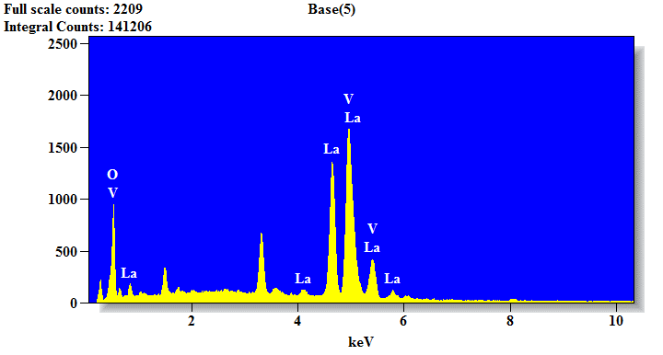
Fig. S1. EDX spectrum of La doped V₂O₅ nanoparticles
Table. S1. Energy spectrum of V₂O₅ and La doped V₂O₅ nanoparticles
Rank | Feature | Impact Level
1 | hv_LaV2O5 | Very High
2 | hv_V2O5 | High
3 | alpha_V2O5 | Moderate
4 | alpha_LaV2O5 | Moderate

Table.S2. Prediction output table
Wavelength_V₂O₅ | Abs_V₂O₅ | hv_V₂O₅ | alpha_V₂O₅ | Wavelength_La@V₂O₅ | Abs_Ln@V₂O₅ | hv_La@V₂O₅ | alpha_La@V₂O₅ | Predicted Bandgap
315.67 | 2.45 | 3.22 | 180.1 | 312.55 | 2.17 | 2.91 | 190.4 | 2.17
412.23 | 1.12 | 2.80 | 140.5 | 405.10 | 1.25 | 2.53 | 170.8 | 1.91

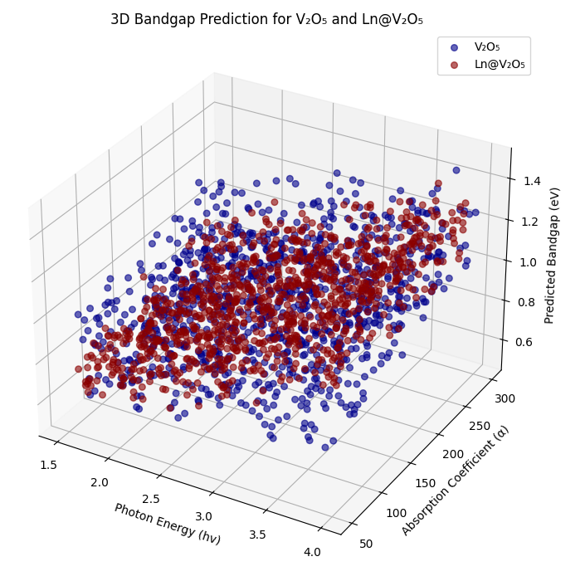

Fig. S2. Relationship between Photon energy (hv), absorption coefficient (α), and the predicted bandgap

