Supplementary Information for
Deep learning driven inverse design of multi-material structures with tailored anisotropic mechanical responses
¹Zhengda Chen, ²Xiangjun Zha, ¹Haocheng Yang, ¹Lin Chen, ¹Xianglei Li, ¹Qingyi Qi, ¹Jigang Huang*
¹ Department of Mechanical Engineering, Sichuan University, Chengdu, 610065, China.
2 Department of Ultrasound, Medical Research Center, Affiliated Hospital of Southwest Jiaotong University, The Third People's Hospital of Chengdu, Chengdu, 610031, Sichuan, China.
*The corresponding author. Email: jigang.huang@scu.edu.cn

Supplementary Note S1 │Dataset establishment.
The simulation and forward prediction model training utilize binary numbers (0 and 1) to represent hard and soft materials, respectively (Fig. 3a). The spatial distribution of materials within the physical samples is represented by the positional relationships of elements within a spatial matrix (Fig. 3b).
To generate the data required for training the forward prediction model, simulations are conducted using the Abaqus finite element simulator (Dassault Systèmes SIMULIA 2022, Johnston, USA). The simulator predicts stress-strain characteristics based on the distribution of soft and hard materials. Custom Python scripts are employed to automatically generate Abaqus input files (.inp) tailored to specific requirements, encapsulating the parameters and conditions necessary to simulate the behavior of the hierarchical architecture. The mesh type used in the simulation is tetrahedral, with a global approximate size of 0.002.
A uniaxial compression test was simulated for each case. The boundary conditions were defined as follows: the bottom surface of the cubic structure was fully fixed (U_{x} = U_{y} = U_{z} = 0), while a uniform vertical displacement was applied to the top surface to achieve a global compressive strain of 20% (Fig. 3c). An implicit solver was employed to ensure convergence. To reduce the complexity of training the deep learning model, reaction forces were recorded at 1% strain increments starting from 0%. For each sample, a total of 21 reaction force values were collected and converted into stress values (Fig. 3d), which served as the ground truth labels for neural network training.
Furthermore, to ensure the diversity of the simulation data, the proportion of soft material within the overall structure followed a uniform distribution, as shown in Fig. 3e. To maximize throughput, 12 different material allocations were batched and simulated concurrently to achieve optimal CPU utilization. The finite element simulations were performed on a workstation equipped with a 13th Gen Intel® Xeon® Gold 5317 processor (3.00 GHz) and 64 GB of RAM. This approach significantly reduced the time required for data acquisition.
Supplementary Figure S1 │Dataset establishment.
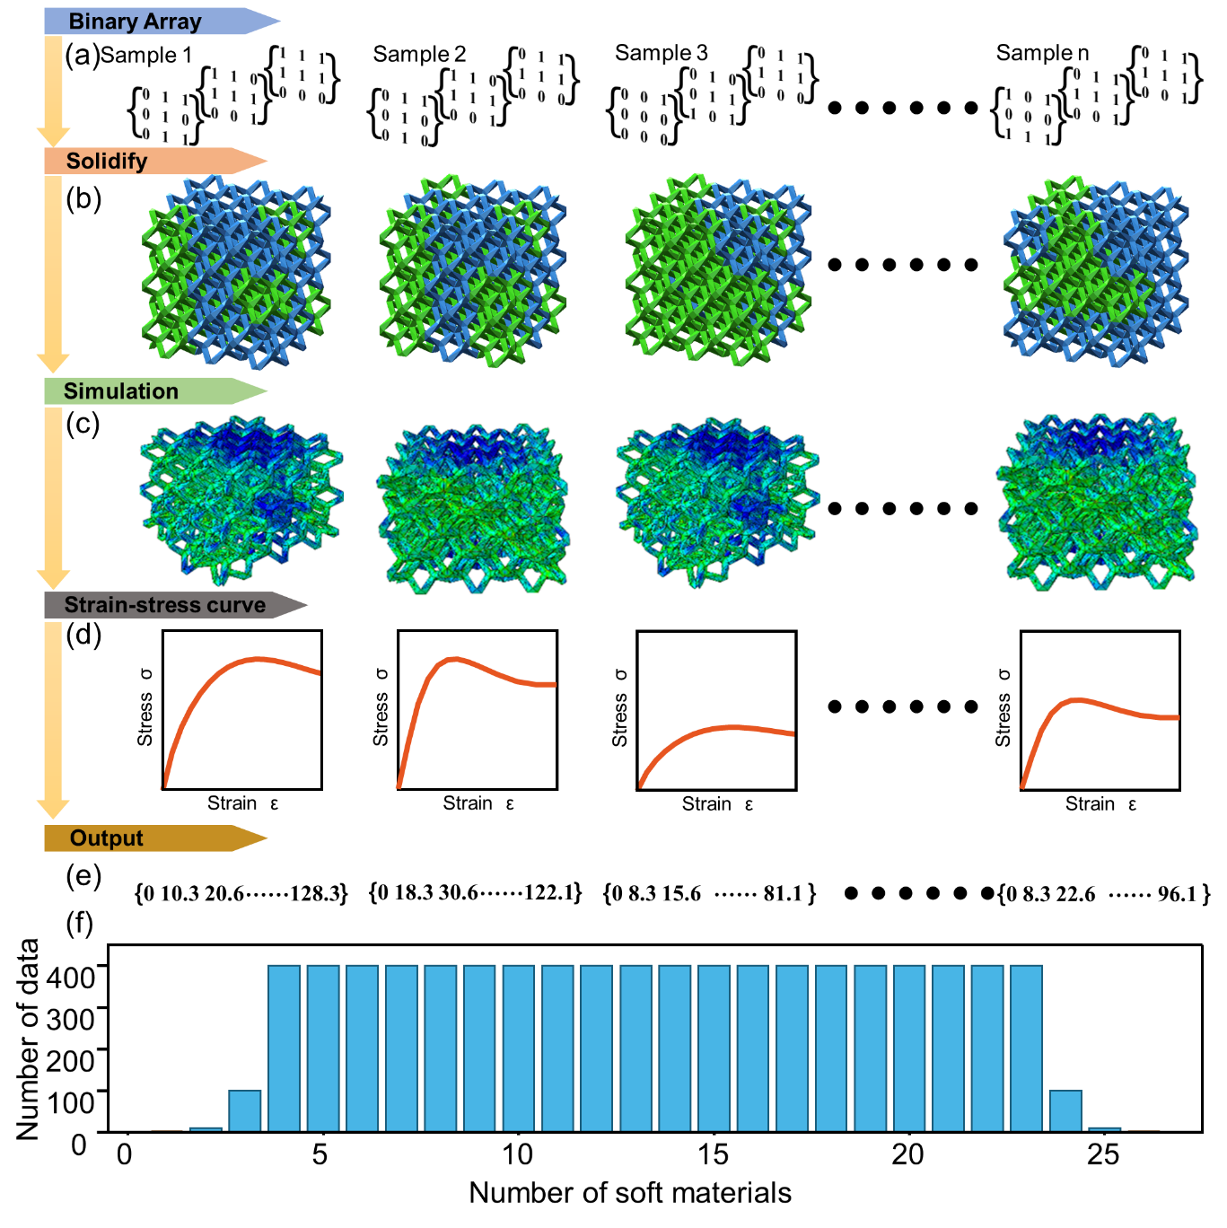
a, Binary array (the input of the model). b, solidified model. c, The simulation progress. d, The strain-stress curve. e, The output of the model. f, The distribution of data.

Supplementary Table S1 │The printing parameters and mechanical properties of the materials used in this work.
Material | PLA | TPU
Layer thickness (mm) | 0.2 | 0.2
Line width (mm) | 0.42 | 0.42
Infill density | 100% | 100%
Speed (mm/s) | 200 | 200
Support | No | No
Nozzle temperature (℃) | 190-230 | 220-240
Toughness (kJ/m²) | 26.6 | 124.3
Strength (MPa) | 76 | 45
Stiffness (MPa) | 2750 | 600

Supplementary Figure S2 │Base unit used in this work. (Scale bar: 3cm)
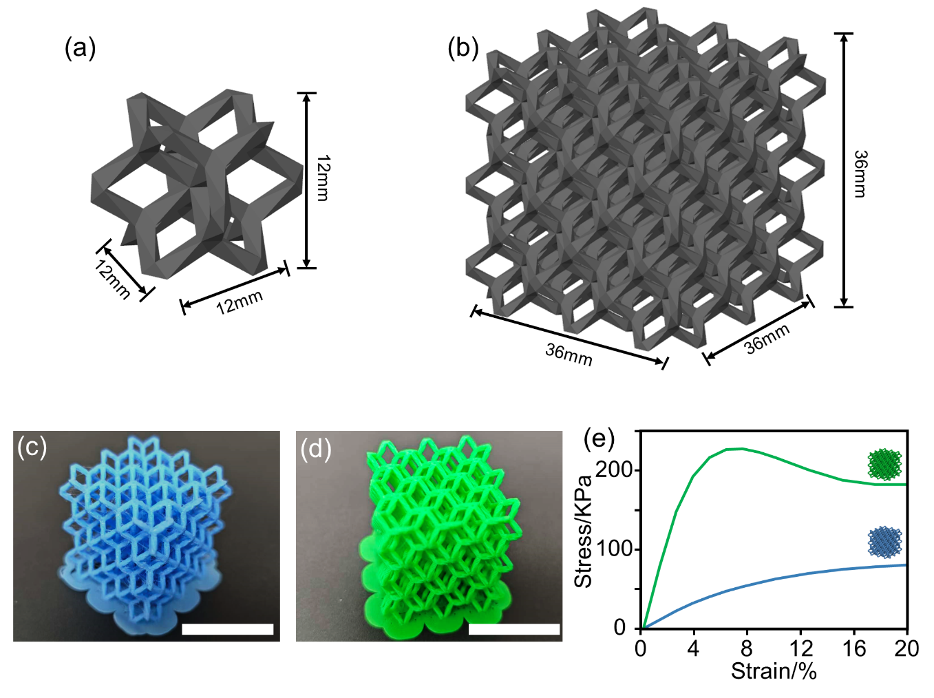
a, The unit. b, 3×3×3 array. c, The printed pure TPU 3×3×3 array. d, The printed pure PLA 3×3×3 array. e, The mechanical properties of the printed pure PLA and TPU arrays.

Supplementary Figure S3 │The optimize for the hyperparameters of the forward model.

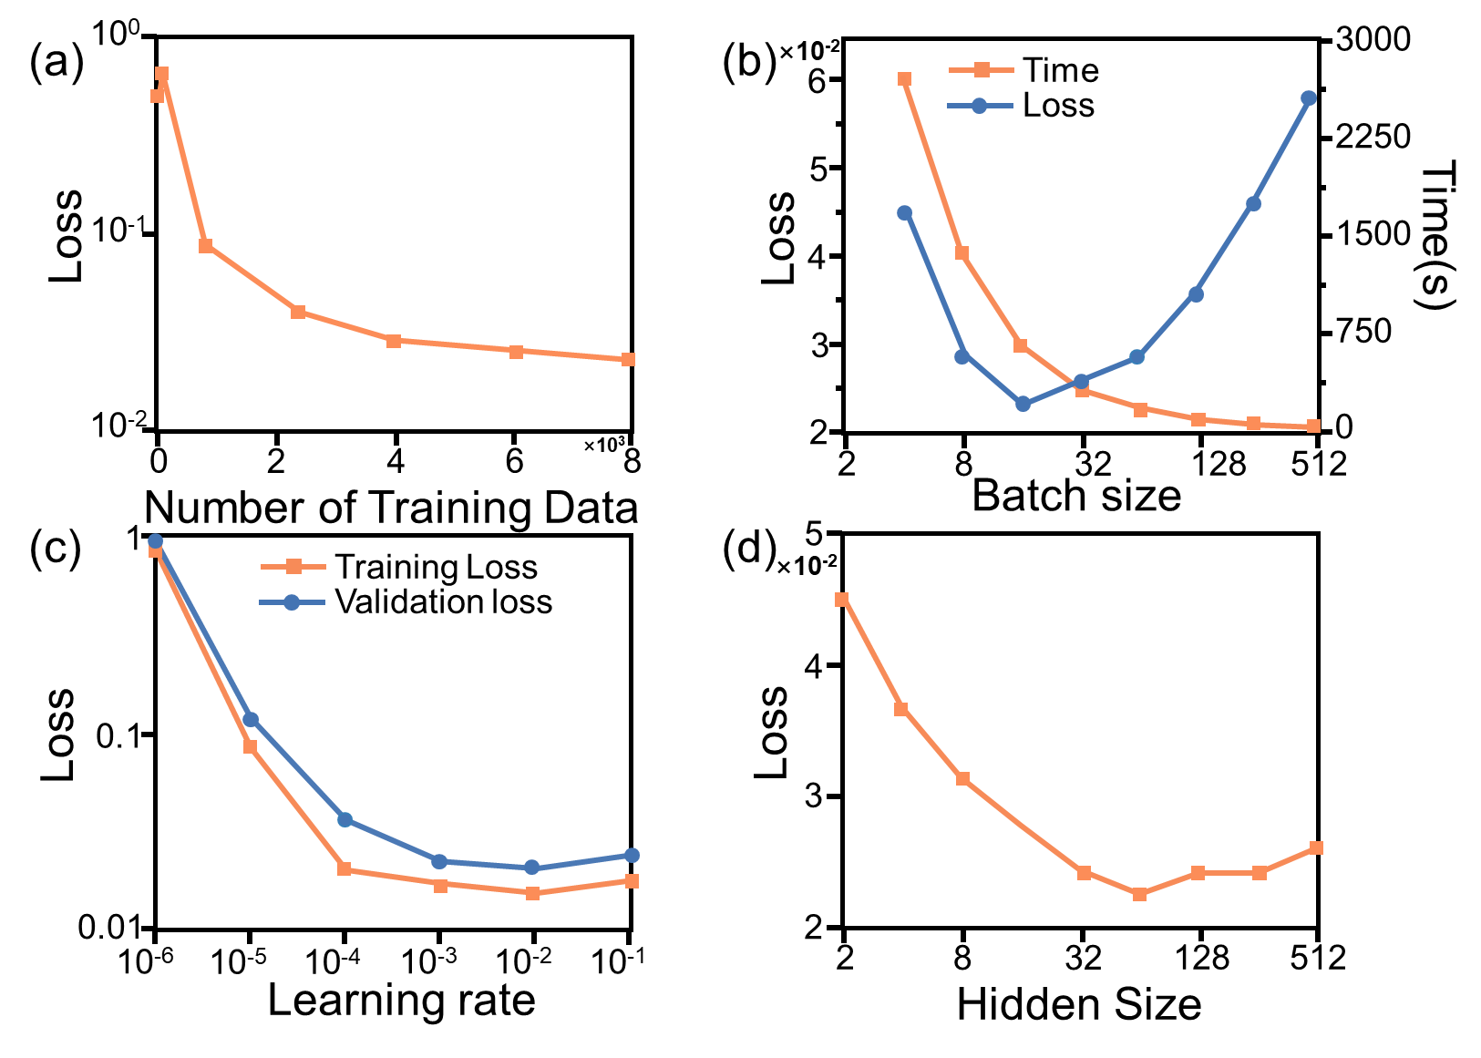
a, The influence of the number of training data on loss. b, The influence of batch size on loss. c, The influence of learning rate on loss. d, The influence of hidden size on loss.

Supplementary Table S2 │Hyperparameters of the forward model.

Parameter | Value
Input dimensions | 1 × 27
Output dimensions | 1 × 21
Total hidden units | 64-128-256
Learning rate | 0.01
Learning rate decay | 2^{-1/2} every 25 epochs
Batch size | 50
Maximum epochs | 500
Validation split | 30%
Early stopping patience | 25 epochs
Loss function | Mean Squared Error (MSE)

Supplementary Figure S4 │The optimize for the hyperparameters of the inverse model.
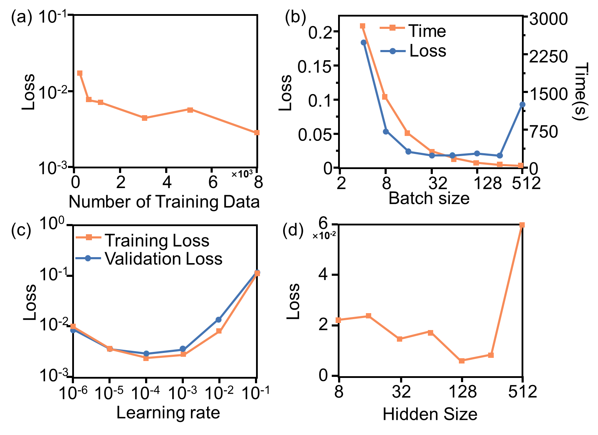
a, The influence of the number of training data on loss. b, The influence of batch size on loss. c, The influence of learning rate on loss. d, The influence of hidden size on loss.

Supplementary Table S2 │Hyperparameters of the inverse model.

Parameter | Value
Input dimensions | 1 × 21
Output dimensions | 1 × 27
Total hidden units | 128-64-32
Learning rate | 0.0001
Learning rate decay | 2^{-1/2} every 25 epochs
Batch size | 64
Maximum epochs | 500
Validation split | 30%
Early stopping patience | 25 epochs
Loss function | Mean Squared Error (MSE)

Supplementary Table S3 │Parameters of the UAV.

Parameter | Value
Weight (g) | 110
V_{xy} (m/s) | 10
V_{z} (m/s) | 6

