Supplementary Information
for the manuscript entitled:
“ Electrospun poly (vinyl alcohol) - chitosan nanofibers integrated with mangiferin: fabrication and properties”
Authors: Thi Hong Nhung Vu^{1*}, Svetlana N. Morozkina^{2,3}, Vera E. Sitnikova³, Yuliya E. Generalova⁴, Quang Sang Nguyen⁵, Mayya V. Uspenskaya²
*Corresponding author: Thi Hong Nhung Vu, Email: vuhongnhungs@gmail.com

Additional figures
Figure S1. Chemical model for mangiferin pK_{a}'s assignment
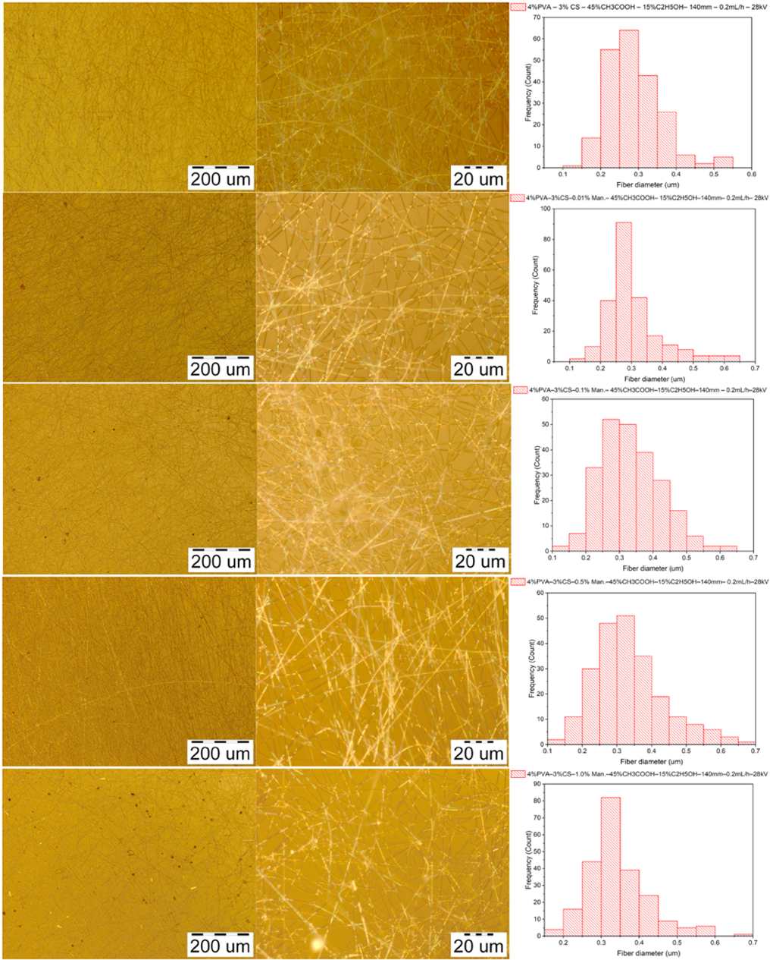
Figure S2. Microscopic images of nanofibers from solutions of 4% PVA - 3% CS - mangiferin at 100- and 1000-fold magnification and their diameter distribution. (Electrospinning parameters: needle-collector distance of 140 mm, feed rate of 0.2 ml/h and voltage of 28 kV).

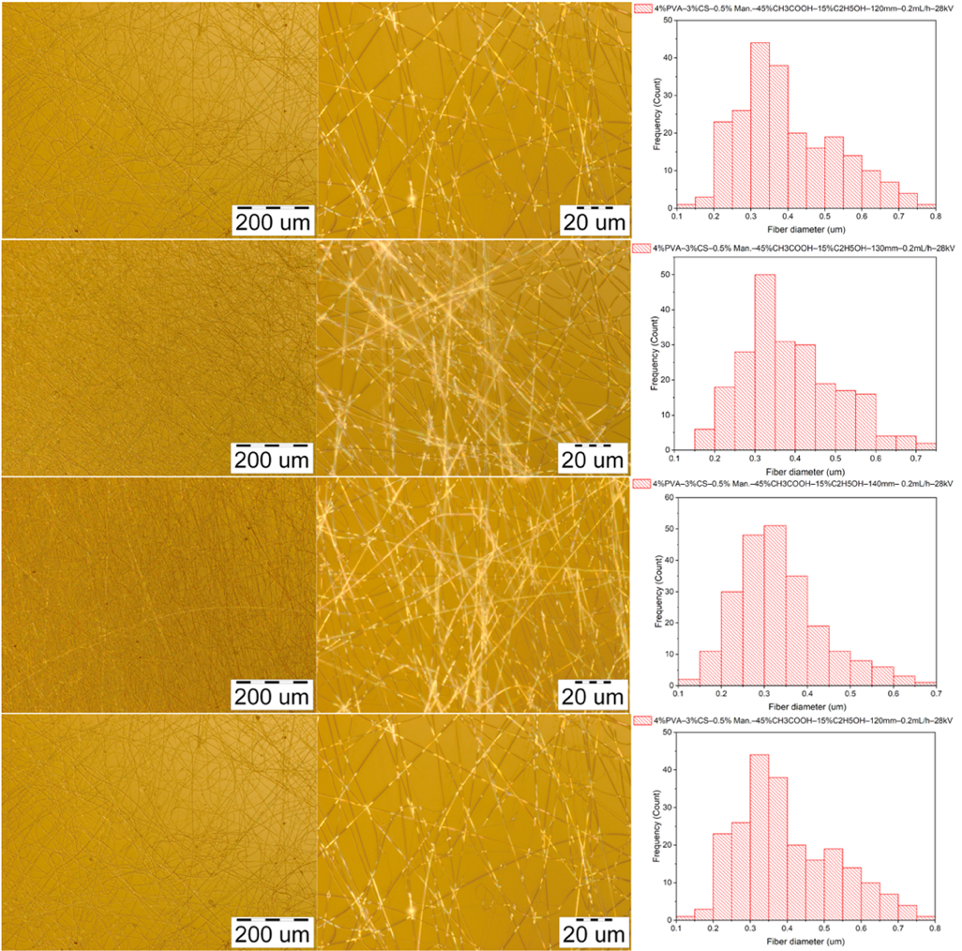
Figure S3. Microscopic images of nanofibers from solutions of 4% PVA - 3% CS – 0.5% mangiferin at 100- and 1000-fold magnification and their diameter distribution. (Electrospinning parameters: needle-collector distance of 120-150 mm, feed rate of 0.2 mL/h and voltage of 28 kV).
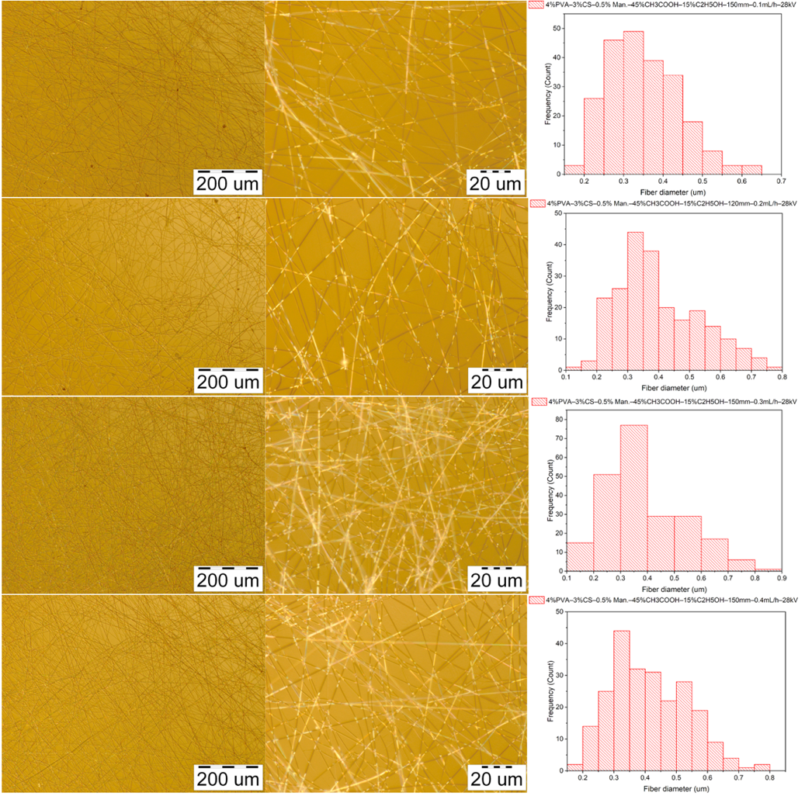
Figure S4. Microscopic images of nanofibers from solutions of 4% PVA - 3% CS – 0.5% mangiferin at 100- and 1000-fold magnification and their diameter distribution. (Electrospinning parameters: needle-collector distance of 150 mm, feed rate of 0.1 – 0.4 mL/h and voltage of 28 kV).
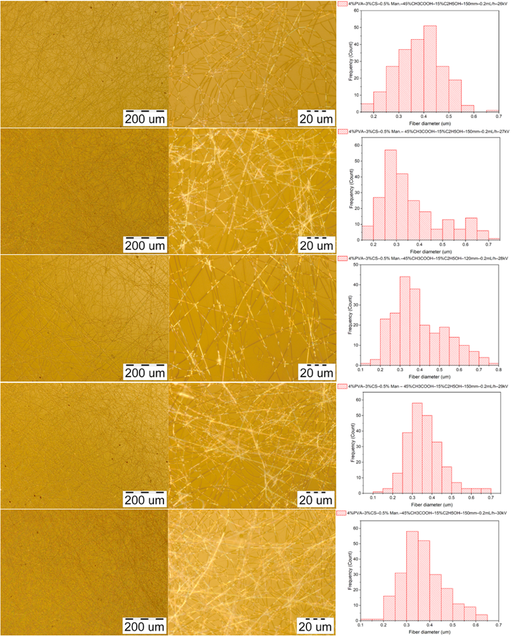
Figure S5. Microscopic images of nanofibers from solutions of 4% PVA - 3% CS – 0.5% mangiferin at 100- and 1000-fold magnification and their diameter distribution. (Electrospinning parameters: needle-collector distance of 150 mm, feed rate of 0.2 mL/h and voltage of 26 – 30 kV).

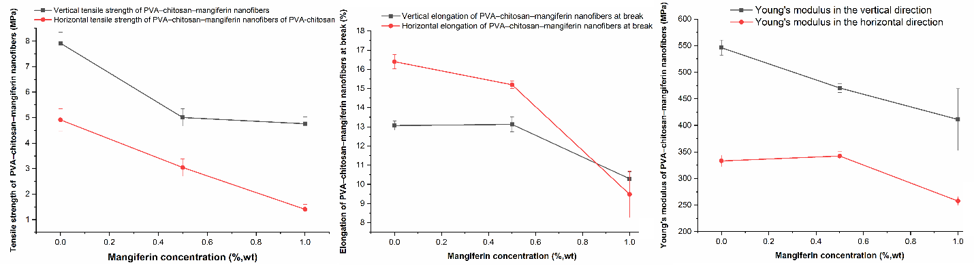
Figure S6. Changes in tensile properties of PVA – CS – mangiferin nanofibers
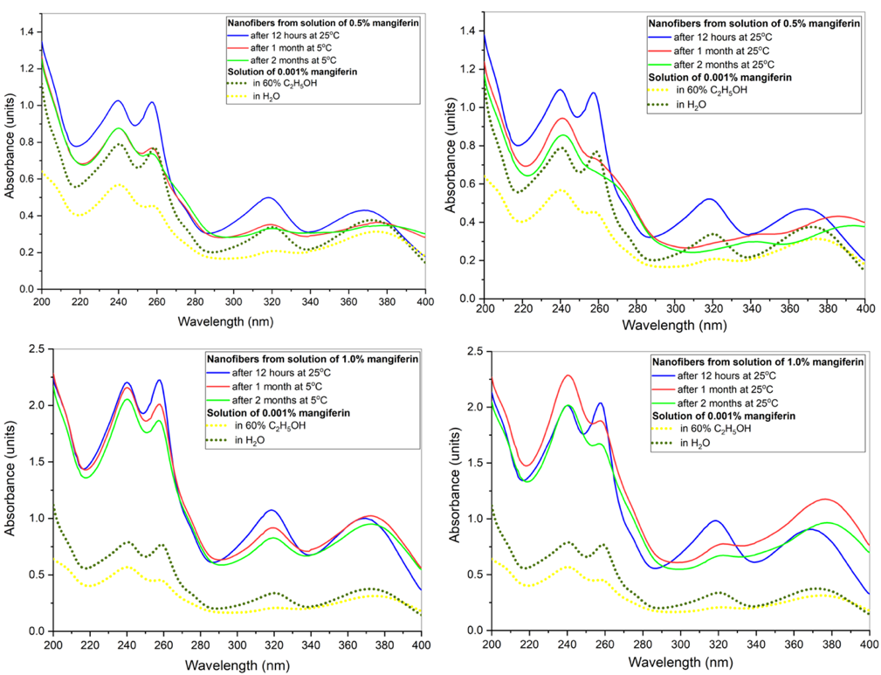
Figure S7. Changes in the UV-visible spectra of aqueous solutions of PVA–chitosan–mangiferin nanofibers during storage
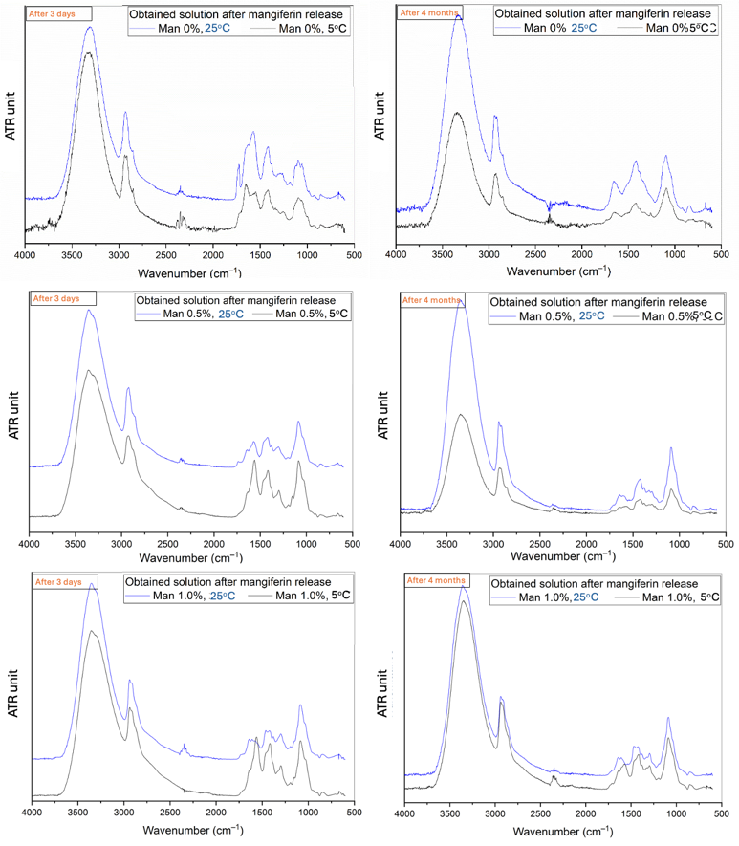
Figure S8. IR spectra of solutions of the studied nanofibers after 4 months of storage in water
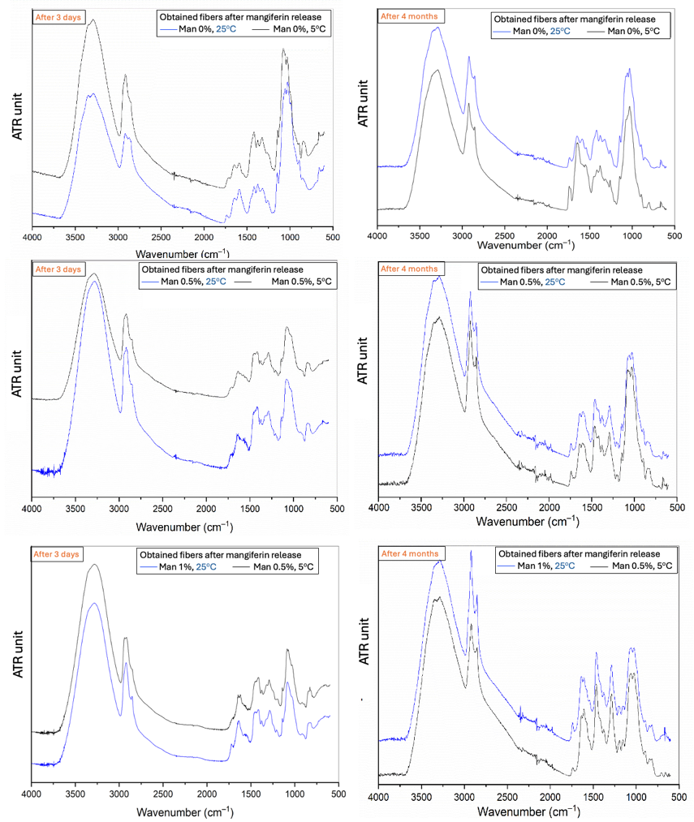
Figure S9. IR spectra of fibers of the studied nanofibers after 4 months of storage in water
References
[S1] B. Gómez-Zaleta, M.T. Ramírez-Silva, A. Gutiérrez, E. González-Vergara, M. Güizado-Rodríguez, A. Rojas-Hernández, UV/vis, 1H, and 13C NMR spectroscopic studies to determine mangiferin pKa values, Spectrochim Acta A Mol Biomol Spectrosc 64 (2006) 1002–1009. https://doi.org/10.1016/j.saa.2005.09.009.

