Supplemental Material
Sample | Number pooled | Cells/ul | Total cells | Viability (%) | Cells used for capture
E12 WT | 2 | 1200 | 36,000 | 98 | 16,000
E12 KO | 2 | 400 | 18,000 | 87 | 13,000
E14 WT | 2 | 2600 | 78,000 | 97 | 16,000
E14 KO | 2 | 2100 | 84,000 | 96 | 16,000
E15 WT | 1 | 800 | 40,000 | 98 | 16,000
E15 KO | 1 | 500 | 25,000 | 99 | 16,000

Supplemental Table 1: Single cell sequencing sample preparation summary

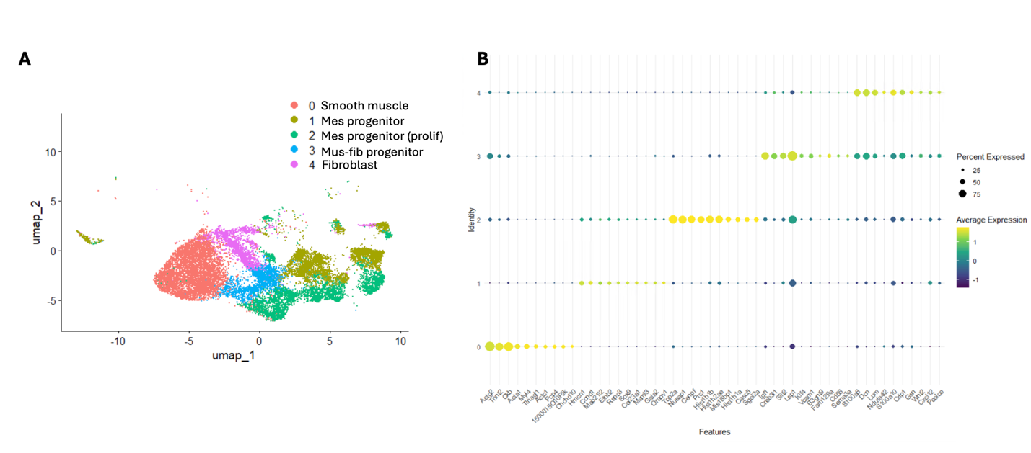
Supplemental Figure 1: Markers for mesenchymal cell populations in WT embryonic bladders integrated from E12 to E15. (A) UMAP of cell populations, Mes – mesenchymal, mus – muscle, fib – fibroblast (B) Top 10 markers obtained through FindAllMarkers function in Seurat.

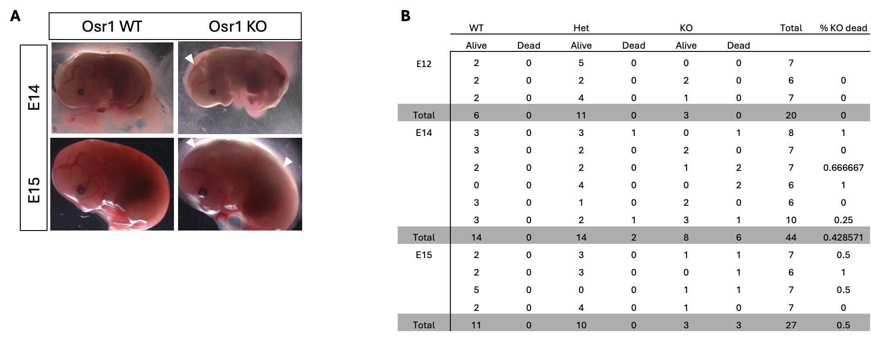
Supplemental Figure 2: Summary of breeding and embryo viability from crosses between Osr1^{+/-} heterozygous mice (A) Representative whole mount imaging of E14 and E15 embryos with spinal edema seen in KO embryos. (B) Summary of viable vs dead embryos, with approximately 50% of Osr1-KO embryos surviving up until E15. KO mice were not viable at later timepoints.
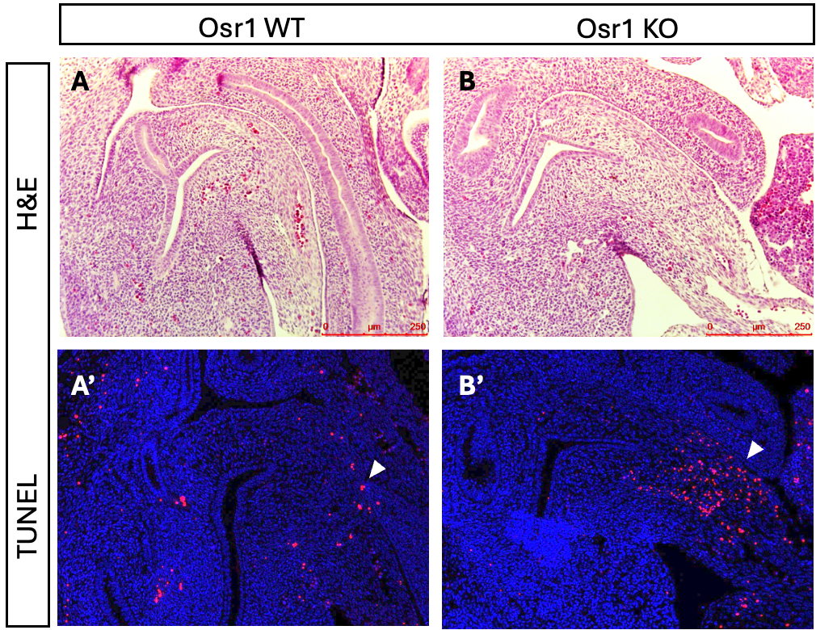
Supplemental Figure 3: Cell death analysis at E12 from sagittal sections: (A) WT embryos had very little cell death as assessed by the TUNEL assay with some occurring at the edge of the primordial bladder (B) KO embryos displayed higher cell death in a similar region to the WT embryos. In both the WT and KO embryos, cell death was concentrated in a region close to the umbilical artery that is not the future bladder.

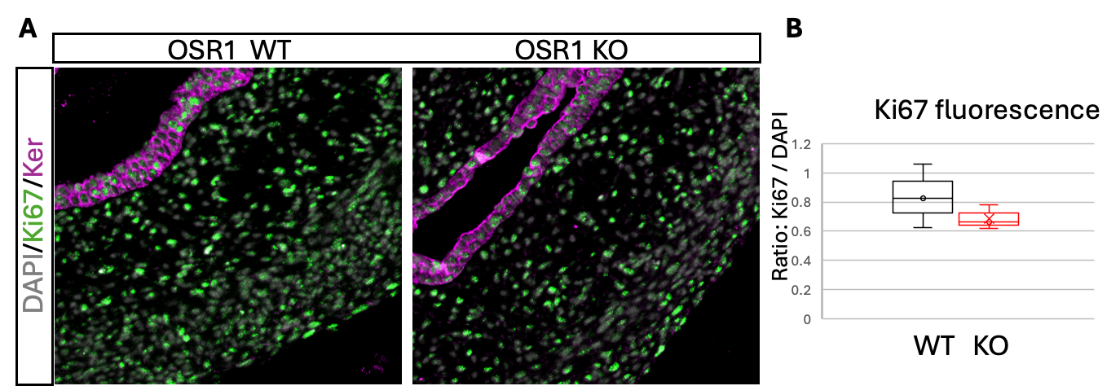
Supplemental Figure 4: Cell proliferation analysis at E14: (A) Both WT and KO embryos had similar and high levels of cell proliferation as shown using an antibody to Ki-67 at E14. Most mesenchymal and epithelial cells (labelled in magenta for keratin) were positive for Ki-67 protein (green). (B) Quantification of Ki-67 fluorescence normalized to DAPI fluorescence, n = 3 bladders/genotype, p = 0.3
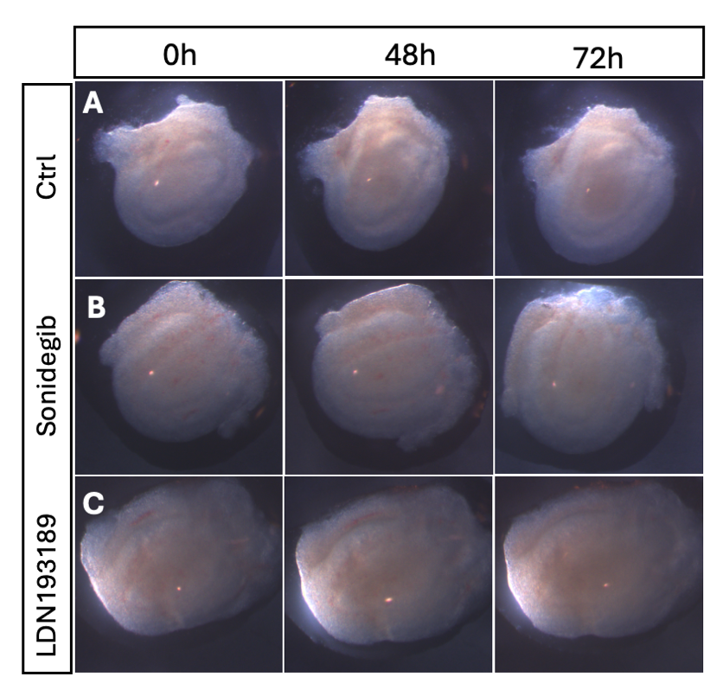
Supplemental Figure 5: Representative whole mount imaging of wildtype embryonic bladders at E13.5 cultured and imaged at 0-, 48- and 72-hours during treatment with inhibitors or in vehicle, DMSO. (A) DMSO control bladder explants. (B) Bladder explants treated with the Smo inhibitor Sonidegib that blocks the SHH pathway, and (C) after treatment with the Alk2/3 inhibitor LDN193189 that blocks the BMP signaling pathway. n=3 bladders/treatment.

