Decision-oriented resilience for sustainable infrastructure across the life cycle

Supplementary information

Marco Domaneschiª, Nadiia Kopiika^{b,c}, Roberta Di Bari^{b,c}, Paola Cavallaroª, Valentina Villaª, Sotirios Argyroudis^{d,c}, Stergios-Aristoteles Mitoulis^{b,c*}
ª Department of Structural, Geotechnical and Building Engineering, Politecnico di Torino, Corso Duca degli Abruzzi 24, Turin, Italy
^{b} University College London, The Bartlett School of Sustainable Construction, The Bartlett, UCL Faculty of the Built Environment, 1-19 Torrington Place, London, WC1E 7HB, UK
^{c} MetaInfrastructure.org, London, UK
^{d} Brunel University of London, Kingston Lane, Uxbridge, Middlesex, London, UB8 3PH, UK
*Corresponding author, E-mail: s.mitoulis@ucl.ac.uk

Supplementary Note 1. Polyfytos bridge: current condition and selected retrofit solutions

Description of the bridge
The Polyfytos bridge (also known as bridge of Servia) is a landmark bridge in the Municipality of Western Macedonia, Kozani, Greece. Conceived by Professor Riccardo Morandi and completed in 1975, the bridge spans the artificial reservoir formed by the Aliakmonas River dam and functions as a strategic transport link between Western Macedonia and the national road network, including the principal Athens–Thessaloniki corridor. At the time of construction, the case study bridge represented the longest overall bridge in Greece, a record that remained until the opening of the Rion–Antirion Bridge nearly 35 years later. The total bridge length is 1,371 m and comprises 29 spans supported by 29 octagonal hollow-core piers with heights varying from 15 m to 50 m according to topography and local geotechnical conditions (see Supplementary Figure 1). Foundations are predominantly spread footings measuring 11.50 m by 15.00 m, founded on a 5 m compacted gravel layer overlying limestone. Piers located within the original riverbed required pile foundations (22 piles per pier of 1.2 m diameter and depths ranging from 16 m to 18 m) to penetrate alluvial deposits and achieve adequate bearing capacity. The plan geometry is curved along the initial 24 spans, introducing combined bending and torsional demands in the superstructure. The first 25 spans are realized as simply supported spans comprising three precast prestressed I-beams continuous transversely and connected by a cast-in-place concrete slab. Expansion joints and elastomeric bearings are provided at each pier location to decouple thermal and long-term movements from the substructure [1].

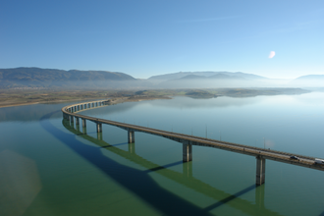
(a)
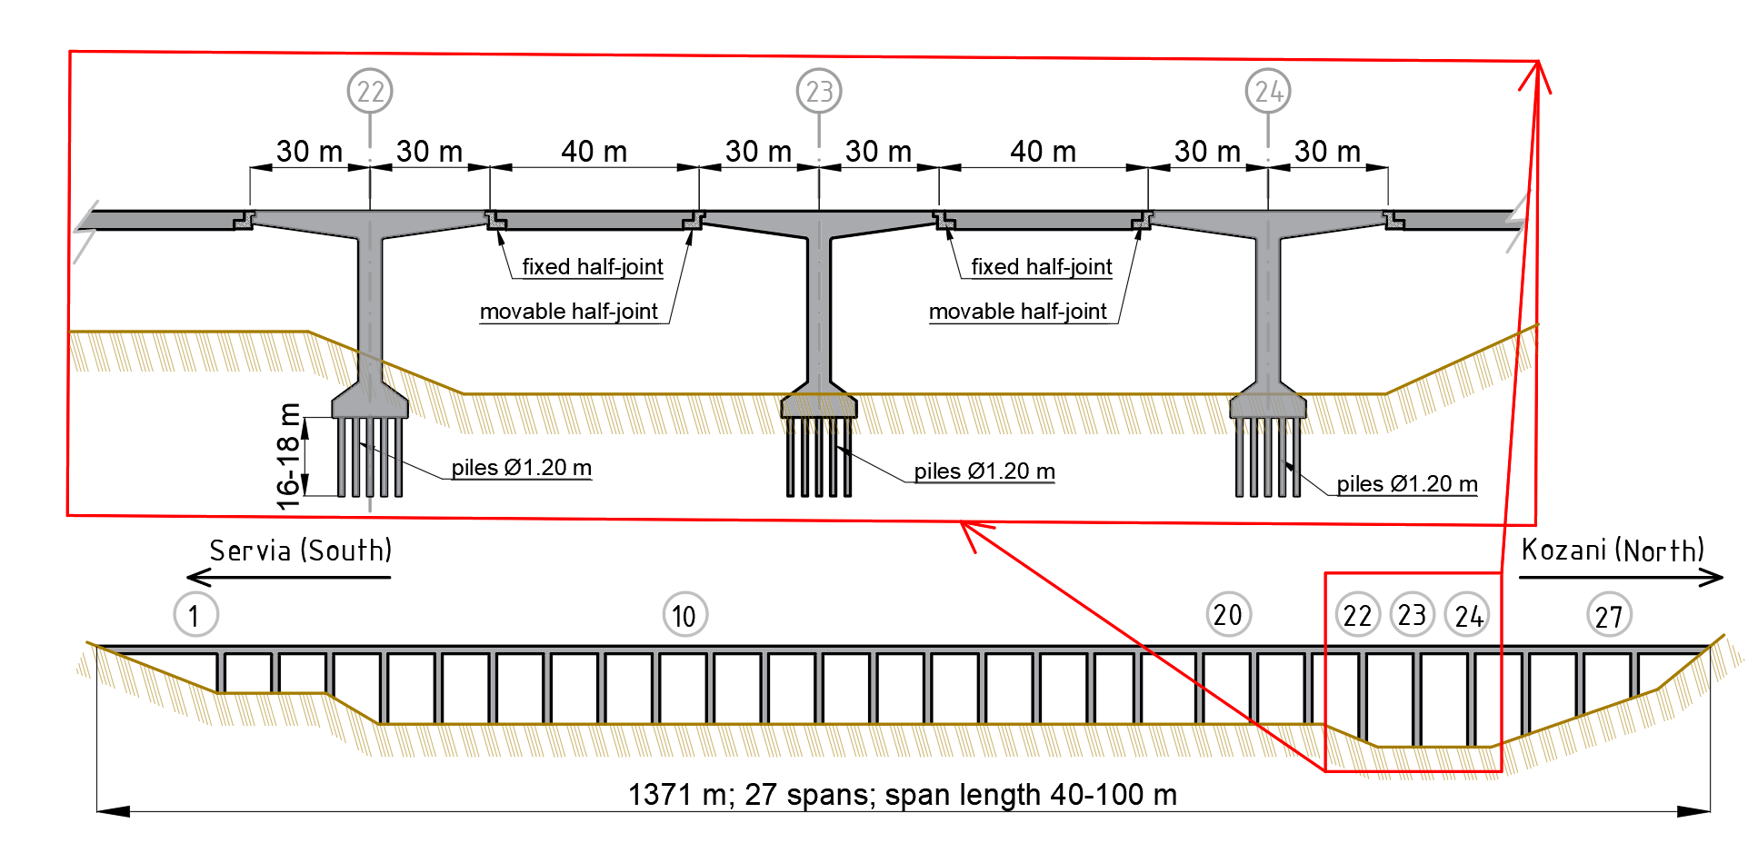
(b)
Supplementary Figure 1. Polyfytos bridge: (a) general view (Image source: Wikimedia Commons, licensed under Creative Commons Attribution Share Alike 3.0); (b) longitudinal section and northern part of the bridge with the cantilevers (reproduced from [1]).
The northernmost part of the bridge (Kozani direction in Supplementary Figure 1b) consists of 4 long spans located over the tallest piers; these spans were executed by the balanced cantilever method. Segmental balanced cantilevers were cast monolithically on piers #22, #23 and #24, producing six cantilever arms of 30 m projecting from the pier faces. Adjacent cantilevers are connected by 40 m long precast, simply supported members, yielding an overall span sequence in the cantilever zone of 70 m, 100 m, 100 m and 70 m (see Supplementary Figure 2b). Original drawings, supplemented by contemporary point-cloud verification, provide the basis for assessing geometry, member sizes and construction details for the segment corresponding to piers #22, #23 and #24, which together account for approximately 260 m of the overall structure and represent the cantilevered portion under study (see Supplementary Figure 2b). The bridge plays a crucial role in the transport network, with limited redundancy, as a prolonged closure has led in the past to substantial detours with significant consequences for mobility and the regional economy [2]. Accordingly, owner and public authority’s objectives, together with available guidelines and benchmarks, require recovery targets that are both ambitious and realistic.

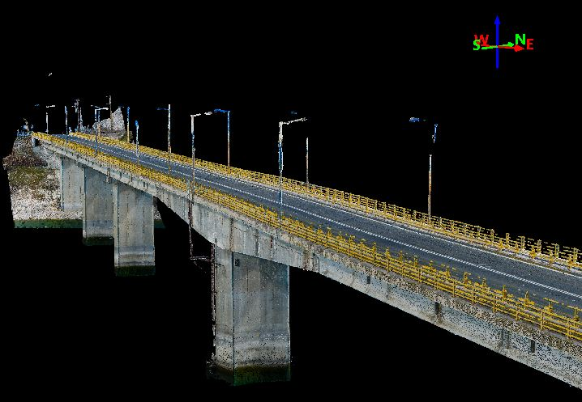
(a)
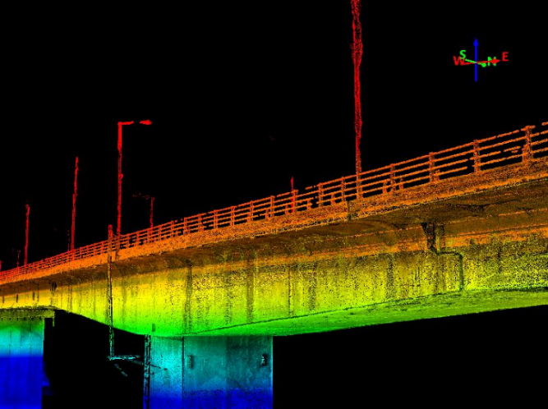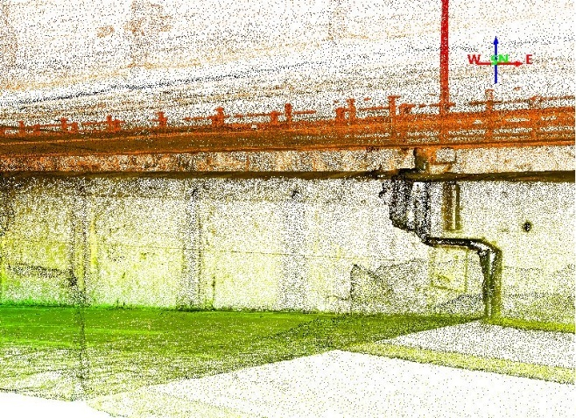
(b) (c)
Supplementary Figure 2. Polyfytos bridge digital twin (DT): (a) overall DT view; (b) elevation-coded segmentation (colour map); (c) detail of a half-joint (Source: [3], owned by MetaInfrastructure).

Identified damage states
The bridge is divided into two main structural zones: the approach spans (piers #1–#21), which are formed by simply supported prestressed concrete girders, and the cantilever zone (piers #22–#24), which consists of segmental balanced cantilevers connected by Gerber-type drop-in girders. The approach spans exhibit deterioration patterns consistent with long-term service conditions of prestressed concrete bridges. Observed damage includes localized cracking, limited concrete spalling, and surface degradation, which are considered manageable through routine maintenance interventions and do not significantly compromise the global structural behaviour. In contrast, the cantilever zone shows a markedly more severe and articulated damage condition. Repeated inspections and recent remote sensing surveys document excessive vertical deflections at the cantilever free ends, extended cracking of the box girder sections, deterioration at half-joints and anchorage regions, and signs consistent with prestressing tendon corrosion. These manifestations have led to operational restrictions, including reduced speed limits and weight limits for heavy vehicles, pending definitive intervention [1].
The observed damage pattern can be interpreted in terms of progressive damage states that have been reported in the literature for the bridge [4,5]. Initial stages are associated with long-term effects such as creep, shrinkage, and prestress losses, resulting in serviceability-level exceedance and progressive increase of cantilever deflections. More advanced damage states correspond to partial or total loss of prestressing force due to tendon corrosion and anchorage deterioration, leading to pronounced stiffness reduction, extensive cracking of the top and bottom slabs, and differential deformations between cantilever arms and the simply supported Gerber-type members. In extreme scenarios, documented in previous studies on the same structure, these mechanisms may evolve towards near-complete loss of prestressing action, with deflection amplitudes exceeding acceptable thresholds and a significant reduction of residual load-bearing capacity, potentially posing risks of unseating at the Gerber joints and local instability of the deck system [6].
The concentration of damage in the cantilever zone is further exacerbated by the structural configuration of the bridge. The variable-depth box girder geometry, high negative bending moments, reliance on staged prestressing, and limited redundancy of the Gerber system make these segments particularly vulnerable to prestress degradation mechanisms and progressive deterioration. Full-scale invasive testing and load trials were not permitted by the bridge owner due to safety concerns at critical locations and the strategic importance of the bridge within the national E65 corridor, which renders detours impractical. Consequently, the identification and characterization of the damage states relied on non-destructive surveys, visual inspections, and point-cloud-based deformation measurements, which provided sufficient evidence to delineate the governing damage mechanisms and to support the subsequent definition and evaluation of retrofit strategies.
Consistent with the damage states identified above, the structural pathology is dominated by long-term deterioration of the tendon anchorages and prestressing tendons (see Supplementary Figures 4 and 5). As-built and as-inspected configurations indicate progressive loss of prestressing and extensive deterioration at half-joints, resulting in differential deformations of the central simply supported segments between half-joints. The box-girder cantilever geometry (variable depth, concentrated negative moments at pier faces and reliance on staged prestressing) makes these locations particularly vulnerable to tendon corrosion and concrete degradation; nevertheless, the simply supported central beams have limited secondary stress transfer owing to their support condition.
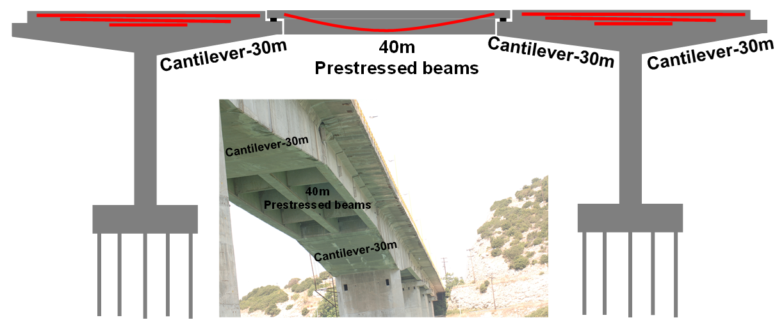
Supplementary Figure 3. Schematic (not to scale) showing prestressing cables (red lines) and view of the deck between Piers 23-24 (Produced and owned by Stergios A Mitoulis).
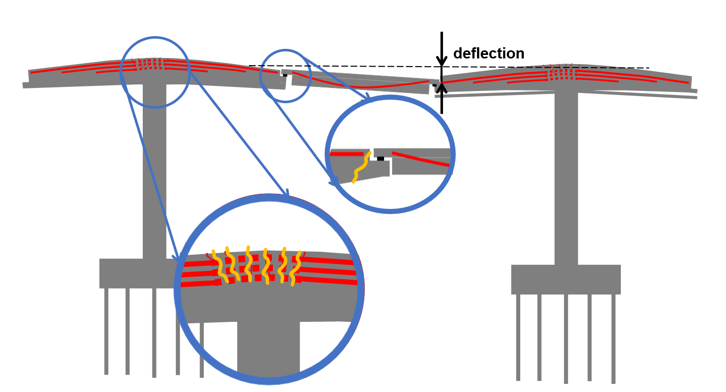
Supplementary Figure 4. Current deteriorated condition of the cantilevers of the bridge after 50 years of service: schematic indicating tendon corrosion hypothesis based on observed cracking (yellow). (Produced and owned by Stergios A Mitoulis).
Given the observed damage, remediation options range from targeted local repairs and external strengthening (e.g., external prestressing, FRP wrapping) to partial or full deck replacement. The next subsection evaluates these retrofitting alternatives in detail.

Retrofitting strategies
Developing a robust retrofit strategy for the case study bridge requires an integrated assessment that balances technical performance, cost-effectiveness, structural durability, operational continuity, environmental sustainability, and respect for the original design intent. The assessment must combine accurate appraisal of the physical condition with the bridge’s functional role in the transport network, projected service life, feasibility of available technologies and cost–benefit considerations [7]. Environmental objectives (e.g. minimizing material waste and embodied carbon and avoiding ecological disturbance) should be incorporated as explicit decision criteria to ensure alignment with sustainable‑development goals [8]. The balanced cantilever beams and Gerber-type girders of the bridge (piers #22–#24) exhibit advanced deterioration, motivating a focused evaluation of interventions that span the full spectrum from minimal repair to full replacement. In contrast, the approach spans display only superficial degradation and are assumed manageable by well-established routine maintenance practices. Therefore, the present analysis concentrates on interventions that address significant loss of capacity and durability in the cantilever section. For systematic evaluation, the proposed interventions are classified into two principal categories: repair and replacement.
Repair strategies aim to extend the service life of the structure by selectively restoring or strengthening its critical components. These interventions are grounded in the principles of structural conservation, and their effectiveness depends on the reliability of the diagnostic assessment and the robustness of the residual structure. Such approaches typically involve less invasive operations and shorter construction periods but may face limitations in terms of achievable performance and long-term resilience. Minimal intervention measures, consisting of light local repairs combined with continued traffic restrictions, were considered at a preliminary stage. However, this option was not regarded as a suitable repair strategy, as it would only mitigate immediate safety concerns without addressing the underlying structural deficiencies. In addition, the level of uncertainty associated with the residual capacity of key components would limit the reliability and durability of such an approach [9]. On this basis, the repair scenarios considered in this study were defined through a review of the literature and consultation with bridge engineers who had inspected and assessed the condition of the bridge.
- Hybrid replacement and external prestressing (Scenario #1): preservation of the existing cantilever beams, replacement of Gerber-type prestressed concrete members with steel beams, and external prestressing tendons. This approach restores the global load-bearing mechanism while retaining substantial portions of the original structure and requires careful compatibility verification, particularly at the interface between old and new materials [10,11].
- Stay‑cable augmentation (Scenario #2): construction of pylons and stay cables anchored to the main piers to redistribute forces from overstressed cantilevers, and facilitate rehabilitation of Gerber joints; partial replacement of Gerber-type members with steel beams. This semi-integral solution changes internal stress flows and increases redundancy [12,13].
- External prestressing (Scenario #3): Retaining cantilevers and Gerber beams, applying external prestressing and comprehensively rehabilitating slabs and half-joints. This preservation‑first option minimizes structural discontinuity, but presumes acceptable tendon and anchorage condition [14].
Replacement scenarios involve complete removal of the existing deck and reconstruction of a new superstructure. These transformational interventions are appropriate when degradation is widespread or residual capacity is inadequate for current and future demands; they allow full compliance with modern load, seismic and serviceability requirements but demand thorough verification of substructure compatibility, dynamic interaction and construction logistics. Three replacement configurations examined are:
- Conventional prestressed concrete deck (Scenario #4): Reconstruction with prestressed concrete beams, replicating the original static scheme, while incorporating modern materials, detailing, and durability improvements. This conservative replacement preserves design continuity and is attractive where long‑term durability is prioritized [15].
- Steel–concrete composite deck (Scenario #5): Replacing the deck with steel beams and a composite concrete slab to reduce self‑weight, accelerate erection and facilitate inspection and modular maintenance [16].
- Prefabricated modular deck with dry joints (Scenario #6): This option emphasizes rapid installation, limited on-site labour, and future reparability, but requires advanced joint technology and careful durability detailing [16,17].
From a methodological standpoint, Scenarios 4 to 6 fall into the category of transformational interventions, wherein the existing structure is not only replaced but reimagined through the lens of modern structural engineering practice. Their adoption, however, must be carefully evaluated against constraints such as construction logistics, environmental impact, and compatibility with the existing substructure. The intervention spectrum in this study is characterised by two main orthogonal dimensions (Supplementary Table 1): extent of intervention and degree of system transformation. The extent of intervention reflects the degree of physical modification applied to the structure, ranging from minimal or local repairs to selective component replacement, substantial partial replacement or system modification, and full deck replacement or reconstruction. The degree of system transformation describes the extent to which each retrofit strategy alters the original structural system and construction approach. Lower levels of transformation correspond to conservative solutions that closely follow the original structural configuration, while higher levels indicate strategies involving more substantial modifications of load paths, structural typology, or construction methods.
Minimal interventions, characterised by limited intervention extent and low system transformation, typically restore only partial functionality with reduced cost, short construction duration, and limited traffic disruption, but provide temporary mitigation. At the opposite end of the spectrum, full replacement strategies allow redefinition of load paths, compliance with current design standards, and enhanced durability, but generally entail higher direct costs, embodied carbon, traffic impact, and the need for rigorous verification of substructure compatibility. Intermediate strategies combine preservation of sound existing elements with targeted replacements or auxiliary load paths to reduce demand on damaged components. These approaches aim to balance performance improvement, constructability, and sustainability.
Supplementary Table 1. Retrofit scenarios
Scenario | Type | Intervention | Gerber joints | External prestressing | Traffic disruption | Degree of system transformation
#1 | Partial repair | Preserved cantilevers + steel beams | Restored | Yes | Moderate | Moderate
#2 | Structural transformation | Stayed cantilevers + partial replacement | Rehabilitated | No | Moderate | High
#3 | Partial repair | Preserved + externally prestressed | Rehabilitated | Yes | Moderate | Moderate
#4 | Full replacement | Full replacement with prestressed concrete | Replaced | No | High | Low
#5 | Full replacement | Steel beams + concrete slab | Replaced | No | High | Moderate
#6 | Full replacement (modular) | Prefabricated segments with dry joints | Replaced | No | Moderate | High

Selecting an optimal retrofit for the case study bridge requires weighing the trade‑offs between transformational replacement (which permits full system redefinition and code compliance but demands major intervention and substructure compatibility) and conservative repair or hybrid measures (which conserve existing fabric, reduce disruption and waste but depend on reliable diagnostics and careful integration). A final decision should follow a rigorous, multidisciplinary appraisal that quantifies structural performance, life cycle costs, constructability, and environmental and operational impacts.

Retrofit strategies: material and performance outlook
Material quantities for each scenario (concrete, reinforcement steel, prestressing tendons, and bituminous pavement layers) were estimated for a representative 100 m span using as‑built geometry and standard material densities in accordance with Eurocode 2, fib Model Code 2010, and EN 1504 for concrete repair practices; results are summarized in Supplementary Table 2.
Supplementary Table 2. The summary of material estimations for recovery scenarios #1 to #6
Scenario | Total Concrete (m³) | Steel (t) | Prestressing (t) | Key Notes
#1 | 264 | 312 (Steel), 31.2 (Rebars) | 3.6 | Hybrid retrofit
#2 | 508 | 312 + 95.38 (Rebars) | 32 (stays) | Partial replacement
#3 | 69 | 7.85 + 3.78 (tendons) | 3.78 | Low material use
#4 | 1052.7 | 31.2 (B450C) | 32.87 | Original design replicated
#5 | 264 | 780 | – | Fast construction
#6 | 520 (C50/60) | 78 | – | Modular, dry jointed
Scenario #3 shows the lowest raw material demand, preserving most of the existing structural mass and targeting only critical repairs or strengthening actions. In contrast, Scenario #4 and Scenario #5 involve complete deck replacement and therefore the highest material demand (over 1,000 m³ of concrete or 780 t of steel), with significantly larger associated embodied carbon. While Scenario 6 also involves full deck reconstruction, its modular construction strategy using precast dry-jointed segments reduces on-site formwork, waste, and curing time, offering a more efficient material deployment, but necessitates rigorous joint design and factory quality control.
Steel-intensive approaches (Scenarios #1, #2, and #5) permit rapid erection and facilitate future disassembly and recycling but also raise life cycle concerns for corrosion protection and embodied emissions. External prestressing (Scenarios #1 to #3) offers efficient capacity restoration with moderate material input, yet it requires careful detailing, corrosion protection of tendons, and frequent inspection of anchorage zones.
Performance projections (subject to diagnostic uncertainty) indicate that full replacement scenarios (#4 to #6) restore full design capacity and provide the longest residual service life under standard maintenance. Scenario #3 yields an estimated 40–60% capacity recovery (based on expert judgement) suitable for moderated traffic, while minimal intervention (Scenario #1) reduces capacity substantially and therefore shifts burden to ongoing maintenance and operational restrictions.
Full‑replacement scenarios (#4 and #5) deliver the greatest durability and restored capacity, but incur high embodied emissions and extended construction downtime; modular prefabrication (Scenario #6) can reduce on‑site time, waste and curing emissions yet requires rigorous joint detailing and factory quality control. Hybrid solutions (e.g., stay‑cable augmentation, Scenario #2) balance preservation and renewal, reducing demolition waste while significantly improving performance, but introduce anchorage complexity and elevated monitoring/maintenance demands—especially in seismic or high‑fatigue contexts. Preservation‑heavy approaches (#2, #5) carry higher uncertainty due to material ageing and historical damage and therefore demand targeted inspection and condition‑based design; by contrast, full replacements simplify future upgrades and reduce uncertainty but increase upfront environmental and economic impacts. These considerations feed directly into the forthcoming life cycle analyses and MCDA, which will include indirect system effects (detours, user costs, energy for post‑tensioning and maintenance) to produce a holistic ranking of options.

Supplementary Note 2. Expert elicitation via structured questionnaire

Description of the questionnaire
A structured expert questionnaire was deployed globally between July 2024 and May 2025 to collect informed judgments on restoration strategies for the Polyfytos bridge. Over 50 international specialists were invited; ten responses were received from practitioners and academics based in the UK, Italy, Spain, Chile, the United Arab Emirates, and China, provided responses. Respondents represented contracting, consultancy, academia, and policy, with substantive experience in bridge design, construction, inspection, maintenance, and strengthening. Seven completed responses - selected for completeness and seniority (>10 years’ relevant experience) - were included in the analysis. Participation was voluntary and anonymized; no personal data were retained. Respondents indicated their domain expertise and received a briefing package (explanatory video and 32-slide PDF) that described the bridge condition and the proposed retrofit strategies (Supplementary Note 1).
The questionnaire combined open-ended and quantitative questions designed to capture operational, technical and scheduling judgements. Key items solicited alternative solutions, estimates of preparatory administrative lead times, durations for demolition over sensitive environments, assessments of operational continuity for full‑replacement scenarios, detailed task‑wise durations for each intervention scenario, and post‑works administrative delays prior to reopening. Respondents entered numeric estimates, selected predefined options, provided free‑text comments and could upload supporting files. The detailed questionnaire is provided online https://eu.jotform.com/assign/240914112382044/240931517853055. The collected data enabled cross‑case comparison of feasibility, schedule risk and operational impact across the proposed retrofit and replacement strategies.

Summary of expert responses
Question 1: Alternative intervention strategies
Experts were also invited to propose alternative intervention strategies based on their professional judgment. Their open‑ended responses illuminate current professional practice and reveal common themes and diverse engineering perspectives on complex bridge deterioration. Four experts independently recommended the Fiber-Reinforced Polymers (FRP) for localized strengthening at half-joints and cantilevers, mentioning low weight, high tensile strength, and minimal added load, while concerns were focused on bond durability and staged application to control stress redistribution. One respondent proposed combining FRP or steel plating with external prestressing to ensure deflection control, while another indicated FRP suitability conditional on the extend of tendon degradation. Two experts suggested more extensive selective interventions: a staged approach combining FRP with propping and the potential later full deck replacement by a steel–concrete composite system; and an in‑situ continuity restoration by staged removal of half-joints, followed by stitching and external prestressing, supported by extensive temporary works. One expert favoured transformational replacement, substituting Gerber/drop-in system with modern balanced-cantilever spans to maximize prefabrication, allow barge-based erection, and eliminate half‑joint‑related maintenance and seismic vulnerabilities (drawing from recent international examples of e.g., the Mtentu Bridge in South Africa [18]. Aesthetics, community continuity, and long-term resilience were highlighted as co-benefits. If right-of-way and budget allow, the expert even suggested building the new bridge next to the existing one.
In summary, there is notable convergence on FRP and external prestressing as pragmatic, low‑disruption measures, while transformational replacement is advocated in cases where budget, access and long‑term resilience objectives justify greater intervention. These qualitative judgments complement the quantitative scenario appraisal and indicate that decision frameworks should couple technical performance metrics with context‑sensitive implementation criteria.
Question 2: Pre-intervention planning activities
To assess the experts’ expectations regarding pre-intervention planning activities for the case study bridge, the survey included a question on whether the following actions would realistically be completed before any full bridge closure for retrofit works: (1) tender and designer appointment; (2) preliminary technical and economic feasibility assessment; (3) final design and execution planning. Five of seven experts indicated (1) and (2), would typically be completed pre-closure. Only two expected full completion of (3) prior to closure, four anticipated partial completion with staged traffic restrictions, and one expected no completion. Experts were asked to estimate the expected duration of each phase in calendar days and to provide any relevant observations. Several respondents emphasized that planning would likely occur in parallel with partial bridge usage, under traffic restrictions, rather than following a complete closure. This reflects a strong inclination toward serviceability retention and staged implementation as part of resilience-oriented strategy. The durations (in days) estimated by the experts for the three preparatory phases are summarized in the Supplementary Table 3, presenting the mean, median, minimum, maximum, standard deviation (Std Dev) and interquartile range (IQR) based on the collected responses.
Supplementary Table 3. Expert-estimated durations (days) for the three preparatory phases.
Phase | Mean | Median | Min | Max | Std Dev | IQR
Tender and designer appointment | 67.3 | 90 | 21 | 120 | 39.3 | 60
Technical & economic feasibility assessment | 98.6 | 90 | 30 | 180 | 70.8 | 135
Final design and execution planning | 188.6 | 180 | 60 | 360 | 106.4 | 120
As expected, the final design phase is the most time-consuming, with high variability. The large IQR for both feasibility and design reflects different assumptions about procurement complexity, regulatory requirements, and design-bid-build dynamics. Experts consistently emphasised that planning will likely proceed in parallel with limited bridge use rather than following full closure, since full closures are undesirable from a resilience perspective. One respondent recommended a formal comprehensive optioneering stage during the feasibility phase to balance technical, economic, and aesthetic criteria before committing to a solution. Another advocated ECI (Early Contractors Involvement) principles [19] to enhance constructability and schedule realism. Finally, one expert noted that their proposed durations reflect minimum realistic values, assuming prior internal assessments and procurement specifications had already been initiated by the authorities.
Question 3: Expected duration of demolition and debris removal
To assess the operational implications of potential deconstruction strategies for the bridge, experts were asked to estimate the expected duration of demolition and debris removal in for two scopes linked to the replacement options (Supplementary Note 1). Removal 1 covers demolition of four 40 m Gerber spans (three precast prestressed beams each) while retaining the balanced cantilevers. Removal 2 covers full demolition of both the six 30 m cantilevers and the four 40 m Gerber spans. Estimates excluded design time and accounted for the site’s environmental sensitivity (lake/river), which constrains access and debris handling. All estimates were required to exclude design time and consider the environmental sensitivity of the site (i.e., over a lake), which constrains accessibility and debris management options. Supplementary Table 4 summarizes the statistical distribution of the expert responses (in calendar days):
Supplementary Table 4. Statistical distribution of expert responses (calendar days) for the two removal types.
Metric | Removal 1 | Removal 2
Mean | 55.9 | 113.6
Standard Deviation | 59 | 88.2
Minimum | 7 | 25
1st Quartile (Q1) | 17 | 75
Median (Q2) | 50 | 90
3rd Quartile (Q3) | 60 | 115
Maximum | 180 | 300
Interquartile Range (IQR) | 43 | 40
Despite the more extensive scope of Removal 2, the IQR values for both scenarios are of similar magnitude, indicating a comparable level of inter-expert agreement on central values, but potentially reflecting different perceptions of site constraints or demolition techniques. Respondents also supplied methodological notes that explain inter‑expert variation. One expert assumed a sequential (non‑parallel) span removal strategy and excluded piers from the demolition. Another proposed reverse-sequencing strategy, aligned with original construction steps, estimating 25 days per Gerber span, 15 days per cantilever, and 35 days for preliminary site operations, with no use of explosives. A third expert cautioned that their estimates were purely indicative and not based on demolition planning expertise. The observed IQR, 43 days for Removal 1 and 40 days for Removal 2, are lower than initially assumed and suggest that the most of expert estimates cluster consistently around the medians (50 and 90 days, respectively). By contrast, the wide standard deviations are driven by a few extreme values (e.g., 180 and 300 days). This discrepancy between IQR (robust) and standard deviation (sensitive to extremes) underscores appropriateness of percentile‑based statistics (median, IQR) when summarising expert judgement from small panels. The relatively short IQR for Removal 2, despite its greater technical scope, suggests that experts implicitly converge towards standardized industrial sequence for full demolition, that is perceived as more logistically scalable than selective dismantling. Overall, the demolition phase is therefore expected to require on the order of 50–90 days, depending on the scope and the method. The tight IQRs lend credibility to the median estimates, but the presence of substantial outliers highlights the importance of detailed contractor planning, risk allowance and conservative scheduling under environmental and access constraints.
Question 4: Operational status of the bridge during interventions
Experts were asked whether the bridge could remain open, fully or partially, during the works, or whether complete closure would be unavoidable. The assessment contrasted two approaches: Scenario #2 (transformative intervention with pylons and cable stays); Scenario #3 (conservative strengthening with external prestressing and local repairs). Experts reached near‑consensus that Scenario #2 requires prolonged full closure or tightly controlled intermittent access. The introduction of a central pylon and stay cables is structurally disruptive: stay tensioning is especially sensitive to traffic‑induced deflections and vibrations and therefore incompatible with live loads. Several respondents explicitly stated that traffic must be fully excluded during socketing and stressing of stays, as these operations are highly sensitive to deformation and require exact tension control. A minority suggested limited exceptions: for example, keeping the deck open during pylon erection (e.g., using jump-forms or steel segments), with scheduled night‑time closures for stay tensioning—but only with precise planning and specialist contractors. Overall, continuous live load presence during Scenario #2 was consistently rejected.
By contrast, for Scenario #3 most respondents judged staged partial closures feasible, although with varying degrees of caution. Restricted lanes and phased operations were considered acceptable for lower‑risk tasks such as installation of external prestress tendons. Several experts recommended short, planned full closures for specific high‑risk activities (particularly cable tensioning and cantilever jacking) to control vibration and deflections. Safety concerns repeatedly cited included sudden joint failure, loss of geometric control during stressing, and adverse interactions with live loads. Two experts indicated that progressive reinstatement of traffic could be achieved within 2–3 months after completing the most sensitive strengthening works, provided deterioration is not more severe than anticipated. In summary, Scenario #3 is broadly compatible with maintaining partial service if operations are carefully sequenced and safety-critical phases are isolated.
Question 5: Duration of intervention tasks
Experts were asked to estimate the total construction time, starting from the commencement of preparatory and structural works, excluding demolition, for each of the predefined scenarios. They were also encouraged to list the main construction tasks involved. captures how duration scales with complexity and intrusiveness, informing phasing, planning and disruption assessment. Supplementary Table 5 reports descriptive statistics (calendar days) for each scenario.
Supplementary Table 5. Statistical distribution of expert responses (calendar days) for the duration of intervention tasks.
Scenario | Mean | Median | Min | Max | Q1 | Q3 | IQR | Std Dev
#1 | 248.3 | 190.0 | 60 | 600 | 95.0 | 337.5 | 242.5 | 207.98
#2 | 320.0 | 230.0 | 90 | 900 | 127.5 | 340.0 | 212.5 | 302.06
#3 | 192.5 | 210.0 | 60 | 300 | 101.25 | 285.0 | 183.75 | 106.67
#4 | 397.5 | 282.5 | 90 | 800 | 185.0 | 653.75 | 468.75 | 306.00
#5 | 303.3 | 280.0 | 90 | 600 | 132.5 | 435.0 | 302.5 | 205.98
#6 | 275.0 | 300.0 | 60 | 600 | 142.5 | 300.0 | 157.5 | 193.88
Scenario #4 (complete precast replacement) has the longest mean duration (397.5 days) and the largest dispersion (IQR = 468.75 days, with Q1 = 185 days and Q3 = 653.75 days), indicating substantial uncertainty and divergence assumptions among experts. By contrast, Scenario #3 (external prestressing) remains the shortest and most consistent, with a low mean (192.5 days) and a comparatively narrow IQR (183.75 days).
The results imply that high standard deviations in Scenarios #4 and #2 (above 300 days) reflect both structural complexity and contrasting beliefs about constructability. The wide quartile spreads demonstrate that even among qualified experts, duration projections for the same scenario can differ by hundreds of days, due to differing assumptions about construction phasing and parallelization, level of prefabrication and supply chain readiness, traffic management integration and weather contingencies. Scenario #6 (modular superstructure over cantilevers) and Scenario #5 (steel–concrete deck) offer intermediate durations, but with substantial variance, underscoring the need to address schedule uncertainty explicitly in planning and to pursue measures
Question 6: Duration of post-intervention tasks
Following physical completion, infrastructure projects require administrative finalization (inspections, compliance verification, certification, documentation handover, stakeholder approval, and public communication). Experts estimated additional calendar days needed for these tasks across scenarios. Supplementary Table 6 summarises the distributions.
Supplementary Table 6 Statistical distribution of expert responses (calendar days) for the duration of post-intervention tasks.
Scenario | Mean | Median | Min | Max | Q1 | Q3 | IQR | Std Dev
#1 | 54.2 | 52.5 | 30 | 90 | 41.25 | 60.0 | 18.75 | 21.08
#2 | 68.3 | 52.5 | 30 | 180 | 37.5 | 60.0 | 22.5 | 56.10
#3 | 62.2 | 51.5 | 30 | 150 | 33.75 | 59.5 | 25.75 | 44.95
#4 | 87.5 | 52.5 | 30 | 300 | 33.75 | 60.0 | 26.25 | 104.96
#5 | 52.5 | 52.5 | 30 | 90 | 33.75 | 60.0 | 26.25 | 22.75
#6 | 62.5 | 52.5 | 30 | 150 | 33.75 | 60.0 | 26.25 | 44.92
Scenario #4 exhibits a high standard deviation (105 days) and a maximum of 300 days, likely reflecting procedural complexity, extensive verification requirements, and heightened institutional scrutiny associated with full-deck replacement. By contrast, Scenarios #5 and #6, also involving deck replacement, have medians near 52.5 days and more moderate dispersion, indicating that administrative durations depend not only on replacement versus retrofit but also on perceived standardization, contractor familiarity, and procedural precedent. For example, modular construction (Scenario #6) may be seen as more “plug-and-play” in terms of certification, while the hybrid steel-concrete solution in Scenario #5 could benefit from well-established approval pathways.
Overall, most scenarios show compact interquartile ranges and central medians around 52–60 days, implying that routine post‑works administrative procedures are generally well codified and governed by institutional routines rather than technical novelty. Custom or hybrid solutions cluster slightly higher (~60 days), reflecting modest additional review needs. A small number of high‑end estimates (up to 150–300 days) drive the observed range and indicate contextual caution. These results justify adopting a default administrative buffer of approximately two months in construction planning. However, for larger or less conventional projects (especially full deck replacement or substantial superstructure modification) planners should allow significantly longer administrative lead times. Quantifying this interval is crucial for realistic assumption of bridge reopening dates and for transparent stakeholder communication.
Question 7 (follow-up question): Expected service life of the interventions
For each scenario, the experts estimated the expected service life (years) of each intervention, defined as the interval until major rehabilitation is required, assuming only routine maintenance. Responses provide a durability perspective to complement prior feasibility and scheduling judgements. Supplementary Table 7 reports descriptive statistics (mean, median, min, max, Q1, Q3, IQR, SD) for the expected service lives by scenario.
Supplementary Table 7. Statistical distribution of expert responses (years) for the expected service-life of the interventions.
Scenario | Mean | Median | Min | Max | Q1 | Q3 | IQR | Std Dev
#1 | 33 | 25 | 25 | 50 | 25 | 38 | 13 | 14
#2 | 58 | 50 | 25 | 100 | 38 | 75 | 38 | 38
#3 | 47 | 25 | 15 | 100 | 20 | 63 | 43 | 46
#4 | 100 | 100 | 100 | 100 | 100 | 100 | 0 | 0
#5 | 83 | 100 | 50 | 100 | 75 | 100 | 25 | 29
#6 | 100 | 100 | 100 | 100 | 100 | 100 | 0 | 0
Full deck replacement scenarios (#4, #5, #6) show the highest projected service life. Both the new precast and modular deck solutions reached unanimous 100-year estimate, while the steel–concrete deck was also scored highly (median = 100), though with greater dispersion, indicating some uncertainty among experts. The hybrid transformation (#2, pylon with stays) received intermediate evaluations (mean = 58), with responses spanning 25–100 years, reflecting divergent views on long‑term performance. Partial retrofit and strengthening were associated with substantially lower expected service lives (means < 50 years) and marked variability, notably for the external prestressing case (std dev = 46). A clear correlation therefore emerges between intervention scope and durability: more comprehensive interventions are judged to provide longer service life, with full deck replacement unanimously considered the most durable strategy. These findings were incorporated into the multi-criteria decision-making formulation, enabling a balanced comparison of longevity, cost, environmental footprint, and operational consequences.

Supplementary Note 3. Statistical variability of functionality curves
Supplementary Figure 5 depicts the functionality curves including the statistical variability of recovery times (minimum, quartiles, and maximum) for the six retrofit strategies. The results show that, while the median trajectories fall within the reference control time of 30 months, the dispersion is significant across scenarios. Scenario #3 again demonstrates the most favourable distribution, with the shortest quartile values (Q1 ≈ 11 months; Q3 ≈ 28 months) and limited maximum recovery time (≈ 37 months). Scenarios #1 and #2 also perform relatively well, with Q3 values close to 32 months, only slightly above the control time. Conversely, scenarios #4, #5, and #6 exhibit broader distributions with upper quartiles and maximum recovery times that exceed the reference threshold by a considerable margin, in some cases extending beyond 4–5 years.
These results emphasize that, although median values suggest compliance with T_{LC}, the uncertainty associated with design, procurement, and construction phases can substantially affect the effective resilience of the intervention. Strategies with narrower variability and lower upper bounds are therefore more robust against implementation delays, while those with wide dispersions present higher risk of non-compliance with the resilience target.
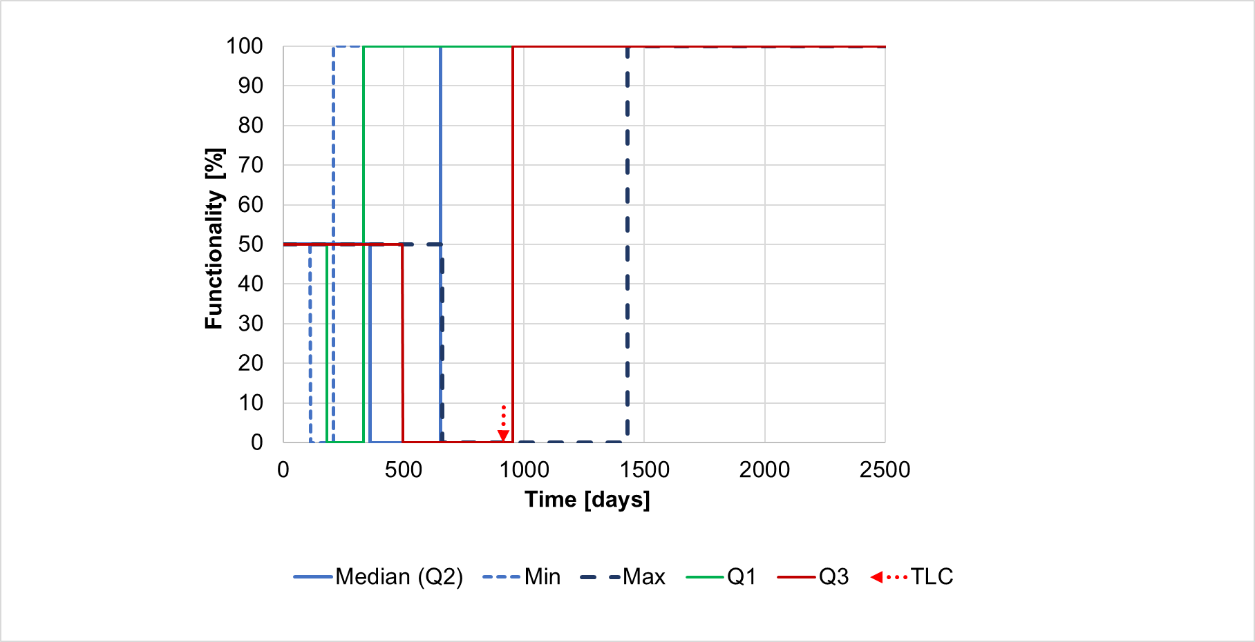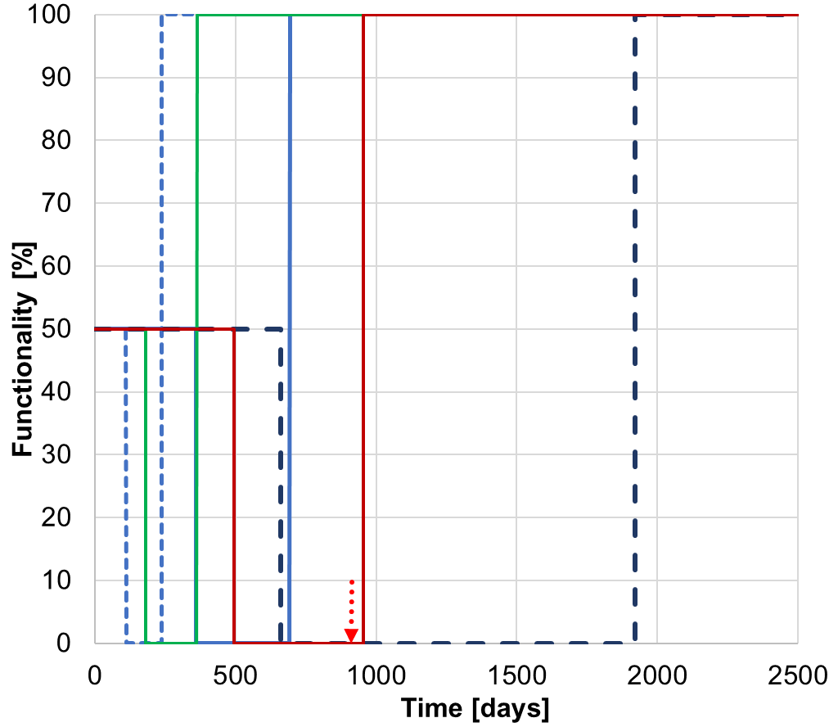
(a) (b)
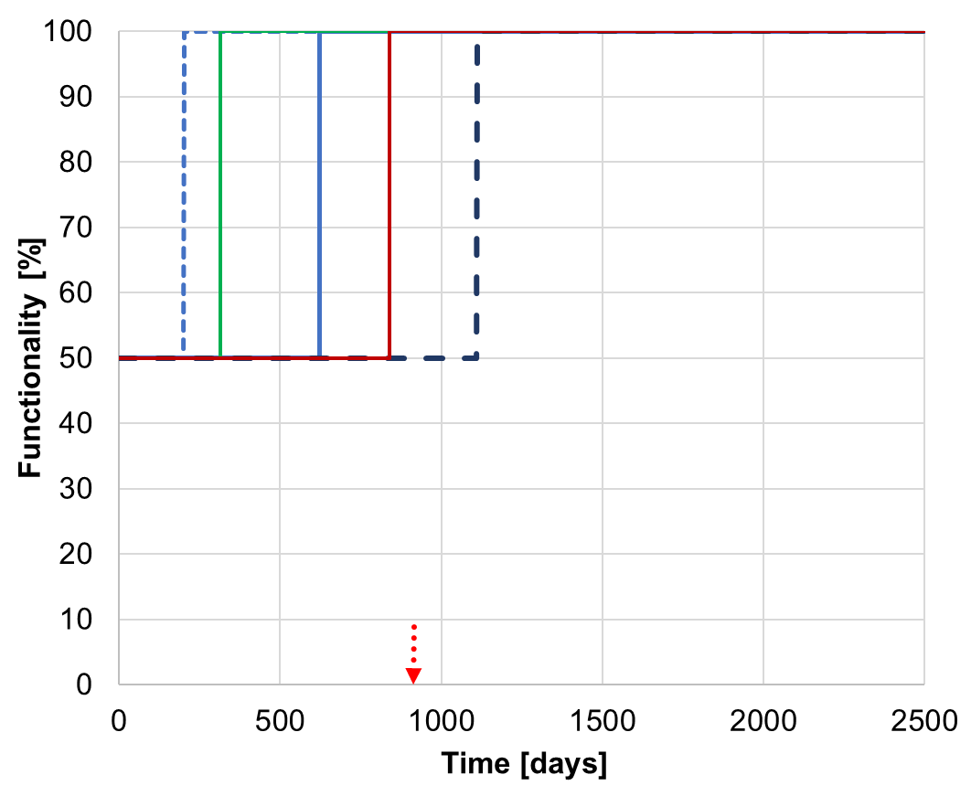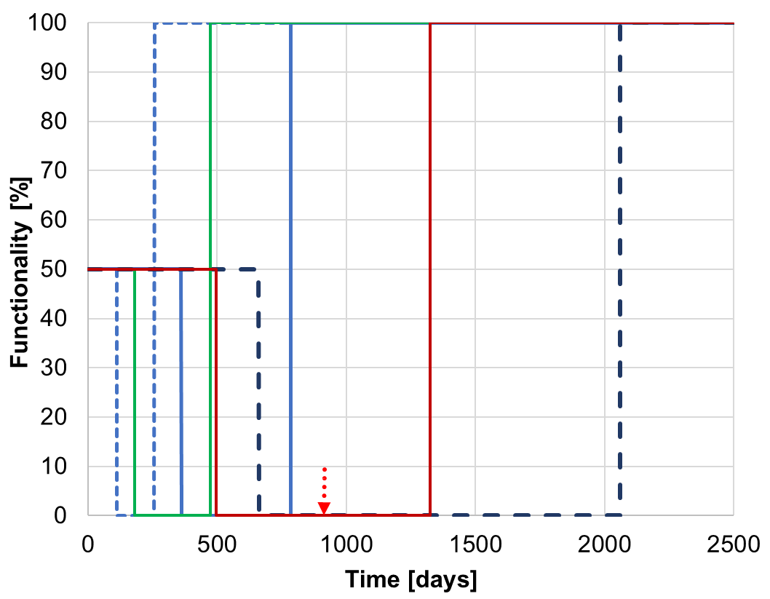
(c) (d)
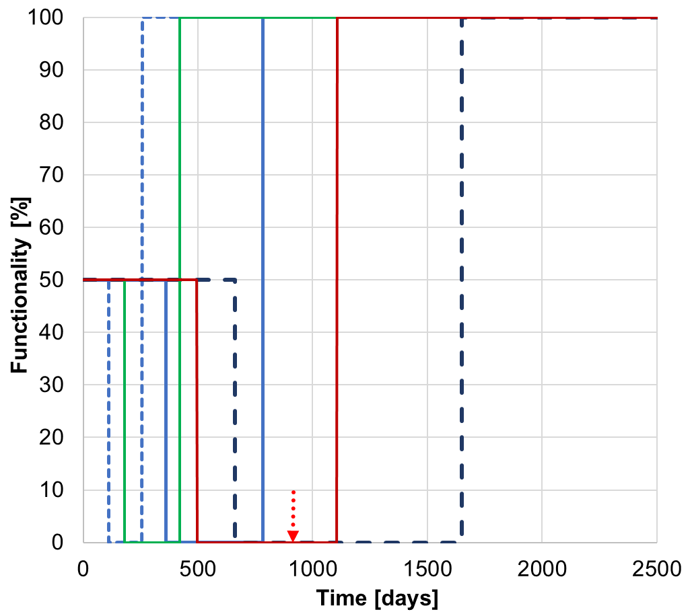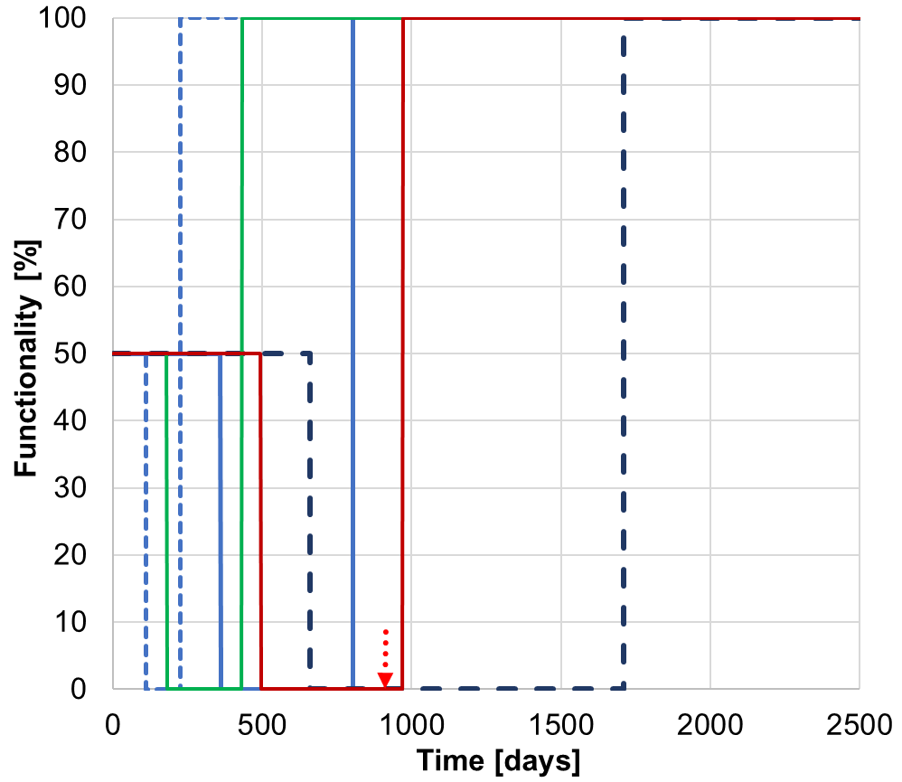
(e) (f)

Supplementary Figure 5. Functionality curves for 6 scenarios: quartiles, minimum and maximum values: (a) #1; (b)#2; (c)#3; (d)#4; (e)#5; (f) #6.

Supplementary Note 4. LCA, LCC and LCI of restoration options
The analysis quantifies the environmental impacts and costs associated with the six retrofit scenarios at asset level, using a functional unit of 1 km of bridge. It is essential to note that scenarios are not functionally equivalent in terms of durability performance: full‑replacement options scenarios #4-6 are estimated to extend service life by up to 80-100 years, while partial interventions (e.g. scenario #1) provide an extension of about 33 years. Where scenarios reach similar operational capacity of 90–100%, differences in longevity and performance are addressed in the MCDA using fit-for-purpose criteria.
The system boundaries of the analysis encompass the demolition and waste processing of damaged bridge parts (C1–C4 according to EN 15643 [20]), the raw materials, transportation to manufacturing (A1–A3), manufacturing (A5), assembly at the construction site (A5) of designed interventions. Finally, the potential impacts due to disassembly (C1), transportation to waste processing (C2), and end-of-life (C3–C4) of the designed interventions are included. The sum of these contributions provides the life cycle impacts. Construction (A5) and demolition (C1) stages are quantified using Environmental Product Declarations (EPDs) where available, supplemented by expert judgement when necessary. Assessed environmental metrics include global warming potential total (GWP), water use (WDP), fossil resource use (ADPF) and resource use of minerals and metals (ADPM), as defined in EN 15804+A2 [21]. Data sources for environmental impacts include EPDs available on the open-access platform EPD International (EPD Library, 2025) [22]. Average data for truck and ship transport processes in Greece are retrieved from Ecoinvent (2025) [23]. Costs are derived from cost databases of construction works in the country. Along with direct costs due to bridge restoration, indirect costs due to disruptions and vehicle detours are calculated as separate metrics. Costs are discounted annually at a rate of 2.8%, reflecting the average base rate in Greece [24, 25] over the last two years (January 2023 to September 2025). Supplementary Table 8 summarizes the case-specific system boundaries, impact categories, data sources, and economic assumptions adopted in the analysis.
Supplementary Table 8. LCA and LCC goal, scope and system boundaries
 | Direct impacts | Indirect impacts
Goal of the analysis | Assessment of environmental impacts, direct and indirect costs due to structural interventions
System definition | Bridge after intervention | Vehicle detours on transport networks
Start of the analysis (y=1) | 2025 | 2025
System boundaries | A1-A3; A5; C1-C4 | A1-A3; A5; C1-C4
Impact categories | GWP, WDP, ADPF, ADPM (LCA); NPV (LCC) | NPV(LCC)
Functional unit | km | km
Data sources | [22, 23] | Construction costs databases (Supplementary Note 4)
Discounting | n.a. | 2.8%

In regard to life cycle inventory (LCI) and impact assessment, for each retrofit scenario, a detailed bill of materials is compiled to quantify material production and end-of-life contributions associated with life cycle stages A1–A3 and C3–C4. Information on raw material extraction and manufacturing is obtained from manufacturers, who also provide viable end-of-life options. Where multiple end-of-life scenarios are available, a conservative assumption corresponding to the highest environmental impact is adopted. On-site construction activities (module A5) are characterized for each scenario based on the machinery employed, its power rating, and operating duration, as reported by contractor-specific data and expert inputs. Demolition activities and waste handling operations are explicitly specified to represent end-of-life stages C1 and C2, including material removal, temporary handling, and transport to processing facilities.

For the application in this paper, demolition materials are assumed to be transported by barge over a distance of 500 m from the demolition site to the lake shore, followed by truck transport over a distance of 140 km to the nearest waste processing facility. All direct life cycle impacts from stages A1–A3, A5, and C1–C4 are normalized by the bridge length (1.37 km) to enable consistent comparison across retrofit alternatives. Indirect impacts associated with traffic disruptions are evaluated by accounting for vehicle detours. A detour length of 60 km is assumed based on OpenStreetMap routing, reflecting the limited network redundancy associated with prolonged closures of the bridge. Detailed bill-of-materials data, construction and demolition parameters, transport assumptions, and environmental datasets used in the assessment are reported in Supplementary Note 4.

Supplementary Table 9. Bill of materials of restoration options and datasets
# | Component | Material | Quantity | Unit | Dataset for LCA [22, 23] | Cost for LCC [EUR/unit]
1 | Cantilever arms | Concrete C40-50 | 512.7 | m³ | S-P-12742 | 194
1 | Cantilever arms | Steel Y1860 | 23.07 | t | S-P-09634
1 | Precast prestressed concrete beams | Precast concrete beam | 280 | m³ | S-P-12778 | 273
1 | Precast prestressed concrete beams | Prestressed Steel Y1860 | 9.8 | t | 000642 | 7000
1 | Concrete deck slab | Concrete C40-50 | 260 | m³ | S-P-12742 | 273
1 | Concrete deck slab | Steel B450-B500 | 31.2 | t | AA_EPD_001 (EPDITALY0004) | 1050
1 | Pavement | Primer Asphalt | 130000 | kg | S-P-06176 | 1.1
1 | Pavement | Waterproofing Membrane | 1300 | m² | EPD-IES-0017715 | 9.3
1 | Pavement | Asphalt Concrete (Binder layout) | 184600 | kg | EPD-IES-0009887:001 | 6.2
1 | Pavement | Asphalt (Draining wear layer) | 184.6 | t | EPD-IES-0018643:002 | 7.2
1 | Expansion joints | Steel/Rubber assemblies | 26 | units/m | n.a. | 0
2 | External prestressing cables | Prestressed Steel Y1860 | 3.6 | t | 000642
2 | Restoration half-joint | Concrete C40-50 | 4 | m³ | S-P-12742 | 194
2 | Steel beams | Structural Steel | 312 | t | EPD-IES-0024020 | 1050
2 | Concrete deck slab | Concrete C40-50 | 260 | m³ | S-P-12742 | 194
2 | Concrete deck slab | steel B450-B500 | 31.2 | t | AA_EPD_001 (EPDITALY0004) | 1050
2 | Pavement | Primer Asphalt | 130000 | kg | S-P-06176 | 1.1
2 | Pavement | Waterproofing Membrane | 1300 | m² | EPD-IES-0017715 | 9.3
2 | Pavement | Asphalt Concrete (Binder layout) | 184600 | kg | EPD-IES-0009887:001 | 6.2
2 | Pavement | Asphalt (Draining wear layer) | 184.6 | t | EPD-IES-0018643:002 | 7.2
2 | Expansion joints | Steel/Rubber assemblies | 26 | units/m | n.a. | 0
3 | Steel beams (new superstructure) | Structural Steel | 780 | t | EPD-IES-0024020 | 1050
3 | deck slab | Concrete C40-50 | 264 | m³ | S-P-12742 | 194
3 | deck slab | Steel B450-B500 | 31.2 | t | AA_EPD_001 (EPDITALY0004) | 1050
3 | Pavement | Primer Asphalt | 130000 | kg | S-P-06176 | 1.1
3 | Pavement | Waterproofing Membrane | 1300 | m² | EPD-IES-0017715 | 9.3
3 | Pavement | Asphalt Concrete (Binder layout) | 184600 | kg | EPD-IES-0009887:001 | 6.2
3 | Pavement | Asphalt (Draining wear layer) | 184.6 | t | EPD-IES-0018643:002 | 7.2
3 | Expansion joints | Steel/Rubber assemblies | 26 | units/m | n.a. | 0
4 | casting pylons | Concrete C40-50 | 400 | m³ | S-P-12742 | 194
4 | casting pylons | Steel B450-B500 | 82.9 | t | AA_EPD_001 (EPDITALY0004) | 1050
4 | installation of cable-stays (high-strength steel cables) | Steel Y1860 | 32 | T | 000642
4 | Restoration half-joint | Concrete C40-50 | 4 | m³ | S-P-12742 | 194
4 | Steel beams (new superstructure) | Structural Steel | 312 | t |  | 1050
4 | Concrete deck slab | Concrete C40-50 | 104 | m³ | S-P-12742 | 194
4 | Concrete deck slab | Steel B450-B500 | 12.48 | t | AA_EPD_001 (EPDITALY0004) | 1050
4 | Pavement | Primer Asphalt | 130000 | kg | S-P-06176 | 1.1
4 | Pavement | Waterproofing Membrane | 1300 | m² | EPD-IES-0017715 | 9.3
4 | Pavement | Asphalt Concrete (Binder layout) | 184600 | kg | EPD-IES-0009887:001 | 6.2
4 | Pavement | Asphalt (Draining wear layer) | 184.6 | t | EPD-IES-0018643:002 | 7.2
4 | Expansion joints | Steel/Rubber assemblies | 26 | units/m | n.a. | 0
5 | High-strength steel cables | Steel Y1860 | 3.78 | T | S-P-09634
5 | Concrete deck slab | Concrete C40-50 | 69 | m³ | S-P-12742 | 194
5 | Concrete deck slab | steel B450-B500 | 7.85 | t |  | 1050
5 | Pavement | Primer Asphalt | 130000 | kg | S-P-06176 | 1.1
5 | Pavement | Waterproofing Membrane | 1300 | m² | EPD-IES-0017715 | 9.3
5 | Pavement | Asphalt Concrete (Binder layout) | 184600 | kg | EPD-IES-0009887:001 | 6.2
5 | Pavement | Asphalt (Draining wear layer) | 184.6 | t | EPD-IES-0018643:002 | 7.2
5 | Expansion joints | Steel/Rubber assemblies | 26 | units/m | n.a. | 0
6 | Prefabricated concrete segments (+ passive reinforcement inside prefabricated elements) | Concrete C50-60 | 520 | m³ | GaBi database (link)
6 |  | Steel B450-B500 | 78 | t | AA_EPD_001 (EPDITALY0004) | 1050
6 | Grouting material | High-Strength Grout | 15990 | kg |  | 0.414
6 | Half-joint restoration concrete | Concrete C40-50 | 4 | m³ | S-P-12742 | 194
6 | Pavement | Primer Asphalt | 130000 | kg | S-P-06176 | 1.1
6 | Pavement | Waterproofing Membrane | 1300 | m² | EPD-IES-0017715 | 9.3
6 | Pavement | Asphalt Concrete (Binder layout) | 184600 | kg | EPD-IES-0009887:001 | 6.2
6 | Pavement | Asphalt (Draining wear layer) | 184.6 | t | EPD-IES-0018643:002 | 7.2
6 | Expansion joints | Steel/Rubber assemblies | 26 | units/m | n.a. | 0

Supplementary Table 9. Additional machinery of restoration options: Detailed information/datasets
# | Machinery | Quantity | Power | Operating time | Dataset for LCA [26] | Costs for LCC
1 | multi-strand jack | 1 | 4 | 504 | Electricity mix Greece | Included in costs of Supplementary Table 8
2 | Crane truck 500 t | 1 | 505 | 6 | Electricity mix Greece | Included in costs of Supplementary Table 8
3 | Crane truck 500 t | 1 | 505 | 6 | Electricity mix Greece | Included in costs of Supplementary Table 8
4 | Crane truck 500 t | 1 | 505 | 6 | Electricity mix Greece | Included in costs of Supplementary Table 8
5 | No machinery |  |  |  |  | Included in costs of Supplementary Table 8
6 | Crane truck 500 t | 1 | 505 | 9 | Electricity mix Greece | Included in costs of Supplementary Table 8

Supplementary Table 10. Demolition of old bridge components: detailed information/datasets
Demolition type | Phase | Machinery | Quantity | Power | Operating time (hrs) | Dataset for LCA [26] | Cost for LCC [EUR/t]
TYPE 1  (Scenarios #1, #3) demolished: beam + cantilever | Demolition deck slab | crawler excavator | 2 | 223.5 | 8 | Electricity mix Greece | 12.5
TYPE 1  (Scenarios #1, #3) demolished: beam + cantilever | Connection central beam | crane truck 500 t | 1 | 505 | 8 | Electricity mix Greece | 12.5
TYPE 1  (Scenarios #1, #3) demolished: beam + cantilever | Cable cut | crawler excavator | - |  |  | Electricity mix Greece | 12.5
TYPE 1  (Scenarios #1, #3) demolished: beam + cantilever | Concrete crushing | crawler excavator |  |  |  | Electricity mix Greece | 12.5
TYPE 1  (Scenarios #1, #3) demolished: beam + cantilever | Transport waste | barge | 1944.893 |  | 0.765 | Barge Transport Greece | 2.6
TYPE 1  (Scenarios #1, #3) demolished: beam + cantilever | Transport waste | truck | 1944.893 |  | 160 | Truck Transport Greece | 2.6
TYPE 2  (Scenarios #2,#4,#6) demolished: beam | Demolition deck slab | crawler excavator | 2 | 223.5 | 8 | Electricity mix Greece | 12.5
TYPE 2  (Scenarios #2,#4,#6) demolished: beam | Connection central beam | crane truck 500 t | 1 | 505 | 8 | Electricity mix Greece | 12.5
TYPE 2  (Scenarios #2,#4,#6) demolished: beam | Cable cut | crawler excavator | - |  |  | Electricity mix Greece | 12.5
TYPE 2  (Scenarios #2,#4,#6) demolished: beam | Transport waste | barge | 709.8 |  | 0.765 | Barge Transport Greece | 2.6
TYPE 2  (Scenarios #2,#4,#6) demolished: beam | Transport waste | truck | 709.8 |  | 160 | Truck Transport Greece | 2.6
TYPE 3  (Scenarios #5) Minor demolition  Existing cantilever arms and Gerber beams are preserved | Local demolition | crawler excavator | 2 | 223.5 | 8 | Electricity mix Greece | 12.5

Supplementary References
- Markogiannaki, O., Xu, H., Chen, F., Mitoulis, S.A., Parcharidis, I., (2022). Monitoring of a landmark bridge using SAR interferometry coupled with engineering data and forensics. International Journal of Remote Sensing, 43(1), 95–119.
- Perugini, E, Pentassuglia F, Winnubst M, Papadopoulou K, Mitoulis, S-A (2025). Ageing bridges disrupt transport networks generating socio-economic and environmental costs. Journal of Traffic and Transportation Engineering (English Edition) –major revisions
- MetaInfrastructure (n.d.). The Polyfytos Bridge Use Case area. MetaInfrastructure Use Cases. https://metainfrastructure.org/use-cases/ (last accessed 12 January 2026).
- Kazantzi, A.K., Moutsianos, S., Bakalis, K., Mitoulis, S.A. (2024). Cause-agnostic bridge damage state identification utilising machine learning. Engineering Structures, 320(1), 118887. https://doi.org/10.1016/j.engstruct.2024.118887
- Izonin, I., Kazantzi, A., Tkachenko, R., Mitoulis, S.A. (2025). GRNN-based cascade ensemble model for non-destructive damage state identification: small data approach. Engineering with Computers 41, 723-738.
- Moutsianos, S., Stefanidou, S. P., Papanikolaou, V. K., & Mitoulis, S. A. (2024). Back-testing the iconic Polyfytos balanced-cantilever bridge to enhance condition assessment. In Proceedings of the Institution of Civil Engineers-Bridge Engineering (pp. 1-13). Emerald Publishing Limited.
- Frangopol, D. M., Dong, Y., Sabatino, S. (2019). Bridge life-cycle performance and cost: analysis, prediction, optimisation and decision-making. In Structures and Infrastructure Systems (pp. 66-84). Routledge.
- Tapia, C., & Padgett, J. E. (2016). Multi-objective optimisation of bridge retrofit and post-event repair selection to enhance sustainability. Structure and Infrastructure Engineering, 12(1), 93-107.
- Ni, X., Leon-Miquel, M., Greiner, Q.R. et al. (2023). Crack sealers for the preservation of concrete bridge decks: a synthesis of a national survey and literature review. J Infrastruct Preserv Resil 4, 23. DOI: 10.1186/s43065-023-00091-8
- Santarsiero, G., Picciano, V. (2023). Durability enhancement of half-joints in RC bridges through external prestressed tendons: The Musmeci Bridge’s case study. Case Studies in Construction Materials, 18, e01813.
- Xu, G., Zeng, M., Su, Q. (2021). Layout and optimization of the external prestressing tendons of hybrid beam rigid frame bridges. IOP Conference Series: Earth and Environmental Science. 719. 032061. DOI: 10.1088/1755-1315/719/3/032061 .
- RMladjov R.V. (2015) Efficient methods for upgrading or reinforcing existing bridges, STRUCTURE – Premier resource for praticing structural engineers, https://www.structuremag.org/article/efficient-methods-for-upgrading-or-reinforcing-existing-bridges
- Yao, W., Ma, J., & Zhang, Y. (2019). Study on the reconstruction of existing bridges with composite structure. In IOP Conference Series: Earth and Environmental Science (Vol. 371, No. 2, p. 022051). IOP Publishing.
- Nordin, H. (2004) Strengthening structures with externally prestressed tendons, Technical Report, 2005: 07 - ISSN: 1402-1536 - ISRN: LTU-TR--05/07--SE. www.diva-portal.org/smash/get/diva2:997963/FULLTEXT01.pdf
- Saleem, M. A., Zafar, M. N., Saleem, M. M., & Xia, J. (2021). Recent developments in the prefabricated bridge deck systems, Case Studies in Construction Materials, 15, e00750, DOI: 10.1016/j.cscm.2021.e00750
- Hällmark, R, Collin, P., Nilsson, M. (2009). Prefabricated Composite Bridges. IABSE Symposium Report. 96. 107-117. DOI: 10.2749/222137809796078748
- Hällmark, R., Collin, P., Nilsson, M. (2013). Large-scale tests on a composite bridge with pre fabricated concrete deck and dry deck joints. Stahlbau, 82(2), 122 - 133, DOI: 10.1002/stab.201310014
- Wang, Z., & Jiadong, R. (2023). ILM Application in 66m Span PC Continuous Beam. In IABSE Symposium: Long Span Bridges, Istanbul, Turkey, 26-28 April 2023 (pp. 1-983). DOI: 10.2749/istanbul.2023.0983.
- Rahmani, F. (2020). Challenges and opportunities in adopting early contractor involvement (ECI): client’s perception. Architectural Engineering and Design Management, 17(1–2), 67–76. DOI: 10.1080/17452007.2020.1811079
- EN 15643. Sustainability of construction works - Framework for assessment of buildings and civil engineering works (2021).
- EN 15804. Sustainability of construction works - Environmental product declarations - Core rules for the product category of construction products (2012).
- EPD Library (n.d.). https://environdMetaIec.com/library (last accessed 14 November 2025).
- Ecoinvent v3.10. https://ecoinvent.org/ecoinvent-v3-10/ (last accessed 14 November 2025).
- Eurostat. Statistics Explained. Inflation in the euro area. https://tinyurl.com/3a4rp4ab (last accessed 14 November 2025).
- World data (n.d.). Inflation trends in Greece. https://tinyurl.com/v5dpnp3k (last accessed 14 November 2025).
- Ecoinvent v3.10. https://ecoinvent.org/ecoinvent-v3-10/ (last accessed 14 November 2025).

