Supplementary Materials
Uncertainty analysis of a machine learning-aided ensemble forecast for coastal flood maps
Jeremy Rohmer¹, S. Lecacheux¹, D. Idier¹, E. Membrado², A. G. Filippini¹, R. Pedreros¹, D. Paradis², A. Dalphinet²
[1]{BRGM, 3 av. C. Guillemin - 45060 Orléans Cedex 2 - France}
[2] {Météo-France, DIROP/MAR, Toulouse}
Correspondence to: J. Rohmer (j.rohmer@brgm.fr)

Numerical simulation of the floods induced by Ciaran and Domingos pseudo-storms
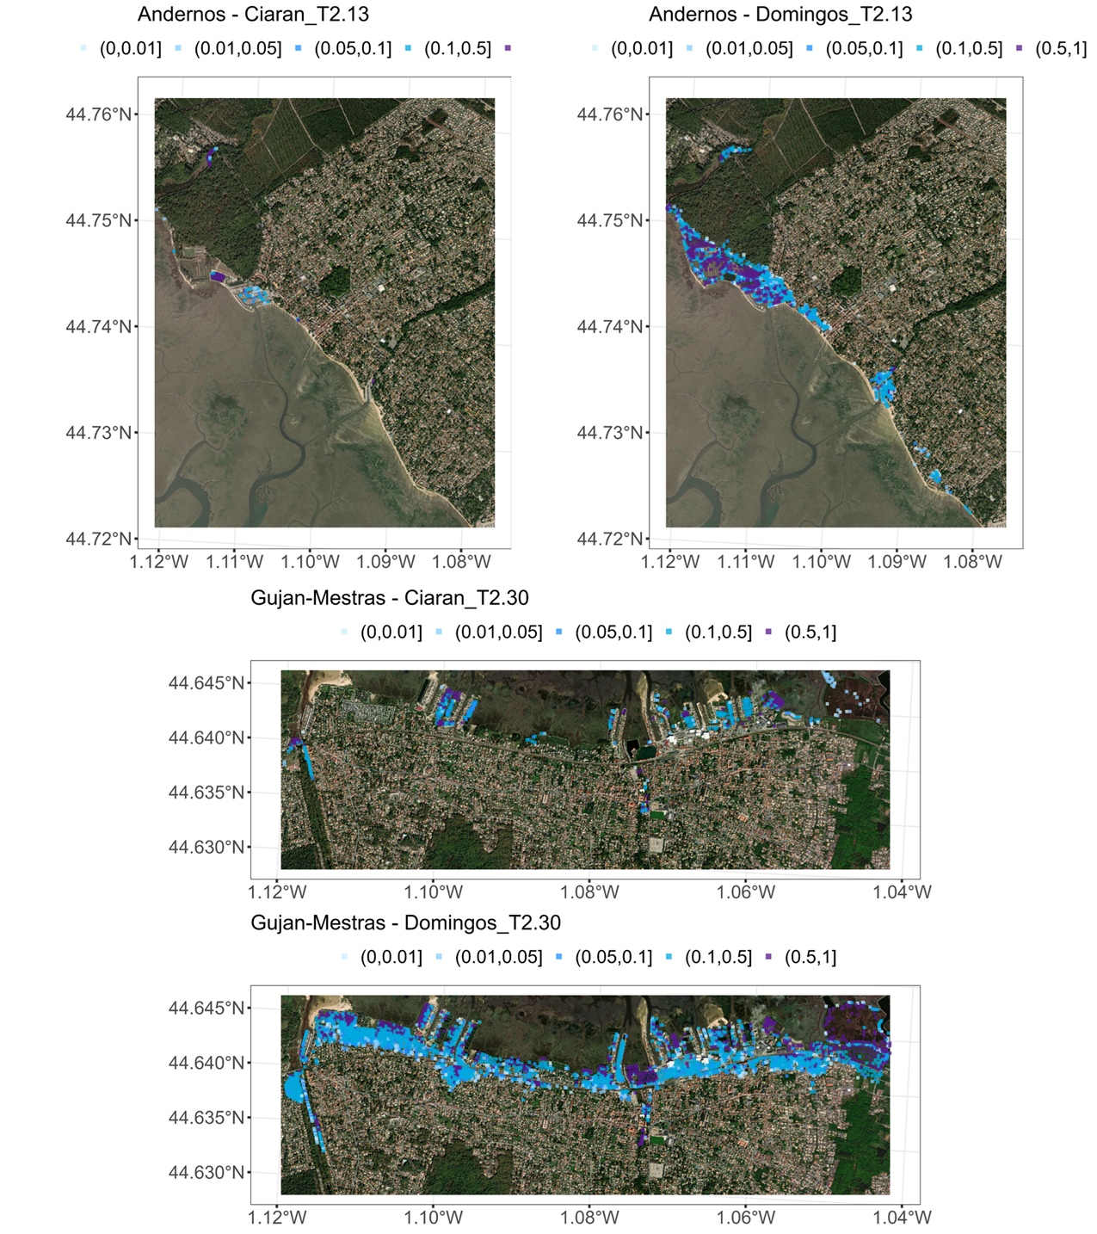
Figure S1. Flood maps numerically simulated at Andernos (top) and at Gujan-Mestras (bottom) for the pseudo-historical storms Ciaran and Domingos considering the meteocecanic conditions described in Table 1 and the high tide level T=2.13 and 2.30 m (indicated in the title of each panel).
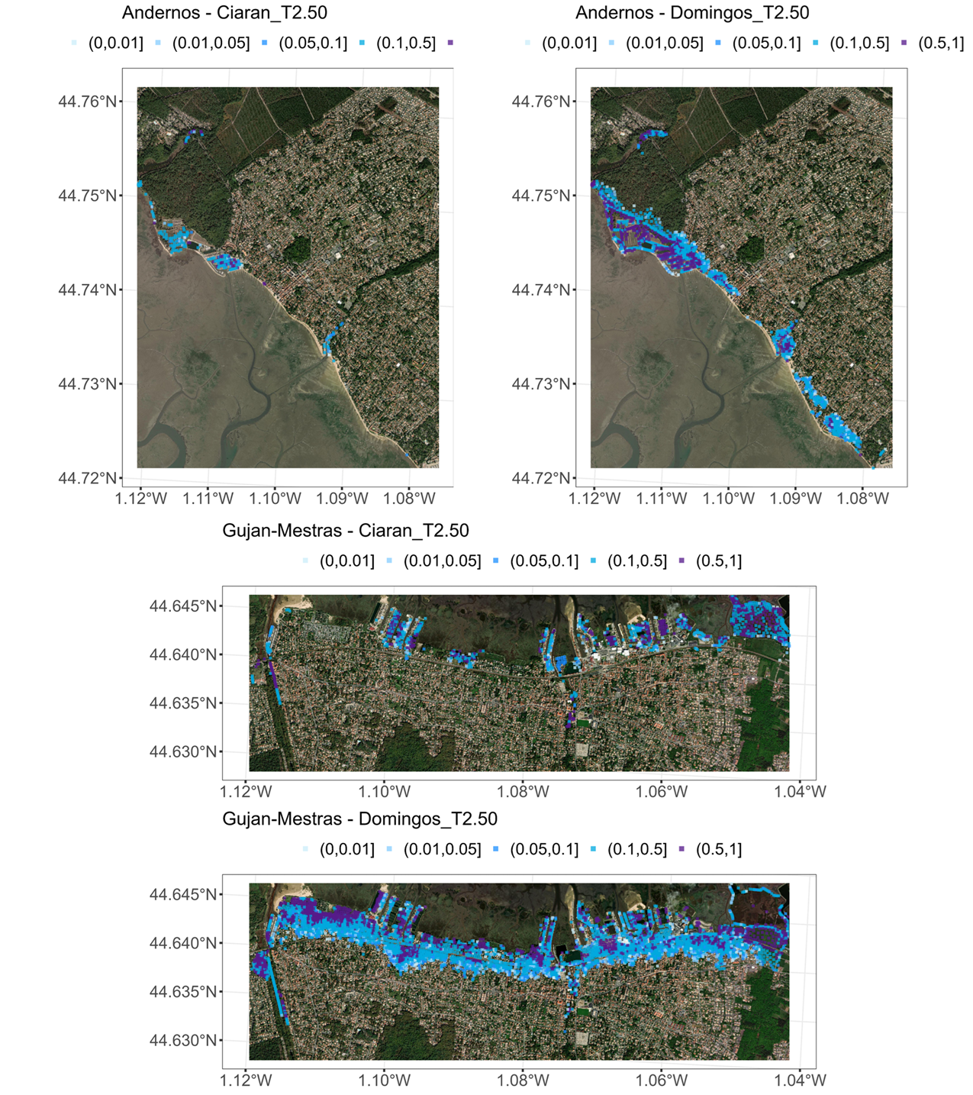
Figure S2. Flood maps numerically simulated at Andernos (top) and at Gujan-Mestras (bottom) for the pseudo-historical storms Ciaran and Domingos considering the meteocecanic conditions described in Table 1 and the high tide level T=2.50 m (indicated in the title of each panel).

Robustness to the GSA assumptions
We analyse the robustness of our GSA results to the parametrisation of the kernel for handling spatial outputs (as described in Sect. 4.3). To do so, we conducted the HSIC-based GSA by varying the total amount of variance explained by the PCA, i.e., 90 or 95%, and by changing the weighting procedure, i.e., weights applied on the one-dimensional Gaussian kernels (‘extern’ approach, as described in Eq. 10), or weights applied on the principal components (‘intern’ approach). Figure S3, left shows how these different assumptions lead to minor changes in the HSIC-ANOVA sensitivity indices when considering the 2-day ahead forecast at Andernos for the pseudo-historical storm Ciaran with T=2.50 m.
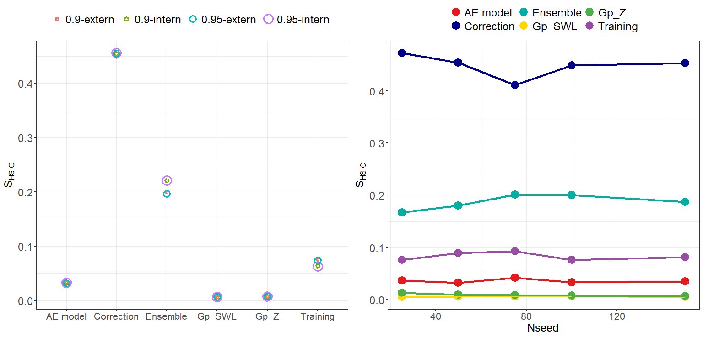
Figure S3. Analysis of the robustness of the GSA results to the parametrisation of the kernel for spatial outputs (left) and to the number of stochastic Gp simulation N_{seed} (right) considering the forecast at lead time of 2 days of the flood map at Andernos for Ciaran pseudo-historical storm with peak tide level at T=2.50m.
The influence of a second assumption was investigated, namely the number of stochastic simulations N_{seed} used to capture the Gp metamodel error (as described in Sect. 4.2). For the same forecast situation described above, we conducted HSIC-based GSA by varying N_{seed} from 25 to 150. The inspection of the convergence of the indices in Fig. S3, right confirms here the validity of our assumption of using N_{seed}=100. This robustness was also checked for two other scenarios of high tide level T=2.13 and T=2.82 m (Fig. S4).

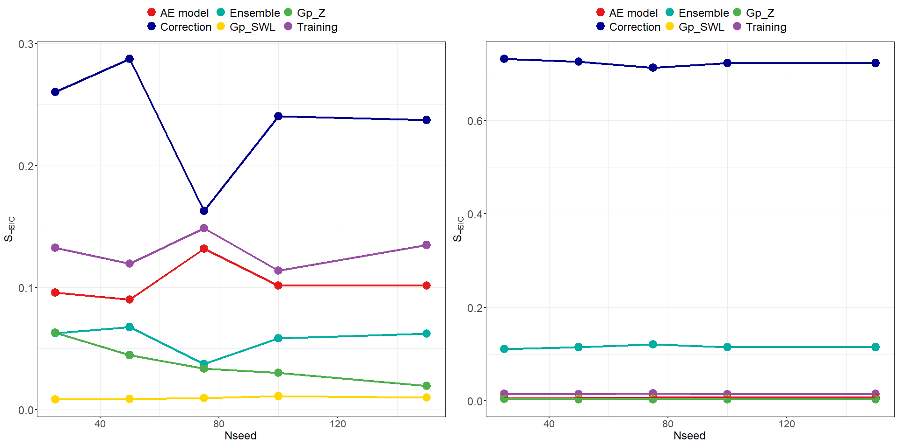
Figure S4. Analysis of the robustness of the GSA results to the number of stochastic Gp simulation N_{seed} considering the forecast at lead time of 2 days of the flood map at Andernos for Ciaran pseudo-historical storm with peak tide level at T=2.13m (left) and T=2.82m (right).

