Does size matter? Morphological and genetic similarities between cashew (Anacardium occidentale) and cajuí (A. humile)

Journal Name: Plant Biosystems

Acalene Gonçalveis-Oliveira¹, Thiago Nascimento¹, Priscila Alves Barroso², Cíntia Luíza da Silva Luz³, Silvokleio da Costa Silva⁴, Andrea Pedrosa-Harand¹*

¹Laboratory of Plant Cytogenetics and Evolution, Department of Botany, Biosciences Centre, Federal University of Pernambuco. Recife, PE, 50.670-901, Brazil.

²Laboratory of Breeding and Data Analysis, Professor Cinobelina Elvas Campus, Federal University of Piauí. Bom Jesus, PI, 64.900-000, Brazil.

³Laboratory of Plant Taxonomy, Department of Plant Biology, Institute of Biology, State University of Campinas, Campinas, Brazil.

⁴Laboratory of Genetics and Germplasm Conservation, Professora Cinobelina Elvas Campus, Federal University of Piauí. Bom Jesus, PI, 64.900-000, Brazil.

*Corresponding author. Email: andrea.harand@ufpe.br

ORCIDs:
Acalene Gonçalveis-Oliveira https://orcid.org/0000-0001-6720-3134
Thiago Nascimento https://orcid.org/0000-0002-7742-0260
Priscila Alves Barroso https://orcid.org/0000-0003-1749-1961
Cíntia Luíza da Silva Luz https://orcid.org/0000-0002-7144-5109
Silvokleio da Costa Silva https://orcid.org/0000-0002-9975-1212
Andrea Pedrosa-Harand https://orcid.org/0000-0001-5213-4770

Supplementary Material – Tables

Table S1 Anacardium accessions analyzed from the Active Germplasm Bank of the Professor Cinobelina Elvas Campus, Federal University of Piauí, in Bom Jesus-PI (AN: A. humile or A. occidentale), and provided by Embrapa Tropical Agroindustry (CNPAT), Fortaleza-CE (BRS: A. occidentale; and BGC: A. occidentale, previously identified as A. othonianum). BRS 226 is a cultivar, and clones from this accession planted in Fortaleza-CE and Parnaíba-PI were evaluated. The abbreviations PI, CE, and GO refer to the states of Piauí, Ceará, and Goiás, respectively, while DF stands for the Federal District
Species | Germplasm ID | Elevation (m) | Municipality | State | Voucher | Geographic Coordinates | Morphological Description | Type of analysis
A. occidentale | AN-700 | 271 | Bom Jesus | PI | 88.968 | 09°05’03.1’’S,  44°20’23.3” W | Tree, red peduncle | Agronomy, cytometry and molecular
A. occidentale | AN-701 | 264 | Bom Jesus | PI | 88.969 | 09°05’03.5” S,  44°20’23.3” W | Tree, yellow peduncle | Agronomy, cytogenetics, cytometry and molecular
A. occidentale | AN-702 | 270 | Bom Jesus | PI | 88.970 | 09°05'51.5"S,  44°20'33.1" W | Tree, yellow peduncle | Agronomy and molecular
A. occidentale | AN-703 | 263 | Bom Jesus | PI | 88.971 | 09°05’53.5” S,  44°20’34.8” W | Tree, red peduncle | Agronomy and molecular
A. occidentale | AN-704 | 262 | Bom Jesus | PI | 88.972 | 09°05’51.7” S,  44°20’34.7” W | Tree, red peduncle | Agronomy, cytogenetics, cytometry and molecular
A. occidentale | AN-705 | 221 | Alvorada do Gurguéia | PI | 88.973 | 08°22’35.0” S,  43°51’27.1” W | Tree, red peduncle | Agronomy, cytometry and molecular
A. occidentale | AN-706 | 117 | Alvorada do Gurguéia | PI | 88.974 | 08°22’35.5” S,  43°51’30.5” W | Tree, yellow peduncle | Agronomy, cytogenetics and cytometry
A. occidentale | AN-707 | 114 | Alvorada do Gurguéia | PI | 88.975 | 08°22’32.4” S,  43°51’31.2” W | Tree, yellow peduncle | Agronomy and cytogenetics
A. occidentale | AN-708 | 103 | Alvorada do Gurguéia | PI | 88.976 | 08°22’53.3” S,  43°51’41.9” W | Tree, yellow peduncle | Agronomy, cytogenetics and molecular
A. occidentale | AN-709 | 202 | Alvorada do Gurguéia | PI | 88.977 | 08°22’43.1” S,  43°51’38.2” W | Tree, yellow peduncle | Agronomy, cytometry and molecular
A. humile | AN-710 | 366 | Corrente dos Matões- Bom Jesus | PI | 88.978 | 09°08’31.7” S,  44°40’36.7” W | Shrub, orange peduncle | Agronomy
A. humile | AN-711 | 364 | Corrente dos Matões- Bom Jesus | PI | 88.979 | 09°08’30.3” S,  44°40’36.5” W | Shrub, yellow peduncle | Agronomy, Cytogenetics and molecular
A. humile | AN-712 | 361 | Corrente dos Matões-Bom Jesus | PI | 88.980 | 09°08’31.3” S,  44°40’36.0” W | Shrub, orange peduncle | Cytogenetics, Cytometry and molecular
A. occidentale | AN-714 | 340 | Corrente dos Matões- Bom Jesus | PI | 88.982 | 09°09’06.9” S,  44°37’23.4” W | Tree, orange/yellowish peduncle | Cytogenetics and molecular
A. occidentale | AN-715 | 366 | Currais | PI | 88.983 | 09°01’05.6” S,  44°23’52.0” W | Tree, orange peduncle | Agronomy, cytogenetics and molecular
A. occidentale | AN-716 | 377 | Currais | PI | 88.984 | 09°00'52.7" S,  44°23'45.8" W | Tree, orange/yellowish peduncle | Agronomy
A. occidentale | AN-717 | 368 | Currais | PI | 88.985 | 09°00’52.6” S,  44°23’46.5” W | Tree, red/orange peduncle | Agronomy, cytometry and molecular
A. occidentale | AN-718 | 378 | Currais | PI | 88.986 | 09°00'51.4"S  44°23'48.5" W | Tree, yellow peduncle | Agronomy and molecular
A. occidentale | AN-719 | 379 | Currais | PI | 88.987 | 09°00’52.3” S,  44°23’47.4” W | Tree, yellow peduncle | Agronomy, cytometry and molecular
A. occidentale | AN-800 | 10 | Parnaíba | PI | 90.237 | 02°51'5.26"S  41°46'0.03"W | Tree, yellow peduncle | Agronomy and molecular
A. occidentale | AN-801 | 6 | Parnaíba | PI | 90.238 | 02°51'6.85" S,  41°45'54.21" W | Tree, yellow peduncle | Agronomy, cytogenetics, cytometry and molecular
A. occidentale | AN-802 | 2 | Parnaíba | PI | 90.239 | 02°51'4.49" S,  41°45'53.95" W | Tree, yellow peduncle | Agronomy
A. occidentale | AN-803 | 10 | Parnaíba | PI | 90.240 | 02°50'4.86" S  41°44'21.85" W | Tree, yellow peduncle | Agronomy, cytogenetics and molecular
A. occidentale | AN-804 | 9 | Parnaíba | PI | 90.241 | 02°50'7.56" S,  41°44'20.04" W | Tree, yellow peduncle | Agronomy
A. occidentale | AN-808 | 48 | Buriti dos Lopes | PI | 90.245 | 03°11'34.64" S,  41°52'43.70" W | Tree, yellow peduncle | Agronomy
A. occidentale | AN-809 | 46 | Buriti dos Lopes | PI | 90.246 | 03°12'27.43" S,  41°52'02.51" W | Tree, yellow peduncle | Agronomy
A. occidentale | AN-810 | 45 | Buriti dos Lopes | PI | 90.247 | 03°12'2.41" S,  41°52'02.27" W | Tree, yellow peduncle | Agronomy
A. humile | AN-830 | - | Uruçuí | PI | - | 08°59'28.9" S  45°05'24.7" W | Shrub, yellow peduncle | Molecular
A. occidentale | BGC-45 | - | CNPAT | GO | - | 16°13'44.6" S  47°58'15.2" W | - | Cytogenetics and cytometry
A. occidentale | BGC-45.2 | - | CNPAT | GO | - | 16°13'44.6" S  47°58'15.2" W | - | Molecular
A. occidentale | BGC-45.4 | - | CNPAT | GO | - | 16°13'44.6" S  47°58'15.2" W | - | Molecular
A. occidentale | BGC-46 | - | CNPAT | GO | - | 16°13'44.6" S  47°58'15.2" W | - | Molecular
A. occidentale | Clone BRS 226 | - | CNPAT | CE | - | - | Tree, red/orange peduncle | Cytogenetics and molecular
A. occidentale | Clone BRS 226 | - | Parnaíba | PI | - | 09°04'54.5" S  44°19'40.3" W | Tree, red/orange peduncle | Agronomy
A. humile | 663 | - | Brasília | DF | - | - | without fruits and pseudofruits | Molecular
A. humile | 670 | - | Brasília | DF | - | - | without fruits and pseudofruits | Molecular
A. occidentale | Goiás | - | Santa Rosa de Goiás | GO | - | 16°01'54.8" S  49°26'40.9" W | Tree, red peduncle | Molecular

Table S2 PCR (Polymerase Chain Reaction) programs used for amplification of nuclear and plastid loci

Locus | Denaturation | 35 cycles |  |  | Final Extension
Locus | Denaturation | Denaturation | Annealing | Extension | Final Extension
matK | 4 min at 94°C | 1 min at 94°C | 1 min at 55°C | 2 min at 72°C | 8 min at 65°C
rps16, trnL-F and ycf1 | 5 min at 95°C | 1 min at 95°C | 1 min at 56°C | 1 min at 72°C | 10 min at 72°C
ITS | 5 min at 95°C | 1 min at 95°C | 1 min at 55°C | 1 min at 72°C | 10 min at 72°C

Table S3 The samples used in the phylogenetic analyses. Species sampled, voucher information, and GenBank accession numbers. Sequences taken from GenBank are listed with the corresponding publication. New sequences were generated during this study
Taxa | Accession | ITS | matK | rps16 | trnL_trnF | ycf1 | Citation (s)
Spondias mombin Jacq | - | AF445882 | NC_035973 | NC_035973 | KR081860 | NC_035973 | Becerra (2003)
Fegimanra africana (Oliv.) Pierre | - | - | AY594489 | AY594599 | AY594515 | - | Pell (2004)
Mangifera indica L. | - | MF678509 | - | - | - | NC_035239 | Fitmawati et al. (2017); Rabah et al. (2017)
Anacardium excelsum (Bertero & Balb. ex Kunth) Skeels | Montiel 32769; BioBot02020; Daly 13970 | KF664193 | JQ586468 | KP055362 | KP055484 | - | Xie et al. (2014); Weeks et al. (2014)
Anacardium parvifolium Ducke | Reserva Ducke (INPA) | - | - | KP055364 | KP055485 | - | Weeks et al. (2014)
Anacardium spruceanum Beth.ex Engl. | INPA2527 | - | - | KP055365 | KP055486 | - | Weeks et al. (2014)
Anacardium occidentale L. | Zhang L sn (KUN) | KF664192; AB071690 | NC_035235 | KF664442 | AY594497 | NC_035235 | Yonemori et al. (2002); Pell (2004); Xie et al. (2014); Rabah et al. (2017)
Anacardium occidentale | AN-700 | - | - | - | - | PRJNA1224782 | This study
Anacardium occidentale | AN-701 | PV089646 | - | - | - | PRJNA1224782 | This study
Anacardium occidentale | AN-702 | - | - | - | - | PRJNA1224782 | This study
Anacardium occidentale | AN-703 | PV089647 | PRJNA1224782 | PRJNA1224782 | PRJNA1224782 | PRJNA1224782 | This study
Anacardium occidentale | AN-704 | PV089648 | - | - | - | PRJNA1224782 | This study
Anacardium occidentale | AN-705 | PV089649 | PRJNA1224782 | PRJNA1224782 | PRJNA1224782 | PRJNA1224782 | This study
Anacardium occidentale | AN-708 | - | - | - | - | PRJNA1224782 | This study
Anacardium occidentale | AN-709 | PV089650 | PRJNA1224782 | PRJNA1224782 | PRJNA1224782 | PRJNA1224782 | This study
Anacardium humile A.St.-Hil. | AN-711 | - | PRJNA1224782 | PRJNA1224782 | PRJNA1224782 | PRJNA1224782 | This study
Anacardium occidentale | AN-714 | PV089651 | PRJNA1224782 | PRJNA1224782 | PRJNA1224782 | PRJNA1224782 | This study
Anacardium humile | AN-712 | PV089703 | PRJNA1224782 | PRJNA1224782 | PRJNA1224782 | PRJNA1224782 | This study
Anacardium occidentale | AN-715 | PV089652 | - | - | - | PRJNA1224782 | This study
Anacardium occidentale | AN-717 | PV089653 | PRJNA1224782 | PRJNA1224782 | PRJNA1224782 | PRJNA1224782 | This study
Anacardium occidentale | AN-718 | - | - | - | - | PRJNA1224782 | This study
Anacardium occidentale | AN-719 | PV089654 | - | - | - | - | This study
Anacardium occidentale | AN-800 | PV089655 | PRJNA1224782 | PRJNA1224782 | PRJNA1224782 | PRJNA1224782 | This study
Anacardium occidentale | AN-801 | PV089656 | - | - | - | PRJNA1224782 | This study
Anacardium occidentale | AN-803 | PV089657 | PRJNA1224782 | PRJNA1224782 | PRJNA1224782 | PRJNA1224782 | This study
Anacardium occidentale | BGC-45.4 | PV089661 | PRJNA1224782 | PRJNA1224782 | PRJNA1224782 | PRJNA1224782 | This study
Anacardium occidentale | BRS 226 | PV089659 | PRJNA1224782 | PRJNA1224782 | PRJNA1224782 | PRJNA1224782 | This study
Anacardium occidentale | BGC-45.2 | PV089660 | - | - | - | PRJNA1224782 | This study
Anacardium occidentale | BGC-46 | - | PRJNA1224782 | PRJNA1224782 | PRJNA1224782 | PRJNA1224782 | This study
Anacardium humile | 830 | - | PRJNA1224782 | PRJNA1224782 | PRJNA1224782 | PRJNA1224782 | This study
Anacardium occidentale | Goiás | PV089658 | PRJNA1224782 | PRJNA1224782 | PRJNA1224782 | PRJNA1224782 | This study
Anacardium humile  Anacardium humile | 663  670 | -  - | PRJNA1224782  - | PRJNA1224782  - | PRJNA1224782  - | -  PRJNA1224782 | This study  This study
Note: “-” indicates sequence not available.
References
Becerra JX (2003) Evolution of Mexican Bursera (Burseraceae) inferred from ITS, ETS, and 5S nuclear ribosomal DNA sequences. Mol Phylogenet Evol 26:300–309. https://doi.org/10.1016/s1055-7903(02)00256-7
Fitmawati, Harahap SP, Sofiyanti N (2017) Phylogenetic analysis of mango (Mangifera) in Northern Sumatra based on gene sequences of cpDNA trnL-F intergenic spacer. Biodiversitas 18:715–719. https://doi.org/10.13057/biodiv/d180238
Pell SK (2004) Molecular systematics of the cashew family (Anacardiaceae). Dissertation, Louisiana State University
Rabah SO, Lee C, Hajrah NH, Makki RM, Alharby HF, Alhebshi AM, Sabir JSM, Jansen RK, Ruhlman TA (2017) Plastome Sequencing of ten nonmodel crop species uncovers a large insertion of mitochondrial DNA in cashew. Plant Genome 10:1–14. https://doi.org/10.3835/plantgenome2017.03.0020
Weeks A, Zapata F, Pell SK, Daly DC, Mitchell JD, Fine PVA (2014) To move or to evolve: contrasting patterns of intercontinental connectivity and climatic niche evolution in “Terebinthaceae” (Anacardiaceae and Burseraceae). Front Genet 5:1–20. https://doi.org/10.3389/fgene.2014.00409
Xie L, Yang ZY, Wen J, Li DZ, Yi TS (2014) Biogeographic history of Pistacia (Anacardiaceae), emphasizing the evolution of the Madrean-Tethyan and the eastern Asian-Tethyan disjunctions. Mol Phylogenet Evol 77:136–146. https://doi.org/10.1016/j.ympev.2014.04.006

Table S4 Qualitative data of pseudofruits (peduncles) from Anacardium occidentale L. and A. humile A.St.-Hil. accessions of the Active Germplasm Bank
BAG ID¹ | CAS² | SCAB³ | RCA⁴ | CAA⁵ | GACA⁶ | CACA⁷ | SCA⁸
AN-700 | Conical to obovate | Angular | Broken | Level | Shallow | Shallow | Smooth and glossy
AN-701 | Cylindrical | Flattened | Absent | Level | Shallow | Shallow | Smooth and glossy
AN-702 | Round | Obliquely flattened | Absent | Level | Absent | Shallow | Smooth and glossy
AN-703 | Round | Obliquely flattened | Absent | Level | Deep | Shallow | Smooth and glossy
AN-704 | Cylindrical | Angular | Absent | Level | Shallow | Deep | Smooth and glossy
AN-705 | Conical to obovate | Angular | Absent | Level | Absent | Shallow | Smooth and glossy
AN-706 | Round | Obliquely flattened | Broken | Level | Absent | Shallow | Smooth and glossy
AN-707 | Conical to obovate | Obliquely flattened | Absent | Level | Shallow | Deep | Smooth and glossy
AN-708 | Pyriform | Obliquely flattened | Broken | Level | Shallow | Deep | Smooth and glossy
AN-709 | Round | Obliquely flattened | Entire | Level | Deep | Shallow | Smooth and glossy
AN-710 | Round | Obliquely flattened | Absent | Level | Absent | Shallow | Smooth and glossy
AN-711 | Conical to obovate | Obliquely flattened | Absent | Level | Absent | Deep | Smooth and glossy
AN-715 | Conical to obovate | Angular | Absent | Level | Shallow | Shallow | Smooth and glossy
AN-716 | Round | Rounded | Absent | Level | Absent | Shallow | Smooth and glossy
AN-717 | Round | Obliquely flattened | Absent | Level | Deep | Absent | Smooth and glossy
AN-718 | Conical to obovate | Angular | Absent | Level | Shallow | Deep | Rough and dull
AN-719 | Conical to obovate | Angular | Broken | Level | Shallow | Shallow | Smooth and glossy
AN-800 | Round | Obliquely flattened | Entire | Level | Absent | Shallow | Smooth and glossy
AN-801 | Conical to obovate | Angular | Entire | Level | Shallow | Shallow | Smooth and glossy
AN-802 | Conical to obovate | Rounded | Entire | Level | Shallow | Shallow | Smooth and glossy
AN-803 | Round | Rounded | Absent | Oblique | Shallow | Shallow | Smooth and glossy
AN-804 | Round | Rounded | Absent | Level | Absent | Shallow | Smooth and glossy
AN-808 | Conical to obovate | Angular | Broken | Level | Absent | Shallow | Smooth and glossy
AN-809 | Conical to obovate | Obliquely flattened | Broken | Level | Shallow | Shallow | Smooth and glossy
AN-810 | Conical to obovate | Obliquely flattened | Broken | Level | Shallow | Shallow | Smooth and glossy
BRS 226 | Cylindrical | Flattened | Entire | Level | Absent | Shallow | Smooth and glossy
BAG ID¹ - Identification of the accessions in the Germplasm Bank
CAS² – Cashew apple shape
SCAB³ – Shape of cashew apple base
RCA⁴ – Ridges on cashew apple
CAA⁵ – Cashew apple apex
GACA⁶ – Grooves on apex cashew apple
CACA⁷ – Cavity at apex cashew apple
SCA⁸ – Skin of cashew apple

Table S5 Scott-Knott analysis based on agronomic data of pseudofruits (peduncles) from accessions of the Active Germplasm Bank of A. occidentale L. and A. humile A.St.-Hil.
BAG ID² | LeCA³  (cm) | WiCA⁴  (cm) | DiCA⁵  (cm) | WeCA ⁶  (g) | TSS⁷  (%) | L⁸ | a⁹ | b¹⁰
AN-700 | 3.48 e¹ | 2.28 e | 2.10 f | 8.52 e | 15.2 c | 61.33 d | 23.79 c | 30.03 g
AN-701 | 2.20 i | 1.92 g | 1.91 f | 5.02 f | 15.9 b | 68.31 b | 13.57 f | 50.32 c
AN-702 | 2.15 i | 2.24 e | 2.04 f | 6.92 f | 14.0 c | 69.61 b | 18.24 d | 48.67 d
AN-703 | 2.24 i | 2.04 f | 1.91 f | 5.44 f | 16.2 b | 57.61 e | 34.08 a | 33.29 f
AN-704 | 5.04 b | 2.21 e | 2.17 e | 12.13 e | 16.5 b | 68.86 b | 20.78 d | 47.60 d
AN-705 | 2.13 i | 1.84 h | 1.83 g | 3.91 f | 13.6 d | 57.90 e | 33.66 a | 34.41 f
AN-706 | 2.44 h | 2.57 d | 2.52 d | 9.19 e | 14.0 c | 75.03 a | 12.35 g | 48.68 d
AN-707 | 2.45 h | 2.42 e | 2.32 e | 9.14 e | 15.1 c | 70.10 b | 17.25 e | 55.71 b
AN-708 | 2.70 g | 2.35 e | 2.50 d | 9.16 e | 13.4 d | 71.94 b | 14.60 e | 54.92 b
AN-709 | 2.27 i | 2.27 e | 2.24 e | 7.42 e | 12.3 e | 67.64 b | 13.57 f | 51.44 c
AN-710 | 1.92 j | 2.14 f | 2.33 e | 6.46 f | 17.4 b | 62.57 d | 16.39 e | 36.71 e
AN-711 | 2.21 i | 1.68 i | 1.82 g | 4.33 f | 19.6 a | 65.31 c | 24.51 c | 49.82 c
AN-715 | 2.96 f | 1.92 g | 1.79 g | 5.22 f | 17.3 b | 59.45 e | 24.83 c | 38.18 e
AN-716 | 1.50 k | 1.62 i | 1.57 h | 3.31 f | 20.0 a | 61.66 d | 23.22 c | 50.93 c
AN-717 | 2.01 j | 2.05 f | 1.98 f | 5.20 f | 14.8 c | 58.80 e | 27.24 b | 37.53 e
AN-718 | 2.30 i | 1.95 g | 1.81 g | 5.36 f | 16.0 b | 59.79 e | 19.34 d | 47.31 d
AN-719 | 2.86 g | 2.01 g | 2.06 f | 6.91 f | 13.0 d | 59.63 e | 30.66 a | 39.53 e
AN-800 | 3.14 f | 3.74 b | 3.55 b | 29.07 c | 13.4 d | 74.93 a | 10.93 g | 56.36 b
AN-801 | 4.34 c | 3.56 b | 3.43 b | 31.37 c | 13.4 d | 69.93 b | 15.24 e | 60.83 a
AN-802 | 3.94 d | 3.68 b | 3.51 b | 34.06 b | 14.0 c | 75.41 a | 5.48 g | 55.08 b
AN-803 | 2.29 i | 2.63 d | 2.62 d | 10.14 e | 15.4 b | 69.21 b | 14.09 f | 49.12 c
AN-804 | 2.88 g | 3.08 c | 3.04 c | 18.81 d | 14.3 c | 70.19 b | 11.41 g | 58.42 a
AN-808 | 3.01 f | 2.13 f | 1.82 g | 7.54 e | 13.5 d | 76.17 a | 10.05 g | 55.16 b
AN-809 | 1.98 j | 2.10 f | 2.00 f | 6.22 f | 16.1 b | 71.08 b | 12.11 g | 52.67 b
AN-810 | 2.00 j | 1.86 h | 1.79 g | 5.86 f | 13.1 d | 67.27 b | 16.09 e | 53.48 b
BRS 226 | 6.21 a | 5.29 a | 5.08 a | 104.02 a | 11.1 e | 59.71 e | 32.51 a | 45.79 d
CV (%) | 10.41 | 9.25 | 9.95 | 36.6 | 13.86 | 5.91 | 20.43 | 8.35
¹Means followed by the same letter in the column do not differ significantly from each other (p ≤ 0.01)
BAG ID² – Identification of the accessions in the Germplasm Bank
LeCA³ – Length cashew apple
WiCA⁴ – Width cashew apple
DiCA⁵ – Diameter cashew apple
WeCA⁶ – Weight cashew apple
TSS⁷ – Total soluble solids content
L⁸ – Lightness
a⁹ – Red/green coordinate (⁺a indicates red and –a indicates green)
b¹⁰ – Yellow/blue coordinate (⁺b indicates yellow and –b indicates blue)

Table S6 Qualitative data of fruits (cashew nuts) from accessions of the Active Germplasm Bank of A. occidentale L. and A. humile A.St.-Hil.
BAG ID¹ | RPSA² | SNA³ | SN⁴ | SNB⁵ | NS⁶ | FN⁷ | SSN⁸
AN-700 | In front of apex | Intermediate | Rounded | Flattened | Oblong-ellipsoid | Rounded | Large
AN-701 | In front of apex | Round | Angular | Flattened | Kidney-shaped | Rounded | Small
AN-702 | In front of apex | Round | Angular | Flattened | Kidney-shaped | Flattened | Large
AN-703 | In front of apex | Round | Rounded | Flattened | Kidney-shaped | Flattened | Large
AN-704 | In front of apex | Round | Rounded | Flattened | Kidney-shaped | Rounded | Large
AN-705 | In front of apex | Round | Angular | Flattened | Kidney-shaped | Flattened | Small
AN-706 | In front of apex | Pointed | Angular | Obliquely flattened | Kidney-shaped | Rounded | Large
AN-707 | In front of apex | Round | Angular | Flattened | Kidney-shaped | Flattened | Large
AN-708 | In front of apex | Intermediate | Rounded | Flattened | Kidney-shaped | Flattened | Small
AN-709 | In front of apex | Intermediate | Angular | Flattened | Oblong-ellipsoid | Flattened | Large
AN-710 | In front of apex | Intermediate | Angular | Flattened | Oblong-ellipsoid | Flattened | Large
AN-711 | In front of apex | Round | Angular | Flattened | Oblong-ellipsoid | Flattened | Large
AN-715 | In front of apex | Round | Angular | Flattened | Oblong-ellipsoid | Flattened | Large
AN-716 | In front of apex | Intermediate | Angular | Flattened | Kidney-shaped | Rounded | Large
AN-717 | In front of apex | Round | Rounded | Flattened | Kidney-shaped | Flattened | Large
AN-718 | In front of apex | Round | Angular | Flattened | Kidney-shaped | Flattened | Large
AN-719 | In front of apex | Round | Rounded | Flattened | Oblong-ellipsoid | Bulging | Small
AN-800 | In front of apex | Intermediate | Angular | Rounded | Kidney-shaped | Rounded | Large
AN-801 | In front of apex | Intermediate | Rounded | Rounded | Kidney-shaped | Flattened | Large
AN-802 | In line with apex | Round | Angular | Rounded | Kidney-shaped | Flattened | Large
AN-803 | In front of apex | Intermediate | Angular | Flattened | Kidney-shaped | Flattened | Large
AN-804 | In front of apex | Round | Rounded | Flattened | Kidney-shaped | Flattened | Small
AN-808 | In front of apex | Round | Angular | Rounded | Kidney-shaped | Flattened | Small
AN-809 | In front of apex | Round | Angular | Rounded | Kidney-shaped | Flattened | Small
AN-810 | In front of apex | Round | Angular | Rounded | Kidney-shaped | Flattened | Large
BRS 226 | In line with apex | Round | Angular | Rounded | Kidney-shaped | Flattened | Large
BAG ID¹ – Identification of the accessions in the Germplasm Bank
RPSA² – Relative position of suture and apex
SN³ – Suture of nut
SNA⁴ – Shape of nut apex
SNB⁵ – Shape of nut base
NS⁶ – Nut shape
FN⁷ – Flanks of nut
SSN⁸ – Stylar scar on nut

Table S7 Scott-Knott analysis based on agronomic data of fruits (cashew nuts) from accessions of the Active Germplasm Bank of A. occidentale L. and A. humile A.St.-Hil.
BAG ID² | NL³  (cm) | NW⁴  (cm) | NT⁵  (cm) | WeN⁶  (g) | L⁷ | a⁸ | b⁹
AN-700 | 1.51 h ¹ | 1.69 d | 1.05 f | 1.20 f | 57.99 a | -2.53 f | 19.21 a
AN-701 | 1.62 g | 1.49 f | 1.08 e | 1.46 e | 54.95 b | -0.62 e | 16.87 b
AN-702 | 1.76 f | 1.54 e | 1.02 f | 1.56 e | 50.97 c | 0.54 d | 20.09 a
AN-703 | 1.60 g | 1.29 h | 0.92 h | 1.10 f | 52.48 c | -1.61 f | 14.96 c
AN-704 | 1.82 f | 1.56 e | 1.12 e | 1.74 e | 51.06 c | 1.16 c | 20.15 a
AN-705 | 1.84 f | 1.40 g | 0.98 g | 1.38 f | 52.82 c | 1.19 c | 19.61 a
AN-706 | 1.69 g | 1.45 f | 0.97 g | 1.55 e | 58.29 a | -1.28 e | 17.84 b
AN-707 | 1.43 h | 1.48 f | 0.99 g | 1.50 e | 50.20 c | -0.20 d | 15.26 c
AN-708 | 1.67 g | 1.62 e | 1.10 e | 1.52 e | 48.74 d | 3.49 a | 16.52 b
AN-709 | 2.01 e | 1.58 e | 0.92 h | 1.68 e | 47.55 d | -2.16 f | 13.53 d
AN-710 | 1.59 g | 1.48 f | 1.10 e | 1.36 f | 41.66 f | -1.87 f | 14.16 c
AN-711 | 1.61 g | 1.61 e | 1.04 f | 1.33 f | 55.67 b | -1.06 e | 20.19 a
AN-715 | 1.58 g | 1.18 i | 0.83 i | 1.10 f | 59.43 a | -2.50 f | 16.58 b
AN-716 | 1.77 f | 1.75 d | 1.18 d | 1.81 e | 50.21 c | 1.45 c | 14.86 c
AN-717 | 1.60 g | 1.46 f | 1.03 f | 1.37 f | 48.88 d | 1.43 c | 15.74 c
AN-718 | 1.55 g | 1.39 g | 0.90 h | 1.03 f | 44.68 e | 0.93 c | 18.37 b
AN-719 | 1.5 g | 1.38 g | 0.93 h | 1.44 e | 48.02 d | 1.54 c | 13.12 d
AN-800 | 2.36 d | 1.74 d | 1.18 d | 3.48 c | 41.79 f | 0.46 d | 13.07 d
AN-801 | 2.64 b | 1.98 c | 1.48 b | 4.67 b | 35.30 h | 1.20 c | 7.84 e
AN-802 | 2.50 c | 2.23 b | 1.20 d | 4.37 b | 38.49 g | 0.89 c | 11.70 d
AN-803 | 2.06 e | 1.59 e | 1.12 e | 2.77 d | 39.13 g | 1.87 b | 12.67 d
AN-804 | 2.09 e | 1.67 d | 1.37 c | 3.00 d | 45.09 e | 1.96 c | 12.42 d
AN-808 | 1.61 g | 1.35 g | 1.02 f | 1.24 f | 41.31 f | -1.64 f | 13.08 d
AN-809 | 1.86 f | 1.36 g | 1.07 e | 1.75 e | 44.33 e | 1.32 c | 13.01 d
AN-810 | 1.85 f | 1.36 g | 1.08 e | 1.60 e | 42.04 f | -1.98 f | 13.08 d
BRS 226 | 3.63 a | 2.99 a | 2.22 a | 10.93 a | 57.13 a | 0.19 d | 13.34 d
CV (%) | 6.68 | 7.50 | 7.74 | 21.37 | 8.40 | 6450 | 19.25
¹Means followed by the same letter in the column do not differ significantly from each other (p ≤ 0.01)
BAG ID² – Identification of the accessions in the Germplasm Bank
NL³ – Nut length
NW⁴ – Nut width
NT⁵ – Nut thickness
WeN⁶ – Weight of nut
L⁷– Lightness
a⁸ – Red/green coordinate (⁺a indicates red and –a indicates green)
b⁹ – Yellow/blue coordinate (⁺b indicates yellow and –b indicates blue)

Table S8 Nucleotide diversity index (π) between populations for nuclear and plastidial datasets
Populations | Nucleotide Diversity (π)
Populations | Nuclear Region | Plastidial Region
A. occidentale cultivated | 0.028231 +/- 0.017896 | 0.089319 +/- 0.051699
A. occidentale Bom Jesus | 0.009852 +/- 0.007094 | 0.000976 +/- 0.001127
A. occidentale Alvorada | 0.032895 +/- 0.033707 | 0.002598 +/- 0.002756
A. occidentale Currais | 0.002204 +/- 0.002264 | 0.000000 +/- 0.000000
A. occidentale Parnaíba | 0.052893 +/- 0.040156 | 0.082844 +/- 0.061894
A. occidentale Santa Rosa | 0.000000 +/- 0.000000 | 0.000000 +/- 0.000000
A. humile Bom Jesus | 0.000000 +/- 0.000000 | 0.003910 +/- 0.004070
A. humile Brasília |  | 0.000000 +/- 0.000000
A. humile Uruçuí |  | 0.000000 +/- 0.000000

Table S9 Population differentiation based on allele frequency variance, pairwise F_{ST} for the nuclear dataset
Populations | A. occidentale cultivated | A. occidentale Bom Jesus | A. occidentale Alvorada | A. occidentale Currais | A. occidentale Parnaíba | A. occidentale Santa Rosa | A. humile Bom Jesus
A. occidentale cultivated | 0.00000
A. occidentale Bom Jesus | 0.17088 | 0.00000
A. occidentale Alvorada | 0.12387 | 0.16418 | 0.00000
A. occidentale Currais | 0.14793 | -0.11392 | 0.20755 | 0.00000
A. occidentale Parnaíba | -0.00236 | 0.23596 | 0.06746 | 0.18702 | 0.00000
A. occidentale Santa Rosa | -0.26415 | 0.46667 | -0.28000 | 0.80000 | -0.36735 | 0.00000
A. humile Bom Jesus | -0.45652 | -0.33333 | -0.77778 | 0.20000 | -0.67500 | 1.00000 | 0.00000

Table S10 Population differentiation based on allele frequency variance, pairwise F_{ST} for the plastidial dataset
Populations | A. occidentale cultivated | A. occidentale Bom Jesus | A. occidentale Alvorada | A. occidentale Currais | A. occidentale Parnaíba | A. occidentale Santa Rosa | A. humile Bom Jesus | A. humile Brasília | A. humile Uruçuí
A. occidentale cultivated | 0.00000
A. occidentale Bom Jesus | -0.19191 | 0.00000
A. occidentale Alvorada | -0.20337 | 0.00000 | 0.00000
A. occidentale Currais | -0.78225 | 0.33333 | -0.33333 | 0.00000
A. occidentale Parnaíba | 0.01187 | -0.09512 | -0.08190 | -0.81592 | 0.00000
A. occidentale Santa Rosa | -0.95350 | 0.92000 | 0.68000 | 1.00000 | -0.82957 | 0.00000
A. humile Bom Jesus | 0.61078 | 0.99755 | 0.99020 | 1.00000 | 0.74021 | 1.00000 | 0.00000
A. humile Brasília | -0.21322 | 0.65714 | 0.50000 | 0.37500 | -0.03496 | 0.37500 | 0.98783 | 0.00000
A. humile Uruçuí | -0.73897 | 0.91667 | 0.68000 | 1.00000 | -0.58351 | 1.00000 | 1.00000 | 0.41176 | 0.00000

Table S11 Significance analysis based on allele frequency variance, pairwise F_{ST} for the nuclear dataset
Populations | A. occidentale cultivated | A. occidentale Bom Jesus | A. occidentale Alvorada | A. occidentale Currais | A. occidentale Parnaíba | A. occidentale Santa Rosa | A. humile Bom Jesus
A. occidentale cultivated | *
A. occidentale Bom Jesus | 0.12355+-0.0031 | *
A. occidentale Alvorada | 0.20404+-0.0035 | 0.33997+-0.0048 | *
A. occidentale Currais | 0.14909+-0.0038 | 0.99990+-0.0000 | 0.19226+-0.0043 | *
A. occidentale Parnaíba | 0.55430+-0.0053 | 0.02891+-0.0017 | 0.39244+-0.0055 | 0.10256+-0.0028 | *
A. occidentale Santa Rosa | 0.99990+-0.0000 | 0.99990+-0.0000 | 0.99990+-0.0000 | 0.99990+-0.0000 | 0.99990+-0.0000 | *
A. humile Bom Jesus | 0.99990+-0.0000 | 0.99990+-0.0000 | 0.99990+-0.0000 | 0.99990+-0.0000 | 0.99990+-0.0000 | 0.99990+-0.0000 | *

Table S12 Significance analysis based on allele frequency variance, pairwise F_{ST} for the plastidial dataset
Populations | A. occidentale cultivated | A. occidentale Bom Jesus | A. occidentale Alvorada | A. occidentale Currais | A. occidentale Parnaíba | A. occidentale Santa Rosa | A. humile Bom Jesus | A. humile Brasília | A. humile Uruçuí
A. occidentale cultivated | *
A. occidentale Bom Jesus | 0.28245+-0.0043 | *
A. occidentale Alvorada | 0.31343+-0.0044 | 0.99990+-0.0000 | *
A. occidentale Currais | 0.99990+-0.0000 | 0.99990+-0.0000 | 0.99990+-0.0000 | *
A. occidentale Parnaíba | 0.34670+-0.0045 | 0.50460+-0.0050 | 0.50411+-0.0048 | 0.49856+-0.0051 | *
A. occidentale Santa Rosa | 0.99990+-0.0000 | 0.99990+-0.0000 | 0.99990+-0.0000 | 0.99990+-0.0000 | 0.99990+-0.0000 | *
A. humile Bom Jesus | 0.99990+-0.0000 | 0.99990+-0.0000 | 0.99990+-0.0000 | 0.99990+-0.0000 | 0.99990+-0.0000 | 0.99990+-0.0000 | *
A. humile Brasília | 0.26819+-0.0042 | 0.33215+-0.0048 | 0.33106+-0.0044 | 0.33759+-0.0046 | 0.51104+-0.0057 | 0.34086+-0.0049 | 0.33521+-0.0042 | *
A. humile Uruçuí | 0.99990+-0.0000 | 0.99990+-0.0000 | 0.99990+-0.0000 | 0.99990+-0.0000 | 0.99990+-0.0000 | 0.99990+-0.0000 | 0.99990+-0.0000 | 0.99990+-0.0000 | *

Table S13 Analysis of Molecular Variance (AMOVA) for seven populations of the nuclear dataset
Source of variation | d.f. | Sum of squares | Variance components | Percentage of variation (%)
Among groups | 2 | 10.613 | -0.36860 Va | -6.63
Among populations within groups | 4 | 27.026 | 0.55368 Vb | 9.96
Within populations | 12 | 64.467 | 5.37222 Vc | 96.67
Total | 18 | 102.105 | 5.55730
Fixation Indices
F_{SC}¹  F_{ST}² | 0.108560  0.03330
F_{CT}³ | -0.06633

F_{SC}¹ – Fixation index among subpopulations within clusters
F_{ST}² – Fixation index among subpopulations relative to the total population
F_{CT}³– Fixation index among clusters relative to the total population

Table S14 Analysis of Molecular Variance (AMOVA) for nine populations of the plastidial dataset
Source of variation | d.f. | Sum of squares | Variance components | Percentage of variation (%)
Among groups | 1 | 123.007 | -0.06342 Va | -0.06
Among populations within groups | 7 | 865.967 | 15.05904 Vb | 13.82
Within populations | 10 | 939.500 | 93.95000 Vc | 86.24
Total | 18 | 1928.474 | 108.94561
Fixation Indices
F_{SC}¹  F_{ST}² | 0.13814  0.13764
F_{CT}³ | -0.00058

F_{SC}¹ – Fixation index among subpopulations within clusters
F_{ST}² – Fixation index among subpopulations relative to the total population
F_{CT}³– Fixation index among clusters relative to the total population

Supplementary Material - Figures

Figure S1 Histograms of relative fluorescence intensities of nuclei isolated from samples of Anacardium. A) A. occidentale previously identified as A. othonianum (BGC-45), B) A. occidentale (AN-709), and C) A. occidentale (AN-719) against the internal standard Solanum lycopersicum, var. Stupicke (control)

Figure S2 Distribution of genome size (pg/2C) of A. occidentale and A. humile accessions across five distinct locations: Bom Jesus highlighted in blue; Alvorada do Gurguéia in green; Currais in red; Parnaíba in purple; Luziânia in orange

Figure S3 Bayesian tree of Anacardium derived from the analysis of plastidial regions matK, rps16, and trnL-F. The posterior probability (PP) values are shown for each node, and asterisks indicate tree accessions of Anacardium occidentale with cashew-type fruits and cashew apples, i.e., the possible hybrids

Figure S4 Bayesian tree of Anacardium derived from the analysis of the plastidial region ycf1. The posterior probability (PP) values are shown for each node, and asterisks indicate tree accessions of Anacardium occidentale with cashew-type fruits and cashew apples, i.e., the possible hybrids

Figure S5 Bayesian tree of Anacardium derived from the analysis of plastidial regions matK, trnL-F, rps16, and ycf1. The posterior probability (PP) values are shown for each node, and asterisks indicate tree accessions of Anacardium occidentale with cashew-type fruits and cashew apples, i.e., the possible hybrids

Figure S6 Bayesian tree of Anacardium derived from the analysis of plastidial regions matK, trnL_trnF, rps16, and ycf1, excluding putative hybrids. Posterior probability (PP) values are shown on each branch node

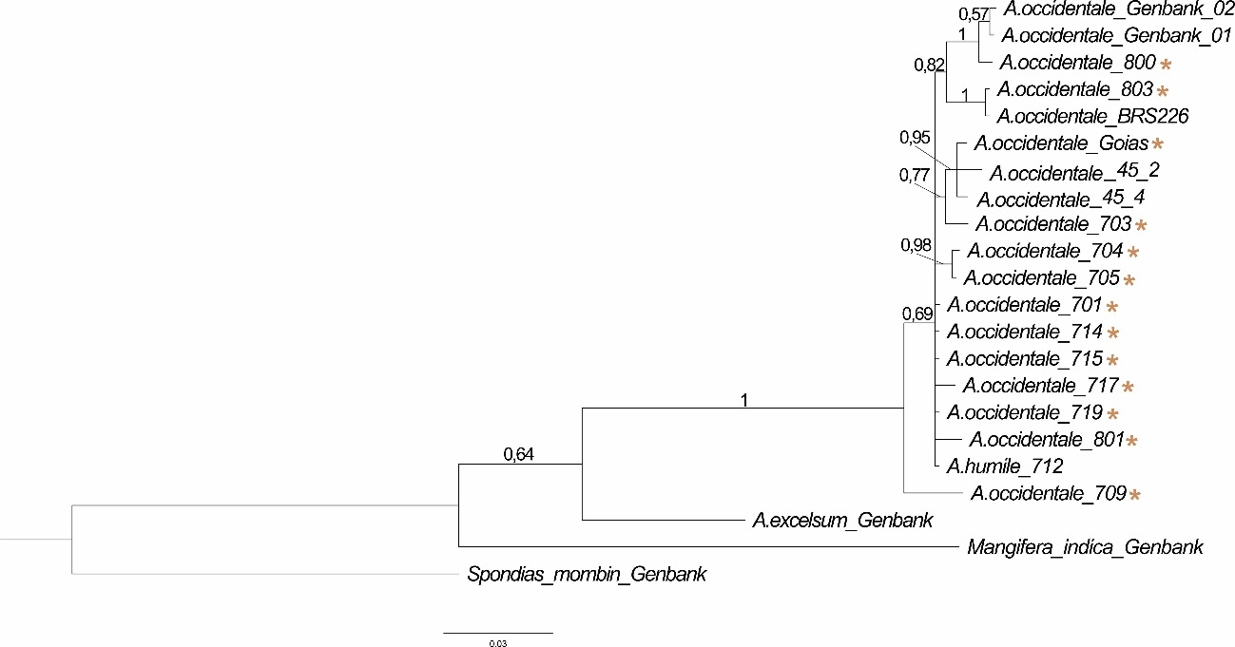
Figure S7 Bayesian tree of Anacardium derived from the analysis of the nuclear ITS region. The posterior probability (PP) values are shown for each node, and asterisks indicate tree accessions of Anacardium occidentale with cashew-type fruits and cashew apples, i.e., the possible hybrids

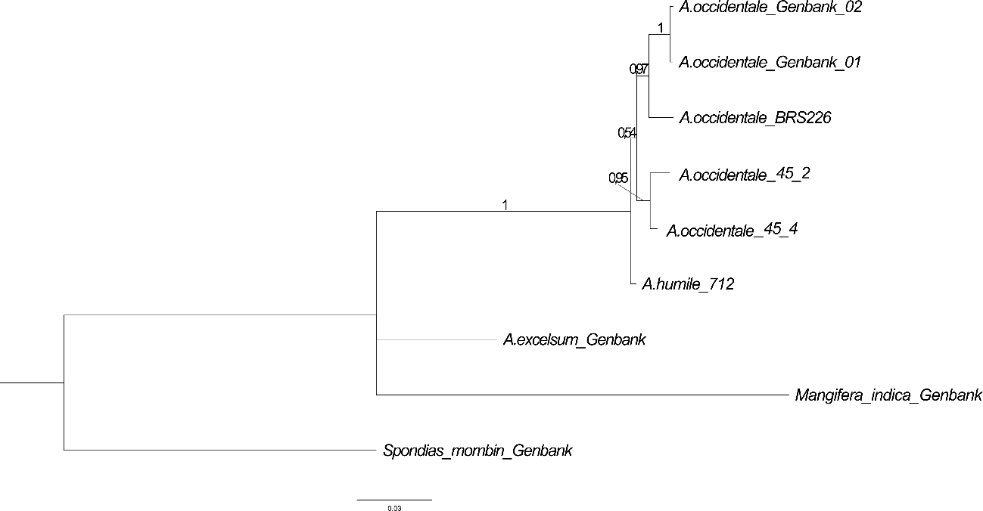
Figure S8 Bayesian tree of Anacardium derived from the analysis of the nuclear ITS region, excluding putative hybrids. Posterior probability (PP) values are shown on the branches

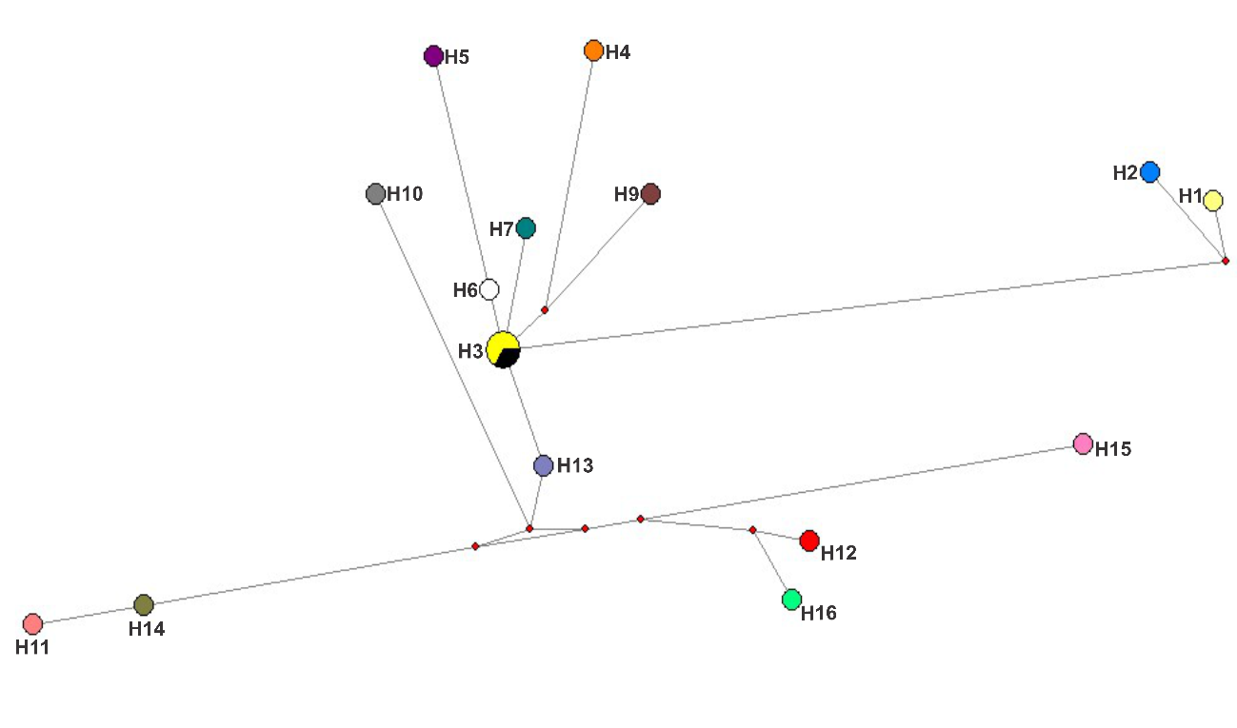
Figure S9 Haplotype distribution patterns of A. humile (H13) and A. occidentale (H1-H12 and H14-H16) for nuclear data. The colours in each pie chart correspond to the haplotypes, and the size of the circle represents the proportion of each haplotype

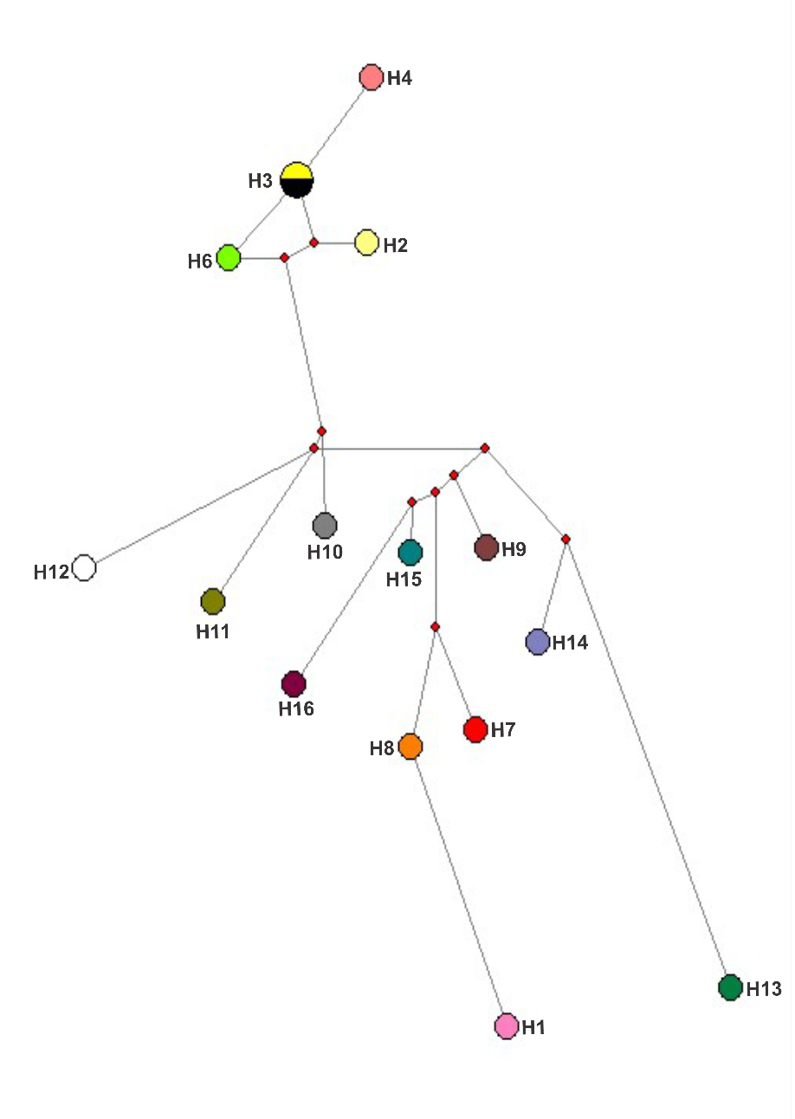
Figure S10 Haplotype distribution patterns of A. humile (H10, H11 and H12) and A. occidentale (H1-H9 and H13-H16) for plastidial data. The colours in each pie chart correspond to the haplotypes, and the size of the circle represents the proportion of each haplotype

