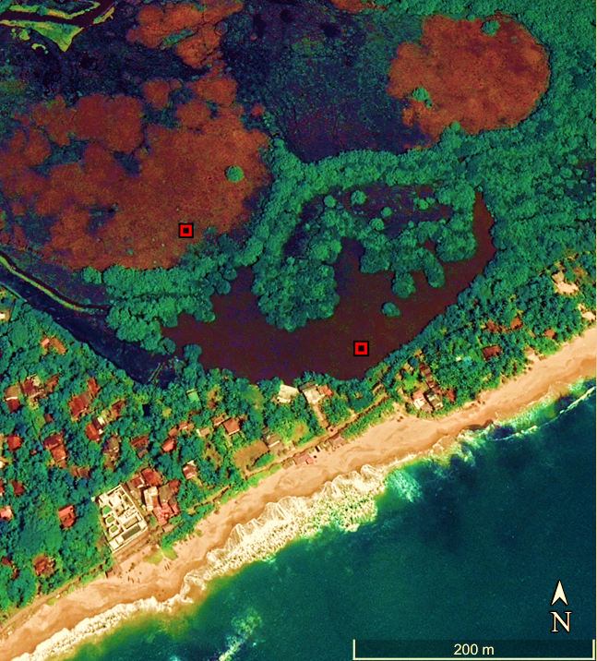
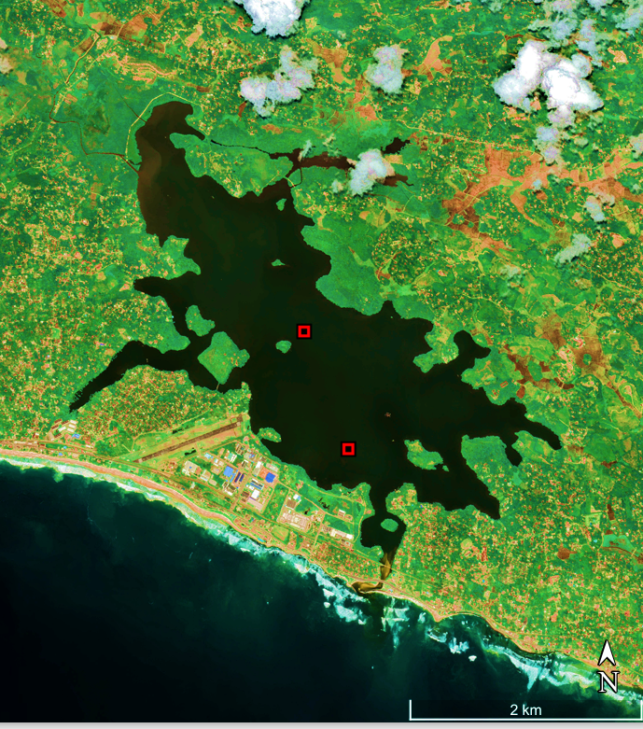
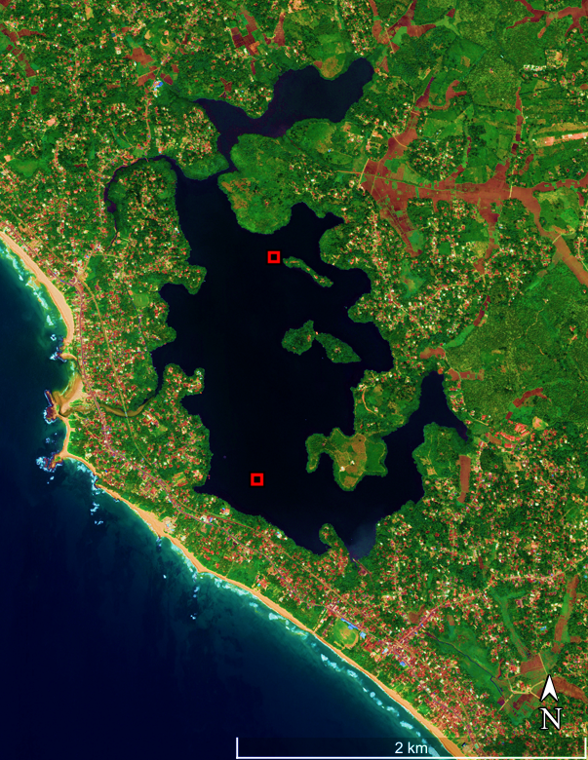
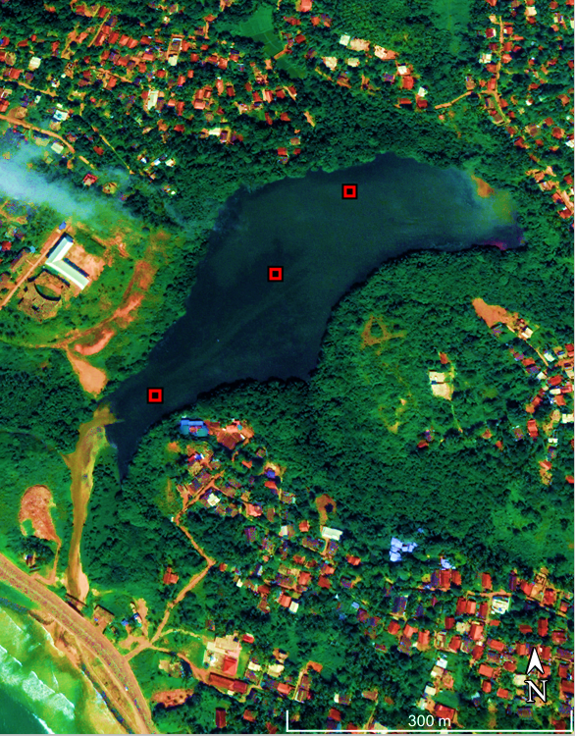
TG (Pit)
TG 1
KG2
KG1
RG2
RG1
DV1
DV2
DV3

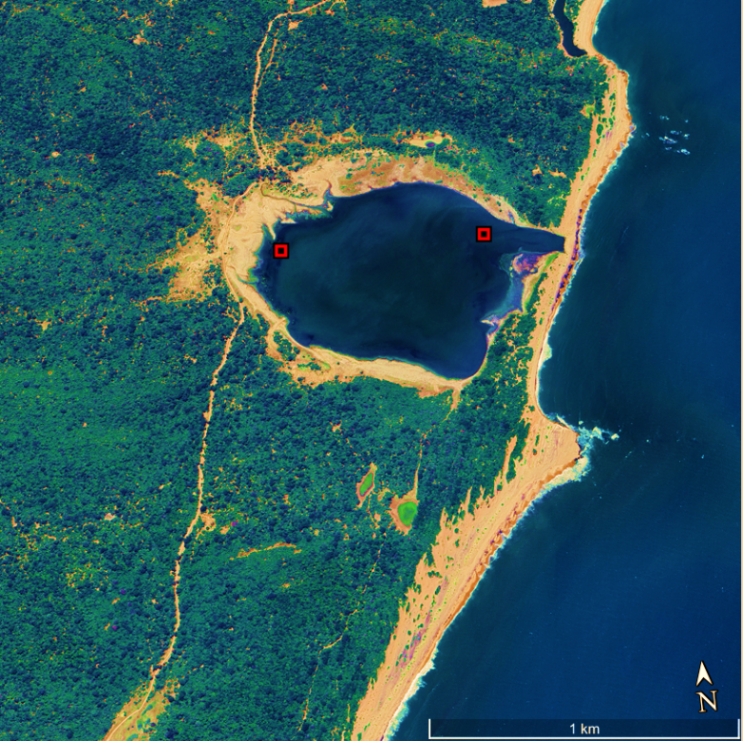
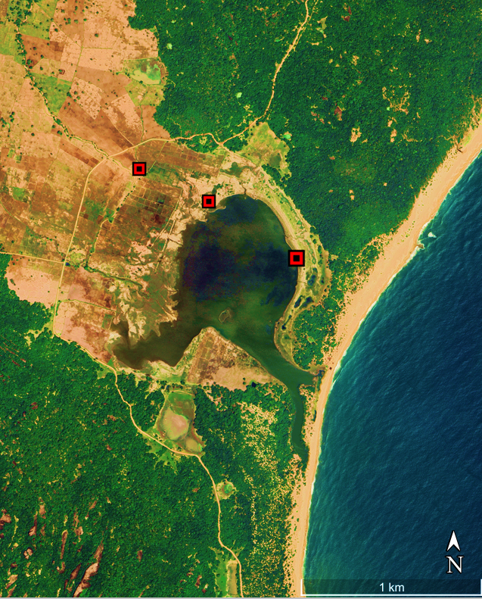
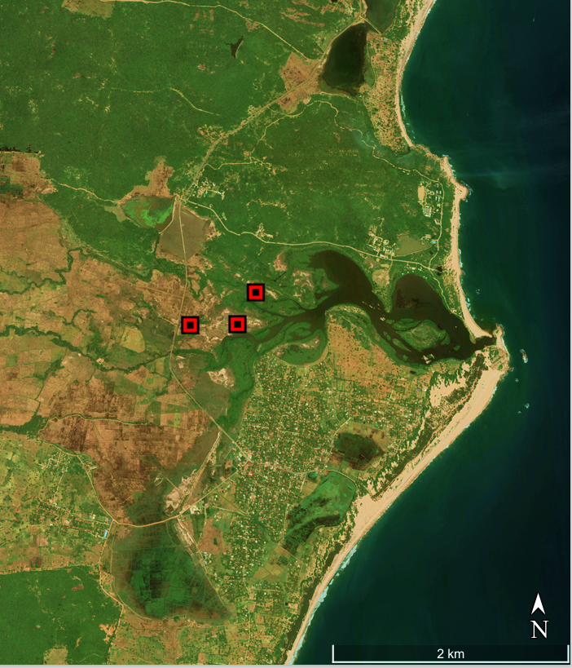
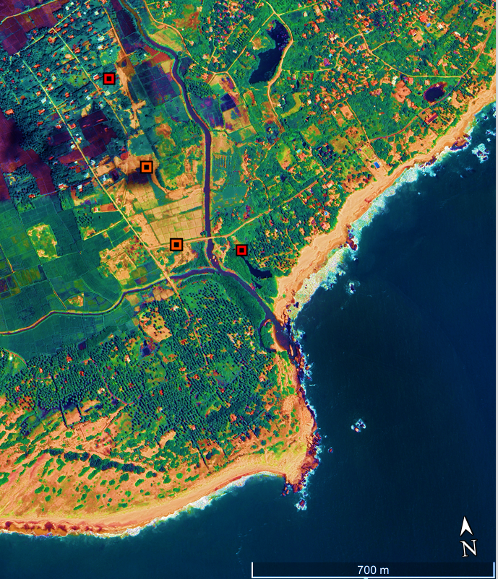
KU51
KU11
OK11
OK21
OK31
PN1
PN2
PN3
KD31
KD21
KD11
KD41

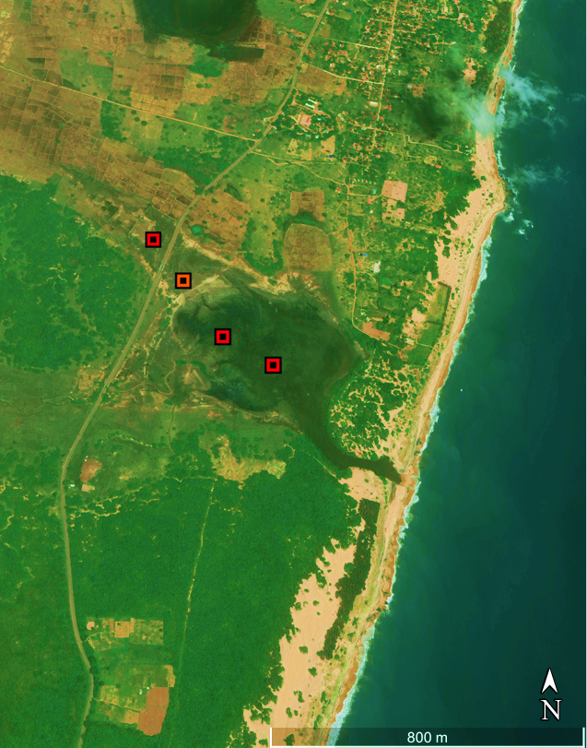
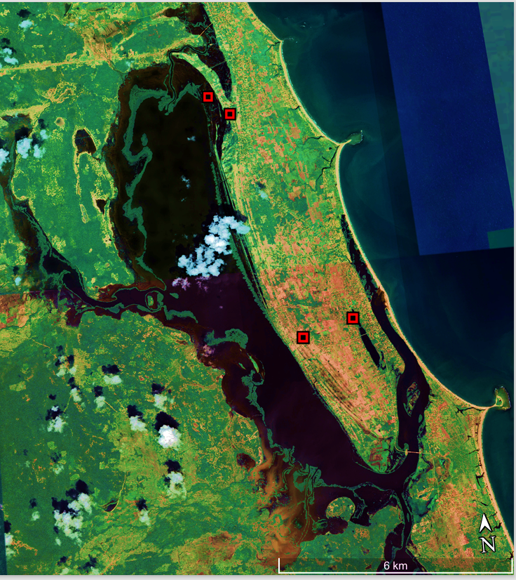
KM1
KM2
KM3
KM4
V31
V32
V12
V13

Figure Supplement 1 – Ten back barrier environments and their coring locations selected for the detailed sedimentological and geochemical analysis

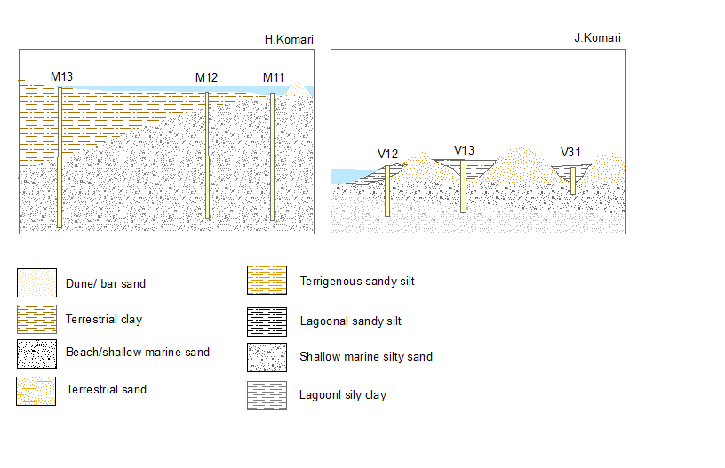

Figure Supplement 2 – Generalized stratigraphic profiles of the ten back barrier environments and their coring locations selected for the detailed sedimentological and geochemical analysis. Startigraphic profiles were contsructed based on the stratigraphyobserved in each core. Depths are not accoding to a scale.

A - Ratgama
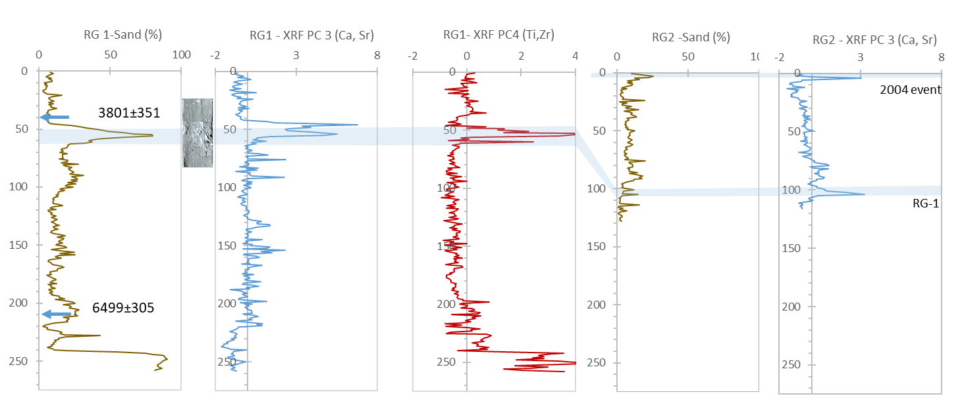

B - Koggala

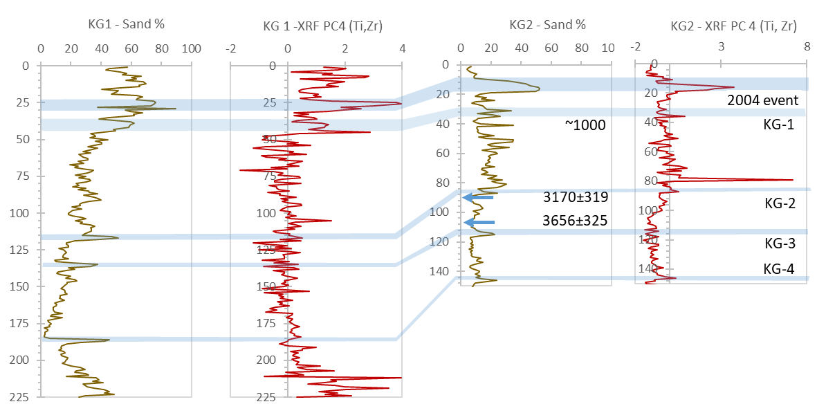

C - Devundara

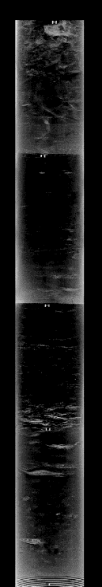
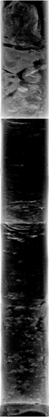

DV-5

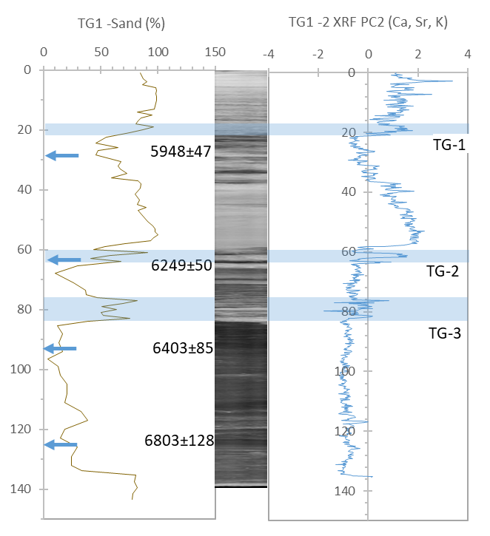
D - Tangalle

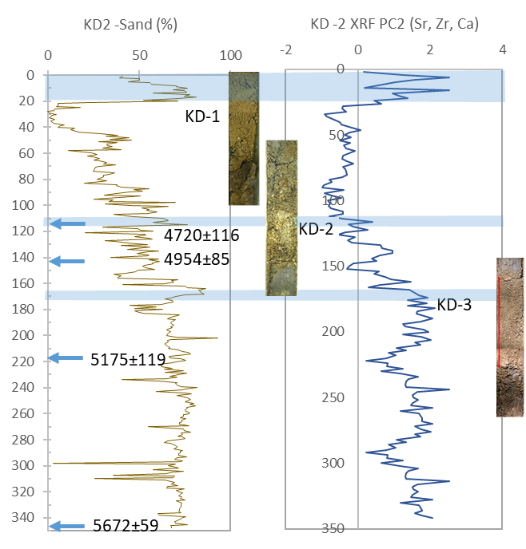
E -1 Kirinda

E-2 Kirinda

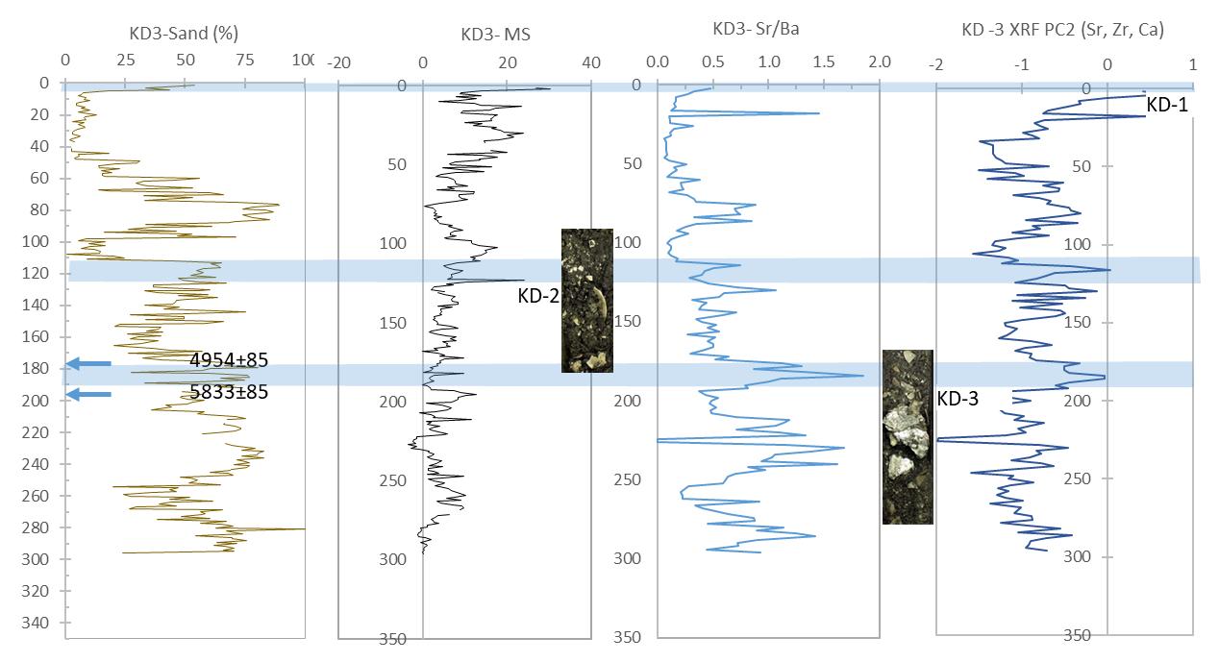

E-3 - Kirinda
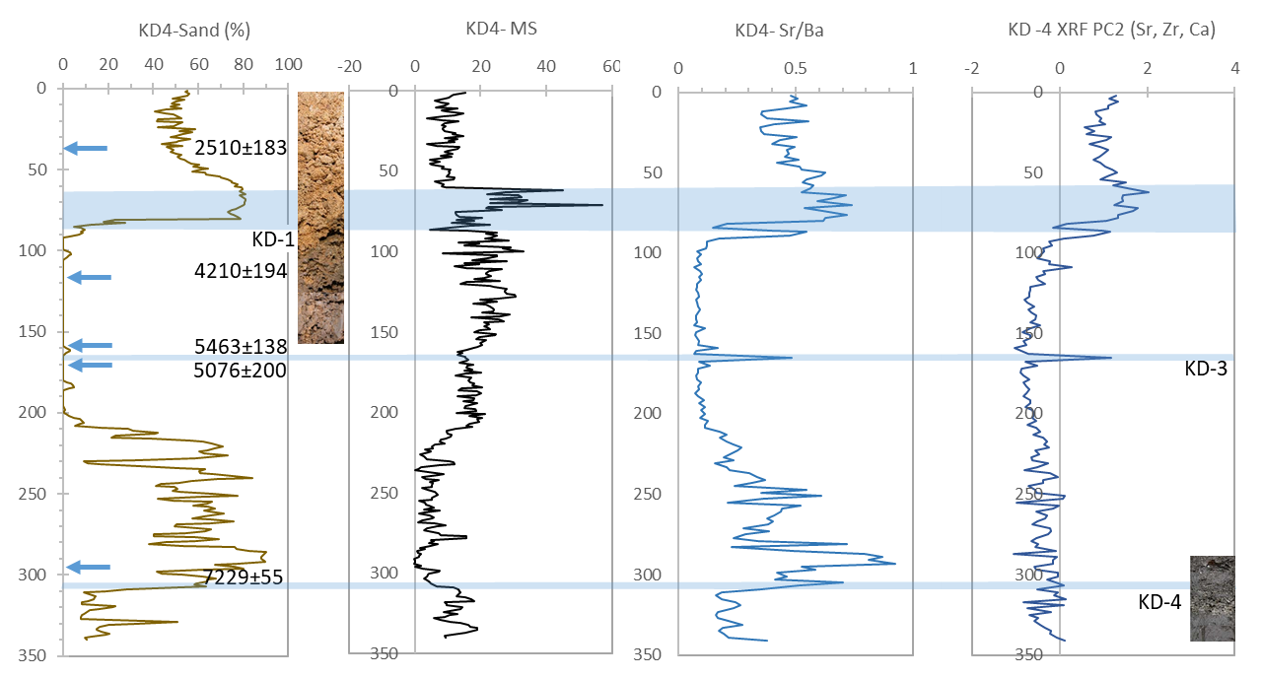

F - Kumana

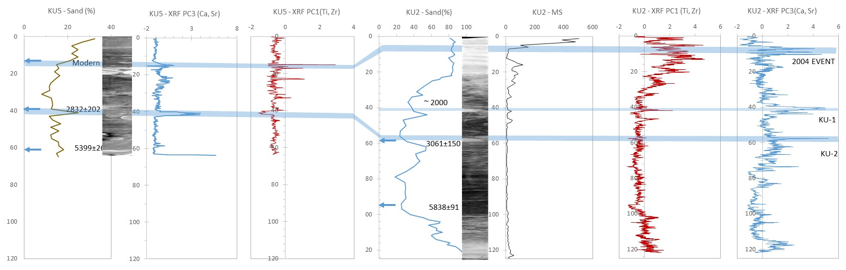

G - Okanda

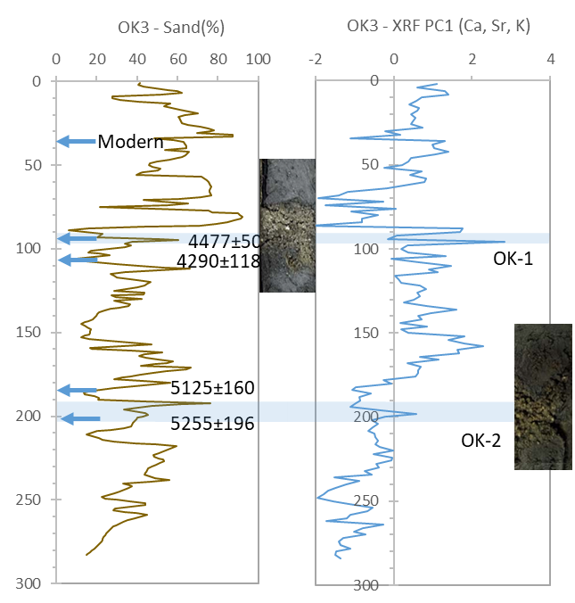

H – Panama

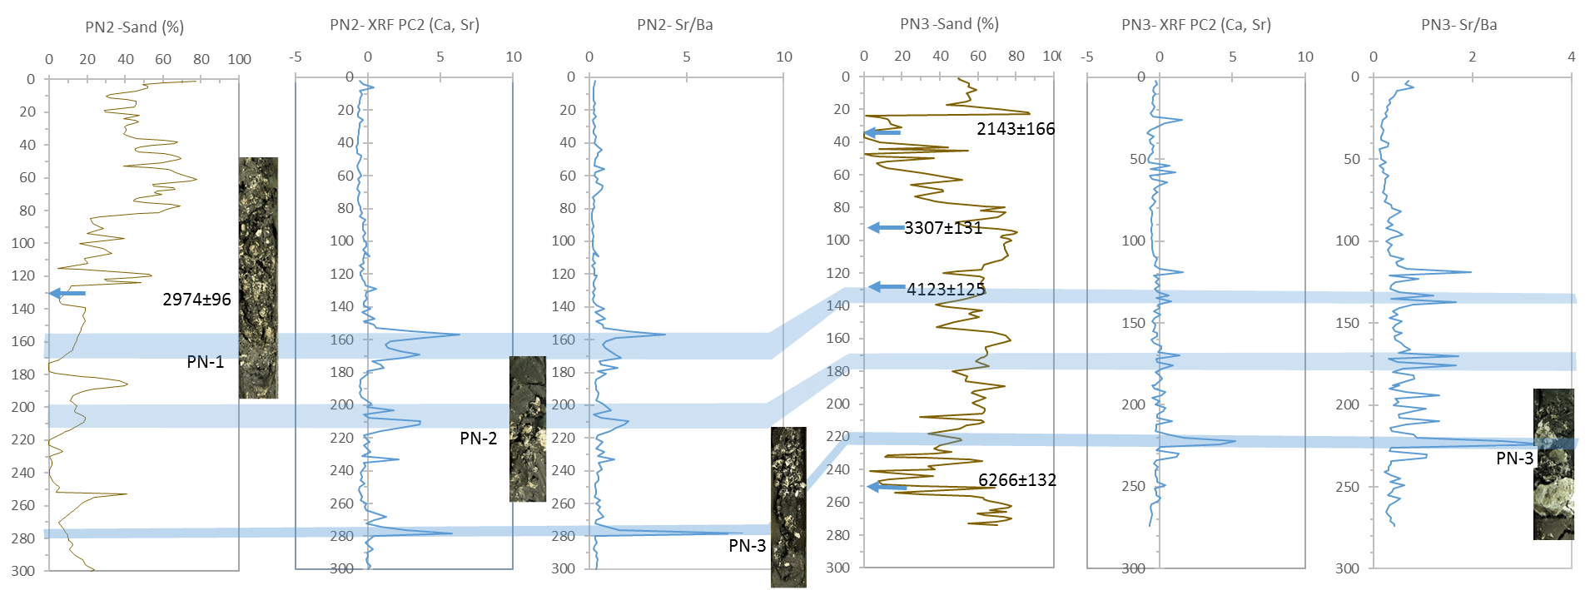

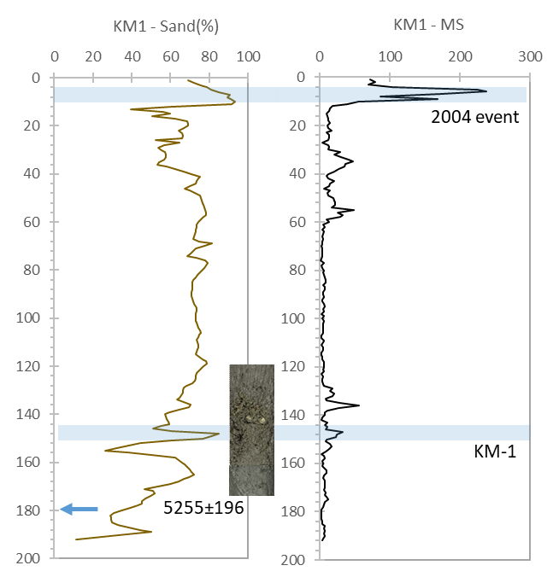
I - Komari

J - Vakarai
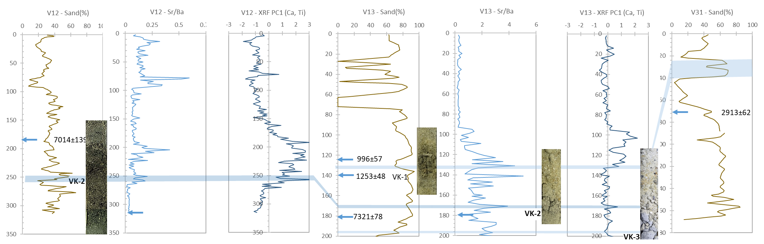

Figure Supplement 3 – Down core variation of proxy data at each site where abrupt marine event layers were recorded. Recognized layers are shaded. Radiocarbon ages are given and the depths are indicated using arrows. Event layers are labelled as per the text. Photographs of the event layers and available X-ray images of the cores are shown.

Figure supplement 4
A -Broken shell fragments in 2004 tsunami layer in Ratgama cores

B – Brocken shell fragments in ~ 4000 yrs BP tsunami sand layer

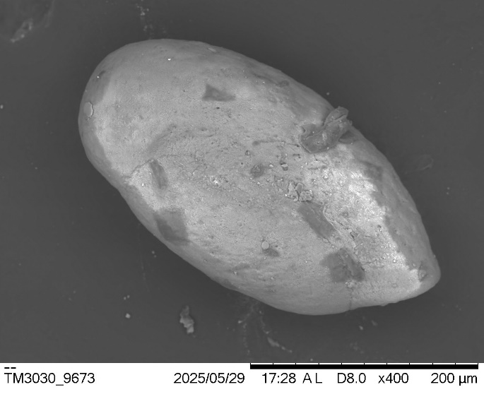
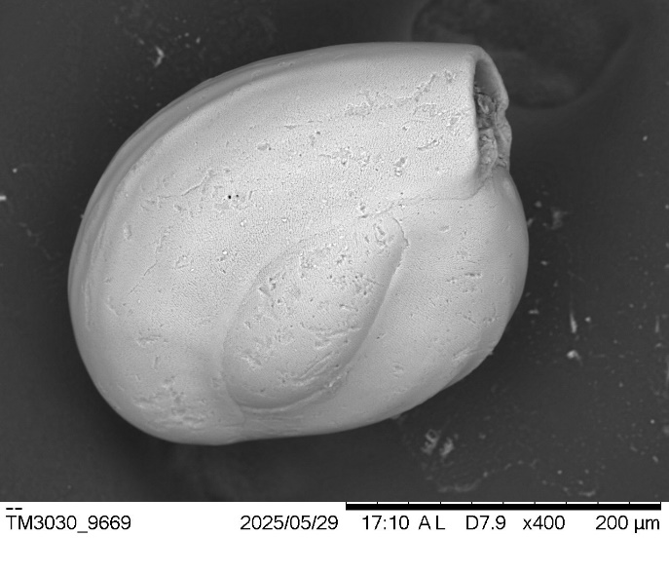
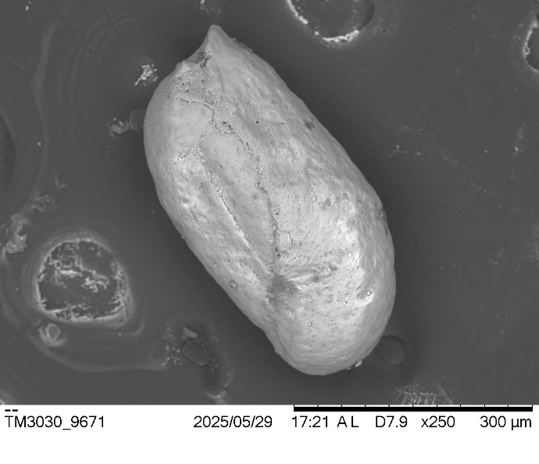
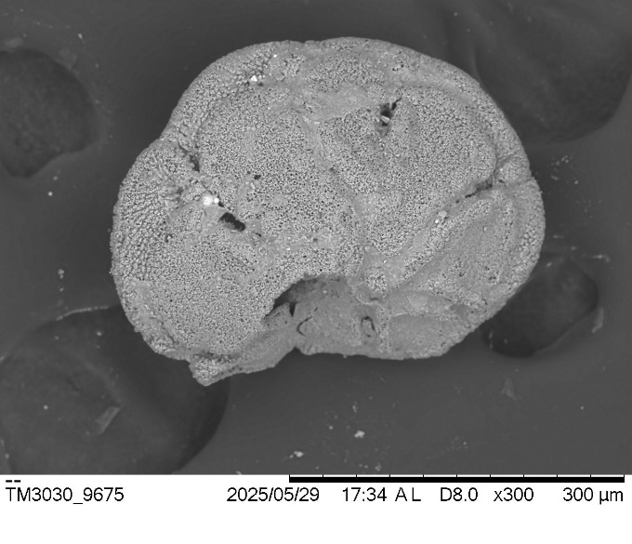
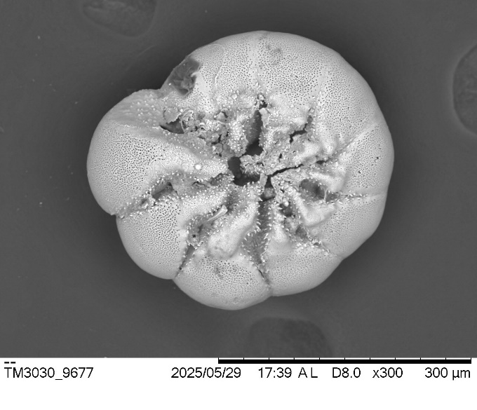
C - Foraminiferal species found in KD2-3 layer (~ 5100 yrs tsunami layer)

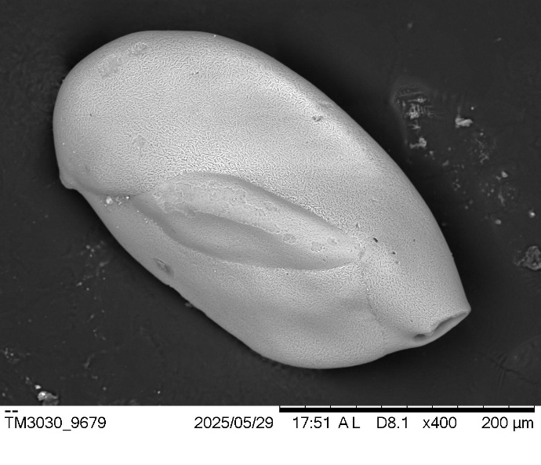
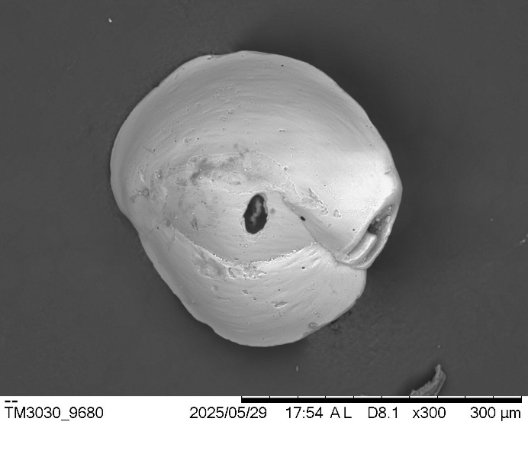
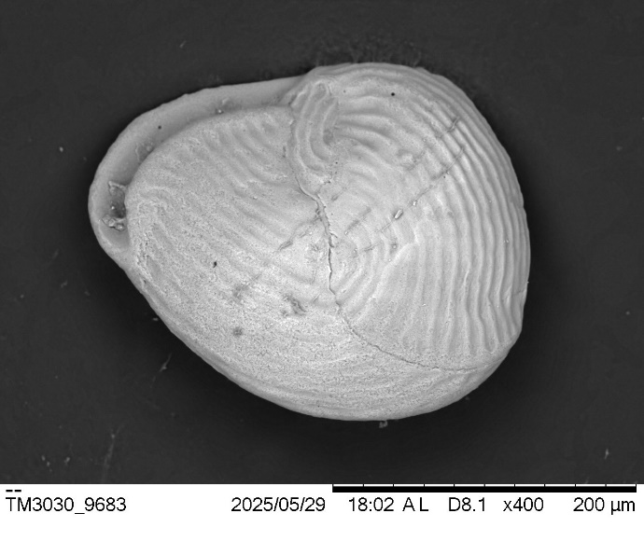
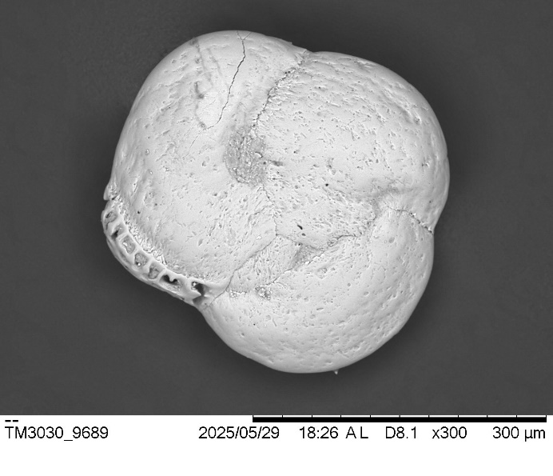
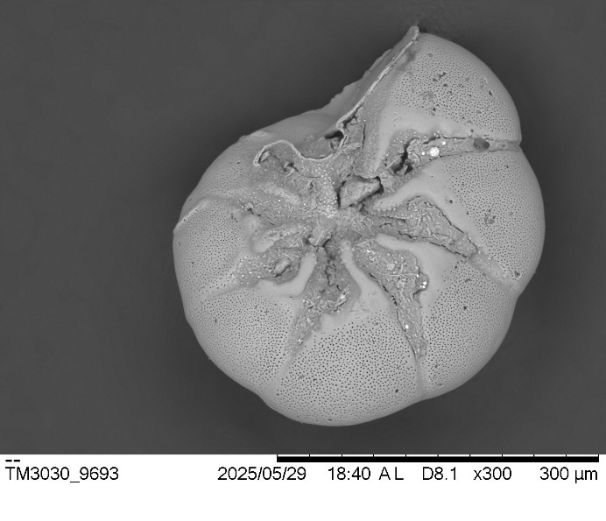
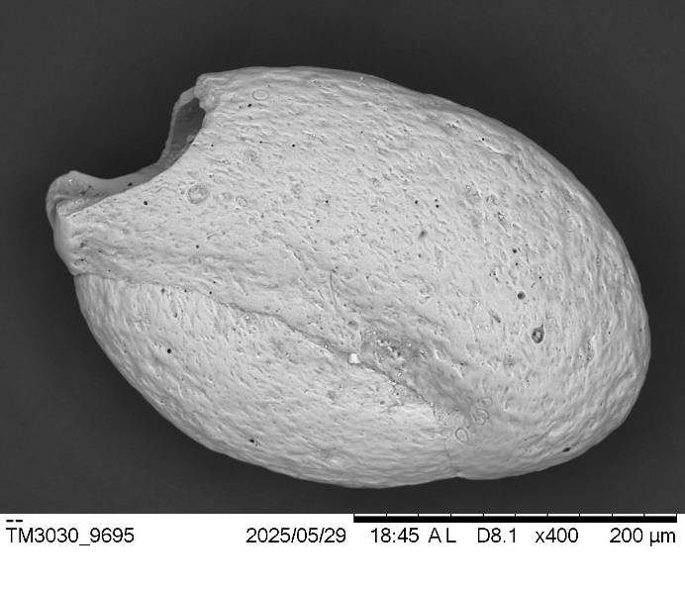
D - Foraminifera species in ~ 7300 yrs BP tsunami layer

