Methods of LC-MS/MS analysis
1) Chemicals and Reagents
Methanol, acetonitrile, formic acid, and isopropyl alcohol were purchased from ANPEL (Shanghai, China). All organic solvents were of LC-MS grade. Ultra-pure water was prepared in-house using a Milli-Q water purification system (Millipore, Bedford, MA, USA).
2) Sample Preparation and Extraction
Samples were slowly thawed at 4 °C, and an appropriate volume (0.5–1.0 mL) was transferred into a centrifuge tube. Extraction solution (methanol-acetonitrile, 1:1, v/v) was added at twice the sample volume, followed by homogenization for 60 s and low-temperature ultrasonic extraction for 30 min. The mixture was centrifuged at 12,000 rpm for 10 min at 4 °C, then allowed to stand at −20 °C for 1 h for protein precipitation. After a second centrifugation at 12,000 rpm for 10 min at 4 °C, the supernatant was dried under vacuum. The residue was reconstituted with 0.1 mL of 50% acetonitrile aqueous solution, homogenized, and centrifuged at 12,000 rpm for 10 min at 4 °C. The final supernatant was collected for instrumental analysis.
3) LC-MS/MS Analysis
The extracted samples were analyzed on an UPLC-Orbitrap-MS system consisting of a Vanquish UPLC system and a Q Exactive HFX mass spectrometer (Thermo Fisher Scientific, Waltham, MA, USA).
UPLC conditions
Analytical column: Waters HSS T3 column (100 × 2.1 mm, 1.8 μm); column temperature: 40 °C; flow rate: 0.3 mL/min; injection volume: 2 μL; mobile phase: A (Milli-Q water containing 0.1% formic acid), B (acetonitrile containing 0.1% formic acid). Gradient elution program: 0–1 min, 100% A; 1–12 min, linear gradient to 5% A and 95% B; 12–13 min, hold at 5% A and 95% B; 13.1 min, return to 100% A; 13.1–17 min, hold at 100% A for re-equilibration.
MS conditions
High-resolution mass spectrometry (HRMS) data were acquired in Full MS/ddMS² mode with a heated electrospray ionization (HESI) source. The ESI source operating parameters were set as follows: sheath gas flow rate: 40 arb; auxiliary gas flow rate: 10 arb; spray voltage: +3000 V/−2800 V; capillary temperature: 350 °C; ion transfer tube temperature: 320 °C. Full scan m/z range: 70–1050 Da; MS1 resolution: 70,000; MS2 resolution: 17,500.

Figure S1. Chromatographic Profiles of HQQR
Figure S1A
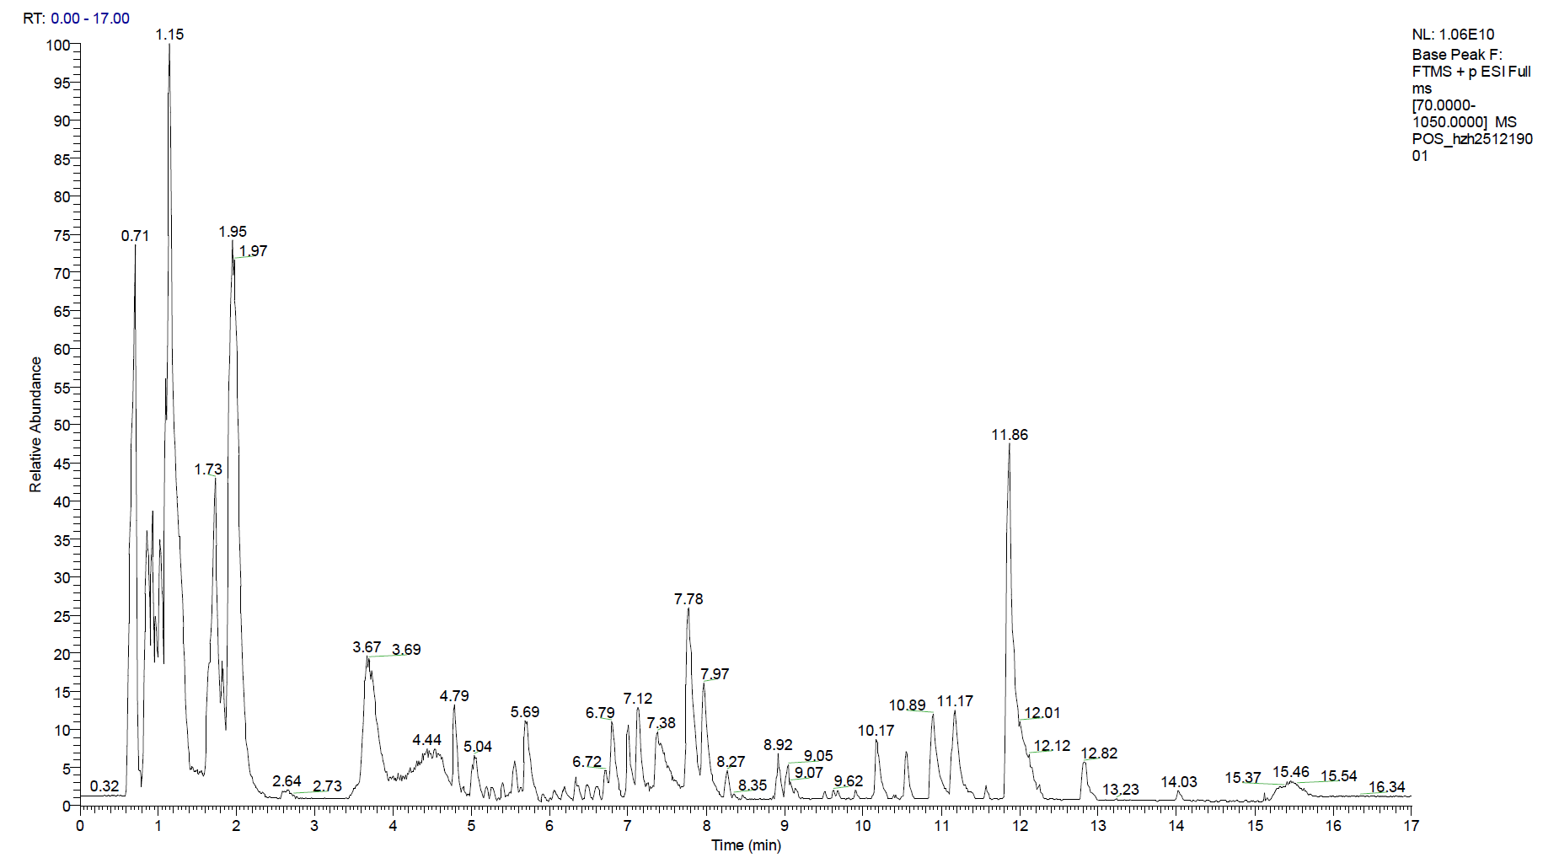
Figure S1B
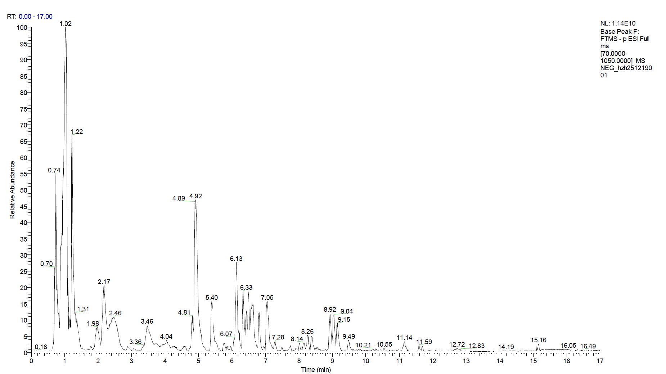

Figure S1C

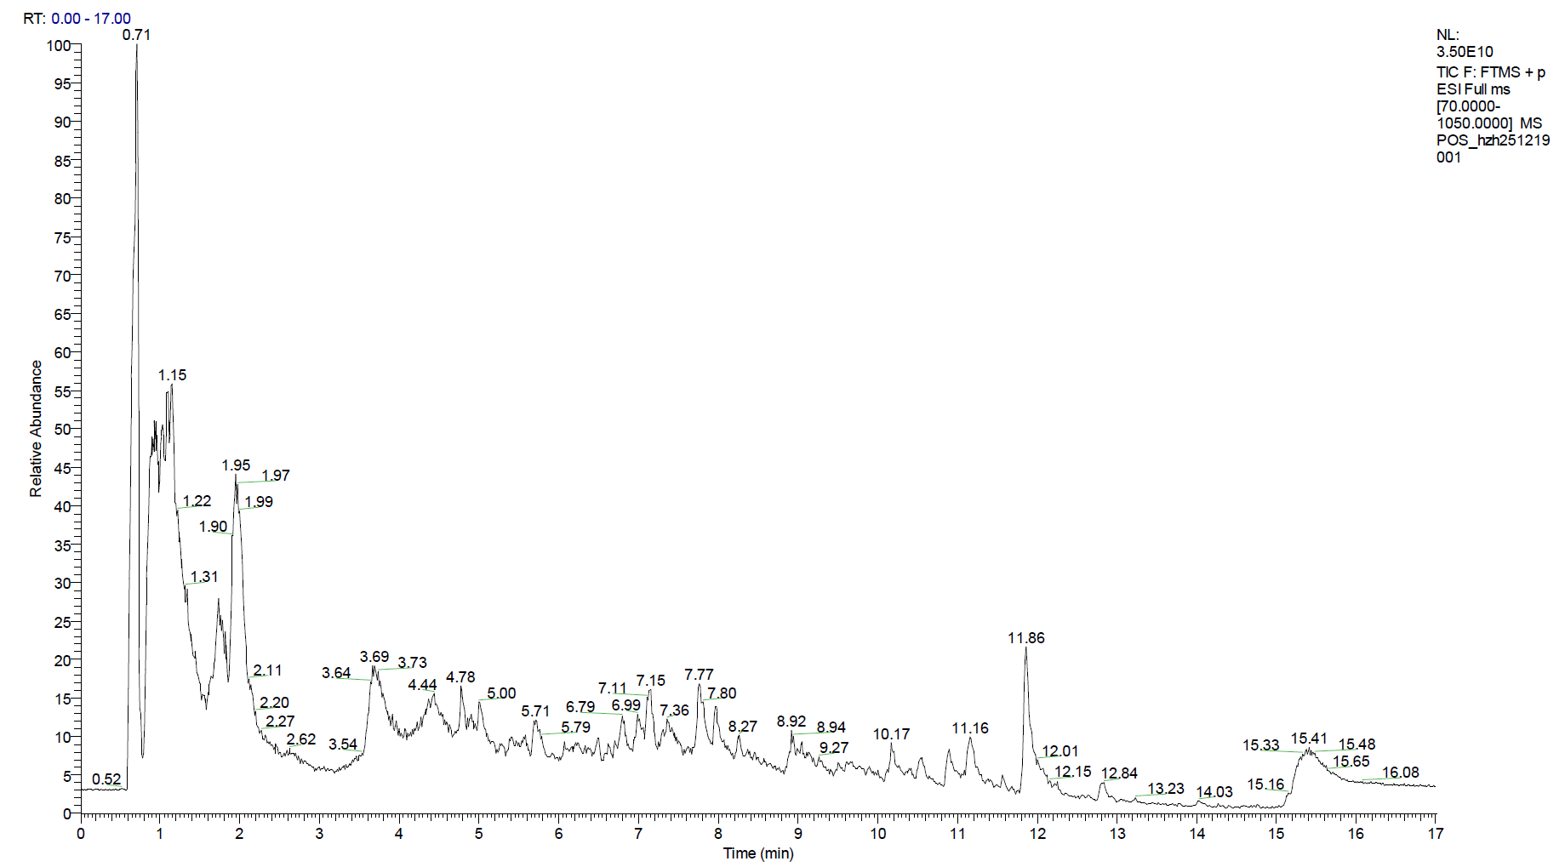
Figure S1D
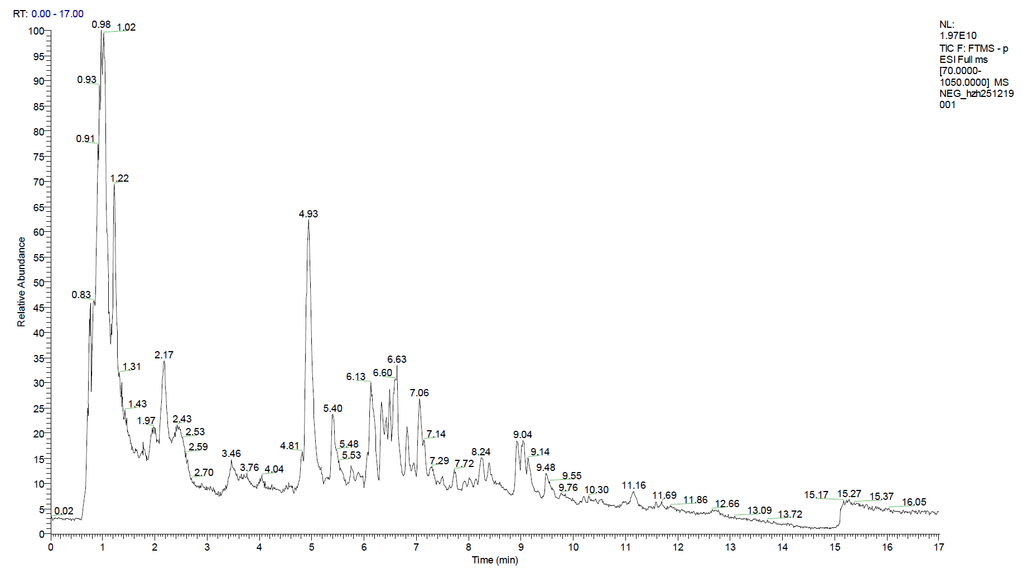
(A, B) Base Peak Chromatograms (BPC) in positive (A) and negative (B) ion modes. BPC plots the intensity of the most abundant ion at each retention time, providing a noise-reduced view of major chemical constituents in HQQR.
(C, D) Total Ion Chromatograms (TIC) in positive (C) and negative (D) ion modes. TIC represents the sum of all detected ion intensities over the full chromatographic run, reflecting the comprehensive chemical complexity of HQQR (including minor constituents and background signals).

Figure S1.
Ang II inhibited cell proliferation in myocardial cells. Myocardial cells were incubated with increasing concentrations of Ang II. Cell viability was measured using CCK-8 assay. Ang II: angiotensin II

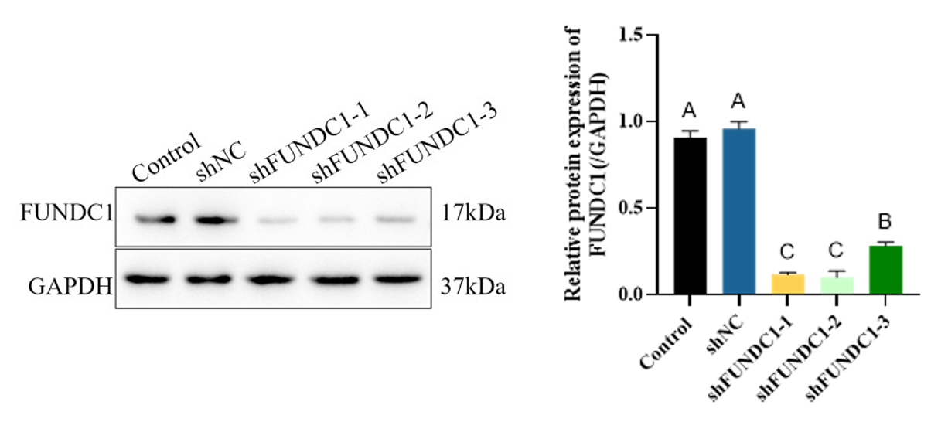
Figure S2.
Representative WB image and quantification of shFUNDC1 (n=3).

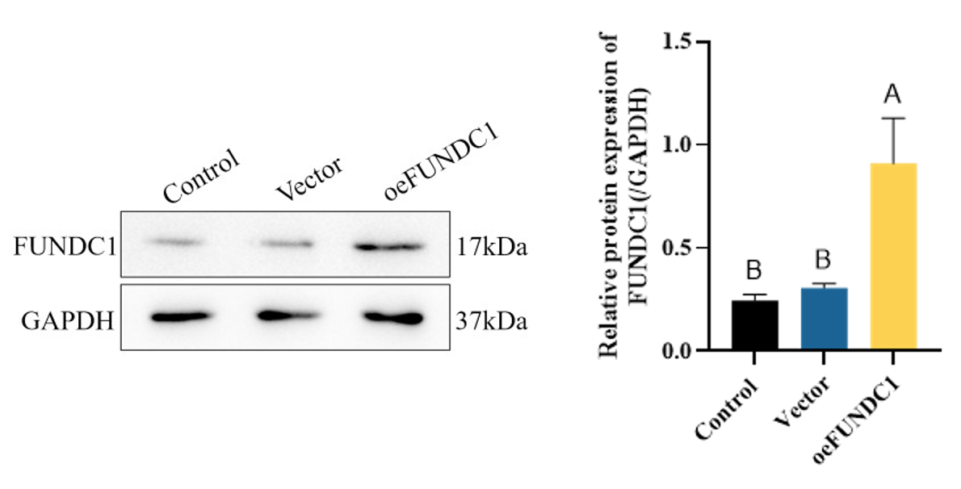
Figure S3.
Representative WB image and quantification of oeFUNDC1(n=3).

