Below is the email that was sent, along with the available media:

Greetings from the PES,

We’re inviting you to participate in a creative and meaningful project led by a medical student in collaboration with the Patient Engagement Studio (PES). This project, called the Layered Lived Experience (LLE) Word Portrait, is a way for us to better understand and celebrate the diverse experiences and identities that shape our community of patients, caregivers, researchers, and medical providers.

Through a short 5–10-minute survey, you’ll be asked to reflect on elements of your identity such as age, medical conditions, caregiver status, veteran experience, and more—and indicate how much each one influences your perspective. Your responses will be used to generate a unique personal word cloud that visually represents your lived experience as it relates to your role in the PES.

You can view the brief project video and get started by clicking the video linked below.

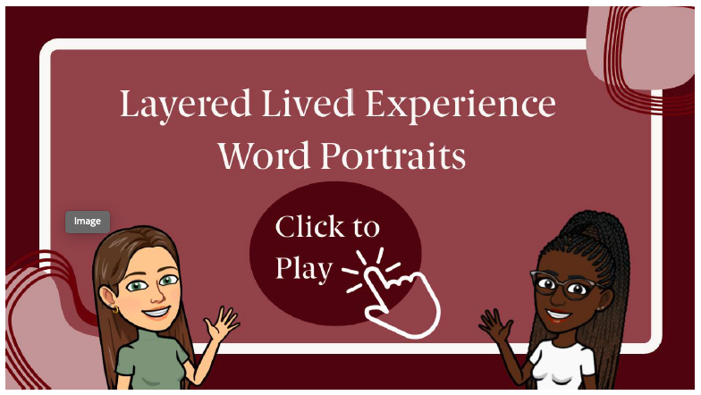

A few things to note:
- This is a student project, so participation is entirely voluntary and uncompensated.
- You don’t need a computer—you can complete the survey on your phone.
- If a question doesn’t apply to you, leave it blank (instead of writing “no” or “N/A”) so that your word cloud reflects only the relevant pieces of your story.
- After you complete the survey medical student, [name redacted] will follow up with your personalized word cloud.

Ready to take the survey? – _Click here to begin.
After working with [name redacted] to create a word cloud you’re happy with, we will invite you to share it with other members of our PES Community on an exciting new platform called Circle (details to follow).

This is more than a demographic exercise—this project reflects the PES belief that our community is made up of people, not data points. Your voice matters, and we hope you’ll take a few minutes to share your story.

With gratitude,

The video mentioned in the above email can be found here:
https://www.canva.com/design/DAGqiQ-NeyM/vTs8J-Lum-H1GnBh7CZMCw/watch?utm_content=DAGqiQ-NeyM&utm_campaign=designshare&utm_medium=link2&utm_source=uniquelinks&utlId=h6d5644f91e

