SUPPLEMENTARY INFORMATION

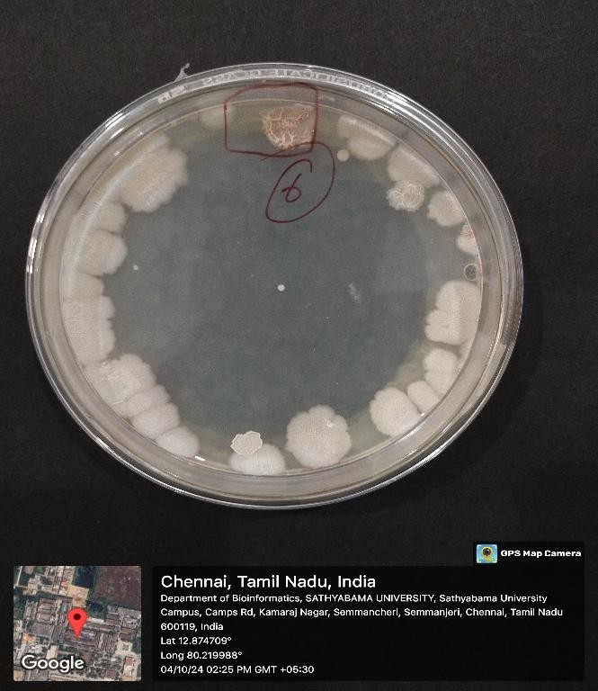
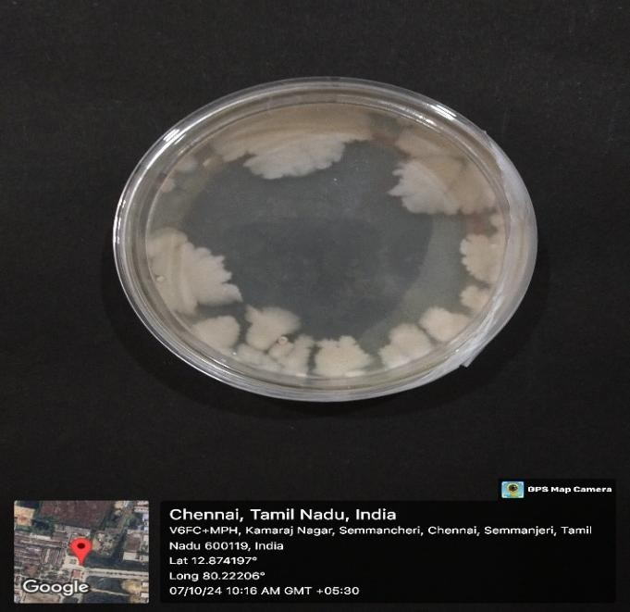
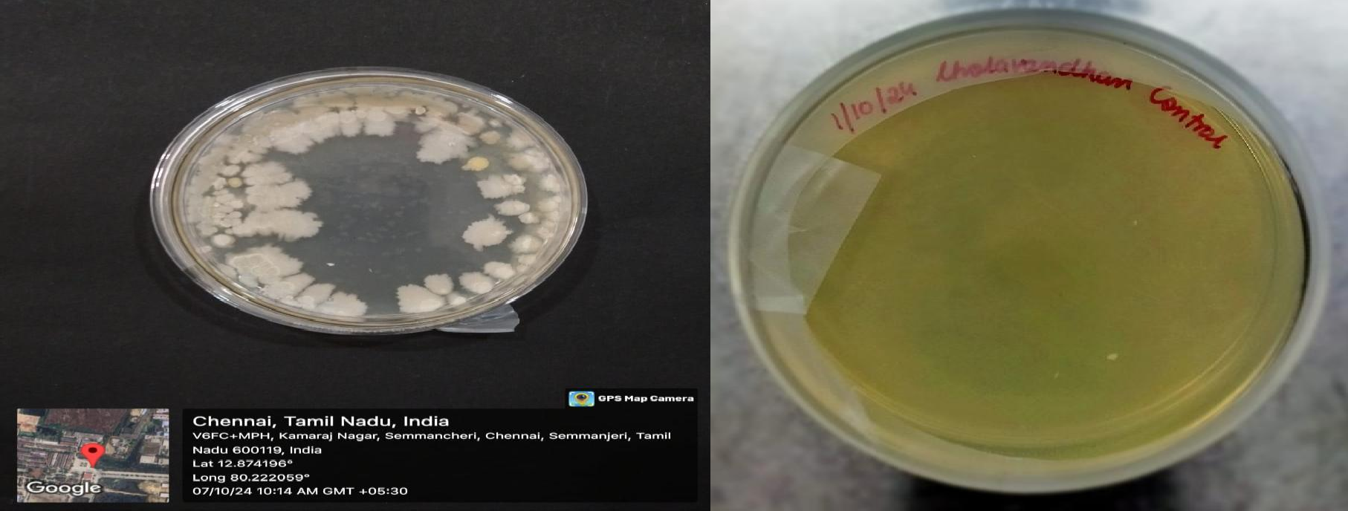
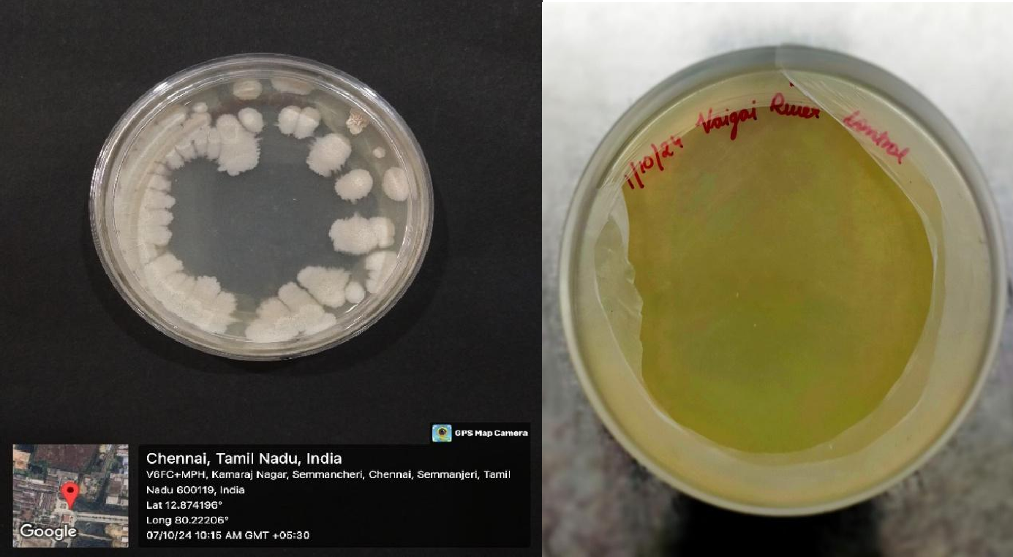
d)
c)
b)
a)

Fig. S1 Bacterial colonies isolated from four different water samples using the spread plate method a) Mudalaikulam b) Mudalaikulam 2 c) Vaigai River d) Sholavandhan

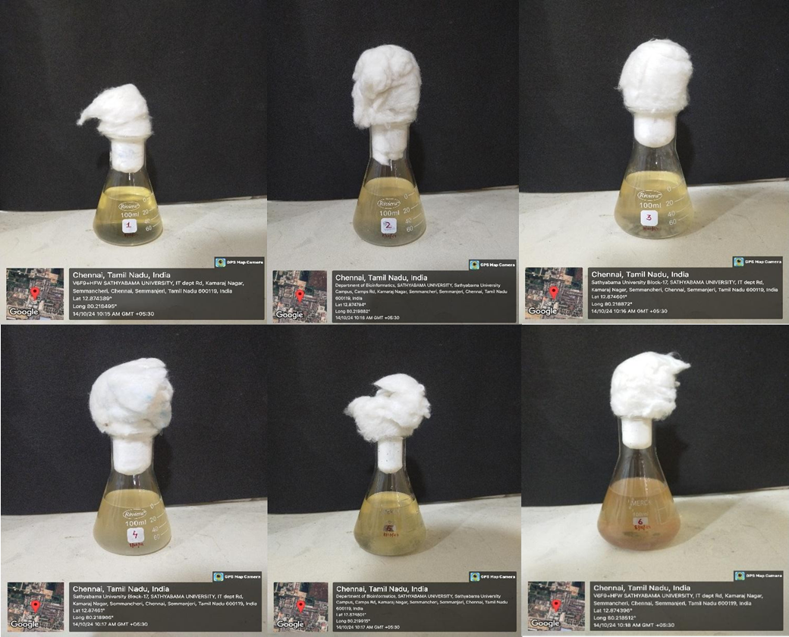
f)
e)
d)
c)
b)
a)
Fig.S2 Nutrient Broth cultures of streak-isolated bacterial colonies: (a) Streak 1, (b) Streak 2, (c) Streak 3, (d) Streak 4, (e) Streak 5, and (f) Streak 6

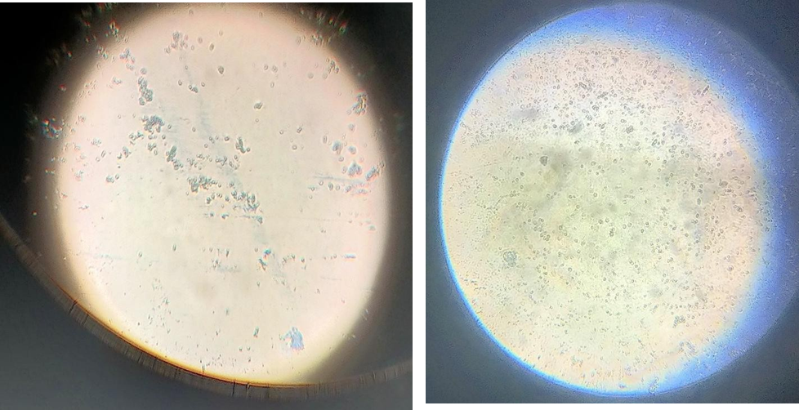
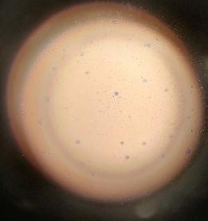
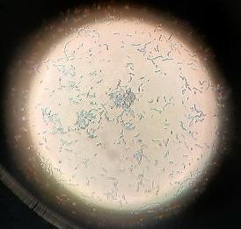
a) b)
f)
e)
c)
b)
a)
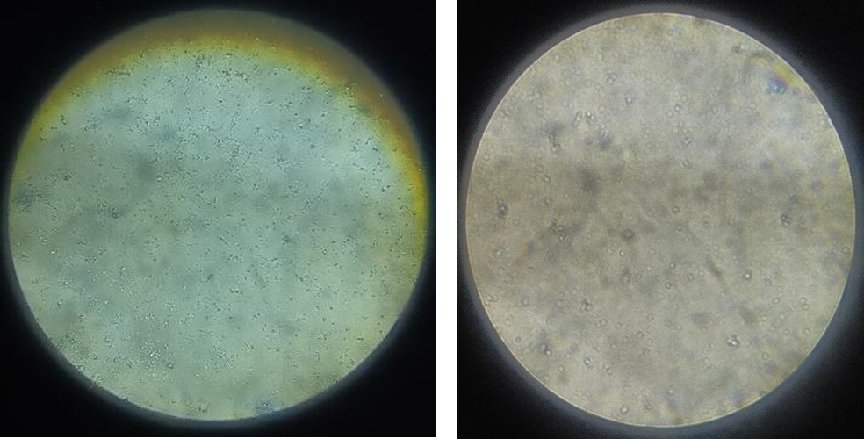
c) d)
e) f)
Fig.S3 Simple Staining of streak isolates a) Streak 1 b) Streak 2 c) Streak 3 d) Streak 4 e) Streak 5 f) Streak 6

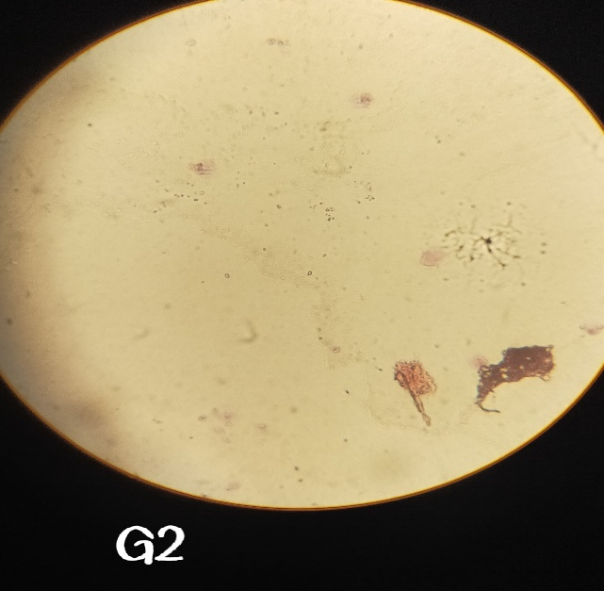
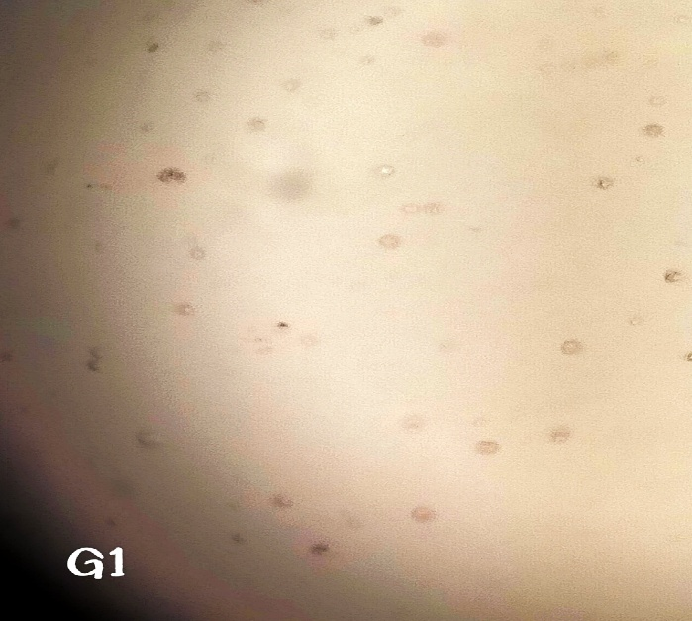

a) b)
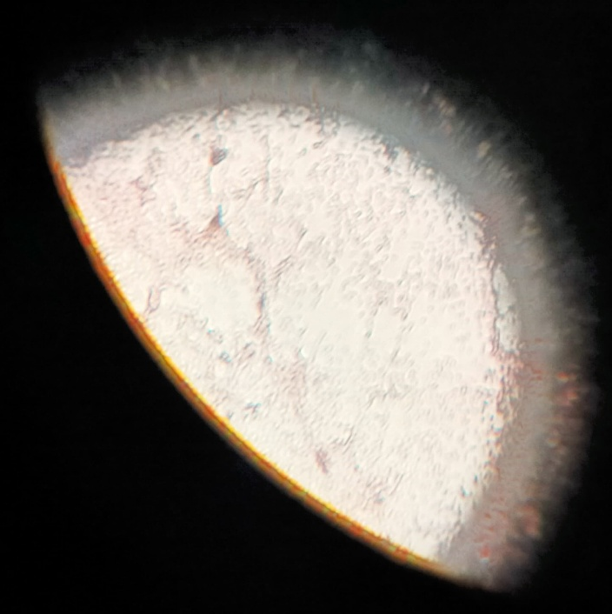
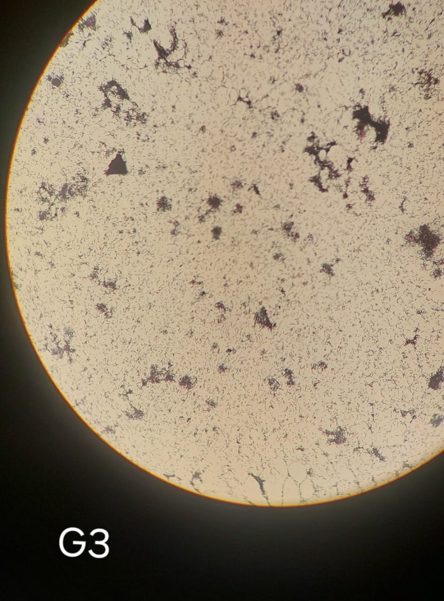
c) d)
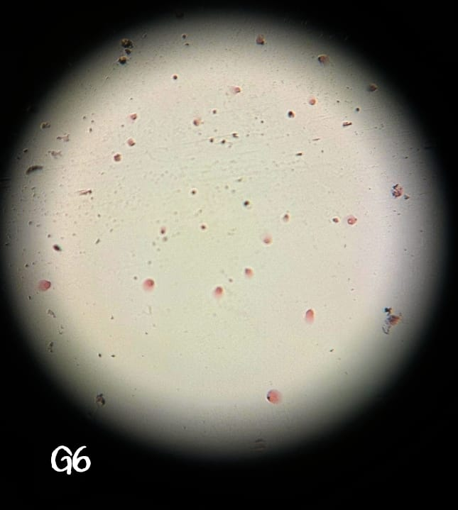
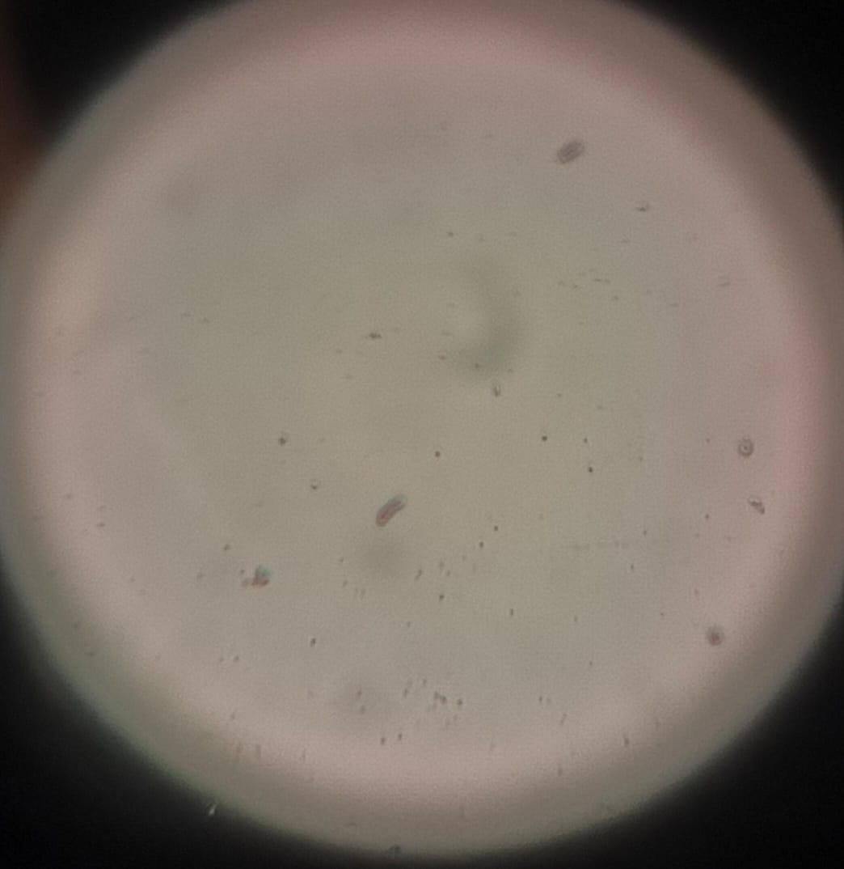
e) f)

Fig.S4 Gram Staining of streak isolates a) Streak 1 b) Streak 2 c) Streak 3 d) Streak 4 e) Streak 5 f) Streak 6
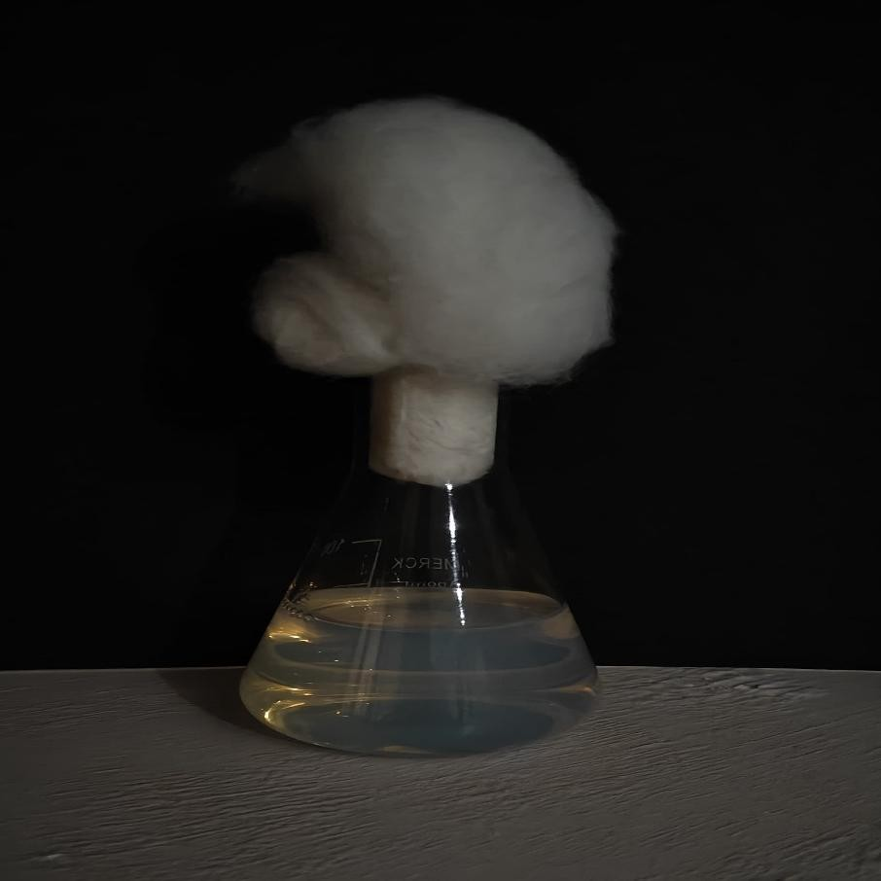

Fig.S5 Unpurified Silver Nanoparticles solution

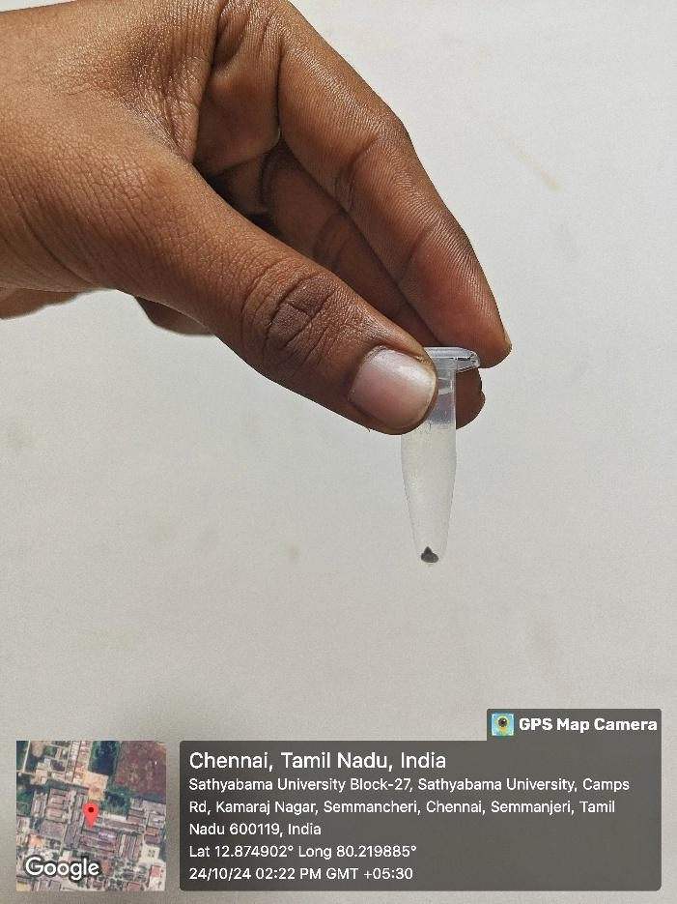
Fig.S6 Purified Silver Nanoparticles

