Supplementary material

Bridging the Gut and Liver: Multi-biotics modulate microbiota composition and corroborate transcriptomic improvements in MASLD

Su Jong Yu, Hyunwoo Oh, Da Jung Kim, Mingeun Jang, Ki Cheon Yoon, Hyojin Noh, Yun Bin Lee, Eun Ju Cho, Jeong-Hoon Lee, Yoon Jun Kim, Hyunsung Kim, Dae Won Jun, Kyoung Wan Yoon, Joo-Youn Cho, Jung-Hwan Yoon

Table of Contents

- Supplementary Materials and Methods……………..…………………..……….………. 2
- Supplementary Figures……………………………………..…………….….……….…… 8
- Supplementary Tables………..……………………………………...….….……….…… 10
Supplementary Materials and Methods

Global metabolomics analysis
Detailed experimental procedure is described in our previous study ¹ . Frozen samples were thawed at 4 °C and 50 µL of each sample was diluted with a 1 ml mixture of acetonitrile:isopropanol:water (3:3:2). Mixed samples were vortexed for 5 minutes and centrifuged at 18,341 × g for 5 minutes at 4 °C. Then, 400 µL of supernatant was evaporated to complete dryness at room temperature and reconstituted with 400 µL with 50% acetonitrile. Subsequently, centrifugation was repeated for 5 minutes at 18,341 × g at 4 °C. The supernatant was then evaporated and the residue was reconstituted with 10 µL of methoxyamine dissolved in pyridine and maintained at 30 °C for 90 minutes under shaking. After the cooling down of the samples to room temperature, 90 μL of a mixture of MSTFA (N-Methyl-N-(trimethylsilyl) trifluoroacetamide) and FAME (fatty acid methyl esters) was added to each experimental sample and the pooled quality control (QC) samples. They were incubated at 70 °C for 45 minutes under shaking. Subsequently, they were transferred to autosampler vials with glass inserts. Aliquots (1 µL) were then injected in splitless mode into an Agilent 7890A gas chromatograph in combination with a Pegasus HT time-of-flight mass spectrometer (Leco Corporation, St. Joseph, MI). Separation was achieved on a DB-5ms capillary column (30 m × 250 μm i.d., 0.25 μm film thickness; (5%-phenyl)-methylpolysiloxane bonded and cross-linked; Agilent J&W Scientific, Folsom, CA, USA), with helium as the carrier gas at a constant flow rate of 1.5 mL/min. Oven temperature was initially set to 50 °C for 0.5 minutes and increased to 330 °C at a constant rate of 20 °C/min up to 20 minutes. Each ion’s intensity was normalized to the total sum of all detected metabolites based on the ChromaTof software and then aligned in line with the retention time (v4.61 Leco Corporation, St. Joseph, MI). Candidates extracted from multivariate analysis (refer to statistical analysis section) were selected based on the similarity, reserve, and probability values (above 700, 800, and 3000, respectively).

Bile acid measurements
Serum samples were prepared in line with the manufacturer’s instructions. Detailed experimental procedure is described in our previous study ². For the liquid chromatography-tandem mass spectrometry (LC-MS/MS), 10 μL of diluted filtrate was injected into the Agilent 1200 series high-performance liquid chromatography (HPLC) system (Agilent Technologies, Santa Clara, CA) which consists of a binary pump (G1312A) and an autosampler (G1367B) with a thermostat (G1330B) set at 10 °C. The chromatographic separation was achieved on an analytical column using the Biocrates® Bile Acids Kit (Biocrates Life Science AG, Innsbruck, Austria) equipped with the AJ0-4287 SecurityGuard™ ULTRA cartridge for C18 HPLC columns (Phenomenex, Torrance, CA). Mobile phase A contained 10 mM ammonium acetate (NH4Ac) and 0.015% formic acid in Milli-Q® water, plus mobile phase B comprised 10 mM NH4Ac and 0.015% formic acid in acetonitrile:methanol:Milli-Q® water 65:30:5 (v/v/v). MS analysis was conducted with the API 4000 QTRAP (Applied Biosystems/MDS Sciex, Foster City, CA, USA) equipped with an electrospray ionization source. The 17 BAs were identified and quantified via the LC-MS/MS system (scheduled multiple reaction monitoring). The abundance of each BA was calculated from the area under the curve (AUC) by normalizing to its respective isotope-labelled internal standard using the Analyst® 1.5.2 software (Applied Biosystems/MDS Sciex). The MetIDQ™ software (BIOCRATES) was used to evaluate the calibration curves, quality controls, and samples. Outliers were selected if more than 50% of the subjects were below the detection limit. A heatmap was generated using the MetaboAnalyst and each concentration was log transformed for visualization.

Analysis of gene expression level
From the CDAHFD and CDAHFD+Multi-biotics fed group samples, total RNA was prepared. The mRNA was hybridizied to GeneChip Mouse Gene 2.0 ST array (Thermo Scientific, USA). The array were scanned with the GeneChip Scanner 3000DX. The collected data was analyzed with the Transcriptome Analysis Console 4.0 (Thermo Scientific, USA). All raw gene expression data were normalized with RMA methods. For the differentially expressed genes, preference was determined based on the analysis with the GeneSpring GX (v14.9.1).

Metagenomic analysis
The microbial DNA was extracted using the DNeasyPowerSoil kit (Quiagen, Hilden, Germany) according to the manufacturer`s protocol and it was quantified using the Quant-IT PicoGreen (Invitrogen). For microbial 16s amplicon sequencing, the libraries were prepared according to the Illumina 16s Metagenomic Sequencing Library protocol to amplify the V3 to V4 regions. The input genomic DNA 2ng was PCR amplified with 5x reaction buffer, 1mM of dNTP mix, 500nM each of the universal primer, and Herculase II Fusion DNA polymerase (Agilent Technologies, Santa Clara, CA). The cycle condition for 1st PCR was 3 minutes at 95°C for the heat activation, and 25 cycles of 30 seconds at 95°C, 30 seconds at 55°C, and 30 seconds at 72°C, followed by a 5 minutes of final extension at 72°C. For the first amplifications, the universal primer pair with Illumina adapter overhang sequences were used and they were as follows:
V3-F: 5’-TCGTCGGCAGCGTCAGATGTGTATAAGAGACAGCCTACGGGNGGCWGCAG-3’,
V4-R: 5’- GTCTCGTGGGCTCGGAGATGTGTATAAGAGACAGGACTACHVGGGTATCTAATCC-3’.

The 1st PCR was purified with AMPure beads(Agencourt Bioscience, Berverly, MA). As a follow up, the Nextrara XT index primer were amplified with the PCR products for the final library construction. The cycle condition for the second PCR was the same as the one for the first PCR except for 10 cycles. Final product were purified with AMpure beads and quantified using qPCR according to the Illumina qPCR quantification protocol (KAPA Library Quantification kit for Illumina sequencing platforms) and qualified using the TapeStation D1000 ScreenTape (Agilent Technologies, Waldbronn, Germany). Finally, the 300 bp paired-end sequencing was performed with the Miseq platform (Illumina, San Diego, USA).
The raw sequence reads were processed using the qiime2 pipeline. The demultiplexed sequences were processed using the DADA2 plugin for sequence quality control and denoising. The sequences were truncated to read length of 280 and 240 base pairs respectively for the forward and reverse reads. After the denoising, taxonomic classification was performed using the SILVA 99 OUT database and chloroplast, Archea, and mitochondria assigned reads were excluded. Microbial abundance analysis was performed with the normalized, randomly selected 10,000 reads. Diversity was calculated with the qiime2 pipeline with the diversity core-metric-phylogenetic plugin.
The Linear discriminant analysis (LDA) Effect Size (LEfSe) analysis was performed to identify any significant between-group difference in the microbiota abundance using the Kruskal-Wallis test.

Statistical analysis of metabolomics data
Multivariate analysis of GC-TOFMS data and pathway analysis were conducted using the Metaboanalyst 4.0. Normalized data sets were entered and principal components analysis (PCA) was performed to examine the between-group difference in overall metabolite profiles. Univariate analyses were performed using Graph Pad Prism version 7 (Graph Pad Software Inc., CA, USA) and SPSS 25.0 software (SPSS Inc., ILL, USA). For the comparison of paired samples, non-parametric equivalent Wilcoxon signed-ranks test was used. Repeated-measures analysis of variance (ANOVA) was conducted to compare the group means while each group has the equal number of sample points. Significance was set at a P-value < 0.05

Total RNA extraction and cDNA synthesis
Total RNA was extracted with Trizol reagent (TaKaRa, Dalian, China) according to the manufacturer's instructions. To avoid genomic DNA contamination, 1 µg sample RNA was treated with 2 U DNase I (Takara) for 30 min at 37°C before reverse transcription (RT); the DNase I was inactivated by incubating the samples at 85°C for 10 min. The concentration of each RNA sample was measured using NanoVue Plus; only the RNA samples with a 260/280 ratio between 1.9 and 2.1 and a 260/230 ratio (an indication of reagent contamination) greater than 2.0 were used for further analysis. First-strand cDNA synthesis was conducted using the Prime-Script RT reagent Kit (TaKaRa, Dalian, China) according to the manufacturer's instructions.

Quantitative RT-PCR
RT-qPCR was conducted in 96-well plates and performed on the QuantStudio 1 Real-Time PCR System (Applied Biosystems) under universal cycling conditions (95°C for 1 min, 40 cycles of 95°C for 5 s, and 60°C for 30 s). Each reaction mix contained 1 µl diluted cDNA, 5 µl PowerUp™ SYBR™ Green Master Mix for qPCR (Applied Biosystems), 3 µl RNase free water, and 0.5 µM of each primer, for a final volume of 10 µl. A no-template control was also included in each run for each gene. Each sample was conducted in technical triplicates with at least two biological replicates. In addition, melting curves were generated at 65–95°C after 40 cycles to check for primer specificity.

Supplementary Figure Legends
Fig. S1. Experimental design of the development of metabolic dysfunction-associated steatotic liver disease (MASLD) model Abbreviations: MASLD, metabolic dysfunction-associated steatotic liver disease; CDAHFD, choline-deficient, L‐amino acid‐defined, high‐fat diet

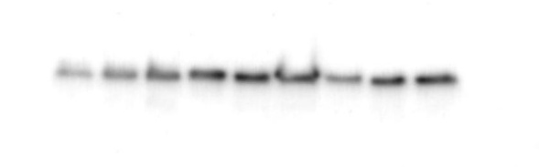
TGF-β _8W
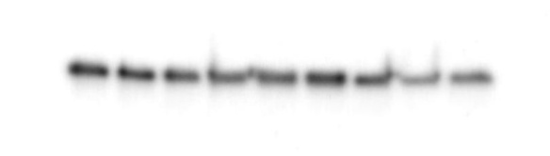
TGF-β _30W

NF-κB _8W
NF-κB _30W
TLR _8W
TLR _30W
GAPDH _8W
GAPDH _30W
Fig. S2. Original electrophoretic gels and blots with gel/membrane edges visible (cropped images presented in Supplementary Figure 6).

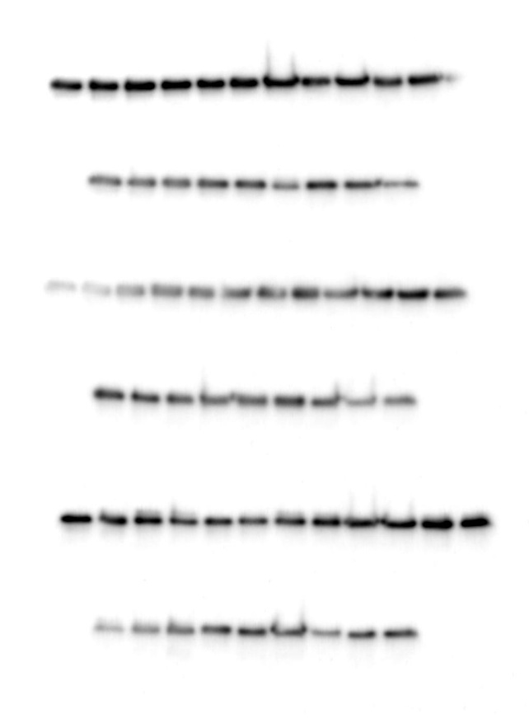
TGF-β _8W, 30W
NF-κB _8W, 30W
TLR _8W, 30W
GAPDH _8W, 30W
Fig. S3. Unprocessed Western blot images. This figure presents the unprocessed, native-resolution scans of the trimmed membrane sections used for Western blot analysis. Because membranes were cut prior to primary antibody incubation to isolate the molecular weight regions of interest, full-length scans of entire membranes are not available. The TIFF files were exported directly from the imaging system without cropping or selective enhancement

Fig. S4. Gross liver morphology from C57BL/6 mice fed with negative control, CDAHFD and CDAHFD+Multi-biotics. Typical features of fatty liver in terms of gross appearance are observed. The fatty liver appears yellow or light yellow in contrast to the normal dark brown color due to the accumulation of lipid in the liver. Additionally, in CDAHFD induced MASLD-related HCC (30 weeks) group, the edge of the fatty liver is blunt and friable.
Fig. S5. Body and Liver weights of CDAHFD-induced MASLD murine model
Fig. S6. Ballooning degeneration, large swollen hepatocytes with ballooning degeneration and Mallory bodies can be found (Yellow solid arrow) (H-E, ×400).
Fig. S7. Oil Red O staining of lipids in liver and quantitative analysis of SD, CDAHFD, and CDAHFD+Multi-biotics group. Dashed line; Tissue damage observed in the tissue during paraffin sectioning, and excluded from the analysis
Fig. S8. Biochemical parameters of early and late stage MASLD mouse model Abbreviations: NC, negative control; PC, positive control; Tx, Treatment group (CDAHFD+Multi-biotics)
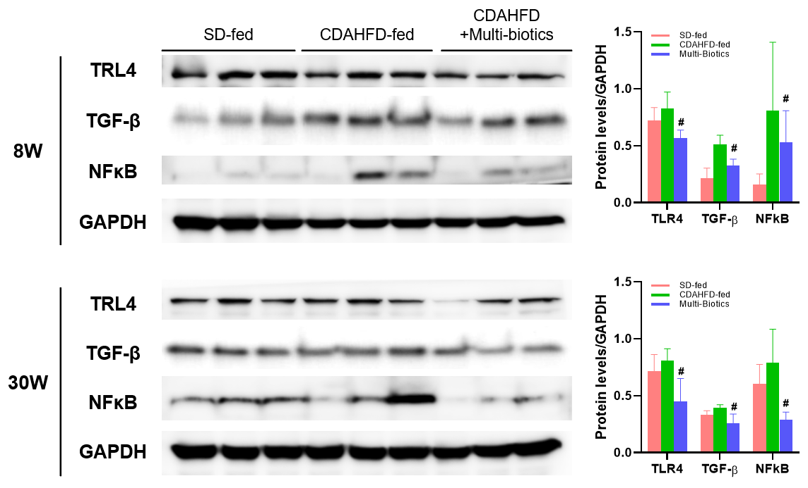
Fig. S9. Hepatic expression of cytokines by real-time RT-PCR and proteins by western blot. (A) Levels of interleukin (IL)-12, Monocyte chemoattractant protein-1 (MCP-1/CCL2) mRNA expression in the liver are significantly higher in the CDAHFD group than in the CDAHFD+Multi-biotics group in the early stages of MASLD model (8 weeks). (B) Western blot analysis of TLR4, TGF-β, and NF-κB protein expression in liver tissues from CDAHFD and CDAHFD+Multi-biotics groups at 8, 30 weeks. Protein levels were significantly reduced in the CDAHFD+Multi-biotics group compared to the CDAHFD group. * Significantly different from the negative control group (p < 0.05). # Significantly different from the positive control group (p < 0.05). # Original blots/gels are presented in Supplementary Figure 10.
Fig. S10. Venn diagram showing the overlap of upregulated and downregulated genes between SD-fed, CDAHFD and CDAHFD+Multi-biotics groups at 8 and 30 weeks. (A) upregulated at 8 weeks (B) downregulated at 8 weeks (C) upregulated at 30 weeks (D) downregulated at 30 weeks
Fig. S11. Metabolites profile as measured by metabolomics using liver tissues of the CDAHFD-induced late stage MASLD (30 weeks). Principal Component Analysis (PCA) score plot.
Supplementary Tables
Table. S1. Body and Liver weights of CDAHFD-induced MASLD murine model
Group | Weight (8W) |  |  | Weight (30W) |  |  | Nodule count
Group | Body (g) | Liver (g) | L/B ratio | Body (g) | Liver (g) | L/B ratio | Nodule count
Negative control (standard diet) | 28.7 | 1.85 | 0.06 | 38.1 | 1.73 | 0.05
Negative control (standard diet) | 26.7 | 1.78 | 0.07 | 34.8 | 2.12 | 0.06
Negative control (standard diet) | 29.6 | 1.75 | 0.06 | 41.6 | 2.05 | 0.05
Negative control (standard diet) | 32.1 | 1.41 | 0.04 | 33.9 | 1.45 | 0.04
Negative control (standard diet) | 25.2 | 1.23 | 0.05 | 39.7 | 1.86 | 0.05
Negative control (standard diet) | 29.6 | 1.50 | 0.05 | 36.3 | 1.57 | 0.04
Negative control (standard diet) | 27.4 | 1.32 | 0.05 | 40.4 | 1.83 | 0.05
Negative control (standard diet) | 27.7 | 1.41 | 0.05 | 40.7 | 1.92 | 0.05
Positive control (CDAHFD) | 24.0 | 2.07 | 0.09 | 35.0 | 2.76 | 0.08 | 7
Positive control (CDAHFD) | 23.3 | 1.90 | 0.08 | 31.5 | 2.46 | 0.08 | 6
Positive control (CDAHFD) | 21.3 | 1.36 | 0.06 | 32.0 | 2.61 | 0.08 | 17
Positive control (CDAHFD) | 21.9 | 1.57 | 0.07 | 31.0 | 2.84 | 0.09 | 20
Positive control (CDAHFD) | 21.5 | 1.26 | 0.06 | 31.7 | 2.56 | 0.08 | 9
Positive control (CDAHFD) | 23.1 | 1.82 | 0.08 | 30.8 | 2.67 | 0.09 | 10
Positive control (CDAHFD) | 22.5 | 1.81 | 0.08 | 33.3 | 3.13 | 0.09 | 3
Positive control (CDAHFD) | 23.1 | 1.95 | 0.08 | 34.8 | 2.87 | 0.08 | 14
Multi-biotics (CDAHFD+Multi-biotics) | 22.0 | 1.65 | 0.08 | 29.1 | 2.48 | 0.09 | 16
Multi-biotics (CDAHFD+Multi-biotics) | 22.4 | 1.40 | 0.06 | 30.8 | 2.72 | 0.09 | 18
Multi-biotics (CDAHFD+Multi-biotics) | 21.0 | 1.93 | 0.09 | 33.0 | 3.19 | 0.10 | 29
Multi-biotics (CDAHFD+Multi-biotics) | 23.1 | 1.58 | 0.07 | 30.1 | 2.67 | 0.09 | 16
Multi-biotics (CDAHFD+Multi-biotics) | 23.4 | 2.01 | 0.09 | 30.8 | 2.86 | 0.09 | 11
Multi-biotics (CDAHFD+Multi-biotics) | 23.6 | 1.82 | 0.08 | 34.6 | 2.83 | 0.08 | 7
Multi-biotics (CDAHFD+Multi-biotics) | 23.1 | 1.66 | 0.07 | 29.9 | 2.98 | 0.10 | 19
Multi-biotics (CDAHFD+Multi-biotics) | 22.7 | 1.73 | 0.08 | 31.9 | 2.42 | 0.08 | 16

Table. S2. Oil Red O staining of lipids in liver and quantitative analysis (%Area) * Tissue damage observed in the tissue during paraffin sectioning, and excluded from the analysis
Group | Quantification Oil-red O (%Area)
Group | 8W | 30W
Negative control (standard diet) | 0.43 | 7.36
Negative control (standard diet) | 0.69 | 0.92
Negative control (standard diet) | 0.82 | 2.66
Negative control (standard diet) | 0.60 | 1.00
Negative control (standard diet) | 0.28 | 3.70
Negative control (standard diet) | 0.83 | 0.29
Negative control (standard diet) | 0.19 | 5.49
Negative control (standard diet) | 0.71 | 0.31
Positive control (CDAHFD) | *16.01 | 51.47
Positive control (CDAHFD) | *24.84 | 48.21
Positive control (CDAHFD) | 35.52 | 50.85
Positive control (CDAHFD) | 36.05 | 33.70
Positive control (CDAHFD) | 35.64 | 35.93
Positive control (CDAHFD) | 36.43 | 39.55
Positive control (CDAHFD) | 33.54 | 44.98
Positive control (CDAHFD) | 29.19 | 44.76
Multi-biotics (CDAHFD+Multi-biotics) | 32.75 | 37.97
Multi-biotics (CDAHFD+Multi-biotics) | 30.02 | 39.46
Multi-biotics (CDAHFD+Multi-biotics) | 39.30 | 31.42
Multi-biotics (CDAHFD+Multi-biotics) | 42.88 | 30.44
Multi-biotics (CDAHFD+Multi-biotics) | 39.03 | 40.72
Multi-biotics (CDAHFD+Multi-biotics) | 43.33 | 39.88
Multi-biotics (CDAHFD+Multi-biotics) | 40.81 | 37.99
Multi-biotics (CDAHFD+Multi-biotics) | 41.71 | 29.50

Table. S3. Biochemical parameters of early and late stage MASLD mouse model
Group | Plasma markers (8W) |  |  |  |  | Plasma markers (30W)
Group | ALT | AST | ALP | TG | T-BIL | ALT | AST | ALP | TG | T-BIL
Negative control (standard diet) | 39 | 62 | 271 | 79 | 0.02 | 25 | 43 | 175 | 84 | 0.00
Negative control (standard diet) | 22 | 45 | 242 | 43 | 0.02 | 24 | 47 | 248 | 105 | 0.03
Negative control (standard diet) | 120 | 143 | 360 | 77 | 0.07 | 25 | 46 | 195 | 72 | 0.02
Negative control (standard diet) | 22 | 41 | 264 | 69 | 0.02 | 26 | 60 | 181 | 65 | 0.00
Negative control (standard diet) | 20 | 44 | 264 | 85 | 0.02 | 21 | 42 | 208 | 126 | -0.01
Negative control (standard diet) | 23 | 40 | 279 | 113 | 0.01 | 22 | 43 | 225 | 109 | 0.01
Negative control (standard diet) | 18 | 44 | 307 | 71 | 0.00 | 28 | 45 | 195 | 91 | -0.01
Negative control (standard diet) | 198 | 219 | 460 | 41 | 0.09 | 28 | 52 | 239 | 98 | -0.02
Positive control (CDAHFD) | 421 | 442 | 547 | 84 | 0.24 | 332 | 307 | 329 | 66 | 0.16
Positive control (CDAHFD) | 413 | 403 | 584 | 38 | 0.25
Positive control (CDAHFD) | 360 | 360 | 487 | 38 | 0.20 | 271 | 298 | 331 | 66 | 0.09
Positive control (CDAHFD) | 427 | 441 | 553 | 28 | 0.24 | 213 | 232 | 368 | 36 | 0.12
Positive control (CDAHFD) | 458 | 479 | 518 | 39 | 0.26 | 194 | 226 | 312
Positive control (CDAHFD) | 354 | 370 | 579 | 97 | 0.14 | 169 | 195 | 361 | 75 | 0.10
Positive control (CDAHFD) | 435 | 454 | 555 | 42 | 0.26 | 210 | 277 | 278 | 120 | 0.06
Positive control (CDAHFD) | 451 | 395 | 551 | 76 | 0.18 | 229 | 202 | 292 | 115 | 0.05
Multi-biotics (CDAHFD+Multi-biotics) | 437 | 478 | 564 | 40 | 0.24 | 262 | 315 | 338 | 68 | 0.10
Multi-biotics (CDAHFD+Multi-biotics) | 751 | 546 | 490 | 73 | 0.13 | 230 | 298 | 305 | 75 | 0.06
Multi-biotics (CDAHFD+Multi-biotics) | 488 | 509 | 629 | 91 | 0.17 | 173 | 323 | 395 | 134 | 0.04
Multi-biotics (CDAHFD+Multi-biotics) | 397 | 353 | 533 | 61 | 0.13 | 236 | 469
Multi-biotics (CDAHFD+Multi-biotics) | 358 | 374 | 538 | 64 | 0.19 | 126 | 183 | 484 | 28 | 0.08
Multi-biotics (CDAHFD+Multi-biotics) | 351 | 369 | 548 | 60 | 0.17 | 257 | 282 | 292 | 102 | 0.06
Multi-biotics (CDAHFD+Multi-biotics) | 304 | 299 | 645 | 63 | 0.11 | 228 | 672 | 385 | 74 | 0.15
Multi-biotics (CDAHFD+Multi-biotics) | 337 | 359 | 617 | 30 | 0.15 | 223 | 383 | 317 | 71 | 0.07

References
1 Kim, D. J. et al. Ursodeoxycholic acid exerts hepatoprotective effects by regulating amino acid, flavonoid, and fatty acid metabolic pathways. Metabolomics 15, 30, doi:10.1007/s11306-019-1494-5 (2019).
2 Kim, D. J. et al. Ursodeoxycholic acid improves liver function via phenylalanine/tyrosine pathway and microbiome remodelling in patients with liver dysfunction. Sci Rep 8, 11874, doi:10.1038/s41598-018-30349-1 (2018).

