Table1: Class-wise Performance Metrics of SafeRide Model
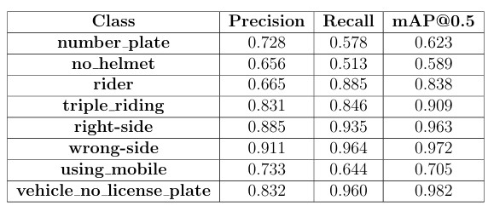

Table 2: Overall Model Performance Metrics
