Decoding local and global fNIRS patterns of kinesthetic and visual-motor imagery in a haptic interface paradigm

Robert Kwaśniak, Arkadiusz Ziółkowski Paweł Augustynowicz and Dariusz Zapała

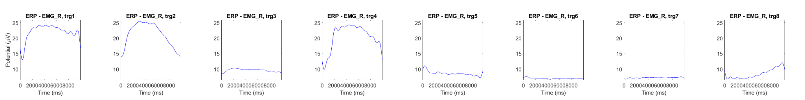

Fig 1. The graphs show muscle tension for both grip compression and imagery for the right hand, for KMI and VMI. The third graph shows muscle tension in uV during imagery for the KMI condition, and the seventh graph shows muscle tension in uV during imagery for the VMI condition.

