Supplemental files for
Spatial distribution of antibiotic resistance genes of the Zaohe-Weihe rivers, China: Exerting a bottleneck in the hyporheic zone
Siqi Shen ^{a,b,c}, Shengke Yang ^{a,b*}, Dan Zhang ^{a,b}, Yang Jia ^{a,b}, Fanfan Zhang ^{a,b}, Yanhua Wang ^{a,d}, Wenke Wang ^{a,b}

ª Key Laboratory of Subsurface Hydrology and Ecology in Arid Areas, Ministry of Education, Chang’an University, Xi’an 710054, China.
^{b} School of Water and Environment, Chang’an University, Xi’an 710054, China.
^{c} China United Northwest Institute for Engineering Design & Research Co.,Ltd.
^{d} School of Geography and Tourism, Shaanxi Normal University, Xi'an 710054, China.

* Corresponding Author:
Tel: +86-135-7200-5085
E-mail: ysk110@126.com

Number of pages: 11
Number of texts: 2
Number of figures: 4
Number of tables: 3
Contents:
Texts:
Text S1 Detail description of qPCR
Text S2 Sample properties in hyporheic zone
Figures:
Fig. S1 The physiochemical properties of groundwater in lateral
Fig. S2 The grain size distribution in sediments
Fig. S3 Distribution characteristics of TOC in sediments in sampling area
Fig. S4 Distribution characteristics of six metals in sediment.
Tables:
Table S1 The details of sampling sites
Table S2 The physiochemical properties of water samples
Table S3 Correlation analysis between MGEs (intI1 and tnpA) and ARGs

Text S1 Detail description of antibiotics treatment methods
The water sample (500 mL) used for antibiotic analysis was first filtered through a glass fiber filter (0.22μm), and then extracted on a solid-phase extraction (SPE) setup (CNWBOND Florisil) through preconditioned Oasis HLB cartridges (Waters, USA). All SPE cartridges are pretreated with methanol (5mL) and ultrapure water (5mL) in sequence. Before the extraction, the water samples were acidified to pH 5.0 by adding drops of 6 mol/L HCl, and then 0.8 g of Na₂EDTA was added as the chelating agent. After the extraction, methanol (5 mL) and dichloromethane (5 mL) were added in sequence to elute the antibiotics in the cartridge. The eluent was collected in brown glass vials and then evaporated to near dryness (approximately 20 μL) under a nitrogen purge. Finally, the concentrated eluent was diluted to a constant- volume of 1.0 mL using methanol. 100 mg sediment samples were loaded in a PTEE tube (50 mL), and were spiked with 50 ng of surrogate, and NaF (0.3 g) was also added as an ion exchanger. Then, 30 mL of extraction buffer (including 15 mL of methanol, 10 mL of citrate buffer and 5 mL of 0.1 M EDTA buffer) was added. The mixture was vortexed and sonicated for 20 min and centrifuged for 10 min at 5000 rpm to separate the solid and liquid phases. The liquid phase from each tube was transferred into a 500 mL glass bottle. All the liquid phases were diluted to 500 mL with ultrapure water. Then, the same SPE procedure previously described for water extraction was used.
Text S2 Detail description of qPCR
Quantitative Real-time PCR (qPCR) assays were carried out to quantify the presence of various antibiotics ARGs, MGEs and the bacterial 16S ribosomal RNA (rRNA) gene. All target genes were quantified by qPCR performed by utilizing StepOnePlus™ SYBR® (Thermo Scientific). The qPCR assays were performed in a reaction volume of 10 μL, and the reaction mixture was composed of 1×TB Green™ Premix Ex Taq™ II (Tli RNaseH Plus)(Takara，Code No. RR820A), 0.4 μM of each primer (Thermo Scientific), and 1 μL of DNA extract. Amplification was conducted with the StepOnePlus™ PCR (Thermo Scientific) using the temperature program of 30 s at 95 °C (initial denaturing and Hot Start Taq activation)，followed by 40 cycles of 5 s, 95 °C, 20 s at the annealing temperature and 20–35 s 60 °C (optical window on), followed by amplification curve analysis. The detection limit of cycles (CT) is 40 cycles.
Text S3 Sample properties in hyporheic zone
The physiochemical factors of all the water samples were shown in Table S2. the relative high concentrations of TOC, TN and COD were all found at S1 and S2, which may relate to the WWTP effluent and urban domestic waster. Taking S3 and S4 as an example, explored the attenuation law of pollutants in the lateral supply hyporheic zone. The three indicators still show the law of TOC>COD>TN in Fig. S1. From S4-1 to S4-6, only TN decreased from 11.1mg/L to 5.08mg/L, and the attenuation rate was 54.2%.
The results of grain size distribution (clay, silt and sand) was shown in Fig. S2, S0, S3 and S4 were mainly composed of sand while S1, S2 and S5 were mainly composed of clay and silt with few contributions of coarse sands (<10%). The distribution characteristics of TOC of sediments in the sampling area were shown in the Fig. S3. The TOC content in the sediments were 0.046%-0.151%, with an average value of 0.097%. Obviously, it can be seen that the high TOC content is mainly concentrated in S1, S2 and S5, which were 0.145%, 0.135% and 0.13% respectively. S1, S2, and S5 were mainly clay. The surface sediment of S4 was mainly sand and fine sand, and the TOC was relatively low, with an average of 0.06%. At lateral, the TOC of S1, S2, and S5 gradually decreased with the distance increase from the river bank while S3 and S4 increased with the distance from the river bank. The fine particle components carry more surface charges and have a larger specific surface area, which will adsorb more pollutants.

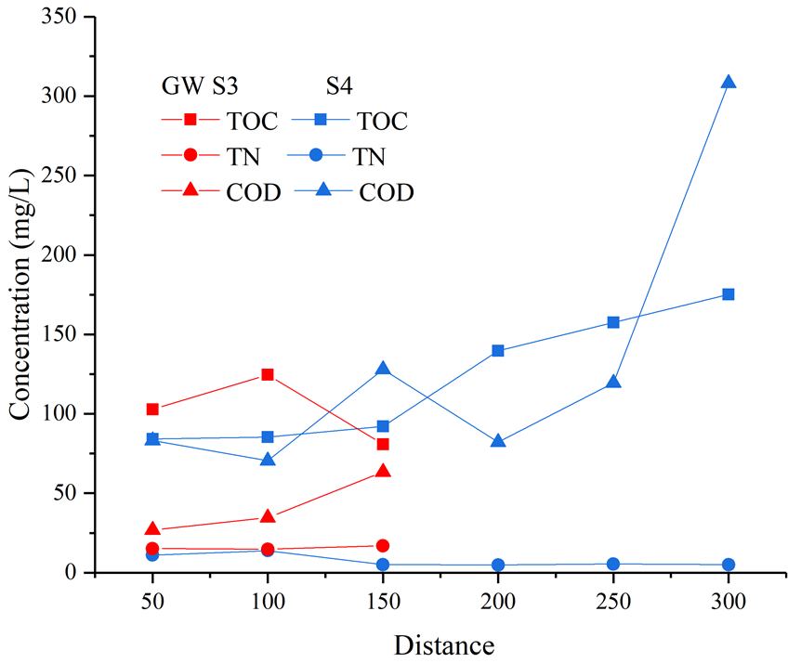
Fig. S1 The physiochemical properties of groundwater in lateral

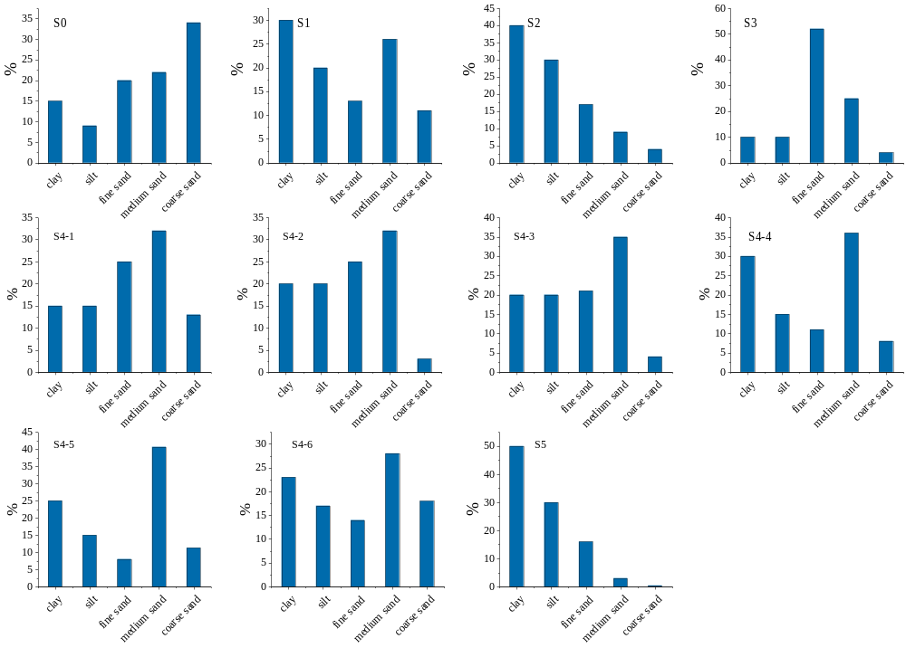
Fig. S2 The grain size distribution in sediments

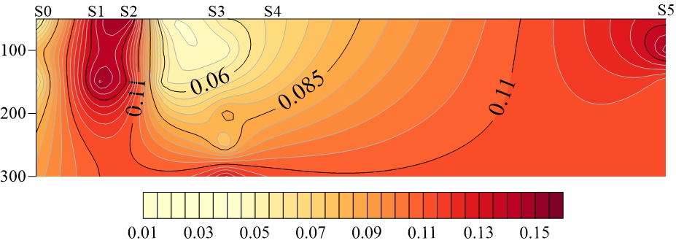
Fig. S3 The distribution characteristics of TOC in sediments in sampling area

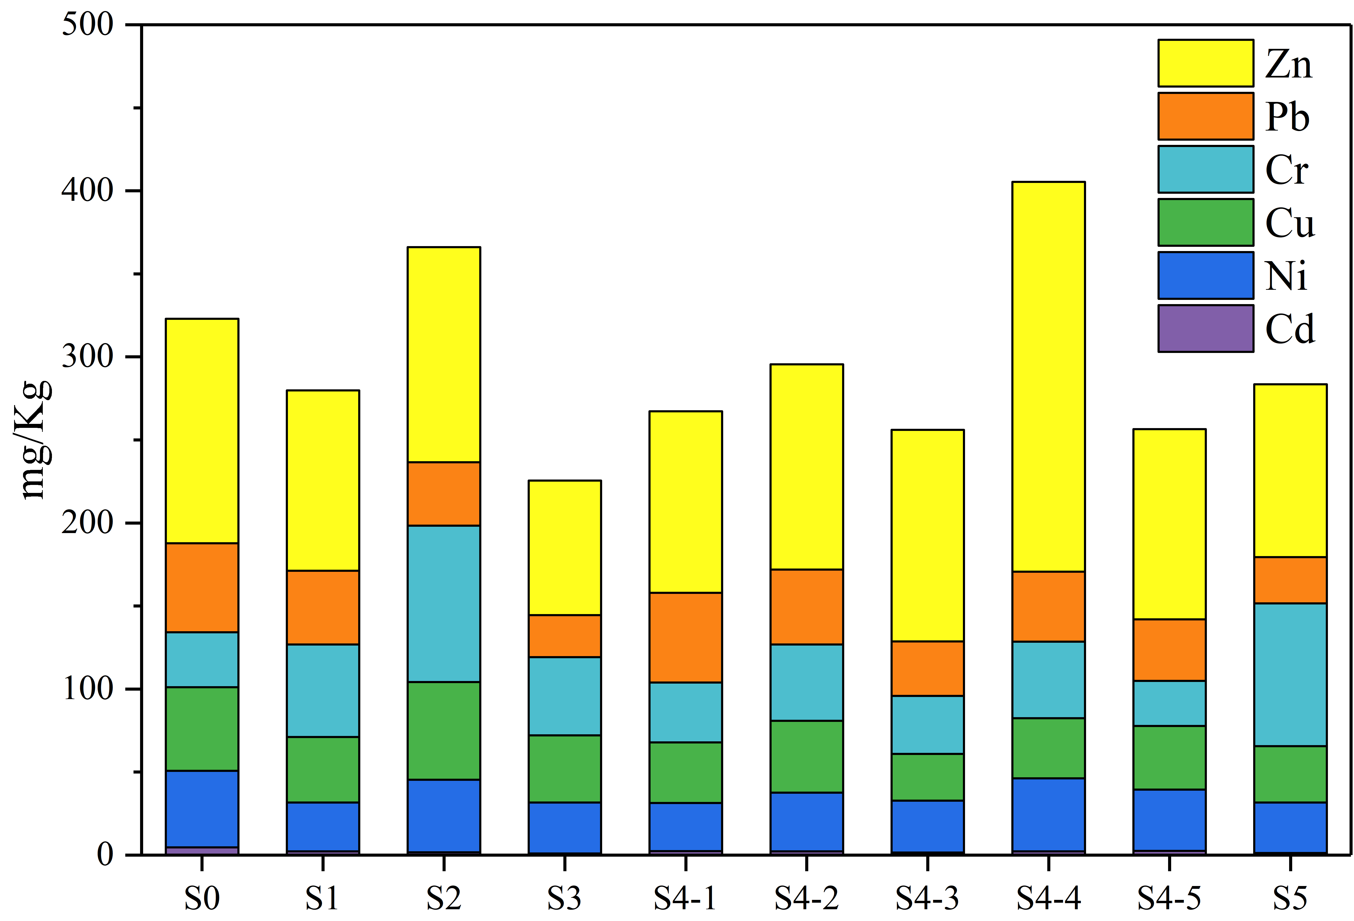
Fig. S4 Distribution characteristics of six metals in sediment.

TableS1 The details of sampling sites
Sampling sites | Latitude and longitude | Groundwater depth (m) | Sampling point information
S0 | N34°23′40″ E108°51′00″ | 0.3 | Background section
S1 | N34°23′15″ E108°51′15″ | 0.2 | Section before Zaohe River enters Weihe River
S2 | N34°23′21″ E108°51′25″ | 0.2 | Control section
S3 | N34°23′25″ E108°51′27″ | 0.1 | Cut section
S4-1 | N34°23′27″ E108°51′34″ | 0.1 | 50cm from the river bank
S4-2 | N34°23′27″ E108°51′34″ | 0.2 | 100cm from the river bank
S4-3 | N34°23′27″ E108°51′34″ | 0.2 | 150cm from the river bank
S4-4 | N34°23′27″ E108°51′34″ | 0.3 | 200cm from the river bank
S4-5 | N34°23′27″ E108°51′34″ | 0.4 | 250cm from the river bank
S4-6 | N34°23′27″ E108°51′34″ | 0.5 | 300cm from the river bank
S5 | N34°23′31″ E108°51′55″ | - | Cut section

Table S2 The physiochemical properties of water samples (mg/L)
Sampling sites |  | S0 | S1 | S2 | S3 | S4 | S5 | Mean
SW | pH | 7.5 | 7.11 | 7.3 | 6.2 | 6.7 | 6.5 | 6.88
SW | T | 12 | 17 | 19 | 18 | 20 | 16 | 17
SW | DO | 10 | 7 | 6 | 7 | 8 | 8 | 7.6
SW | COD | 29.34 | 59.75 | 120.51 | 48.22 | 62.29 | 52.32 | 62.07
SW | TOC | 55.50 | 79.44 | 74.33 | 76.84 | 79.93 | 84.84 | 75.15
SW | TN | 9.75 | 21.20 | 19.82 | 19.59 | 22.43 | 19.95 | 18.79
GW | pH | 7.1 | 6.8 | 6.77 | 6.2 | 6.5 | - | 6.67
GW | T | 9 | 12 | 13 | 12 | 14 | - | 12
GW | DO | 4 | 3 | 2 | 2 | 3 | - | 2.8
GW | COD | 56.71 | 106.32 | 55.25 | 63.31 | 83.25 | - | 72.96
GW | TOC | 67.94 | 102.46 | 121.50 | 102.78 | 84.07 | - | 95.75
GW | TN | 13.27 | 20.01 | 14.62 | 15.13 | 11.10 | - | 14.82

 | Samples |  | aac(6’)-Ib-3 | aadA-01 | aadA2-03 | blaOXA-1 | catB3 | msr(D) | mexF | sul1 | sul2 | tetG-02 | tetM-01 | tetX
intI1 | water | r | 0.561 | 0.842** | 0.540 | 0.846** | 0.475 | 0.556 | 0.041 | 0.787** | 0.919** | 0.626 | 0.602 | 0.729*
intI1 | water | p | 0.092 | 0.002 | 0.107 | 0.004 | 0.165 | 0.095 | 0.911 | 0.007 | 0.000 | 0.053 | 0.066 | 0.017
intI1 | sediment | r | 0.581 | 0.891* | 0.637 | -0.329 | 0.381 | 0.637 | 0.031 | 0.952** | 0.918** | 0.851* | 0.823* | 0.978**
intI1 | sediment | p | 0.226 | 0.017 | 0.248 | 0.671 | 0.527 | 0.247 | 0.954 | 0.003 | 0.010 | 0.032 | 0.044 | 0.004
intI1 | total | r | 0.402 | 0.582* | 0.375 | 0.130 | 0.211 | 0.435 | 0.056 | 0.880** | 0.821** | 0.641** | 0.423 | 0.679**
intI1 | total | p | 0.123 | 0.018 | 0.168 | 0.672 | 0.450 | 0.105 | 0.836 | 0.000 | 0.000 | 0.007 | 0.103 | 0.005
tnpA-03 | water | r | 0.147 | 0.306 | 0.937** | 0.857** | 0.532 | 0.506 | -0.228 | -0.073 | 0.799** | 0.648* | 0.977** | 0.768**
tnpA-03 | water | p | 0.631 | 0.268 | 0.000 | 0.000 | 0.092 | 0.112 | 0.453 | 0.805 | 0.001 | 0.023 | 0.000 | 0.001
tnpA-03 | sediment | r | 0.570 | 0.579 | 0.557 | 0.489 | 0.583 | 0.577 | 0.335 | 0.610 | 0.596 | 0.417 | 0.316 | 0.526
tnpA-03 | sediment | p | 0.109 | 0.102 | 0.194 | 0.325 | 0.224 | 0.134 | 0.378 | 0.081 | 0.090 | 0.304 | 0.408 | 0.181
tnpA-03 | total | r | 0.598** | 0.416* | 0.820** | 0.621** | 0.848** | 0.707** | -0.421 | 0.158 | 0.525* | 0.465* | 0.763** | 0.589**
tnpA-03 | total | p | 0.003 | 0.043 | 0.000 | 0.006 | 0.000 | 0.001 | 0.051 | 0.470 | 0.012 | 0.039 | 0.000 | 0.004
tnpA-04 | water | r | 0.224 | -0.250 | -0.156 | -0.315 | -0.136 | -0.118 | 0.350 | 0.356 | -0.337 | 0.219 | -0.050 | -0.360
tnpA-04 | water | p | 0.462 | 0.368 | 0.580 | 0.318 | 0.690 | 0.729 | 0.242 | 0.211 | 0.260 | 0.494 | 0.884 | 0.205
tnpA-04 | sediment | r | 0.759* | 0.675* | 0.435 | 0.601 | 0.519 | 0.272 | 0.625 | 0.673* | 0.728* | 0.715* | 0.351 | 0.578
tnpA-04 | sediment | p | 0.011 | 0.032 | 0.329 | 0.207 | 0.292 | 0.515 | 0.053 | 0.033 | 0.017 | 0.046 | 0.320 | 0.134
tnpA-04 | total | r | -0.024 | -0.124 | -0.209 | -0.286 | -0.335 | -0.300 | 0.528** | 0.342 | -0.085 | 0.032 | 0.036 | -0.186
tnpA-04 | total | p | 0.914 | 0.555 | 0.351 | 0.251 | 0.189 | 0.212 | 0.010 | 0.102 | 0.700 | 0.892 | 0.879 | 0.407
Table S3 Correlation analysis between MGEs (intI1 and tnpA) and ARGs
** p<0.01
* p<0.05

