sTable1
OCD (N=12)
Sex (% female) | 41.7 (n=5)
Age at implantation (in years) | 41.1±10.3
Y-BOCS at baseline | 31.9±5.4
MADRS at baseline | 17.4±9.3
Age at onset of illness (in years) | 15.0±4.4
Duration of illness (in years) | 25.1±10.9
Number of prior medications | 6.7±2.7
Demographic clinical characteristics for investigation of disease specific connectivities. Values are mean ± SD; MADRS = Montgomery Asberg Depression Rating Scale; Y-BOCS = Yale-Brown Obsessive Compulsive Scale

sTable2

cortico-subcortical (projection fibers).
OCD, right
/ | / | / | / | /
OCD, left
vlPFC-STN | 0.042509* | 1.785364 | 2.060626 | +

cortico-cortical (association fibers)
OCD, right
OFC - dmPFC | 0.002874* | 0.070413 | 3.076905 | +
dmPFC - (pre)motor | 0.005914* | 0.144895 | -2.829137 | -
dACC- (pre)motor | 0.038283* | 0.937938 | 2.107082 | +
OCD, left
OFC - (pre)motor | 0.045535* | 1.115605 | 2.031808 | +
dmPFC - (pre)motor | 0.023238* | 0.569325 | -2.314515 | -
dACC - dmPFC | 0.040420* | 0.990286 | 2.083707 | +

sTable: Disease specific connectivities for obsessive-compulsive disorder (OCD). P values and effect sizes.

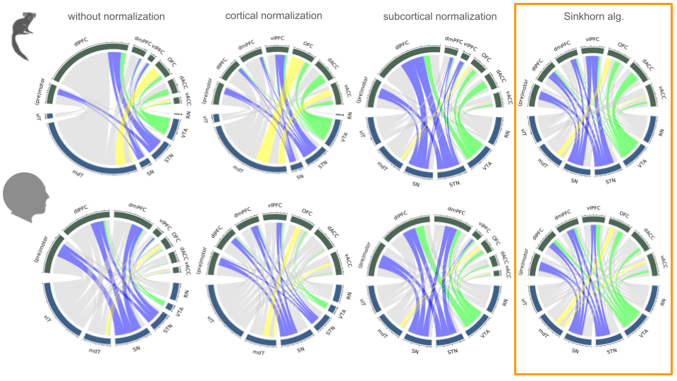
sFigure1: Different strategies for normalisation of cord-plots. Note the amount of similarity achieved with bilateral adjustment to subcortical and cortical fibers - according to the Sinkhorn principle - despite different tracking technologies being taken (marmoset, AAvATT vs. human, HCP DTI-FT).

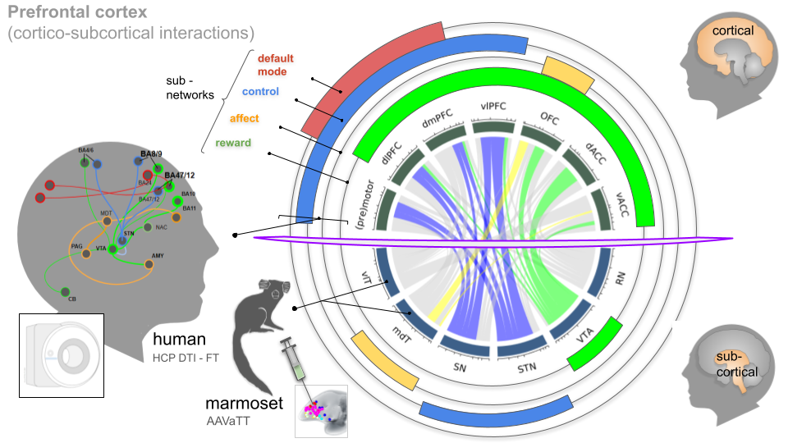

sFigure2: Qualitative comparison of sub-network contributions between marmoset (cord-plot, center) and human (orbitals). The purple equator separates cortical and subcortical territories.

