Supplementary Material

Title of the article: Establishment of a Gene Expression Signature for Colitis-Associated Colorectal Cancer to Assess Cancer-Promoting Effects of Standard IBD Treatments
Authors: Sarah Pashapour, Nesa Kazemifard
Corresponding Authors: Shaghayegh Baradaran Ghavami¹, Mohammad Kazemi²
¹ Department of Genetics and Molecular Biology, School of Medicine, Isfahan University of Medical Sciences, Isfahan, Iran
² Basic and Molecular Epidemiology of Gastrointestinal Disorders Research Center Research Institute for Gastroenterology and Liver Diseases, Shahid Beheshti University of Medical Sciences Tehran Iran.

Supplementary Method
Selected datasets underwent quality control analysis using R packages ggplot2 and grid to perform principal component analysis (PCA). After merging datasets, the final merged dataset included 87 controls, 161 UC, 137 CRC and 11 CAC samples.
Supplementary Result
After merging datasets, the final merged dataset included 87 controls, 161 UC, 137 CRC and 11 CAC samples.
Supplementary Figure S1
Title: PCA provided by R software
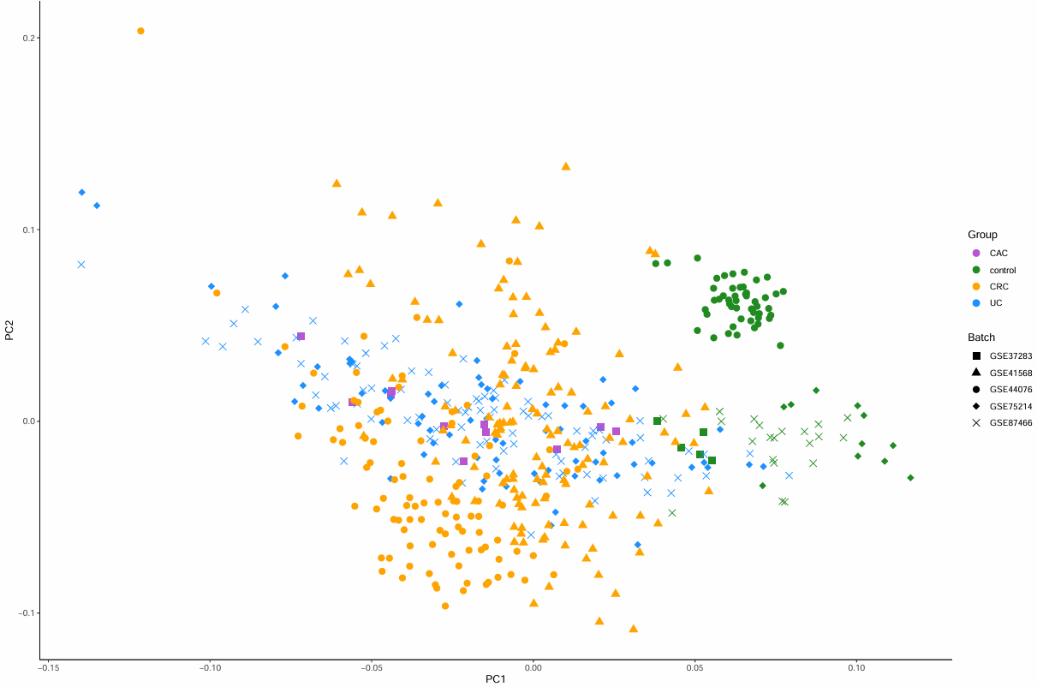
Legend: Colors mention disease groups and shape of the samples are indication of different batches. As presented in the plot, after applied batch correction, samples are divided by their disease. Ovels around samples of each disease are for more clearance of division.

Supplementary Notes
Scripts used for data analysis are available from the corresponding author upon reasonable request.

