Supplementary Methods
- Plant material
Genome Assembly and Annotation: Clones of “Bad Astra” and “1JHW” were produced by division of crowns dug from field nurseries and moved to a greenhouse at TLI in Salina, Kansas, USA where the subsequent pollination and hybrid evaluation also took place. All plants were grown in peat-based potting medium supplemented with 5 g/pot Osmocote fertilizer and sub-irrigated every other day or as needed to maintain plant health. Additional slow-release Osmocote pellets were pressed into the potting medium as needed to maintain deep green foliage. Silphium is strongly self-incompatible but selfing was further minimized by spraying the pollen-recipient’s heads with water after pollen production in late morning (new florets undergo anthesis each day) and allowing heads to dry before manually applying freshly harvested pollen from the pollen donor to the stigmas of the recipient’s ray florets. Several F1 seeds were obtained and germinated in July after cold-moist stratification for 4 weeks. Seedlings were grown in 1-gallon pots in the greenhouse until early September when they were placed in a 5 C vernalization chamber for 6 weeks and then returned to the greenhouse. By mid-December 2020, hybrids were bolting (producing a stalk for the first time). The individual F1 hybrid “3ZZP” was selected because it was vigorous and produced a stalk with squircle cross-sectional shape clearly intermediate between the square/astroid shape of S. perfoliatum and the terete/circle shape of S. integrifolium and placed in darkness at room temperature for 2 weeks. There was concern that chlorophyll and secondary metabolites could interfere with the extraction of high molecular weight DNA, therefore, young, dark-grown leaves were flash frozen in liquid nitrogen for DNA extraction. Young leaves from the parents were also flash frozen, but without the dark treatment. The plants were returned to the greenhouse to develop further. About a year later, the interspecific hybrid 3ZZP had produced multiple stalks and heads at various stages of development. Different plant organs were harvested into liquid nitrogen for RNA extraction.

Silphium Association Panel (SAP): In early March 2024, the dormant crowns of the genets in the Silphium association panel were dug, washed, and divided into 5 or more clonal replicates of each genet at TLI. Crown pieces were stored in sealed plastic bags and refrigerated prior to shipping to the HudsonAlpha in Huntsville, Alabama. for planting. There, the root crowns were planted in 4" Square Extra Deep Landmark Nursery Pots with the FoxFarm K-9 Cube potting soil and grown for 2 weeks in a greenhouse and then transferred to the field on April 19, 2024. Soil was prepared with a cultivator and fertilizer (NPK 10-10-10) at 50 Kg ha⁻¹ was applied based on soil testing. Individual plants were spaced at 0.9 m within rows and 2 m between rows. In Salina, KS, root crown pieces were planted in 1-gallon plastic pots filled with potting medium (described above) and grown outside with daily watering. On May 24, 2024, using a mechanized auger, 25 cm diameter holes were drilled in a mowed hay meadow on the campus of The Land Institute. The meadow had been planted to smooth brome (Bromus inermis) long ago but has been invaded by native prairie forbs and grasses. Holes were spaced at 0.9 m within rows and 2.1 m between rows. Plants were transplanted to the holes along with 4 osmocote pellets and hand watered.

Supplementary figures
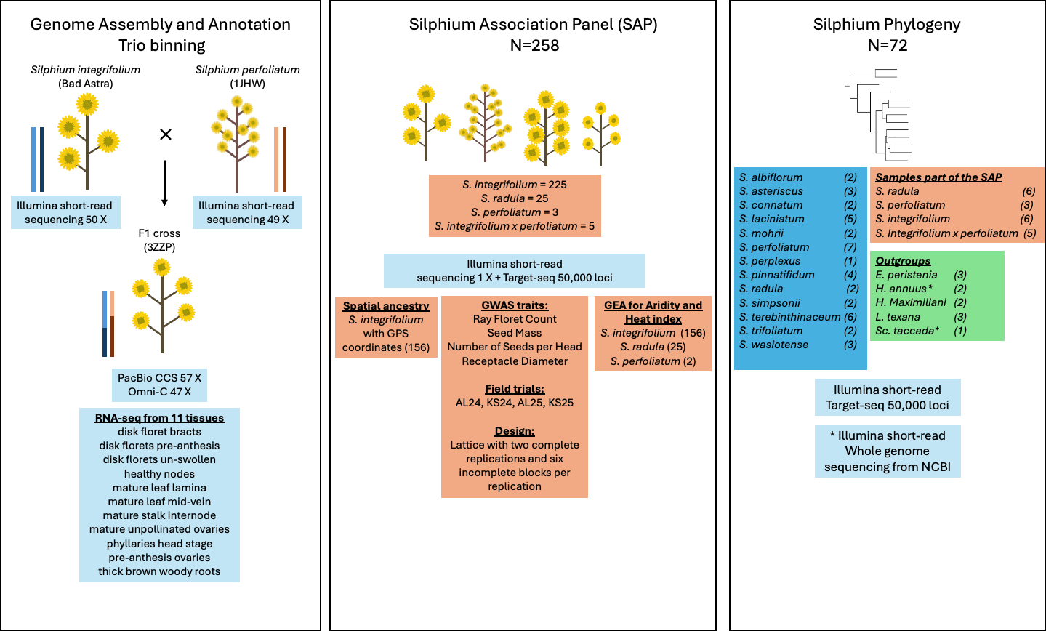Figure S1. Summary of populations, experimental design and data used in this research.

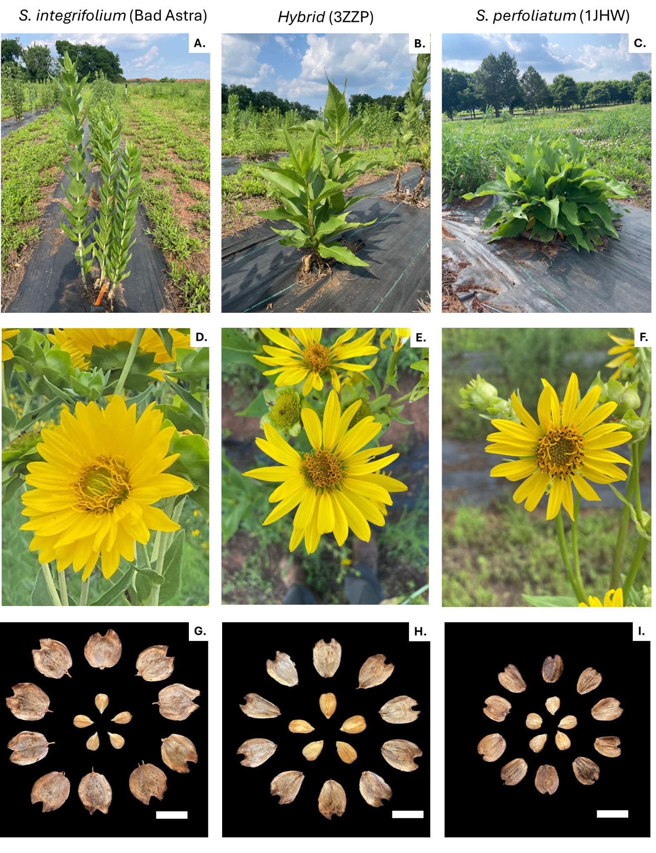Figure S2. Image of the genets sequenced for the genome assembly. A. Bad Astra is the female parent and B. 3ZZP is the hybrid and C. is the male parent 1JHW in the interspecific cross. (Images A, B and C were taken on June 2, 2025, in Huntsville -AL). Capitulum of Bad Astra (D), 3ZZP (E) and 1JHW (F). Whole seeds and kernels collected from open pollinated Bad Astra (G), 3ZZP (H) and 1JHW(I). The scale bar in G, H and I is 1 cm.

Figure S3. GenomeScope 2.0 k-mer profile for S. integrifolium (Bad astra) (A) and for S. perfoliatum (1JWH) (B). K-mer counting performed with Jellyfish on Illumina short-read data and k-mer size =21. (C) S. integrifolium and (D) S. perfoliatum smudgeplot version 0.4.

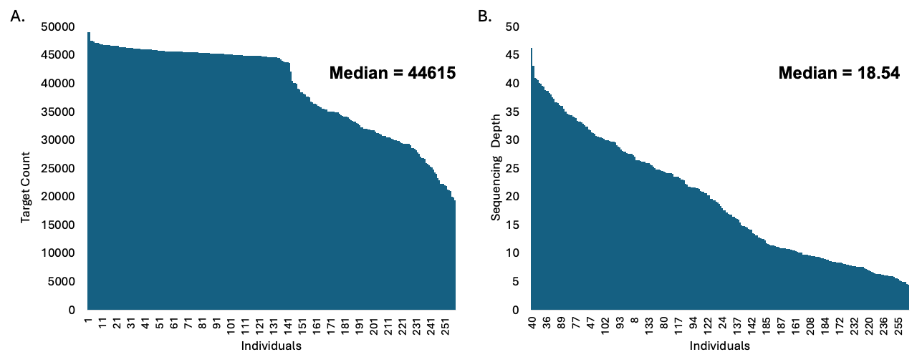Figure S4. Summary of the target-sequencing with the Silphium50K panel in the SAP (n=258). A. Number of targets obtained for each accession. B. Median sequencing depth on target across the accessions in the SAP.

Figure S5. A. SNP density across the seven chromosomes (449554 SNPs). B. Linkage Disequilibrium decay between neighbor markers. C. Histogram of observed heterozygosity of markers across the 258 individuals.

Figure S6. Aridity and heat index maps with 183 georeferenced sites. A. For aridity, lower values in red indicate dryer environments and higher values in blue indicates more humid environments. B. For heat index, higher temperatures are in red and colder temperatures are in blue.

Figure S7. S. integrifolium and S. perfoliatum chloroplast gene structure.

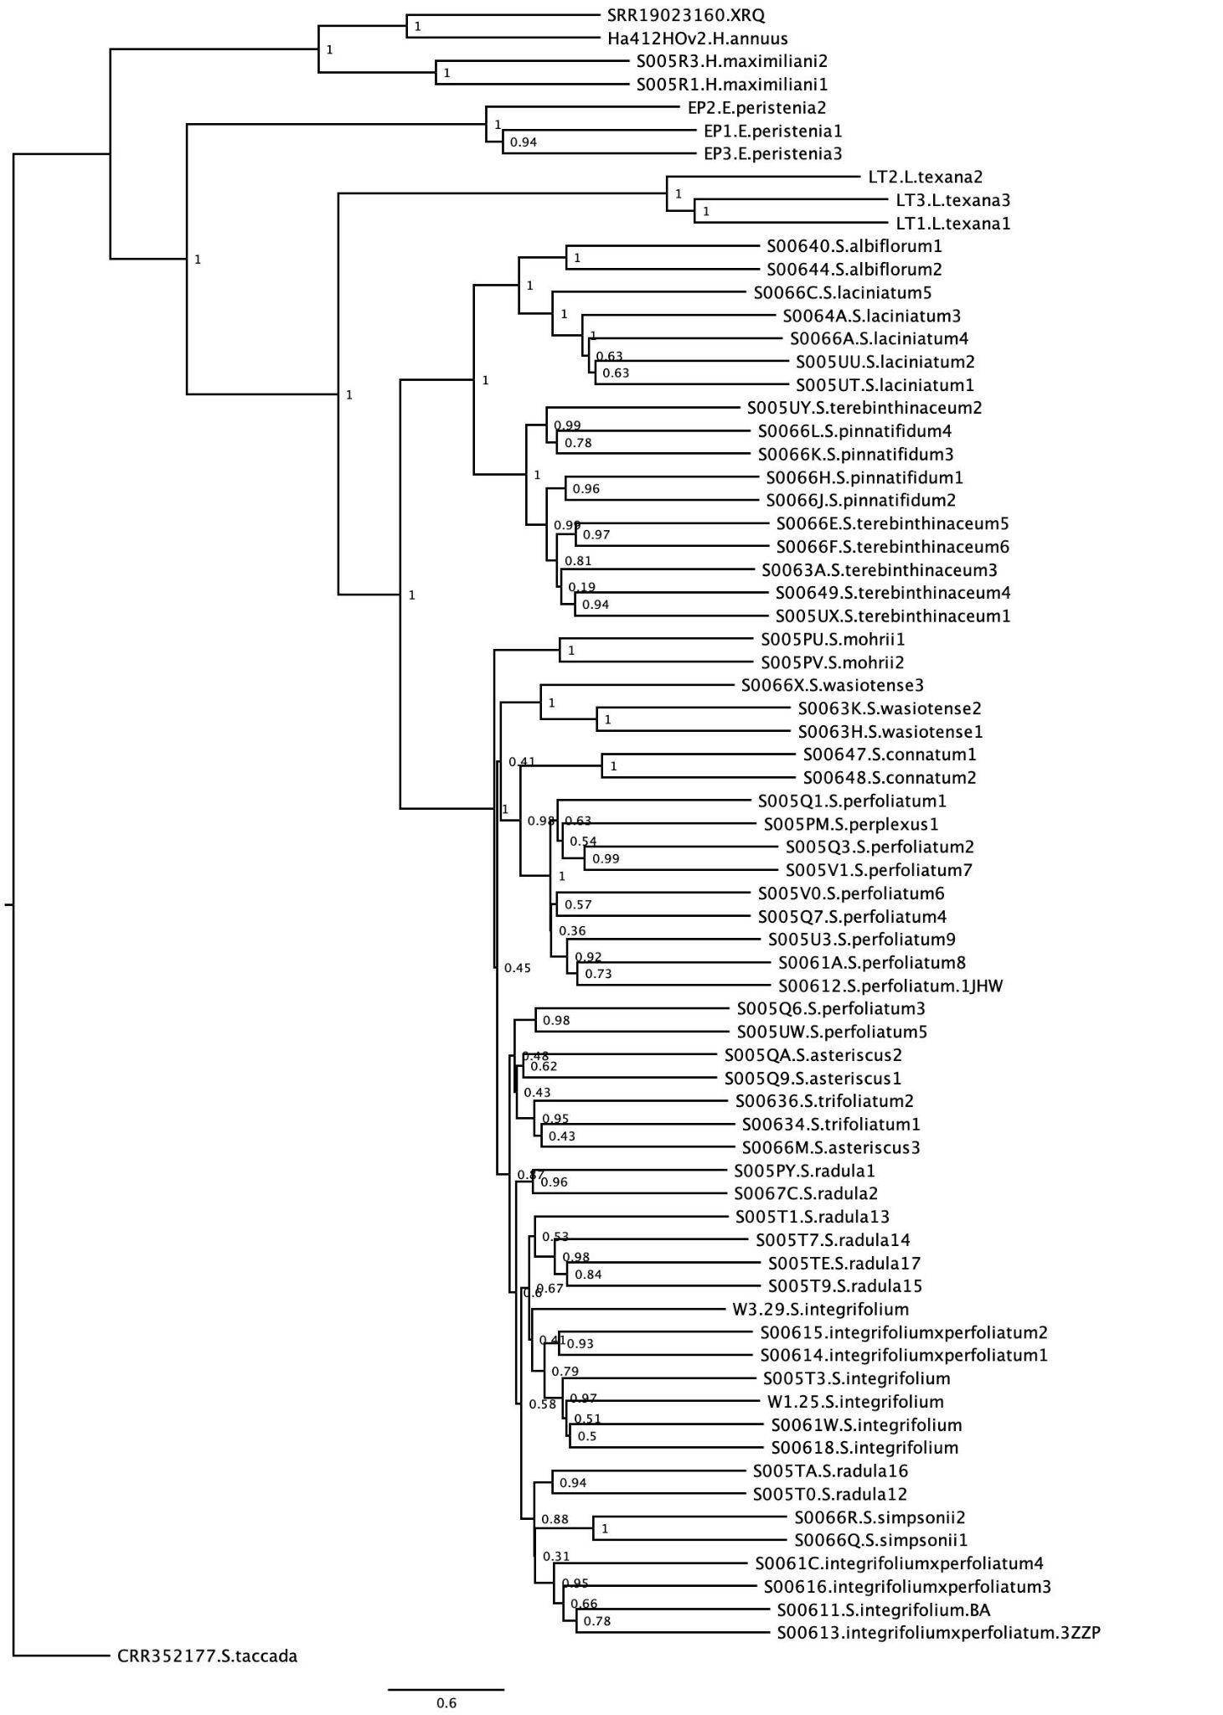Figure S8. Phylogeny of Silphium based on 789 nuclear loci.
Figure S9. A. Individual ancestry coefficients estimated for 156 S. integrifolium with K ancestral populations ranging from 2 to 5. B. Cross validation score as a function of the number of populations K (ranging from 1 to 8).

Figure S10. Pearson correlation among environmental indexes and phenotypic traits. Phenotypic correlation calculated based on the raw values across each environment. Only correlations with significance p<0.001 are shown. Abbreviations: AL–Alabama; KS– Kansas; 24–2024; 25–2025; AI–Aridity Index; HI–Heat Index; RFC-Ray Floret Count, RD–Receptacle Diameter; SM–Seed Mass; SNC–Seed Number Count.

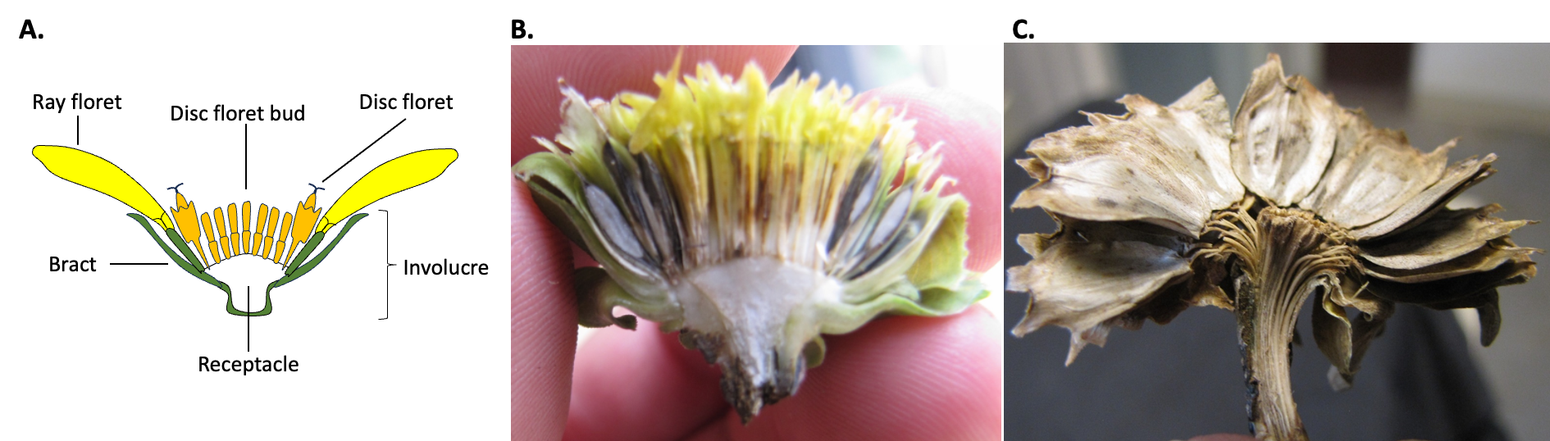Figure S11. A. Silphium capitulum structure. B. Cross section of the capitulum at stage 6 showing the seeds developing in the outer ring of ray florets and C. mature seed head.

Figure S12. Performance of all the genets in the SAP across the different environments. Environmental mean is indicated with the black line. Abbreviations: al–Alabama; ks– Kansas; 24–2024; 25–2025

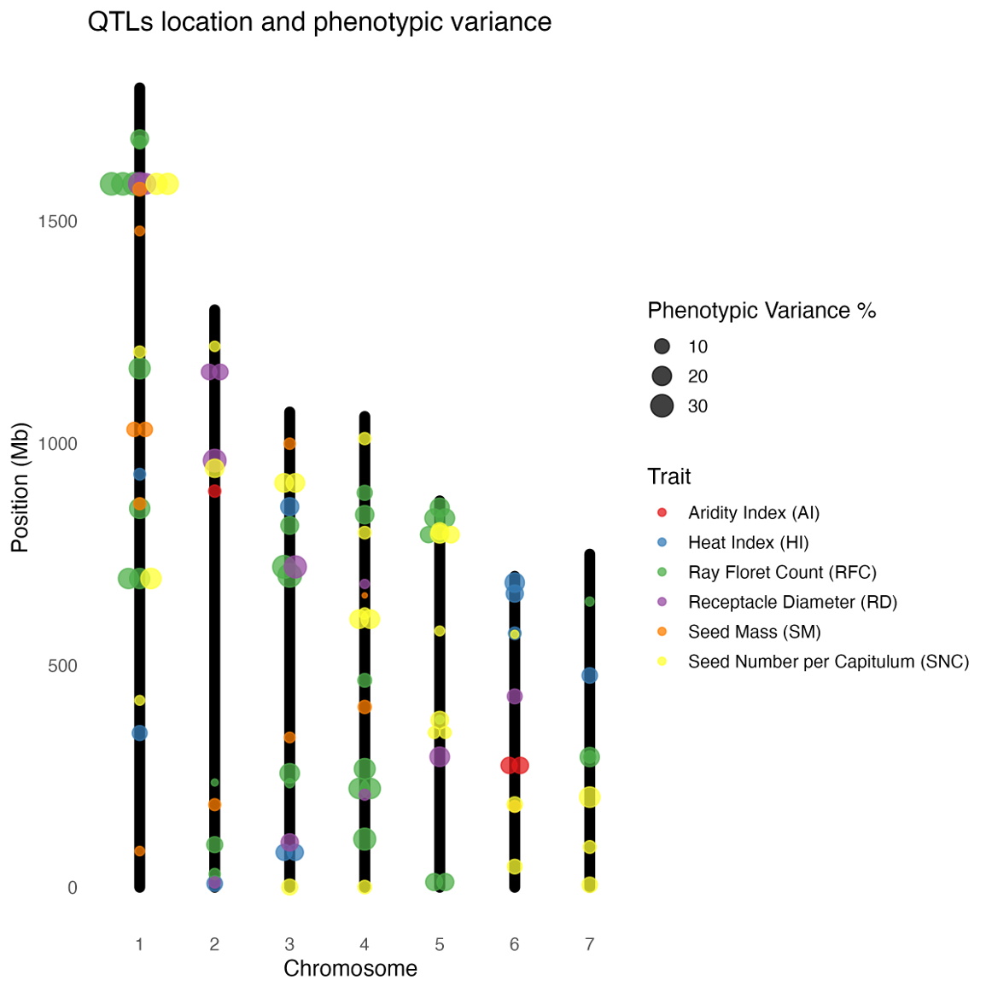
Figure S13. Position of the 81 QTLs identified with more than 1% of the phenotypic variance.

Figure S14. GWAS results for ray floret count (RFC) for the two models (BLINK and FarmCPU) for the four environments (AL24, KS24, AL25, KS25) and the combination of environments.

Figure S15. GWAS results for seed mass (SM) for the two models (BLINK and FarmCPU) for the four environments (AL24, KS24, AL25, KS25) and the combination of environments.

Figure S16. GWAS results for receptacle diameter (RD) for the two models (BLINK and FarmCPU) in the environments (AL25, KS25) and the combination of environments.

Figure S17. GWAS results for seed number per capitulum (SNC) for the two models (BLINK and FarmCPU) in the environments (AL25, KS25) and the combination of environments.

Figure S18. GEA results for aridity index for the two models (BLINK and FarmCPU).

Figure S19. GEA results for heat index for the two models (BLINK and FarmCPU).

Supplementary Tables

Table S1. Silphium development scale used in this study.
Stage | Name | Description | Image
1 | Rosette | First stage that all expanded leaves are leaning away from the center | 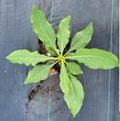
2 | Bolting | First sign of shoot apex above ground | 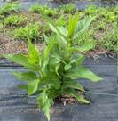
3 | Capitulum | Hard round bud can be seen | 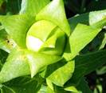
4 | Ligules | First ligules of ray florets visible; usually flattened | 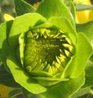
5 | Anthesis | Anthesis of first floret in capitulum | 
6 | Corolla Senescence | First ligules wither, drop or discolor | 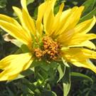
7 | Capitulum maturation | Seeds noticeably swelling; white stylar-remains/scar of each seed visible; capitulum mostly green | 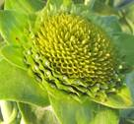
8 | Shattering | Fruits dehisce as the vascular bundles connecting them to the head weaken and break | 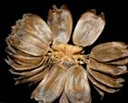
Table S2. List of traits and environment of evaluation.
Traits | Acronym | Unit | AL24 | KS24 | AL25 | KS25
ray_floret_count | RFC | Count | X | X | X | X
seed_mass | SM | Average mass of 20 seeds in milligrams | X | X | X | X
seed_number_per_capitulum | SNC | Seed count per head |  |  | X | X
receptacle_diameter | RD | Diameter of the largest receptacle |  |  | X | X
Aridity index | AI | Index
Heat index mean | HI | Index

Table S3. Variance components and heritability of traits measured in the Silphium Association Panel (SAP) N=258.
Component | Ray floret count (RFC) | Average seed mass (SM) | Seed number per capitulum (SNC) | Receptacle diameter (RD)
Genotype | 62.84*** | 17.16*** | 56.07*** | 1.88***
G x E | 10.67*** | 5.01*** | 16.98*** | 0.31**
Environment | 9.48*** | 2.69*** | 0 | 0.03**
Replication | 0 | 0.13* | 0.01 | 0
Residual | 21.98 | 12.31 | 44.16 | 1.3
Heritability | 0.92 | 0.86 | 0.74 | 0.80
Note: Significance calculated with an ANOVA-Type Estimation of Mixed Models
*** Indicates the significance at a probability level of 0.001.

