Disagreement between anterior segment optical coherence tomography devices in eyes with a shallow anterior chamber
Journal name: International Ophthalmology
Bruno L. B. Esporcatte MD PhD, Arthur F. Brun MD, Norton S. Yanagimori MD, Luiz Alberto S. Melo Jr MD PhD, Roberto M. Vessani MD PhD, Guilherme H. Bufarah MD, Norma Allemann MD PhD, Ivan Maynart Tavares MD PhD
Authors’ affiliation: Department of Ophthalmology and Visual Sciences, Paulista School of Medicine, Federal University of Sao Paulo, São Paulo – SP, Brazil
Corresponding author: Ivan Maynart Tavares, MD
E-mail: im.tavares@unifesp.br

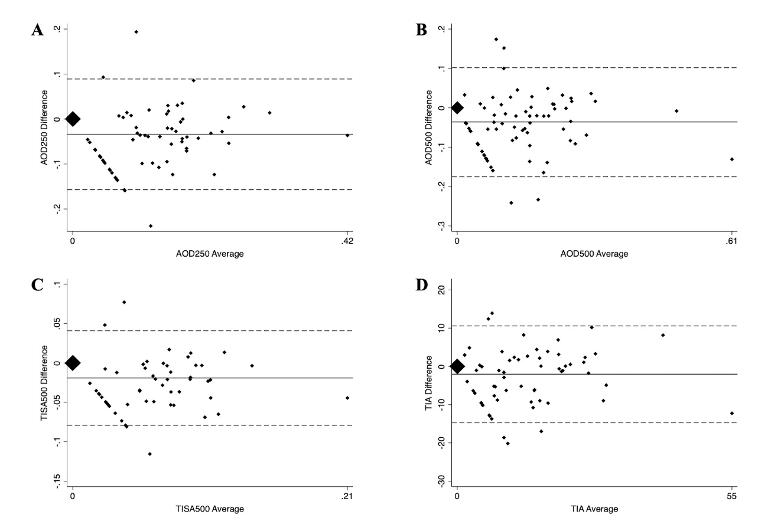
Supplemental fig. 1 Angle-related parameters: A (AOD250), B (AOD500), C (TISA500), and D (TIA). Legend: AOD250 and AOD500 = angle opening distance at 250 μm and 500 μm; TISA500 = trabecular–iris space area at 500 μm; TIA = trabecular–iris angle.
Note: In all graphs, the data are distributed according to the difference between the measurements obtained with the two devices (y-axis: Visante® OCT – DRI OCT Triton®) and the mean of the values obtained (x-axis). The larger diamond represents patients for whom both devices assigned a value of zero to the variable. The solid line represents the mean difference between measurements and the dashed lines represent the limits of agreement

