Extended Data

Extended methods
Serum hormone quantification in UCSB HAS (menopause cohort):
All participants fasted for 8 hours before a morning venous blood draw. Women who were still menstruating were scheduled in the early follicular phase (day 3–5) of their menstrual cycle, pursuant to subject report.
Serum was analyzed for six gonadotropin and sex steroid hormones: follicle-stimulating hormone (FSH), 17β-estradiol, progesterone, sex-hormone binding globulin (SHBG), dehydroepiandrosterone sulfate (DHEAS), and testosterone at the Brigham and Women’s Hospital Research Assay Core. 17β-estradiol, progesterone, and testosterone were determined by liquid chromatography mass-spectrometry, and FSH, SHBG, and DHEAS by chemiluminescent immunoassay (Beckman Coulter). Assay sensitivities, dynamic range, and intra-assay coefficients of variation (respectively) were as follows: estradiol, 1 pg/mL, 1–500 pg/mL, <5% relative standard deviation (RSD); progesterone, 0.05 ng/mL, 0.05–10 ng/mL, 9.33% RSD; testosterone, 1.0 ng/dL, 1–2000 ng/dL, <4% RSD; FSH, 0.2 mIU/mL, 0.2–200 mIU/mL, 3.1-4.3%; SHBG, 0.33 nmol/L, 0.33-200 nmol/L, 4.5–4.8%; DHEAS, 2 ug/dL, 2–1000 ug/dL, 1.6–8.3%.
All 6 hormones were measured in women, and the latter three were measured in men. Hormone levels were log-transformed and expressed in standard deviations to aid interpretability.
Blood proteomics:
Serum/plasma was analyzed on the NULISAseq CNS panel (~120 proteins) using the automated Alamar Argo HT workflow to generate immunocomplexes tagged with both sample-specific and target-specific DNA barcodes. Samples were pooled into a single library for next-generation DNA sequencing. Protein concentrations are reported in NULISA Protein Quantification (NPQ) units, which are computed by normalizing the relative concentration of each analyte using internal and inter-plate controls and log₂-transforming the normalized values. Given that APOE4 protein expression proxies APOE4 genotype (bimodal distribution), we excluded APOE4 from proteomics analyses. Protein concentrations were winsorized at the three-interquartile limit.
Determining amyloid positivity in UCSF BrANCH (aging cohort 2):
Plasma p-tau181/Aβ42 was assayed on Simoa (Quanterix) across three batches in the broader BrANCH cohort (1,266 samples across N=664 participants). Batch effects were quantified via linear regression on samples shared across batches, with model estimates subsequently applied to all samples to align cross-batch values on the same scale. Amyloid positivity was determined using a sample-specific, batch-harmonized p-tau181/Aβ42 threshold that optimized classification of visually read Aβ-PET 18F-AV45 positivity in the broader BrANCH cohort (AUC=0.88).

AD biomarkers in WRAP (aging cohort 1):
Plasma p-tau217/Aβ42 was measured on the Lumipulse G System (Fujirebio) at the Michael T. Zuendel Biomarker Laboratory at Banner Sun Health Research Institute.
Cognitive composite scores in aging cohorts:
WRAP (aging cohort 1): Composite cognitive scores were calculated by averaging sample-based z-scores on tests for memory (Rey Auditory Verbal Learning Test total learning and delayed recall, Logical Memory IA and IIA) and executive function (Trail Making Test Part B, Weschler Adult Intelligence Scale–Digit Symbol Substitution Test, and Animal fluency), respectively.
BrANCH (aging cohort 2): Domain-specific cognitive scores were computed by averaging sample-based z-scores for memory (Benson Figure Recall and California Verbal Learning Test II immediate recall, delayed recall, and discrimination index) and executive function (Stroop interference, modified Trail Making Test, phonemic fluency, and Digit Span Backwards).
Cross-cohort, cross-platform validation in UK Biobank:
The UK Biobank is a population-based prospective cohort study with multi-omics and clinical data on approximately 500,000 participants aged 40-69 years. The UKB-PPP consortium generated proximity extension assay (PEA) Olink plasma proteomics data on a subset participants’ baseline samples, resulting in up to 2,923 protein measurements from 52,995 participants in the post-UKB-PPP quality control dataset. Of these, N=17,487 female participants reported being postmenopausal at baseline (answered “yes” to "Have you had your menopause (periods stopped)?"), and N=6,542 female participants reported not being postmenopausal at baseline (answered “no”; N=3,272 with hysterectomy and N=1,231 not sure/prefer not to answer excluded). Of the resultant sample of N=24,029 pre- and postmenopausal women, we further restricted to participants who reported no history of bilateral oophorectomy (N=22,809; N=1,220 excluded), no current use of menopausal hormone therapy (N=21,910; N=899 excluded); and were aged 45-60 at the time of the Olink blood draw to more closely mirror the UCSB HAS sample (N=10,926 [N=3,789 premenopausal, N=7,137 postmenopausal]; N=10,984 excluded).
To mitigate the confound between age and menopause status, we created age-matched samples of pre- and postmenopausal women (R “MatchIt” package). Pre- and postmenopausal women were matched with a 1:1 ratio using nearest-neighbour matching without replacement and a 0.05 SD caliper. This resulted in a sample of N=1,407 premenopausal women and N=1,407 postmenopausal women who were nearly exactly matched on age (Figure 6A, Table S10), which was used for all downstream proteomics analyses.
PC1 in aging cohorts:
Because one protein (BDNF) in the original score was not included in the NULISA assays performed in WRAP, we recomputed PC1 in the spontaneous menopause cohort after removing BDNF and applied these weightings in WRAP. Loadings for the remaining shared proteins among the two versions were very similar (Figure S1). BrANCH included the full menopause signature score.
Sensitivity analyses:
To further address the possibility that menopause proteomic differences are driven by chronological (vs. endocrine) aging, we performed sensitivity analyses repeating models in a subsample of participants with a tightly restricted age range (i.e., 47–53; N=54 total; N=17 pre-, N=22 peri-, N=15 post-menopausal). These analyses yielded very similar findings to the main results (Figure S5, Table S12), suggesting the observed proteomic differences between menopause groups were not substantially confounded by chronological age. In aging cohorts, we performed additional sensitivity analyses re-estimating models after excluding participants who self-reported a history of bilateral oophorectomy (N=3 WRAP, N=19 BrANCH), which also produced similar findings (Tables S13-16). Additionally, given plasma p-tau is represented as both a predictor of interest (i.e., p-tau231 from PC1) and a marker of AD pathobiology related to a primary outcome (i.e., orthogonal plasma p-tau/Aβ42 ratios), we computed an alternate version of the menopause signature excluding p-tau231 (Figure S1). Analyses yielded a very similar pattern of results to the main analyses excluding ptau231, though as expected, effect sizes for p-tau/Aβ42 were mildly attenuated (Table S17). Finally, in the UKB, we re-ran differential abundance analyses additionally adjusting for factors that systematically differed between pre- and postmenopausal women (i.e., years of education, history of hormone therapy use, current hormonal contraceptive use), which yielded highly consistent findings to the main analyses (Figure S6).

Figure S1. Comparison of PC1 loadings with and without inclusion of BDNF and p-tau231.

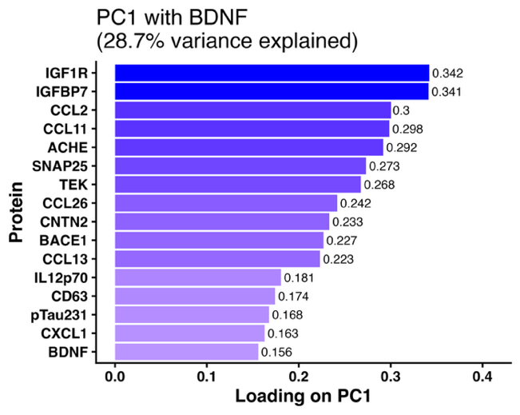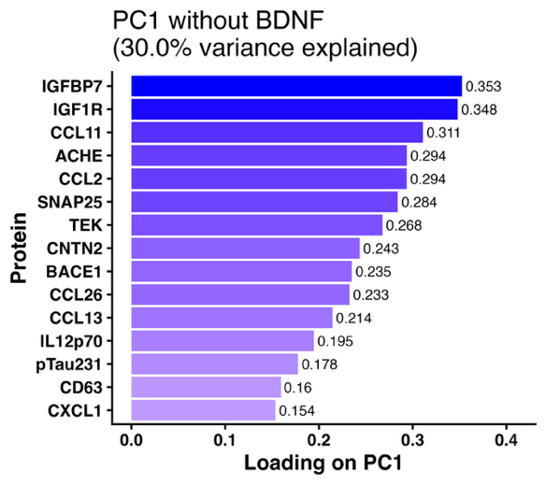
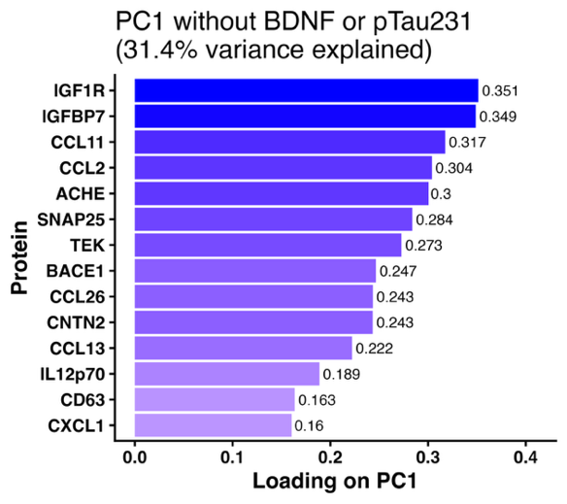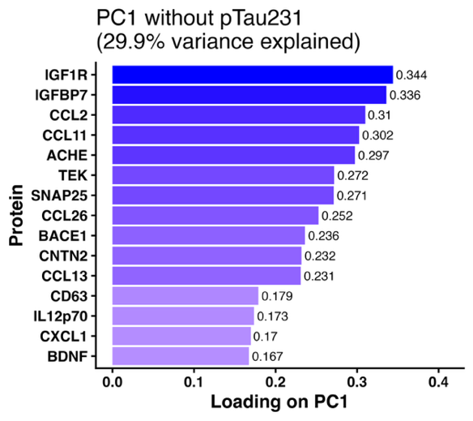

Figure S2. Variance plot for principal components analysis.
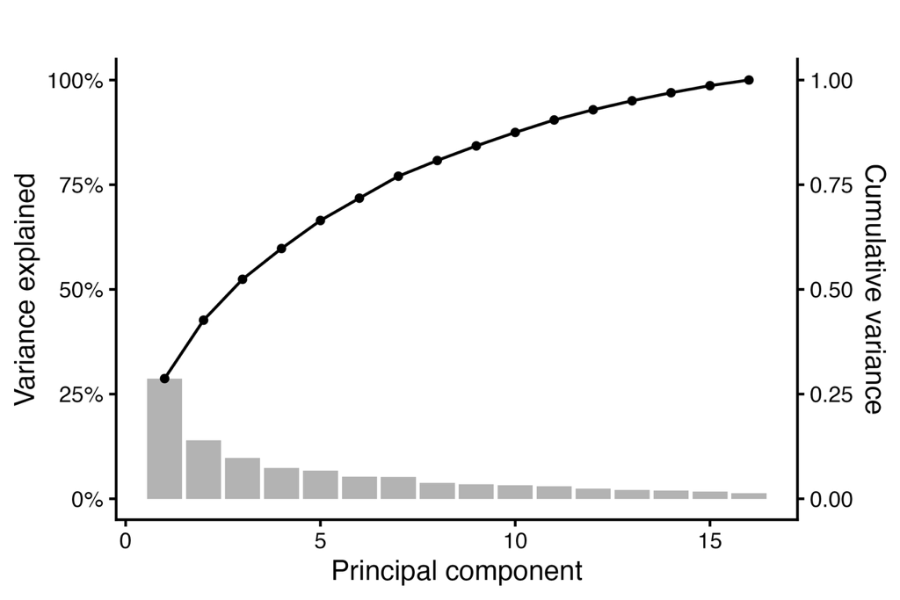
Figure S3. Means and standard deviations (SD) of PC1 loadings across 1,000 bootstrapped resampling iterations.
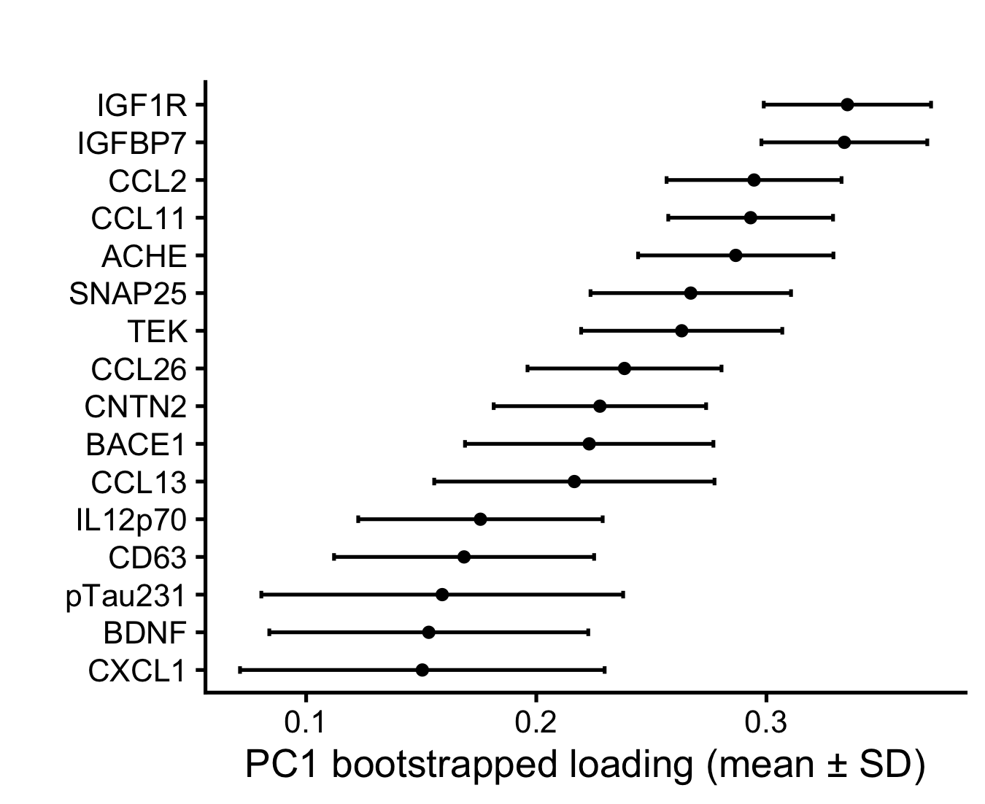

Figure S4. Distributions of plasma biomarkers of neurodegeneration by menopause status.

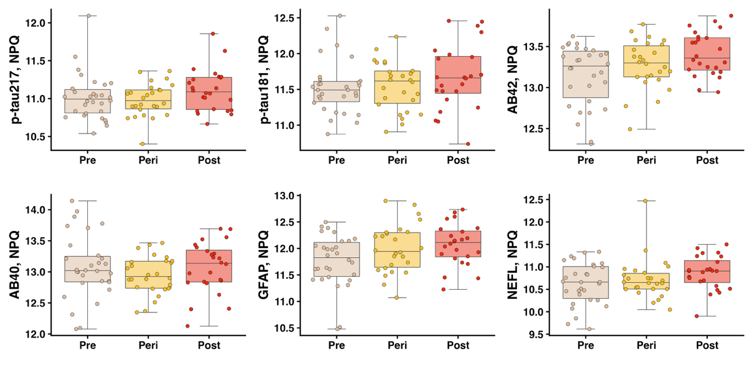

Figure S5. Comparison of log2fold change in protein levels in postmenopausal vs. premenopausal women, in the whole UCSB analytic sample (x-axis) and an age-restricted subset (age 47-53, y-axis).

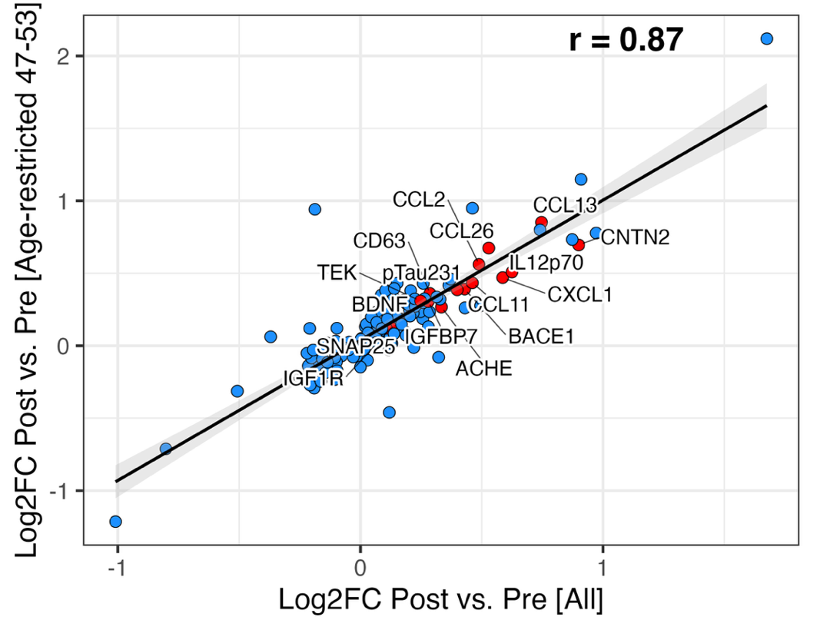

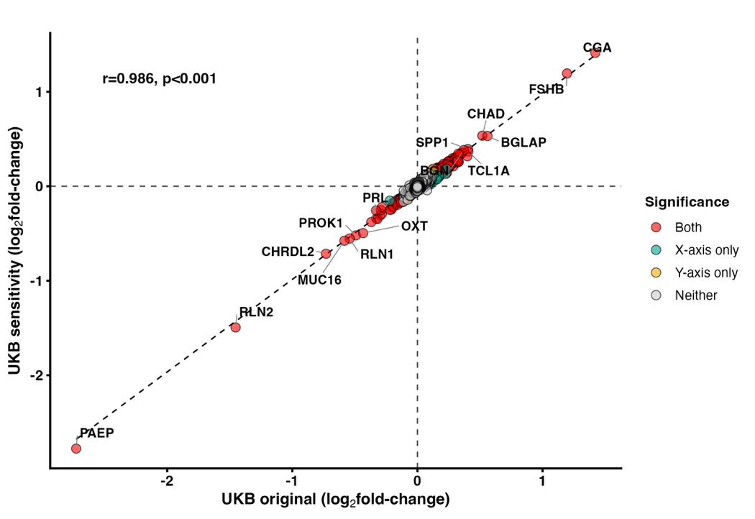
Figure S6. Comparison of log2fold change in protein levels in postmenopausal vs. premenopausal women in the UKB, in main analyses (x-axis) and sensitivity analyses (y-axis).

