Supplementary Information for “A failed human expansion out of Africa 100,000 years ago” Rose et al.

Contents:

- Site context & Stratigraphy
- Single-grain OSL dating
- Lithic Assemblages
- Lithic Taphonomy Analysis
- Phytolith Analysis
- Palaeoclimatic & Archaeogenetic Framework
- In Memoriam: Anthony E. Marks (1938-2025)
- References
- Computer Code Availability

1. Site Context & Stratigraphy

1.1. Geologic setting and excavated sites
The Nejd plateau in southern Oman’s Dhofar Governorate is an arid limestone tableland incised by deep wadis that expose Tertiary bedrock and extensive chert-bearing layers. Previous surveys documented over 250 Middle Stone Age/Middle Palaeolithic (MSA/MP) sites across this landscape, the vast majority characterized by Nubian Levallois technology¹. The three excavated sites—TH505 (Aybut Hills 5), TH584 (Aybut Hills 6), and TH571 (Upper Amut 1)—represent a subset of these findspots and were selected during the 2022 and 2023 field seasons based on three criteria: (1) presence of diagnostic Dhofar Nubian artefacts in situ or eroding from sedimentary contexts, indicating burial potential; (2) proximity to sedimentary basins or accumulation zones likely to preserve Quaternary deposits; and (3) evidence of post-depositional bleaching on surface artefacts, indicating prior burial and subsequent exhumation.
Most Dhofar Nubian sites occur as deflated surface scatters directly overlying chert-bearing bedrock, without associated fine-grained sediments suitable for luminescence dating. The buried sites presented here thus represent exceptional preservation contexts within a predominantly deflated landscape (Fig. S1). TH505, first documented as a dense Dhofar Nubian surface scatter in 2013, was tested with three trenches during the 2022 and 2023 field seasons. The first trench involved cleaning an earlier test pit that had been mechanically excavated by a backhoe in 2013, revealing Nubian Levallois products cemented within a petrogypsic horizon (Unit D); however, the induration of this deposit precluded further excavation. A second 1 m² test square encountered no stratified deposits. A third excavation (3 m²) in 2023 targeted less cemented sediments exposed in a nearby gully section, yielding a high density of artefacts and deposits suitable for OSL dating. A 10 x 10 m systematic surface collection was made around this excavation unit to sample surface material and complement the buried assemblage. TH584 was discovered in 2022 when artefacts were observed eroding from a shallow gully; excavations in 2022–2023 exposed 12 m² to bedrock. TH571, situated at the margin of an endorheic basin adjacent to a Dhofar Nubian workshop, was tested in 2022 (sterile loess sequence) and 2023, when excavations closer to the basin edge unearthed an artefact-bearing layer beneath the loess.
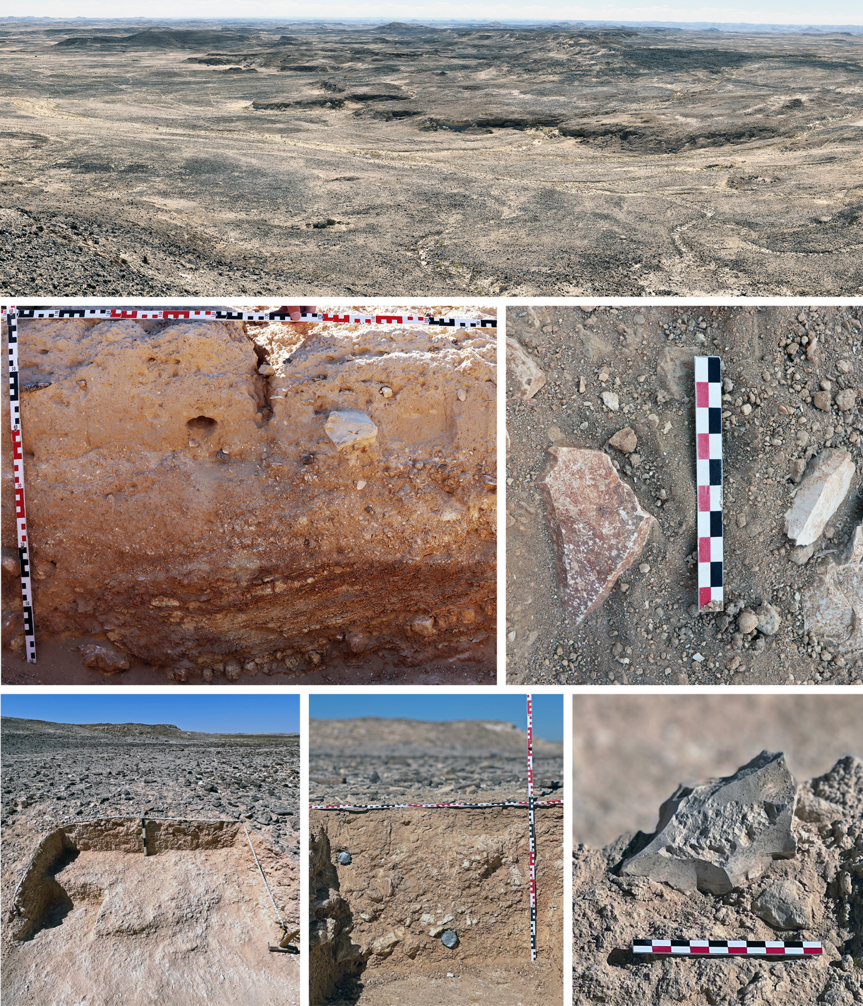
Fig. S1 | Field photos and landscape context of excavated sites. Top: Panoramic view of the Upper Amut plateau near TH571 (Upper Amut 1); Centre left: TH571 stratigraphic profile showing sterile loess overlying artefact-bearing gravels. Centre right: Unit B in situ artefacts at TH505. Bottom left: 2022 excavation area at TH584 showing stratified deposit beneath gravel pavement. Bottom middle: Stratigraphic profile at TH584 showing positions of OSL tubes in Units A and B. Bottom right: Heavily bleached and partially desilicified, in situ Nubian Levallois core in Unit A at TH584. Undamaged edges show minimal post-depositional transport.

1.2. Sediment accumulation and post-depositional processes

Sediment accumulation on the Nejd plateau occurs through two primary mechanisms: colluvial transport of slope debris from adjacent limestone outcrops, and aeolian deposition of carbonate silt during periods of reduced vegetation cover. At TH505 and TH584 (Figs. S2–S3), the artefact-bearing deposits consist predominantly of locally derived slope debris—angular to subangular limestone and chert fragments in a sandy-silt matrix—transported short distances (metres to tens of metres) from immediately adjacent outcrops. The limited transport distance is evidenced by the angular character of clasts and the absence of fluvial sorting or rounding.
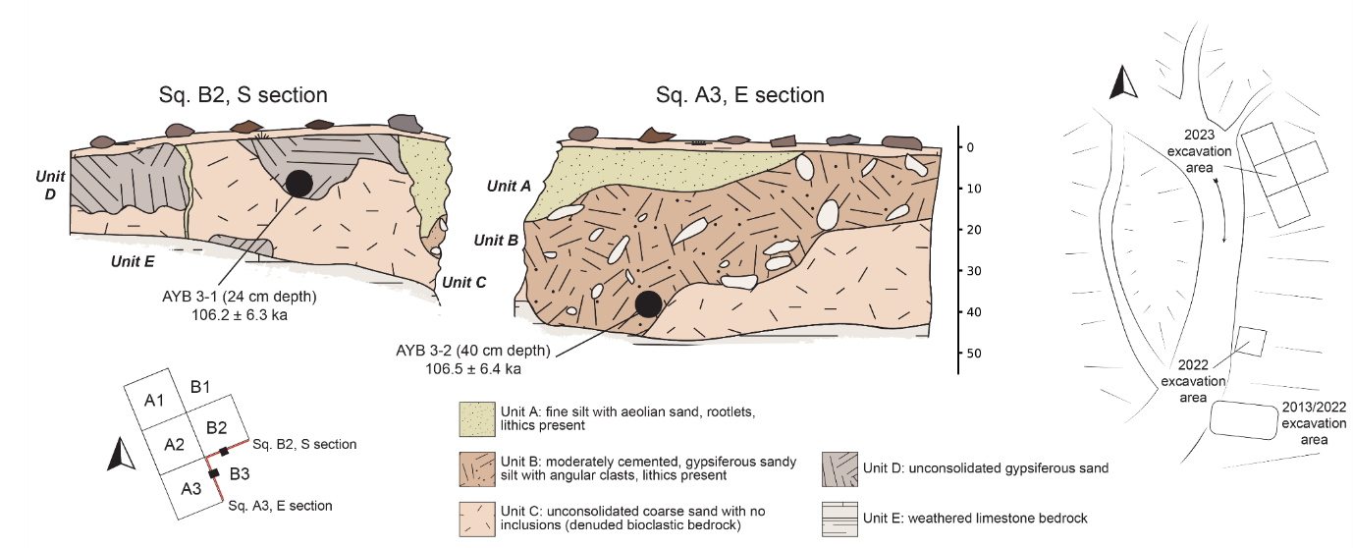
Fig. S2 | TH505 (Aybut Hills 5) stratigraphic sections and site plan. Left: South section of Square B2 showing position of OSL sample AYB 3-1. Centre: East section of Square A3 showing OSL sample AYB 3-2. Lithic artefacts concentrated in Units B and D. Depth scale in cm. Right: Site plan showing excavation areas from 2022 and 2023 field seasons relative to the erosional gully.
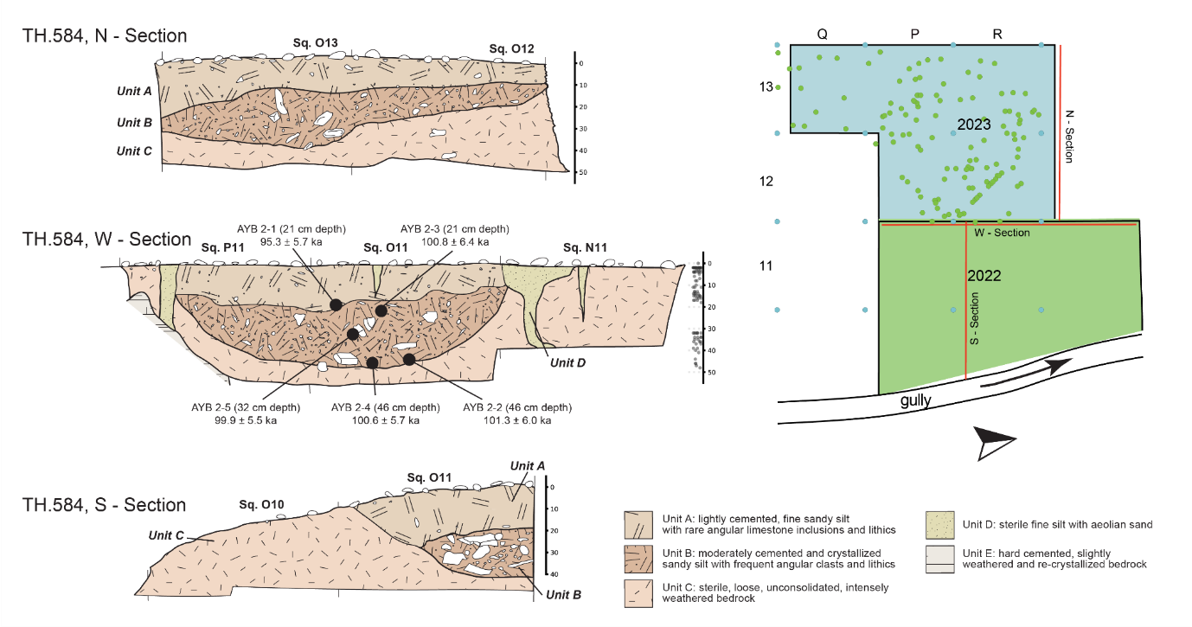
Fig. S3 | TH584 (Aybut Hills 6) stratigraphic sections and site plan. Top left: North section of 2023 excavation area. Depth scale in cm. Centre left: West section of 2022 excavation area, scatterplot strip next to scale shows vertical distribution of artefacts. Bottom left: South section of 2022 excavation area. Right: Site plan showing excavation areas from 2022 in green and 2023 in blue relative to the erosional gully.
A distinctive feature of the buried deposits at TH505 and TH584 is the development of petrogypsic (calcium sulphate) cementation within the artefact-bearing horizons. This induration results from evaporative concentration of sulphate-rich groundwater, a process common in arid limestone terrains where shallow aquifers experience seasonal fluctuation. The cementation post-dates artefact deposition, as evidenced by gypsum crystals encasing lithic pieces (e.g., Extended Data Fig. 1: 1), and contributes to the preservation of stratigraphic integrity by inhibiting bioturbation and deflation.
At TH571, the depositional setting differs substantially (Fig. S4). The site occupies the margin of a small endorheic basin adjacent to an exposed chert source. Quaternary loess deposits—aeolian carbonate silt with grain sizes predominantly <30 μm—accumulated within a palaeotopographic depression, reaching thicknesses exceeding one metre. Similar loess accumulations exposed along a bulldozed seismic line approximately 1 km east of the site reach 1.5 m thickness, suggesting these sediments represent erosional remnants of a formerly more extensive aeolian mantle. The consolidated character of the loess renders it relatively resistant to erosion compared to surrounding unconsolidated sediments. Lithic artefacts occur in a basal layer beneath the loess, within a mixed matrix of small, rounded gravels and aeolian fines, indicating accumulation during an earlier phase of landscape stability prior to loess deposition.
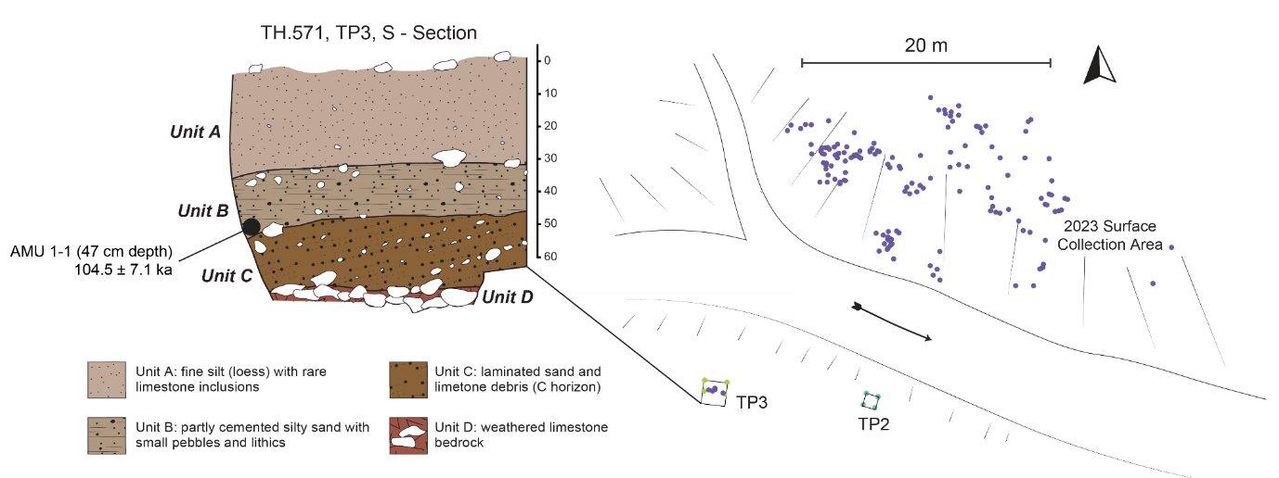
Fig. S4 | TH571 (Upper Amut 1) stratigraphic sections and site plan. Left: South section of Test Pit 3 (TP3) showing position of OSL sample AMU 1-1. Depth scale in cm. Right: Site plan showing excavation area relative to loess deposit south of gully and adjacent surface scatter. Purple dots indicate piece-plotted lithics in 2023 surface collection.

1.3. Site Descriptions
TH505 (Aybut Hills 5). TH505 is situated on a gully exposure within the proximal upper tributaries to Wadi Aybut, at the boundary between the Umm Er Radhuma Formation (Palaeocene) and the overlying Rus Formation. The Umm Er Radhuma consists of shallow marine limestones containing abundant chert nodules that served as the primary raw material source for lithic production. Artefacts occur within a layer of calcareous sand (Unit D) that is partially cut and filled with aeolian sand from sterile Unit A, as well as in an underlying layer of semi-cemented petrogypsic silt-sand. The compressed stratigraphic sequence (~50 cm total thickness) yielded diagnostic Dhofar Nubian cores and products. Two OSL samples were collected from the artefact-bearing deposits in Units B and D.
TH584 (Aybut Hills 6). Approximately 250 m west of TH505, TH584 is situated on a high terrace above Wadi Aybut, some 700 m from the active channel. Surface reconnaissance identified a bleached Nubian Levallois assemblage eroding from a shallow gully. Excavation of the exposed profile revealed a low density of stratified artefacts in an upper aeolian layer (Unit A), with most concentrated within a semi-cemented sandy silt layer (Unit B). Unit B, interpreted to be a buried polymict pediment, overlies a horizon of denuded bedrock approximately 50 cm beneath the surface (Unit C). Five OSL samples were collected from the artefact-bearing units.
TH571 (Upper Amut 1). TH571 is located on the Upper Amut plateau within a rare occurrence of Quaternary loess deposits adjacent to a small tributary of Wadi Amut. Most artefacts were collected from a homogenous surface scatter of Dhofar Nubian material. Test excavations yielded stratified lithic artefacts in Unit B underlying the sterile loess Unit A, including Nubian Levallois products (Extended Data Fig. 1) in a mixed matrix of small, rounded gravels with aeolian input. One OSL sample was extracted from the artefact-bearing layer, which sits atop a truncated layer of bedrock detritus (Fig. S1).

Geochronology methods and results

2.1. Single-grain OSL dating

2.1.1. Sample collection and preparation
OSL samples were collected by driving steel tubes horizontally into cleaned stratigraphic sections at each site. All samples were immediately sealed with light-proof plastic upon extraction and additional bulk sediment was collected from material directly surrounding each sample for dosimetry and water content assessments.
The quartz fractions were extracted from the unexposed central portions of the OSL dating sample tubes under safe light conditions (630 nm LEDs, <0.15 μW/cm² power density at sample position) at the Mawson Optical Dating and Archaeological Luminescence (MODAL) laboratory, Adelaide University, Australia. Owing to the limited availability of fine to medium sand-sized quartz in these samples, it was necessary to focus on the very fine to fine sand-sized quartz fractions for dating purposes. Depending on available quartz yields, either the 90–125, 90–180 or 90–300 μm fractions were prepared for burial dose estimation using standard procedures². Sediment samples were initially sieved to isolate the very fine to medium sand fraction (90–300 μm). Organics and carbonates were then eliminated using concentrated (30%) hydrogen peroxide (H₂O₂) and hydrochloric (HCl) acid digestion. Quartz grains were isolated using heavy liquid (LST lithium heteropolytungstate) density ranges of 2.62 g/cm³ to 2.72 g/cm³. The 90–125, 90–180 or 90–300 µm quartz fractions were then sieved and etched with hydrofluoric (HF) acid to remove the alpha-irradiated external layers (48% HF digestion for 40 min). Etched grains were subsequently washed in 30% hydrochloric acid to remove any precipitated fluorides and re-sieved using a 63 µm sieve to eliminate any disaggregated grains.

2.1.2. Equivalent dose (D_{e}) estimation
Single-grain OSL measurements were made using a Risø TL-DA-20 reader equipped with blue LEDs (470 ± 20 nm, maximum power of 92 mW/cm2), infrared LEDs (peak emission 870 nm, maximum power of 349 mW/cm2), and a 10 mW Nd:YVO4 single-grain laser attachment emitting at 532 nm (maximum power of ~50 W/cm2). Ultraviolet OSL signals were detected using an EMI 9235QA photomultiplier tube fitted with 7.5 mm-thick Hoya U-340 filters. Samples were irradiated with a mounted ⁹⁰Sr/⁹⁰Y beta source that had been calibrated to administer known doses to multi-grain aliquots and single-grain discs (average single-grain dose rate at the time of measurement = 0.09 Gy/s). For single-grain measurements, spatial variations in the beta dose rate across the disc plane were taken into account by undertaking hole-specific calibrations using gamma-irradiated quartz.
Individual equivalent dose (D_{e}) values were determined using the single-aliquot regenerative-dose (SAR) procedure shown in Table S1, which includes a natural and regenerative-dose preheat (PH₁) of 260 ºC for 10 s and a test-dose preheat (PH₂) of 200 ºC for 10 s, as determined from dose recovery tests undertaken on sample OMANRG-10 (see below). Single-grain quartz D_{e} measurements were made by manually loading the 90–125, 90–180 or 90–300 quartz fractions into standard single-grain aluminium discs drilled with an array of 300 μm x 300 μm holes. This pseudo‐single‐grain measurement configuration resulted in an average of ~3–18 grains being placed in each grain-hole position (assuming a uniform grain size distribution)³. A significant proportion of grain‐hole positions measured using this configuration (23–60%) still produced OSL signals that are statistically indistinguishable from background (Table S2), which suggests close approximation to true single‐grain resolution or at least minimal influences of multi‐grain averaging effects (e.g., ref. 4).
Individual D_{e} values were only included in the final age calculation if they satisfied a series of quality-assurance criteria, as detailed in Arnold et al.^{5,6}. Single-grain OSL D_{e} estimates were rejected from further consideration if they exhibited one or more of the following properties: (i) weak or no signals (i.e., the net intensity of the natural test-dose signal (T_{n}) was less than three times the standard deviation of the late-light background signal); (ii) poor recycling ratios (i.e., the ratios of sensitivity-corrected luminescence responses (L_{x}/T_{x}) for two identical regenerative doses were not consistent with unity at 2σ); (iii) high levels of signal recuperation / charge transfer between SAR cycles (i.e., the sensitivity-corrected luminescence response of the 0 Gy regenerative-dose point amounted to >5% of the sensitivity-corrected natural signal response (L_{n}/T_{n}) at 2σ); (iv) poorly defined or non-monotonic dose-response curves (i.e., those displaying no discernible dose-response curve, or a zero (flat) or negative response with increasing dose) and dose-response curves displaying very scattered L_{x}/T_{x} values (i.e., those that could not be successfully fitted with the Monte Carlo procedure and, hence, did not yield finite D_{e} values and uncertainty ranges). Grains rejected for failing this quality assurance criterion primarily display relatively dim signals and hence their L_{x}/T_{x} uncertainties are too large for meaningful dose-response curve construction or finite D_{e} evaluation. This criterion is therefore functionally equivalent to criterion (v) of Demuro et al.⁷; i.e., net T_{n} signal has a relative error of >30%) but it additionally captures grains with ill-suited dose-response properties; (v) saturated or non-intersecting natural signals (i.e., L_{n}/T_{n} values equal to, or greater than, the I_{max} saturation limit of the dose-response curve at 2σ); (vi) extrapolated natural signals (i.e. L_{n}/T_{n} values lying more than 2σ beyond the L_{x}/T_{x} value of the largest regenerative-dose administered in the SAR procedure); (vii) contamination by feldspar grains or inclusions (i.e., the ratio of the L_{x}/T_{x} values obtained for two identical regenerative doses measured with and without prior IR stimulation (OSL IR depletion ratio⁸) was less than unity at 2σ).
Individual D_{e} estimates are presented with their 1σ error ranges, which are derived from three sources of uncertainty: (i) a random uncertainty term arising from photon counting statistics for each OSL measurement, calculated using Eq. 3 of Galbraith⁹; (ii) an empirically determined instrument reproducibility uncertainty of 1.5 for each single-grain measurement (calculated for the specific Risø reader used in this study and following the approach outlined in Jacobs et al.¹⁰); and (iii) a dose-response curve fitting uncertainty determined using 1000 iterations of the Monte Carlo method described by Duller¹¹ and implemented in Analyst v4.
Between 800 and 2000 single-grain D_{e} measurements were made for each sample. Single-grain OSL D_{e} values were calculated by integrating the first 0.08 s of stimulation and subtracting a late-light background from the last 0.25 s. Representative OSL dose-response and decay curves for grains of sample OMANRG-4 that passed the quality assurance criteria are shown in Figure S5. The majority of accepted grains display rapidly decaying OSL curves (reaching close to background levels within ~0.5 s), which are characteristic of quartz signals dominated by the most readily bleached (so-called ‘fast’) OSL component (Fig. S5: compare OSL decay curve shape for a fast-dominated Risø calibration quartz grain; Hansen et al.¹²). The single-grain OSL dose-response curves are all well-represented by a single saturating exponential function, as has been widely reported for quartz grains with fast-dominated signals (e.g., refs. 5,10,13,14).
On average, 30% of accepted grains per sample display moderately bright T_{n} (25 Gy) OSL signals of 100-1000 cts/0.08 s (e.g., Fig. S5B), and 3% of accepted grains per sample have relatively bright T_{n} OSL signals of >1000 cts/0.08 s (e.g., Fig. S5A). 67% of accepted grains have relatively dim T_{n} signal intensities of <100 cts/0.08 s (e.g., Fig. S5D), while sample OMANRG-4 contains a small number (<1%) of very bright accepted grains displaying T_{n} OSL signal intensities >10,000 cts/0.08 s (e.g. Fig. S5C). The average T_{n} OSL signal intensities of grains that passed the SAR quality assurance criteria is 180 cts/0.08 s for the eight OSL samples.

2.1.3. SAR D_{e} validation tests
A series of dose recovery tests were undertaken to assess the suitability of the SAR procedures for OSL D_{e} determination. The suitability of the OSL D_{e} determination procedure (Table S1) was initially evaluated using multiple-grain aliquot dose-recovery tests to ascertain optimal preheating conditions for bulk grain populations. These tests were performed on ~180-grain aliquots of sample OMANRG-10 using a regenerative dose preheat (PH₁) of either 220 ºC for 10 s, 240 ºC for 10 s or 260 ºC for 10 s, and a series of different test dose preheat (PH₂) conditions (160 ºC for 10 s, 180 ºC for 10 s, 200 ºC for 10 s, 200 ºC for 0 s, 220 ºC for 10 s). A known laboratory dose of 50 Gy was applied to groups of three aliquots after optically bleaching their natural OSL signals using two 1,000 s blue LED stimulations separated by a 10,000 s pause (to ensure complete decay of any phototransferred charge in the 110 ºC TL trap). The administered dose was treated as a surrogate natural dose and subsequently measured using a multiple-grain version of the SAR sequence shown in Table S1, which involved replacing 125°C green laser stimulations with 125°C blue LED stimulations for 60 s, and inserting a 50°C IR bleach for 40 s prior to each OSL measurement to remove any feldspar signal contamination. The most suitable multiple-grain dose-recovery results were obtained using a PH₁ of 260 ºC for 10 s and a PH₂ of 200 ºC for 10 s (Fig. S6A). This preheat combination yielded a weighted mean measured-to-given dose ratio of 1.02 ± 0.03, low inter-aliquot D_{e} scatter, mean recycling ratios in agreement with unity at 1σ (0.99 ± 0.02) and a mean recuperation ratio of less than 1%.
To confirm the suitability of the optimal multiple-grain OSL SAR procedure at the single-grain scale of analysis, we repeated the dose recovery test on 600 grains of sample OMANRG-10 using the optimum multiple-grain preheat conditions (PH₁ of 260 ºC for 10 s and a PH₂ of 200 ºC for 10 s). A laboratory dose of 70 Gy was administered to this batch of quartz grains after bleaching the natural signals using the same procedure described above. The administered dose was chosen to be similar to the expected mean natural dose of OMANRG-10, as determined from preliminary single-grain D_{e} measurements made on 100 grains of this sample. The single-grain dose recovery test yielded a mean measured to given dose ratio of 0.99 ± 0.02 and a corresponding overdispersion value of 14 ± 3 % (Fig. S6B). These results confirm the general suitability of the chosen SAR procedure and quality-assurance criteria for single-grain D_{e} estimation over the natural dose range of OMANRG-10. They also provide a minimum estimate of the intrinsic single-grain D_{e} scatter and overdispersion that is expected to originate from the laboratory procedures themselves, and from grain-to-grain variations in luminescence responses to the fixed SAR conditions.

2.1.4. Single-grain OSL D_{e} results
Table S3 provides a summary of the single-grain D_{e} values obtained for the OSL dating samples. The single-grain D_{e} distributions of grains that passed the SAR quality assurance criteria for each sample are also shown as radial plots in Figure S7. The samples all exhibit relatively homogenous single-grain OSL D_{e} distributions that are consistent with well-bleached, unmixed sediments (e.g., refs. 5,15-19). The OSL datasets are characterised by limited D_{e} scatter (relative D_{e} range = 1.9–2.8) and have low overdispersion values ranging from 25 ± 2% to 32 ± 2% (Table S3). These overdispersion values are consistent with (i.e., within 2σ of) those typically reported for well-bleached and undisturbed single-grain D_{e} datasets (e.g., refs. 6,17,20) and they are systematically higher than the 2σ overdispersion range obtained in the dose recovery tests for sample OMANRG-10 (14 ± 3%). None of the single-grain OSL D_{e} datasets are significantly positively skewed according to the weighted skewness test outlined by Bailey and Arnold¹⁸ and Arnold and Roberts²¹. Application of the maximum log likelihood (L_{max}) test²² also indicates that the central age model (CAM) is statistically favoured over the three- or four-parameter minimum age models (MAM-3 or MAM-4) of Galbraith et al.²³ for all D_{e} datasets.
Collectively, these single-grain OSL D_{e} characteristics suggest that the samples do not suffer from major extrinsic D_{e} scatter related to insufficient bleaching prior to burial (e.g., refs. 14,15) or widespread post-depositional sediment mixing between units (e.g., refs. 3,24). The low overdispersion observed for these samples is primarily attributable to intrinsic experimental scatter captured by the dose recovery test (e.g., refs. 4,10,24,25), with minor additional contributions likely related to extrinsic field-related scatter such as beta-dose spatial heterogeneity (e.g., refs. 26,27,28,29). We have therefore used the weighted mean (CAM) D_{e} values to derive the final OSL burial dose estimates for these samples (Table S3) in accordance with the L_{max} test results¹⁷.

2.1.5. Dose rate determination
Table S3 summarises the dose rate estimate for eight OSL samples. The external beta and gamma dose rates have been estimated from mass fractions of K, Th, and U elements determined by instrumental neutron activation analysis (INAA) at the Czech Academy of Sciences Nuclear Physics Institute. INAA measurements were performed on 150-mg aliquots of dried and homogenised bulk sediments collected directly from the OSL dating sampling position (Table S4). The original bulk samples were pulverized for 10 minutes using an agate planetary ball mill prior to making aliquots. For analysis, the sample aliquots were heat-sealed in PE disk-shape capsules (diameter of 25 mm). The sample capsules were formed in a column stack, together with in-house synthetic multi-element calibrators³⁰⁻³², an empty capsule (capsule blank signal), and a control sample of SRM 2711A Montana Soil II (NIST), and then inserted into an aluminium container for neutron irradiation. Iron foil monitors were inserted in between each set of 5 to 6 samples and/or calibrators to determine the axial neutron flux gradient in the stack during the 2-hr irradiations performed at the experimental nuclear reactor LVR-15 (operated by Research Centre Rez). The thermal, epithermal, and fast neutron fluence rates were approximately 2.6 × 10¹³ cm⁻² s⁻¹, 3.9 × 10¹² cm⁻² s⁻¹, and 2.9 × 10¹² cm⁻² s⁻¹, respectively. Counting of the gamma spectra for the irradiated capsules was performed with coaxial HPGe detectors (relative efficiency 50 to 80 %, FWHM resolution of 1.8–1.9 keV, both for the 1.33 MeV photons of ⁶⁰Co) after decay times of about 5, 10, and 20 days. The detectors were interfaced with a computer-controlled gamma-spectroscopy analyser through a chain of associated linear electronics. Quantification was carried out by the comparator method. The combined uncertainty included contributions from the net peak areas of samples and calibrator determinations, elemental composition of calibrators, and an estimated contribution from differences between sample and calibrator dimensions at the level of 1.5 % of the mass fraction determined. The mass fractions of K, Th, and U for a control sample agreed well with the certified values within the experimental uncertainty, thus supporting the accuracy of the INAA results. The elemental concentrations of K, U and Th determined using INAA (Table S4), together with their 1σ analytical uncertainties, were used to calculate the beta and gamma dose rates of the OSL samples by applying the conversion factors of Guérin et al.³³ (see footnotes in Table S3 for details).
For samples collected <30 cm below the present-day surface (OMANRG-1, OMANRG-4, OMANRG-9), the gamma dose rates derived from INAA measurements have been corrected for non-infinite matrix geometries using the gamma dose rate gradients outlined in Appendix H (Table H1) of Aitken³⁴, and assuming the present-day sediment–air boundary distances are representative of average long-term conditions (see below). As it was not possible to perform additional in situ gamma dose rate evaluations at the time of sample collection (e.g., using portable field gamma-ray spectrometry), a systematic uncertainty of 10% has also been added in quadrature to the INAA K, U and Th analytical uncertainties to account for any minor spatial variability in the surrounding (~30 cm diameter) gamma radiation fields of the OSL samples; i.e., spatial heterogeneity in the gamma ionisation spheres that might not have been fully represented by the bulk sediment samples collected from the immediate surrounding of the OSL tube positions.
The cosmic-ray dose rates have been calculated using the approach described in Prescott and Hutton^{35,36}, taking into consideration site altitude, geomagnetic latitude, and density and thickness of present-day sediment overburden. The present-day overburden thicknesses are considered broadly representative of the long-term average overburden thicknesses at the three study sites given their geomorphic context (i.e. they are located on top of a stable desertic plateau with very limited topography and no evidence of localised incision by wadis). A small, assumed internal (alpha plus beta) dose rate of 0.03 ± 0.01 Gy / ka has been included in the final dose rate calculation for this sample, based on published ²³⁸U and ²³²Th measurements for etched quartz grains from a range of locations (e.g., refs. 37-41) and an alpha efficiency factor (a-value) of 0.04 ± 0.01^{42,43}.
The final dose rates have been calculated after making allowance for beta-dose attenuation^{44,45} and long-term sediment water content^{34,46}. A long-term water content equivalent to 10% of the present-day ‘proportional saturated water content’ value (i.e., present-day water content / saturated water contents x 100)² has been assumed for each sample. This value was derived from assessments of area-specific proportional saturated water contents assessments undertaken on a range of open-air Late Pleistocene to Holocene samples from the Dhofar and Duqm regions of southern Oman (present-day average water content = 7.1% of sediment saturation capacity; n = 18 samples), and factoring in the potential for slightly higher moisture contents prior to excavation and exposure of the sediment profiles.
Using this approach, the long-term sediment moisture contents of the OSL samples are assumed to range between 2.4% and 4.1% of dry sediment weight (Table S3). A 1σ relative uncertainty of 50% (100% at 2σ) has been assigned to these long-term moisture estimates to accommodate any variations in hydrologic conditions during burial. The assigned 2σ uncertainty ranges ensure that the long-term sediment moisture contents span reasonable hydrological scenarios during the last interglacial and subsequent glacial period (i.e., between 0% and 20% of the measured saturated water content for this sample). These long-term sediment moisture content values overlap with published values for similar types of Palaeolithic deposits from arid regions of the Arabian Peninsula (e.g., refs. 47-49). It is worth noting that the final age of the OSL samples would only change by ~1% for each 1% increase or decrease in long-term water content, and therefore our OSL chronologies and interpretations are largely insensitive to the preferred choice of long-term water content.
Table S1 | Single-aliquot regenerative-dose (SAR) procedures used for dose-recovery measurements and D_{e} determination. Each of these SAR measurement cycles was repeated for the natural dose, 5 different sized regenerative doses and a 0 Gy regenerative-dose (to measure OSL signal recuperation). Both the smallest and second largest non-zero regenerative-dose cycles were repeated at the end of the SAR procedure to assess the suitability of the test-dose sensitivity correction. The smallest regenerative-dose cycle was also repeated a second time with the inclusion of step 2 to check for the presence of feldspar contaminants using the OSL IR depletion ratio of Duller⁸. L_{x} = regenerative dose signal response; L_{n} = natural dose signal response; T_{x} = test dose signal response for a laboratory dose cycle T_{n} = test dose signal response for the natural dose cycle.
Single-grain OSL SAR procedure
Step | Treatment | Symbol
1 | Dose (Natural or laboratory) | N or D
2 ª | IRSL stimulation (50ºC for 60 s)
3 | Preheat 1 (260ºC for 10 s) | PH₁
4 | Single-grain OSL stimulation (125ºC for 2 s) | L_{n} or L_{x}
5 | Test dose (25 Gy) | T_{d}
6 | Preheat 2 (200 for 10 s) | PH₂
7 | Single-grain OSL stimulation (125ºC for 2 s) | T_{n} or T_{x}
8 | Repeat measurement cycle for different
 | sized regenerative doses
ª Step 2 is only included in the single-grain OSL SAR procedure when measuring the OSL IR depletion ratio⁸.
Table S2 | Single-grain OSL classification statistics for the dose recovery and natural D_{e} measurements. The proportion of grains that were rejected from final D_{e} estimation after applying the various SAR quality assurance criteria are shown in rows 5-13. These criteria were applied to each single-grain measurement in the order listed. T_{n} = natural test dose signal response; L_{n}/T_{n} = sensitivity-corrected natural signal response; L_{x}/T_{x} = sensitivity-corrected regenerative-dose signal response; I_{max} = saturation OSL intensity of the fitted dose response curve.
Sample name | OMANRG-4 | OMANRG-5 | OMANRG-9 | OMANRG-1 | OMANRG-3 | OMANRG-10 | OMANRG-10 | OMANRG-2 | OMANRG-6
SAR measurement type | D_{e} | D_{e} | D_{e} | D_{e} | D_{e} | D_{e} | Dose  recovery | D_{e} | D_{e}
Total measured grains (n) | 2000 | 800 | 1200 | 1200 | 1200 | 1200 | 600 | 1200 | 1800
Grains rejected for failing SAR quality assurance criteria (%)
T_{n} <3σ background | 60 | 26 | 46 | 48 | 23 | 29 | 21 | 23 | 58
Low-dose recycling ratio ≠ 1 at ±2σ | 4 | 6 | 7 | 5 | 6 | 7 | 9 | 7 | 6
High-dose recycling ratio ≠ 1 at ±2σ | 3 | 6 | 4 | 5 | 6 | 5 | 8 | 6 | 4
OSL-IR depletion ratio <1 at ±2σ | 3 | 4 | 5 | 3 | 6 | 6 | 5 | 6 | 3
0 Gy L_{x}/T_{x} >5% L_{n}/T_{n} | <1 | <1 | <1 | <1 | 0 | <1 | 0 | <1 | <1
Non-intersecting grains (L_{n}/T_{n} > dose response curve saturation) | <1 | 2 | <1 | 0 | <1 | <1 | <1 | <1 | <1
Saturated grains (L_{n}/T_{n} ≥ dose response curve I_{max} at ±2σ) | <1 | 2 | 1 | 0 | <1 | <1 | 2 | <1 | <1
Extrapolated grains ( L_{n}/T_{n} values >2σ beyond largest L_{x}/T_{x} value) | 0 | 0 | 0 | 0 | 0 | 0 | 0 | 0 | 0
Anomalous dose response / unable to perform Monte Carlo fit | 18 | 31 | 23 | 22 | 39 | 30 | 29 | 33 | 25
Sum of rejected grains (%) | 89 | 77 | 87 | 83 | 82 | 78 | 74 | 76 | 96
Sum of accepted grains (%) | 11 | 23 | 13 | 17 | 18 | 22 | 26 | 24 | 4

Table S3 | Summary of environmental dose rates, equivalent dose (D_{e}) data and final ages for the OSL dating samples from sites TH505, TH584 and TH571.
Sample ID  (OSL) | Site | Field ID | Sample  depth  (cm) | Grain  size  (μm) | Water  content  (%) ª | Environmental dose rate (Gy/ka) |  |  |  |  |  | Equivalent dose (D_{e}) data |  |  | Age  (ka) ^{e,i}
 |  |  |  |  | Beta  dose rate ^{b} | Gamma  dose rate ^{b} | Cosmic  dose rate ^{c} | Internal  dose rate ^{d} | Total  dose rate ^{e} |  | No. of  grains ^{f} | OD  (%) ^{g} | D_{e}  (Gy) ^{e,h} | Age  (ka) ^{e,i}
OMANRG-4 | TH.505 AYB3-1 | 24 | 90 – 180 | 3.7 ± 1.8 | 0.26 ± 0.01 | 0.18 ± 0.01 | 0.20 ± 0.02 | 0.03 ± 0.01 | 0.67 ± 0.03 |  | 217 / 2000 | 26 ± 2 | 71.0 ± 1.8 | 106.2 ± 6.3
OMANRG-5 | TH.505 AYB3-2 | 40 | 90 – 180 | 4.1 ± 2.1 | 0.42 ± 0.02 | 0.27 ± 0.02 | 0.19 ± 0.02 | 0.03 ± 0.01 | 0.91 ± 0.04 |  | 185 / 800 | 32 ± 2 | 96.9 ± 2.8 | 106.5 ± 6.4
OMANRG-9 | TH.584 AYB2-1 | 21 | 90 – 180 | 2.6 ± 1.3 | 0.42 ± 0.02 | 0.26 ± 0.02 | 0.20 ± 0.02 | 0.03 ± 0.01 | 0.91 ± 0.04 |  | 161 / 1200 | 31 ± 3 | 87.0 ± 2.7 | 95.3 ± 5.7
OMANRG-1 | TH.584 AYB2-3 | 21 | 90 – 300 | 3.6 ± 1.8 | 0.30 ± 0.01 | 0.19 ± 0.01 | 0.20 ± 0.02 | 0.03 ± 0.01 | 0.72 ± 0.04 |  | 122 / 1200 | 26 ± 3 | 72.1 ± 2.5 | 100.8 ± 6.4
OMANRG-3 | TH.584 AYB2-5 | 32 | 90 – 125 | 2.4 ± 1.2 | 0.37 ± 0.02 | 0.22 ± 0.01 | 0.20 ± 0.02 | 0.03 ± 0.01 | 0.82 ± 0.04 |  | 221 / 1200 | 25 ± 2 | 81.7 ± 1.9 | 99.9 ± 5.5
OMANRG-10 | TH.584 AYB2-2 | 46 | 90 – 180 | 3.1 ± 1.5 | 0.27 ± 0.01 | 0.17 ± 0.01 | 0.19 ± 0.02 | 0.03 ± 0.01 | 0.67 ± 0.03 |  | 263 / 1200 | 26 ± 2 | 67.9 ± 1.5 | 101.3 ± 6.0
OMANRG-2 | TH.584 AYB2-4 | 46 | 90 – 125 | 3.3 ± 1.6 | 0.30 ± 0.01 | 0.20 ± 0.01 | 0.19 ± 0.02 | 0.03 ± 0.01 | 0.72 ± 0.04 |  | 290 / 1200 | 25 ± 2 | 72.5 ± 1.5 | 100.6 ± 5.7
OMANRG-6 | TH.571 AMU1-1 | 47 | 90 – 300 | 2.5 ± 1.2 | 0.29 ± 0.01 | 0.19 ± 0.01 | 0.19 ± 0.02 | 0.03 ± 0.01 | 0.70 ± 0.03 |  | 65 / 1800 | 25 ± 4 | 73.6 ± 3.3 | 104.5 ± 7.1
ª Long-term estimated water content, expressed as % of dry mass of mineral fraction, with an assigned 1σ uncertainty of ±50%. The long-term water content of this sample is taken as equivalent to 10% of the present-day saturated water content on the basis of region-specific proportional saturated water contents assessments undertaken on similar samples from southern Oman.
^{b} Beta and gamma dose rates have been calculated using instrumental neutron activation analysis (INAA), after making allowance for beta dose attenuation due to grain-size effects and HF etching^{44,45}. Radionuclide concentrations have been converted to dose rates using the conversion factors given in Guérin et al.³³.
^{c} Cosmic-ray dose rates were calculated according to Prescott and Huntley^{35,36} and assigned a relative 1σ uncertainty of ± 10%.
^{d} The assumed internal alpha and beta dose rate for quartz, with an assigned relative 1σ uncertainty of ±30%, is based on intrinsic ²³⁸U and ²³²Th contents published by Mejdahl³⁷, Bowler et al.³⁸ Jacobs et al.³⁹, Pawley et al.⁴⁰ and Lewis et al.⁴¹, and an a-value of 0.04 ± 0.01^{42,43}. Intrinsic radionuclide concentrations and specific activities have been converted to dose rates using the factors given in Guérin et al.³³, making allowance for beta dose attenuation due to grain-size effects⁴⁴.
^{e} Mean ± total uncertainty (68% confidence interval), calculated as the quadratic sum of the random and systematic uncertainties.
^{f} Number of D_{e} measurements that passed the SAR rejection criteria and were used for D_{e} determination / total number of D_{e} values analysed.
^{g} OD = overdispersion, defined as the relative spread in the D_{e} dataset beyond that associated with the measurement uncertainties for individual D_{e} values and calculated using the central age model (CAM) of Galbraith et al.²³.
^{h} Sample averaged D_{e} value has been calculated using the CAM²³.
^{i} Total uncertainty includes a systematic component of ±2% associated with laboratory beta-source calibration.
Table S4 | Instrumental neutron activation (INAA) elemental concentrations used for external beta and gamma dose rate evaluations
Sample ID  (INAA) | Sample ID  (OSL) | Site | Field ID | Mass (mg) ª | K | U | Th
 |  |  |  | (%) ^{b} | (ppm) ^{b} | (ppm) ^{b}
ID737 | OMANRG-4 | TH.505 | AYB3-1 | 152.07 | 0.191 ± 0.007 | 0.883 ± 0.020 | 0.983 ± 0.015
ID739 | OMANRG-5 | TH.505 | AYB3-2 | 151.30 | 0.357 ± 0.010 | 0.994 ± 0.023 | 1.760 ± 0.030
ID055 | OMANRG-9 | TH.584 | AYB2-1 | 149.42 | 0.351 ± 0.015 | 1.061 ± 0.022 | 1.507 ± 0.024
ID735 | OMANRG-1 | TH.584 | AYB2-3 | 152.18 | 0.248 ± 0.009 | 0.815 ± 0.021 | 1.099 ± 0.017
ID733 | OMANRG-3 | TH.584 | AYB2-5 | 150.72 | 0.230 ± 0.010 | 0.706 ± 0.017 | 1.158 ± 0.018
ID057 | OMANRG-10 | TH.584 | AYB2-2 | 150.67 | 0.225 ± 0.012 | 0.971 ± 0.016 | 0.706 ± 0.017
ID731 | OMANRG-2 | TH.584 | AYB2-4 | 150.04 | 0.315 ± 0.012 | 0.812 ± 0.021 | 0.951 ± 0.016
ID741 | OMANRG-6 | TH.571 | AMU1-1 | 150.06 | 0.258 ± 0.008 | 0.681 ± 0.019 | 1.183 ± 0.019
ª Measurements made on dried and powdered sediment sub-samples.
^{b} Mean ± total uncertainty (68% confidence interval), calculated as the quadratic sum of the random and systematic uncertainties.

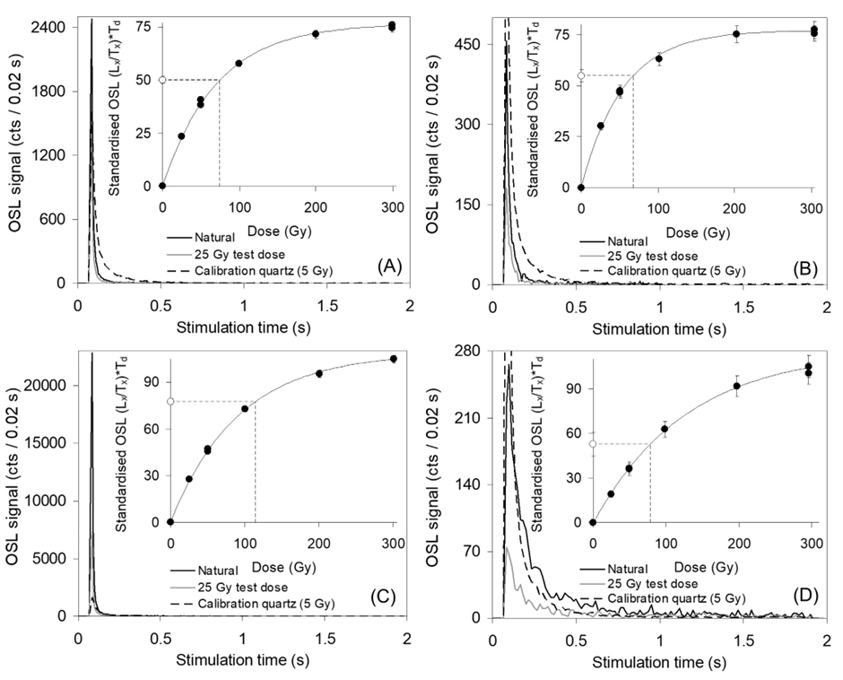
Fig. S5 | Representative single-grain OSL decay and dose-response curves for quartz grains from sample OMANRG-4. The decay curve of a fast-component dominated calibration quartz grain is shown for comparison (Risø calibration quartz standard)¹². In the insets, the open circle denotes the sensitivity-corrected natural OSL signal, and filled circles denote the sensitivity-corrected regenerated OSL signals. (A) grain with bright OSL signal (Tn intensity = ~1,000–10,000 counts / 0.08 s). (B) grain with very bright OSL signal (Tn intensity = >10,000 counts / 0.08 s). (C) grain with moderate OSL signal brightness (Tn intensity = 100–1,000 counts / 0.08 s). (D) grain with relatively dim OSL signal (Tn intensity = <100 counts / 0.08 s).

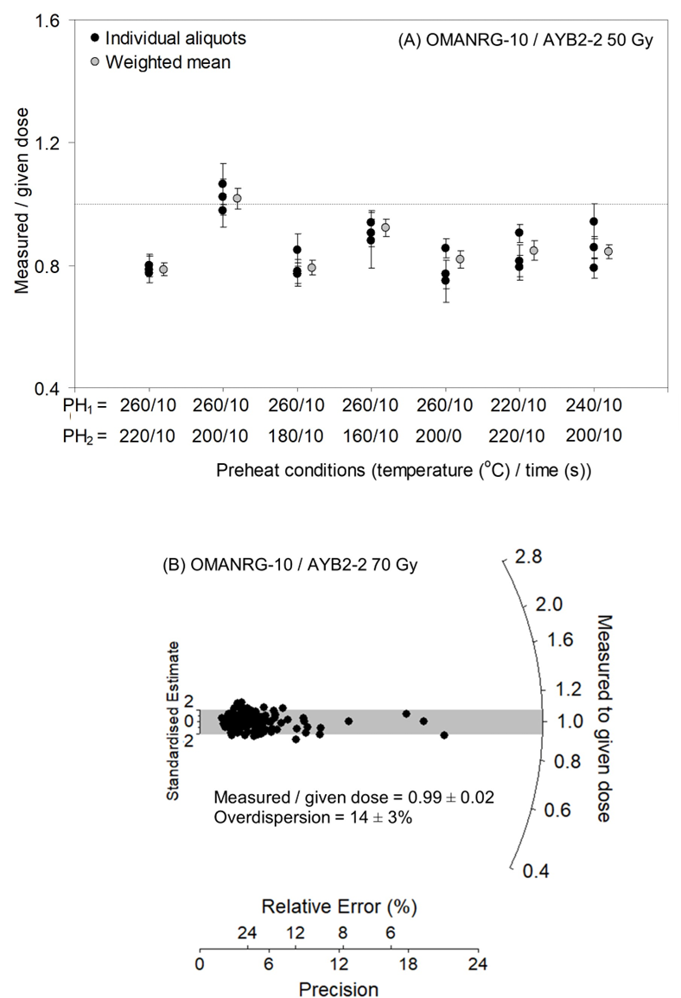
Fig. S6 | Multiple-grain and single-grain OSL dose-recovery test results. (A) Measured-to-given dose ratios versus different regenerative-dose (PH1) and test dose preheat (PH2) conditions for ~180-grain aliquots of sample OMANRG-10. The natural OSL signals of the multi-grain aliquots were optically bleached with two 1000 s blue LED illuminations at ambient temperature, each separated by a 10 000 s pause. A known dose of 50 Gy was then administered to each aliquot and a multi-grain aliquot version of the SAR procedure shown in Table S1 was subsequently used to estimate this dose. (B) Measured-to-given dose ratios obtained for individual quartz grains of sample OMANRG-10 in the 70 Gy single-grain SAR dose-recovery test (PH1 = 260 oC, 10s; PH2 = 200 oC, 10 s). The grey shaded region in plot B is centred on the weighted mean measured to given dose ratio. Individual De values that fall within the shaded region are consistent with the weighted mean measured to given dose ratio at 2σ.

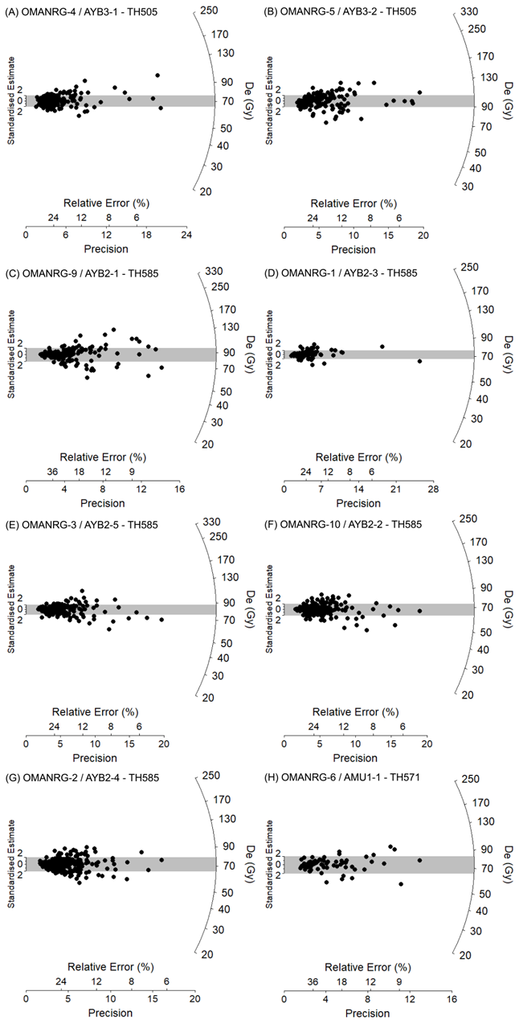
Fig. S7 | Single-grain equivalent dose (De) distributions for the OSL samples. The grey bands on these radial plots are centred on the weighted mean De values used for age calculation, which were derived using the central age model²³. Individual De values that fall within the shaded region are consistent with the weighted mean burial dose at 2σ.

2.2. Bayesian age modelling
CQL code used to construct the Dhofar Nubian Phase model in OxCal v4.4.4⁵⁰:
Plot()
{
Outlier_Model("General",T(5),U(0,4),"t");
Sequence("Dhofar Nubian")
{
Boundary("Start Dhofar Nubian");
Phase("Dhofar Nubian Phase")
{
Date("AYB1-2", N(calBP(107013), 9000))
{
color="mediumblue";
Outlier("General", 0.05);
};
Date("AYB1-1", N(calBP(106013), 9000))
{
color="mediumblue";
Outlier("General", 0.05);
};
Date("OMANRG-5", N(calBP(106517), 6351))
{
color="mediumblue";
Outlier("General", 0.05);
};
Date("OMANRG-4", N(calBP(106243), 6345))
{
color="mediumblue";
Outlier("General", 0.05);
};
Date("OMANRG-6", N(calBP(104547), 7119))
{
color="mediumblue";
Outlier("General", 0.05);
};
Date("OMANRG-10", N(calBP(101256), 5967))
{
color="mediumblue";
Outlier("General", 0.05);
};
Date("OMANRG-2", N(calBP(100621), 5725))
{
color="mediumblue";
Outlier("General", 0.05);
};
Date("OMANRG-3", N(calBP(99878), 5525))
{
color="mediumblue";
Outlier("General", 0.05);
};
Date("OMANRG-1", N(calBP(100769), 6435))
{
color="mediumblue";
Outlier("General", 0.05);
};
Date("OMANRG-9", N(calBP(95289), 5725))
{
color="mediumblue";
Outlier("General", 0.05);
};
Date("Dhofar Nubian age");
};
Boundary("End Dhofar Nubian");
};
};
Table S5 | Summary of Bayesian modelling results for the Dhofar Nubian sites. The likelihood (unmodelled) and posterior (modelled) age ranges are presented for each of the numerical dating samples. Posterior (modelled) ranges are also shown for the modelled age of the Dhofar Nubian industry and the delineating start and end boundaries of the Phase model. Posterior ages are presented as the 68.3% and 95.4% highest probability density ranges. The mean and 1σ uncertainty ranges of the modelled posterior distributions are shown for comparison (assuming a normally distributed probability density function). The unmodelled and modelled age estimates have been rounded to the nearest 10 years. The last three columns summarise the convergence integrals, posterior outlier probabilities and agreement indices for all individual posterior distributions. The A_{model} value provides a measure of correspondence between the measurement data and the modelled posterior distributions as a whole. The A_{overall} values provide a measure of correspondence between individual likelihood and posterior distributions.
 |  | Unmodelled age (ka BP) |  |  | Modelled age (ka BP) |  |  | Agreement
 | Dating sample | 68.3% | 95.4% | Mean ± 1σ | 68.3% | 95.4% | Mean ± 1σ | index (%) | Post. (%) | Conv. (%)
Dhofar Nubian ageª |  |  |  |  | 105.1–99.1 | 109.2–95.1 | 102.1 ± 3.4 |  |  | 99.9
End Dhofar Nubian |  |  |  |  | 102.8–96.2 | 105.1–91.6 | 98.8 ± 3.5 |  |  | 96.5
 | OMANRG-9 | 101.2–89.4 | 106.7–83.8 | 95.3 ± 5.7 | 104.3–98.7 | 107.0–94.9 | 101.2 ± 3.0 | 81.6 | 5.0 | 100.0
 | OMANRG-1 | 107.4–94.1 | 113.6–87.9 | 100.8 ± 6.4 | 104.8–99.1 | 108.1–95.8 | 102.0 ± 3.0 | 127.3 | 4.8 | 100.0
 | OMANRG-3 | 105.6–94.2 | 110.9–88.8 | 99.9 ± 5.5 | 104.7–99.1 | 107.6–95.8 | 101.8 ± 2.9 | 120.3 | 4.8 | 100.0
 | OMANRG-2 | 106.5–94.7 | 112.1–89.2 | 100.6 ± 5.7 | 104.8–99.1 | 107.8–95.9 | 101.9 ± 2.9 | 124.5 | 4.8 | 100.0
 | OMANRG-10 | 107.3–95.2 | 113.2–89.3 | 101.3 ± 6.0 | 104.8–99.2 | 108.1–95.8 | 102.0 ± 2.9 | 127.0 | 4.8 | 99.8
 | OMANRG-6 | 111.8–97.3 | 118.8–90.3 | 104.5 ± 7.1 | 105.1–99.3 | 109.0–95.3 | 102.4 ± 3.1 | 125.3 | 4.9 | 100.0
 | OMANRG-4 | 112.8–99.7 | 118.9–93.6 | 106.2 ± 6.3 | 105.3–99.5 | 109.0–96.6 | 102.6 ± 3.0 | 111.7 | 4.9 | 100.0
 | OMANRG-5 | 113.0–100.0 | 119.2–93.8 | 106.5 ± 6.4 | 105.3–99.5 | 108.9–96.6 | 102.6 ± 3.0 | 109.6 | 4.9 | 100.0
 | AYB1-OSL01 | 115.3–96.7 | 124.0–88.0 | 106.0 ± 9.0 | 105.3–99.1 | 109.2–95.9 | 102.4 ± 3.2 | 124.3 | 4.9 | 100.0
 | AYB1-OSL02 | 116.3–97.7 | 125.0–89.0 | 107.0 ± 9.0 | 105.4–99.2 | 109.2–96.0 | 102.5 ± 3.2 | 119.1 | 4.9 | 100.0
Start Dhofar Nubian |  |  |  |  | 108.0–101.3 | 113.2–99.0 | 105.5 ± 3.7 |  |  | 96.6
 |  |  |  |  |  |  |  | A_{model} = 156.8
 |  |  |  |  |  |  |  | A_{overall} = 157.2
ª Modelled age range has been calculated from the posterior probabilities of the start and end boundaries of the Dhofar Nubian Phase model using the date query function in OxCal v4.4.

Lithic Assemblages

3.1. Assemblage composition
The three sites yielded a combined total of 655 lithic artefacts from stratified and surface contexts (Fig. S8; Tables S6-S8). All artefacts were manufactured from large (~20-40 cm) slabs of Paleocene-Eocene chert that outcrop locally. The three assemblages are technologically consistent with the Dhofar Nubian industry as defined by Rose et al.⁵¹. Large Nubian Levallois cores dominate the prepared core component at each site (Fig. S9): 69% at TH505 (22/32 Levallois cores), 91% at TH571 (64/70 Levallois cores), and 80% at TH584 (4/5 Levallois cores). Alternative Levallois strategies (centripetal, convergent) are rare or absent, a pattern characteristic of Dhofar Nubian assemblages and distinct from contemporaneous industries in the eastern Mediterranean and northern Arabia, where multiple Levallois variants co-occur. Non-Levallois core types, including bidirectional and unidirectional flake/blade cores, are present in minor proportions, consistent with the technological range of Dhofar Nubian assemblages documented in surface assemblages across the Nejd plateau. The low frequency of tools (Table S10; 4% of total assemblage; n=28) and the predominance of cores and primary debitage confirm the workshop character of these sites, located adjacent to chert-bearing outcrops of the Umm Er Radhuma Formation. Notably, stratified contexts at all three sites contain diagnostic Nubian Levallois cores and products, demonstrating that the dated sediments directly bracket Dhofar Nubian occupation rather than later reoccupation events.

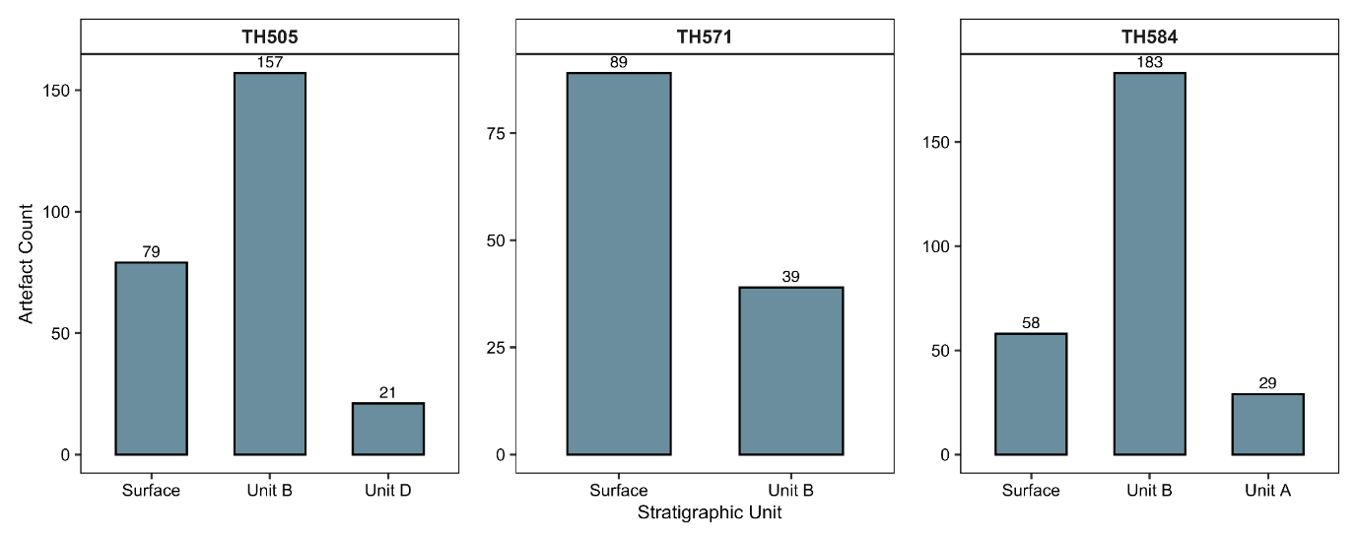Fig. S8 | Artefact counts per unit at each site.

Table S6 | TH505 (Aybut Hills 5) lithic assemblage composition by stratigraphic unit. Values in parentheses indicate percentage of column total.
Artefact Class | Artefact Type | Surface | Unit B | Unit D | Total
core | Nubian Levallois | 20 (25%) | 0 (0%) | 2 (10%) | 22
 | convergent Levallois | 0 (0%) | 0 (0%) | 1 (5%) | 1
 | indeterminate Levallois | 3 (4%) | 0 (0%) | 1 (5%) | 4
 | bidirectional | 4 (5%) | 0 (0%) | 2 (10%) | 6
 | flake | 3 (4%) | 0 (0%) | 3 (14%) | 6
 | pre-core/indeterminate | 3 (4%) | 3 (2%) | 2 (10%) | 8
 | unidirectional | 10 (13%) | 0 (0%) | 7 (33%) | 17
debitage | blade | 6 (8%) | 41 (26%) | 1 (5%) | 48
 | cortical | 1 (1%) | 5 (3%) | 0 (0%) | 6
 | flake | 20 (25%) | 104 (66%) | 1 (5%) | 125
tool | Levallois product | 9 (11%) | 4 (3%) | 1 (5%) | 14
TOTAL |  | 79 | 157 | 21 | 257

Table S7 | TH571 (Upper Amut 1) lithic assemblage composition by stratigraphic unit. Values in parentheses indicate percentage of column total.
Artefact Class | Artefact Type | Surface | Unit B | Total
chip | chip | 0 (0%) | 1 (3%) | 1
core | Nubian Levallois | 64 (72%) | 0 (0%) | 64
 | centripetal Levallois | 2 (2%) | 0 (0%) | 2
 | convergent Levallois | 2 (2%) | 0 (0%) | 2
 | indeterminate Levallois | 2 (2%) | 0 (0%) | 2
 | bidirectional | 6 (7%) | 0 (0%) | 6
 | flake | 1 (1%) | 1 (3%) | 2
 | pre-core/indeterminate | 1 (1%) | 1 (3%) | 2
 | unidirectional | 1 (1%) | 1 (3%) | 2
debitage | blade | 0 (0%) | 6 (15%) | 6
 | cortical | 0 (0%) | 4 (10%) | 4
 | flake | 0 (0%) | 22 (56%) | 22
tool | Levallois product | 8 (9%) | 2 (5%) | 10
 | retouched_piece | 1 (1%) | 0 (0%) | 1
 | sidescraper | 1 (1%) | 1 (3%) | 2
TOTAL |  | 89 | 39 | 128

Table S8 | TH584 (Aybut Hills 6) lithic assemblage composition by stratigraphic unit. Values in parentheses indicate percentage of column total.
Artefact Class | Artefact Type | Surface | Unit A | Unit B | Total
chip | chip | 0 (0%) | 3 (10%) | 43 (23%) | 46
core | Nubian Levallois | 2 (3%) | 1 (3%) | 1 (1%) | 4
 | indeterminate Levallois | 0 (0%) | 0 (0%) | 1 (1%) | 1
 | bidirectional | 0 (0%) | 0 (0%) | 1 (1%) | 1
 | flake | 0 (0%) | 0 (0%) | 1 (1%) | 1
 | pre-core/indeterminate | 0 (0%) | 0 (0%) | 9 (5%) | 9
 | unidirectional | 0 (0%) | 1 (3%) | 2 (1%) | 3
debitage | blade | 8 (14%) | 3 (10%) | 19 (10%) | 30
 | cortical | 15 (26%) | 4 (14%) | 22 (12%) | 41
 | flake | 33 (57%) | 17 (59%) | 83 (45%) | 133
tool | endscraper | 0 (0%) | 0 (0%) | 1 (1%) | 1
TOTAL |  | 58 | 29 | 183 | 270

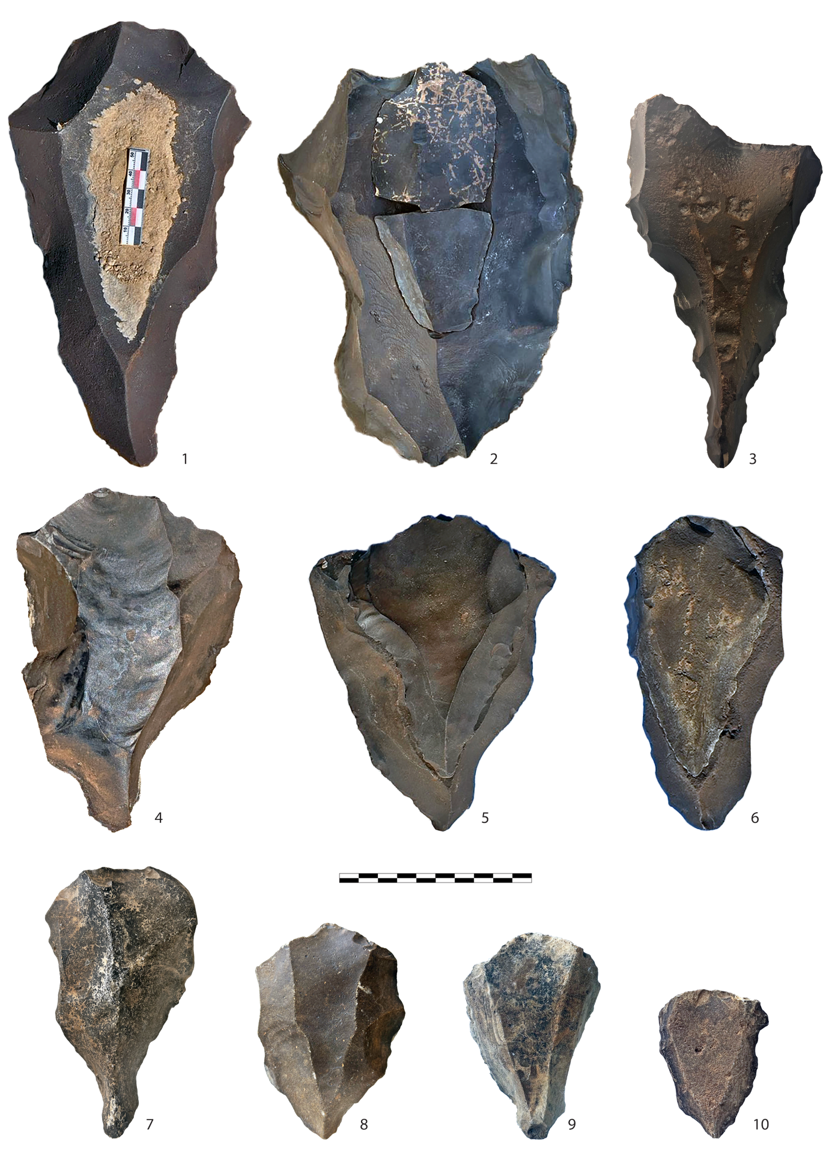
Fig. S9 | Selected Nubian Levallois cores from surface contexts at study sites. 1, 4, 5, 6: Cores from TH505. 2-3: Cores from TH571. 7-10: Cores from TH584. Specimens depicted in 2, 5, 6 are shown with refit Nubian Levallois points. Scale bar = 10 cm.
Table S9 | Core metric attributes by reduction strategy and site. Values are means with standard deviations in parentheses. Geometric mean = ∛(L × W × T). Elongation index = Length/Width.
Site | Core Type | n | Length (mm) | Width (mm) | Thickness (mm) | Geometric Mean | Elongation Index
TH505 | Bidirectional | 6 | 118.6 (17.8) | 78.3 (21.8) | 51.2 (6.9) | 77.3 (9.4) | 1.58 (0.33)
 | Nubian | 19 | 116.6 (27.7) | 85.2 (22.9) | 41.3 (10.1) | 73.7 (15.6) | 1.4 (0.27)
 | Unidirectional | 16 | 112.1 (21.9) | 69.2 (20.6) | 56.3 (18.5) | 73.8 (10.9) | 1.73 (0.55)
TH571 | Bidirectional | 5 | 129.1 (7.8) | 97 (15.7) | 41.1 (11) | 79.5 (8.8) | 1.36 (0.26)
 | Nubian | 60 | 125.4 (20.4) | 88.8 (15.4) | 39.6 (8.8) | 75.5 (10.8) | 1.43 (0.24)
 | Unidirectional | 2 | 96.2 (6.3) | 71 (9.8) | 48 (14.7) | 68.6 (8.8) | 1.37 (0.28)
TH584 | Bidirectional | 1 | 139.1 (NA) | 44.2 (NA) | 101.4 (NA) | 85.4 (NA) | 3.15 (NA)
 | Nubian | 3 | 111.5 (21.7) | 79 (9.2) | 36.7 (7.6) | 68.5 (11.4) | 1.4 (0.11)
 | Unidirectional | 3 | 134.4 (26.9) | 55.1 (21.2) | 62.6 (22.2) | 74.6 (3.3) | 2.8 (1.57)
TOTAL |  | 115
Table S10 | Retouched tool types by site. Counts represent all stratigraphic units combined.
Tool Type | TH.505 | TH.571 | TH.584 | Total
Levallois blank | 14 | 10 | 0 | 24
Sidescraper | 0 | 2 | 0 | 2
Retouched point | 0 | 1 | 0 | 1
Endscraper | 0 | 0 | 1 | 1
TOTAL | 14 | 13 | 1 | 28

3.2. Lithic database guide
The lithic database can be found in the accompanying file: lithic_database_20260109.csv. Each row in the spreadsheet represents an individual artefact and each column is a qualitative or quantitative variable. The variables are as follows:
Site. Dhofar Archaeological Project (DAP) site designations all have a two-letter prefix signifying the wilayat (local municipality) where the site was found, followed by a sequential numeral. Our surveys on the Nejd Plateau were carried out within wilaya Thumrait (TH), Muqshin (MU), and Shalim (SJ). It should be noted that we used the 2010 wilaya boundaries for naming sites, which are subject to change.
Industry. Sites from the Rose et al.⁵¹ database are assigned to either Mudayyan (Cluster III) or Dhofar Nubian (Cluster I/II) industries. Sites from this study are assigned to Excavated Sites for comparative purposes.
Art_No. Arbitrary artefact number assigned in the lab.
Geologic_Unit. Designates stratigraphic context of each artefact.
Art_Class. Artefact class:
- debitage – identifiable blanks more than 2 cm in maximum dimension
- core – flaked raw material with more than two scars
- tool – retouched blanks and preferential products
- chip – detached pieces less than 2 cm in maximum dimension
Art_Type. Condensed list of artefact types:
- bi – bidirectional core
- blade – blade blank
- cortical – blank >50% cortex
- flake – flake blank
- indeterm – indeterminate debitage or core
- Kombewa – core on flake
- Lev_cent – centripetal Levallois core
- Lev_conv – convergent Levallois core
- Lev_indeterm – indeterminate Levallois/Nubian core
- Lev_Nub – Nubian Levallois core
- Lev_product – Levallois product (all preferential points, flake, blades)
- ortho&crossed – orthogonal or crossed core
- pre-core&indeterm – pre-core or indeterminate core
- radial&multi-plat radial or multi-platform core
- uni_blade – unidirectional blade core
- uni_flake – unidirectional flake core
Core_Type. Variable used to generate the ternary plots in R code. This column summarizes three types of cores:
- bi – bidirectional core (all configurations with opposed platforms detaching blanks from a single working surface)
- Lev_Nub – Nubian Levallois core
- uni – unidirectional core (only specimens with two or more removals to filter out tested cobbles and early stage cores)
Condition. Artefact condition. Indicates which part(s) of the specimen is intact:
- complete
- distal
- fragment
- lateral
- medial
- medial-distal
- proximal
- proximal-lateral
- proximal-medial
Nub_MDR_Angle. Angle of the median distal ridge (MDR) of Nubian Levallois cores. Measured as close to the edge as possible for consistency.
Tool_Type. Simplified tool type list:
- backed_knife – blunt cortical backing or abrupt retouch opposite the cutting edge of a blank
- burin – includes all sub-types where at least one burin spall has been removed from the edge of a blank
- denticulates – consistent serrated retouch across one complete edge of the blank
- endscraper – consistent semi-steep retouch across the distal edge of a blank
- Levallois_blank – unmodified final products of preferential cores
- notch – either single blow or retouch creating concave edge (includes single and double notches)
- perforator – includes awl, drills, and any blank with a retouched puncturing end
- retouched_piece –blank or chunk with irregular retouch
- retouched_point –blank with convergent retouch forming a pointed end
- sidescraper – consistent steep or semi-steep retouch across one or both lateral edges of a blank
- truncation – abrupt retouch across the transversal edge of a blank
Max_Length. Maximum length measured along the technical axis.
Max_Width. Maximum width measured along the technical axis.
Thickness. Thickness measured at midpoint.
Plat_Width. Width of the striking platform.
Plat_Depth. Maximum depth of the striking platform.
Pref_Scar_Length. When measurable, length of the final preferential scar on a prepared working surface.
Pref_Scar_Width. When measurable, width of the final preferential scar on a prepared working surface.
Geo_Mean. Geometric mean: 3√/length x width x thickness.
Index_Elongation. Index of elongation (length / width).
Bleaching. See Supplementary Information Section 4.

Lithic Taphonomy Analysis
Post-depositional processes can significantly affect the integrity of archaeological assemblages and the reliability of chronometric dates. To evaluate the taphonomic integrity of excavated contexts at TH584, we analysed the distribution of post-depositional bleaching across stratigraphic units. Bleaching is a chemical weathering process in which lithic artefacts turn progressively white as they are exposed to water-saturated alkaline sediments over time⁵². In an undisturbed depositional sequence, artefacts from deeper (older) strata should exhibit greater bleaching intensity than those from shallower (younger) strata or surface contexts.

4.1. Methods
During analysis of the TH584 assemblage, we recorded bleaching intensity for all recovered artefacts (n = 166) on a four-point ordinal scale: none, light, moderate, and heavy. Artefacts were assigned to three stratigraphic contexts: surface (n = 82), Unit A (n = 14), and Unit B (n = 70). We tested whether bleaching intensity increased systematically with stratigraphic depth using two complementary statistical approaches:
- Cochran-Armitage trend test: Tests for a monotonic trend in ordinal data (bleaching severity) across ordered groups (stratigraphic depth). This test specifically evaluates whether there is a linear increase in bleaching with depth.
- Kruskal-Wallis test with post-hoc pairwise comparisons: A non-parametric test that evaluates whether bleaching scores differ significantly among stratigraphic units, followed by Bonferroni-corrected pairwise Wilcoxon rank-sum tests to identify which units differ from one another.
All statistical analyses were conducted in R version 4.3.2 using the coin package for trend tests.

4.2. Results
Post-depositional bleaching intensity increased significantly with stratigraphic depth (Table S11; Fig. S10). Surface artefacts showed predominantly minimal bleaching (40% none, 25% light, 25% moderate) with only 10% showing heavy bleaching. In contrast, buried contexts showed progressively greater bleaching: Unit A contained 62% moderate and 38% heavy bleaching, while Unit B contained 45% moderate and 66% heavy bleaching, with no artefacts showing light or no bleaching.
The Cochran-Armitage trend test confirmed a significant increase in bleaching with depth (χ² = 49.68, df = 1, p < 0.001). The Kruskal-Wallis test similarly demonstrated significant differences in bleaching among stratigraphic units (χ² = 61.77, df = 2, p < 0.001).
Post-hoc pairwise comparisons revealed that surface artefacts differed significantly from both Unit A (p < 0.001) and Unit B (p < 0.001), while the two buried layers did not differ significantly from one another (p = 0.30, Bonferroni-corrected). This pattern indicates that both Unit A and Unit B experienced similar post-depositional groundwater conditions, while surface materials were exposed to substantially different taphonomic processes.
Table S11 | Distribution of post-depositional bleaching by stratigraphic unit at TH584. Values represent artefact counts with percentages in parentheses.
Stratigraphic Unit | None | Light | Moderate | Heavy | Total | Mean
Surface | 16 (40%) | 10 (25%) | 10 (25%) | 4 (10%) | 40 | 1.05
Unit A | 0 (0%) | 0 (0%) | 10 (62%) | 6 (38%) | 16 | 2.38
Unit B | 0 (0%) | 0 (0%) | 45 (41%) | 66 (59%) | 111 | 2.59
TOTAL |  |  |  |  | 167

4.3. Interpretation
The increase in post-depositional bleaching with stratigraphic depth provides taphonomic evidence for the integrity of the depositional sequence at TH584. This pattern is consistent with progressively longer exposure to groundwater saturation in deeper contexts, as would be expected in an undisturbed archaeological deposit.
The lack of significant difference between Units A and B, despite both differing significantly from surface contexts, indicates that both buried layers appear to have undergone comparable groundwater-influenced weathering; hence, likely represent a continuous depositional phase. This interpretation is supported by the homogenous lithic assemblage, which argues against a scenario of widely separated events. The marked difference between surface and buried contexts reflects the distinct taphonomic histories of these assemblages: surface materials have been subjected to chemical varnish, aeolian polishing, and mechanical edge damage, while buried materials have been protected from surface processes but exposed to groundwater.
These results support the reliability of OSL ages obtained from sediments associated with Units A and B. The taphonomic data demonstrate that these layers have not been significantly disturbed by post-depositional mixing or redeposition, providing confidence that dated sediments reflect primary depositional contexts rather than reworked material. Notably, buried artefacts across all three sites exhibit fresher edge condition than surface material— sharp, pristine edges with minimal mechanical damage—indicating rapid burial following discard rather than prolonged surface exposure prior to interment. This pattern, visible in the buried lithic photos (Extended Data Fig. 1), supports a close temporal correspondence between artefact deposition and the OSL-dated sediments that house them.

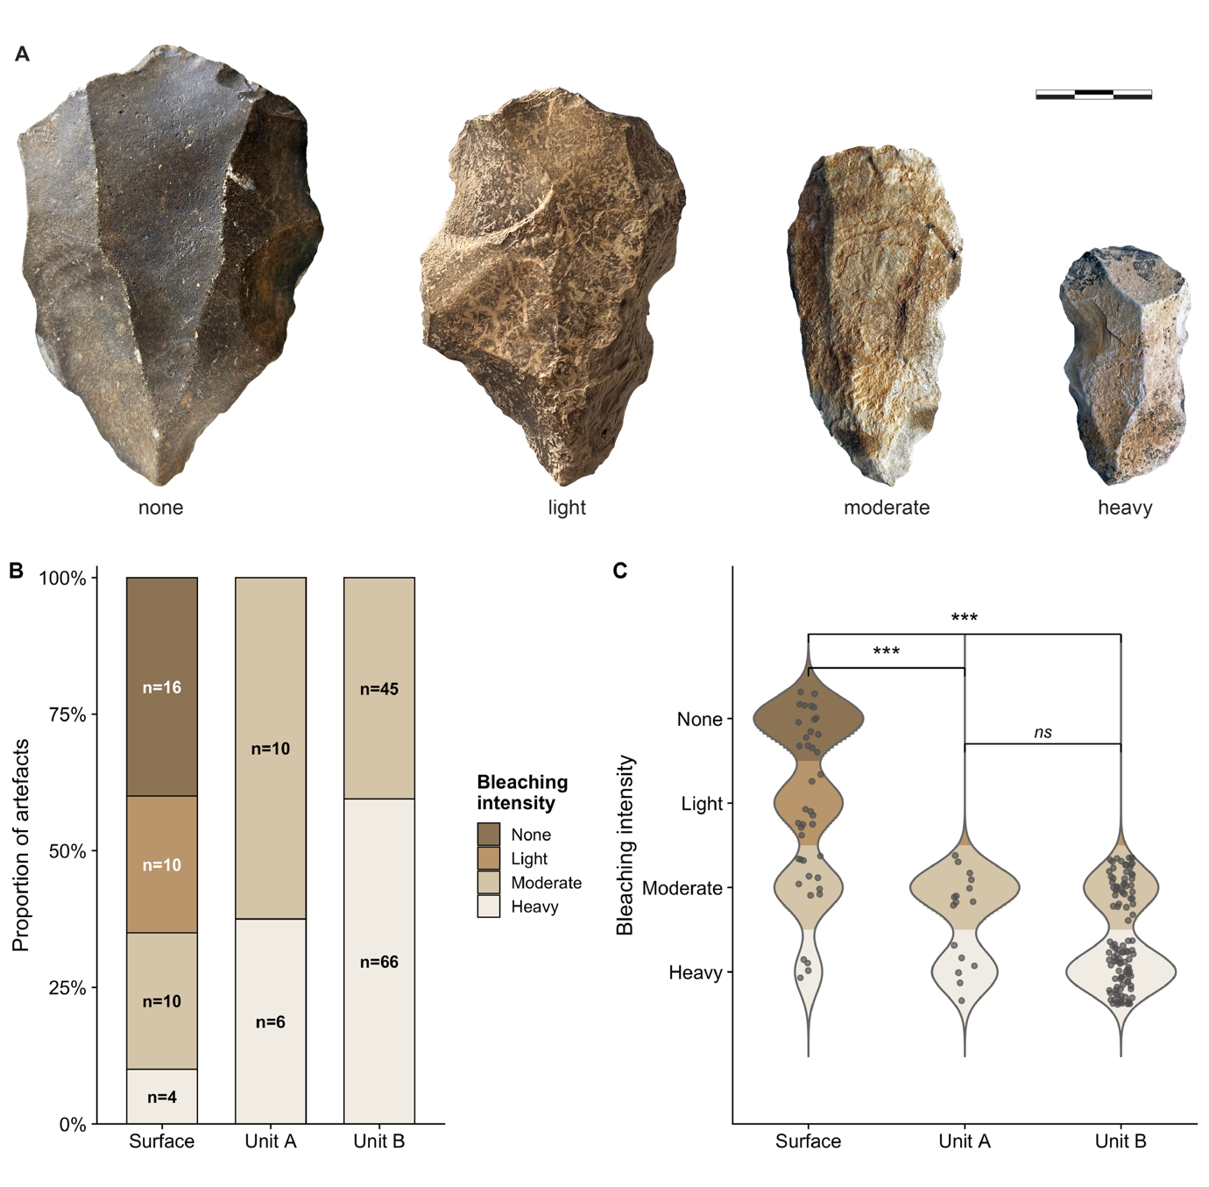
Fig. S10 | Post-depositional bleaching analysis at TH584. (A) Representative artefacts from TH584 showing the four-point bleaching scale recorded during excavation. Scale bar = 3 cm. (B) Distribution of bleaching intensity across stratigraphic contexts. Numbers inside bars indicate artefact counts. (C) Statistical comparison of bleaching intensity among stratigraphic units. Violin plots show distribution density. Individual artefacts shown as points. Brackets indicate statistical significance from post-hoc pairwise Wilcoxon tests with Bonferroni correction: *** p < 0.001, ns = not significant.

Phytolith Analysis
The samples yielded a total of 164 identifiable phytoliths. Despite low overall abundance, consistent with the antiquity of the deposits and the arid depositional environment, phytoliths were present in all samples, with counts ranging from 22 to 31 per sample. Grass (Poaceae) phytoliths dominate the assemblage, represented by bulliform/oblong cells (n=23), hair/phillaris cells (n=21), and papillae. Diagnostic multi-celled grass phytoliths, including honeycomb pentagonal forms, were identified in sample 121, confirming the presence of grasses. Spheroid echinate morphotypes potentially indicative of palms (Arecaceae) occur in four samples (n=4), though their characteristics differ from modern date palm, appearing more baculite or tuberculate than echinate. A single multi-celled phytolith consistent with woody tissue was identified in sample 122.
Table S12 | Phytolith morphotype counts by sample. Sample IDs indicate site (TH584 or TH59) and sample number. Taxonomic affiliations shown where identifiable.
Morphotype | TH.584-121 | TH.584-122 | TH.584-123 | TH.59-109 | TH.59-110 | TH.59-120 | Total
Round | 0 | 0 | 0 | 1 | 0 | 0 | 1
Oblong bulliform (Poaceae) | 5 | 1 | 0 | 16 | 0 | 1 | 23
Square | 2 | 2 | 0 | 0 | 0 | 0 | 4
Papillae | 1 | 0 | 0 | 0 | 1 | 0 | 2
Non-grass multicelled | 0 | 1 | 0 | 2 | 2 | 0 | 5
Spheroid echinate (Palmae) | 1 | 0 | 0 | 0 | 2 | 1 | 4
Square small | 14 | 22 | 13 | 3 | 13 | 27 | 92
Rod | 3 | 0 | 4 | 0 | 0 | 0 | 7
Segmented rod | 2 | 0 | 1 | 0 | 0 | 0 | 3
Hair/Phalaris (Poaceae) | 1 | 2 | 2 | 9 | 5 | 2 | 21
Tip | 0 | 0 | 2 | 0 | 0 | 0 | 2
TOTAL | 29 | 28 | 22 | 31 | 23 | 31 | 164
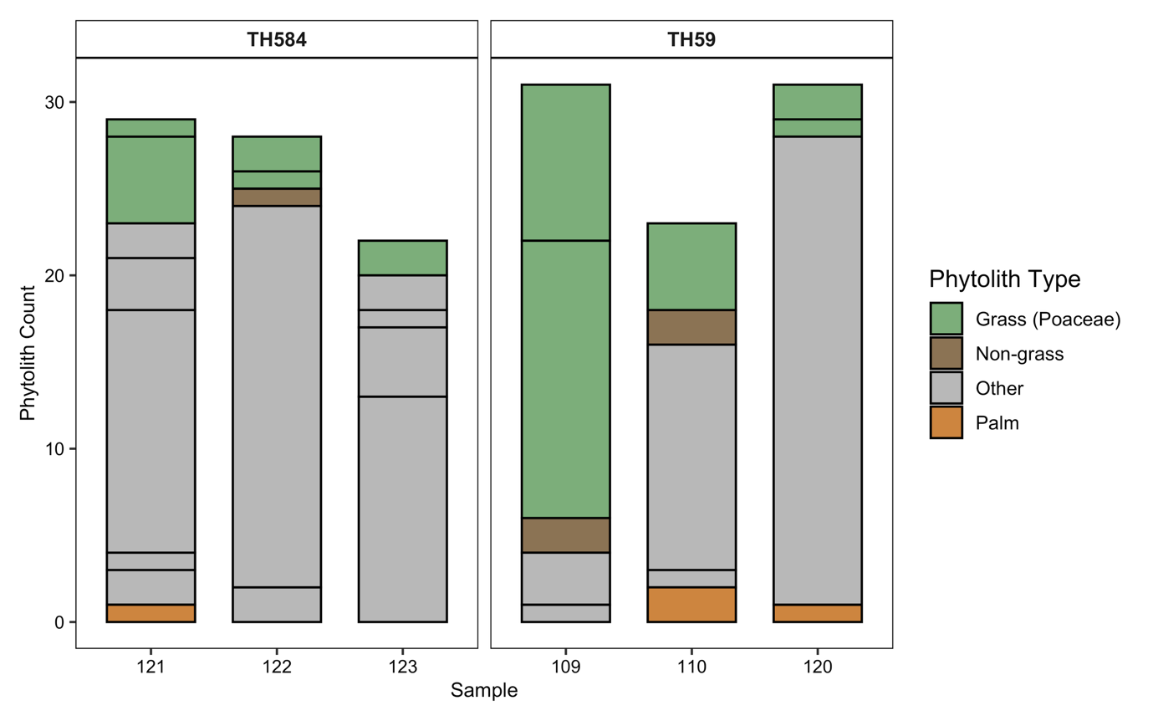
Fig. S11 | Phytolith assemblage composition by site and sample. Bar chart showing relative abundance of phytolith morphotypes from TH59 (Aybut Auwal) and TH584. Grass (Poaceae) morphotypes dominate all samples, including bulliform/oblong cells, hair/phillaris cells, and papillae. Spheroid echinate forms potentially indicative of palms (Arecaceae) occur in low frequencies. Sample numbers correspond to Table S9.

Palaeoclimatic & Archaeogenetic Framework
The regional distribution of sites with Nubian Levallois technology shown in Figure 1A was compiled from a comprehensive review of published literature. Site locations and technological assignments are compiled from refs. 1,51,53-57.
Figure 3 integrates multiple palaeoclimate proxy records with OSL chronologies for Nubian Levallois assemblages across three geographic regions: Northeast Africa (Panel A), the Negev and central/northern Arabia (Panel B), and southern Arabia (Panel C). The figure illustrates the paleoenvironmental context for the expansion of Middle Stone Age populations producing Nubian Levallois technology and identifies 'crossing windows' when both climatic conditions and Red Sea sea-levels were simultaneously favourable for dispersal via the southern route through the Bab el-Mandeb strait.

6.1. Humidity index calculation
We employ the log-transformed titanium to aluminium ratio (-log[Ti/Al]) as a humidity proxy following established methodology for marine sediment cores from the Gulf of Aden and eastern Mediterranean. Titanium is primarily found in coarse silt fractions typical of wind-blown terrigenous detritus, making it a robust indicator of aeolian dust input and, by extension, continental aridity. Aluminium serves as a dilution correction, as both elements are part of major subgroups of terrigenous input but respond differently to environmental forcing. The negative log transformation inverts the signal so that positive anomalies indicate wetter conditions (reduced dust flux) and negative anomalies indicate drier conditions (increased dust flux).

6.2. ODP Site 967 δ¹⁸O (Northeast Africa)
Panel A displays the oxygen isotope record from ODP Site 967, located at 34.068°N, 32.725°E in the eastern Mediterranean on the northern Eratosthenes Seamount at 2,252 m water depth⁵⁸. We use the δ¹⁸O record from planktonic foraminifera G. ruber as a proxy for Nile discharge intensity, which integrates precipitation across the Nile catchment including the Ethiopian Highlands—the primary moisture source for Northeast African Middle Stone Age populations. More negative δ¹⁸O values reflect enhanced freshwater discharge during humid periods. Data were obtained from the published dataset⁵⁹ and are presented as anomalies relative to the mean value across the displayed interval (190-57 ka). The gradient fill indicates the direction and magnitude of deviation from baseline conditions: green shading represents positive anomalies (wetter conditions/enhanced Nile discharge), while tan/brown shading represents negative anomalies (drier conditions/reduced discharge).

ODP Site 967 humidity index (Negev and Northern Arabia)
Panel B employs the -log(Ti/Al) humidity index derived from X-ray fluorescence (XRF) measurements of ODP Site 967 sediments. This index serves as a wetness proxy integrating conditions across the northern Nile catchment and eastern Mediterranean source regions for Saharan and African dust⁶⁰. The ODP 967 record is appropriate for the Negev and northern Arabian sites as it reflects large-scale monsoon dynamics affecting the broader eastern Mediterranean region. Data processing followed the methodology of Konijnendijk et al.⁶⁰ and Grant et al.⁵⁹, with a 5-point running mean applied for smoothing.

6.3. KL15 humidity index (Southern Arabia)
Panel C presents the -log(Ti/Al) aridity index from marine sediment core KL15, recovered from the Gulf of Aden. This core provides the most proximal palaeoclimate record to the Dhofar region and directly reflects Indian Ocean Monsoon intensity affecting southern Arabia. The KL15 record shows higher-amplitude variability than ODP 967, capturing precession-scale monsoon fluctuations relevant to the Dhofar occupation chronology. XRF data follow the methodology established by Fischer et al.⁶¹, with hierarchical cluster analysis confirming that Ti and Al represent distinct but related components of terrigenous input: aluminium correlates with silicon (fine fraction), while titanium correlates with iron (coarse aeolian fraction). The log-ratio transformation corrects for carbonate dilution effects typical of compositional data from marine archives.

6.4. Anomaly calculation and visualization
For all panels, humidity indices were converted to anomalies by subtracting the mean value across the 191-57 ka interval. A 5-point running mean was applied to reduce high-frequency noise while preserving millennial-scale variability. Anomalies are visualized using gradient-filled polygons where colour intensity scales with distance from the baseline: green gradients indicate progressively wetter conditions above the mean, while tan/brown gradients indicate progressively drier conditions below the mean. This visualization approach emphasizes the relative magnitude of climate excursions and allows direct comparison of timing across the three geographic regions.

6.5. Sea level reconstruction and the -50 m threshold
Red Sea relative sea level (RSL) data were obtained from the probabilistic reconstruction of Grant et al.⁶², which provides a continuous record for the past 500 ka based on high-resolution δ¹⁸O measurements from Red Sea sediment cores. This reconstruction accounts for changes in the oxygen isotope composition of Red Sea water caused by restricted exchange with the Indian Ocean at the Bab el-Mandeb strait during sea level lowstands.
The -50 m sea level threshold represented by the dashed maroon line in Panel C marks a key threshold in crossing conditions at the Bab el-Mandeb strait. Detailed bathymetric analysis by Lambeck et al.⁶³ and Hill et al.⁶⁴ demonstrates that when Red Sea levels drop below approximately -50 m relative to present, the minimum water crossing distance reduces to <5 km via island-hopping south of the Hanish Sill. At this threshold, crossing becomes feasible with passive rafting, without requiring sophisticated seafaring technology⁶⁵. The opposing shorelines are clearly intervisible and multiple short (<4 km) crossings are possible between emerged islands. These channel configurations remained favourable for extended periods (thousands of years) due to the steep submarine topography.
Above the -50 m threshold, crossing distances rapidly exceed 25 km with no intervisibility between shores, approximating modern conditions at the Bab el-Mandeb. The steep bathymetric profiles in the strait region mean that this transition between 'easy crossing' and 'difficult crossing' conditions is relatively abrupt rather than gradual. The -50 m threshold therefore provides a meaningful paleogeographic constraint on when southern dispersal routes into Arabia were most accessible to populations without advanced maritime capabilities.

6.6. Identification of 'crossing windows'
The light blue-shaded vertical bands in Panel C indicate periods when conditions were simultaneously favourable for dispersal through the southern route. A crossing window is defined as any interval meeting two criteria: (1) Red Sea relative sea level below -50 m (narrow crossing distance <5 km), and (2) positive humidity anomaly in the KL15 record (wetter-than-average conditions in southern Arabia). The conjunction of these factors represents intervals when human populations could both physically traverse the Bab el-Mandeb with minimal water crossing and find sufficient freshwater and ecological resources to sustain themselves in the Arabian interior after arrival.
The algorithm interpolates both sea level and humidity records to 0.1 ka resolution, identifies continuous intervals meeting both conditions, and filters for windows exceeding 200 years duration to exclude brief, potentially ephemeral opportunities. The resulting windows represent sustained periods of favourable conditions.

6.7. Homo sapiens to Neanderthal gene flow
The purple bar in Panel B indicates the estimated timing of gene flow from early Homo sapiens into Neanderthals, as inferred from genomic analyses. Li et al.⁶⁶ demonstrate that approximately .5% of Neanderthal ancestry derives from H. sapiens populations that left Africa prior to the main out-of-Africa dispersal. This introgression is estimated to have occurred between 120-100 ka, with population size analyses suggesting the contributing H. sapiens population was small (~2,500 effective individuals) and did not persist to contribute to present-day non-African ancestry. The temporal overlap between this inferred gene flow event and the spread of Nubian core technology into the eastern Mediterranean region around 110 ka suggests that populations expanding out of Africa during this interval were potentially contemporaneous with, and may have contributed to, this early episode of human-Neanderthal contact.

6.8. Data processing & software
All data processing and visualization for Figure 3 were performed in R (version 4.3.2) using the tidyverse, ggplot2, readxl, and patchwork packages. Raw proxy data were filtered to the 190-57 ka interval, smoothed with a 5-point running mean, and converted to anomalies relative to interval means. Sea level data were linearly scaled to overlay on the humidity axis in Panel C, with a secondary y-axis providing the conversion to metres relative to present. Gradient polygons were constructed by interpolating anomaly time series to 0.1 ka resolution and creating filled polygons for each 0.1 ka segment with transparency proportional to anomaly magnitude. The figure uses a colourblind-friendly palette distinguishing wet (green: #1B7837), dry (tan: #C2A05F), sea level (blue: #4575B4), and crossing windows (light blue: #3A7BA6).
Palaeoclimate proxy data are available from their original publications: ODP 967^{59,60}, KL15⁶¹, and Red Sea relative sea level⁶². Numeric ages for Northeast African, eastern Mediterranean, and southern Arabian Nubian sites are listed in Table S13. The raw data and R code used to generate Figure 3 are available for download from the OSF repository here: https://osf.io/jt7ke/.
Table S13 | Numeric ages for all Afro-Arabian Nubian Levallois sites displayed in Figure 3.
Panel A: North Africa (African Nubian Levallois Complex)
Site | Age (ka) | Uncertainty (ka) | Age Type | Method | Reference
Kharga Bulaq (KH/BQ-04) | 114 | ±2 | Minimum | U-series on tufa | 67
Kharga Mata'na G (KH/MT-02) | 128 | ±1 | Maximum | U-series on tufa | 67
Kharga Mata'na G (MAT002G) | 103 | ±7 | Minimum | U-series on tufa | 68
Kharga Midauwara (KH/MD-10) | 125 | ±2 | Maximum | U-series on tufa | 67
Taramsa 1 (OSL 897/4) | 117 | ±11 | Maximum | OSL | 69
Taramsa 1 (OSL 897/3) | 89 | ±10 | Minimum | OSL | 69
Taramsa 1 (OSL TAR-4) | 79 | ± 5 | Minimum | OSL | 69
Taramsa 1 (OSL 897/9) | 73 | ± 8 | Maximum | OSL | 69
Sodmein Cave (MP5 combined mean) | 118 | ±8 | Direct | TL | 70,71
Sodmein Cave (SodTL1) | 88 | ±10 | Direct | TL | 71
Sodmein Cave (SodTL2) | 87 | ±9 | Direct | TL | 71
Sodmein Cave (SodTL2) | 89 | ±9 | Direct | OSL | 71
Sai Island 8-B-11 | 152 | ±10 | Maximum | OSL | 72
Panel B: Negev & Northern Arabia
Site | Age (ka) | Uncertainty (ka) | Age Type | Method | Reference
Dimona South (DPV-3) | 116 | ±8 | Direct | OSL | 73
Dimona South (DPV-2) | 111 | ±11 | Direct | OSL | 73
Ein Ziq 4 (TRS-17) | 106 | ±10 | Direct | pIR-IRSL | 74,75
Ein Ziq 4 (TRS-17) | 111 | ±16 | Direct | OSL | 74,75
Ein Ziq 4 (EZK-7) | 90 | ±6 | Direct | pIR-IRSL | 75
Ein Ziq 4 (EZK-7) | 82 | ±5 | Direct | OSL | 75
Ein Ziq 4 (EZK-8) | 98 | ±7 | Direct | OSL | 75
Ein Ziq 5 (TRS-18) | 87 | ±7 | Direct | OSL | 74,75
Umm al-Sha'al (AKE31-3) | 87 | ±10 | Direct | OSL | 76
Umm al-Sha'al (AKE31-4) | 71 | ±6 | Direct | OSL | 76
Umm al-Sha'al (AKE31-5) | 81 | ±9 | Direct | OSL | 76
Panel C: Southern Arabia (Dhofar, Oman)
Site | Age (ka) | Uncertainty (ka) | Age Type | Method | Reference
Aybut Hills 5 (AYB 3-1) | 106 | ±6 | Direct | OSL | This study
Aybut Hills 5 (AYB 3-2) | 107 | ±6 | Direct | OSL | This study
Aybut Hills 4 (AYB 2-1) | 95 | ±6 | Direct | OSL | This study
Aybut Hills 4 (AYB 2-3) | 101 | ±6 | Direct | OSL | This study
Aybut Hills 4 (AYB 2-5) | 100 | ±6 | Direct | OSL | This study
Aybut Hills 4 (AYB 2-2) | 101 | ±6 | Direct | OSL | This study
Aybut Hills 4 (AYB 2-4) | 101 | ±6 | Direct | OSL | This study
Upper Amut 1 (AMU 1-1) | 105 | ±7 | Direct | OSL | This study
Aybut Auwal (AYB-OSL01) | 106 | ±9 | Direct | OSL | 47
Aybut Auwal (AYB-OSL02) | 107 | ±9 | Direct | OSL | 47
Notes:
OSL = Optically Stimulated Luminescence; TL = Thermoluminescence, U-series = Uranium-series, pIR-IRSL = post-Infrared Infrared Stimulated Luminescence.
Minimum ages indicate that the archaeological deposits are older than the dated material (radiometric ages provide terminus ante quem constraints). Maximum ages indicate that the archaeological deposits are younger than the dated material (radiometric ages provide terminus post quem constraints). Direct ages refer to cases where dating samples have been collected from sediment layers that contain archaeological materials.
All uncertainties are shown as 1σ.
For Dhofar sites, sample IDs in parentheses correspond to laboratory designations from the OSL dating summary (see Table S3 for full analytical data).
TH59 (Aybut Auwal) ages were originally published in Rose et al.⁴⁷ as a weighted mean of 107 ± 6 ka; individual sample ages shown here.

In Memoriam: Anthony E. Marks (1938–2025)
We dedicate this work to Anthony E. Marks, whose career began and ended with Nubian technology. During the UNESCO Nubian salvage campaigns of the 1960s, Tony was among the first to document this unique form of prepared core technology. More than half a century later, the same technological signature unexpectedly appeared thousands of kilometres away in the deserts of southern Oman. From the Nile valley to the Nejd plateau, Tony's intellectual legacy spans the full geographic range of this distinctive techno-cultural phenomenon. A fuller account of his contributions to Palaeolithic archaeology appears in Rose et al.⁷⁷.
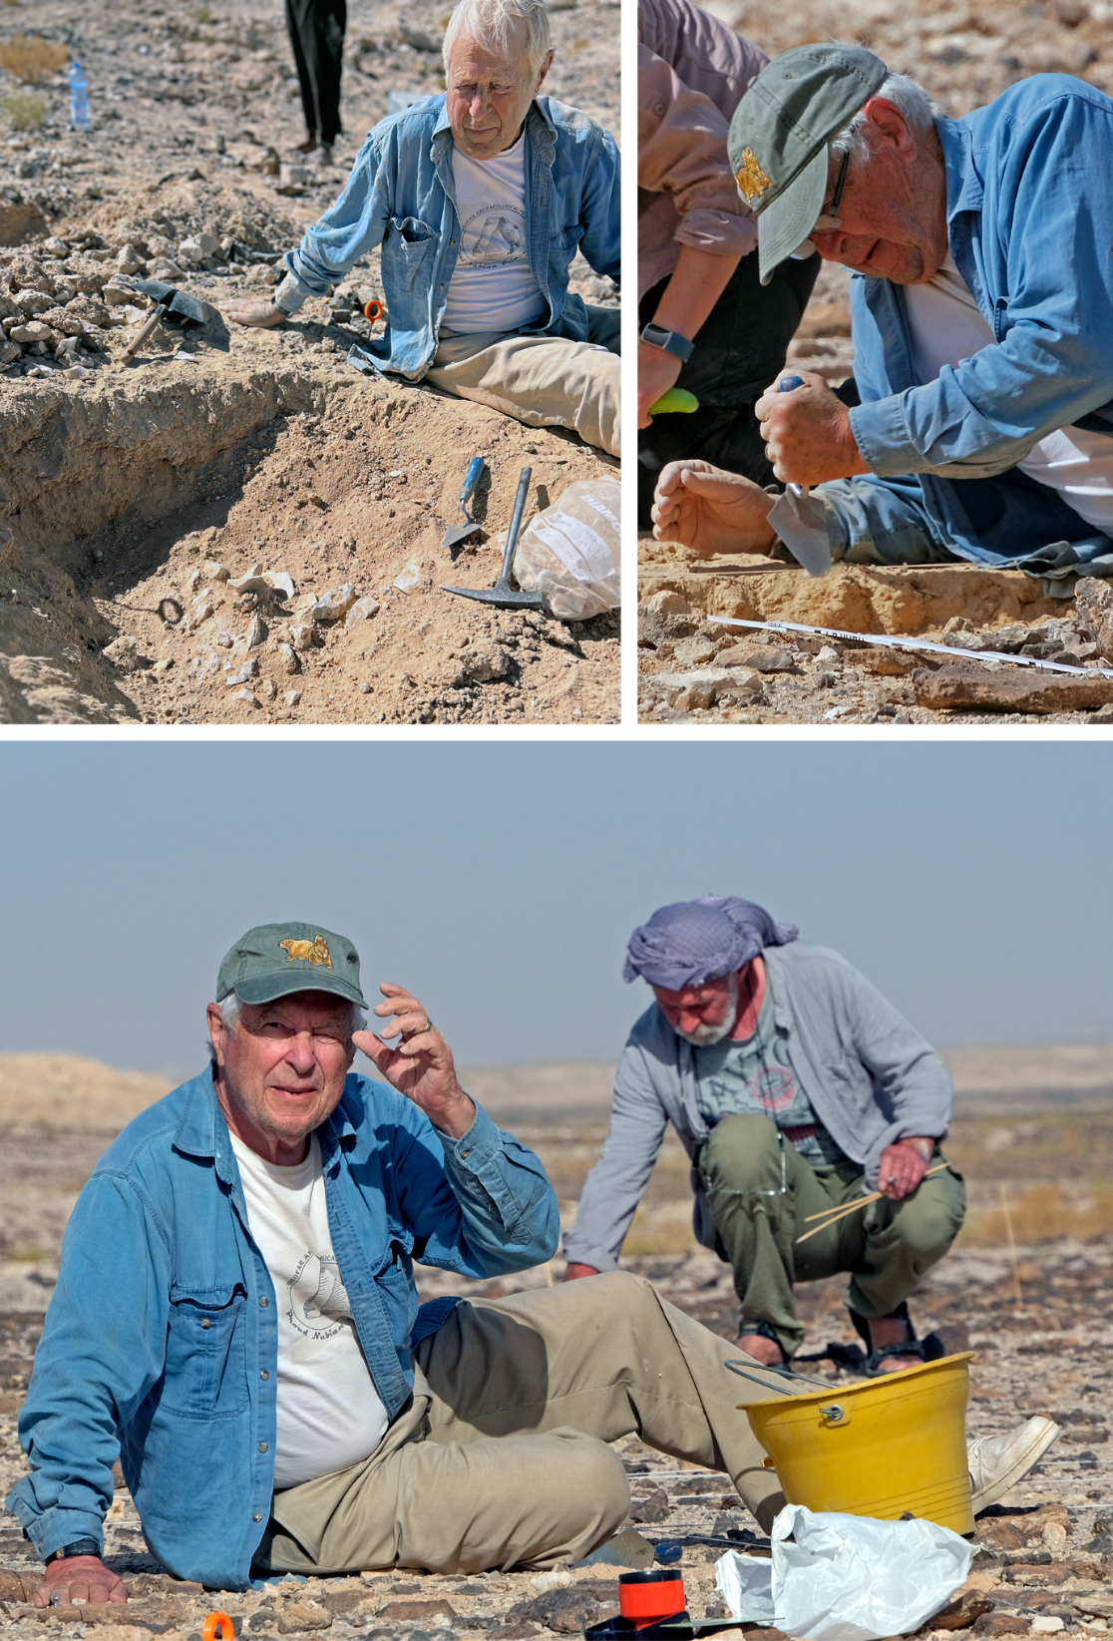
Fig. S12 | Anthony E. Marks excavating Aybut Hills 5 & 6 during the 2023 field season.

References
      - Rose, J. I. et al. Prehistoric settlement patterns in southern Oman from the Lower Palaeolithic to the Neolithic. Paléorient 49, 83–108 (2023).
      - Aitken, M. J. An Introduction to Optical Dating (Oxford University Press, 1998).
      - Arnold, L. J., Demuro, M. & Navazo Ruiz, M. Empirical insights into multi-grain averaging effects from ‘pseudo’ single-grain OSL measurements. Radiat. Meas. 47, 652–658 (2012).
      - Demuro, M., Arnold, L. J., Froese, D. G. & Roberts, R. G. OSL dating of loess deposits bracketing Sheep Creek tephra beds, northwest Canada: Dim and problematic single-grain OSL characteristics and their effect on multi-grain age estimates. Quat. Geochronol. 15, 67–87 (2013).
      - Arnold, L. J. et al. OSL dating of individual quartz 'supergrains' from the Ancient Middle Palaeolithic site of Cuesta de la Bajada, Spain. Quat. Geochronol. 36, 78–101 (2016).
      - Arnold, L. J. et al. Examining sediment infill dynamics at Naracoorte Cave megafauna sites using multiple luminescence dating signals. Quat. Geochronol. 70, 101301 (2022).
      - Demuro, M., Arnold, L. J., Aranburu, A., Gómez-Olivencia, A. & Arsuaga, J. L. Single-grain OSL dating of the Middle Palaeolithic site of Galería de las Estatuas, Atapuerca (Burgos, Spain). Quat. Geochronol. 49, 254–261 (2019).
      - Duller, G. A. T. Distinguishing quartz and feldspar in single grain luminescence measurements. Radiat. Meas. 37, 161–165 (2003).
      - Galbraith, R. A note on the variance of a background-corrected OSL count. Ancient TL 20, 49–51 (2002).
      - Jacobs, Z., Duller, G. A. T. & Wintle, A. G. Interpretation of single-grain D_{e} distributions and calculation of D_{e}. Radiat. Meas. 41, 264–277 (2006).
      - Duller, G. A. T. Assessing the error on equivalent dose estimates derived from single aliquot regenerative dose measurements. Ancient TL 25, 15–24 (2007).
      - Hansen, V., Murray, A., Buylaert, J.-P., Yeo, E.-Y. & Thomsen, K. A new irradiated quartz for beta source calibration. Radiat. Meas. 81, 123–127 (2015).
      - Yoshida, H., Roberts, R. G., Olley, J. M., Laslett, G. M. & Galbraith, R. F. Extending the age range of optical dating using single ‘supergrains’ of quartz. Radiat. Meas. 32, 439–446 (2000).
      - Arnold, L. J. et al. Paper II – dirt, dates and DNA: OSL and radiocarbon chronologies of perennially frozen sediments in Siberia and their implications for sedimentary ancient DNA studies. Boreas 40, 417–445 (2011).
      - Arnold, L. J. et al. Optical dating of perennially frozen deposits associated with preserved ancient plant and animal DNA in north-central Siberia. Quat. Geochronol. 3, 114–136 (2008).
      - Jacobs, Z. et al. The age of three Middle Palaeolithic sites: single-grain optically stimulated luminescence chronologies for Pech de l'Azé I, II and IV in France. J. Hum. Evol. 95, 80–103 (2016).
      - Arnold, L.J., Roberts, R.G. Stochastic modelling of multi-grain equivalent dose (De) distributions: Implications for OSL dating of sediment mixtures. Quat. Geochronol. 4, 204–230 (2009).
      - Bailey, R. M. & Arnold, L. J. Statistical modelling of single grain quartz D_{e}​ distributions and an assessment of procedures for estimating burial dose. Quat. Sci. Rev. 25, 2475–2502 (2006).
      - Demuro, M. et al. Chronological constraint of Neanderthal cultural and environmental changes in southwestern Europe: MIS 5–MIS 3 dating of the Axlor site (Biscay, Spain). J. Quat. Sci. 38, 890–920 (2023).
      - Arnold, L. J. et al. Single-grain TT-OSL bleaching characteristics: Insights from modern analogues and OSL dating comparisons. Quat. Geochronol. 49, 45–51 (2019).
      - Arnold, L.J., Roberts, R.G. Paper I – Optically stimulated luminescence (OSL) dating of perennially frozen deposits in north-central Siberia: OSL characteristics of quartz grains and methodological considerations regarding their suitability for dating. Boreas 40, 389–416 (2011).
      - Arnold, L. J., Roberts, R. G., Galbraith, R. F. & DeLong, S. B. A revised burial dose estimation procedure for optical dating of young and modern-age sediments. Quat. Geochronol. 4, 306–325 (2009).
      - Galbraith, R. F., Roberts, R. G., Laslett, G. M., Yoshida, H. & Olley, J. M. Optical dating of single and multiple grains of quartz from Jinmium rock shelter, northern Australia: part I, experimental design and statistical models. Archaeometry 41, 339–364 (1999).
      - Arnold, L. J. et al. OSL dating of the Middle Palaeolithic Hotel California site, Sierra de Atapuerca, north-central Spain. Boreas 42, 285–305 (2013).
      - Galbraith, R. F., Roberts, R. G. & Yoshida, H. Error variation in OSL palaeodose estimates from single aliquots of quartz: a factorial experiment. Radiat. Meas. 39, 289–307 (2005).
      - Nathan, R. P., Thomas, P. J., Jain, M., Murray, A. S. & Rhodes, E. J. Environmental dose rate heterogeneity of beta radiation and its implications for luminescence dating: Monte Carlo modelling and experimental validation. Radiat. Meas. 37, 305–313 (2003).
      - Arnold, L. J. et al. Luminescence dating and palaeomagnetic age constraint on hominins from Sima de los Huesos, Atapuerca, Spain. J. Hum. Evol. 67, 85–107 (2014).
      - Martin, L. et al. Dosimetric study of sediments at the beta dose rate scale: Characterization and modelization with the DosiVox software. Radiat. Meas. 81, 134–141 (2015).
      - Smedley, R. K., Duller, G. A. T., Rufer, D. & Utley, J. E. P. Empirical assessment of beta dose heterogeneity in sediments: implications for luminescence dating. Quat. Geochronol. 56, 101052 (2020).
      - Řanda, Z., Vobecký, M., Kuncíř, J. & Benada, J. Multielement standards in routine reactor neutron activation analysis. J. Radioanal. Chem. 46, 95–107 (1978).
      - Řanda, Z., Kučera, J. & Soukal, L. Elemental characterization of the new Czech meteorite Morávka by neutron and photon activation analysis. J. Radioanal. Nucl. Chem. 257, 275–283 (2003).
      - Kučera, J., Mizera, J., Řanda, Z. & Vávrová, M. Pollution of agricultural crops with lanthanides, thorium and uranium studied by instrumental and radiochemical neutron activation analysis. J. Radioanal. Nucl. Chem. 271, 581–587 (2007).
      - Guérin, G., Mercier, N. & Adamiec, G. Dose-rate conversion factors: update. Ancient TL 29, 5–8 (2011).
      - Aitken, M. J. Thermoluminescence Dating (Academic Press, 1985).
      - Prescott, J. R. & Hutton, J. T. Cosmic and gamma ray dosimetry for TL and ESR. Nucl. Tracks Radiat. Meas. 14, 223–227 (1988).
      - Prescott, J. R. & Hutton, J. T. Cosmic ray contributions to dose rates for luminescence and ESR dating: large depths and long-term time variations. Radiat. Meas. 23, 497–500 (1994).
      - Mejdahl, V. Internal radioactivity in quartz and feldspar grains. Ancient TL 5, 10–17 (1987).
      - Bowler, J. M. et al. New ages for human occupation and climatic change at Lake Mungo, Australia. Nature 421, 837–840 (2003).
      - Jacobs, Z. et al. Extending the chronology of deposits at Blombos Cave, South Africa, back to 140 ka using optical dating of single and multiple grains of quartz. J. Hum. Evol. 51, 255–273 (2006).
      - Pawley, S. M. et al. Age limits on Middle Pleistocene glacial sediments from OSL dating, north Norfolk, UK. Quat. Sci. Rev. 27, 1363–1377 (2008).
      - Lewis, R. J. et al. Insights into subtropical Australian aridity from Welsby Lagoon, north Stradbroke Island, over the past 80,000 years. Quat. Sci. Rev. 234, 106262 (2020).
      - Rees-Jones, J. Optical dating of young sediments using fine-grain quartz. Ancient TL 13, 9–14 (1995).
      - Rees-Jones, J. & Tite, M. S. Optical dating results for British archaeological sediments. Archaeometry 39, 177–187 (1997).
      - Mejdahl, V. Thermoluminescence dating: beta-dose attenuation in quartz grains. Archaeometry 21, 61–72 (1979).
      - Brennan, B. J. Beta doses to spherical grains. Radiat. Meas. 37, 299–303 (2003).
      - Readhead, M. L. Thermoluminescence dose rate data and dating equations for the case of disequilibrium in the decay series. Nucl. Tracks Radiat. Meas. 13, 197–207 (1987).
      - Rose, J. I. et al. The Nubian Complex of Dhofar, Oman: an African Middle Stone Age industry in southern Arabia. PLoS ONE 6, e28239 (2011).
      - Matter, A. et al. Reactivation of the Pleistocene trans-Arabian Wadi ad Dawasir fluvial system (Saudi Arabia) during the Holocene humid phase. Geomorphology 270, 88–101 (2016).
      - Bretzke, K. et al. Archaeology, chronology, and sedimentological context of the youngest Middle Palaeolithic assemblage from Jebel Faya, United Arab Emirates. Archaeol. Anthropol. Sci. 17, 60 (2025).
      - Bronk Ramsey, C. Bayesian analysis of radiocarbon dates. Radiocarbon 51, 337–360 (2009).
      - Rose, J. I. et al. Lithic miniaturization and technological innovation on the Southern Dispersal Route out of Africa. J. Paleolithic Archaeol. 8, 40 (2025).
      - Borrazzo, K. Lithic taphonomy in desert environments: Contributions from Fuego-Patagonia (southern South America). Quat. Int. 422, 19–28 (2016).
      - Demidenko, Y. E., Le Tensorer, J.-M. & von Falkenstein-Wirth, V. The Nubian Levallois technology in central Syria in the context of the Middle-Upper Palaeolithic transitional period and the IUP variability in the Eastern Mediterranean Levant. Litikum 11, 9–34 (2023).
      - Hallinan, E. A synthesis and critical inventory of Nubian cores in Middle Stone Age and Middle Palaeolithic assemblages. J. Open Archaeol. Data 12, 9 (2024).
      - Samawi, O. & Hallinan, E. More than surface finds: Nubian Levallois core metric variability and site distribution across Africa and Southwest Asia. J. Paleolithic Archaeol. 7, 26 (2024).
      - Chlachula, D. et al. Evidence of Middle Palaeolithic human occupation in south-central Oman. Antiquity 99(404), e9 (2025).
      - Hilbert, Y. H. et al. Nubian cores along the coast of the central Levantine corridor: Exploring variability of Levallois point production in Lebanon. J. Paleolithic Archaeol. 9, 3 (2026).
      - Emeis, K.-C. et al. Proc. Ocean Drill. Prog. Init. Rep. 160 (1996).
      - Grant, K. M. et al. A 3 million year index for North African humidity/aridity and the implication of potential pan-African humid periods. Quat. Sci. Rev. 171, 100–118 (2017).
      - Konijnendijk, T. Y. M. et al. Chronological constraints on Pleistocene sapropel depositions from high-resolution geochemical records of ODP Sites 967 and 968. Newsletters on Stratigraphy 47, 263–282 (2014).
      - Fischer, M. L. et al. Spatio-temporal variations of climate along possible African–Arabian routes of H. sapiens expansion. Quat. Sci. Adv. 14, 100174 (2024).
      - Grant, K. M. et al. Sea-level variability over five glacial cycles. Nat. Commun. 5, 5076 (2014).
      - Lambeck, K. et al. Sea level and shoreline reconstructions for the Red Sea: isostatic and tectonic considerations and implications for hominin migration out of Africa. Quat. Sci. Rev. 30, 3542–3574 (2011).
      - Hill, J. et al. Sea-level change, palaeotidal modelling and hominin dispersals: The case of the southern Red Sea. Quat. Sci. Rev. 293, 107719 (2022).
      - Hölzchen, E. et al. Estimating crossing success of human agents across sea straits out of Africa. Palaeogeogr. Palaeoclimatol. Palaeoecol. 590, 110845 (2022).
      - Li, L., Comi, T. J., Bierman, R. F. & Akey, J. M. Recurrent gene flow between Neanderthals and modern humans over the past 200,000 years. Science 385, eadi1768 (2024).
      - Smith, J. R. et al. New age constraints on the Middle Stone Age occupations of Kharga Oasis, Western Desert, Egypt. J. Hum. Evol. 52, 690–701 (2007).
      - Smith, J. R. et al. A reconstruction of Quaternary pluvial environments and human occupations using stratigraphy and geochronology of fossil-spring tufas, Kharga Oasis, Egypt. Geoarchaeology 19, 407–439 (2004).
      - Van Peer, P., Vermeersch, P. M. & Paulissen, E. Chert Quarrying, Lithic Technology and a Modern Human Burial at the Palaeolithic Site of Taramsa 1, Upper Egypt (Leuven University Press, 2010).
      - Mercier, N. et al. TL dates of burnt lithics from Sodmein Cave (Red Sea Mountains, Egypt). Quat. Sci. Rev. 18, 623–630 (1999).
      - Schmidt, C. et al. Multi-emission luminescence dating of heated chert from the Middle Stone Age sequence at Sodmein Cave (Red Sea Mountains, Egypt). J. Archaeol. Sci. 63, 94–103 (2015).
      - Van Peer, P. et al. The early to Middle Stone Age transition and the emergence of modern human behaviour at site 8-B-11, Sai Island, Sudan. J. Hum. Evol. 45, 187–193 (2003).
      - Oron, M. et al. Nubian Levallois technology during MIS 5: refitted lithic sequences and OSL ages of Dimona South, Israel. J. Paleolithic Archaeol. 7, 4 (2024).
      - Avni, Y. et al. Chrono-sequences of alluvial terraces and fossilized water bodies as a predictive model for detecting Lower and Middle Palaeolithic sites in the Negev desert, Israel. Quat. Sci. Rev. 268, 107114 (2021).
      - Oron, M. et al. Nubian Levallois cores from MIS 5 alluvial terraces in the Negev Desert: new insights into the Middle Paleolithic in the arid regions of the southern Levant. J. Paleolithic Archaeol. 8, 4 (2025).
      - Crassard, R. et al. Middle Palaeolithic occupations in central Saudi Arabia during MIS 5 and MIS 7: new insights on the origins of the peopling of Arabia. Archaeol. Anthropol. Sci. 11, 3101–3120 (2018).
      - Rose, J. I., Bicho, N., Usyk, V. I. & Winchell, F. Anthony E. Marks (1938–2025): Pioneer of the Palaeolithic. J. Paleolithic Archaeol. 9, 6 (2026).

Computer Code Availability
Raw data and R code have been deposited in an OSF research compendium and can be accessed via https://osf.io/jt7ke/.

