Supplementary Materials for: Liu Z., et al., Identification of biomarkers associated with acute lung injury after cardiopulmonary bypass by integrative transcriptomic analysis and clinical validation.

Table S1. Primer sequences
Genes | Forward Primer (5’-3’) | Reverse Primer (5’-3’)
CD163 | GCGGGAGAGTGGAAGTGAAAG | GTTACAAATCACAGAGACCGCT
IL10 | GACTTTAAGGGTTACCTGGGTTG | TCACATGCGCCTTGATGTCTG
PPARG | GGGATCAGCTCCGTGGATCT | TGCACTTTGGTACTCTTGAAGTT
ACTB | CATGTACGTTGCTATCCAGGC | CTCCTTAATGTCACGCACGAT

Supplemental figures

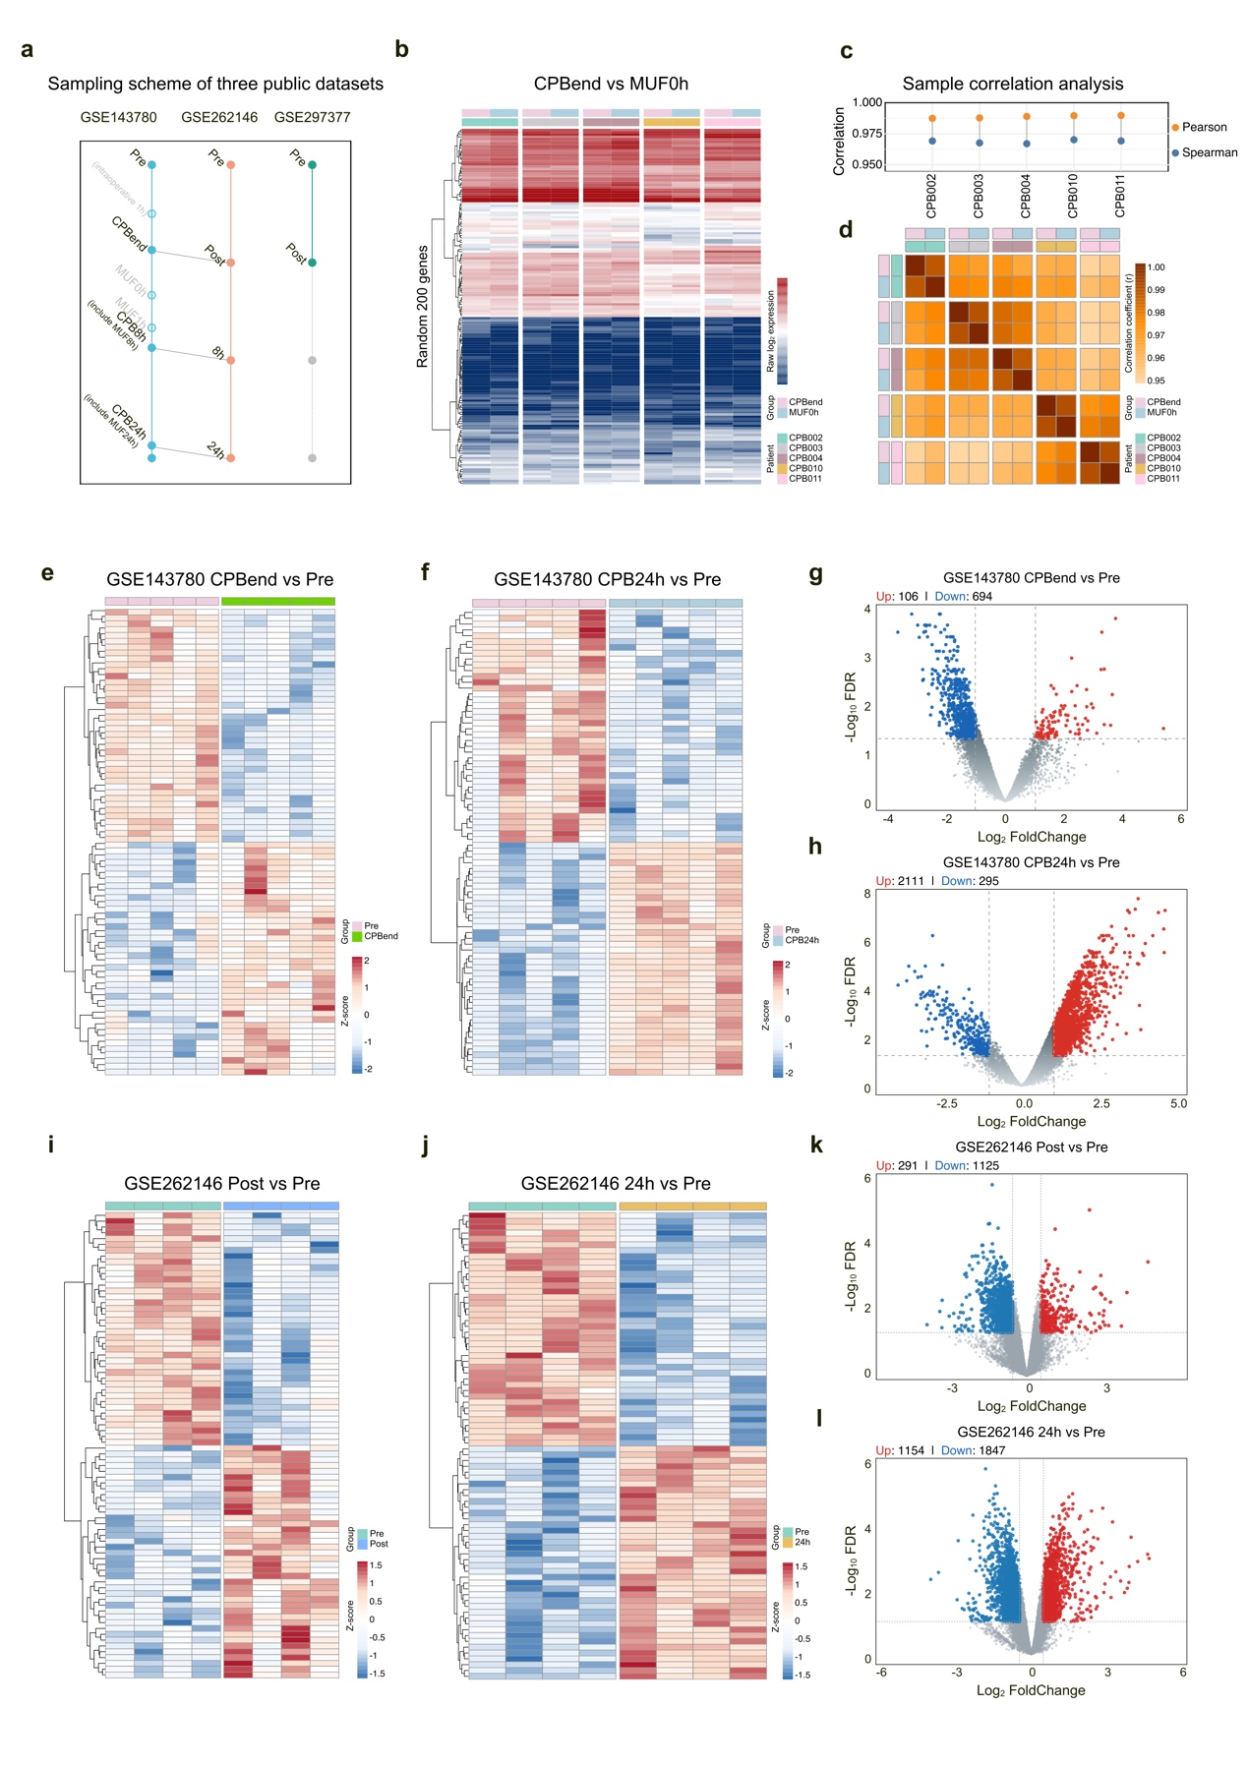

Figure S1. Transcriptomic comparisons and differential expression analyses across CPB datasets.
(a) Sampling schemes of GSE297377 (neutrophils), GSE262146 (PBMC single-cell), and GSE143780 (whole blood).
(b) Heatmap comparing representative differentially expressed genes (DEGs) between CPBend and MUF0h samples in GSE143780.
(c, f) Sample-sample similarity between CPBend and MUF0h, shown by (c) Pearson/Spearman correlation plots and (d) a correlation heatmap.
(e, f) Heatmaps of DEGs in GSE143780 comparing (e) CPBend versus PreCPB and (f) CPB24h versus PreCPB.
(g, h) Volcano plots corresponding to (e, f), highlighting significantly upregulated and downregulated genes.
(i, j) Heatmaps of DEGs in GSE262146 comparing (i) PostCPB versus PreCPB and (j) CPB24h versus PreCPB.
(k, l) Volcano plots corresponding to (i, j), showing direction and magnitude of differential expression.

Figure S2. Lineage-specific transcriptional responses to CPB in the PBMC single-cell dataset.
(a) Dot plot displaying canonical marker gene expression across major PBMC lineages in GSE262146.
(b) KEGG pathway enrichment of differentially expressed genes (DEGs) in the monocyteñmacrophage lineage at postCPB, CPB8h, and CPB24h compared with preCPB. KEGG pathway enrichment was performed using the KEGG database; no KEGG pathway maps were reproduced.
(c, d) GO Biological Process (c) and KEGG (d) enrichment of DEGs in T lymphocytes at postCPB and CPB24h versus preCPB. KEGG pathway enrichment was performed using the KEGG database; no KEGG pathway maps were reproduced.
(e, f) GO Biological Process (e) and KEGG (f) enrichment of DEGs in B lymphocytes at CPB24h versus preCPB. KEGG pathway enrichment was performed using the KEGG database; no KEGG pathway maps were reproduced.
(g) GO Biological Process enrichment of DEGs in NK cells at CPB24h versus preCPB.

