Supporting Information
A Novel Bismaleimide-Urea Resin: Breaking the Trade-off Between Strength, Toughness and Thermal Stability via Molecular Design
Kangbo Zhaoª, Mosha Cheng^{b}, Umut Bakhbergen^{c}, Sherif Araby^{c*}, Sensen Hanª, Haochen Yuanª, Qingshi Meng^{a,*}
ª College of Aerospace Engineering, Shenyang Aerospace University, Shenyang 110136, China
^{b} Department of Oral and Maxillofacial Surgery, School and Hospital of Stomatology, China Medical University, Liaoning Provincial Key Laboratory of Oral Disease 110002
^{c} Department of Mechanical and Aerospace Engineering, Nazarbayev University, Astana 010000, Kazakhstan
*Corresponding Authors: Sherif Araby and Qingshi Meng
Email: Sherif.gouda@nu.edu.kz, and mengqingshi@hotmail.com

Content
S1. Experiment details 3
S1.1 Materials 3
S1.2 Characterizations 3
S1.3 Molecular dynamics 4
S2. Analysis of BMI-urea 5
S2.1 The XRD of BMI-urea 5
S2.2 Impact strength of BMI-urea 6
S2.3 Swelling resistance of BMI-urea 8
S2.4 Molecular dynamics analysis 9
S2.5 AI system-assisted prediction 13
References 14

S1. Experiment details

S1.1 Materials
Isophorone diisocyanate (IPDI) with 99% purity was purchased from Shanghai Aladdin Biochemical Technology Co. 325. Diamine-terminated poly(propylene glycol) with commercial name Jeffamine D2000 (J2000) was supplied by Huntsman, China. Isophorone diamine (IPDA) was sourced from Chuzhou Huisheng Material Co., LTD, while bismaleimide (BMI) ‒ from Honghu Shuangma New Material Technology Co., Ltd.

S1.2 Characterizations
Fourier-transform infrared (FTIR) spectra were obtained by a Nicolet iS50 spectrometer from Thermo Scientific, USA. Solid state 13C NMR spectra were recorded on a Bruker 400WB spectrometer (500 MHz) at room temperature. X-Ray diffraction (XRD) was performed using diffraction technology Mini-Materials Analyser (MMA) at room temperature. The tube voltage applied was 35 kV with an X-ray power of 1 kW. Atomic force microscopy (AFM, Bruker Dimension Icon, USA), equipped with a NanoScope V controller and NanoScope version 8.0 software from Veeco/Digital Instruments, USA was employed to visualize the phase characteristics of polymer samples. Scanning was conducted at scan rates of 0.5 to 1 Hz. Thermogravimetric analysis (TGA Q500, TA Instruments Inc.) was performed under N2 atmosphere within temperature range 25−800 ºC at a heating rate of 10 ºC/min.
Tensile test was carried out on dumb-bell shaped specimens at strain rate of 5 mm/min using a 2 kN load cell tensile machine WDW-100E. The test was performed according to ISO 527-4:2023 standard with 3 specimens sized 115×12.5×4 mm and 75 mm gauge length. Scanning electron microscopy (SEM, using a Philips XL30 Feg) was used to image the fracture surface of PUU/graphene nanocomposites. A thin layer of platinum was coated on the surface for SEM imaging at an accelerating voltage of 5 kV. The impact experiments were performed on the Charpy impact testing machine (Kebiao) according to ISO 179-1:2000. An aluminium plate (12.5×100×2 mm) was used as a substrate where a 2-mm polymer layer was coated. The low-speed impact damage test was carried out on a paint film impact testing machine (Xiangmin QCJ-120). Hemispherical (8 mm) drop weight impactor (1 kg) was used to impact an aluminium plate (40×40×2 mm) coated with polymer. The swelling capacity of polymer was determined by putting 10 mg samples in 5 wt% H2SO4, 5 wt% NaOH, and 5 wt% NaCl solutions at room temperature. The weight of the samples was measured for a duration of 30 days.

S1.3 Molecular dynamics
In this study, the molecular structures of the reactants and reaction products were selected for simulation using the Materials Studio software package. The constructed monomer structures of IPDI, J2000, IPDA and BMI are shown in Figure S1. Initially, the individual structures of all reactants from Step 1 and Step 2 of the reaction (Figure S1) – IPDI, J2000, IPDA, BMI and diamine-ureax/y were optimized with the Forcite module employing COMPASSII force field. Both electrostatic and van der Waals interactions were treated using the atom-based method. Subsequently, an amorphous cubic cell containing BMI and diamine-ureax/y molecules – the reactants of the Step 2 of the reaction (Figure S1) – was created with the Amorphous Cell module and further optimized using the Forcite module under the COMPASSII force field. Finally, the electrostatic potential and frontier molecular orbitals of IPDI, J2000, IPDA, diamine-ureax/y and BMI were calculated using the Dmol3 module in Materials Studio.
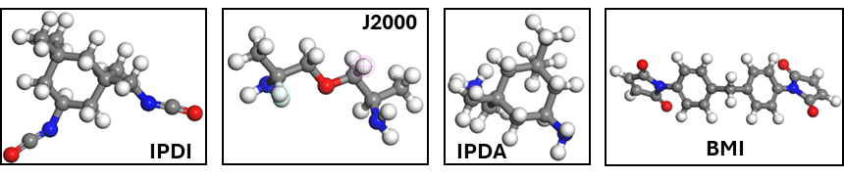
Figure S1 Molecular model of reactant
Following structural optimization, the intermolecular compatibility of the modelled systems was assessed through binding energy (Eb) analysis. Eb, defined as the negative of the interaction energy (Einter), provides a direct measure of the strength of interaction between two reactants. The interaction energy is derived from the total equilibrium energy of the combined system relative to the isolated components. Accordingly, Eb for BMI-ureax/y formation can be calculated as exemplified in Eq. S1.
$$E_{b}=-E_{itner}=-[E_{total}-(E_{BMI}+E_{diamine-urea_{x/y}})]$$ | Eq. S1

S2. Analysis of BMI-urea

S2.1 The XRD of BMI-urea
The XRD pattern of BMI given in Figure S2(a) shows the material with high crystallinity by sharp narrow diffraction peaks in the region of 2θ from 10 to 40°. Excess of crystallinity in BMI causes its brittleness [1]. Intermolecular charge transfer complexation occurs when electron-rich groups interact with electron deficient sites between chains [2]. In rigid polyimides (e.g. BMI) such interactions promote chain alignment contributing to short-range order and crystallinity, as shown in Figure S2(a). Stronger and weaker intensities of the peaks correspond to prominent and subordinate crystal planes, respectively [3]. In addition, the peak pattern is linked to the structure and abundance of planes of diffraction. In contrast, the XRD pattern of diamine-urea consists of a broad diffraction peak without any detectable sharp peaks as shown in Figure S2(a&b), which indicates the amorphous molecular structure [3]. The broad diffraction peak appears at around 20° which corresponds to polyureas and polyurethanes reported in the literature [4, 5]. Figure S2(a&b) show broad almost featureless humps for BMI-ureas. The intensity of this amorphous halo slightly increases and shifts depending on the IPDI/J2000 ratio. Figure S2(b) demonstrates that BMI-urea_{2/1} displays the most diffuse pattern, suggesting the highest degree of amorphousness. Conversely, BMI-urea_{3/1} shows slightly higher peak definition, reflecting a comparatively more rigid and ordered network. This corresponds to highest and lowest content of flexible segment in BMI-urea_{2/1} and BMI-urea_{3/1}, respectively. Hence, incorporation of diamine-urea disrupts the ordered BMI matrix, transforming it into an amorphous elastomeric network.
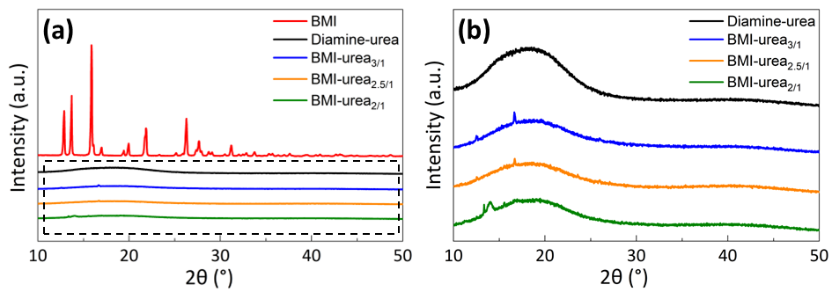
Figure S2. XRD results of BMI, diamine-urea, and BMI-urea polymers: (a) general scale; (b) lower intensity scale.

S2.2 Impact strength of BMI-urea
Figure S3(b1) shows visible cracking at the corner of the sample for BMI-coated substrate. As illustrated schematically in Figure S3(c1&d1) the rigid BMI network facilitates rapid crack propagation without significant deformation, resulting in low resistance to impact loading. In contrast, BMI-urea coatings significantly enhanced impact strength: particularly, more than 30% for 2.5/1 and 3/1 IPDI/J2000 ratios as shown in Figure S3(a). Figure S3(b2-b4) demonstrates that BMI-ureas resisted impact loading without fracture. This enhancement can be attributed to the synergistic interplay between flexible soft and rigid hard segments in urea. A dual mechanism of impact resistance results from: (i) energy absorption via segmental mobility and bond deformation; (ii) structural reinforcement through stiff hard segments [4, 6, 7]. The schematic diagrams in Figure S3(c2-c4&d2-d4) how the flexible J2000 chains permit plastic flow under stress, while the IPDI-induced hard domains maintain network integrity and resist crack initiation along with BMI [8]. Notably, BMI-urea_{2.5/1} in Figure S3(b2) demonstrated the best resistance by resulting in the smallest deformation after impact compared to both BMI-urea_{2/1} with the widest observable deformation and BMI-urea_{3/1} which also deformed significantly after being impacted. More significant deformation in BMI-urea_{3/1} can be attributed to high IPDI/J2000 ratio, i.e. low flexible segment content. It should be noted that BMI-urea_{2/1} displayed only a slight (about 5%) improvement in impact strength. The possible reason can be in the low IPDI content that limited the strength contributed by the hard segment in urea. In addition, limited energy absorption can be attributed to excessive homopolymerization of BMI at this low IPDI content. Since IPDI acts as a “Michael donor” during the Michael addition copolymerization reaction [8], insufficient IPDI content reduces the likelihood of diamine-urea bridging between two BMI molecules. This leads to reduced Michael addition and increased BMI self-polymerization [9]. Hence, the formation of brittle BMI-rich regions formation is promoted, diminishing the ability of BMI-urea_{2/1} to dissipate impact energy.

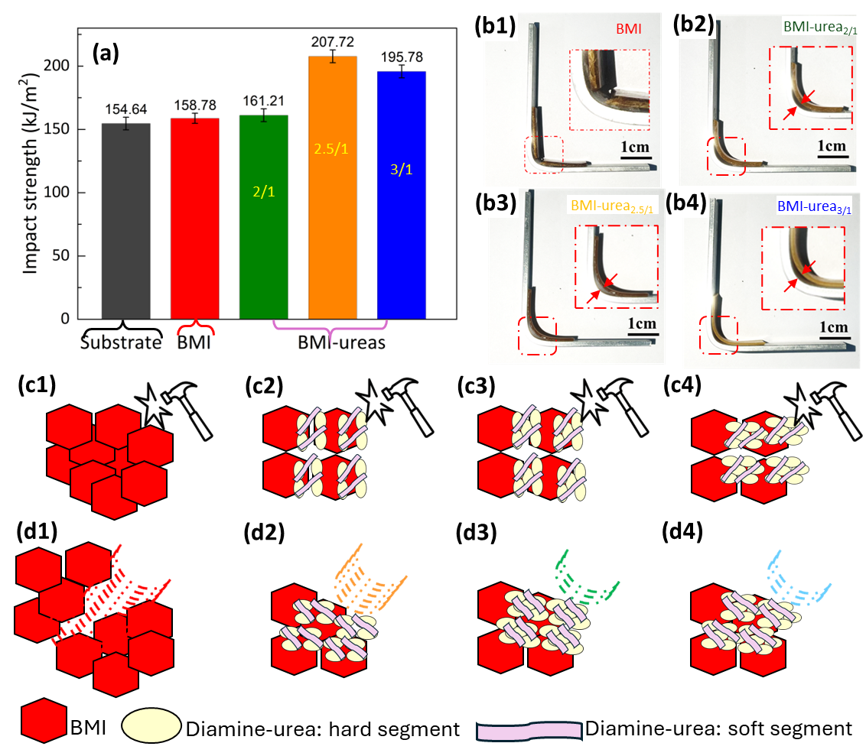
Figure S3. Impact testing of BMI-ureas: (a) Impact strength; (b) digital images of samples after impact testing: (b1) BMI; (b2) BMI-urea_{2/1}; (b3) BMI-urea_{2.5/1}; (b4) BMI-urea_{3/1}; schematics of the effect of impact testing on microstructure (c) before testing: (c1) BMI; (c2) BMI-urea_{2/1}; (c3) BMI-urea_{2.5/1}; (c4) BMI-urea_{3/1}; (d) after testing: (d1) BMI; (d2) BMI-urea_{2/1}; (d3) BMI-urea_{2.5/1}; (d4) BMI-urea_{3/1}.

S2.3 Swelling resistance of BMI-urea
Figure S4 illustrates the swelling behaviour of BMI and BMI-urea samples in 5wt% solution of strong acid, strong base and salt over 30 days. BMI-urea polymers exhibited higher weight gain rate compared to neat BMI across all environments. The weight gain rate increased with the decrease of IPDI/J2000 ratio. This trend is attributed to the introduction of flexible polyurea segments, which increase the hydrophobicity and free volume of the network, promoting liquid uptake [6, 10, 11]. Moreover, the micro-phase-separated morphology of BMI-urea, consisting of soft urea-rich domains and rigid BMI segments, allows greater solvent diffusion pathways compared to the densely crosslinked, rigid BMI matrix [8, 9]. The increased swelling in BMI-urea_{2/1} reflects its higher content of soft segments, leading to reduced crosslinking density and enhanced permeability. In contrast, BMI-urea_{3/1} maintains low levels of swelling comparable to neat BMI sample.
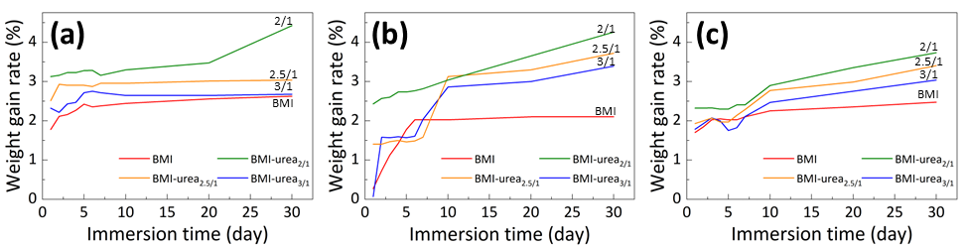
Figure S4. Chemical resistance of BMI and BMI-ureas in 5 wt%: (a) H₂SO₄; (b) NaOH; (c) NaCl.
Figure S4 shows the greatest swelling was observed in alkaline (NaOH), followed by acidic (H₂SO₄), and the lowest in salt (NaCl) solutions. Three factors synergistically influence the chemical resistance of BMI-ureas: the rigidity of the structure (degree of homopolymerization); the presence of aliphatic chains (from diamine-urea); and the hydrogen bonds. Hence, BMI-ureas exhibited higher weight gain in alkaline solution due to the presence of flexible urea and ether linkages, which are more susceptible to alkaline hydrolysis and facilitate water uptake due to disruption of hydrogen bonding [10, 11].

S2.4 Molecular dynamics analysis
Figure S5(a) illustrates the charge distribution of atoms in these molecules. In J2000, the terminal amino groups exhibit nitrogen atom charges of -0.706 and -0.680. This indicates a marked asymmetry that suggests unequal reactivity of the two amino groups. Dring its reaction with IPDI, the amino group with more negative charge (-0.706) predisposed to reaction. Hence, the reaction follows the scenario shown in Figure 2(a&b). In contrast, IPDA shows a highly symmetrical structure, with terminal nitrogen atoms carrying nearly identical charges (-0.727 and -0.733). This leads to almost equivalent reactivity of both amino groups. However, when amino group is bonded to an atomic ring, it enhances the electrophilic substitution [12]. Hence, the reaction scenario should follow the schematics in Figure 2(b&c).
The nucleophilicity and electrophilicity of each reactive site can be determined from the molecular electrostatic potential. Electron cloud distribution of IPDI, J2000, and IPDA, shown in Figure S5(b) influences the selectivity and efficiency of the reaction. The isocyanate group (-NCO) in IPDI molecule exhibits significant electrophilic properties. The central carbon atom, bonded to the electronegative nitrogen and oxygen atoms, carries a notable positive charge (δ⁺), making it highly susceptible to nucleophilic attack [13]. In contrast, the amino group (-NH₂) at the terminal positions of J2000 and IPDA molecules exhibits typical nucleophilic characteristics. The lone pair electrons (δ⁻) on the nitrogen atom actively engage with the electrophilic carbon atom of IPDI. The complementary electrostatic interactions between these sites facilitate an efficient reaction.
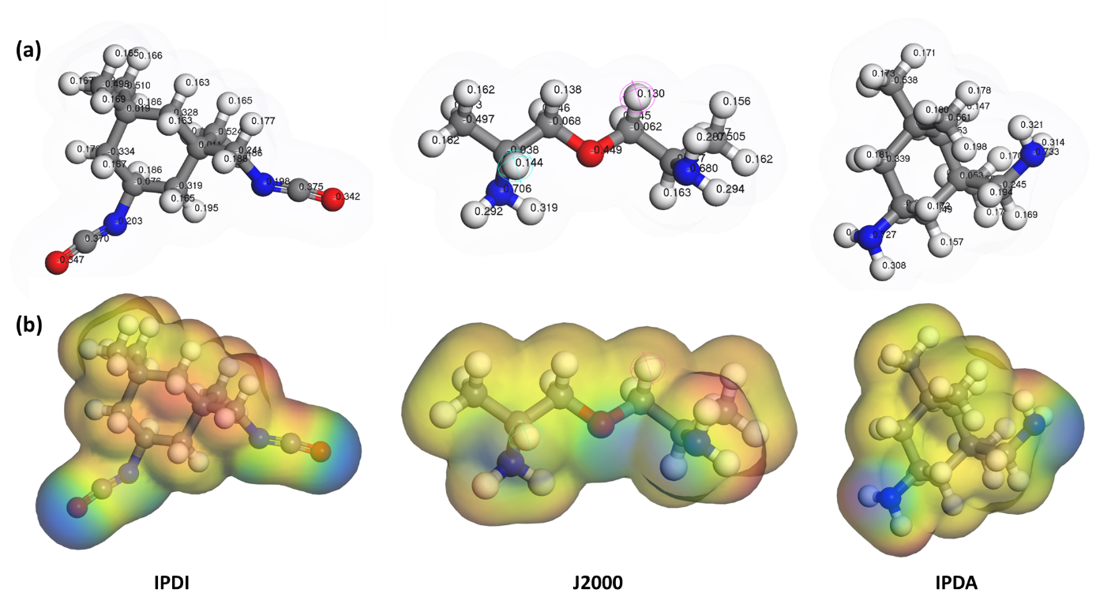
Figure S5. (a) Atomic charges in molecules and (b) molecular electron cloud distribution of IPDI, IPDA and J2000.
The atomic charges in molecules and molecular electron cloud distribution of BMI and diamine-urea are given in Figure S6. At the molecular level, the C=C double bond within the maleimide ring of the BMI molecule demonstrates a prominent negative electrostatic potential due to the accumulation of π-electrons, positioning it as a typical electrophilic site. Conversely, the hydrogen atoms attached to the -NH₂ groups at the termini of the diamine-urea oligomer exhibit a distinct positive electrostatic potential, rendering them nucleophilic sites. The complementary nature of these electrostatic potentials directly facilitates the Michael addition reaction: the positively charged -NH₂ groups are attracted to the negatively charged C=C double bonds, initiating a nucleophilic attack and resulting in the formation of stable covalent bonds [14, 15].
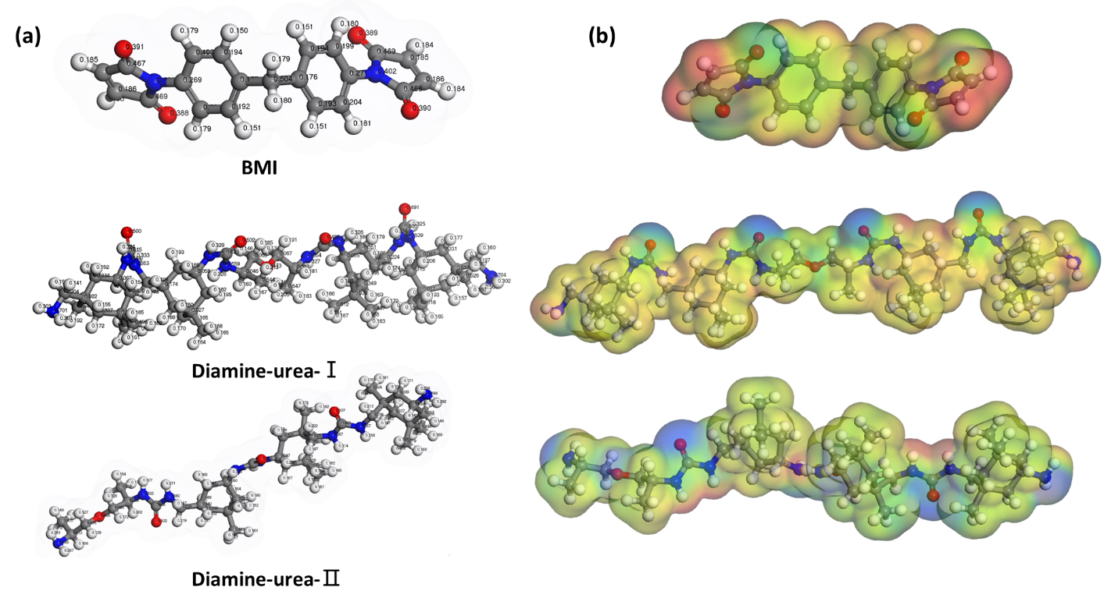
Figure S6. (a) Atomic charges in molecules and (b) molecular electron cloud distribution of BMI and diamine-urea.
Figure S7 shows molecular dynamic simulations of BMI-urea systems with different compositions. In all three cases, BMI molecules interact with diamine-urea pre-polymers. As the J2000 content increases, the network structure becomes denser and more entangled. The red brackets highlight the progressive microstructural differences, confirming that the molar ratio adjustment directly affects chain packaging, interaction density, and ultimately the toughness-rigidity balance of the BMI-urea resin.
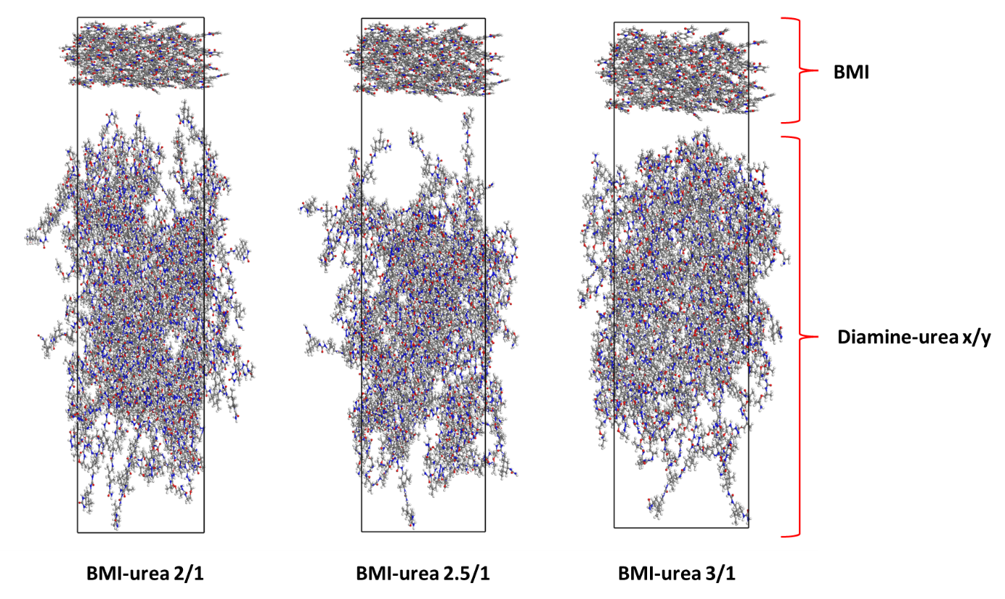
Figure S7. Molecular layer models of BMI-urea _{2/1}, BMI-urea _{2.5/1} and BMI-urea _{3/1}

S2.5 AI system-assisted prediction

Table S1. Different AI predictions of structural forms and performance analysis in the synthesis process of BMI-urea resin.
AI | Chemical structure form | Microscopic characteristics | Morphology features
GPT | BMI–urea link | Chemical bridging between urea chains and BMI | FTIR: C=C shows attenuation at 1630 cm⁻¹; N-H/C-N exhibits enhancement at 1560/1390 cm⁻¹
GPT | BMI–urea link | Chemical bridging between urea chains and BMI | NMR: The compounds contain both 172 (imide) and 160 (urea)
GPT | BMI homopolymerization | Rigid highly cross-linked microregions | FTIR: C-H (3100 - 3000 cm⁻¹) and ring characteristic decay mode;
GPT | BMI homopolymerization | Rigid highly cross-linked microregions | NMR: Complexification in the aromatic/alkene carbon region
DeepSeek | BMI-urea link | -NH is covalently connected to C=C | FTIR shows a weakened C=C peak (1630 cm⁻¹);
DeepSeek | BMI-urea link | -NH is covalently connected to C=C | NMR: 172 ppm (imide) + 160 ppm (urea)
DeepSeek | BMI- homopolymerization | Rigid highly cross-linked brittle domain | FTIR: =C-H peak (3100 - 3000 cm⁻¹) has weakened
Kimi | BMI-urea link | The flexible chain is anchored to the rigid BMI network | FTIR shows a decrease at 1630 cm⁻¹ for maleimide;
Kimi | BMI-urea link | The flexible chain is anchored to the rigid BMI network | NMR indicates the coexistence of imide at 172 ppm and urea at 160 ppm.
Kimi | BMI- homopolymerization | Highly cross-linked brittle domain | FTIR: =C-H (3100—3000 cm⁻¹) and the ring peak is weakened;
Kimi | BMI- homopolymerization | Highly cross-linked brittle domain | Cross-section: brittle fracture morphology
Claude | BMI-urea link | -NH is covalently connected to C=C | FTIR: C=C peak becomes weaker;
Claude | BMI-urea link | -NH is covalently connected to C=C | NMR: 172 ppm (imide) + 160 ppm (urea)
Claude | BMI- homopolymerization | BMI is achieved through free radical polymerization | FTIR: =C-H peak has weakened.

References
[1] V. Choudhary, E. Fitzer, M. Heine, Carbon fibre reinforced bismaleimide composites, I, Die Angewandte Makromolekulare Chemie 160(1) (1988/05/01).
[2] S.C. M., M. Krishna, S. K., K.S. Rai, Preparation and Characterization of Chain‐Extended Bismaleimide/Carbon Fibre Composites, International Journal of Polymer Science 2010(1) (2010/01/01).
[3] İ. Uzun, İ. Uzun, Methods of determining the degree of crystallinity of polymers with X-ray diffraction: a review, Journal of Polymer Research 2023 30:10 30(10) (2023-09-28).
[4] J. Fan, A. Chen, J. Fan, A. Chen, Studying a Flexible Polyurethane Elastomer with Improved Impact-Resistant Performance, Polymers 2019, Vol. 11, Page 467 11(3) (2019-03-12).
[5] M.A. Javaid, M. Rizwan, R.A. Khera, K.M. Zia, K. Saito, M. Zuber, J. Iqbal, P. Langer, Thermal degradation behavior and X-ray diffraction studies of chitosan based polyurethane bio-nanocomposites using different diisocyanates, International Journal of Biological Macromolecules 117 (2018/10/01).
[6] Z. Gao, S. Araby, U. Bakhbergen, K. Zhao, Y. Yu, S. Peng, R. Cai, Q. Meng, Efficient production of ultrafine poly-p-phenylene benzobisoxazole nanofibres for high-performance polyurea nanocomposites, Progress in Organic Coatings 205 (2025) 109301.
[7] X. Cui, C. Zhang, S. Araby, R. Cai, G. Kalimuldina, Z. Yang, Q. Meng, Multifunctional, flexible and mechanically resilient porous polyurea/graphene composite film, Journal of Industrial and Engineering Chemistry 105 (2022/01/25).
[8] H. Li, W. Huang, F. Zhao, H. Cheng, Synthesis of Novel Nonisocyanate Poly(imide-urea)s from CO2-based Polyureas, ACS Sustainable Chemistry & Engineering 12(22) (May 20, 2024).
[9] R.J. Iredale, C. Ward, I. Hamerton, Modern advances in bismaleimide resin technology: A 21st century perspective on the chemistry of addition polyimides, Progress in Polymer Science 69 (2017/06/01).
[10] S. Nagaraj, S.P.K. Babu, Protective polyurea coating for enhanced corrosion resistance of sole bars in railway coaches, Materials Today: Proceedings 27 (2020/01/01).
[11] S. Han, S. Li, X. Zhang, D. Liu, S. Guo, B. Wang, Q. Meng, Enhancing the protective performance of anti-impact, corrosion resistant and flame retardant polyurea coatings using bio-based supramolecular decorated montmorillonite, Construction and Building Materials 435 (2024/07/12).
[12] P. Kočovský, Addition Reactions: Polar Addition.
[13] I. Olazabal, A. González, S. Vallejos, I. Rivilla, C. Jehanno, H. Sardon, Upgrading Polyurethanes into Functional Ureas through the Asymmetric Chemical Deconstruction of Carbamates, ACS Sustainable Chemistry & Engineering 11(1) (December 27, 2022).
[14] H. Cai, J. Shi, X. Zhang, Z. Yang, L. Weng, Q. Wang, S. Yan, L. Yu, J. Yang, H. Cai, J. Shi, X. Zhang, Z. Yang, L. Weng, Q. Wang, S. Yan, L. Yu, J. Yang, Characterization of Mechanical, Electrical and Thermal Properties of Bismaleimide Resins Based on Different Branched Structures, Polymers 2023, Vol. 15, Page 592 15(3) (2023-01-24).
[15] W. Wang, Y. Wang, G. Kong, Z. Wang, C. Yang, Z. Zhou, K. Wang, S. Liu, Research progress in toughness modification of bismaleimide resin, Engineering Plastics Application 52(11) (2024) 165-170.

