Supplementary Material for Review
Supplementary Figure 1. The components of ECM upregulation and downregulation change with tumor development in the TCGA cohort.

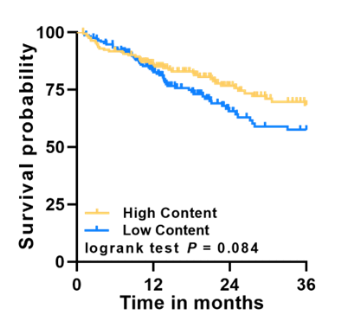
Supplementary Figure 2. The TCGA patient cohort was divided into high and low groups according to the tumor ECM content, and the survival curve was plotted.

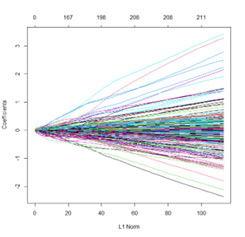
Supplementary Figure 3. 371 cases of HCC patients were used to construct a prognostic model based on the LASSO regression algorithm.

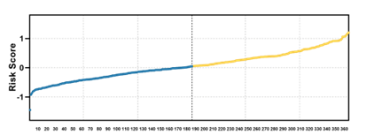
Supplementary Figure 4. The survival of 371 HCC patients gradually deteriorated with the increase of risk score.

Supplementary Figure 5. ROC analysis of ECM related gene signature for prediction of recurrence risk at 1, 3, and 5 years in TCGA cohort.

Supplementary Figure 6. Kaplan-Meier curves of survival probability and disease free survival in all TCGA patients with HCC based on risk score.

GEO140520
ICGC
SRRSH
Supplementary Figure 7. The survival of HCC patients in the GEO, ICGC and SRRSH cohorts gradually deteriorated with the increase of risk scores.

Supplementary Figure 8. Kaplan-Meier curves of survival probability and disease free survival in all GEO140520 cohort patients with HCC based on risk score.

Supplementary Figure 9. Kaplan-Meier curves of survival probability in all ICGC cohort patients with HCC based on risk score.

Supplementary Figure 10. Kaplan-Meier curves of survival probability and disease free survival in all SRRSH cohort patients with HCC based on risk score.
Supplementary Table 1. Sequences of the primers for Real-Time Reverse Transcription Polymerase Chain Reaction (qRT-PCR).
Gene |  | Sequence
GAPDH | Forward: | 5′-CATCACTGCCACCCAGAAGACTG-3′
 | Reverse: | 5′-ATGCCAGTGAGCTTCCCGTTCAG-3′
ADAM9 | Forward: | 5′-TCCATTGCTCTTAGCGACTGT-3′
 | Reverse: | 5′-GGGGTTCAATCCCATAACTCG-3′
SP1 | Forward: | 5′-TGGCAGCAGTACCAATGGC-3′
 | Reverse: | 5′-CCAGGTAGTCCTGTCAGAACTT-3′
TP53 | Forward: | 5′-CAGCACATGACGGAGGTTGT-3′
 | Reverse: | 5′-TCATCCAAATACTCCACACGC-3′

