The roles of competition and facilitation in producing zonation along an experimental flooding gradient: a tale of two tails with ten freshwater marsh plants — Supplementary materials
R code for statistical analyses
- Monoculture vs polycultures: Survival
# Load glmmTMB, DHARMa, emmeans and car packages.
null <- glmmTMB(Survival2003 ~ 1 + (1|Lane), data = MPsurvival)
genpois <- glmmTMB(Survival2003 ~ Neighbours*Flooding + (1|Lane), data = MPsurvival, family=list(family="genpois",link="log"))
AIC(null, genpois)
simulate <- simulateResiduals(fittedModel = genpois)
plot(simulate)
Anova(genpois, type="III")

- Monoculture vs polycultures: Overall test of flooding parameters
# Rescaling to avoid 0 and 1.
transform01 <- function(x) {(x * (length(x) - 1) + 0.5) / (length(x))}
Monopoly2$Min.rescaled <- transform01(Monopoly$Min)
# Load glmmTMB, DHARMa, emmeans and car packages.
null <- glmmTMB(Min.rescaled ~ 1 + (1|Lane), data=Monopoly, family=list(family="beta",link="logit"))
beta <- glmmTMB(Min.rescaled ~ Neighbours*Year + (1|Lane), data=Monopoly, family=list(family="beta",link="logit"))
beta.z <- glmmTMB(Min.rescaled ~ Neighbours*Year + (1|Lane), data=Monopoly, ziformula=~1, family=list(family="beta",link="logit"))
beta.v <- glmmTMB(Min.rescaled ~ Neighbours*Year + (1|Lane), data=Monopoly, family=list(family="beta",link="logit"), dispformula=~Neighbours)
beta.zv <- glmmTMB(Min.rescaled ~ Neighbours*Year + (1|Lane), data=Monopoly, ziformula=~1, family=list(family="beta",link="logit"),dispformula=~Neighbours)
AIC(null,beta,beta.z,beta.v,beta.zv)
simulate <- simulateResiduals(fittedModel = beta.v)
plot(simulate)
Anova(beta.v, type="III")

- Monoculture vs polycultures: Differences in Flooding Parameters by Year and Species
# Rescaling to avoid 0 and 1.
transform01 <- function(x) {(x * (length(x) - 1) + 0.5) / (length(x))}
Monopoly2003$Min.rescaled <- transform01(Monopoly2003$Min)
# Load glmmTMB, DHARMa, emmeans and car packages.
beta.null <- glmmTMB(Min.rescaled ~ 1 + (1|Block), data=Monopoly2003, family=list(family="beta",link="logit"))
beta <- glmmTMB(Min.rescaled ~ Neighbours*Species + (1|Block), data=Monopoly2003, family=list(family="beta",link="logit"))
beta.z <- glmmTMB(Min.rescaled ~ Neighbours*Species + (1|Block), data=Monopoly2003, family=list(family="beta",link="logit"), ziformula = ~1)
beta.v <- glmmTMB(Min.rescaled ~ Neighbours*Species + (1|Block), data=Monopoly2003, family=list(family="beta",link="logit"), dispformula=~Neighbours)
beta.zv <- glmmTMB(Min.rescaled ~ Neighbours*Species + (1|Block), data=Monopoly2003, family=list(family="beta",link="logit"), ziformula = ~1, dispformula=~Neighbours)
# Comparing models
AIC(beta.null, beta, beta.z , beta.v, beta.zv)
simulate <- simulateResiduals(fittedModel = beta.v)
plot(simulate)
Anova(Min2003.beta.v, type="III")
# Main effects:
min2003.emm <- emmeans(beta.v, pairwise~Species)
plot(min2003.emm, comparisons = TRUE, type="response", alpha=0.05)
pairs(min2003.emm, simple="Species")
# Interactions:
min2003.int.emm <- emmeans(beta.v, pairwise~Neighbours*Species)
plot(min2003.int.emm, comparisons = TRUE, type="response", alpha=0.05)
pairs(min2003.int.emm, simple="Neighbours")

- Monoculture vs polycultures: NImp_{A} index
# Load lme4, DHARMa, emmeans and car packages.
# Create quadratic variables.
AcorusNImpA$Flooding2 <- AcorusNImpA$Flooding^2
#Test null vs linear and quadratic models.
null <- lmer(NImpA ~ 1 + (1|Block), data=AcorusNImpA)
lmm1 <- lmer(NImpA ~ Flooding + (1|Block), data=AcorusNImpA)
lmm2 <- lmer(NImpA ~ Flooding + Flooding2 + (1|Block), data=AcorusNImpA)
AIC(null, lmm1, lmm2)
simulate <- simulateResiduals(fittedModel = lmm2)
plot(simulate)
Anova(lmm2, type="III")

5) Monoculture vs bicultures : Survival
# Load glmmTMB, DHARMa, emmeans and car packages.
null <- glmmTMB(survival2004 ~ 1 + (1|Lane), data = CladPaniS)
genpois <- glmmTMB(Survival2004 ~ Neighbours*Flooding + (1|Lane), data = CladPaniS, family = genpois(link="log"))
AIC(null,genpois)
Anova(genpois, type="III")
simulate <- simulateResiduals(fittedModel = genpois)
plot(simulate)
Anova(genpois, type=”III”

- Monoculture vs bicultures : Flooding parameters
# Rescaling to avoid 0 and 1.
transform01 <- function(x) {(x * (length(x) - 1) + 0.5) / (length(x))}
PontPeltF$Min.rescaled <- transform01(PontPeltF$Min)
# Load glmmTMB, DHARMa, emmeans and car packages.
null <- glmmTMB(Min.rescaled ~ 1 + (1|Lane), data=PontPeltF)
beta <- glmmTMB(Min.rescaled ~ Neighbours*Year*Species + (1|Lane), data=PontPeltF, family=list(family="beta",link="logit"))
beta.z <- glmmTMB(Min.rescaled ~ Neighbours*Year*Species + (1|Lane), data= PontPeltF, ziformula = ~1, family=list(family="beta",link="logit"))
beta.v <- glmmTMB(Min.rescaled ~ Neighbours*Year*Species + (1|Lane), data= PontPeltF, family=list(family="beta",link="logit"), dispformula = ~Neighbours)
beta.zv <- glmmTMB(Min.rescaled ~ Neighbours*Year*Species + (1|Lane), data= PontPeltF, ziformula = ~1, family=list(family="beta",link="logit"),dispformula = ~Neighbours)
AIC(null, beta, beta.z, beta.v, beta.zv)
simulate <- simulateResiduals(fittedModel = beta.v)
plot(simulate)
Anova(beta.v, type="III")

Online Supplementary Table S1. Analysis of deviance table of the survival of ten species as a function of the presence or absence of neighbours and the flooding extent. Generalized Poisson distributions fit best and were used. Ward type III χ² tests are given, and significant effects (P < 0.05) are in bold.
Source | df | 2002 |  |  | 2003 |  |  | 2004 |  |  | 2005
Source | df | χ² | P |  | χ² | P |  | χ² | P |  | χ² | P
neighbours | 1 | 13.8 | 0.0002 |  | 80.1 | <0.0001 |  | 72.2 | <0.0001 |  | 89.9 | <0.0001
flooding | 1 | 0.1 | 0.82 |  | 117.9 | <0.0001 |  | 115.8 | <0.0001 |  | 102.9 | <0.0001
neighbours x flooding | 1 | 2.6 | 0.11 |  | 10.4 | 0.0013 |  | 2.6 | 0.11 |  | 2.4 | 0.12

Online Supplementary Table S2. Analysis of deviance table of the overall minimum flooding limit, overall maximum flooding limit, overall range of flooding and overall mode of the flooding distribution as functions of the presence or absence of neighbours and year. Ward type III χ² tests were used, and significant effects (P < 0.05) are in bold.

 |  | Minimum |  |  | Maximum |  |  | Range |  |  | Mode
Source of variation | df | χ² | P |  | χ² | P |  | χ² | P |  | χ² | P
neighbours | 1 | 69.4 | <0.0001 |  | 1.1 | 0.29 |  | 4.6 | 0.031 |  | 0.6 | 0.45
year | 2 | 0.0 | 0.99 |  | 28.5 | <0.0001 |  | 29.5 | <0.0001 |  | 1.8 | 0.41
neighbours x year | 2 | 0.9 | 0.62 |  | 5.1 | 0.079 |  | 8.8 | 0.012 |  | 0.6 | 0.75

Online Supplementary Table S3. Analysis of deviance table by year for the minimum flooding, maximum flooding, the range and the mode of the plant distributions across flooding levels against the presence of neighbours, species and their interaction. Wald type III χ² tests were used, and significant effects (P < 0.05) are shown in bold.

Year | Surviving species | Source | df | Minimum |  |  | Maximum |  |  | Range |  |  | Mode
 |  |  |  | χ² | P |  | χ² | P |  | χ² | P |  | χ² | P
2003 | All 10 species | neighbours | 1 | 22.8 | <0.0001 |  | 0.1 | 0.77 |  | 4.8 | 0.028 |  | 0.4 | 0.55
2003 | All 10 species | species | 9 | 2.9 | 0.97 |  | 198.7 | <0.0001 |  | 171.1 | <0.0001 |  | 55.0 | <0.0001
2003 | All 10 species | neighbours x species | 9 | 5.2 | 0.82 |  | 67.6 | <0.0001 |  | 37.6 | <0.0001 |  | 12.5 | 0.19
2004 | 8 species:  Acorus, Cladium, Juncus, Panicum, Peltandra, Pontederia, Sagittaria, Saururus | neighbours | 1 | 21.1 | <0.0001 |  | 0.1 | 0.71 |  | 9.7 | 0.0019 |  | 0.1 | 0.80
2004 |  | species | 7 | 6.3 | 0.50 |  | 467.8 | <0.0001 |  | 136.7 | <0.0001 |  | 22.6 | 0.0020
2004 |  | neighbours x species | 7 | 24.6 | 0.0009 |  | 19.6 | 0.0065 |  | 32.9 | <0.0001 |  | 26.8 | 0.0004
2005 | 5 species:  Cladium, Juncus, Panicum, Peltandra, Saururus | neighbours | 1 | 7.6 | 0.0060 |  | 11.6 | 0.0007 |  | 7.4 | 0.0064 |  | 0.2 | 0.6328
2005 | 5 species:  Cladium, Juncus, Panicum, Peltandra, Saururus | species | 4 | 1.4 | 0.84 |  | 53.4 | <0.0001 |  | 30.5 | <0.0001 |  | 29.0 | <0.0001
2005 | 5 species:  Cladium, Juncus, Panicum, Peltandra, Saururus | neighbours x species | 4 | 2.6 | 0.62 |  | 14.1 | 0.0069 |  | 7.1 | 0.13 |  | 19.1 | 0.0007

Table S4. Summary analysis of deviance table of the NImpA index for each species separately. Linear or quadratic models were selected with AIC. Wald type III χ² tests were used, and significant effects (P < 0.05) are shown in bold.

Species | Source of varation | df | χ2 | P
Acorus | Intercept | 1 | 2.7 | 0.10
 | Linear | 1 | 45.8 | < 0.0001
 | Quadratic | 1 | 46.7 | < 0.0001
Cladium | Intercept | 1 | 74.3 | < 0.0001
 | Linear | 1 | 17.1 | < 0.0001
Juncus | Intercept | 1 | 26.0 | < 0.0001
 | Linear | 1 | 59.2 | < 0.0001
Panicum | Intercept | 1 | 0.1 | 0.75
 | Linear | 1 | 0.3 | 0.56
Peltandra | Intercept | 1 | 3.1 | 0.076
 | Linear | 1 | 0.1 | 0.82
Pontederia | Intercept | 1 | 0.1 | 0.79
 | Linear | 1 | 11.4 | 0.0007
Rhynchospora | Intercept | 1 | 16.5 | < 0.0001
 | Linear | 1 | 3.4 | 0.063
 | Quadratic | 1 | 2.8 | 0.095
Sagittaria | Intercept | 1 | 17.4 | < 0.0001
 | Linear | 1 | 7.2 | 0.0071
Saururus | Intercept | 1 | 34.5 | < 0.0001
 | Linear | 1 | 9.0 | 0.0027
 | Quadratic | 1 | 10.0 | 0.0016
Schoenoplectus | Intercept | 1 | 3.5 | 0.063
 | Linear | 1 | 29.6 | < 0.0001
 | Quadratic | 1 | 25.7 | < 0.0001

Online Supplementary Table S5. Analysis of deviance tables by species pairing for the minimum flooding, maximum flooding, the range and the mode of the plant distributions across flooding levels against the presence of neighbours, species, year and their interactions. Year is a repeated measure. Wald type III χ² tests were used, and significant effects (P < 0.05) are shown in bold.

Pairing | Source of variation |  | Min |  |  | Max |  |  | Range |  |  | Mode
Pairing | Source of variation | df | χ² | P |  | χ² | P |  | χ² | P |  | χ² | P
Panicum- Cladium | neighbours | 1 | poor fit |  |  | 35.8 | <0.0001 |  | 43.4 | <0.0001 |  | 10.0 | 0.0015
Panicum- Cladium | species | 2 |  |  |  | 3.9 | 0.15 |  | 1.6 | 0.45 |  | 4.1 | 0.13
Panicum- Cladium | year | 1 |  |  |  | 49.6 | <0.0001 |  | 30.5 | <0.0001 |  | 39.8 | <0.0001
Panicum- Cladium | neighb x sp | 2 |  |  |  | 9.6 | 0.0080 |  | 10.6 | 0.0050 |  | 2.6 | 0.27
Panicum- Cladium | neighb x yr | 1 |  |  |  | 15.1 | 0.0001 |  | 10.6 | 0.0011 |  | 31.9 | <0.0001
Panicum- Cladium | species x yr | 2 |  |  |  | 22.9 | <0.0001 |  | 12.5 | 0.0020 |  | 4.0 | 0.14
Panicum- Cladium | neighb x sp x yr | 2 |  |  |  | 4.7 | 0.09 |  | 2.5 | 0.29 |  | 11.3 | 0.0035
Peltandra-Pontederia | neighbours | 1 | 0.01 | 0.93 |  | 6.3 | 0.012 |  | 3.5 | 0.06 |  | 3.9 | 0.049
Peltandra-Pontederia | species | 2 | 0.45 | 0.80 |  | 10.3 | 0.006 |  | 5.7 | 0.06 |  | 9.2 | 0.010
Peltandra-Pontederia | year | 1 | 0.50 | 0.48 |  | 0.0 | 0.98 |  | 0.1 | 0.73 |  | 0.7 | 0.410
Peltandra-Pontederia | neighb x sp | 2 | 0.16 | 0.92 |  | 1.1 | 0.57 |  | 0.1 | 0.96 |  | 1.1 | 0.566
Peltandra-Pontederia | neighb x yr | 1 | 0.24 | 0.62 |  | 4.9 | 0.026 |  | 2.9 | 0.09 |  | 5.4 | 0.021
Peltandra-Pontederia | species x yr | 2 | 0.83 | 0.66 |  | 2.4 | 0.30 |  | 1.2 | 0.56 |  | 4.1 | 0.127
Peltandra-Pontederia | neighb x sp x yr | 2 | 0.52 | 0.77 |  | 0.8 | 0.68 |  | 0.7 | 0.72 |  | 2.8 | 0.251
Panicum-Pontederia | insufficient survival

Table S6. Summary analysis of deviance table of the NImpA index for species in each species pairing. Linear or quadratic models were selected with AIC. Wald type III χ² tests were used, and significant effects (P < 0.05) are shown in bold.

Pairing | Species | Source of variation | df | χ² | P
Panicum- Cladium | Cladium | Intercept | 1 | 35.9 | <0.0001
Panicum- Cladium | Cladium | linear | 1 | 5.9 | 0.015
Panicum- Cladium | Panicum | Intercept | 1 | 0.7 | 0.40
Panicum- Cladium | Panicum | linear | 1 | 0.0 | 0.96
Peltandra-Pontederia | Peltandra | Intercept | 1 | 0.4 | 0.54
Peltandra-Pontederia | Peltandra | linear | 1 | 0.8 | 0.38
Peltandra-Pontederia | Pontederia | Intercept | 1 | 0.0 | 0.90
Peltandra-Pontederia | Pontederia | linear | 1 | 1.1 | 0.30
Pontederia-Panicum | Pontederia | Intercept | 1 | 0.0 | 0.96
Pontederia-Panicum | Pontederia | linear | 1 | 6.5 | 0.011
Pontederia-Panicum | Panicum | Intercept | 1 | 0.0 | 0.86
Pontederia-Panicum | Panicum | linear | 1 | 0.3 | 0.61

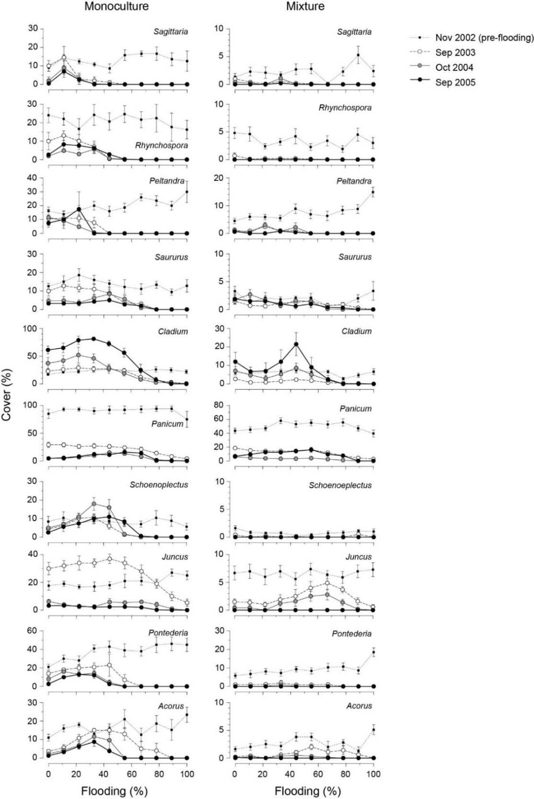

Online Supplementary Figure S1: Cover of individual species when grown in monoculture and in multi-species mixture along the experimental flooding gradient in fall 2002 (pre-flooding) and in autumn 2003, 2004 and 2005 (mean ± SE). Species are ordered by their 2003 mode of distribution of flooding when grown in monoculture. Flooding is expressed as percent flooding during the growing season.
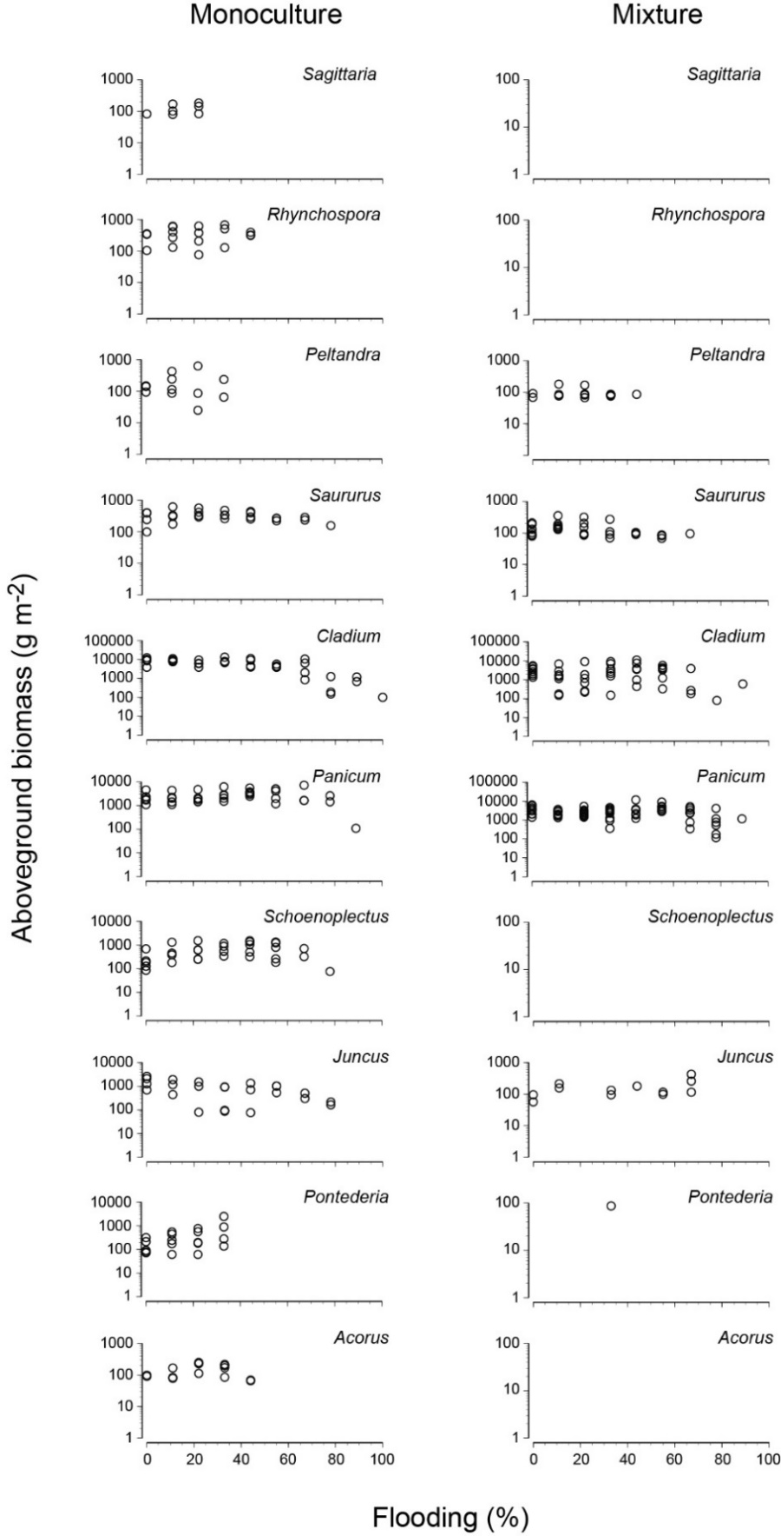

Online Supplementary Figure S2: Scatter plots of biomass in autumn 2005 of individual species when grown in monoculture and in multi-species mixture along the experimental flooding gradient. Flooding is expressed as percent flooding during the growing season.

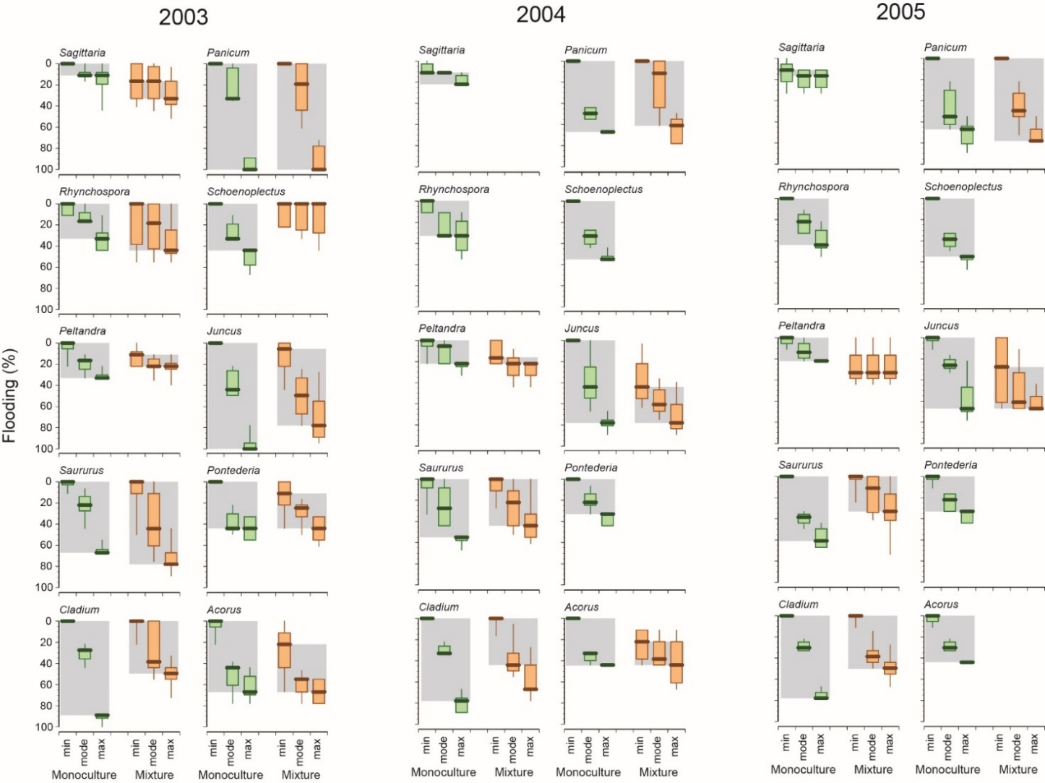

Online Supplementary Figure S3. Box plots of the minimum limit, mode of the distribution and maximum limit along the experimental flooding gradient for the ten marsh species when grown in monoculture (green) and in multi-species mixture (orange) in the autumn of 2003, 2004 and 2005. The background grey shading shows the range from the median minimum limit to the median maximum limit. Species are ordered by their 2003 mode of distribution of flooding when grown in monoculture. Flooding is expressed as percent flooding during the growing season.

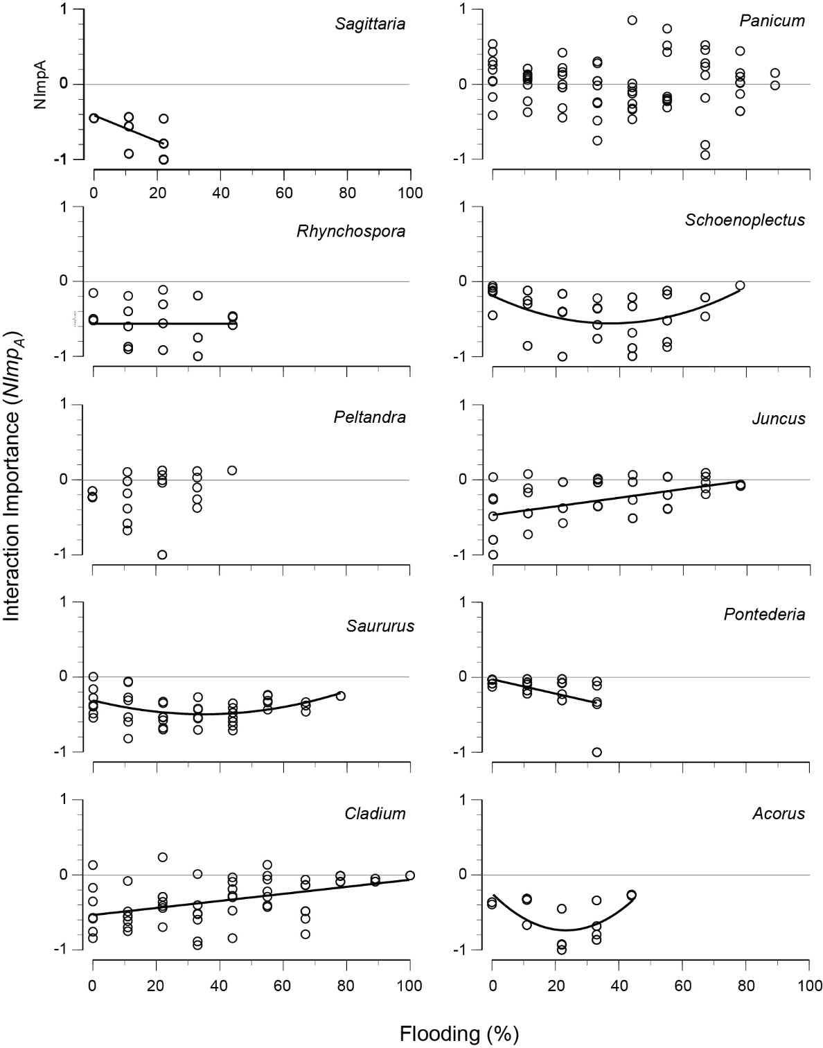

Online Supplemental Figure S4. Scatterplots by species of additive interaction importance index (Nimp_{A}), calculated from autumn 2005 final biomass data, for the multispecies mixtures along the flooding gradient. Regression lines are only shown for those species with significant regressions or significant intercepts (P < 0.05).

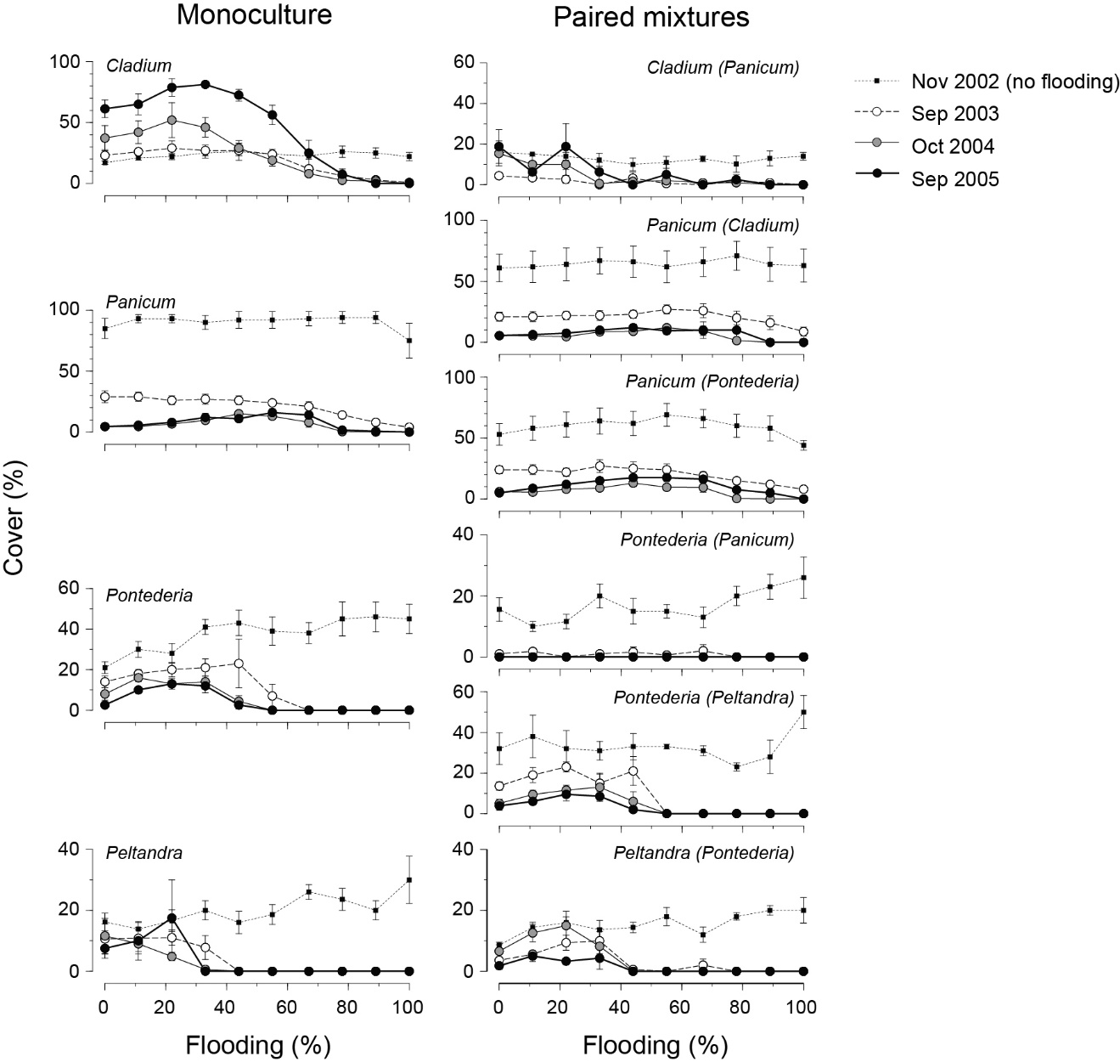

Online Supplementary Figure S5: Cover of individual species when grown in monoculture and in two species mixture along the experimental flooding gradient in fall 2002 (pre-flooding) and in fall 2003, 2004 and 2005. Flooding is expressed as percent flooding during the growing season.

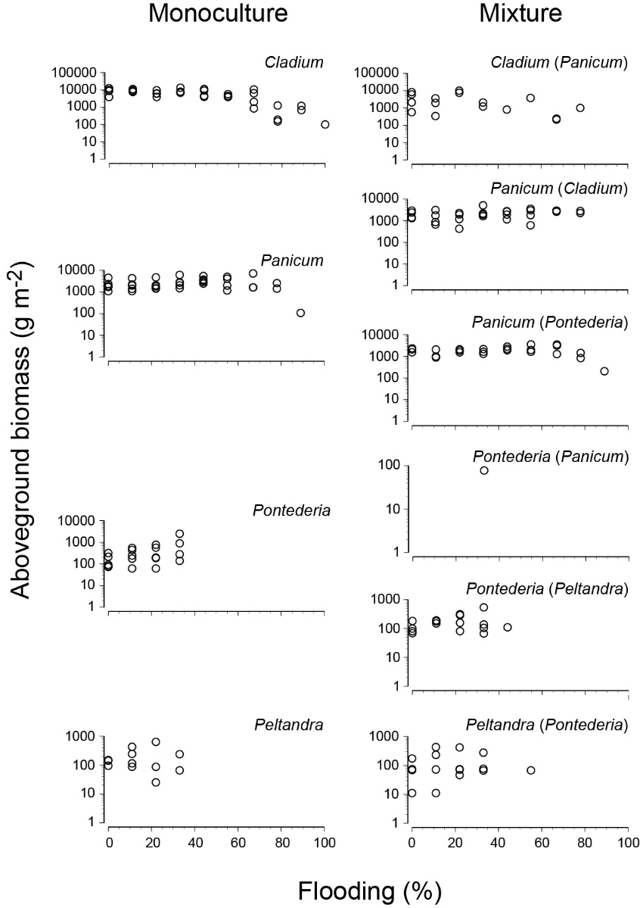

Online Supplementary Figure S6: Biomass in autumn 2005 of individual species when grown in monoculture and in two species mixture along the experimental flooding gradient. Flooding is expressed as percent flooding during the growing season.
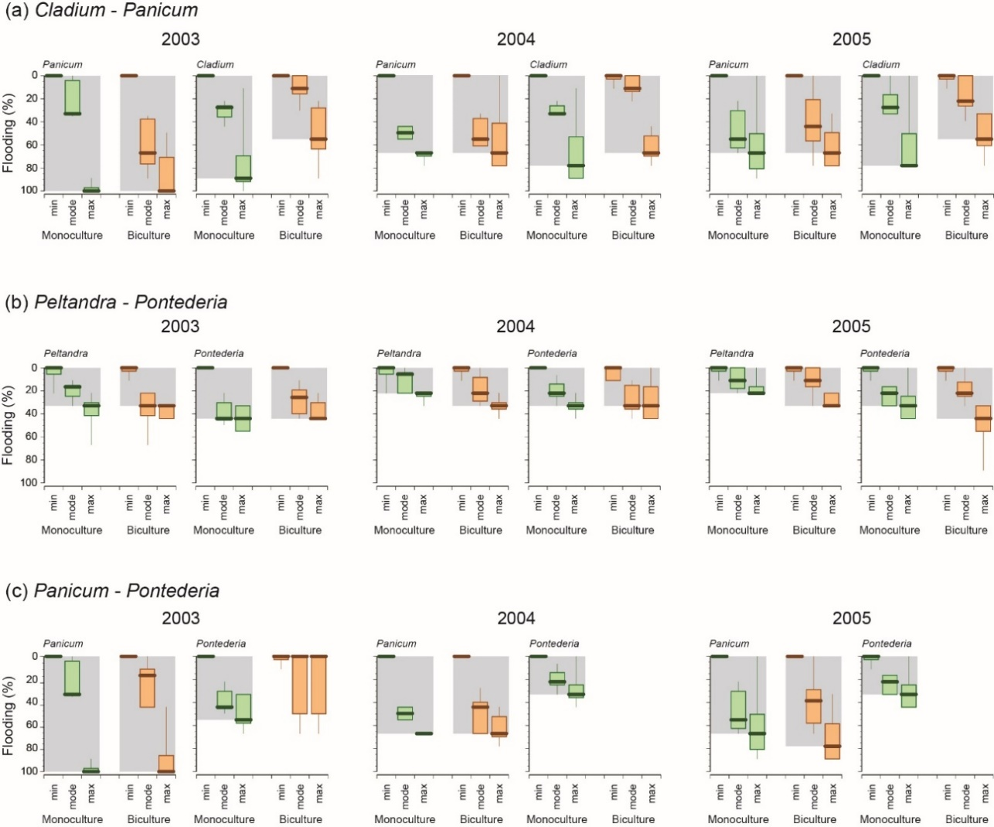

Online Supplementary Figure S7: Box plots of the minimum limit, mode of the distribution and maximum limit along the experimental flooding gradient for each of the three species pairings, (a) Cladium and Panicum, (b) Peltandra and Pontederia and (c) Panicum and Pontederia, when grown in monoculture (green) and in two species mixture (orange) in the autumn of 2003, 2004 and 2005. The background grey shading shows the range from the median minimum limit to the median maximum limit. Flooding is expressed as percent flooding during the growing season.
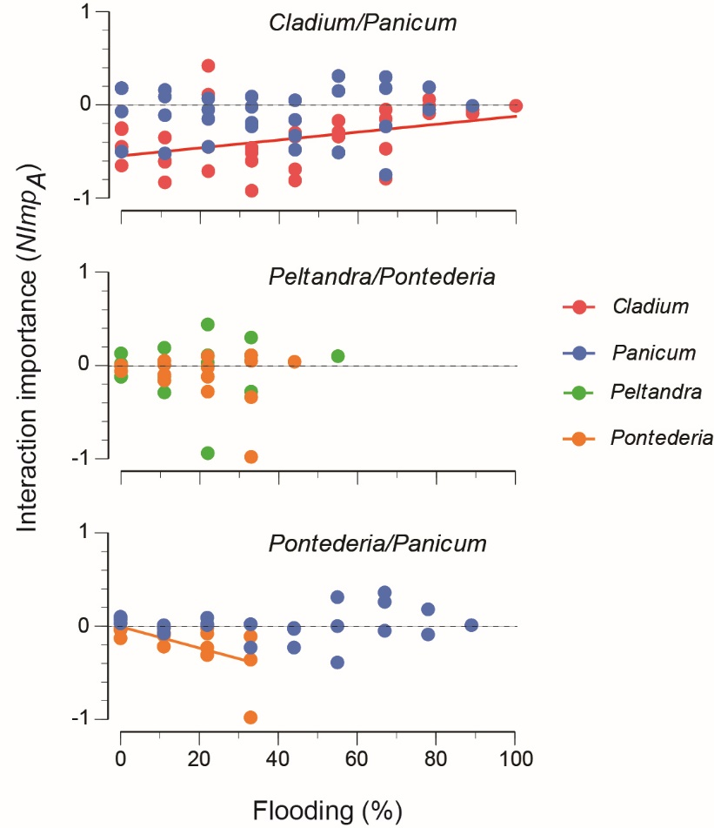

Online Supplemental Figure S8. Scatterplots by each species pair of additive interaction importance indices (Nimp_{A}), calculated from autumn 2005 final biomass data along the flooding gradient. Regression lines are only shown for those species with significant regressions or significant intercepts (P < 0.05).

