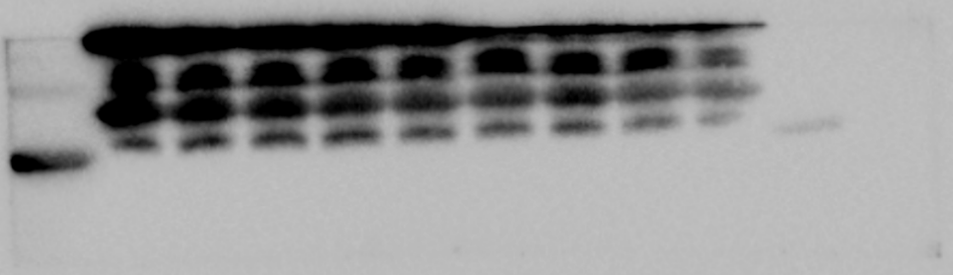
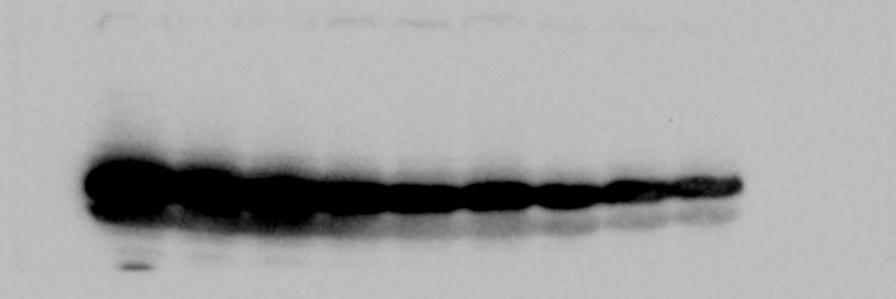
10 kDa
FABP3 15 kDa
17 kDa
52 kDa
Fig4-LPL1-1
17 kDa
10 kDa
Fig4-FABP3-3
Fig4-FABP3-2
Fig4-FABP3-1

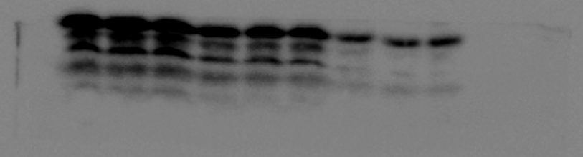
10 kDa
FABP3 15 kDa

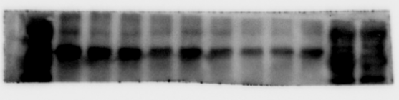
LPL1 53 kDa
65 kDa

Fig4-LPL1-2
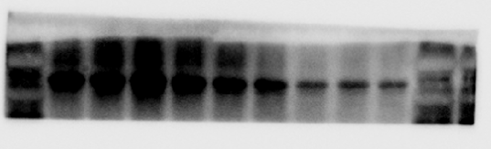
LPL1 53 kDa

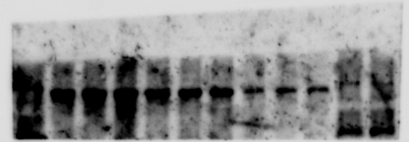
LPL1 53 kDa
Fig4-LPL1-3

Fig4-GADPH-1
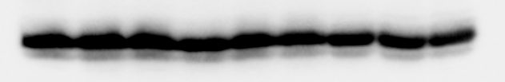
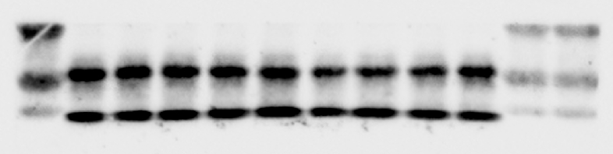
41 kDa
GAPDH 39 kDa
GAPDH 39 kDa
Fig4-GADPH-2

Fig4-GADPH-3

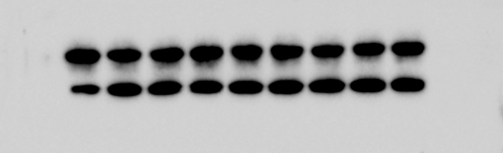
41 kDa
GAPDH 39 kDa

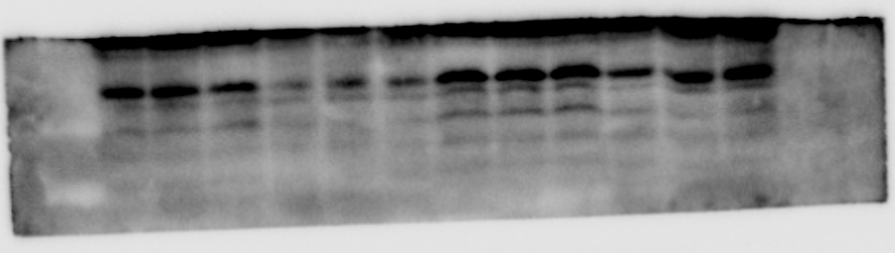
Fig7-FABP3
Piperidine
1.2μm-6D
Control-6D
Piperidine
1.2μm-3D
Control-3D

FABP3

Fig7-FABP3
Control-3D
Piperidine
1.2μm-3D
Control-6D
Piperidine
1.2μm-6D
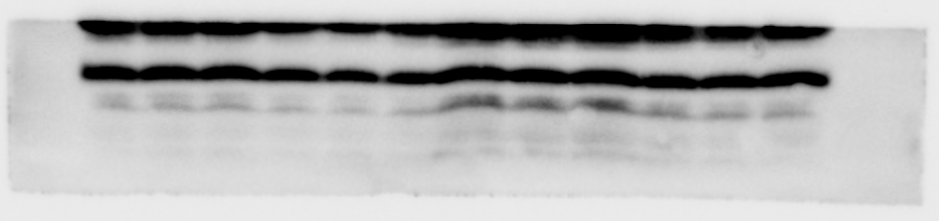
FABP3

Fig7-FABP3
Control-3D
Piperidine
1.2μm-3D
Control-6D
Piperidine
1.2μm-6D

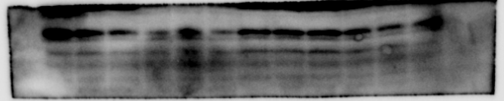
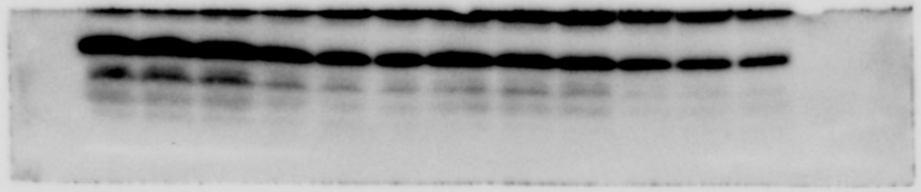
FABP3
Control-9D
Piperidine
1.2μm-9D
Control-9D
Piperidine
1.2μm-9D
FABP3

Fig7-FABP3

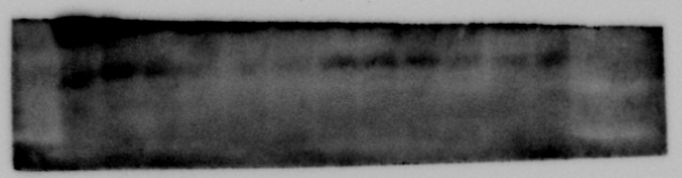
Fig7-FABP3
Piperidine
1.2μm-9D
Control-9D
Piperidine
1.2μm-9D
Control-9D
FABP3

Fig7-GAPDH

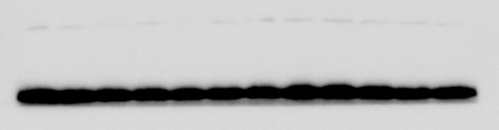
GAPDH

Fig7-GAPDH
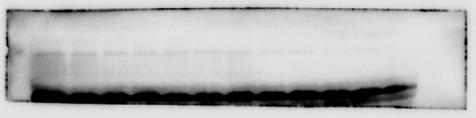

GAPDH

Fig7-GAPDH
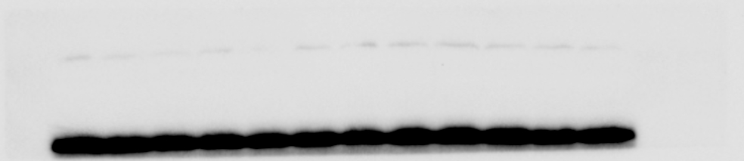
GAPDH

