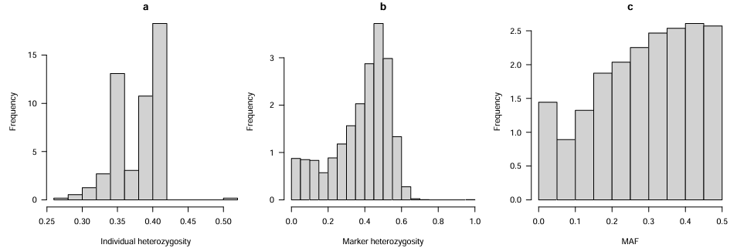
Supplementary Material
Figure S1 Heterozygosity and Minor Allele Frequency.This figure shows the frequency distribution of heterozygosity and minor allele frequency (MAF) for cattle individuals and genomic markers.

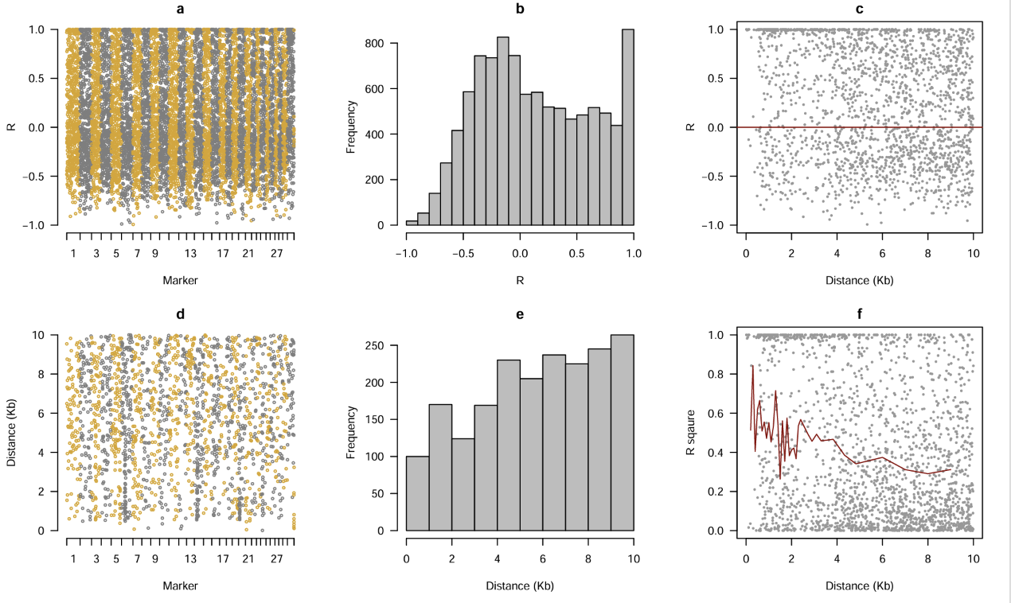
Figure S2 Visualization of genetic marker relationships and linkage disequilibrium (LD) patterns.(A) Heatmap of pairwise Pearson correlation coefficients (R) among genetic markers, with marker positions on the x- and y-axes;(B) Frequency distribution of pairwise correlation coefficients (R) across all marker pairs;(C) Scatter plot of pairwise correlation coefficients (R) against physical distance (Kb) between markers; the red horizontal line indicates no correlation (R = 0);(D) Heatmap of physical distances (Kb) between genetic markers, with marker positions on both axes;(E) Frequency distribution of pairwise physical distance intervals (Kb) among markers;(F) Scatter plot of squared correlation coefficients (R²) versus physical distance (Kb) between markers; the red trend line depicts LD decay with increasing genomic distance.

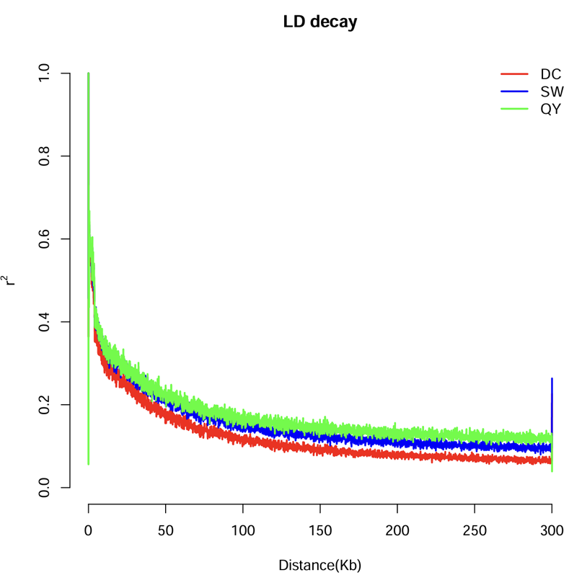

Figure S3 LD decay curves across three populations (Qingyang (QY), Dachang (DC)and Sunwu (SW) ). The LD between SNP markers, measured by $r^{2}$, is plotted against their physical distance (Kb). The LD decay curves were generated using PopLDdecay-3.42, which calculates genome-wide LD and summarizes its decay with increasing inter-marker distance.

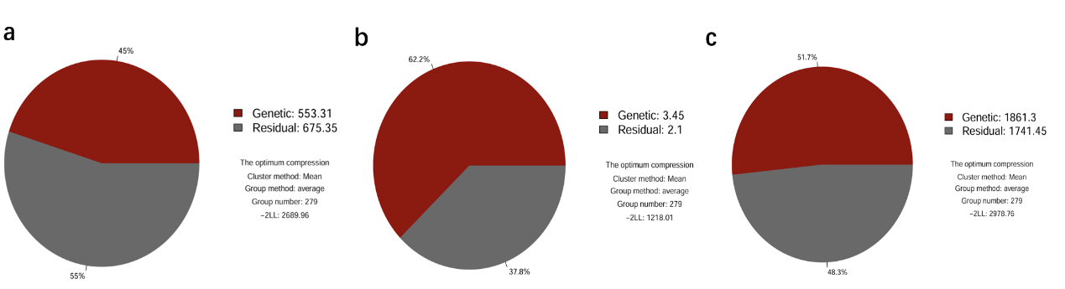
Figure S4 Proportion of genetic and residual variance components estimated for three traits using the MLM (Mixed Linear Model).(a) CW (Carcass Weight), (b) DP (Dressing Percentage), and (c) LW (Live Weight).The pie charts represent the percentage of genetic (dark red) and residual (gray) variance for each trait. Variance components were estimated under the optimum compression model, with mean clustering and average group method (group number: 279). The log-likelihood value (−2LL) of the model is provided for each trait. The estimated heritabilities (proportion of genetic variance) were 45% for CW, 62.2% for DP, and 51.7% for LW.

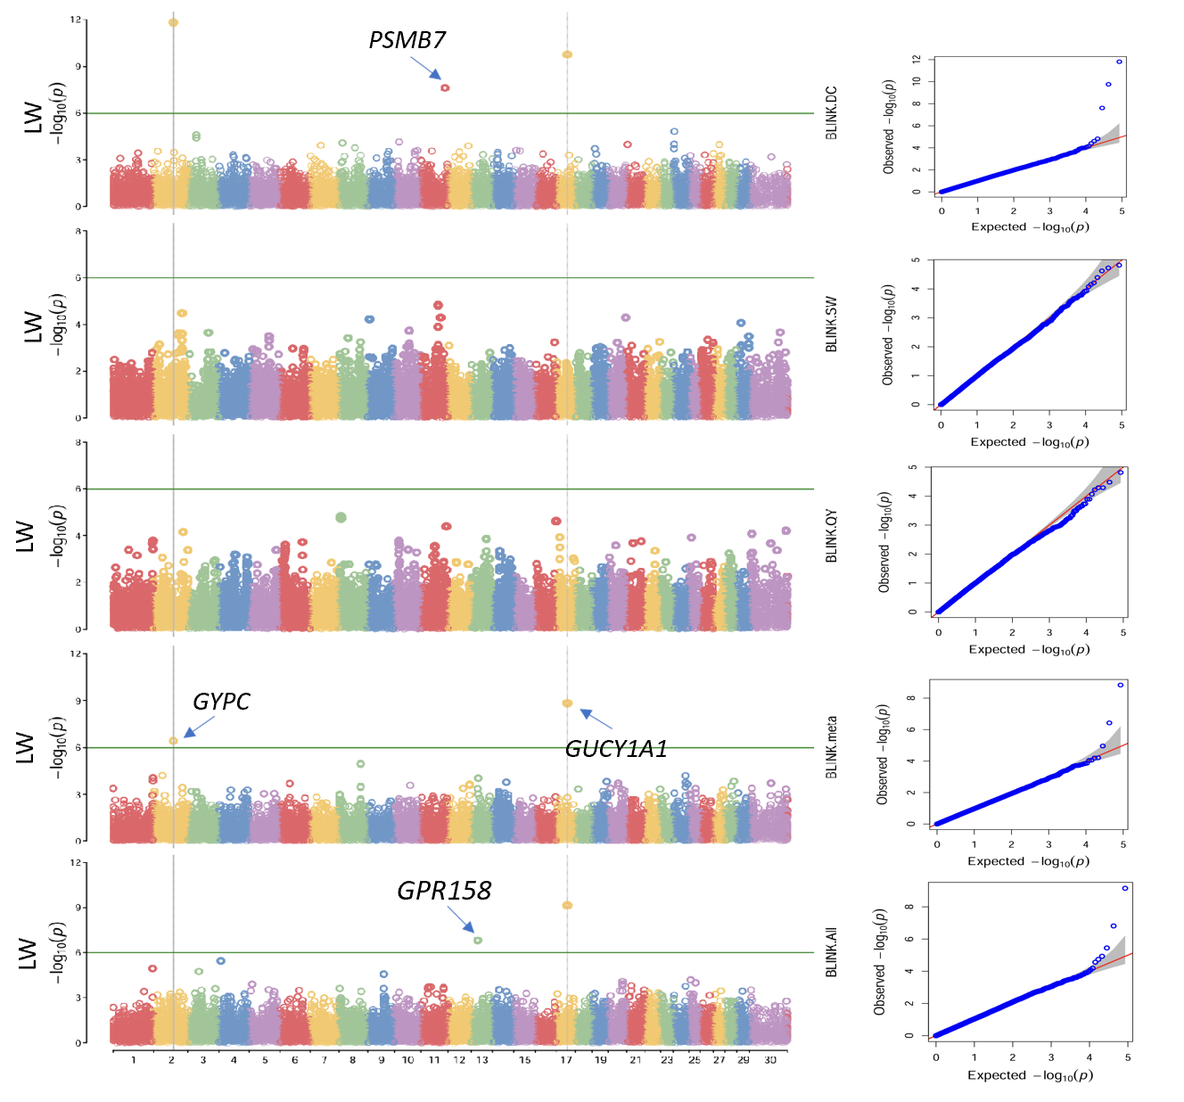

Figure S5 Manhattan and quantile–quantile (QQ) plots of the p-values for the genome-wide association study of the LW trait in cattle, performed separately for the Sunwu, Dachang, and Qingyang populations, for the combined population, and for the meta-analysis, based on the BLINK method；the horizontal line of significance threshold (p-value < 1.01 × 10⁻⁶) was used to distinguish significantly associated loci, and the different colors to distinguish different chromosomes.

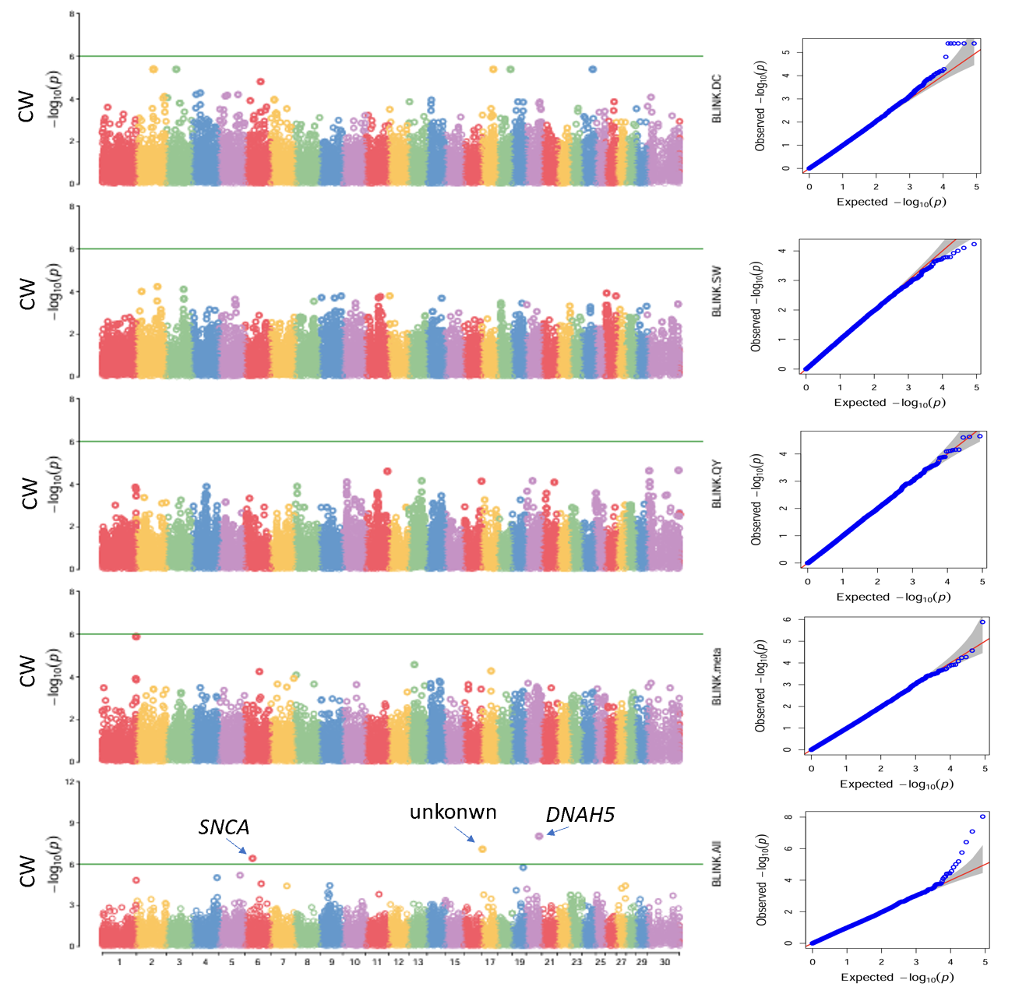

Figure S6 Manhattan and quantile–quantile (QQ) plots of the p-values for the genome-wide association study of the CW trait in cattle, performed separately for the Sunwu, Dachang, and Qingyang populations, for the combined population, and for the meta-analysis, based on the BLINK method；the horizontal line of significance threshold (p-value < 1.01 × 10⁻⁶) was used to distinguish significantly associated loci, and the different colors to distinguish different chromosomes.

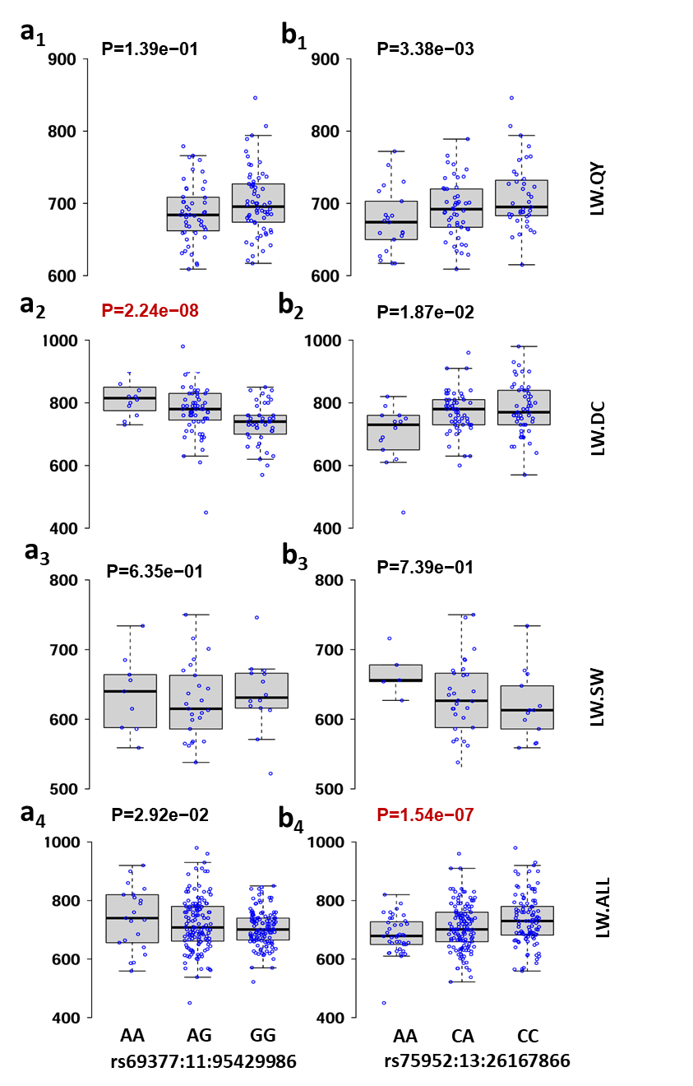
Figure S7 Boxplots showing the distribution of LW phenotypic values for different genotypes at each significant SNP. Each row represents a distinct population: Qingyang (QY), Dachang (DC), Sunwu (SW) and ALL (the combined dataset of all populations). Genotype classes are shown on the x-axis, and the observed LW values (kg) are displayed on the y-axis. For each significant SNP, the p-values for that SNP in different populations are shown in red at the top of the panel.

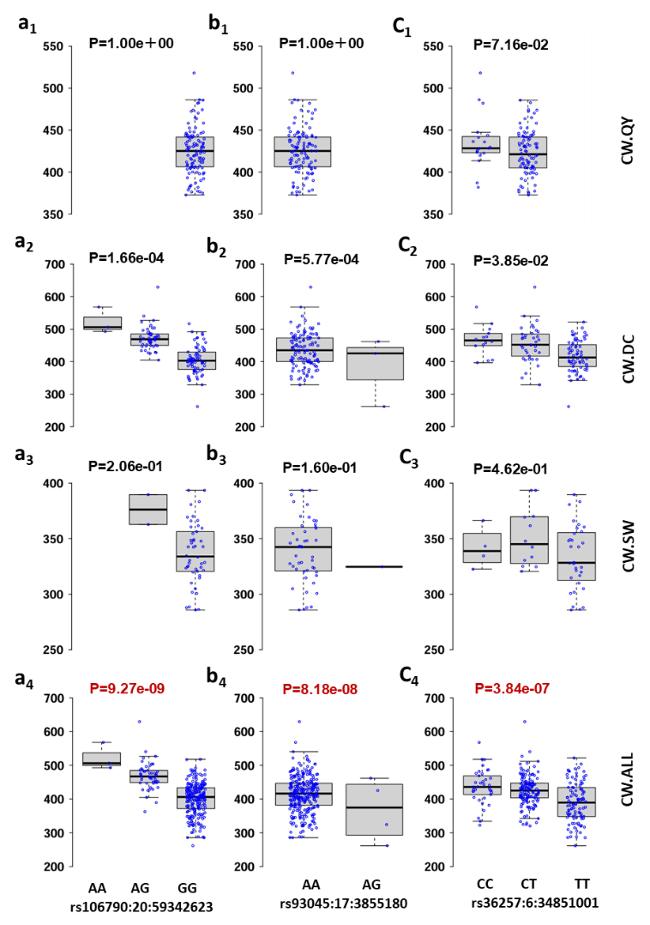
Figure S8 Boxplots showing the distribution of CW phenotypic values for different genotypes at each significant SNP. Each row represents a distinct population: Qingyang (QY), Dachang (DC), Sunwu (SW) and ALL (the combined dataset of all populations). Genotype classes are shown on the x-axis, and the observed CW values (kg) are displayed on the y-axis. For each significant SNP, the p-values for that SNP in different populations are shown in red at the top of the panel.

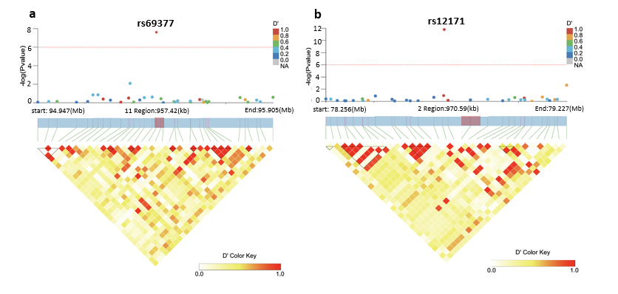
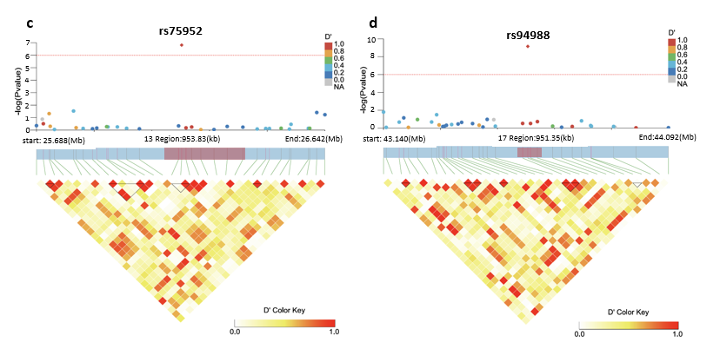

Figure S9 Local Manhattan plots (top), annotated gene regions (middle), and linkage disequilibrium (LD) heatmaps (bottom) for SNPs significantly associated with LW. Each panel shows the genomic region surrounding the lead SNP, with window sizes adjusted according to local SNP density and LD patterns. In the Manhattan plots, the red horizontal line represents the genome-wide significance threshold (p < 1.01 × 10⁻⁶).The middle panel displays the annotated gene structures within the targeted genomic interval; the pink shaded blocks indicate the gene regions overlapping or adjacent to the lead SNP, highlighting potential candidate genes. The LD heatmaps illustrate pairwise D′ values among SNPs in the region, where darker red indicates stronger LD.

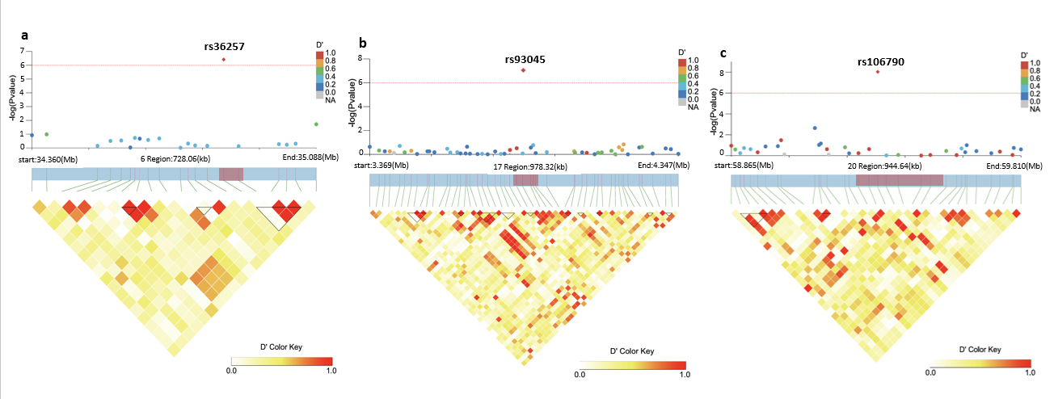
Figure S10 Local Manhattan plots (top), annotated gene regions (middle), and linkage disequilibrium (LD) heatmaps (bottom) for SNPs significantly associated with CW. Each panel shows the genomic region surrounding the lead SNP, with window sizes adjusted according to local SNP density and LD patterns. In the Manhattan plots, the red horizontal line represents the genome-wide significance threshold (p < 1.01 × 10⁻⁶).The middle panel displays the annotated gene structures within the targeted genomic interval; the pink shaded blocks indicate the gene regions overlapping or adjacent to the lead SNP, highlighting potential candidate genes. The LD heatmaps illustrate pairwise D′ values among SNPs in the region, where darker red indicates stronger LD.

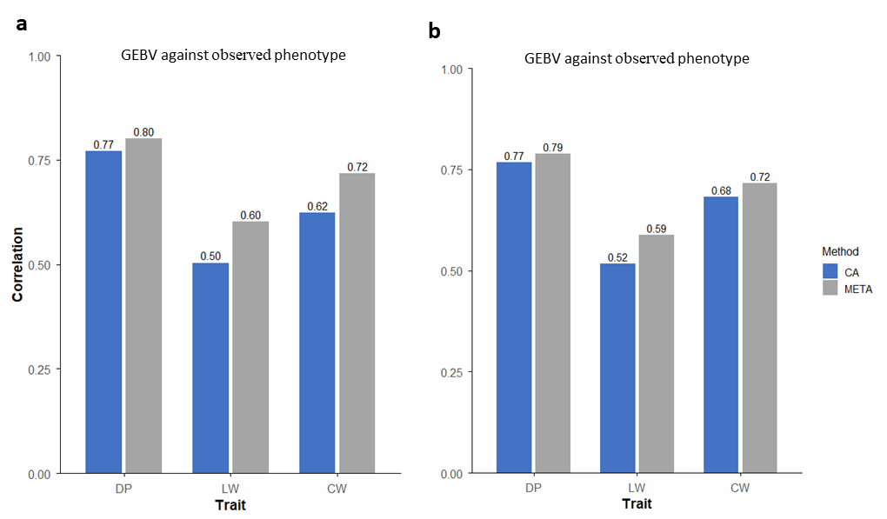
Figure S11 Comparison of genomic prediction performance between the CA and META models across three slaughter traits (DP, LW, CW) under two population-division strategies. Genomic selection (GS) was performed using an MABLUP framework. Panel (a) shows results based on the biologically structured (normal) population division, whereas panel (b) shows results obtained from a random population division. GEBV against observed phenotype, representing the correlation between genomic estimated breeding values (gEBVs) and observed phenotypes. Blue and grey bars represent CA and META, with correlation values labeled above each bar.

Table S1 Significant SNPs identified by the BLINK GWAS method and their estimated genetic effects
SNP No. * | Chr | position | PVE（%） | Effect | method
rs5563 | 1 | 112371771 | 16.10493 | 0.031397 | BLINK
rs9962 | 2 | 34488282 | 2.68955 | 0.010565 | BLINK
rs12183 | 2 | 79056259 | 44.35025 | 0.040103 | BLINK
rs30285 | 5 | 48843409 | 6.235688 | -0.01081 | BLINK
rs37571 | 6 | 45331116 | 2.213864 | -0.00847 | BLINK
rs95061 | 17 | 44994156 | 4.25656 | -0.01737 | BLINK
rs99644 | 18 | 59327463 | 6.18016 | -0.00944 | BLINK
rs116390 | 23 | 40500113 | 20.51488 | -0.01499 | BLINK
rs127557 | 27 | 36709501 | 68.05572 | -0.06509 | BLINK
rs36257 | 6 | 34851001 | 2.190922 | -12.7971 | BLINK
rs93045 | 17 | 3855180 | 52.50343 | 72.74001 | BLINK
rs106790 | 20 | 59342623 | 24.82766 | -35.9071 | BLINK
rs12171 | 2 | 78736403 | 91.86077 | 388.8639 | BLINK
rs69377 | 11 | 95429986 | 1.55319 | -43.2099 | BLINK
rs75952 | 13 | 26167866 | 7.003888 | 19.71486 | BLINK
rs94988 | 17 | 43621923 | 20.96367 | -30.172 | BLINK
SNP No.* indicates the sequence number in the entire tag list.Chromosomes and locations refer to physical location information in genomic data. PVE (Phenotypic Variance Explained) denotes the proportion of phenotypic variance explained by each SNP. Effect refers to represents the estimated allelic effect. Method indicates the GWAS model used for detecting the SNP.

