Extended Data for

Concurrence of ferroelectricity and metallicity in perovskite ultrathin films
Hongxu Duan¹†, Zhihao Gao^{2,3}†, Tao Li^{1, 4*}, Yan Li¹, Feiyan Hou¹, Junying Zhang⁵, Yifeng Ren³, Yue Liu¹, Yuhao Qiu⁶, Shenghao Cai⁶, Yaolin Wang¹, Xi Deng³, Shaohao Wang⁴, Tiaoyang Li⁴, Yanqing Wu^{4, 7}, Yu Deng³, Jiangjing Wang⁵, Di Wu³, Xuegang Chen⁶, Yuefeng Nie³, Hongtao Yuan³, Fei Li⁸, Yurong Yang^{3*}, Tai Min^{1, 2, 3,4*}

¹Center for Spintronics and Quantum Systems (CSQS), State Key Laboratory for Mechanical Behavior of Materials and School of Materials Science and Engineering, Xi’an Jiaotong University, Xi’an, Shaanxi 710049, China.
²School of Advanced Manufacturing Engineering, Nanjing University, Suzhou 215163, China.
³State Key Laboratory of Solid State Microstructures, Nanjing University, Nanjing 210093, China.
⁴FZU-Jinjiang Joint Institute of Microelectronics, Jinjiang Campus, Fuzhou University, Jinjiang 362200, China.
⁵Center for Alloy Innovation and Design (CAID), State Key Laboratory for Mechanical Behavior of Materials, Xi'an Jiaotong University, Xi'an, Shaanxi 710049, China.
⁶Center of Free Electron Laser and High Magnetic Field, State Key Laboratory of Opto-Electronic Information Acquisition and Protection Technology, Anhui Provincial Key Laboratory of Magnetic Functional Materials and Devices, Anhui University, Hefei 230601, China.
⁷School of Integrated Circuits and Beijing Advanced Innovation Center for Integrated Circuits, Peking University, Beijing 100871, China.
⁸Electronic Materials Research Laboratory (Key Lab of Education Ministry), State Key Laboratory for Mechanical Behavior of Materials and School of Electronic and Information Engineering, Xi'an Jiaotong University, Xi’an, Shaanxi 710049, China.

*Corresponding author. Email: tai.min@nju.edu.cn (T.M.); yangyr@nju.edu.cn (Y.Y.); taoli66@xjtu.edu.cn (T.L.)

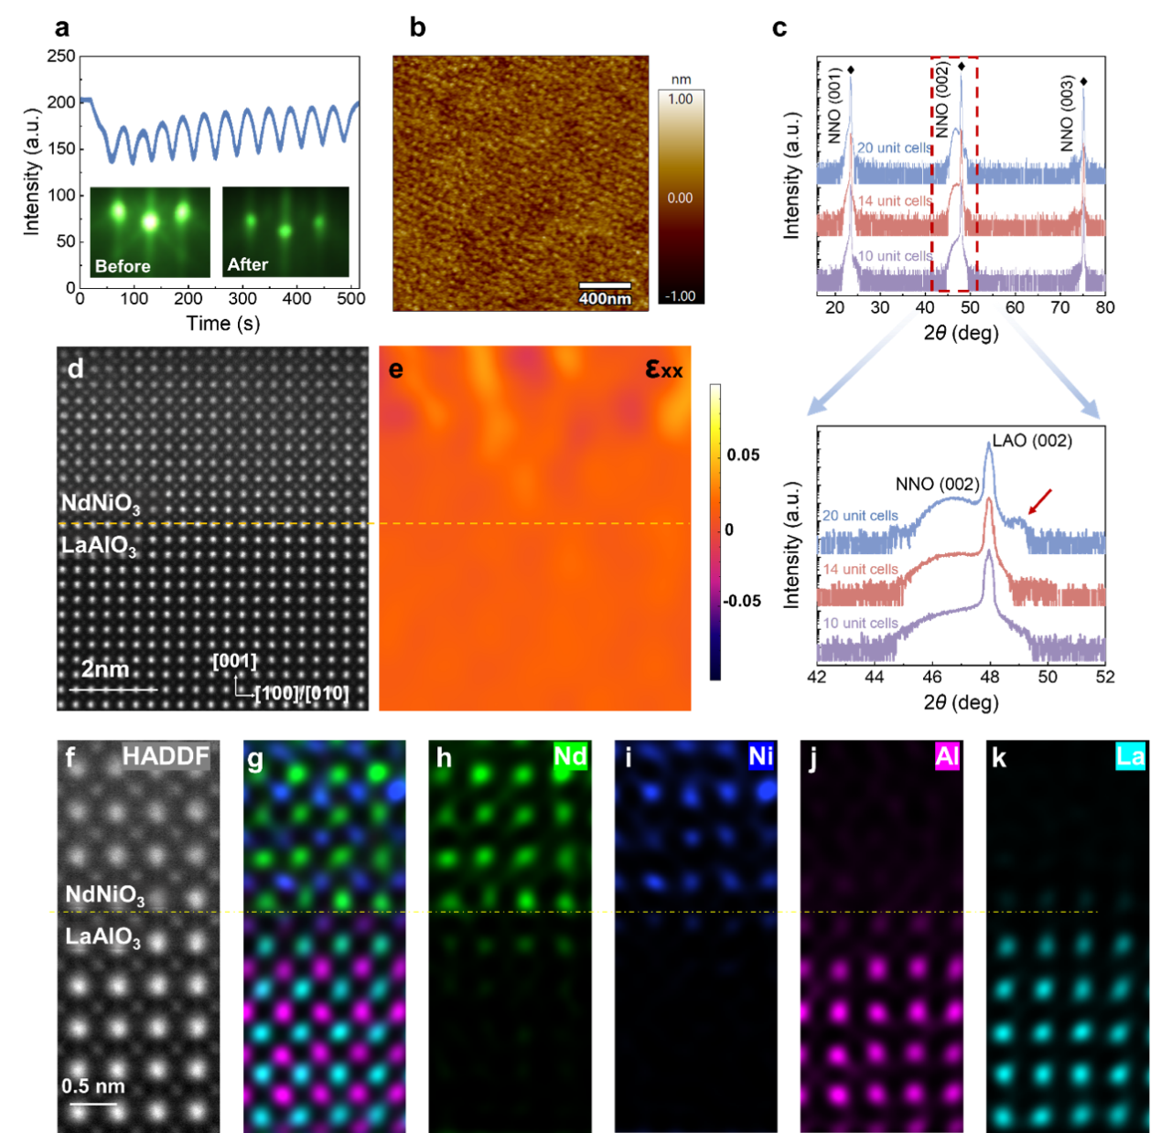

Extended Data Fig. 1 | Ozone-assisted PLD deposition of epitaxial NdNiO₃ films on (001)-oriented LaAlO₃ single crystal substrate. a, RHEED intensity oscillation during the PLD deposition process of a representative NNO film with a thickness of 12 unit cells. The insets show RHEED diffraction patterns from the LAO substrate before deposition and from the NNO film after PLD deposition, demonstrating a two-dimensional, layer-by-layer growth pattern. b, An AFM morphology image of an as-grown NNO film with a root-mean-square roughness of 0.157 nm. c, The full X-ray diffraction XRD spectra of 10, 14, and 20 unit-cell thick (001)-oriented NNO films, with an enlarged view near the (002) peaks shown below. The distinct peaks associated with the presence of the Laue fringe are indicated by the red arrow. d, e, HAADF-STEM image of the heteroepitaxial NNO/LAO (d) and respective deformation of the in-plane lattice parameter of the NNO film with respect to the LAO substrate (ε_{xx}, color scales) by geometrical phase analysis (GPA) (e). ε_{xx} is virtually zero throughout the NNO film, showing a good in-plane lattice match. f-k, Cross-sectional HAADF-STEM image of the film and corresponding elemental mappings of full, Nd, Ni, Al, and La, respectively.

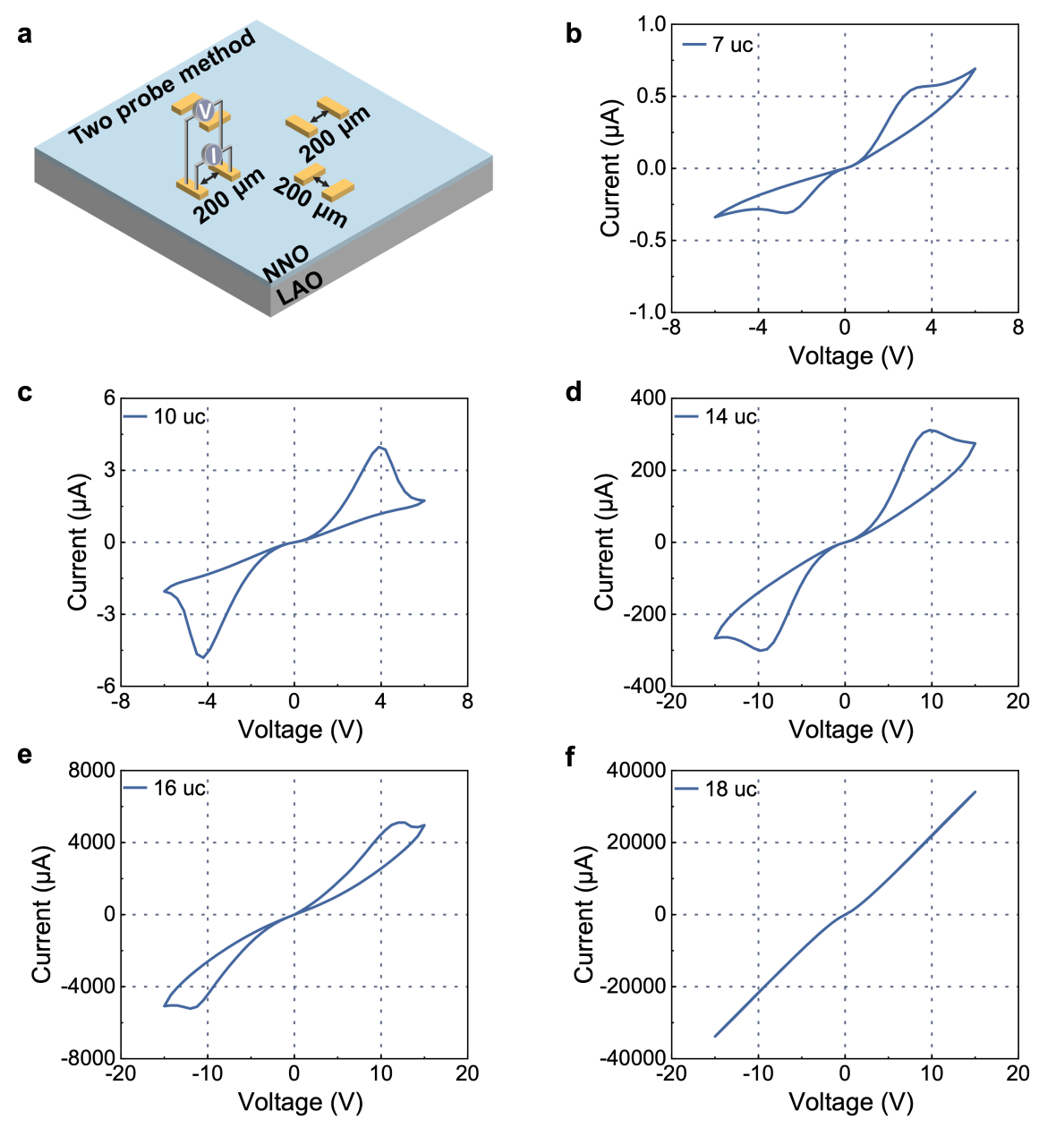

Extended Data Fig. 2 | DC I-V sweeps of (001)-oriented NNO films with different thicknesses. a, Schematic for DC I-V sweep and PUND measurements. The distance between the electrodes is 200 μm as labelled. b-f, DC I-V sweeps of (001)-oriented NNO films with thickness ranging from 7 to 18 unit cells.

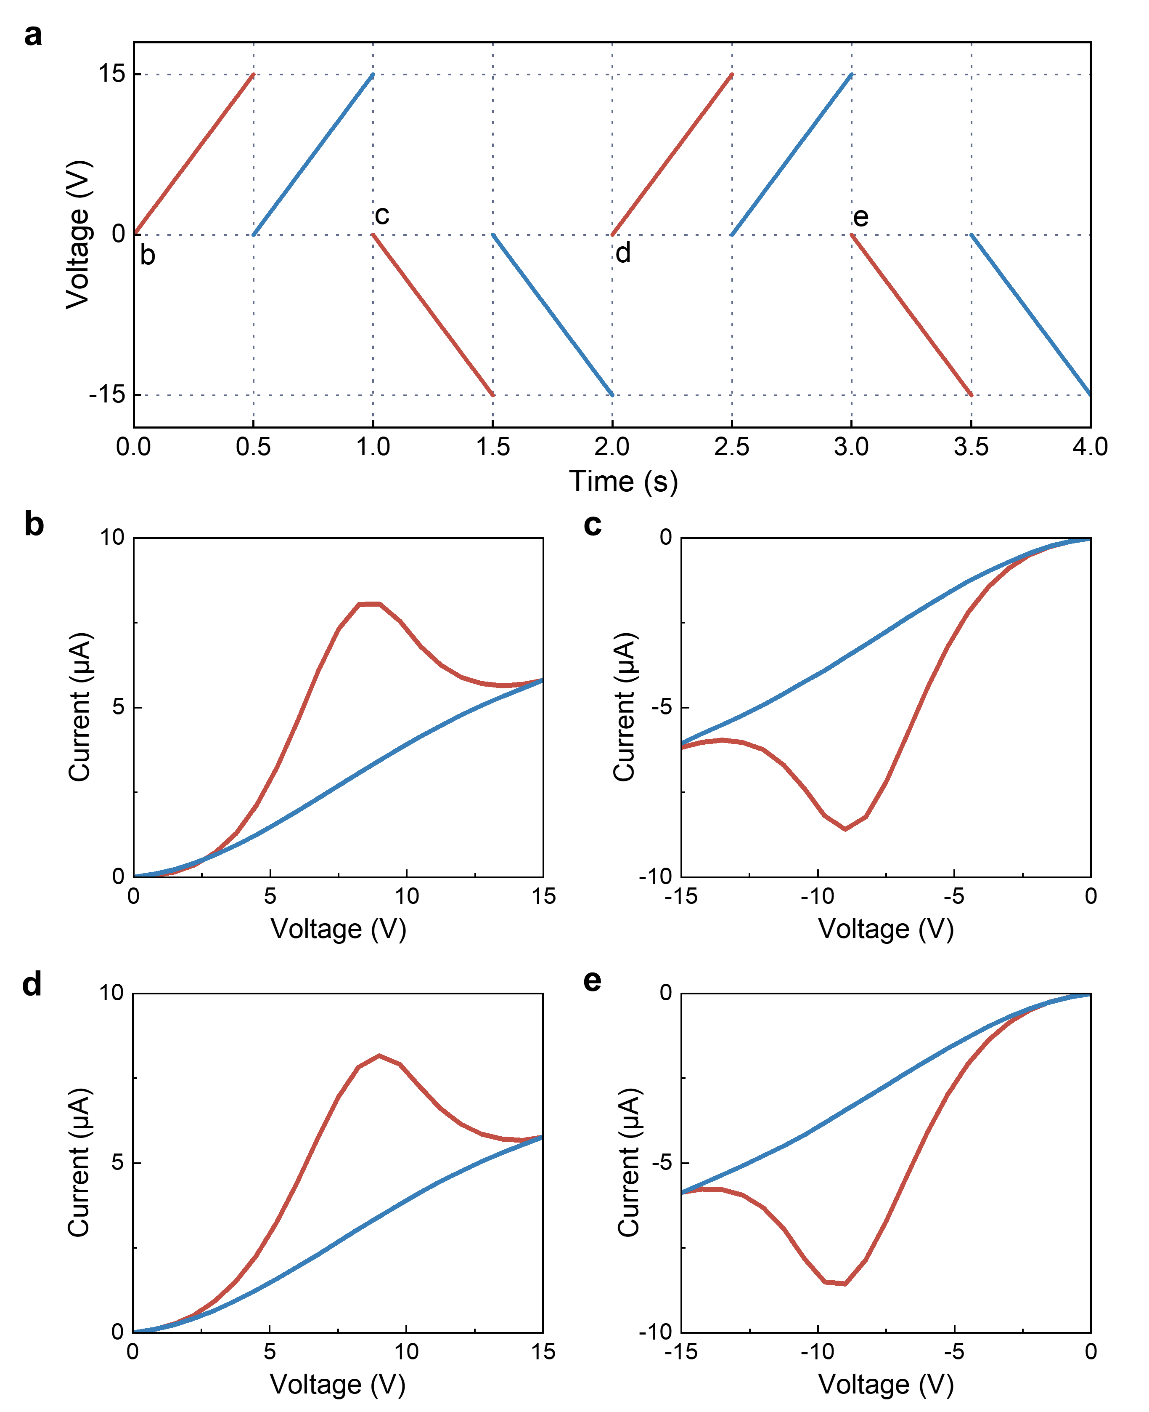

Extended Data Fig. 3 | Double-wave measurements of (001)-oriented NNO thin film with a thickness of 10 unit cells. a, Applied voltage window (0 to +15 V and 0 to −15 V) over time. The voltage waveform was applied twice at the positive and negative bias windows, respectively. b-e, I-V curves for different double wave sweeps labeled as (b)-(e) in a. The red and blue lines represent the first and second sweeps, respectively.

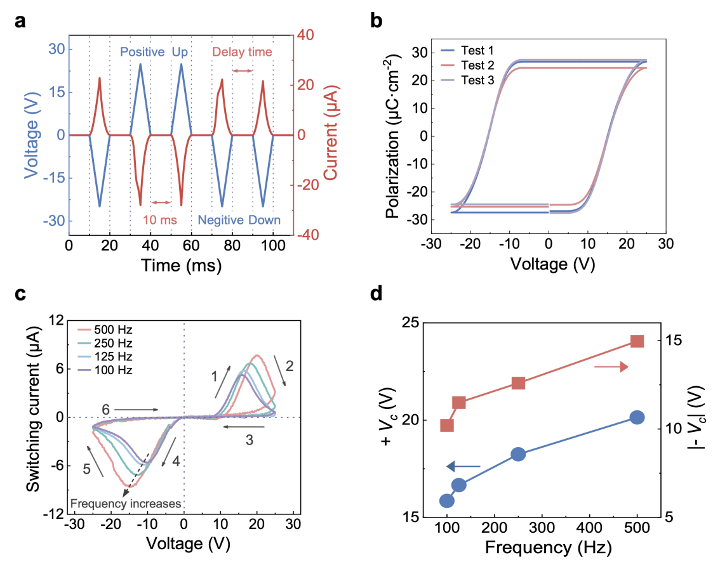
Extended Data Fig. 4 | Positive up negative down (PUND) measurements. a, PUND waveform (blue) and the observed raw current signal (red) from a 10 unit-cell thick (001)-oriented NNO film under a frequency of 100 Hz. b, P-V loops obtained from different devices on NNO films with thicknesses of 10 unit cells. The remanent polarization ranges from 24.5 to 27.5 µC cm⁻². c, Frequency-dependent I-V curves after subtracting the nonferroelectric response in PUND measurements. The numbers and arrows indicate the sweeping sequence. d, Coercive voltages (V_{C}), which correspond to the positive and negative current peaks, are plotted against the PUND measurement frequencies.
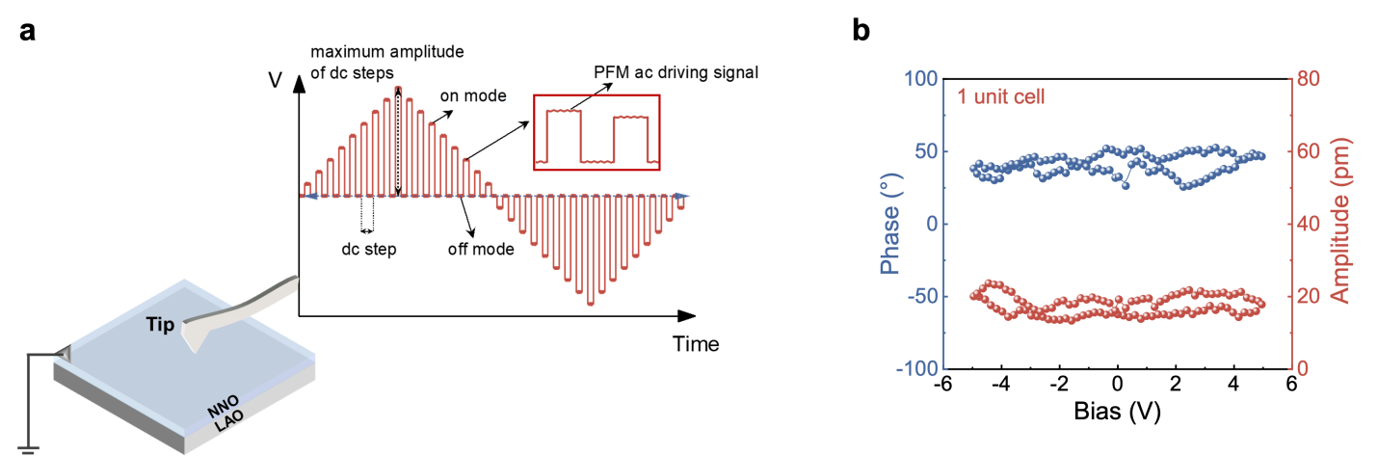

Extended Data Fig. 5| Switching Spectroscopy PFM measurements. a, Schematic of PFM measurement. The sample is grounded via the side of the NNO ultrathin films, while the electric bias is applied through the conductive probe. The local remanent ferroelectric hysteresis loops are acquired by the demonstrated triangular-square voltage waveform. b, No hysteresis loops can be obtained on 1 unit-cell thick NNO films.

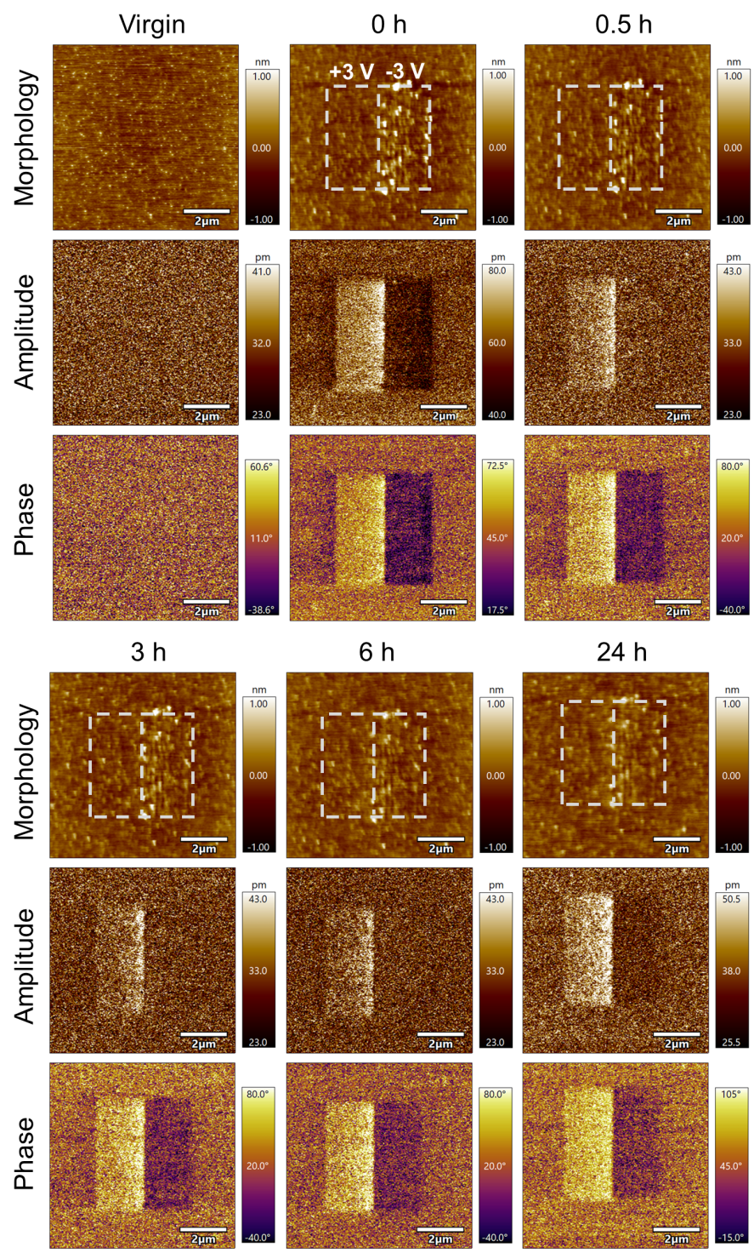

Extended Data Fig. 6 | Electric poling and ferroelectric polarization retention measurements of (001)-oriented NNO thin film. The morphology, amplitude, and phase evolution with time after domain poling using ±3 V_{DC} voltages.

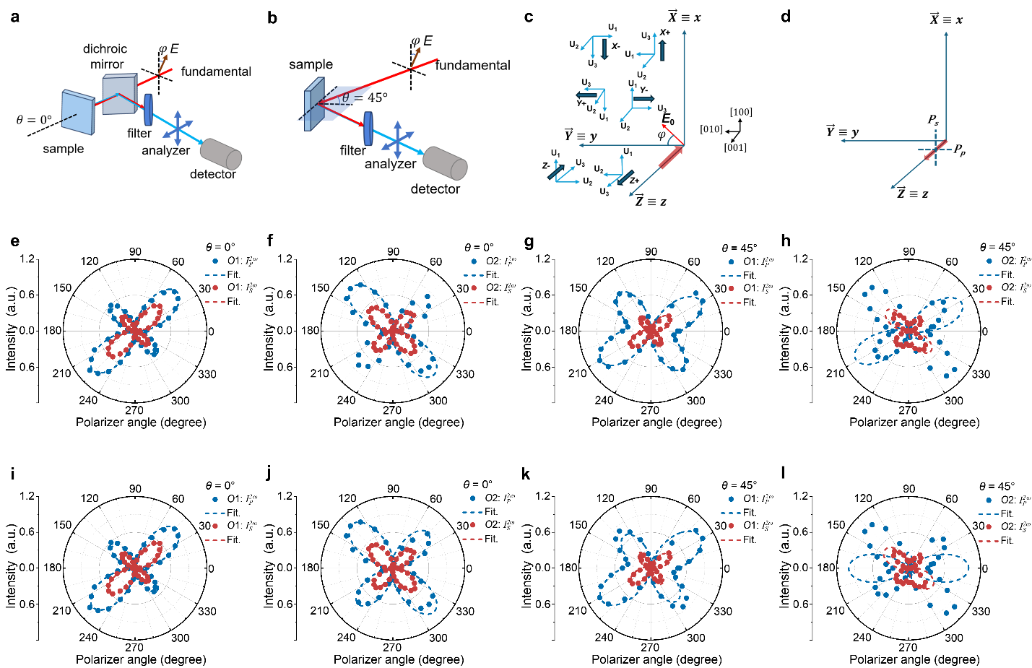

Extended Data Fig. 7 | SHG measurements of NNO ultrathin films with a thickness of 10 unit cells. a, b, Schematic diagrams of SHG measurements of the normal incidence configuration (a) and oblique incidence configuration (b). θ and φ denote the incident angle and the polarization angle of the fundamental laser beam, respectively. c, Schematic illustration of the six possible domain variants (X+, X-, Y+, Y-, Z+, and Z-) in the x-y-z space, along with the corresponding crystal axes (U₁, U₂, U₃) for each variant. The incident light E₀ is linearly polarized, with the azimuthal angle between the direction of E₀ and the y-axis defined as φ. d, Schematic of the emitted second harmonic wave, showing the two polarization configurations (P_{p} and P_{s}) for the analyzer. e-h, SHG polar plot fittings using point group C₄. When the sample is rotated by 90° in-plane (f, h), the polar plots do not satisfy C₄ symmetry. i-l, SHG polar plot fittings using point group C_{4v}. When the sample is rotated by 90° in-plane (j, l), the polar plots do not satisfy C_{4v} symmetry.

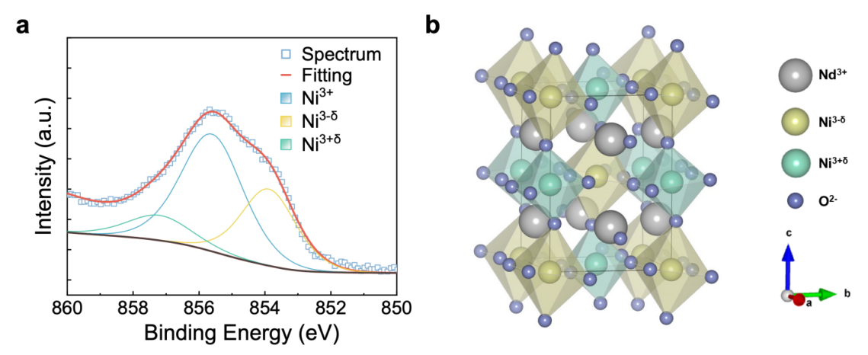

Extended Data Fig. 8 | Multivalent Ni ions in NNO thin film. a, XPS spectrum of Ni 2p in (001)-oriented NNO film with thicknesses of 15 unit cells. Revealed the multivalency of Ni ions. b, Schematic of the nonequilibrium geometrically stabilized structure of the NNO unit cell. Green, yellow, grey, and purple balls represent Ni^{3+δ}, Ni^{3-δ}, Nd³⁺, and O²⁻ ions, respectively.

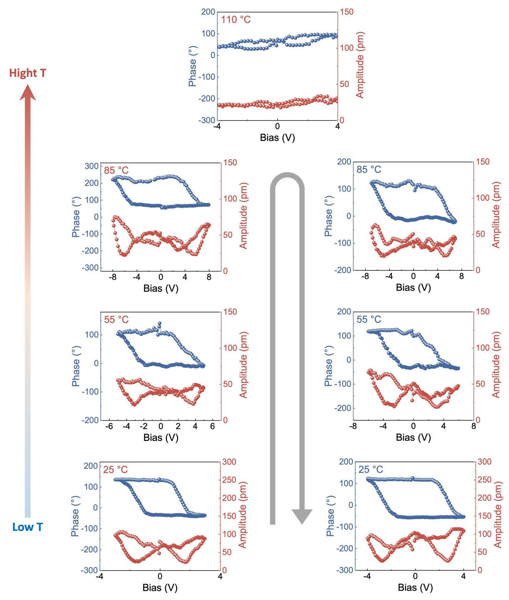

Extended Data Fig. 9 | Temperature-dependent PFM hysteresis loops in amplitude and phase of 14 unit-cell thick (001)-oriented NNO thin film. The gray arrow indicates the temperature-varying sequence.

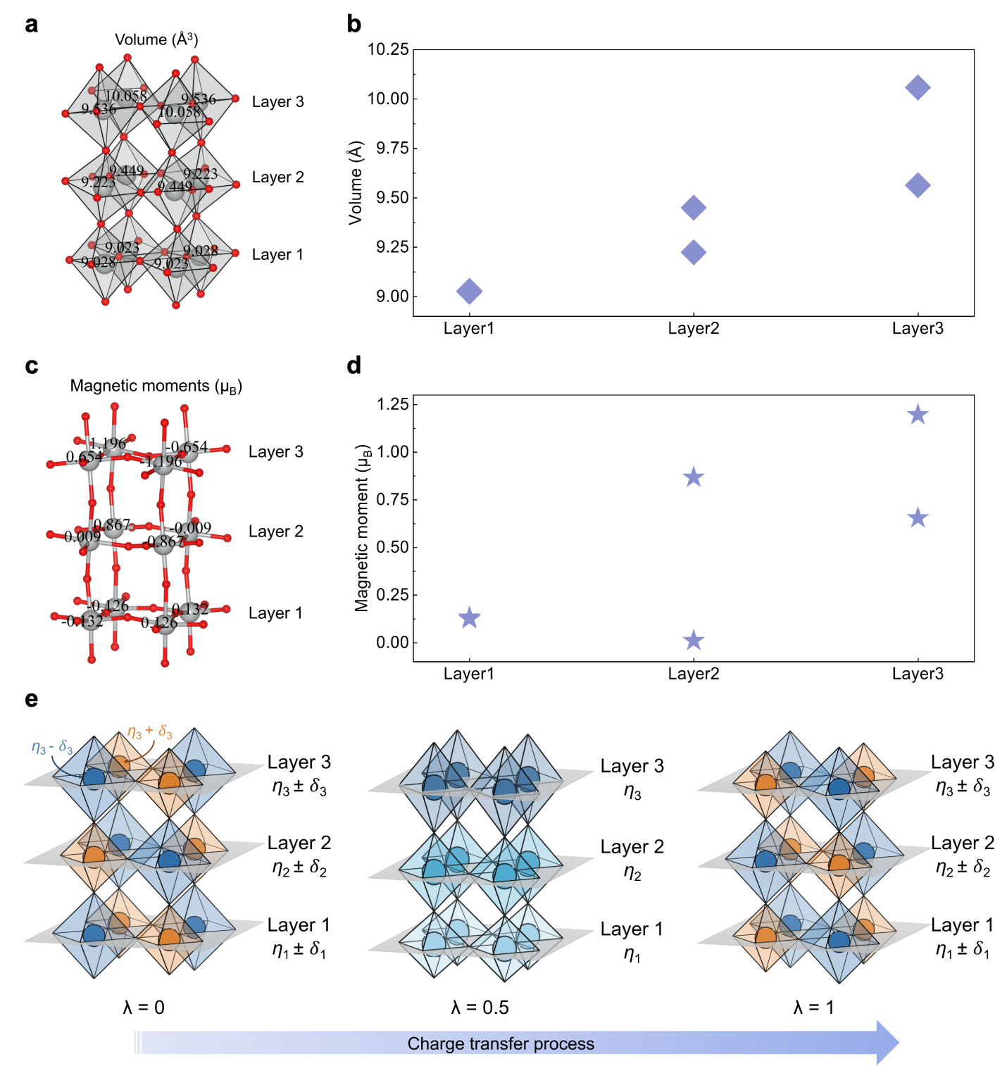

Extended Data Fig. 10 | Comprehensive analysis of layer-dependent checkerboard charge order in (001)-oriented NNO thin films. a, Spatial mapping of oxygen octahedron volumes, showing an intralayer checkerboard pattern with variation across layers 1–3 (bottom to top). b, Quantified layer-resolved trend of the octahedron volume extracted from panel (a). c, Spatial mapping of the local magnetic moment on each Ni ion. d, Quantified layer-resolved trend of the Ni magnetic moment extracted from panel (c). e, Schematic of the charge-ordered states of the 3 unit cells thick NNO film along the charge transfer process. The η_{x} (x = 1, 2, 3) represents the base charge, and 𝛿_{x} (x = 1, 2, 3) represents the charge transfer for each corresponding layer.

