Sublethal costs of infection reduce performance of collective tasks in social insects: a modelling study

Supraja Rajagopal¹, Takao Sasaki^{1,2}, Richard J. Hall^{1,3,4}
1: Odum School of Ecology, University of Georgia, Athens, 30602, GA, USA
2: Brain and Cognitive Sciences, University of Rochester, Rochester, NY 14627, USA
3: Center for the Ecology of Infectious Diseases, University of Georgia, Athens, GA, 30602, USA
4: Department of Infectious Diseases, University of Georgia, Athens, 30602, GA, USA

Supplementary Material:

S1 Sensitivity of model outcomes to infection prevalence and baseline parameters

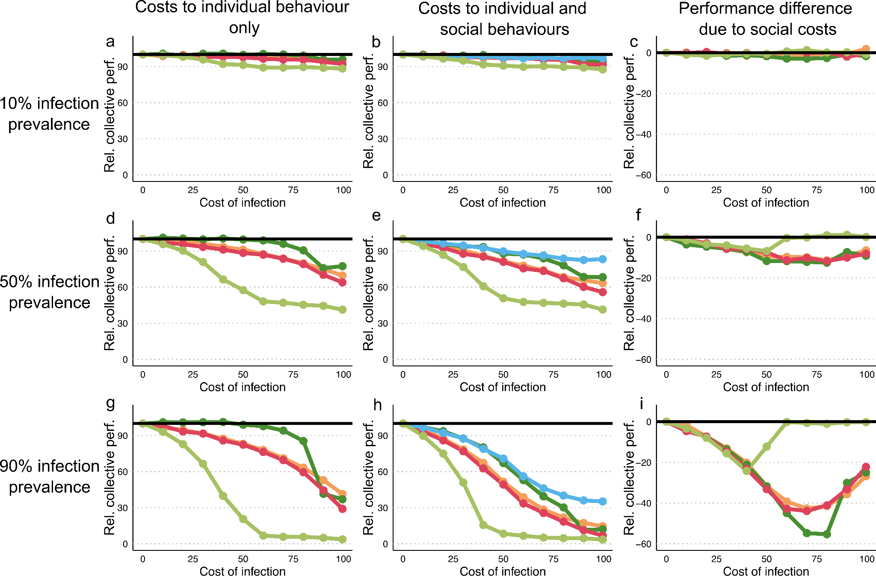
Fig S1: Relative colony performance (a,d,g) when individual behaviours are impacted by infection (b,e,h) when individual behaviours and social interaction costs are co-varied as the cost of infection to different behavioral processes increases. Relative colony performance is the net energy gain to an infected colony (food brought to the colony minus the total energy expenditure of all ants engaged in the foraging task) normalized by the performance of an infection free colony; and the cost of infection is the proportionate reduction in an individual or social behavior due to infection (see Methods). Each of these metrics is multiplied by 100 so that results are expressed as a percentage. Colours indicate which individual behaviours are impacted by infection (light green - walk speed, red - distance at which food cue is perceived, orange - turning angle, dark green - giving up time). In (b,e,h) the blue line is the cost of infection to social interactions (reduced probability of recruitment when at least one individual in the dyad is infected), and the colours of the other lines correspond to the corresponding individual cost of infection in (a). The black horizontal line represents the performance of a disease-free colony. (c,f,i) The additional reduction in performance when social costs of infection occur in addition to individual costs of infection (i.e. the difference between each coloured line in figures (a) and (b) All simulations were run at 50% infection prevalence for the duration of one foraging bout (90 minutes). Plotted values represent the mean performance averaged over 50 simulation runs

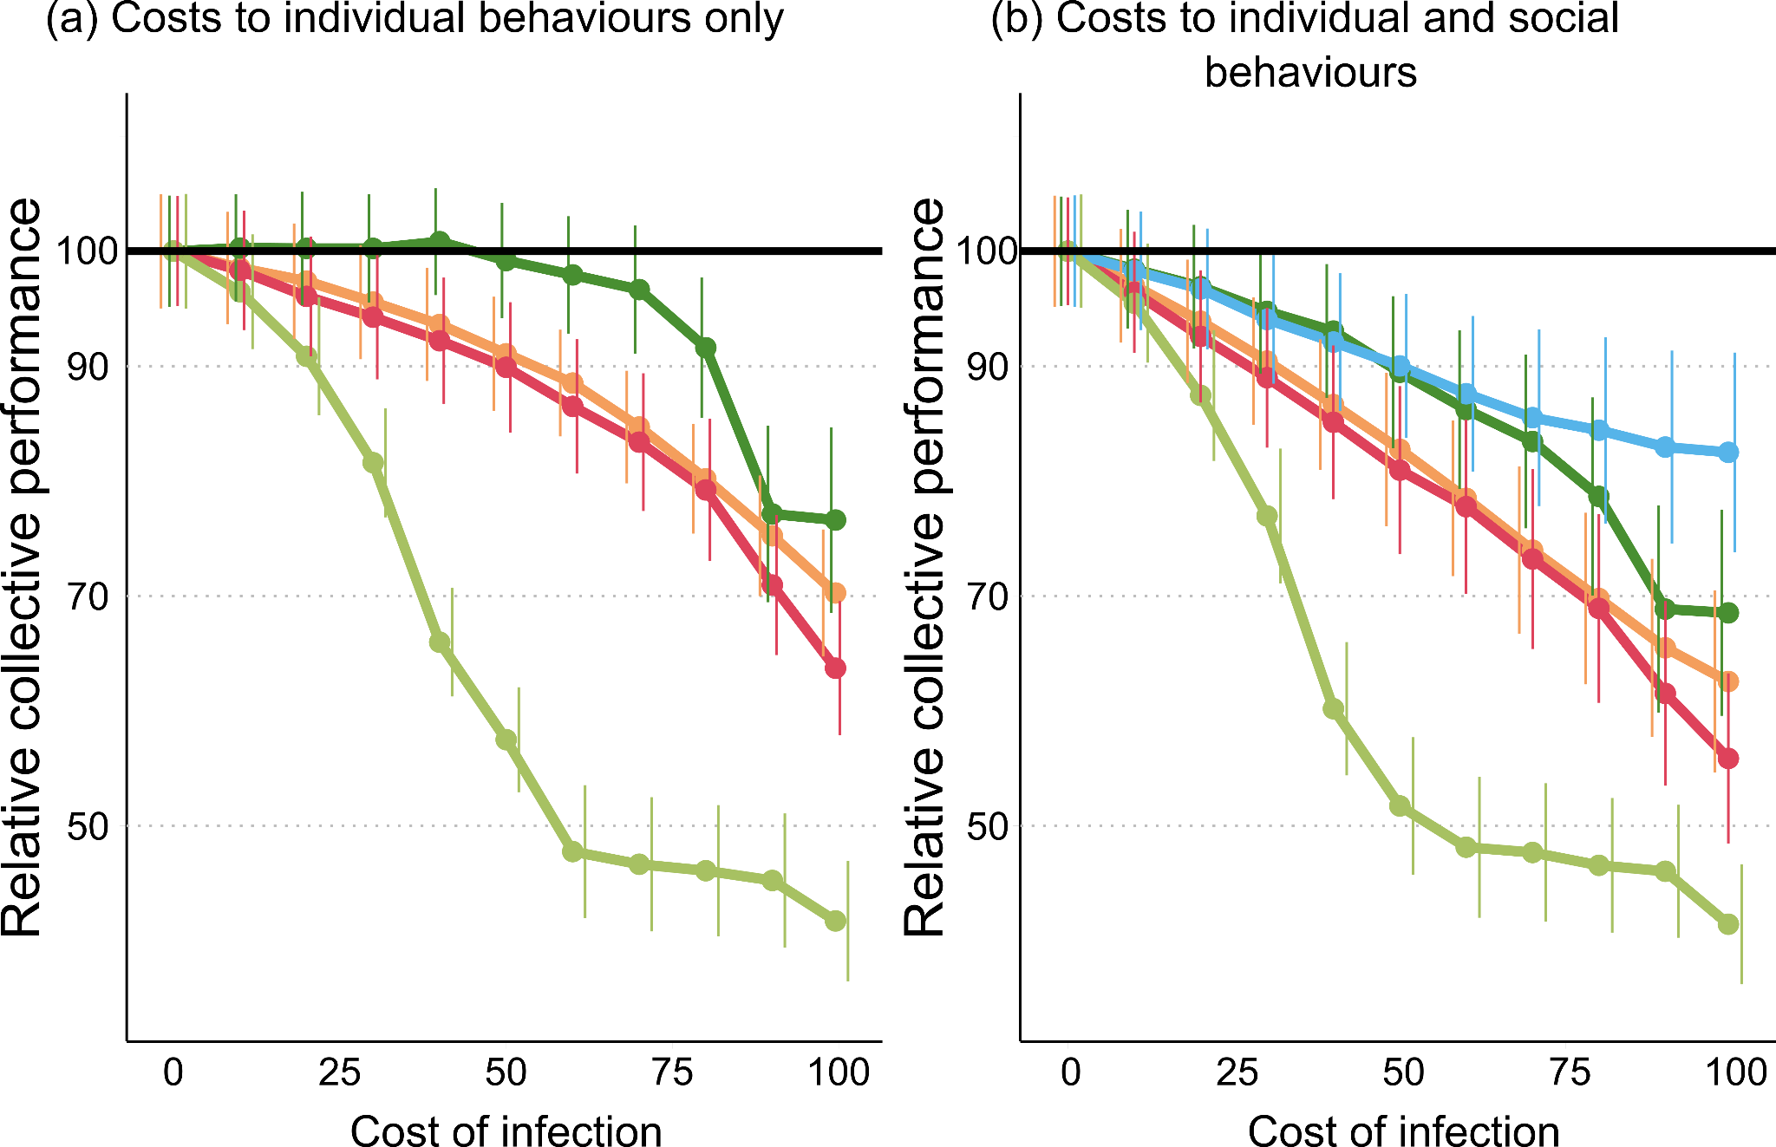
Fig S2: Relative colony performance (a) when individual behaviours are impacted by infection (b) when individual behaviours and social interaction costs are co-varied as the cost of infection to different behavioral processes increases. Relative colony performance is the net energy gain to an infected colony (food brought to the colony minus the total energy expenditure of all ants engaged in the foraging task) normalized by the performance of an infection free colony; and the cost of infection is the proportionate reduction in an individual or social behavior due to infection. Each of these metrics is multiplied by 100 so that results are expressed as a percentage. Colours indicate which individual behaviours are impacted by infection (light green - walk speed, red - distance at which food cue is perceived, orange - turning angle, dark green - giving up time). In (b) the blue line is the cost of infection to social interactions (reduced probability of recruitment when at least one individual in the dyad is infected), and the colours of the other lines correspond to the corresponding individual cost of infection in (a). The black horizontal line represents the performance of a disease-free colony. All simulations were run at 50% infection prevalence for the duration of one foraging bout (90 minutes). Plotted values represent the mean performance averaged over 1,000 simulation runs, with error bars showing standard deviation.
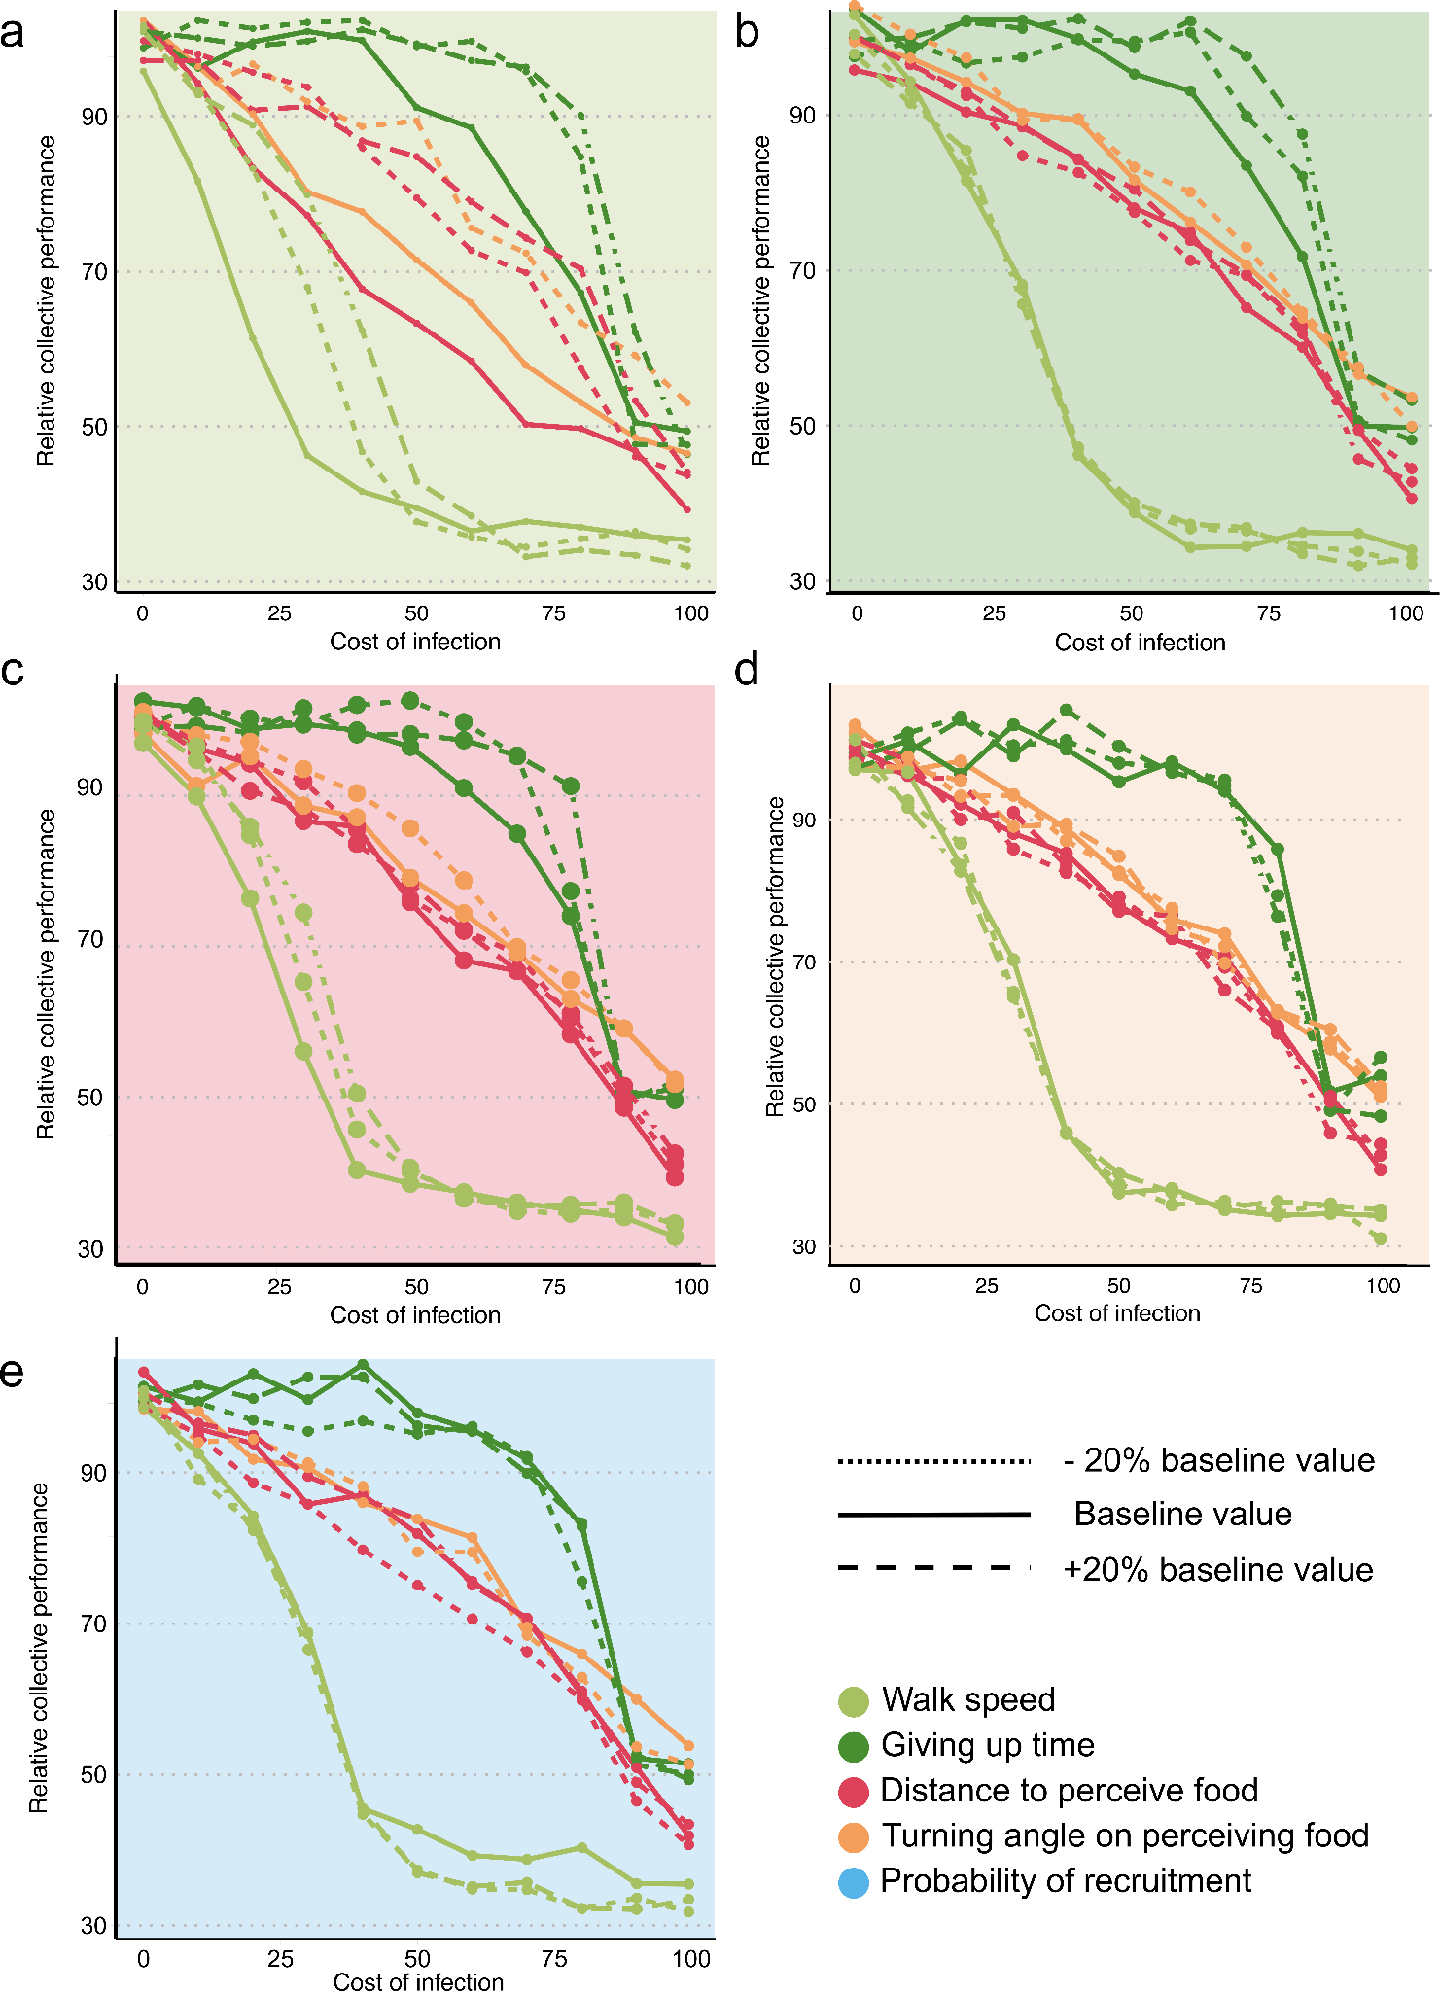
Fig S3. Sensitivity of results to baseline parameters - relative colony performance as cost of infection to individual behaviour increases. Each panel represents the colony performance over a +/- 20% in our baseline parameter values for (a) walk speed (b) giving up time (c) distance at which food cue is perceived (d) turning angle (e) probability of recruitment. All simulations were run at 50% disease prevalence for the duration of one foraging bout (90 minutes). Colours indicate different behavioural mechanisms that can be affected by infection in individuals (light green - walk speed, orange - turning angle, red - distance at which food cue is perceived, dark green - giving up time), and the presence of colour in the background of the plot signify which parameter’s baseline values were varied. Linetype indicates the variation in baseline parameter - solid is the baseline value, dotted lines are -20% in the baseline value and dashed lines are +20% in the baseline values

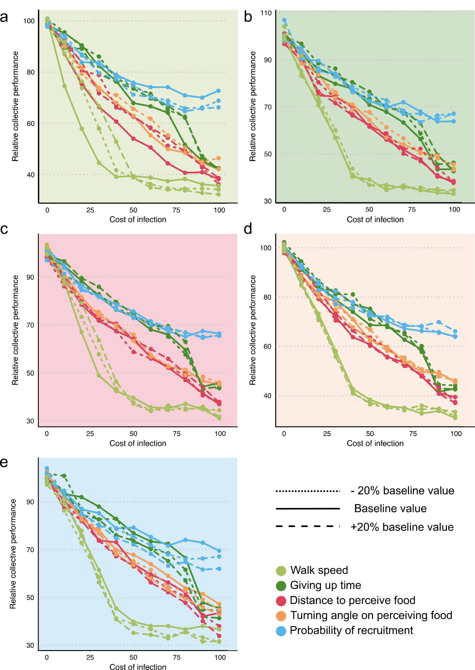

Fig S4: Sensitivity of results to baseline parameters - relative colony performance as cost of infection to individual and social behaviour increases. Each panel represents the colony performance over a +/- 20% in our baseline parameter values for (a) walk speed (b) giving up time (c) distance at which food cue is perceived (d) turning angle (e) probability of recruitment. All simulations were run at 50% disease prevalence for the duration of one foraging bout (90 minutes). Colours indicate different behavioural mechanisms that can be affected by infection in individuals (light green - walk speed, orange - turning angle, red - distance at which food cue is perceived, blue - probability of recruitment, dark green - giving up time), and the presence of colour in the background of the plot signify which parameter’s baseline values were varied. Linetype indicates the variation in baseline parameter - solid is the baseline value, dotted lines are -20% in the baseline value and dashed lines are +20% in the baseline values

S2. Full description of agent-based model
We outline a description of our agent-based model using the ‘Overview, Design Concepts and Details’ protocol, with some modifications to reduce redundancy (Grimm et al., 2006).

Purpose
The overall purpose of the model was to explore how sublethal effects of infection to individual behaviour could scale up and affect collective outcomes in social insect colonies, using collective foraging in Temnothorx ants as a model organism.

Entities, State Variables and Scales
In all our model runs we simulated 100 active foraging ants. At the start of the model run foragers are divided into two different types, scouts (N = 25) and recruits (N = 75), based on typical proportions of scouts and recruits in social insect colonies (Seeley, 2009; Shaffer et al., 2013). We were interested in understanding colony level impacts of sublethal changes to individual behaviour. To do this, ants were assigned an infection status at the start of the model of either “uninfected” or “infected”, and infected ants experienced a reduction in individual behaviour.
Agents were located on a two-dimensional square grid with 140 X 140 patches. Following the previous model, the width of a patch corresponded to 1 cm in our model. Agents could occupy any position in the area and were not restricted to edges of a patch. The nest was located at the centre patch and all agents started at this position. We designed the simulated colony’s foraging scenario to mimic experimental setups used to study collective foraging behaviour in these ants (cite). A single food patch was provided to the colony for foraging at a distance of 40 cm from the nest. The food patch was ad libitum and provided the energetic equivalent of 1 M sucrose solution when ants foraged. Simulations were run in discrete time steps, where each time step corresponded to 1 second and each simulation was run for 90 min, which is based on empirical data about the length of foraging bouts in Temnothorax ants (Sasaki et al., 2020).

Parameterization
Table S1: Variables used in the agent-based model
Variable | Value | Information source
Distance from nest to food source | 40 cm | (Goy et al., 2021)
Energy gained on foraging | 0.75 J | (Goy et al., 2021)
Walk speed | 0.8 cm/sec | (Goy et al., 2021)
Food sensing distance | 20 cm | See Ant movement submodel
Orientation angle on sensing food | 30° | See Ant movement submodel
Feeding time | 120 sec | (Goy et al., 2021)
Time a returned forager stays back in the nest | 60 sec | (Goy et al., 2021; Grüter et al., 2018)
Probability of leading a tandem run | 0.25 | See Recruitment submodel
Probability of following a tandem run | 0.25 | See Recruitment submodel
Energy cost of walking outside | 2.446 × 10^-7 J/tick | (Goy et al., 2021)
Time spent by scout ant searching for food before returning home | 600 | (Goy et al., 2021)

Process overview
Individual foraging ants collected food from a provided food source and returned to the home nest to unload food. Ants could participate in foraging as scout ants that independently search for the food or on being recruited to the food by a knowledgeable individual. The amount of food brought back to the nest is equivalent to the energy gained by the colony, while the distance spent walking by ants is the energy lost by the colony.

Submodels
Ant movement
All scouting ants leaving the nest at the start of the simulation pick a random starting direction to move in. Scouts performed a random walk when moving, implemented similarly to the original model (Goy et al., 2021). When scouts reach within the radius of their sensing distance from the food, they start performing a directed random walk, constraining their turning angle and orienting every 5 seconds towards the food. Ants that have found food can make multiple trips to and from the food or recruit other individuals. Knowledgeable ants that return to food reorient towards the food every 5 sec, as they have learned the location of the food site (Sasaki et al., 2020). These ants move with a larger turning angle near the nest and walk more directly with a smaller turning angle when they are within sensing distance of the food. The values of the turning angle and sensing distance were determined by running model scenarios with a single ant across a range of turning angle and sensing distance values. Each combination was run 100 times and the proportion of runs where the food was found and number of trips made to the food were calculated and plotted (Fig S5). Values of sensing distance and turning angle that aligned with empirical observations of food detection and visitation were selected.

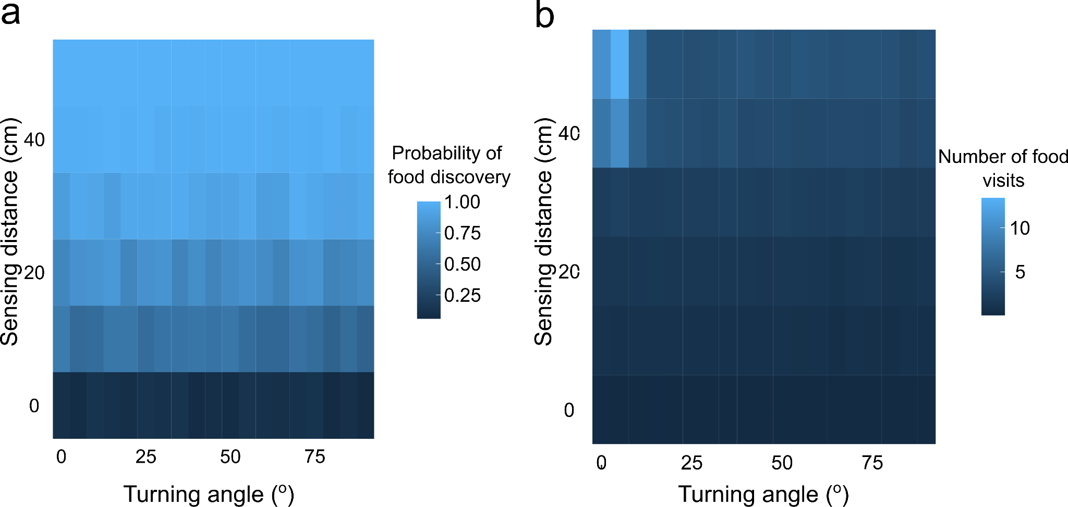
Fig S5: (a) Food discovery rates and (b) Number of food visits made by a single ant across 100 model scenarios with movement rules governed by a range of sensing distance and turning angle values

Recruitment via tandem running behaviour
Knowledgeable ants probabilistically recruit ants waiting at the home nest to the food site, and recruits probabilistically join an invitation to recruitment. These probability values were determined by running model scenarios with two ants across a range of leading and following probability values. Each combination was run 100 times and the proportion of food visits that were tandem runs were calculated and plotted (Fig S6). Probability of leading and following were set at 0.25, which led to a recruitment probability of 0.6 to a high quality food site 40 cm away, matching empirical observations made by (Grüter et al., 2018) (Fig S6).
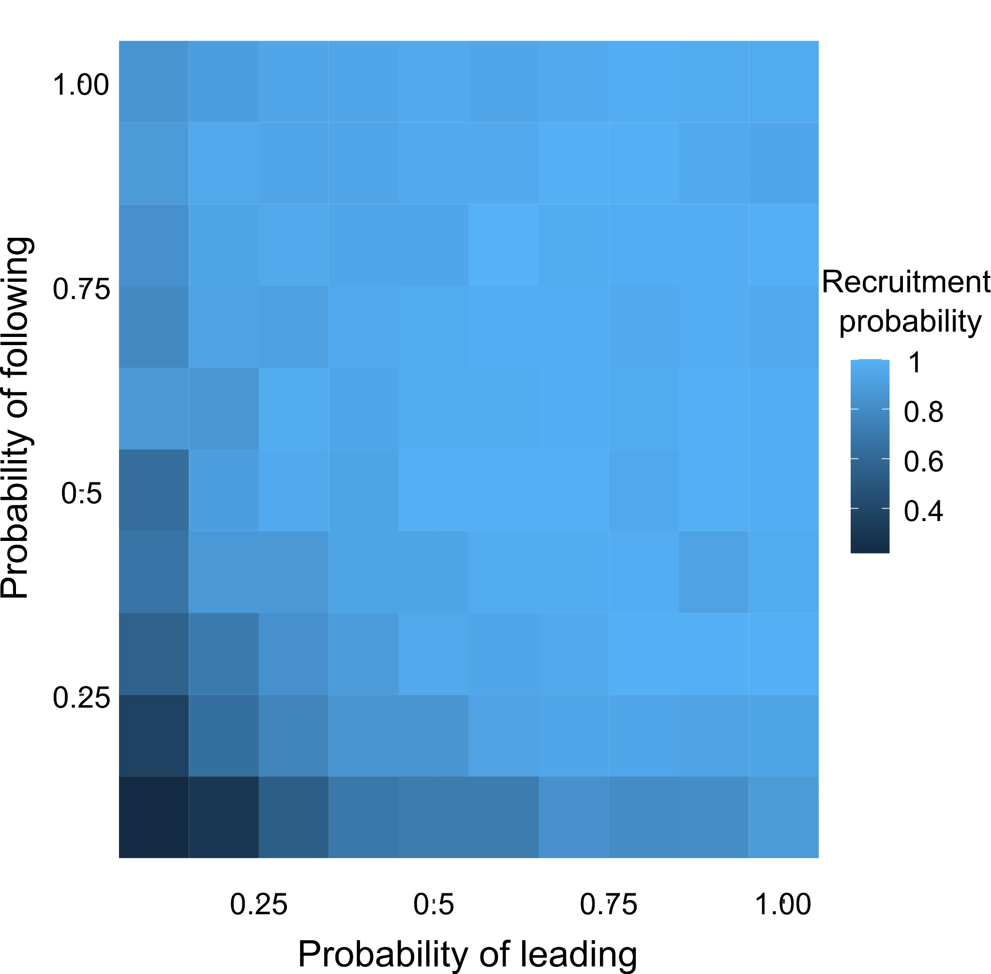
Fig S6: Recruitment rates over the whole model run in a two ant model scenario across 100 model scenarios with recruitment rules governed by a range of leading and following probabilities.

Ant infection status
At the beginning of each model run, ants are randomly assigned an infection status (“uninfected” or “infected”) according to the colony’s infection prevalence. Assignment was independent of task role, such that scouts and recruits had equal probabilities of infection; however, a greater number of infected recruits was expected due to their higher abundance.

References:
- Goy, N., Glaser, S. M., & Grüter, C. (2021). The adaptive value of tandem communication in ants: Insights from an agent-based model. Journal of Theoretical Biology, 526, 110762. https://doi.org/10.1016/j.jtbi.2021.110762
- Grimm, V., Berger, U., Bastiansen, F., Eliassen, S., Ginot, V., Giske, J., Goss-Custard, J., Grand, T., Heinz, S. K., Huse, G., Huth, A., Jepsen, J. U., Jørgensen, C., Mooij, W. M., Müller, B., Pe’er, G., Piou, C., Railsback, S. F., Robbins, A. M., … DeAngelis, D. L. (2006). A standard protocol for describing individual-based and agent-based models. Ecological Modelling, 198(1), 115–126. https://doi.org/10.1016/j.ecolmodel.2006.04.023
- Grüter, C., Wüst, M., Cipriano, A. P., & Nascimento, F. S. (2018). Tandem Recruitment and Foraging in the Ponerine Ant Pachycondyla harpax (Fabricius). Neotropical Entomology, 47(6), 742–749. https://doi.org/10.1007/s13744-017-0571-6
- Sasaki, T., Danczak, L., Thompson, B., Morshed, T., & Pratt, S. C. (2020). Route learning during tandem running in the rock ant Temnothorax albipennis. Journal of Experimental Biology, 223(9), jeb221408. https://doi.org/10.1242/jeb.221408
- Seeley, T. D. (2009). The Wisdom of the Hive: The social physiology of honey bee colonies. Harvard University Press.
- Shaffer, Z., Sasaki, T., & Pratt, S. C. (2013). Linear recruitment leads to allocation and flexibility in collective foraging by ants. Animal Behaviour, 86(5), 967–975. https://doi.org/10.1016/j.anbehav.2013.08.014

