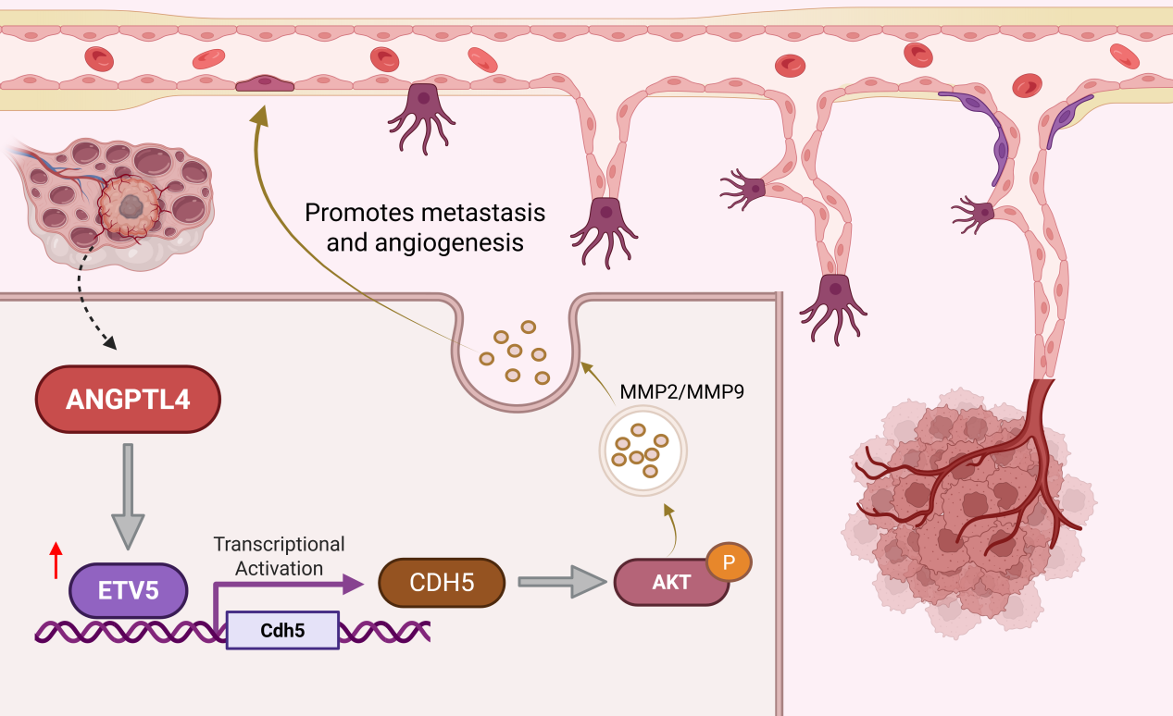

Supplementary Figure 1.
An elevated ANGPTL4 in ovarian cancer increases the expression of CDH5 by up-regulating ETV5 which could binding to CDH5 promoter region, would activate AKT followed by induction of MMP9. At the same time, high expression of ANGPTL4 can promote angiogenesis of ovarian cancer.

